

|  |
| --- |
| Driving Strategic Import Reforms through Advanced Analytics |
|  |
| May 6  ZION TECH HUB  Authored by: Team Ruby |

# Outline

1. Introduction

* Background
* Objectives of the Analysis
* Scope and HS Code Focus

2. Methodology

* Data Sources
* Tools Used
* Analytical Techniques (Cleaning, Forecasting, Anomaly Detection, Modeling)

3. Key Findings

* Import Volume Trends and Forecast
* Tax Revenue Trends, Forecast, and Leakage
* Fastest Growing Import Categories
* Opportunities for Import Substitution
* Innovation Funding Insights

4. Policy Implications

* Taxation Policy Reform
* Strategic Import Substitution
* Innovation Funding Allocation

5. Recommendations

6. Visual Insights

* Charts, Tables, Forecast Graphs

7. Limitations and Next Steps

8. References and Links

# INTRODUCTION

Background

This report presents insights from a data-driven analysis of Nigeria’s imports under HS Code 85 (Electrical Machinery and Equipment). The objective was to uncover trends in import volumes and tax performance, identify fast-growing import categories, and simulate policy interventions that can guide strategic reforms. The overarching goal is to support government decision-making in optimizing import taxation, encouraging local innovation, and reducing external dependency.

Objectives of the Analysis

The analysis seeks to:

* Analyze import and tax trends under HS Code 85
* Forecast future import volumes and tax revenues
* Identify fast-growing import categories for potential regulation or incentives
* Model impact scenarios for local substitution and innovation funding
* Develop a data-driven framework for allocating innovation funds
* Provide actionable policy recommendations to improve revenue collection and enhance national self-sufficiency

Scope and HS Code Focus

This report focuses on HS Code 85, which covers a broad range of electrical machinery and equipment, including transformers, generators, telecommunication devices, and components. The dataset includes import records from 2023, enhanced with estimated tax rates, growth trends, and substitution potential. Key focus areas include:

* Import trends and forecasting
* Tax performance and anomaly detection
* High-growth import categories
* Simulation of import substitution impacts
* Strategic allocation of innovation funding

# METHODOLOGY

Data Sources

The analysis draws primarily from two structured datasets:

1. ZTH Data Analysis Hackathon.xlsx
   * Source: Zion Tech Hub
   * Description: This dataset contains detailed transactional records of imports under HS Code 85 (Electrical Machinery and Equipment).
   * Structure:
     + Format: Excel (.xlsx)
     + Size: 133,736 rows × 18 columns
     + Key Columns:
       - Custom Office
       - Reg Number, Reg. Date
       - Importer
       - HS Code, HS Description
       - FOB Value (N), CIF Value (N), Total Tax (N)
       - Country of Origin/Supply
2. cet_tariff.xlsx
   * Source: Nigeria Trade Portal and Nigeria Customs Service Tariff Document
   * Description: This dataset provides expected tariff breakdowns for items classified under HS Code 85.
   * Structure:
     + Format: Excel (.xlsx)
     + Key Columns:
       - CET Code
       - Description
       - ID (Import Duty), VAT, LVY (Levy), SU (Supplementary Duty), EXC (Excise), DOV (Value Adjustment)

Together, these datasets allowed for the merging of import transaction records with their corresponding tax expectations, forming the basis for tax anomaly detection, forecasting, and policy modeling.

Tools Used

The analysis combined spreadsheet, programming, and visualization tools to ensure a robust and scalable workflow:

* Microsoft Excel: Used for initial data inspection, cleaning, quick aggregations, and spotting early anomalies.
* Python (Pandas, Prophet, Matplotlib, Seaborn): Applied extensively for data preprocessing, forecasting (using Prophet), exploratory data analysis, and statistical modeling.
* Google Colab: Served as the primary development environment, enabling real-time collaboration and access to cloud computing for processing the dataset.
* Power BI: Used to design and build the interactive dashboard, providing stakeholders with accessible visual storytelling and insight navigation.

Analytical Techniques

A range of techniques were applied to derive insights and develop models:

* Data Cleaning & Preparation  
  The raw import and tariff data were cleaned to address missing values, inconsistent formatting, and outliers. Tax components were recalculated for accuracy, and dates were normalized and resampled for monthly aggregation.
* Forecasting  
  The Prophet time-series model was used to forecast import values and tax revenues over a 5-year horizon. Forecasts captured seasonality and trends based on 2023 data, providing a forward-looking view under current conditions.
* Anomaly Detection  
  Expected tax values were calculated using benchmark tariff rates from the CET schedule and compared to reported taxes. Z-score analysis and Isolation Forest modeling were used to flag anomalies, potentially indicating under-reporting or inefficiencies.
* Growth Analysis  
  Monthly import values were grouped by HS code, and linear regression was used to estimate growth rates. This highlighted fast-growing import categories warranting attention for regulation or support.
* Policy Scenario Modeling  
  Simulations modeled the fiscal and industrial impact of substituting 20–30% of key imports with local production. This helped quantify potential savings and industrial development benefits.
* Innovation Fund Allocation Modeling  
  A scoring framework ranked HS codes based on import value, growth rate, and substitution feasibility. This informed a rational and targeted strategy for directing limited innovation funding to high-impact areas.

# KEY FINDINGS

Import Trends and Forecast:

1. Import Concentration and High-Value Categories  
Nigeria’s import portfolio under HS Code 85 is significantly concentrated in a few product categories:

* The top 5 HS codes account for nearly 30% of the total CIF value.
* Telephones for Cellular Networks (HS Code 8517120000) are the most frequently imported item.
* Machines for Data Transmission (HS Code 8517620000) represent the highest import value at ₦102.28 billion, contributing 13.05% of the total CIF value.

2. Country Dependence and Supply Chain Risk

* Over 54% of Nigeria’s electrical imports (by CIF value) originate from China, with India (8.94%) and the United Kingdom (6.05%) trailing behind.
* China also dominates the supply chain, accounting for ₦66.48 billion (65.01%) of imports under HS Code 8517620000.
* This dual dependency poses a strategic supply chain risk, especially in light of global geopolitical and economic uncertainties that could disrupt trade flows or inflate costs.

3. Seasonal Import Patterns

* CIF import values peaked in January, followed by a notable dip in February, indicating possible seasonal procurement cycles.
* Moderate fluctuations occurred across subsequent months, with dips observed in May and November.

4. Import Value Forecast

* Forecasting results project a steady increase in import volumes, with CIF values rising from ₦783 billion in 2019 to ₦844 billion by 2024, reinforcing Nigeria’s continued reliance on foreign electrical goods.

5. Country-Specific Forecast

* Interestingly, projected imports from China are expected to fall drastically from ₦420 billion to ₦7 billion by 2024. While this suggests an opportunity for diversification, it may also point to over optimistic assumptions or potential changes in reporting/sourcing.

6. Scenario Modeling: Fiscal Impact of Import Reduction

* A 12% drop in overall import volume between 2020 and 2024 is projected to result in a ₦449 billion revenue shortfall, assuming the current tax realization rate of 91.7%.
* A 20% reduction in imports from China alone could lead to a ₦154 billion cumulative tax shortfall over five years. However, the diminishing gap by 2024 indicates potential resilience and adaptability in the system.

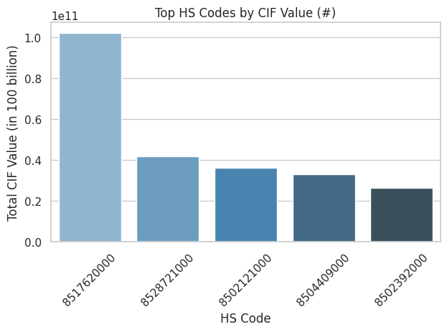 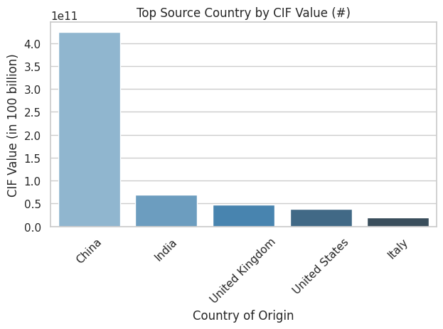

Fig 3.1 Chart showing Top HS Code by Import Value Fig 3.2 Chart showing country of supply by HS Code

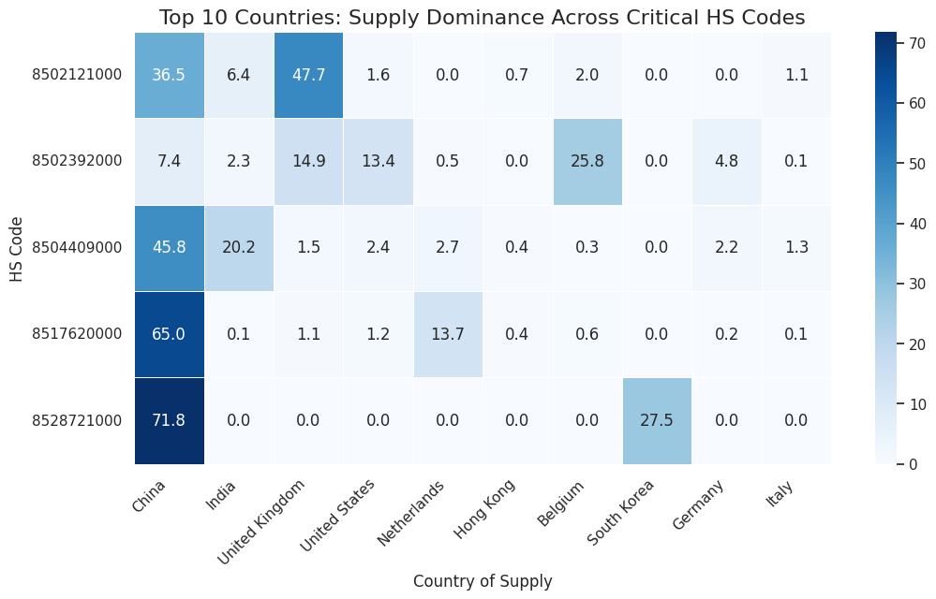

Tax Revenue Trends, Forecast, and Leakage:

1. Significant Tax Gap  
Analysis revealed a notable shortfall between expected and actual tax revenue. While the expected tax for HS Code 85 imports in 2023 was ₦109.02 billion, actual collections amounted to only ₦100.16 billion, leaving a tax gap of ₦8.86 billion. This reflects a 0.5 percentage point drop from the expected average tax rate (17.6%) to the observed rate (17.1%).

2. Disparities Across Customs Offices  
Custom offices handling large import volumes recorded substantial tax gaps, indicating compliance or enforcement inefficiencies:

* Tin Can Island: ₦2.42B gap
* Apapa Port: ₦2.28B gap
* Tin Can 2: ₦1.76B gap

These discrepancies suggest the need for tighter oversight and process harmonization at key entry points.

3. High-Risk Importers  
Several major importers were found to have significant shortfalls between expected and observed tax payments:

* Dangote Petroleum Refinery: ₦2.23B
* MultiChoice Nigeria: ₦1.98B
* Indorama Eleme Fertilizer: ₦1.50B

Their observed tax rates were markedly below expected benchmarks, raising concerns around possible under-declaration, misclassification, or aggressive tax optimization strategies.

4. HS Code-Specific Gaps  
Products with the highest tax discrepancies include:

* Reception Apparatus (HS 8528719000) – ₦2.17B
* High-Voltage Conductors (HS 8544600000) – ₦2.07B

These items may be undervalued or misclassified, resulting in consistent under-taxation.

5. Anomaly Detection and Risk Flagging  
Using both Z-Score and Isolation Forest models, statistical outliers with suspiciously low tax rates were flagged, including:

* Dangote Cement PLC
* Dangote Petroleum Refinery

These entities should be prioritized for further investigation and possible audit.

6. Exempt or High-Gap Entities  
Organizations like the UN World Food Programme and the British High Commission showed tax gaps exceeding 50%. While these may stem from legitimate exemptions, they warrant documentation and transparent justification.

7. Forecasted Revenue Decline  
Despite a projected rise in import volumes, tax revenue is forecasted to decline from ₦100 billion in 2019 to ₦60 billion by 2024. This trend contrasts with an expected revenue projection of ₦112 billion, indicating growing inefficiencies driven by exemptions, policy loopholes, or reporting gaps.

Fig 3.3 Chart showing Tax Gap((N) by Custom Office Fig 3.4 Chart showing Tax Gap(N) by Importers

Fastest Growing Import Categories:

* HS 8502111000 – Diesel Generators (<75Kva)

These generators are critical for off-grid and backup power supply. Their rising import trend reflects persistent energy infrastructure gaps and increasing reliance on self-generated electricity.

* HS 8541401000 – Solar Panels and Cells

Imports of solar technology have surged, indicating growing adoption of renewable energy solutions in response to unreliable grid access and global sustainability trends.

* HS 8544600000 – High-Voltage Electric Conductors

The demand for high-capacity transmission lines is accelerating, likely driven by infrastructure expansion and energy distribution projects.

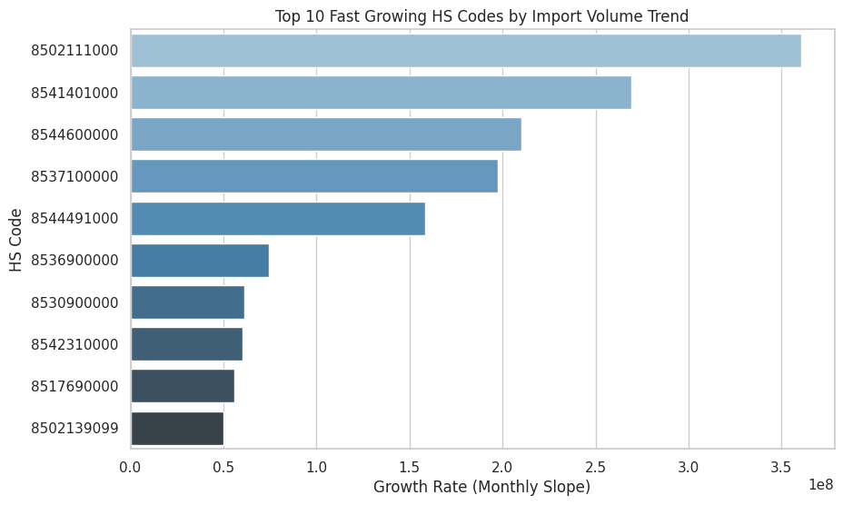

Fig 3.5 Chart showing Top 10 fast growing HS Codes

Opportunities for Import Substitution:

* High-Growth HS Codes as Innovation Levers

The fastest-growing HS codes, such as solar panels and cells, diesel generators, and electric control systems present strategic opportunities for local production and innovation. These categories not only exhibit substantial import volumes but also align with long-term infrastructure and energy trends, making them prime candidates for targeted investment.

* Significant Fiscal Savings from Substitution

A 20–30% substitution of key imported electrical machinery could yield between ₦5.2 trillion and ₦10.9 trillion in cumulative savings. Products such as machines for voice/data transmission and small-scale diesel generators offer especially high fiscal impact, due to their combined import value and substitutability.

* Boost to Industrialization and Employment

Redirecting just 30% of imports in these categories into domestic production could generate over ₦3.5 trillion in economic value driving approximately ₦1 trillion in job-related activity and ₦1.5 trillion in industrial sector growth. These figures highlight the catalytic role of innovation-led substitution in achieving economic diversification and employment generation.

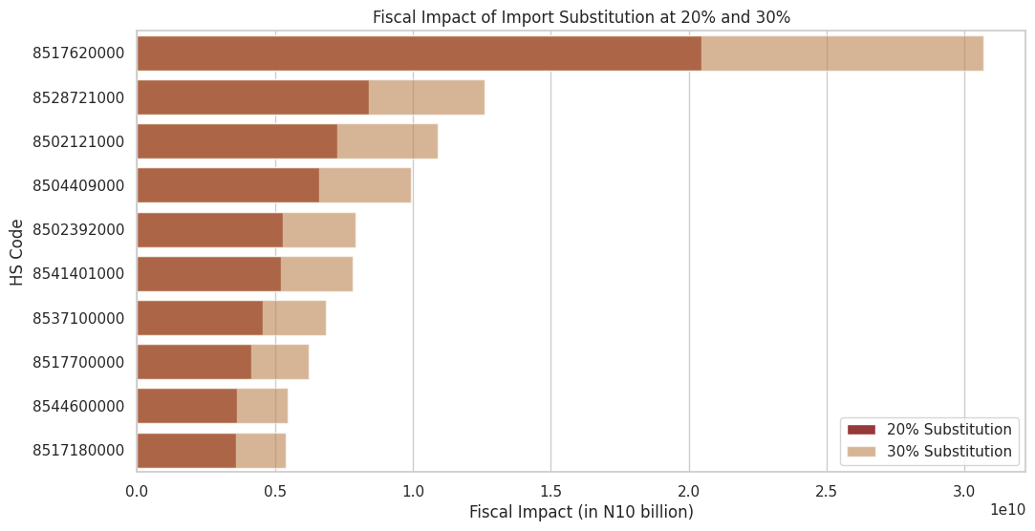  
Fig 3.6 Chart showing Top 10 HS Codes by fiscal impact of substitution

Innovation Funding Insights:

Strategic Allocation of ₦100 Billion Innovation Stimulus

A targeted ₦100 billion innovation fund was modeled to prioritize electrical machinery categories with the highest fiscal impact and import substitution potential. Allocation was based on a weighted scoring system combining import volume, growth rate, and critical sector relevance.

Top 5 Funded Categories

The top five categories, commanding over 56% of the total fund, include:

* Solar Cells (HS 8541401000) – ₦13.8B
* Data Transmission Machines (HS 8517620000) – ₦11.7B
* Static Converters (HS 8504400000) – ₦11.7B
* High-Voltage Electric Conductors (HS 8544600000) – ₦10.6B
* Electric Control Panels (HS 8537100000) – ₦9.6B

Remaining Allocation

The remaining ₦42.6 billion is distributed among five other promising categories, ensuring a diversified innovation portfolio while maximizing industrial impact and fiscal returns.

# POLICY IMPLICATIONS

Taxation Policy Reform

* Significant leakage (₦8.86B gap) and declining efficiency in tax collection demand urgent reforms.
* Major ports (Tin Can, Apapa) and high-risk companies (e.g., Dangote, MultiChoice) require focused audit and enforcement.
* Observed tax underperformance versus expected rates highlights the need for stronger compliance systems and oversight.

2. Strategic Import Substitution

* Fast-growing categories like solar tech, generators, and conductors show strong substitution potential.
* A 20–30% substitution in select categories can save Nigeria ₦5–₦10 trillion and stimulate ₦3.5 trillion in domestic activity.
* Long-term reliance on imports from countries like China increases vulnerability.

3. Innovation Funding Allocation

* ₦100B innovation fund should target high-impact, fast-growing import categories.
* Optimal allocation supports solar panels, data transmission machines, converters, and power infrastructure components

# RECOMMENDATIONS

A. Taxation & Customs Enforcement

1. Conduct Targeted Audits
   * Prioritize forensic audits for flagged companies (e.g., Dangote Petroleum, Indorama).
   * Re-examine HS codes 8528719000 and 8544600000 for undervaluation or misclassification.
2. Improve Port Compliance Systems
   * Use anomaly detection models (e.g., Z-score, Isolation Forest) for real-time fraud alerts.
   * Integrate digital invoicing and e-customs to reduce manual manipulation.
3. Review Exemptions & Leakages
   * Reassess entities with high gaps (e.g., UN agencies, embassies) to validate exemption status and tighten oversight.

B. Strategic Import Substitution

1. Target High-Growth HS Codes for Substitution  
   Focus policy tools (e.g., tariffs, grants) on:
   * Solar cells → Local assembly & manufacturing
   * High-voltage conductors → Domestic cable production
   * Control panels → Industry-specific tech clusters
   * Diesel gensets → Local CKD assembly with hybrid promotion
2. Develop Substitution Industrial Hubs
   * Establish sector-based industrial parks around top HS categories to drive economies of scale and investment.
3. Link to Employment Strategy
   * Integrate import substitution programs with job creation policies in clean energy, electronics, and light manufacturing.

C. Innovation & Fiscal Planning

1. Deploy ₦100B Fund Strategically
   * Align allocations with import sensitivity and local readiness; track impact across fiscal savings and job creation.
2. Offer Innovation Incentives
   * Provide tax breaks, grants, and R&D credits for firms investing in local alternatives to high-import goods.
3. Use Forecasting for Policy
   * Institutionalize time-series forecasting to proactively manage revenue shortfalls and substitution planning.

# VISUAL INSIGTS

Charts, Tables, Forecast Graphs

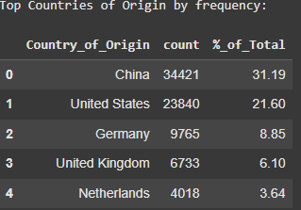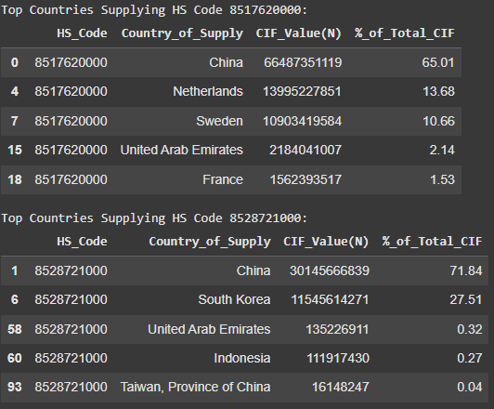

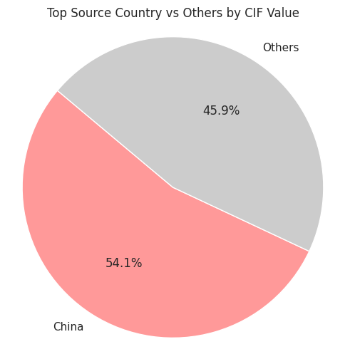

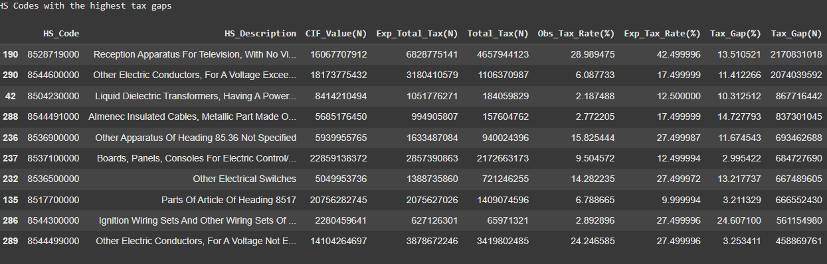

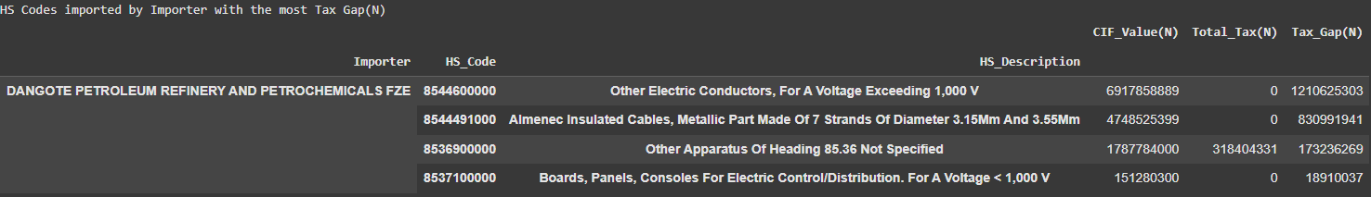

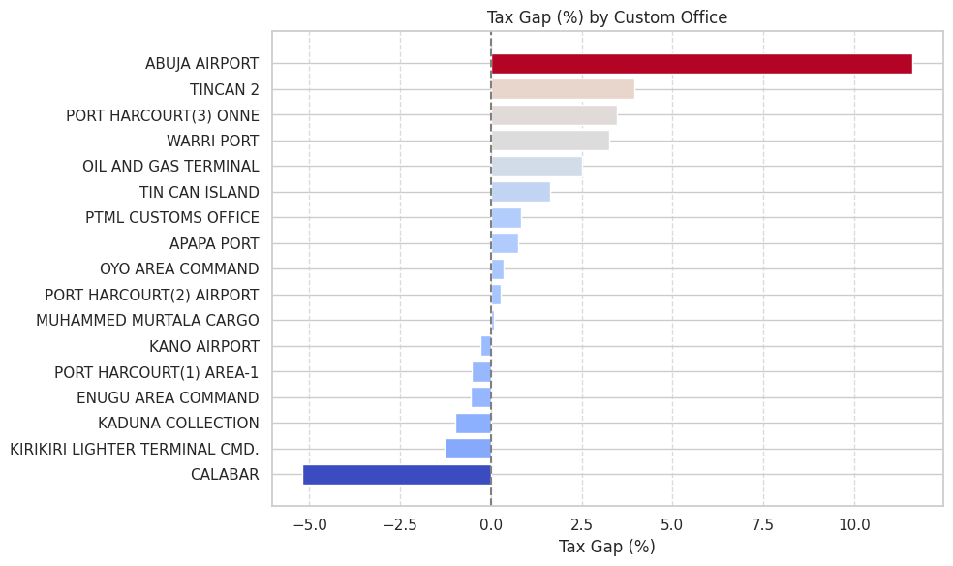

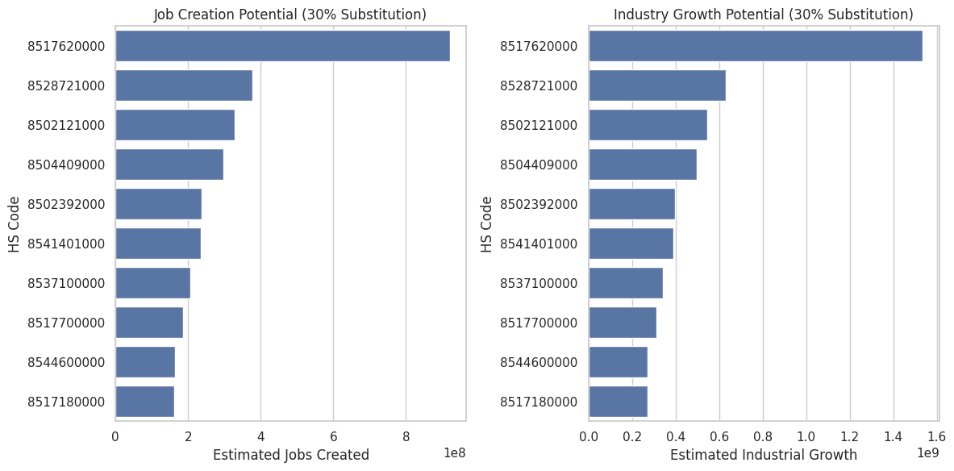

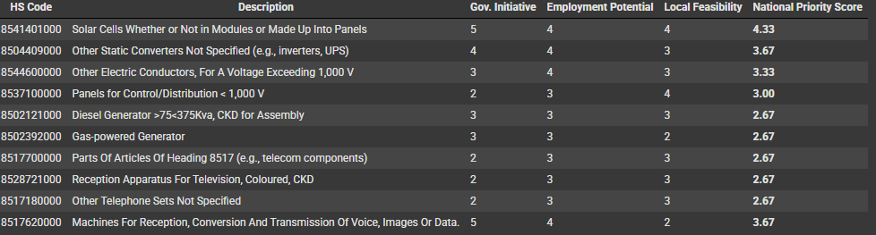

LIMITATION AND NEXT STEPS

Classification Inconsistencies (HS Codes)

* Misclassification or broad HS code definitions (e.g., 8528719000) may obscure actual product-level insights, requiring deeper customs data integration.

Assumption of Static Economic Behavior

* Substitution scenarios assume consistent consumer and business behavior, not accounting for potential price, quality, or supply chain barriers.

Limited Access to Supplier Contract Details

* Vendor-level data (e.g., pricing, contract volumes) was not fully available, which may affect precision in fiscal impact estimation.

Restricted View of Innovation Ecosystem Readiness

* Innovation fund allocation assumes sectoral readiness and absorptive capacity, which needs verification via local capacity assessments.

Next Steps

1. Deep-Dive into High-Risk HS Codes
   * Conduct detailed compliance reviews and product-level audits for codes like 8544600000 (Conductors) and 8528719000 (Transmission Equipment).
2. Supplier-Level Analysis
   * Expand analysis to include supplier/vendor profiling to identify over-reliance, monopolies, or underperformance.
3. Local Industry Capability Mapping
   * Commission a sectoral readiness study to assess the feasibility of local production for high-priority import categories.
4. Enhanced Customs-Data Integration
   * Collaborate with NCS to improve access to real-time HS code-level, port-level, and exemption classification data.
5. Set Up a Monitoring & Evaluation (M&E) Framework
   * Establish a KPI-driven system to track the impact of substitution efforts, fiscal recovery, and job creation in real-time.

# REFERENCES AND LINKS

GITHUB: <https://github.com/nifemifaith07/ZTH_Reform_Analytics_Hackathon.git>

DRIVE: <https://drive.google.com/drive/folders/1KH0RgM0lzzHW_j7V8E6WdBoQLuYCz_tU?usp=drive_link>

POWERBI: <https://app.powerbi.com/links/n0ziMDLWbP?ctid=66b3f0c2-8bc6-451e-9603-986f618ae682&pbi_source=linkShare>

NOTEBOOK: <https://colab.research.google.com/drive/1RyCaCtG7I-S0wTNKjfLj-rzrC_jjoW-y>

TRADE PORTAL: <https://trade.gov.ng/en/downloads>