

**UNIVERSITY OF VOCATIONAL TECHNOLOGY**

100, Kandawala Road, Ratmalana

Bachelor of Technology in Software Technology

Computer Programming

1st Semester

Assignment 02

|  |
| --- |
| M.N.M. Nifraz |
| SOF/21/B2/21 |

**UNIVERSITY OF VOCATIONAL TECHNOLOGY**

**SRI LANKA**

Assignment Template & Feedback Form

|  |  |  |  |
| --- | --- | --- | --- |
| Course Title | Bachelor of Technology in Software Technology | Module | IT104021 |
| Student’s Name | M.N.M. Nifraz | Batch No. | B2 |
| Reg. No. | SOF/21/B2/21 | Semester | 01 |
| Resource Person | Mr. Nishantha Anuruddha | Assignment No. | 02 |
| Issued on | 24/07/2022 |  |  |
| Submitted on | 12/08/2022 | Received By |  |

Feedback from the Resource Person:

|  |  |
| --- | --- |
| Key Strength: |  |
| To Improve Report: |  |
| General Comments: |  |

Grade:

Date: …………………………………………………

………………………………………………

Resource Person’s Signature

………………………………………………

Resource Person’s Signature

1. Write a C++ program to perform following task.

a. Create a 2D integer array of 3 columns & 4 rows and initially, set all values to 0

b. User is able to enter integer values only and the maximum no. of elements is 12.

i. But whenever user enters (-1) before filling the entire 2D array then program should stop taking inputs.

ii. Inform user how many values already inserted in each turn

c. Once data entry process is over, print all values of the array

d. Find the maximum & minimum values and print them

i. (-1) & (0) are not to be consider as minimum values

e. Calculate the average of only the entered values

Source Code:

#include <iostream>

#include <iomanip>

#include <cmath>

using namespace std;

int main()

{

    cout << "Number Grid\n"

         << setfill('=') << setw(12) << "\n";

    const int ROWS = 4;

    const int COLUMNS = 3;

    int intArray[ROWS][COLUMNS] = {0};

    int inputCount = 0;

    int sum = 0;

    cout << "Enter " << (ROWS * COLUMNS) << " numbers to fill a " << COLUMNS << "x" << ROWS << " grid.\n"

         << "(-1 to stop)\n\n";

    int inputValue = 0; // temporary variable to store the input

    for (int i = 0; i < ROWS && inputValue != -1; i++)

    {

        cout << "[Row #" << (i + 1) << "/" << ROWS << "]\n";

        for (int j = 0; j < COLUMNS; j++)

        {

            // read number

            cout << "[Column #" << (j + 1) << "/" << COLUMNS << "] number #" << (inputCount + 1) << "/" << (ROWS * COLUMNS) << ": ";

            cin >> inputValue;

            if (inputValue == -1) // check if input is -1

            {

                cout << "You've entered -1. The program will stop taking any further inputs.\n";

                break; // break the loop. the outer loop will also will break since the outer loop condition fails.

            }

            intArray[i][j] = inputValue; // store the value

            sum += intArray[i][j];       // add the value to sum

            inputCount++;                // increment the count

        }

    }

    if (inputCount == 0) // check if count is 0

    {

        // print the message

        cout << "You haven't entered any values.\n"

             << "The program will exit now.";

        return 0; // return main

    }

    // set min and max to first element

    int max = intArray[0][0];

    int min = intArray[0][0];

    // print results

    cout << "\n"

         << "Results\n"

         << setfill('=') << setw(8) << "\n";

    // print the grid

    cout << "Grid Content:\n";

    for (int i = 0; i < ROWS; i++)

    {

        for (int j = 0; j < COLUMNS; j++)

        {

            // print each element

            cout << intArray[i][j] << "\t";

            // check if value is 0

            if (intArray[i][j] == 0)

            {

                continue; // skip min, max check

            }

            // check if value is greater than max

            if (intArray[i][j] > max)

            {

                max = intArray[i][j]; // assign to max

            }

            // check if value is less than min

            if (intArray[i][j] < min)

            {

                min = intArray[i][j]; // assign to min

            }

        }

        cout << "\n";

    }

    //print output

    cout << "You have entered " << inputCount << " values.\n";

    cout << "Maximum: " << max << "\n";

    cout << "Minimum: " << min << "\n";

    cout << "Sum of entered values: " << sum << "\n";

    cout << "Average (" << sum << "/" << inputCount << "): " << (double)sum / inputCount << "\n";

}

Sample Output: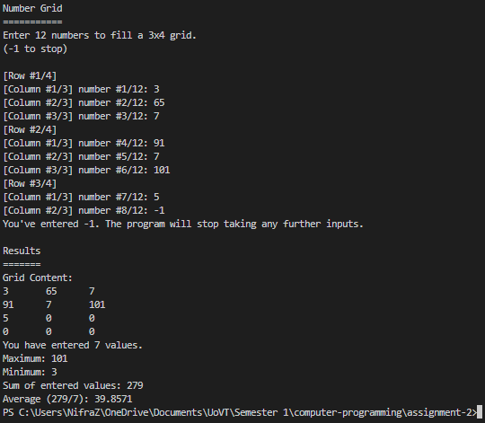

2. Write a program to count number of words in a user entered string.

a. (Hint: use C-Style String to store user input value.)

Source Code:

#include <iostream>

#include <iomanip>

#include <cmath>

using namespace std;

int main()

{

    cout << "Word Counter\n"

         << setfill('=') << setw(13) << "\n";

    const int MAX_CHARS = 1024;

    //read the text

    cout << "Enter the text (" << MAX_CHARS << " characters max): ";

    char s[MAX_CHARS];

    cin.getline(s, MAX_CHARS);

    int wordCount = 0; //set wordCout to 0

    // variable to hold the flag if last char was space

    // initially set to true, to start counting the first word

    bool isInSpace = true;

    for (int i = 0; i < MAX_CHARS; i++)

    {

        if (s[i] == '\0') //check if NUL character

        {

            break; //break the loop

        }

        if (s[i] == ' ') //check if space

        {

            isInSpace = true; //set space flag

        }

        //if not space AND the last character was space

        else if (isInSpace)

        {

            wordCount++; //increment wordCount

            isInSpace = false; //remove space flag

        }

    }

    // print results

    cout << "\n"

         << "Results\n"

         << setfill('=') << setw(8) << "\n";

    cout << "Your text contains " << wordCount << " words.";

}

Sample Output:

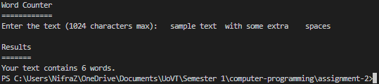

3. Create a 2D character array (C-Style String type) (5 rows & 10 columns)

a. Store "Yamaha", "Honda", "Benz", "Tata", "Suzuki" strings

b. Print base memory address without using address (&) operator (See image below)

c. Print each row values using a for loop (See image below)

d. Print each element using two for loops, & you must print only not null values (See image below)

Source Code:

#include <iostream>

#include <iomanip>

#include <cmath>

using namespace std;

int main()

{

    // assign the array

    char chArray[5][10] = {

        "Yamaha",

        "Honda",

        "Benz",

        "Tata",

        "Suzuki"};

    // print base memory address

    cout << "chArray = " << chArray << "\n";

    // print each row values (words)

    for (int i = 0; i < 5; i++)

    {

        cout << "chArray[" << i << "] = " << chArray[i] << "\n";

    }

    // print each element

    for (int i = 0; i < 5; i++)

    {

        for (int j = 0; j < 10; j++)

        {

            if (chArray[i][j] == '\0') // skip if NUL char

            {

                continue;

            }

            cout << "chArray[" << i << "][" << j << "] = " << chArray[i][j] << "\n";

        }

    }

}

Sample Output:

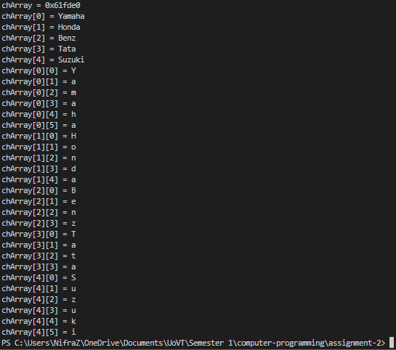

4. User will enter long text with colon separated. example Book:Pen:Pencil:Table:Desk

a. Use String object to store user input value (string str)

b. You must print the values one after another, after splitting the string using delimiter (:)

c. All letters should be UPPERCASE

d. Hint:

i. You can use substring () & find () string functions support

ii. You can use while loop support

Source Code:

#include <iostream>

#include <iomanip>

#include <cmath>

using namespace std;

int main()

{

    cout << "Word Splitter & Uppercase\n"

         << setfill('=') << setw(26) << "\n";

    //read text

    cout << "Enter the text (seperate the words using ':' colon): \n";

    string text;

    cin >> text;

    for (int i = 0; i < text.length(); i++)

    {

        // check if char is between small case range

        if (text[i] >= 'a' && text[i] <= 'z')

        {

            text[i] -= 32; // deduct 32 to get the uppercase char

        }

        if (text[i] == ':') // check if char is colon

        {

            text[i] = '\n'; // replace with newline character (to split)

        }

    }

    // print results

    cout << "\n"

         << "Results\n"

         << setfill('=') << setw(8) << "\n";

    cout << text;

}

Sample Output:

