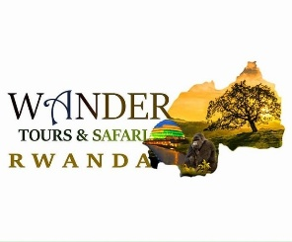

**Study tour in Rwanda, Africa**

_______________________________________________________________________________

**Wander tours & safari Rwanda ltd** is an international tourism company based in Kigali Rwanda with 9 years of experience in tourism business, we are experienced tour operator ,specialized in educational tours and travels . (Study tour) we believe that creative education always needs research and observation. Though, technology has made it easier now days to research online and explore new things. However sometimes physical learning is very important.

The purpose of our study tour Program is to give students an opportunity to develop an understanding and appreciation that international travel can bridge the gap to learning by experiencing other cultures and fostering critical thinking.

Within our study tour division, our sole focus is on short-term, study tour programs, all academic and culturally blended by design. Through global networks and collaboration with educators, we build high-quality and sustainable programs that give as many students as possible access to life-changing experiences.

**Our vision** is to open study tours access to all learners regardless of gender identity, race, physical ability, sexual orientation, and socioeconomic status so that they have the opportunity to develop the soft skills required to navigate today's interconnected world.

**Our goal** is to increase access to study tours opportunities by expanding and diversifying our network of colleagues and travelers to create an intercultural experience that is educational and transformational for all learners.

**We believe that**:

1. We all learn better through experience.

2. Travel is an educational platform to fuel lifelong growth.

3. Global competencies are crucial in today’s world.

4. Travel can positively impact students in just 10 to 14 days.

**Why study tour in Rwanda**

Explore Africa's most peaceful country, experiencing the indescribable natural beauty and cultural renaissance of a determined people. Participants in our study tour program go behind the exterior, side-by-side with courageous souls who give voice to the voiceless and help make visible what is invisible in our own communities. Our adventures include an overnight wilderness excursion to the Silverback gorilla preserve. The tour offers students the unique opportunity to learn first-hand about the country  and for many. Rwanda Exquisitely green, this “land of a thousand hills” is characterized by regional growth and local traditions. Travelers learn the hidden histories behind.. This tour will give participants Opportunity to learn more about Rwandan genocide and its aftermath through on-site experience. By visiting relevant sites and meeting key actors in Rwanda, participants learnt about the genocide as well as Rwanda’s approaches to post-genocide justice and reconciliation.

# **Why partner with our study tour Program**?

Whether it’s a focus on academics, safety, or dedicated support, we promise to provide an unparalleled partnership, from day one to the flight home.

**Our Education Tour Programs**

1. Discipline-Focused programs

Our Discipline-Focused programs center on subject-specific experiences and cultural immersion through the lens of a field of study.

* **Skill Development**

Foster essential skills and leadership building through hands-on workshops

and sessions led by field experts.

* 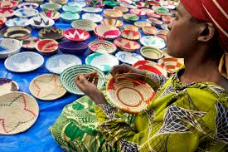**Arts & Humanities**

Shape your own creative experience. Enter rare museums, meet local artists, or take to the streets for your own inspiration

* 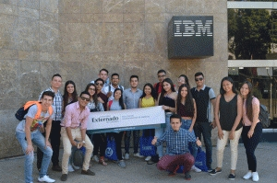.**Business & Innovation**

Experience the scope of the global economy—

from government visits to access to international corporations.

* **History & Political Science**

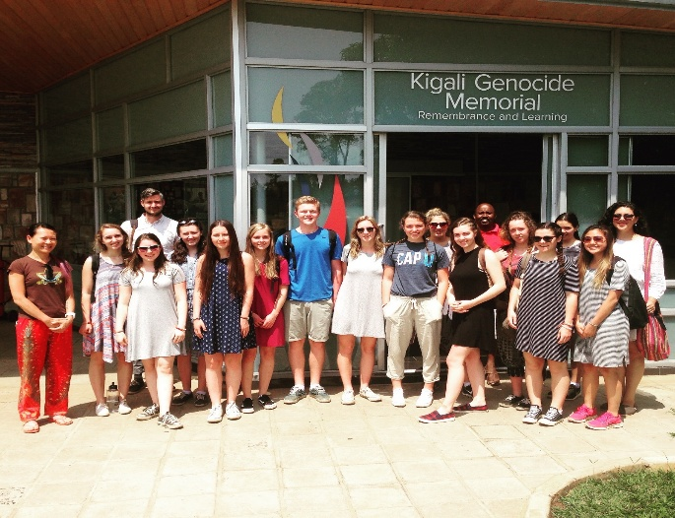Any of our programs will take you back in time to the places where history was literally made.

1. **Our Intercultural-Focused programs**

Intercultural focused programs emphasize cultural exploration and weave in learning moments flexible to your curriculum.

* **Cultural Experience**

Our educational travel and cultural exchange programs provide international and domestic travel experiences, hands-on learning and lasting cultural connections for both students and adults..

* 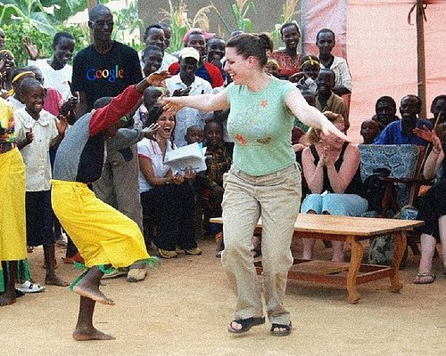 **Intercultural Studies**

Explore Rwanda 's cultural diversity, remarkable wildlife and natural Protection

**Learning outcomes on this program**

Confidence • Curiosity • Global perspective • Empathy • Adaptability • Relatability • Self-Awareness

1. **An approach that improves the world**

* **Building cultural intelligence**

Developing the capability to function effectively in multicultural situations helps us increase awareness of, and manage, our biases and can also drive inclusive and equitable learning environments.

* **World Animal Protection partnership**

Throughout all our travel, we work to implement animal welfare guidelines by working closely with the nonprofit organization World Animal Protection..

**Global citizenship through study abroad**

Study tour is essential to every student and institution in higher education—regardless of academic concentration. It fosters cross-cultural competency required in an increasingly interconnected world, and produces students who are more knowledgeable, reflective and aware

**.Our role** is to help you shape the next generation of global citizens. Because when educators frame their curriculum around the curiosity, humility and discovery of an international experience, powerful learning moments happen

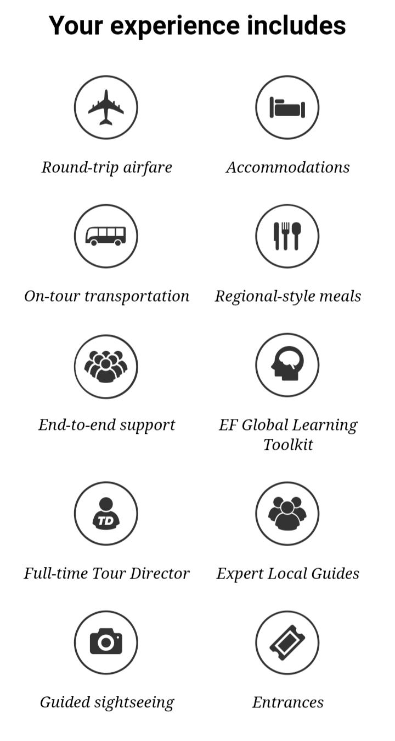.

# **Affiliations**

We work closely with our partners to ensure their institutional needs are met, and we’re connected to the standards and values of the greater global education community.

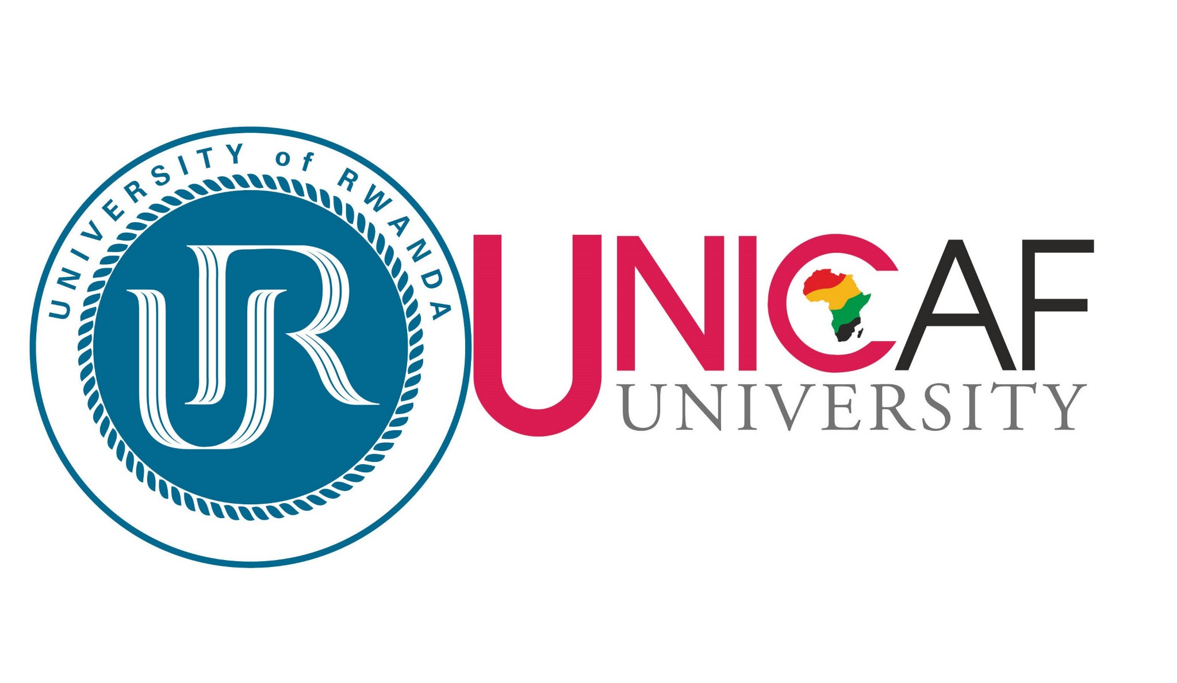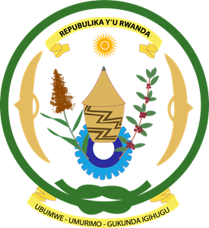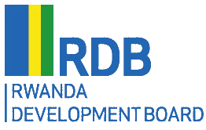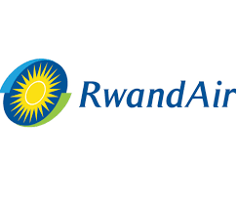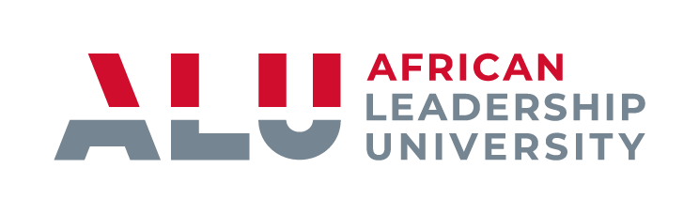 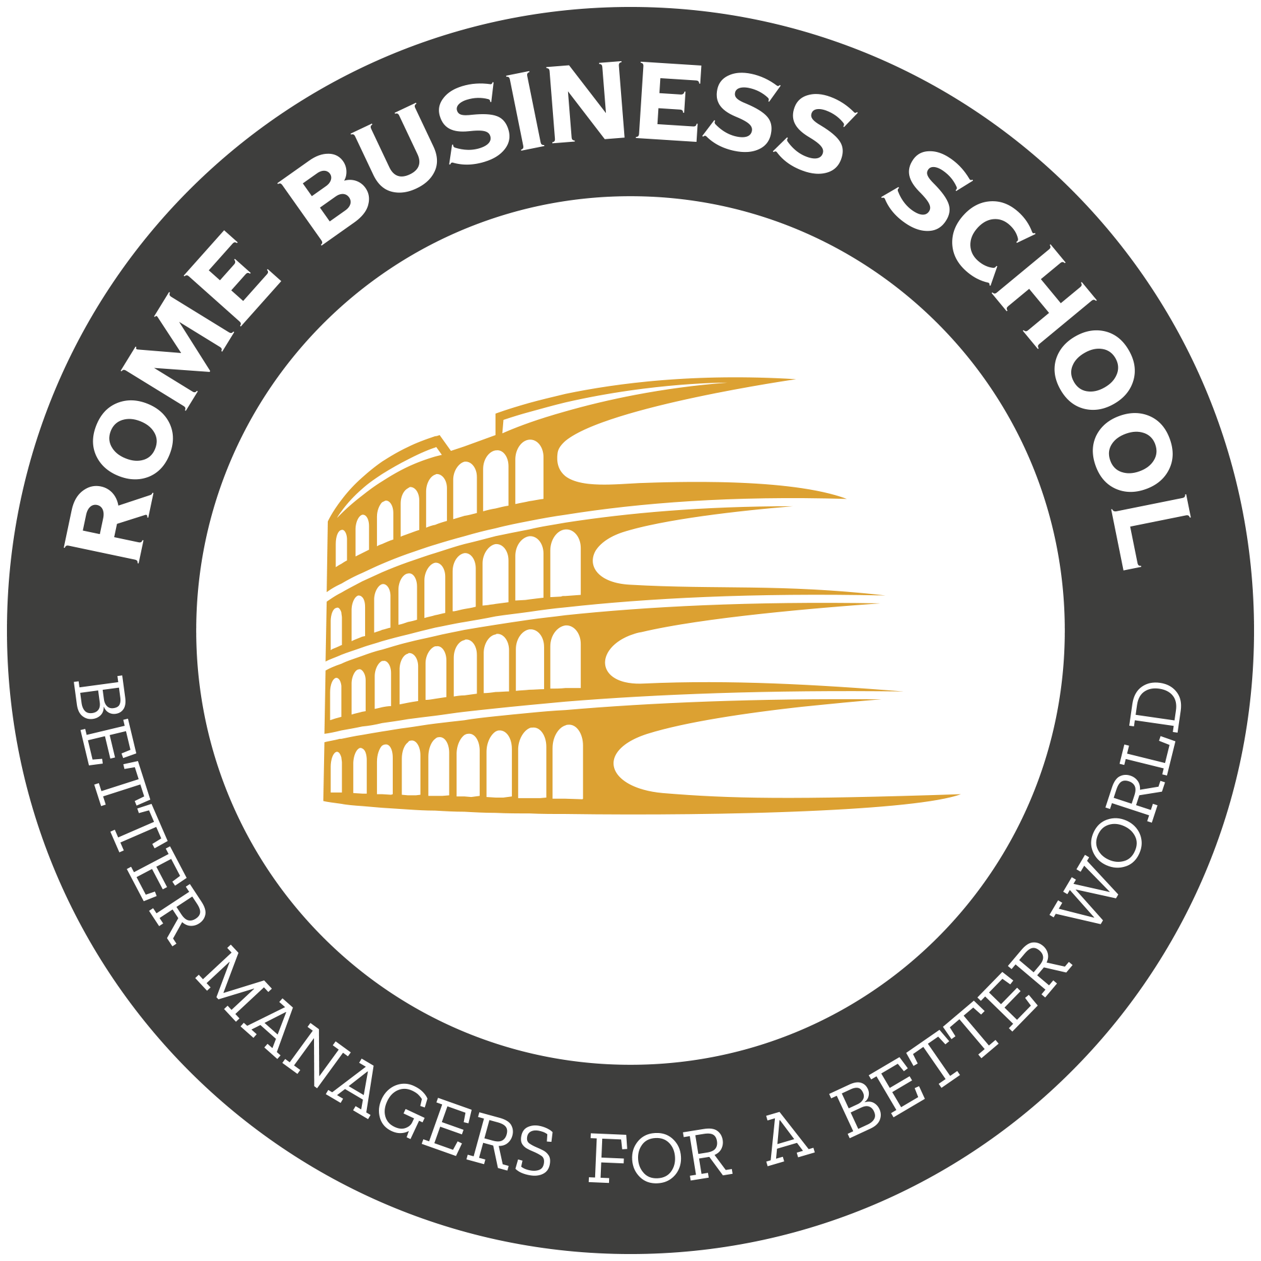**Ministry of education Rwanda**