- Create 2 Activities from 1st Activity on click move to 2nd activity (Using Intent)

- Create an Activity and move to facebook login page on a button click(making use of Intent).

- Read message from 1st Activity and pass it onto the 2nd Activity on a button click.
activity_main.xml
<?xml version="1.0" encoding="utf-8"?>
<RelativeLayout
xmlns:android="http://schemas.android.com/apk/res/android"
xmlns:app="http://schemas.android.com/apk/res-auto"
xmlns:tools="http://schemas.android.com/tools"
android:layout_width="match_parent"
android:layout_height="match_parent"
tools:context=".activity_main">
<EditText
android:id="@+id/send_text_id"
android:layout_width="300dp"
android:layout_height="wrap_content"
android:textSize="25dp"
android:hint="Input"
android:textStyle="bold"
android:layout_marginTop="20dp"
android:layout_marginLeft="40dp"/>
<Button
android:id="@+id/send_button_id"
android:layout_width="wrap_content"
android:layout_height="40dp"
android:text="send"
android:textStyle="bold"
android:layout_marginTop="150dp"
android:layout_marginLeft="150dp"/>
</RelativeLayout>
activity_main2.xml
<RelativeLayout xmlns:android="http://schemas.android.com/apk/res/android"
xmlns:app="http://schemas.android.com/apk/res-auto"
xmlns:tools="http://schemas.android.com/tools"
android:layout_width="match_parent"
android:layout_height="match_parent"
tools:context="org.cy2_p03.Main2Activity">
<TextView
android:id="@+id/received_value_id"
android:layout_width="300dp"
android:layout_height="50dp"
android:textStyle="bold"
android:textSize="40dp"
android:layout_marginTop="20dp"
android:layout_marginLeft="40dp"/>
</RelativeLayout>

Mainactivity.java

package com.example.sjcet.cy2_p03;
import android.content.Intent;
import android.support.v7.app.AppCompatActivity;
import android.os.Bundle;
import android.view.View;
import android.widget.Button;
import android.widget.EditText;
public class MainActivity extends AppCompatActivity {
// define the variable
Button send_button;
EditText send_text;
@Override
protected void onCreate(Bundle savedInstanceState)
{
super.onCreate(savedInstanceState);
setContentView(R.layout.activity_main);
send_button = (Button)findViewById(R.id.send_button_id);
send_text = (EditText)findViewById(R.id.send_text_id);
// add the OnClickListener in sender button
// after clicked this button following Instruction will run
send_button.setOnClickListener(new View.OnClickListener() {
@Override
public void onClick(View v)
{
// get the value which input by user in EditText
// and convert it to string
String str = send_text.getText().toString();
// Create the Intent object of this class Context() to Second_activity class
Intent intent = new Intent(getApplicationContext(), MainActivity.class);
// now by putExtra method put the value in key, value pair
// key is message_key by this key we will receive the value, and put the string
intent.putExtra("message_key", str);
// start the Intent
startActivity(intent);
}
});
}
}

main2activity.java

package com.example.sjcet.cy2_p03;
import android.content.Intent;
import android.support.v7.app.AppCompatActivity;
import android.os.Bundle;
import android.widget.TextView;
public class Main2Activity extends AppCompatActivity {
TextView receiver_msg;
@Override
protected void onCreate(Bundle savedInstanceState)
{
super.onCreate(savedInstanceState);
setContentView(R.layout.activity_main2);
receiver_msg = (TextView)findViewById(R.id.received_value_id);
// create the get Intent object
Intent intent = getIntent();
// receive the value by getStringExtra() method
// and key must be same which is send by first activity
String str = intent.getStringExtra("message_key");
// display the string into textView
receiver_msg.setText(str);
}
}

output
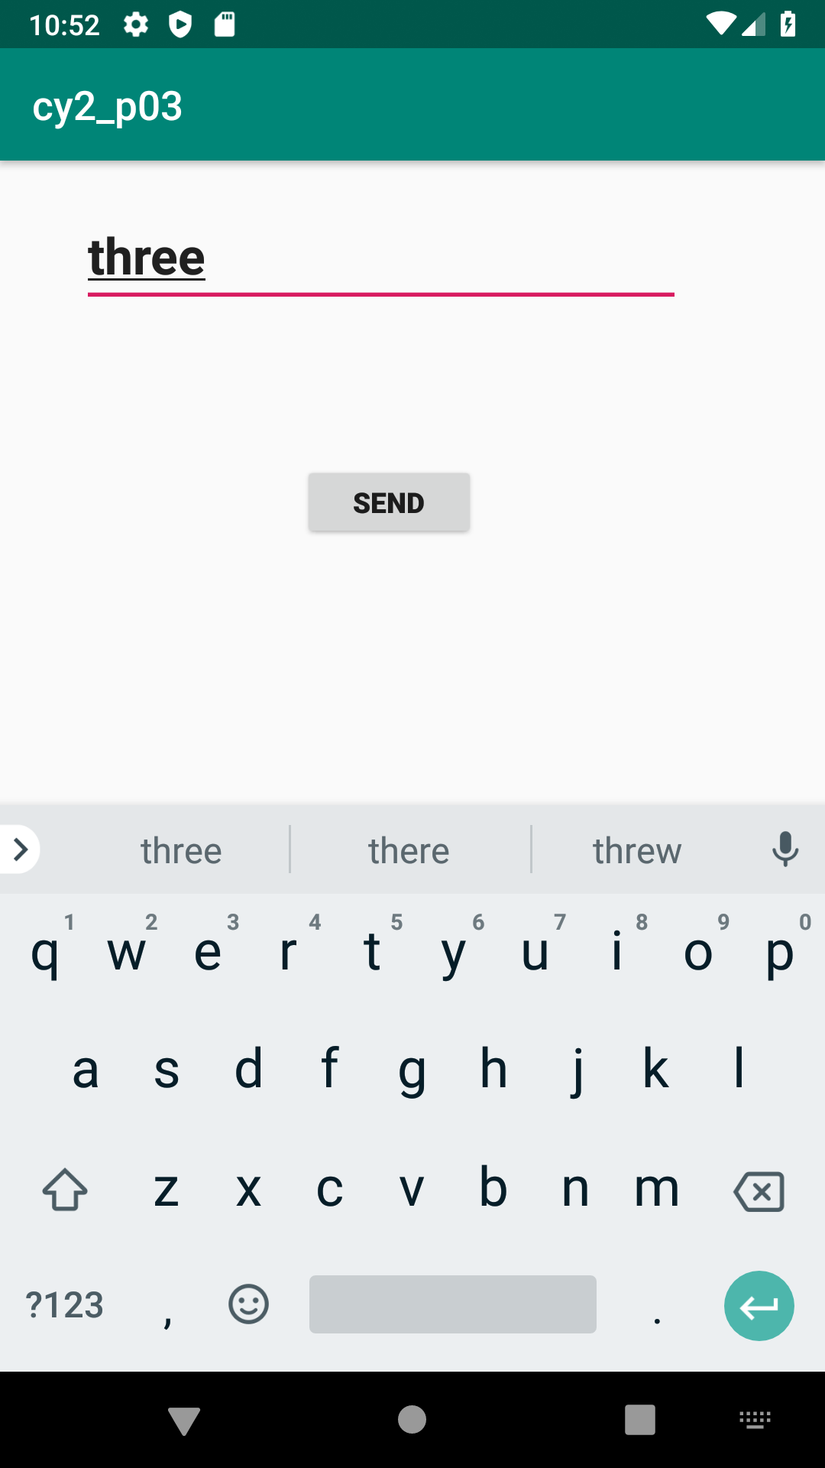

- Create a registration page with full validation and pass the information to the second activity (using shared preference)

Mandatory fields : fname,lname,gender,email,phone number,password,dob(date picker)

