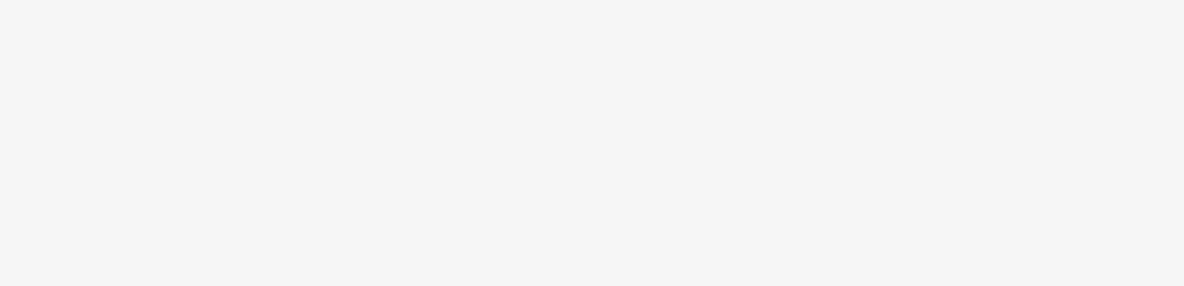

HARSHIT NIGAM

C:\Users\abdou\Desktop\Resumes for Customer\Customer Project\Resume 2\icon6.pngC:\Users\abdou\Desktop\Resumes for Customer\Customer Project\Resume 2\icon2.pngC:\Users\abdou\Desktop\Resumes for Customer\Customer Project\Resume 2\icon4.pngC:\Users\abdou\Desktop\Resumes for Customer\Customer Project\Resume 2\icon5.pngC:\Users\abdou\Desktop\Resumes for Customer\Customer Project\Resume 2\icon6.pngC:\Users\abdou\Desktop\Resumes for Customer\Customer Project\Resume 2\icon2.pngC:\Users\abdou\Desktop\Resumes for Customer\Customer Project\Resume 2\icon3.pngC:\Users\abdou\Desktop\Resumes for Customer\Customer Project\Resume 2\icon1.png

EDUCATIONAL QUALIFICATIONS

* 84 % marks in B.Tech Computer Science Engineering from United Institute Of Technology ,Prayagraj afflicated to AKTU University,Lucknow
* 83 % marks in Senior Secondary (XII) from Bishop Johnson School ,Prayagraj afflicated to ISC Board
* 77 % marks in Secondary (X) from Bishop Johnson School, Prayagraj afflicated to ICSE Board

Python, Java, JavaScript, Java Advanced, Rest API, Machine Learning ,MERN Stack, Spring, Spring Boot, Hibernate

* Certificate in Android App Development with Java
* Certificate in Web Development and Network Management
* Education Camp and Study Tour in Bangkok,Thailand

CERTIFICATES

**Projects Developed**

* Develop an Android App for PDF Scanner and OCR ,name ScanIt in playstore
* Build a Realtime Chat Application on MERN Stack
* Build a Twitter Sentimental Analysis on Machine Learning in Industrial Training
* Build a Writing Post App on Android Studio using Google Firebase by which a person post a story which will be see to others
* Fixed Bugs in an Existing Apps

**Email:**

nigamharshit20@gmail.com

**Phone:**

7071348746

**Address:**

653/553 Old Katra ,Prayagraj

**Linkedin:**

[www.linkedin.com/in/harshit-nigam-b17448182](http://www.linkedin.com/in/harshit-nigam-b17448182)

**Github:**

nigamharshit

**Hackerrank:**

nigamharshit20

SOFT SKILLS

Adaptability

Strong Work Ethic

Quick Learner

Team Work

HARD SKILLS

Personal Details

**DOB :** 25-12-1997

**Languages Known:**  English ,Hindi

**Nationality:** Indian

EXPERIENCE

To work in a pragmatic way in an organization where I can show my talent and enhance my skills to meet company goals and objective with full integrity and zest .

CONTACT

Software Developer ,Full Stack Developer

CAREER OBJECTIVE