PROJECT FILE
WORKING WITH MONGO DB DOCUMENTS AND COLLECTIONS

SUBMITTED TO – _MR HARENDRA SINGH_ RAJPOOT
ROLL NO -1250258263 (22)
SUBMITTED BY – Minsi Nigam
BCA – Data Science & Artificial Intelligence
SEMESTER – ODD (3rd)
UNIVERSITY / COLLEGE – BBD UNIVERSITY
CREATE OPERATION- The Create operation is used to add new documents to a collection. MongoDB provides methods like insertOne() for single documents and insertMany() for multiple documents.
Read Operation- The Read operation retrieves documents from a collection. MongoDB uses methods like find() to fetch multiple documents and findOne() to retrieve a single document.

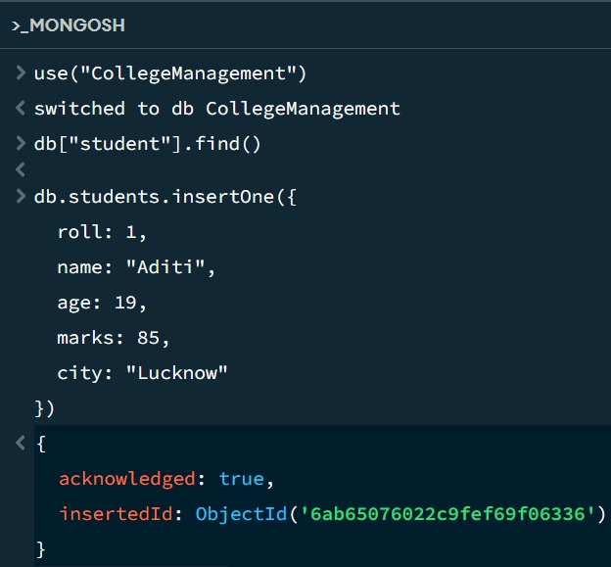

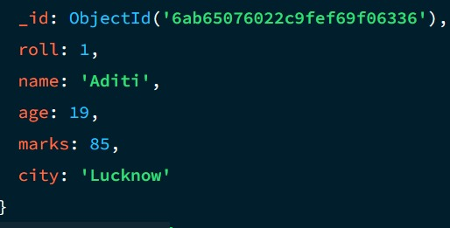
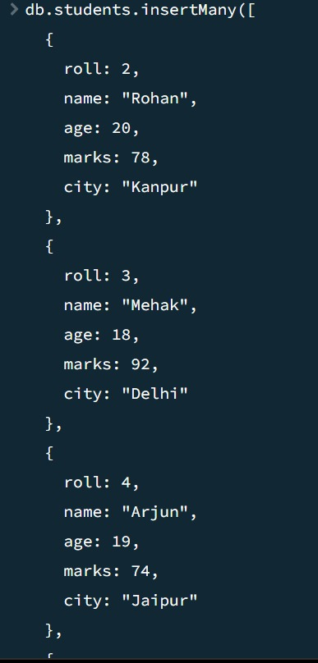
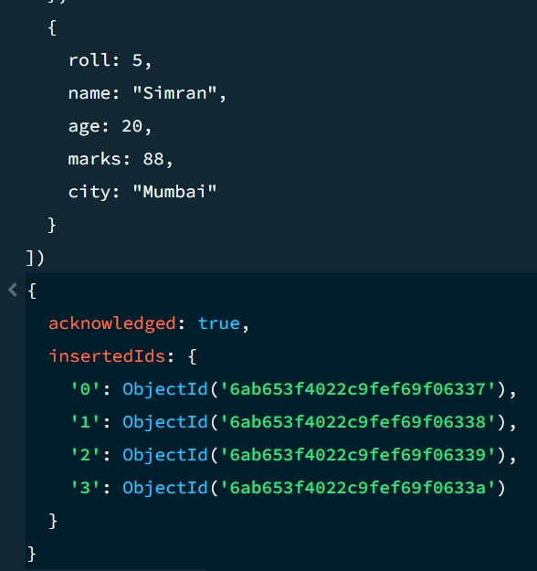

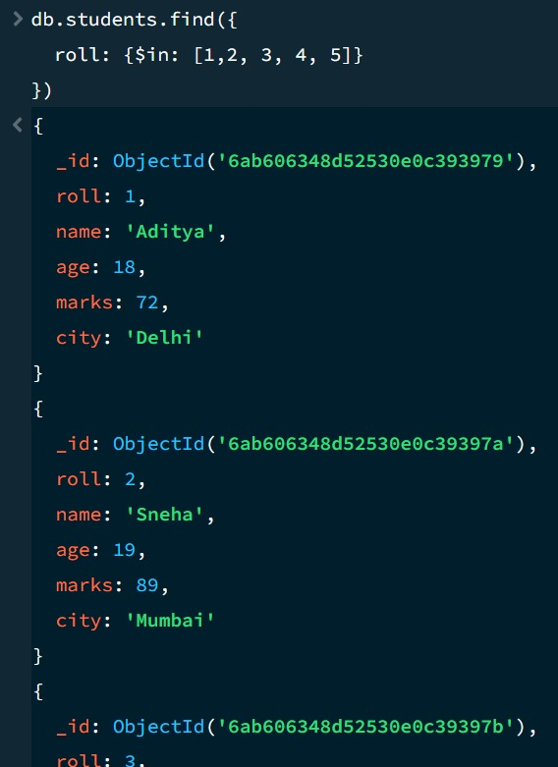
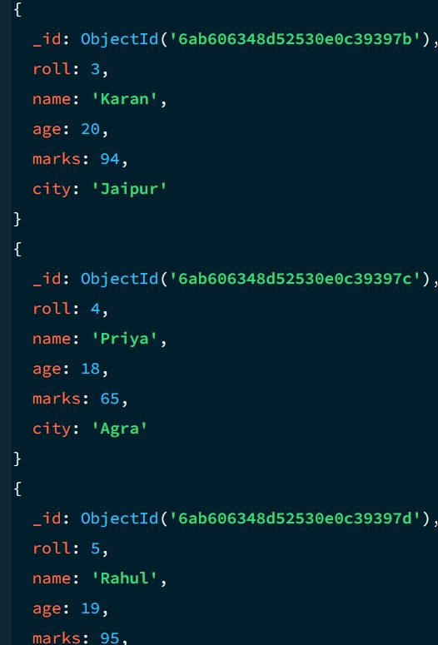
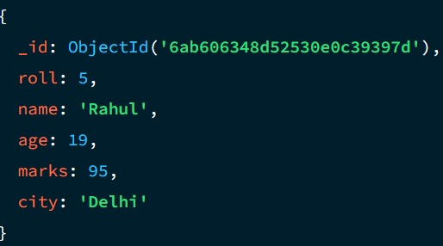
UPDATE OPERATION- The Update operation modifies existing documents. MongoDB provides methods like update One() to update a single document and update Many() to update multiple documents. The $set operator is commonly used to specify the fields to update.

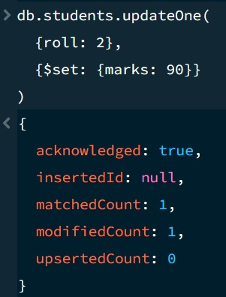
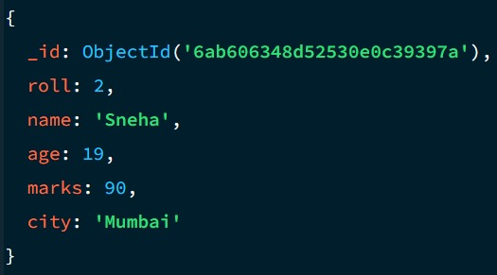
DELETE OPERATION- The Delete operation removes documents from a collection. MongoDB offers deleteOne() to delete a single document and deleteMany() to remove multiple documents based on a filter.
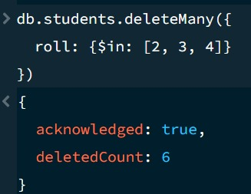
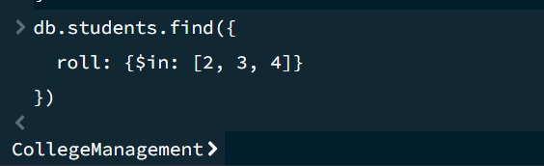
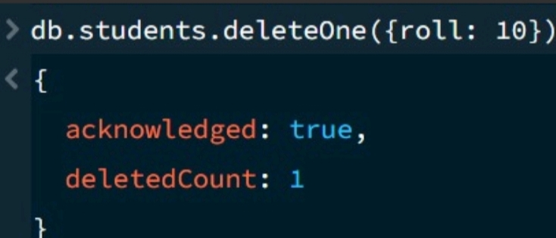
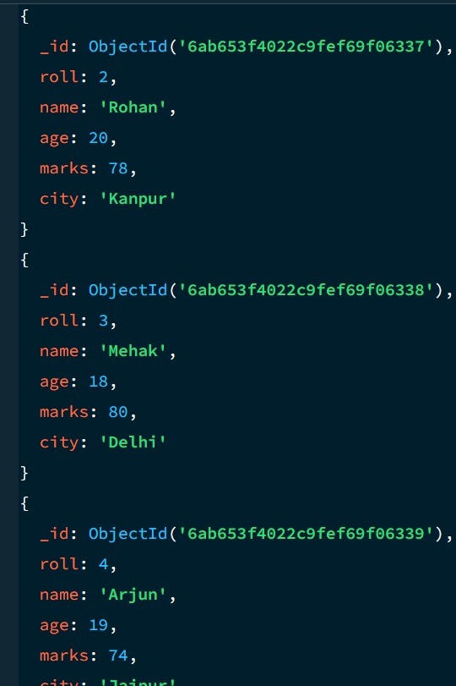

Using greater than in Mongo DB
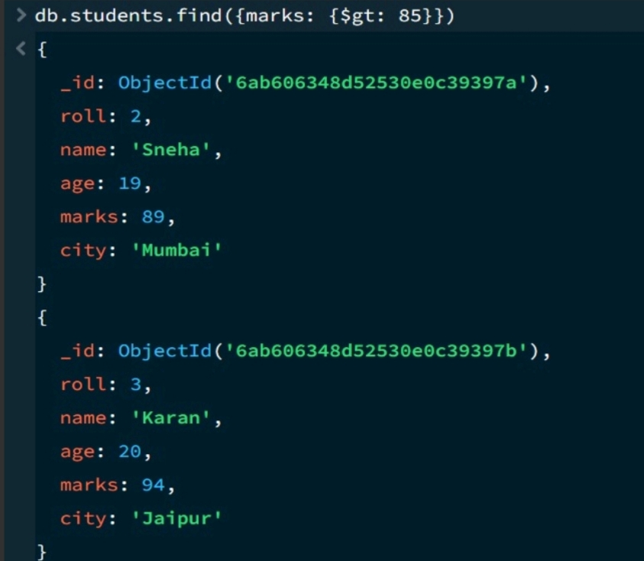
Using less than in Mongo DB
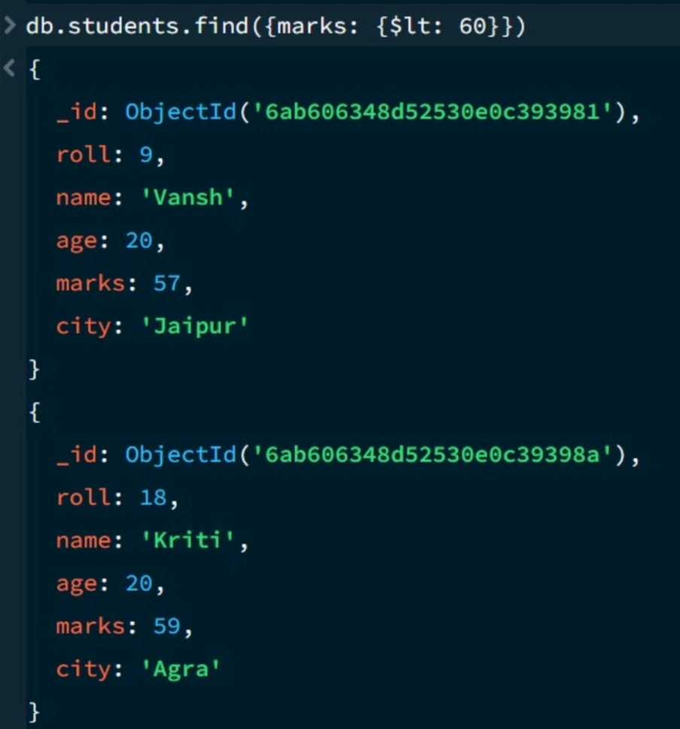

Using greater than or equal to in Mongo DB- $gte
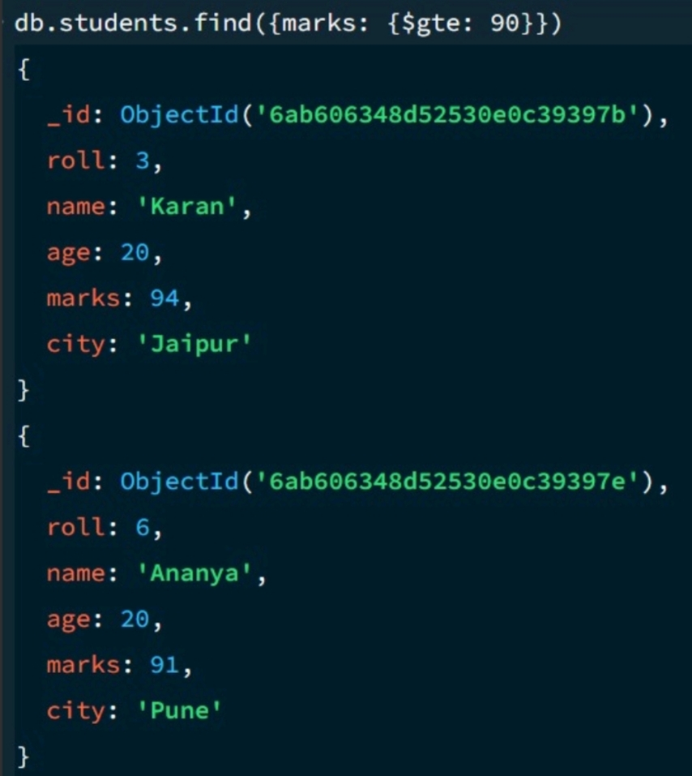

Using less than or equal to in Mongo DB- $lte
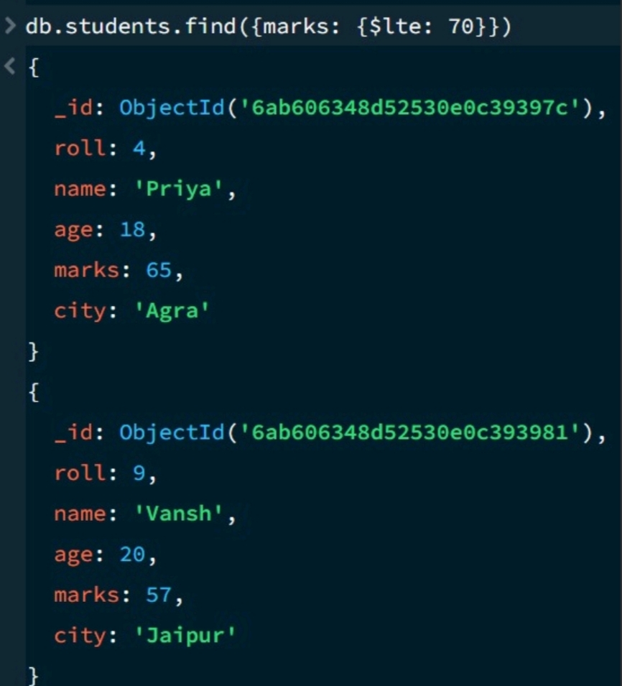

Using Conditional Operation in Mongo DB
AND Operation:-
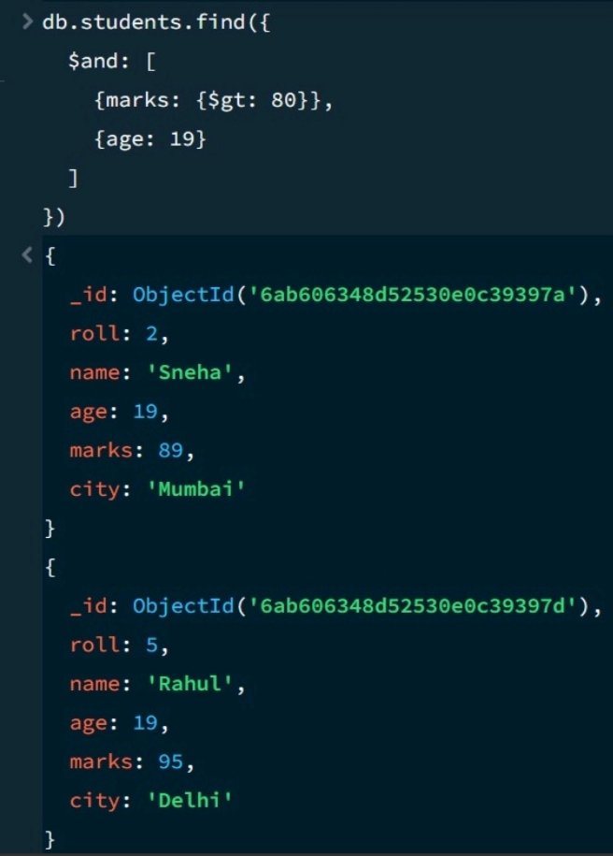
Using Conditional Operation in Mongo DB
OR Operation:-
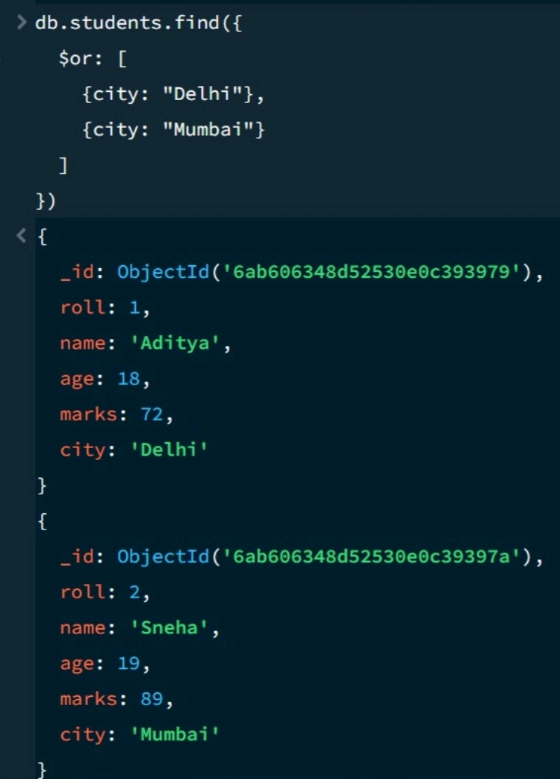
Using Sort Operation in Mongo DB-
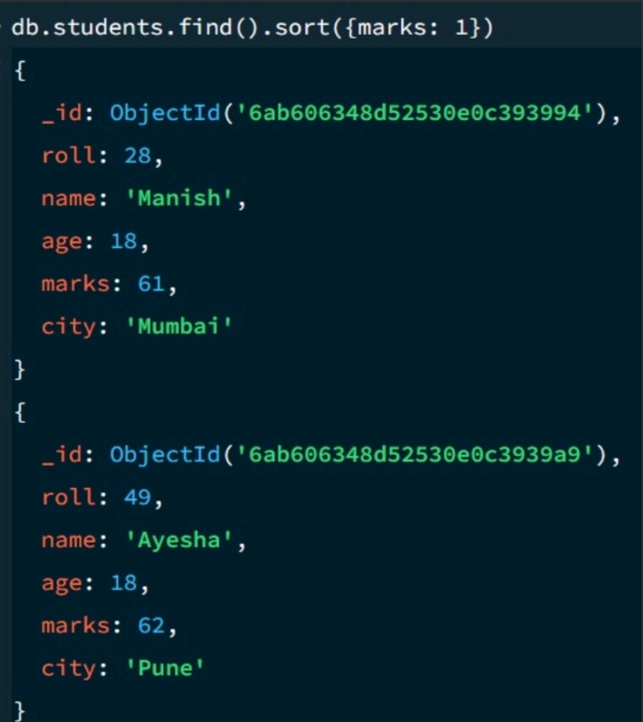
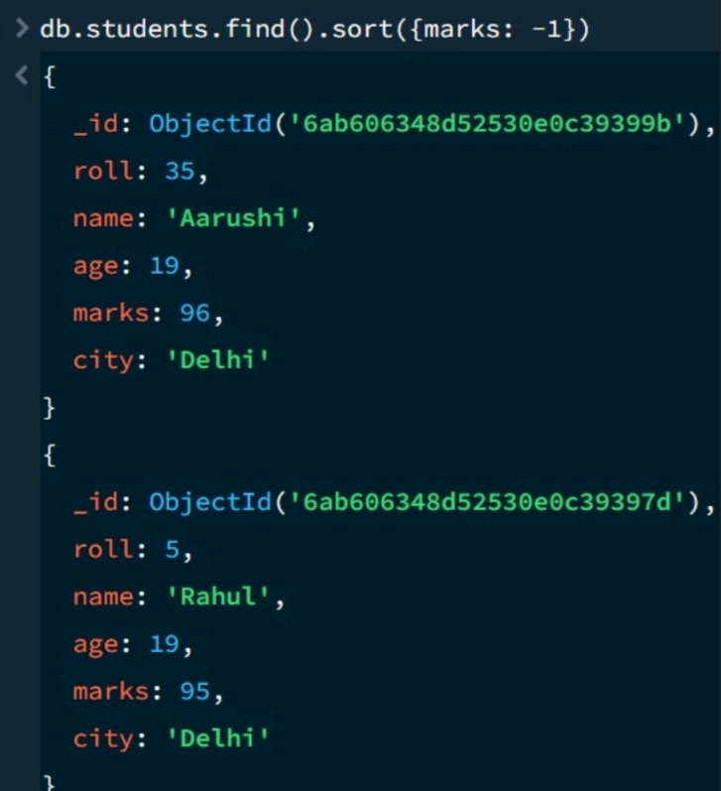

Using Limit Operation in Mongo DB-
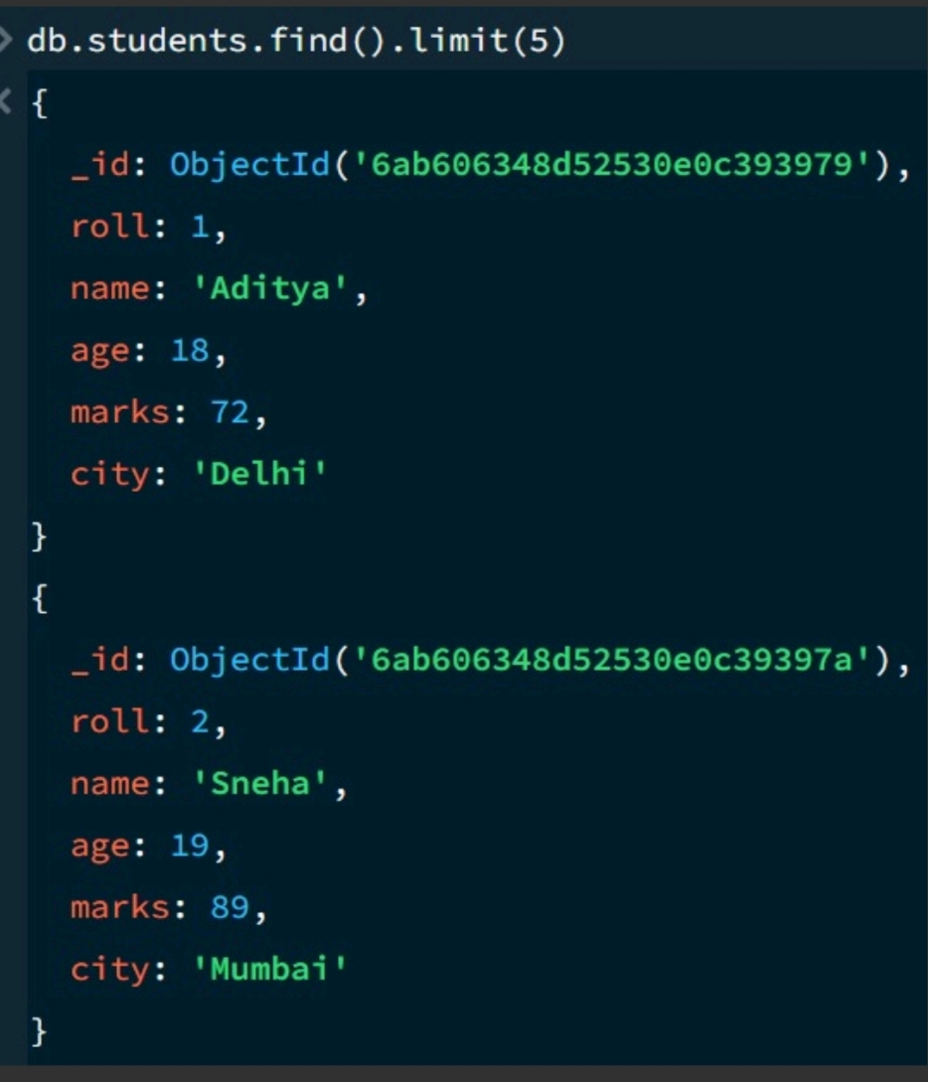

Using Search Operation in Mongo DB-
SEARCH by City
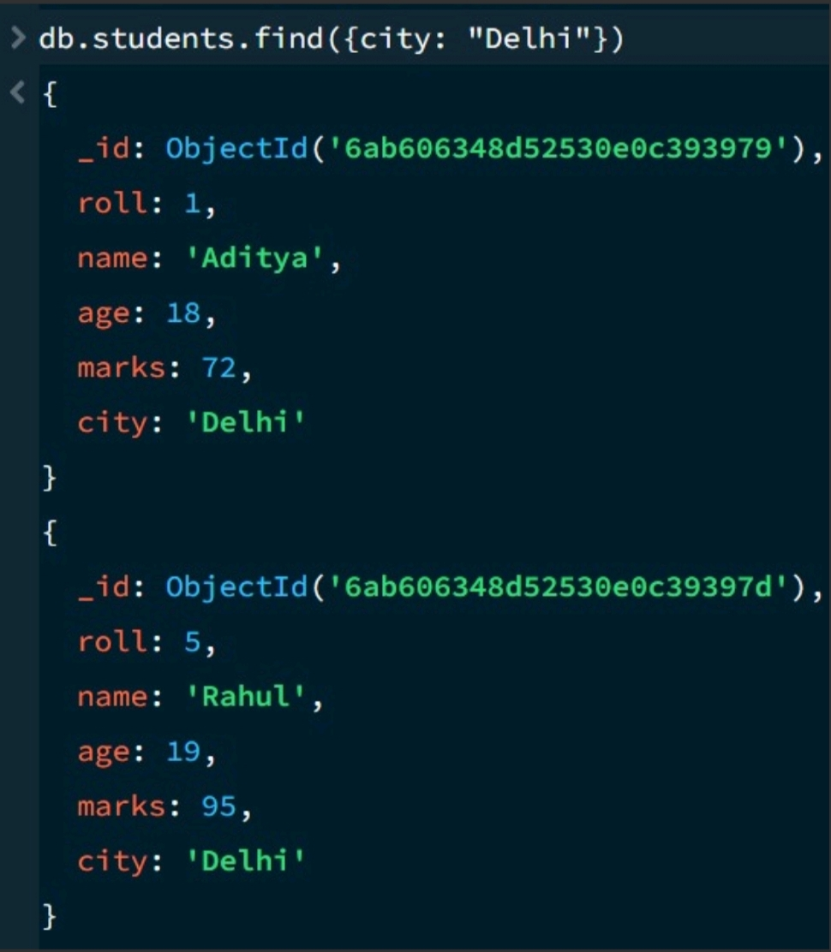

COUNT DOCUMENTS-
