**VIVA-1**

**GRAPHICS AND ANIMATION TOOLS**

**LAPTOP IN BLENDER**

1. Add a plane in the workspace and set the X and Y boundaries to create a rectangular surface with X slighly greater than Y.
2. Go to edit mode select a face and extrude upwards to create a cuboidal shape. Use copy paste to create another plane with same dimensions. Rotate the second plane by 90-95 degress and move it to edge of first plane and move it upwards of z axis to create two rectangular boxes edge to edge .
3. Select the outer face of the plane-1(screen) and use bevel to bevel or cut the boxes inwards to create a laptop like sculpture .
4. Do the same on plane-2(base)
5. On plane-1(screen) use inset on the plane to inset new face inside the original face.
6. Intrude the inner place sllighly inwards to create the laptop screen.
7. In edit mode select side face and hit Y to separate the surface from mesh and use loop cut only on the side face. Use multiple loop cuts and place them appropriately to form rectangular cuts of similar size.
8. Select one of the rectangular cuts and inset a face and intrude it inwards to create a usb slot. Do it similarly for all the cuts and attach the plane back to mesh.
9. Similarly on other side create a single loop cut to create one slit for charging point. Make sure to change the shape so as to not look extremely similar to other slots.
10. Create two vertical loop cuts on the base and place them on extreme left and extreme right.
11. Similarly for horizontal sides . We can use scale to place them symmetrically. Make two loop cuts in the middle extremely close to each other. These cuts will separate left mouse tochpad with right touchpad and click.
12. At the bottom there will be two rectangular cuts separated by a narrow slit. Inset the cuts and extrude them to create a touchpad.
13. Inset the middle surface and intrude it to add keyboard
14. Add a cube and bevel it to create a key. Place it on the middle surface.
15. Copy it multiple times to create a keyboard. Place it appropriately on the keyboard.
16. Add another cube scale it down and extrude the side surface to create the space bar.
17. To colour the laptop use material tab in the side pane and add desired colours for the laptop.
18. Decrease roughness, Increase tint and mettallic texture on the inner surfce of screen to resemble a shiny screen surface.

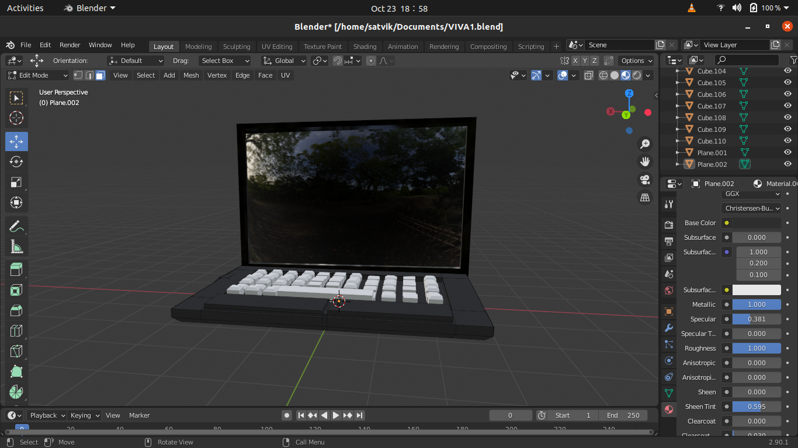

**SPECS IN GIMP**

1. Search for an image in google to be used as a reference.
2. New-> select 1280*840 and create a new sheet with white background.
3. Add the downloaded image as a new layer.
4. Use the fuzzy select to select the inner surface and colour it with desired colour.
5. Do the same with other side.
6. Use fuzzy select to select the frame and colour it with your choice. I will be leaving them black.
7. Add a different colour to background if desired.

