**1.Executive Summary**

Blazing burger is a fast food restaurant chain, it was three stores in New York, In Brooklyn, lower Manhattan and Upper West side. From the visualizations on Page1 we can see that Upper west side produces more revenue than the other two, it generates most of its revenue on weekends Friday, Saturday and Sunday. Page 2 depicts the health inspection score over area to see the performances of these restaurant present specific to a zip code. Then their revenue is showed in relation to the health score with time, over the year 2014, this shows lower Manhattan store performing worst, this impacts on the revenue performance for the restaurant location. Furthermore, the score distribution can be seen based on cuisine type and boro.

**2.Screenshots**

Worksheet1

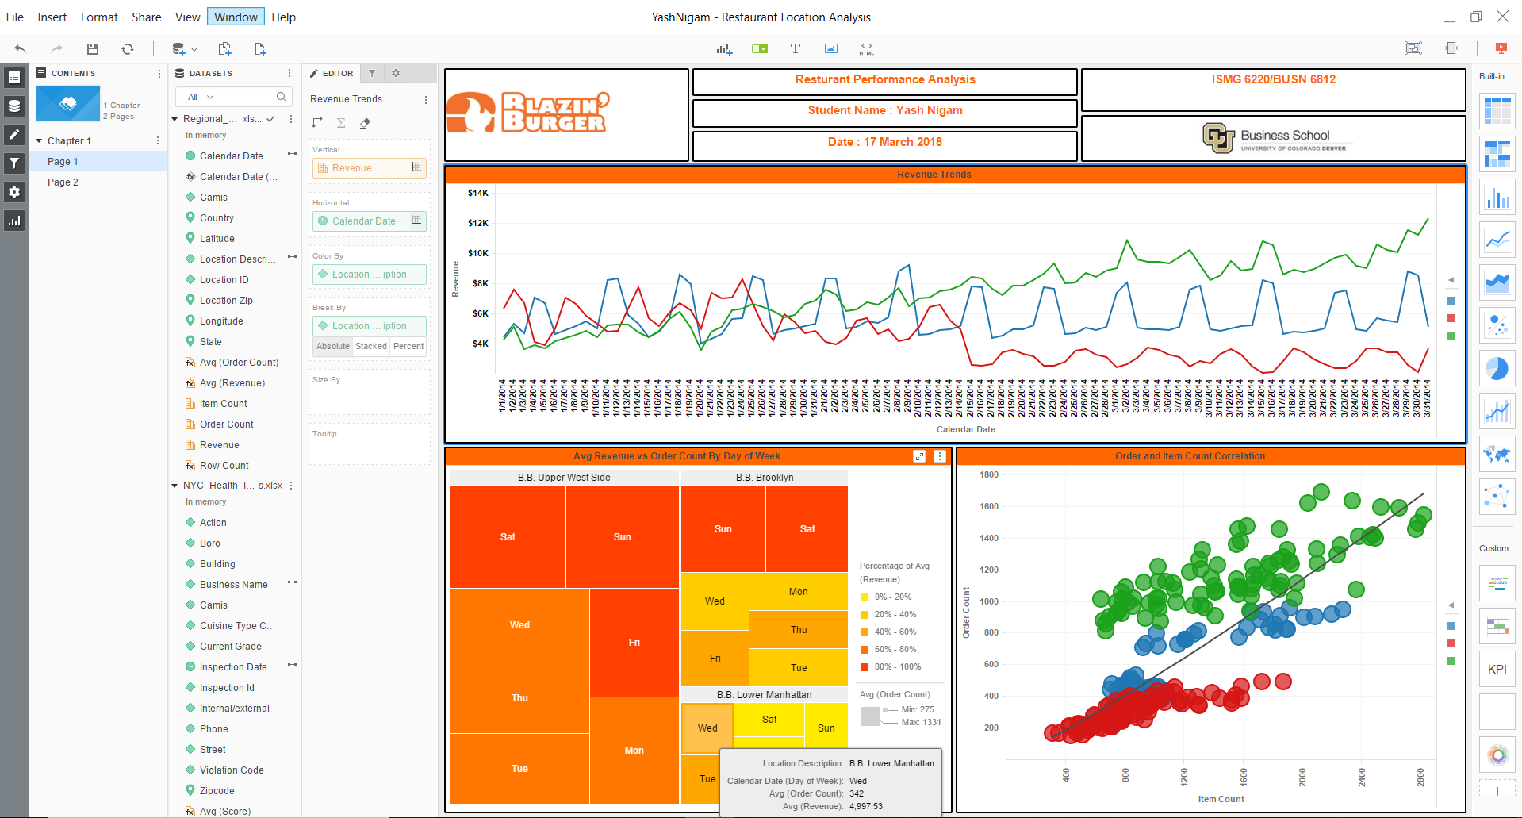

Revenue Trends

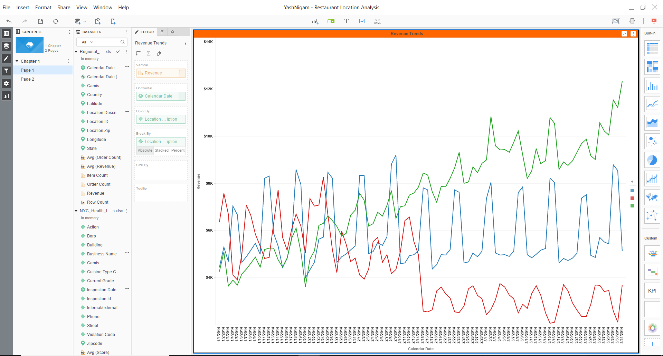

Avg revenue vs order count

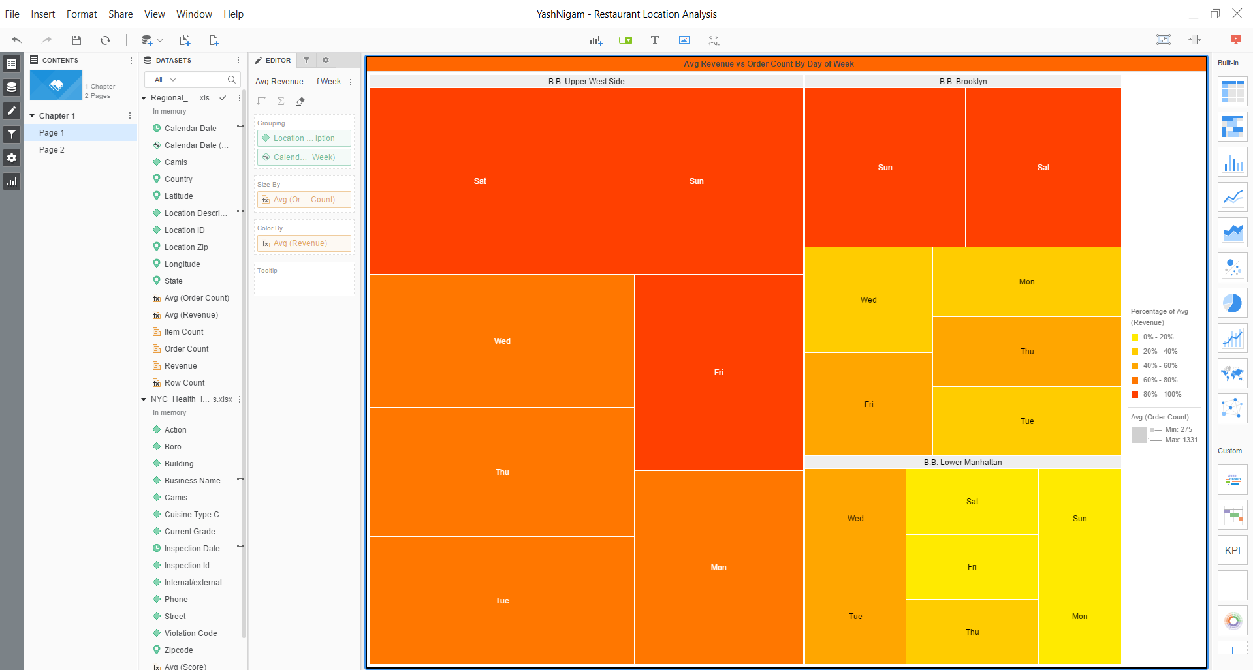

Order and Item correlation

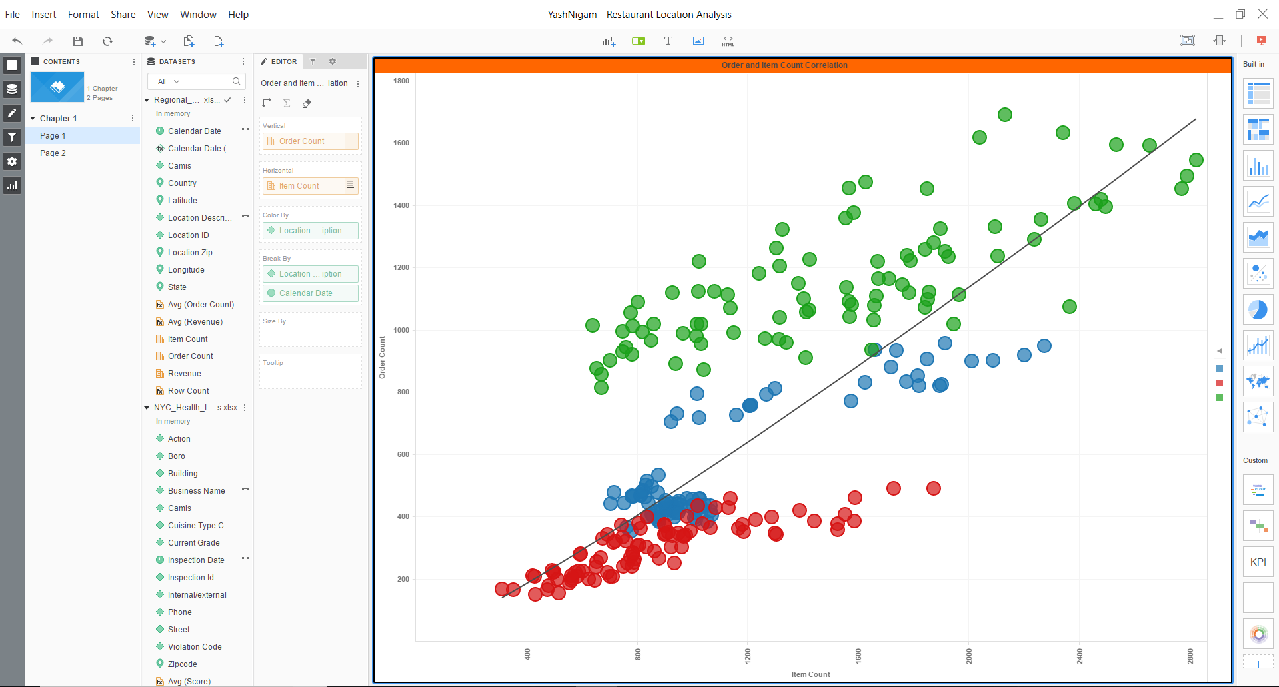

Worsheet2

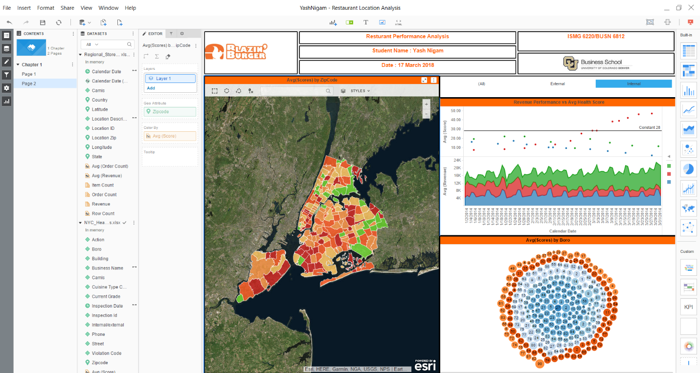

Avg score by zipcode

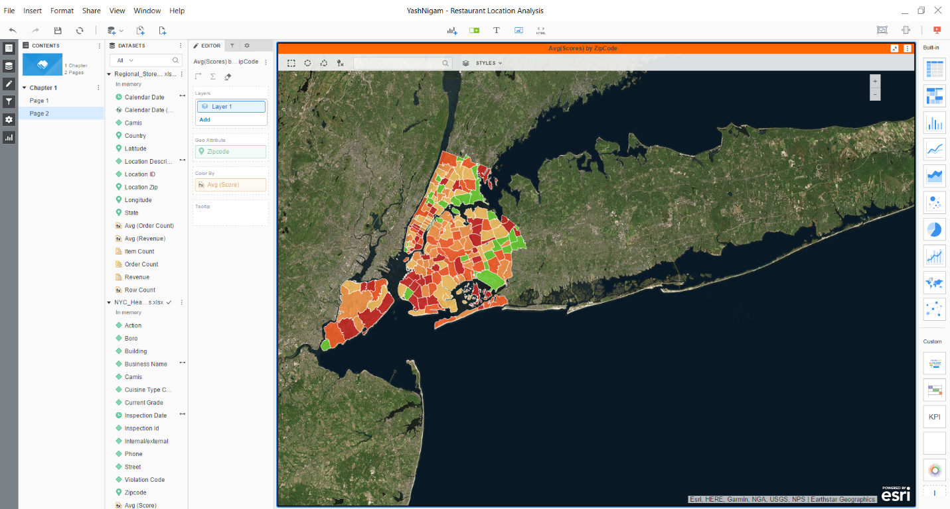

Revenue performance vs avg health score



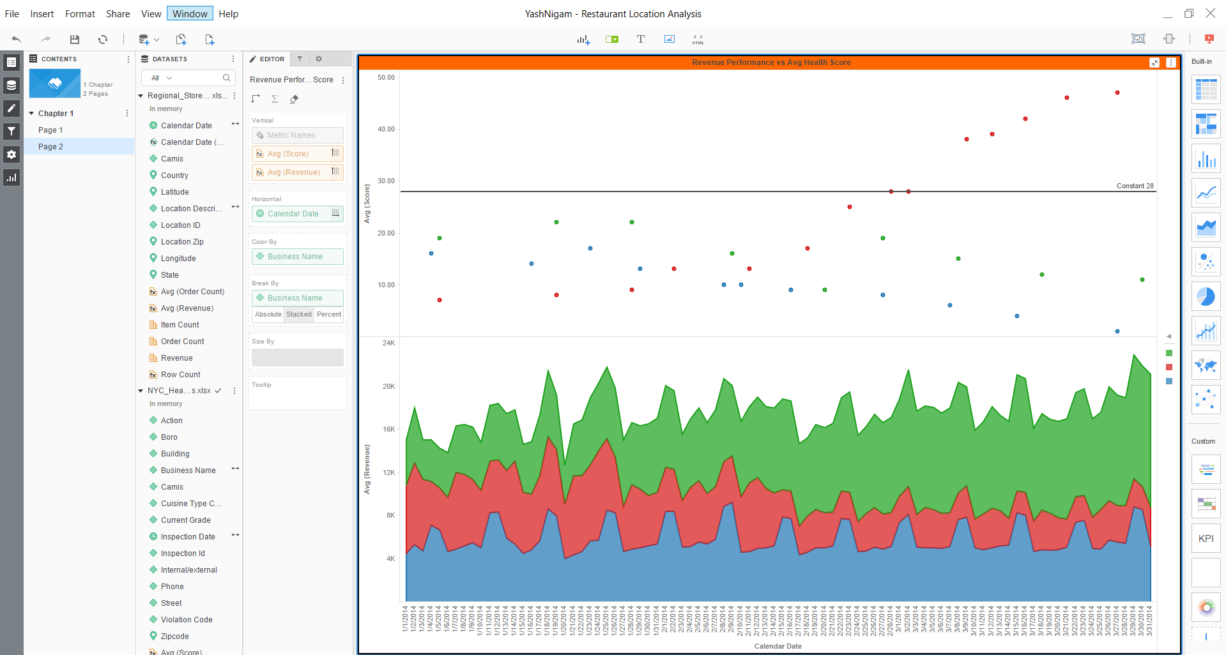

Avg score by boro

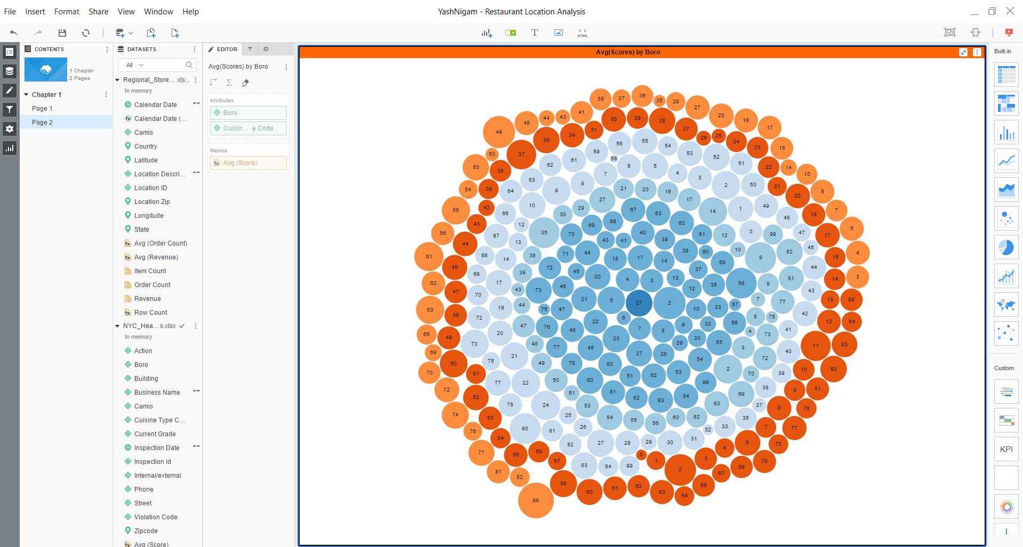

**3.Data Wrangling**

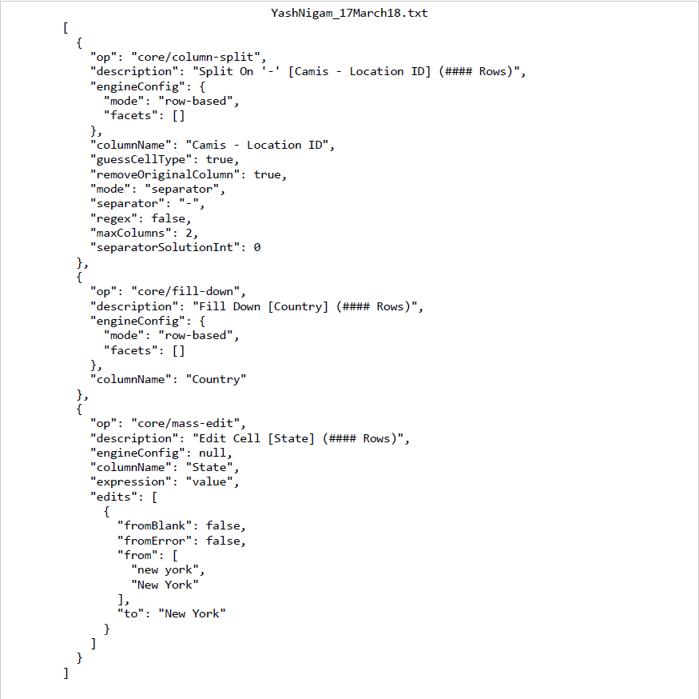

**4.Strengths/weakness of MicroStrategy BI tool**

Strengths

- User friendly and easy to operate interface with operations like drag and drop and instant changes in graphs can show which graph fulfills the user requirements.

- Conditional formatting lets the user to select key data to be shown on the chart

-It has the capability to easily integrate and use third party software and tools

Weakness

-It takes time in processing when a large data source is being used

-It lacks when the user wishes to perform advanced analytics with the data and visualizations

**5.Recommendations**

MicroStrategy should be made compatible to work with high volume data sources and they can add the advanced analytics feature in it.  
Upon using both, the desktop and online version, I see a lot of changes in the interface and mapping of MicroStrategy, this can be worked on to make the interface common and more user friendly.