**MILESTONE EVALUATION SHEET**

**MILESTONE NO.**

|  |  |
| --- | --- |
|  | **10** |
|  |  |

|  |  |
| --- | --- |
| **DATE:11/13/2018** | **COURSE NO.: ISMG 6060** |
|  | **INSTRUCTOR: Ersin Dincelli** |

|  |  |
| --- | --- |
| **TEAM NO. OR NAME** | **TEAM MEMBERS** |
|  | **Yash Nigam** |
|  |  |
|  |  |
|  |  |
|  |  |

|  |
| --- |
| **Student comments:** |
|  |
|  |
|  |
|  |
|  |

|  |  |  |  |  |  |  |
| --- | --- | --- | --- | --- | --- | --- |
| **Instructor comments:**   |  | | --- | | **Windows Navigation Diagram** | | Need to show labels for the arrows. | | **Storyboard** | | Need to include all objects on your Windows Navigation Diagram. | | **Windows Layout Diagrams** | | This is more like an HTML prototype. | |

**Score:9**

1. Develop two use scenarios, **draw a Windows Navigation Diagram**, and design a storyboard

|  |
| --- |
| Use Scenario: Client generates a staffing request to hire a new employee |
| 1. Client creates a StaffingRequest to hire a new employee  2. Contract Manager verifies the contract details with the client and approves the request for further process.  3. If the contract is not valid, the request is returned to the client along with the memo for the reason of decline.  4. The validated requests are inserted in the database for the placement department to start looking for eligible candidates and interview them |

|  |
| --- |
| Use Scenario: Candidates are shortlisted and verified according to the contract |
| 1. The validated requests are stored in the database.  2. Based on the contract, the candidate’s qualification, experience, and other details are checked  3. Shortlisted candidates are interviewed by the placement department  4. Selected candidates are marked ‘reserved’ and the arrangement department contacts them and agrees to the contract.  5. The placed candidate detail is sent to the client |

**Windows Navigation Diagram**

<<Form>>

Selected candidates sent to client

<<Form>>

Client Requirement

Details

<<Window>>

List of candidates

<<Form>>

Contract Validation at PSSM

<<Textbox>>

Placement terms

<<button>>

Verification

<<button>>

Create staffing Request

<<button>>

List the eligible candidates

<<button>>

Reserve

<<Button>>

Send to Client, attached profile

<<button>>

Send to arrangements

<<button>>

Contract Details

<<button>>

Open Profile

<<Dropdown>

Assign

<<button>>

Returned Memo

<<Window>>

Close staffing request

<<Window>>

Create Memo (return the request to client)

%3CmxGraphModel%3E%3Croot%3E%3CmxCell%20id%3D%220%22%2F%3E%3CmxCell%20id%3D%221%22%20parent%3D%220%22%2F%3E%3CmxCell%20id%3D%222%22%20value%3D%22%22%20style%3D%22verticalAlign%3Dtop%3Balign%3Dleft%3BspacingTop%3D8%3BspacingLeft%3D2%3BspacingRight%3D12%3Bshape%3Dcube%3Bsize%3D10%3Bdirection%3Dsouth%3BfontStyle%3D4%3Bhtml%3D1%3Brounded%3D0%3Bshadow%3D0%3Bcomic%3D0%3BlabelBackgroundColor%3Dnone%3BstrokeColor%3D%23000000%3BstrokeWidth%3D1%3BfillColor%3D%23ffffff%3BfontFamily%3DVerdana%3BfontSize%3D12%3BfontColor%3D%23000000%3B%22%20vertex%3D%221%22%20parent%3D%221%22%3E%3CmxGeometry%20x%3D%22120%22%20y%3D%2270%22%20width%3D%22330%22%20height%3D%22220%22%20as%3D%22geometry%22%2F%3E%3C%2FmxCell%3E%3C%2Froot%3E%3C%2FmxGraphModel%3E

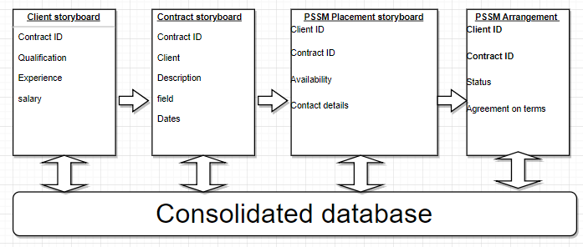

2.Based on your answers to part a, **create Windows Layout Diagrams** for the user interface and develop a set of real use cases for the user

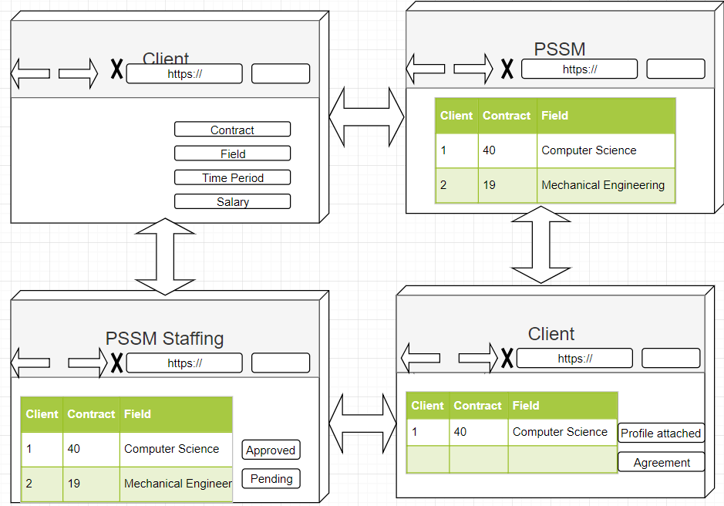

3. How would your user interface design have to be modified if you were to deploy it on a tablet? What about a smartphone?

For user interface design to deploy in a tablet or smartphone, the important point is to consider space limitation, the kind of input (touch/manual key), the target audience, in this case, clients and PSSM employee’s needs are to evaluate for a tablet or smartphone version, with smart devices capacities like GPS and accelerometers, the functioning of an interface can be enhanced. One of the major implications is the screen orientation, which is scrollable vertically, with touchscreen devices, factors like tapping, pinching, spreading, flicking and scrolling should be considered in designing.

4. What, if any, social media sites should PSSM con­sider?

PSSM can consider Facebook and Twitter for their branding, marketing, and even operations, they can differentiate and innovate with linking LinkedIn profiles of all the candidates in the database along with their application, company details can also be added here to help the candidate learn about the company through their website and LinkedIn page.

5. How would your answers change if you were developing the system for a global audience?

PSSM would serve global clients and candidates, for this basic requirement like multilingual capabilities, cultural and sociological factors will be considered. For a global reach, most of the interface design would remain the same, just the target audience will change as soon as the user allows the user detection or applies the filter themselves.