**MILESTONE EVALUATION SHEET**

**MILESTONE NO.**

|  |  |
| --- | --- |
|  | **6** |
|  |  |

|  |  |
| --- | --- |
| **DATE:** | **COURSE NO.: ISMG 6060** |
|  | **INSTRUCTOR: Ersin Dencelli** |

|  |  |
| --- | --- |
| **TEAM NO. OR NAME** | **TEAM MEMBERS** |
|  | **Yash Nigam** |
|  |  |
|  |  |
|  |  |
|  |  |

|  |
| --- |
| **Student comments:** |
|  |
|  |
|  |
|  |
|  |

|  |  |  |  |  |  |  |
| --- | --- | --- | --- | --- | --- | --- |
| **Instructor comments:**   |  | | --- | | **Sequence Diagram** | | Need to create a sequence diagram for each scenario of each use case. | | Need to indicate execution occurrence for each object. | | **Communication Diagram** | | Need to create a communication diagram for each scenario of each use case. | | **Behavioral State Machine Diagram**  Need to create a behavioral state machine diagram for each class in the class diagram. | |

**Score:9**

**Sequence Diagram**

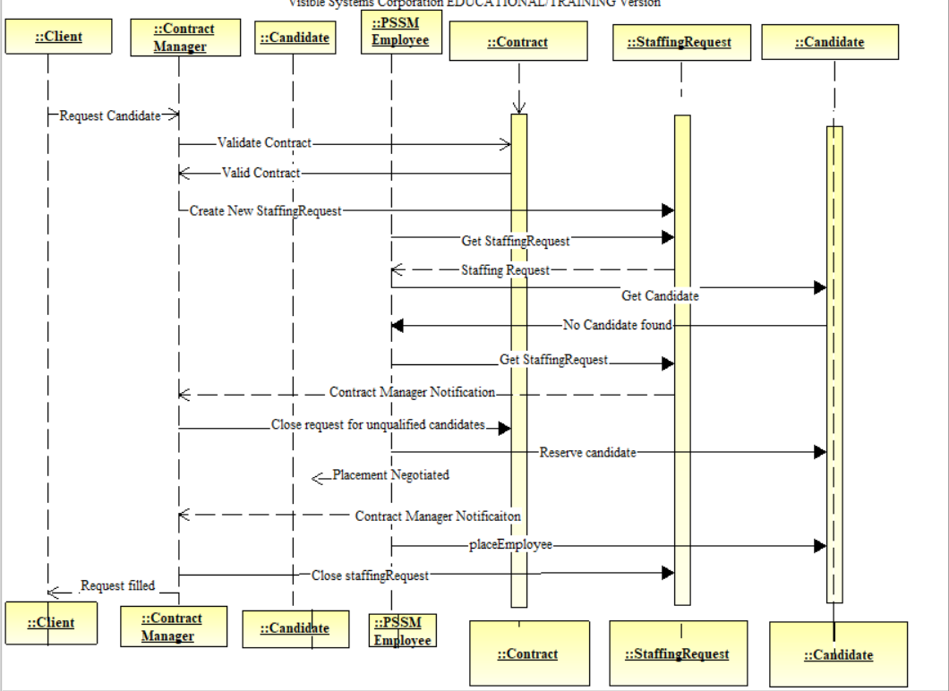

**Communication Diagram**

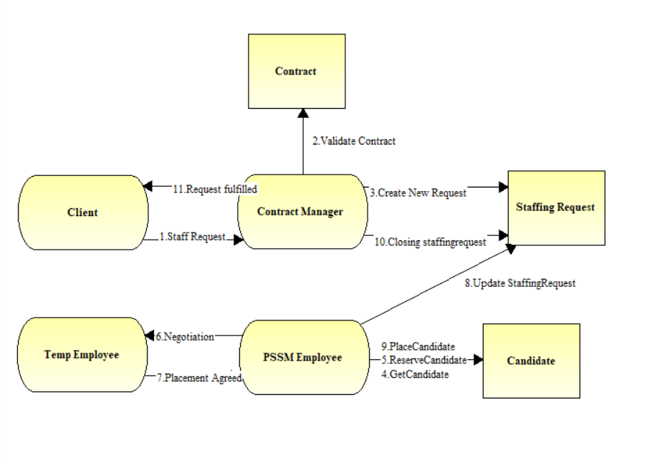

**Behavioral state machine**

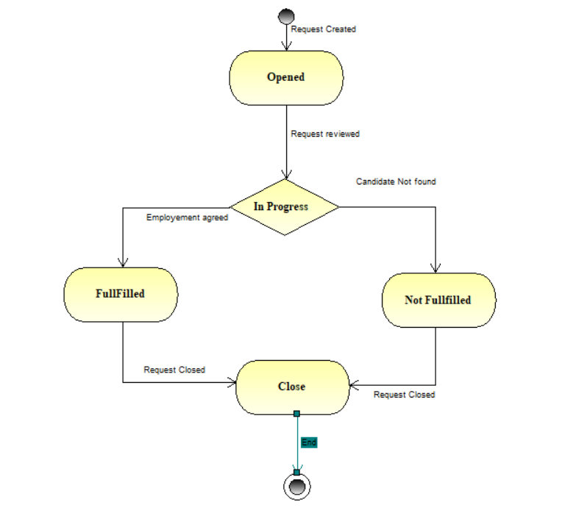

**Crude Analysis**



**Verification and validation of behavioral model**

-All actors and objects in sequence diagrams included in communication diagrams.

-Sequence diagram messages → communication diagram associations

-Sequence diagram messages → communication diagram messages

-Sequence diagram guard conditions → communication diagram guard conditions

-Communication diagram sequence numbers reflect sequence diagram order

-Behavior state machine transitions → sequence and communication diagram messages

-Behavior state machine transitions → CRUDE matrix classification

-CRUDE matrix entries → messages between actors and objects, behavior state machine transitions