**MILESTONE EVALUATION SHEET**

**MILESTONE NO.**

|  |  |
| --- | --- |
|  |  |
|  | **7** |

|  |  |
| --- | --- |
| **DATE: 10/23/2018** | **COURSE NO.: ISMG 6060** |
|  | **INSTRUCTOR: Ersin Dincelli** |

|  |  |
| --- | --- |
| **TEAM NO. OR NAME** | **TEAM MEMBERS** |
|  | **Yash Nigam** |
|  |  |
|  |  |
|  |  |
|  |  |

|  |
| --- |
| **Student comments:** |
| **Hi Professor, to create the package diagram I was trying to do it through visual analyst, but I was not able to add the entities to the classes. Since we have the submission date today, I have completed it through MS Word and put in an email to the support team.** |
| **It is okay. There is no specific diagram for package diagrams in VA.** |
|  |
|  |
|  |

|  |  |  |  |  |
| --- | --- | --- | --- | --- |
| **Instructor comments:**   |  | | --- | | **Package Diagram** | | Better to create more than one package according to the dependency among classes. | | **Design Strategy** | | It would be better if you can provide more explanation from the aspects of business need, project skills, and project management. | |

**Score:9.5**

**Package Diagram**

Problem Domain

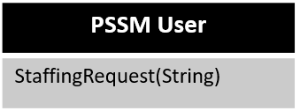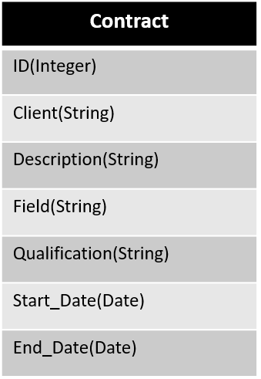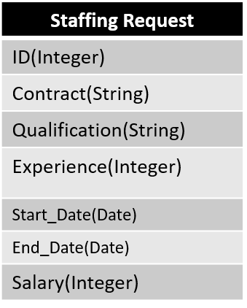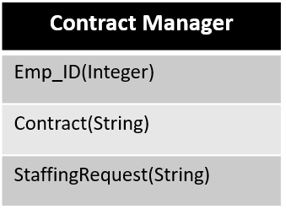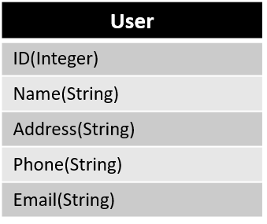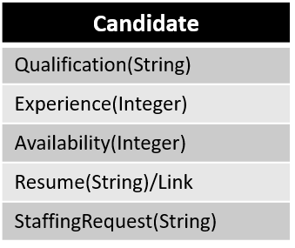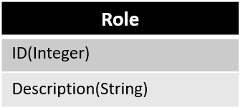

**Validation and Verification walkthrough**

-Derived from the Class Diagram and Crud Matrix

-The problem domain is created based on identified packages from the previous classes and reviews

-All the dependency matrices are based on relationships of the communication diagram, Crude matrix, and association with the Class Diagram.

**Design Strategy**

According to the current functionality and understanding of the system, I would recommend Packaged Software strategy because, PSSM does not have a dedicated Information Technology department which supports the organization, earlier they were doing a lot of manual and paperwork, resulting in a system with slow processing and less involvement of automated processes. With the proposed system we are trying to add a consolidated database and analytical capabilities to the entire process, which requires IT expertise and capabilities, with the current staff, in-house development is not possible, the cost of hiring developers, testers and IT managers would result in a very costly affair. With the packaged software, PSSM has a variety of systems to browse and select the one which makes PSSM’s goals and requirements. It is more efficient to buy a product which is already created, tested and proven, along with this, it is easier to install in a short period of time, the biggest advantage with this system is the conflict resolution and expertise provided by the vendor who developed the software/system. Systems like ERP, enterprise resource planning, provides the advantage of automation to the entire company. They also provide modifications to the software according to the needs of the customer.