**MILESTONE EVALUATION SHEET**

**MILESTONE NO.**

|  |  |
| --- | --- |
|  | **8** |
|  |  |

|  |  |
| --- | --- |
| **DATE:10/30/2018** | **COURSE NO.: ISMG 6060** |
|  | **INSTRUCTOR: Ersin Dincelli** |

|  |  |
| --- | --- |
| **TEAM NO. OR NAME** | **TEAM MEMBERS** |
|  | **Yash Nigam** |
|  |  |
|  |  |
|  |  |
|  |  |

|  |
| --- |
| **Student comments:** |
|  |
|  |
|  |
|  |
|  |

|  |  |  |  |  |  |  |
| --- | --- | --- | --- | --- | --- | --- |
| **Instructor comments:**   |  | | --- | | **Invariants for attributes and relationships** | | Need to add invariants for relationships as well. | | **Contract** | | In Clients (consumers) section, need to list an instance of a class that sends a message to a server (supplier) object that executes one of its methods in response to the request. | | **Method Specification Form** | | Need to list messages in the Data Type columns. | |

**Score:9**

1. For each class in the structural model, using Object Constraint Language (OCL),create **a set of invariants for attributes and relationships**and **add them to the CRC cards for the classes**

**Front:**

|  |  |  |  |
| --- | --- | --- | --- |
| **Class Name:** Contract | **ID:** 1 | | **Type:** Concrete |
| **Description:** This class describes the contracts negotiated between the client and PSSM staffing agency | | | **Associated Use Cases:** 3 |
| **Responsibilities**  Responsibility1  Addition to the consolidated contract table  Assigned the staffing request  Assign to PSSM candidate (another department)  Hire the candidate | | **Collaborators**  Collaborator1  Database  StaffingRequest  Candidate  Candidate | |

**Back:**

|  |
| --- |
| **Attributes:**  Attribute1  Contract_ID (1..1) (integer)  Contract_Date (0..1) (Date)  Client_Name (1..1) (String)  Client_Address (1..1) (string)  Client_Phone (1..1) (string)  Client_Email (1..1) (string) CandidateDetail (0..1) (String array) |
| **Relationships**:  **Generalization (a-kind-of):**  **Aggregation (has-parts):**  **Other Associations:** Candidate,StaffingRequest |

**Front:**

|  |  |  |  |
| --- | --- | --- | --- |
| **Class Name:** Candidate | **ID:** 2 | | **Type:** Concrete |
| **Description:** This class represents the available candidate details visible to the client and PSSM using consolidated database. | | | **Associated Use Cases:** 3 |
| **Responsibilities**  Responsibility1  Added_Employee Added to contract  Hold/reserve Place | | **Collaborators**  Collaborator1  Database  Contract  StaffingRequest  StaffingRequest | |

**Back:**

|  |
| --- |
| **Attributes:**  Attribute1  EmpID (0..1) (integer)  EmpStatus (1..1) (string) [available, reserved, placed]  EmpName (1..1) (string)  EmpAddr (1..1) (string)  EmpPhone (1..1)(string)  EmpEmail (1..1) (string)  Experience (0..1) (integer) Qualification (0..1)(free text field) [bachloers, masters, doctorate]  Expected Salary (1..1) (float) ContractID (1..1) (integer) |
| **Relationships**:  **Generalization (a-kind-of):**  **Aggregation (has-parts):**  **Other Associations:** Contract, StaffingRequest |

**Front:**

|  |  |  |  |
| --- | --- | --- | --- |
| **Class Name:** StaffingRequest | **ID:** 3 | | **Type:** Concrete |
| **Description:** This class represents staffing request used to manage placements for PSSM clients and candidates. | | | **Associated Use Cases:** |
| **Responsibilities**  Responsibility1  Add to table  Assign to contract  Reserve candidate  Place candidate  Close | | **Collaborators**  Collaborator1  Database  Contract  Candidate  Candidate  Database | |

**Back:**

|  |
| --- |
| **Attributes:**  Attribute1  RequestID (1..1) (integer)  Status (0..1) (string) [Open, closed]  ContractID (1..1) (integer)  Description (0..1) (free text field)  Experience reqst (0..1) (integer)  Qualification reqst (0..1) (string) [bachleors, masters, doctorate]  Salary Offered (1..1) (float) Reserved Candidate (1..1) (int array)  Placed Candidate (1..1) (int array) |
| **Relationships**:  **Generalization (a-kind-of):**  **Aggregation (has-parts):**  **Other Associations:** Contract, Candidate |

2.Choose one of the classes in the structural model. Create a **contract**(see**figures 8-22**(page 309) and **8-25** (page 313) in the textbook)**for each method in that class**. Be sure to use OCL to specify the preconditions and the post-condition. Be as complete as possible.

|  |
| --- |
| **Method Name**: Addition to contract table **Class Name**: Contract **ID**: 1 |
| **Clients (Consumers) :** Client, PSSM |
| **Associated use cases :** AddCandidateDetail |
| **Description of responsibilties:**  Adding a new staffing request from the client to the consolidated database which would enable the employees of PSSM and the client to look at the progress of the staffing request throughout the process of hiring a candidate. |
| **Arguments Received :**  Staffing requirements checked with the existing contract with the client |
| **Type of value returned :**  Staffing request number/ID to track the request and add or edit anything with the candidate detail |
| **Pre-conditions:**  Client should have an active contract with PSSM and all the terms are to be agreed on beforehand |
| **Post-conditions:**  The staffing request should be kept in database for the ease of tracking and reporting & for documentation purposes. |

|  |
| --- |
| **Method Name**: Assign staffing request **Class Name**: Contract **ID**: 2 |
| **Clients (Consumers) :** PSSM |
| **Associated use cases :** StaffingRequest |
| **Description of responsibilties:**  Once the staffing request is put in the database, the request goes to employees responsible for finding and contacting the candidates with the most suitable profile given on the description. |
| **Arguments Received :**  Staffing requirement requirement should be aligned to the contract description |
| **Type of value returned :**  The shared database will provide the list of candidates to interview and shortlist based on the staffing request and the client will be notified |
| **Pre-conditions:**  Staffing request should be valid and PSSM also checks for the valid contract and details related to the candidate requirement |
| **Post-conditions:**  The staffing request is passed on to the placement department for the selection of the right candidate. |

|  |
| --- |
| **Method Name**: Assign candidate to placement department **Class Name**: Contract **ID**: 3 |
| **Clients (Consumers) :** PSSM |
| **Associated use cases :** CandidateDetail |
| **Description of responsibilties:**  The candidates would be shortlisted from the database and the requirement from the contract will be matched |
| **Arguments Received :**  None |
| **Type of value returned :**  Candidates from the consolidated database, shortlisted on the basis of the client requirements |
| **Pre-conditions:**  Candidate must be available for the time of contract and the client holds a valid contract with PSSM |
| **Post-conditions:**  The candidates list is passed onto the arrangement department for contacting the candidates and hiring them. |

|  |
| --- |
| **Method Name**: Hiring the candidate **Class Name**: Contract **ID**: 4 |
| **Clients (Consumers) :** Client, PSSM |
| **Associated use cases :** CandidateDetails |
| **Description of responsibilties:**  The arrangment department hires the candidates, settle the benefits and negotiations and report the hired candidate profile to the client |
| **Arguments Received :**  If there is no candidate, the client is informed and the search is continued for a suitable candidate |
| **Type of value returned :**  Candidates that match the requirement of the client and agree to the terms and conditions of the employment |
| **Pre-conditions:**  Candidate list is provided by the placmeent department and the selected candidate is available to the tenure. |
| **Post-conditions:**  Client is sent the hiring details of the candidate and the candidate is marked as placed by the manager. |

3.Create a **method specification for each method in the class you chose**. Use both **Structured English** and **Activity Diagrams** for the algorithm specification

Addition to contract table

|  |  |  |
| --- | --- | --- |
| **Method Specification Form** | | |
| Method Name: **Addition to contract table** | Class Name:  **Contract** | ID: 1 |
| Contract ID:1 | Programmer: Jerry Seinfeld | Date due: 12/31/2018 |
| Language used: Java, SQL | | |
| Arguments received | | |
| Data Type: | Notes: | |
| Messages sent & arguments passed | | |
| ClassName.MethodName | Data Type | Notes: |
| Contract.ContID  Contract.ContDate  Contract.ClientDetail  Contract.CandidateInfo | Integer  Date  String  String Array | ContractID gives unique key to track the request  To track the project  Client information for staffing request  Candidate details in the consolidated request |
| Arguments returned | | |
| Data Type: | Notes: | |
| Algorithm specification:  Check the client’s contract with PSSM before inserting the staffing request If the contract is active, proceed else Return the request with reason slip and notify the contract manager. For all valid contracts Update the database with a new entry as ContractID | | |
| Miscellaneous notes: | | |
|  | | |

Activity Diagram

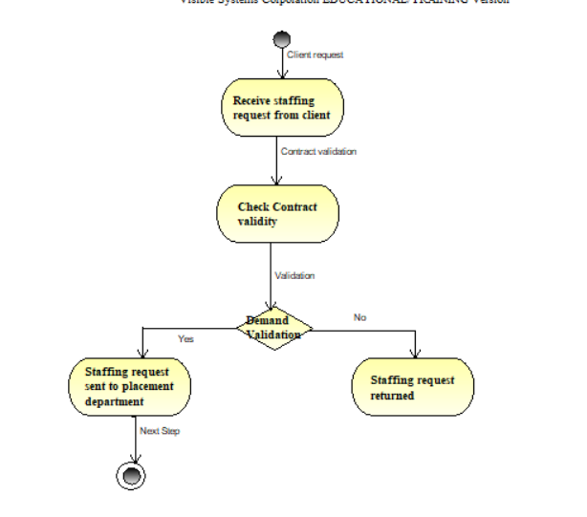

Assign to staffing request

|  |  |  |
| --- | --- | --- |
| **Method Specification Form** | | |
| Method Name:  Assign staffing request | Class Name:  **Contract** | ID: 2 |
| Contract ID: 1 | Programmer: George Castanza | Date due:  12/31/2018 |
| Language used: Java, SQL | | |
| Arguments received | | |
| Data Type: | Notes: | |
| Messages sent & arguments passed | | |
| ClassName.MethodName | Data Type | Notes: |
| Contract.ContID  Contract.ContDate  Contract.ClientDetail  Contract.CandidateInfo | Integer  Date  String  String Array | ContractID gives unique key to track the request  To track the project  Client information for staffing request  Candidate details in the consolidated request |
| Arguments returned | | |
| Data Type: | Notes: | |
| Algorithm specification:  The placement department starts looking for candidates from the consolidated database and verirfying the contract  If contract is valid, return  Else, search for the criteria from the staffing request and contract.  List of eligible and available candidates sent to the arrangement department.  If, candidate is not found, report the client with acknowledgment slip | | |
| Miscellaneous notes: | | |
|  | | |

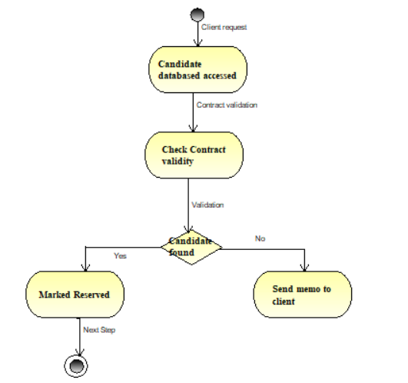

Assign candidate to placement department

|  |  |  |
| --- | --- | --- |
| **Method Specification Form** | | |
| Method Name:  Assign candidate to placement department | Class Name:  **Contract** | ID: 3 |
| Contract ID: 1 | Programmer: George Castanza | Date due:  12/31/2018 |
| Language used: Java, SQL | | |
| Arguments received | | |
| Data Type: | Notes: | |
| Messages sent & arguments passed | | |
| ClassName.MethodName | Data Type | Notes: |
| Contract.ContID  Contract.ContDate  Contract.ClientDetail  Contract.CandidateInfo | Integer  Date  String  String Array | ContractID gives unique key to track the request  To track the project  Client information for staffing request  Candidate details in the consolidated request |
| Arguments returned | | |
| Data Type: | Notes: | |
| Algorithm specification:  Placement department verifies the candidate profiles and work experience  If matched send the profiles for interview  If selected, send the profile to arrangemnt department  Else notifiy the client about the shrotage on candidate or requirements adjusment by them | | |
| Miscellaneous notes: | | |
|  | | |

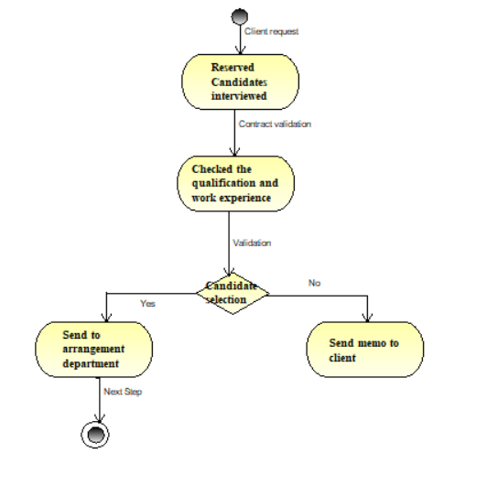

Hiring the candidate

|  |  |  |
| --- | --- | --- |
| **Method Specification Form** | | |
| Method Name:  Hiring the candidate | Class Name:  **Contract** | ID: 4 |
| Contract ID: 1 | Programmer: Jerry Seinfeld | Date due:  12/31/2018 |
| Language used: Java, SQL | | |
| Arguments received | | |
| Data Type: | Notes: | |
| Messages sent & arguments passed | | |
| ClassName.MethodName | Data Type | Notes: |
| Contract.ContID  Contract.ContDate  Contract.ClientDetail  Contract.CandidateInfo | Integer  Date  String  String Array | ContractID gives unique key to track the request  To track the project  Client information for staffing request  Candidate details in the consolidated request |
| Arguments returned | | |
| Data Type: | Notes: | |
| Algorithm specification:  The shortlisted candidates are contacted to discuss terms and offer  If, the candidate agrees to the term and contract details  The candidate is given the offer letter and the candidate profile is sent to the client  Else, the candidate does not aceept the offer, the request is on hold and sent to ID = 2  The staffing request is closed and candidate is marked as Hired | | |
| Miscellaneous notes: | | |
|  | | |

