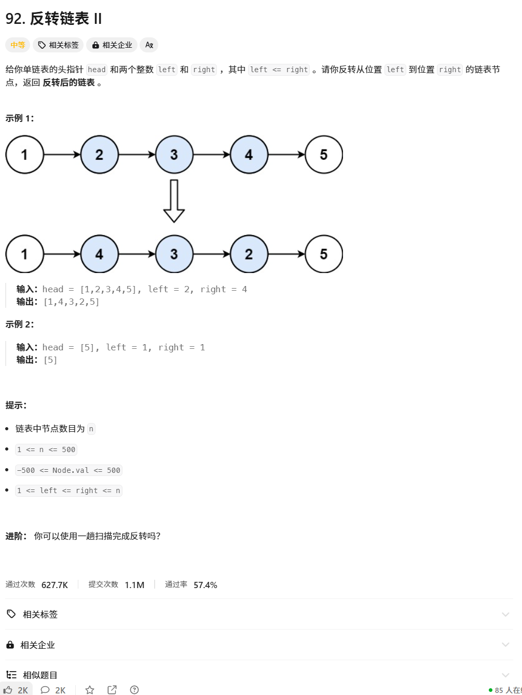[92. 反转链表 II - 力扣（LeetCode）](https://leetcode.cn/problems/reverse-linked-list-ii/description/)

[86. 分隔链表 - 力扣（LeetCode）](https://leetcode.cn/problems/partition-list/description/)

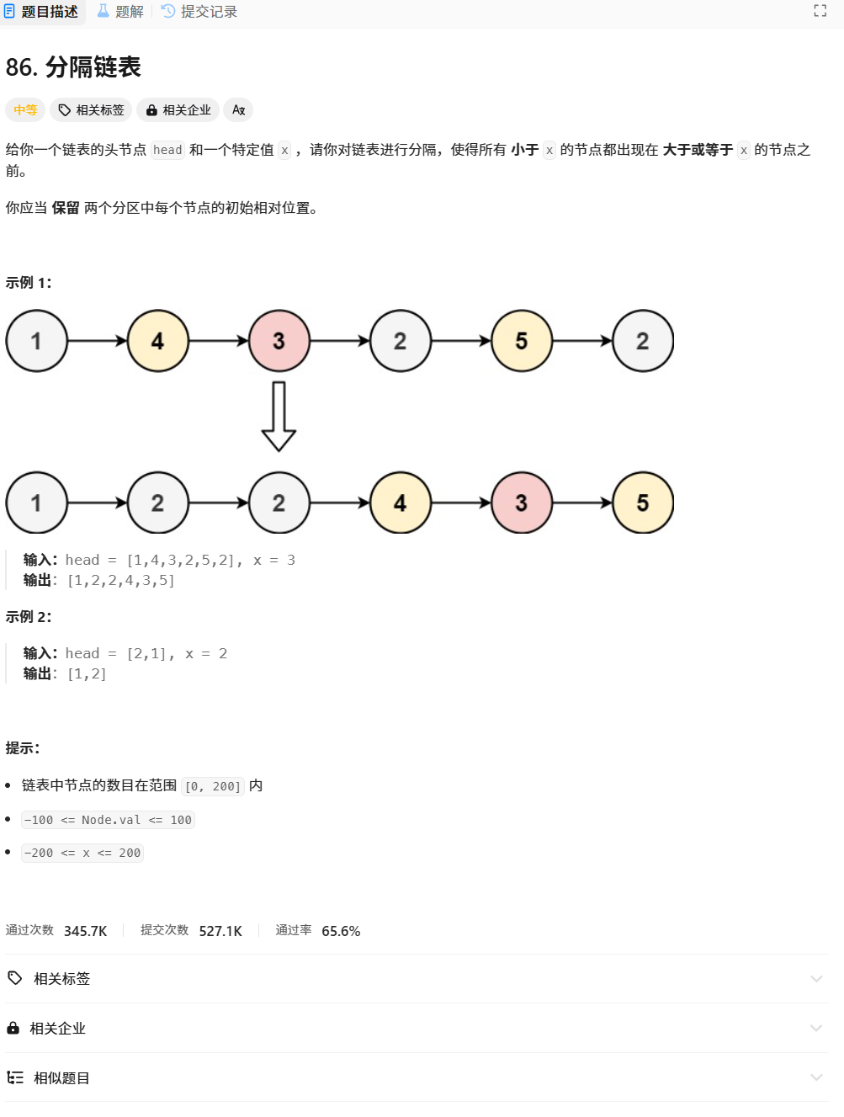

[167. 两数之和 II - 输入有序数组 - 力扣（LeetCode）](https://leetcode.cn/problems/two-sum-ii-input-array-is-sorted/description/)