We are working to correct for geometrical distortions introduced by the lens in our imaging system at DanMAX. To evaluate and correct for these distortions, we have measured a checkerboard pattern during a previous beamtime. This pattern serves as the reference for evaluating radial distortion caused by the lens.
I have made a preliminary Python script to correct for the geometrical distortions in the lens. You can access the script via the following GitHub repository: https://github.com/nigedtu/Distortions. The script is contained in the file geometric_shape_distortions_martins_gold_sample_tester_4.py, and it utilizes the grid_scan_2398_corrected.h5 data file from the February beamtime.
All necessary files required to run the Python script are included in the repository, except for the actual measured data, which is too large for Git. The Python script uses OpenCV's Harris Corner Detector to identify the corners from the checkerboard pattern and leverages code from Discorpy (available here: Discorpy GitHub) to evaluate and correct the distortion.
The following image are produced from the Python Script and shows the performance of the correction.

The image below is the original data captured during the experiment. The left panel shows the full field of view. This serves as the raw input for evaluating and correcting the lens distortion.
The right panel presents a zoomed-in section of the original image, showing the checkerboard pattern. This zoomed-in view highlights small particles on the Scintillator which will affect precision of finding the corners on the checkerboard patten.
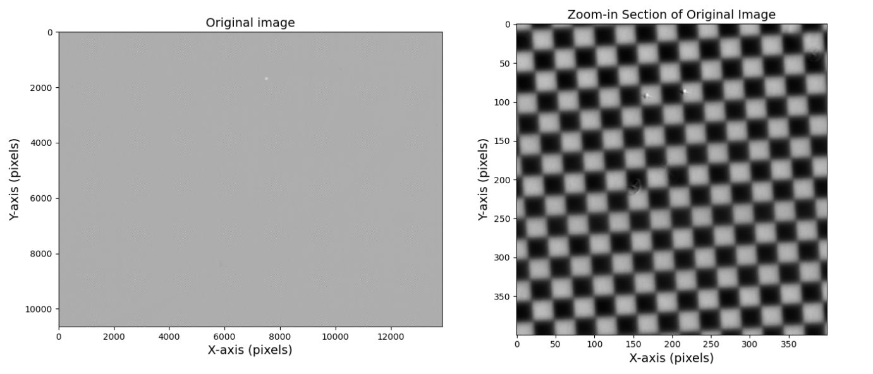

The below image illustrates the steps involved in identifying the corners and overlaying centroids on the original image using OpenCV's Harris Corner Detector.
- The top-left panel shows the original image.
- The top-right panel displays the single centroids matrix, where the identified centroids are marked, indicating the locations of the detected corners from the checkerboard pattern using the Harris corner detection technique. (Note they are to small to see without zooming-in)
- The bottom-left panel shows the overlay of single centroids on the original image, where the detected centroids (marked in red) are overlaid on the original image to visualize their positions. (Note they are to small to see without zooming-in)
- The bottom-right panel presents a zoomed-in section of the image [3000:3400, 3000:3400], with the centroids overlaid in red, highlighting the locations of the detected corners. Here the effect of the particles can be observed.

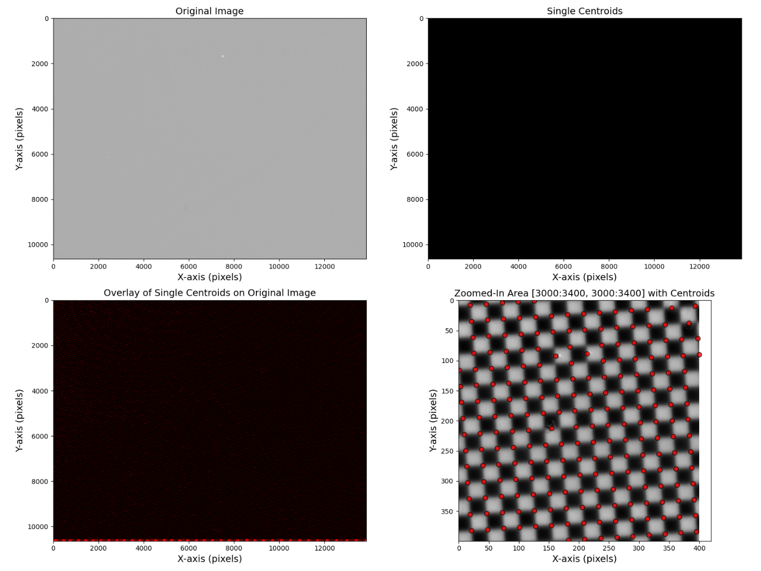
Median distance between two dots: 26.07

These figures show the original image with grouped vertical and horizontal dots. The centroids of the dots have been identified and grouped into lines. The different colors represent different groups of dots along the vertical and horizontal direction.
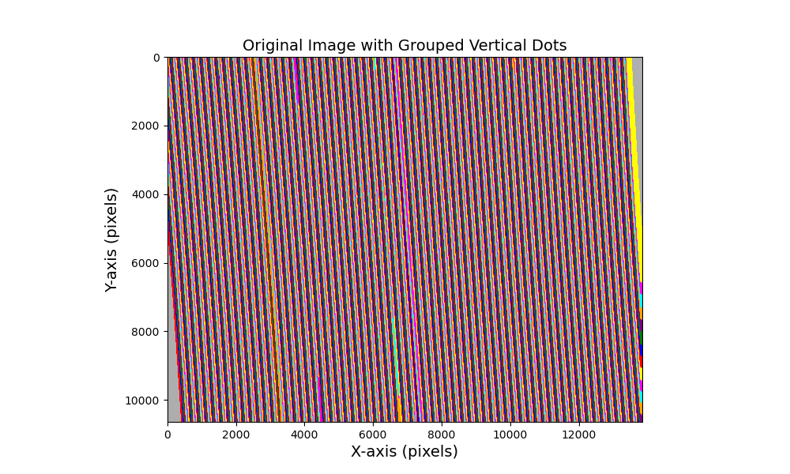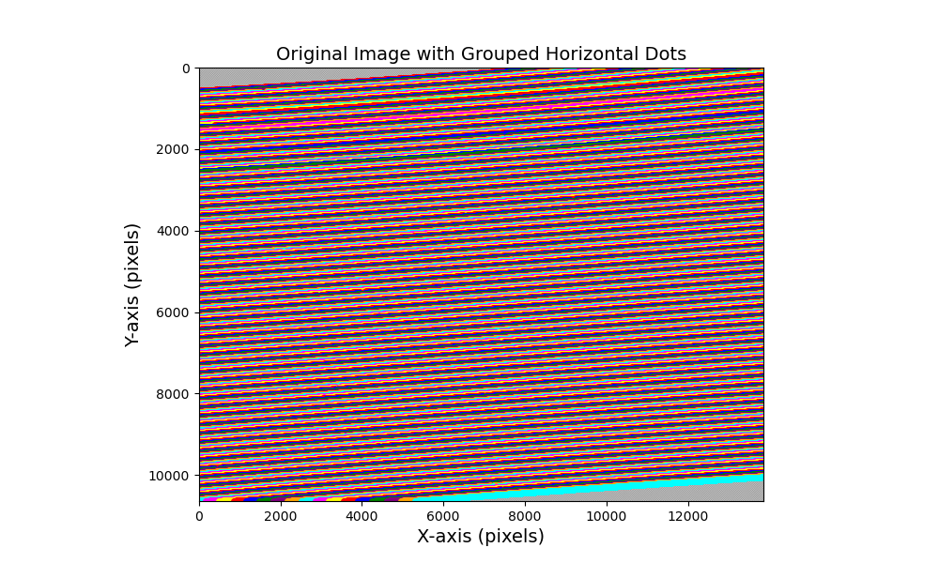

These figures displays the length of arrays in the grouped vertical and horizontal dots. The plot shows the number of dots in each line as a function of the line index (i). This shows that the grouping works due to the lines having similar lengths. However, some lines are shorter than expected which is due to some larger particles will cut of some of the grouped lines. I am working on optimizing this step.
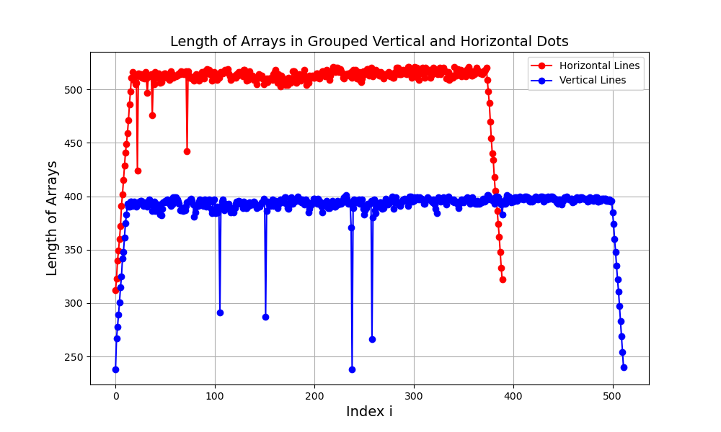

The two plots below show the residuals of the vertical and horizontal lines in the image before applying the distortion correction.
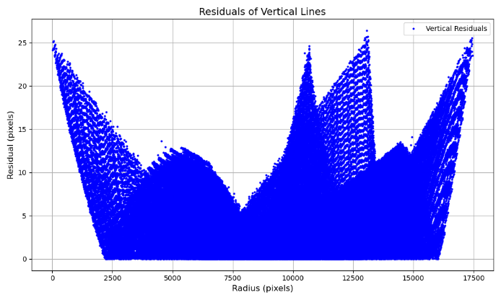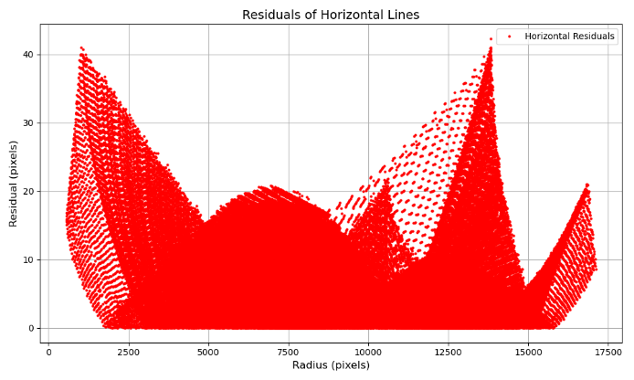

This figure shows the original image with the coarse center of distortion marked in red. The center of distortion is a critical reference point used to correct for the geometrical distortion caused by the lens.
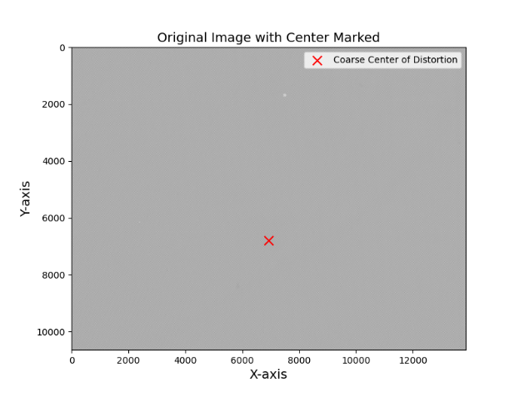
I use Discorpy’s Backward-from-Forward Function to calculate the distortion correction.
The function is detailed in: Radial lens distortion correction with sub-pixel accuracy for X-ray micro-tomography, by Nghia T. Vo.
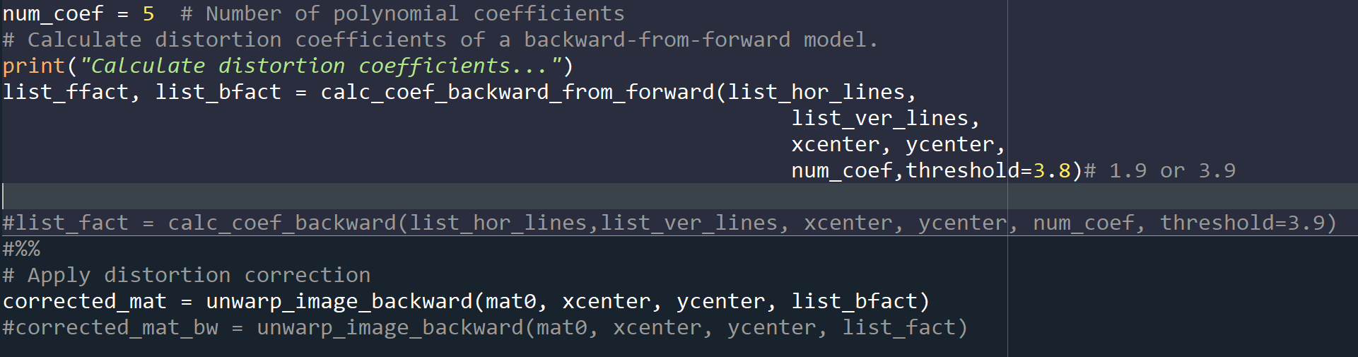
The correction works; however, the results are not at sub-pixel accuracy. Below image shows the difference between corrected and non-corrected checkerboard

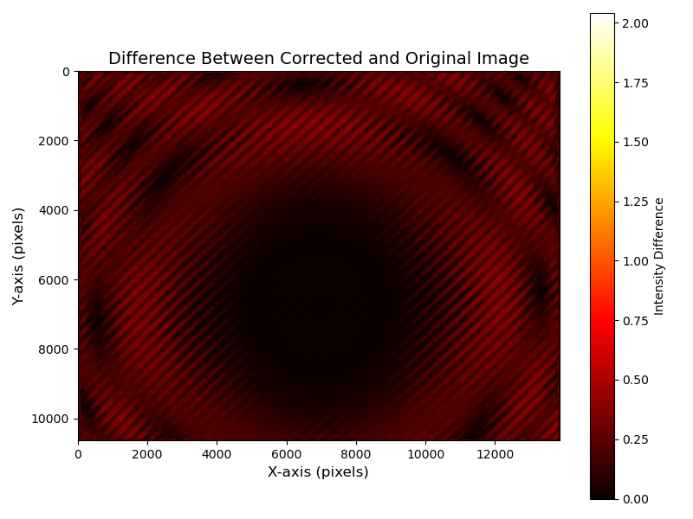

The two plots below show the residuals of the vertical and horizontal lines in the image after applying the distortion correction. The residuals are greatly reduced, but I am trying to improve this even further.

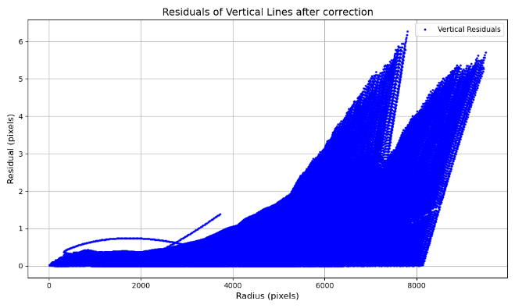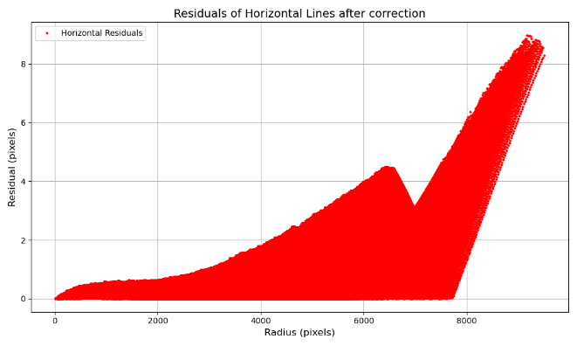

Below image shows the grouped vertical and horizontal lines before correction, each at three positions: near the Center of distortion, and near the edges. Both center lines are relatively straight, however the lines near the edges clearly highlights the barrel distortion.
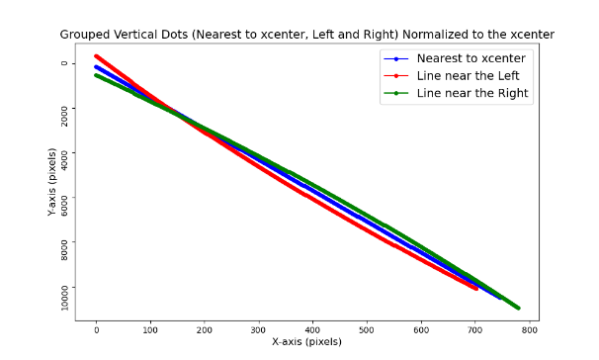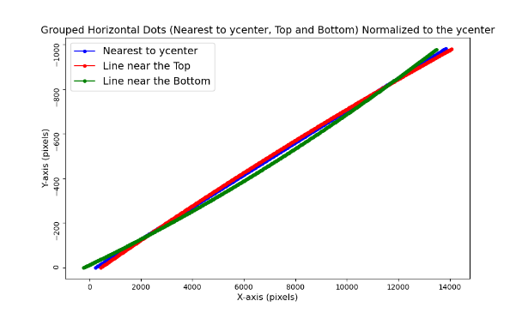
Below image shows the grouped vertical and horizontal lines after correction, each at three positions: near the Center of distortion, and near the edges. The correction has made the lines more parallel, showing the improvement using the correction model. However, the horizontal lines are less parallel. I will continue to improve on this.
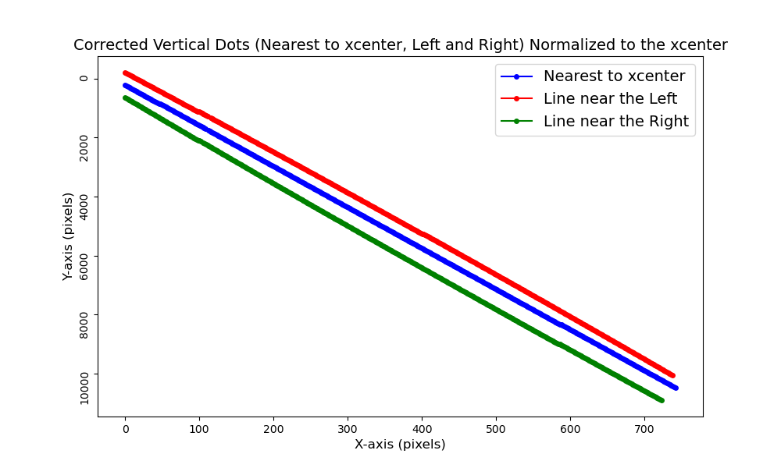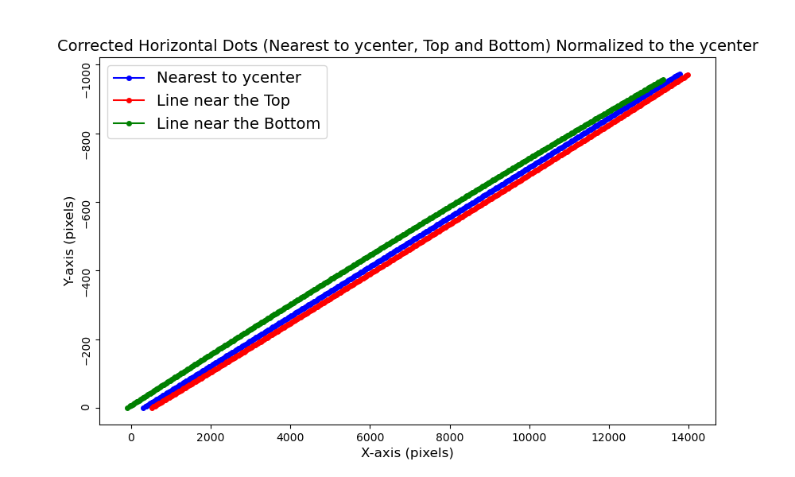

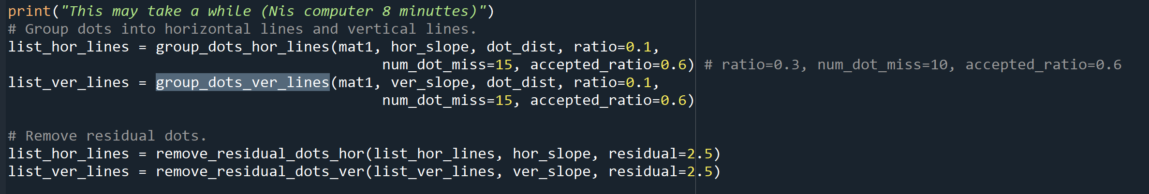
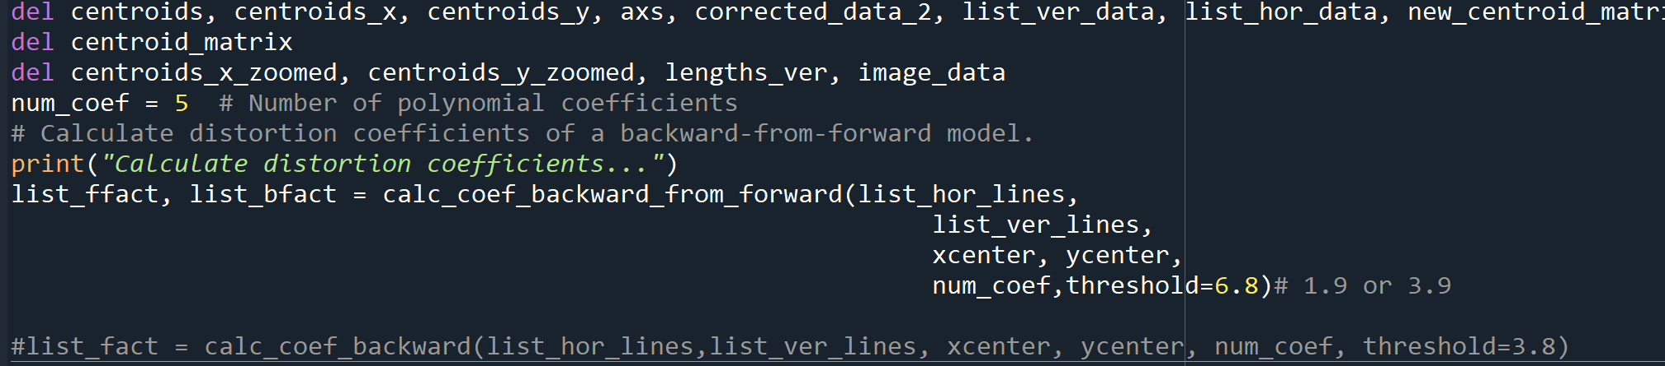

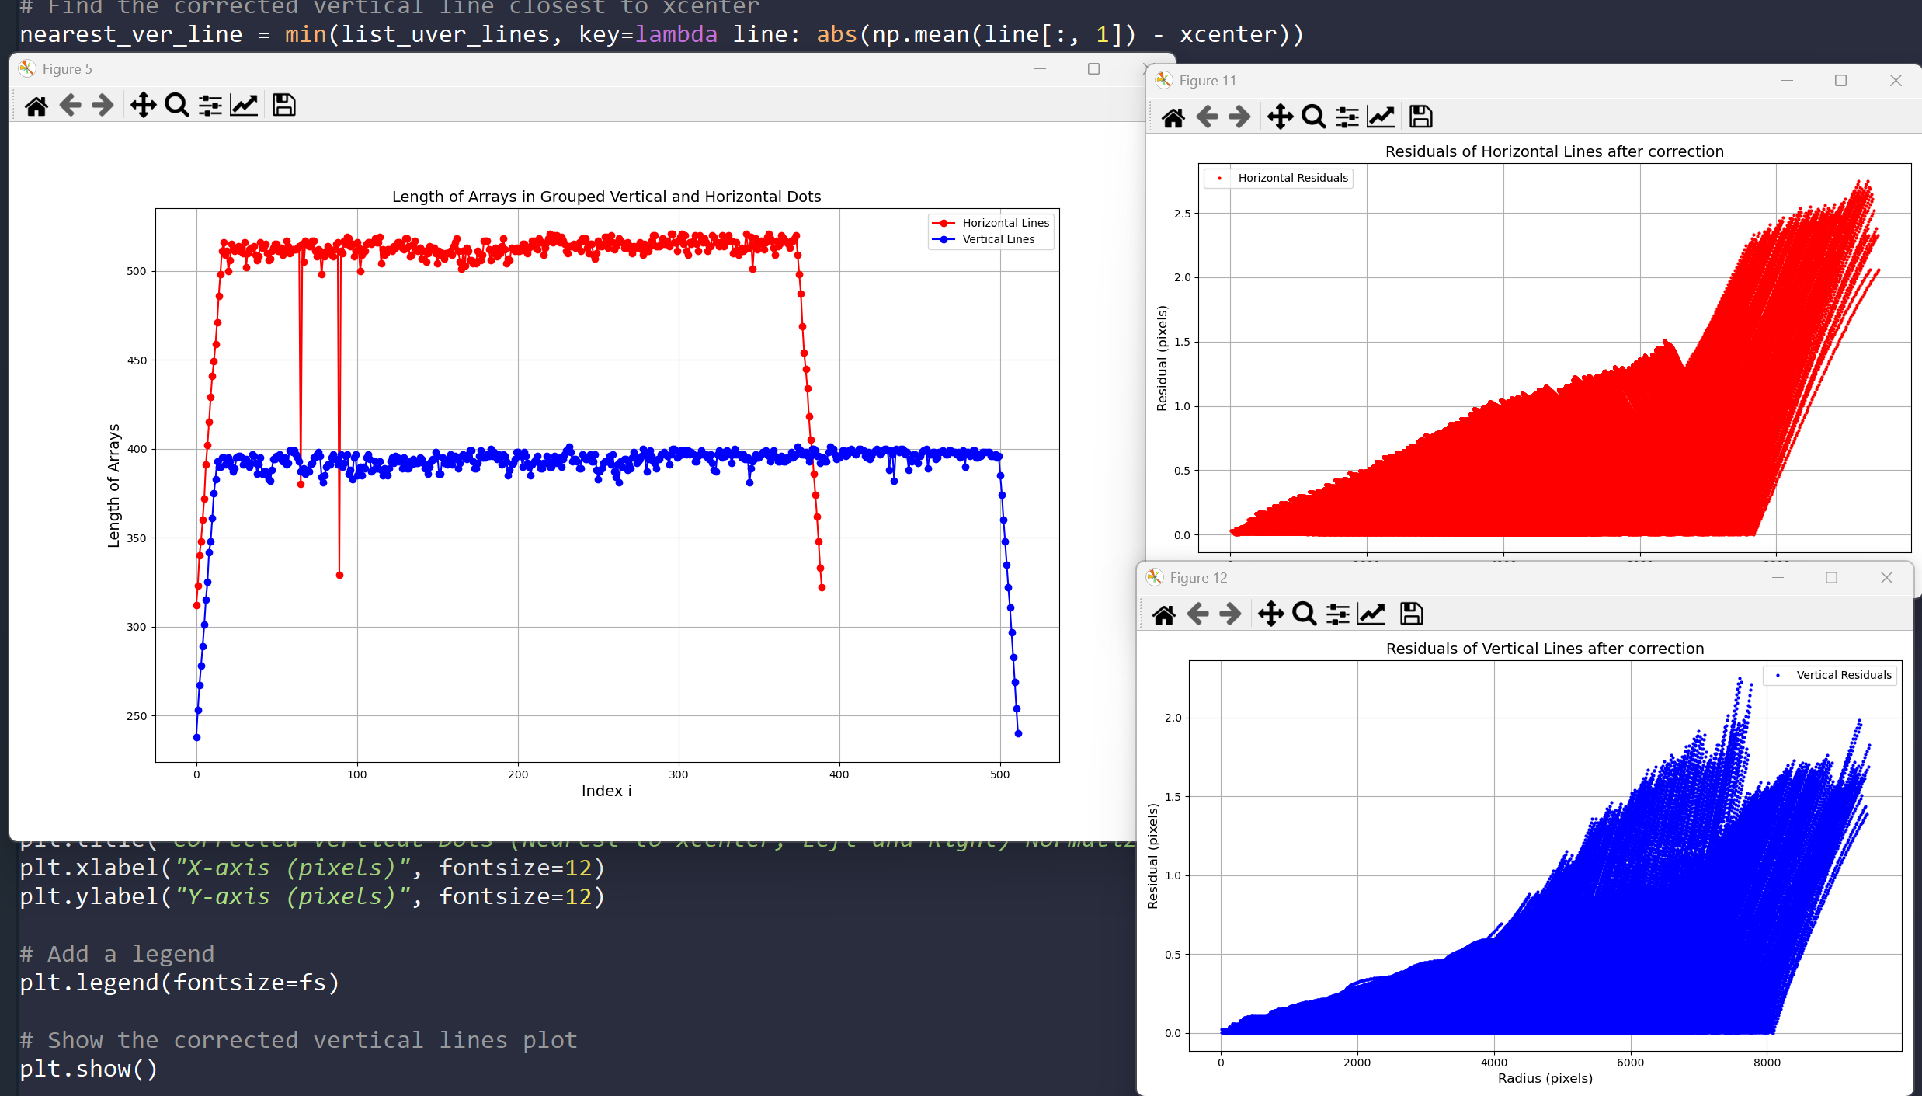
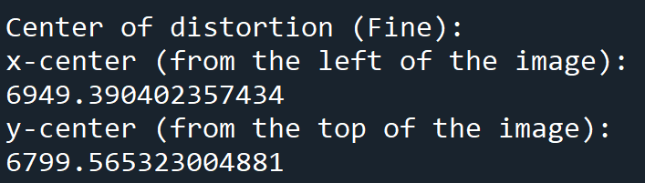

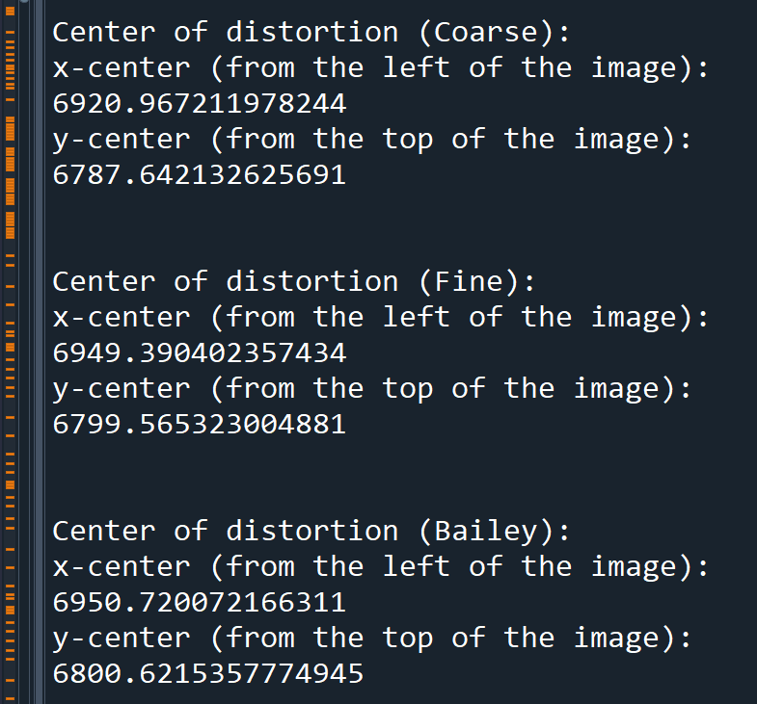
Using Bailey iterations=2
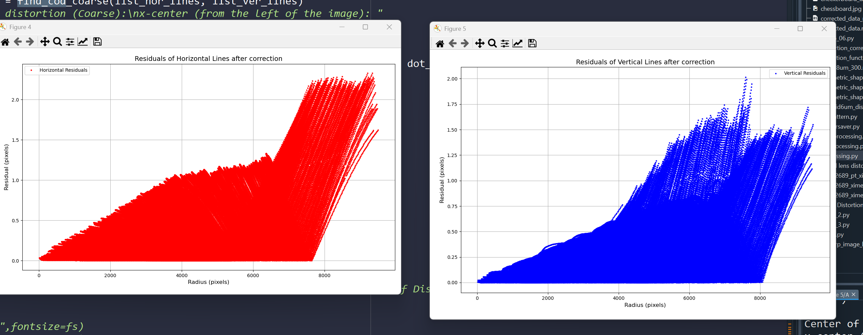

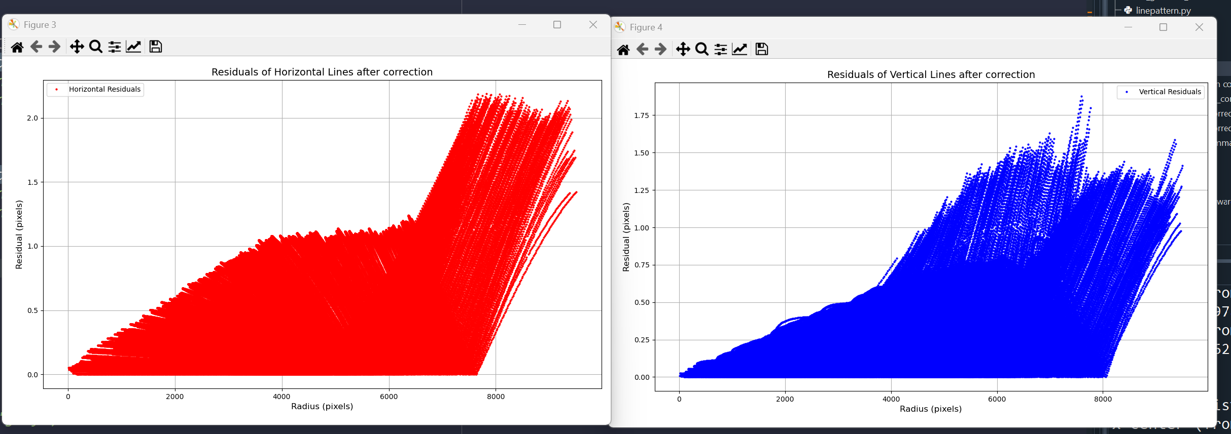
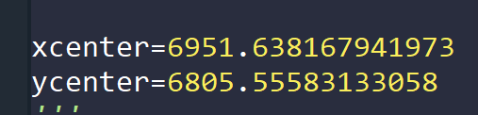

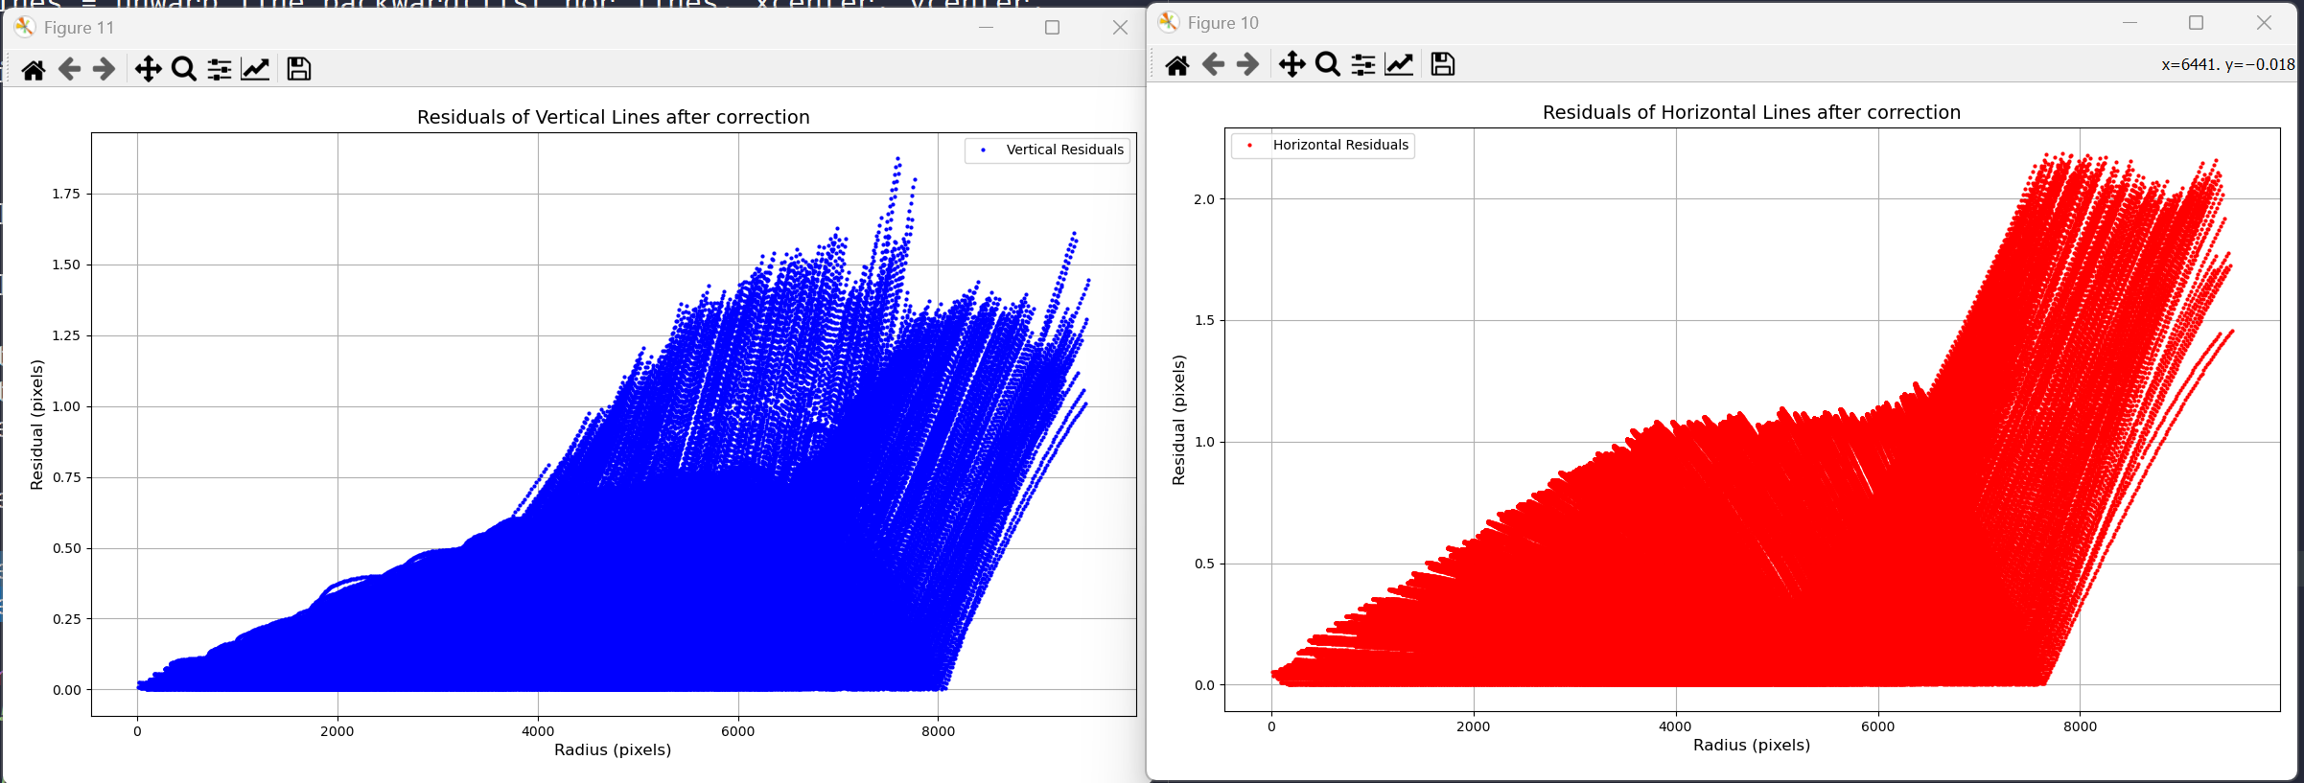
We have sub pixel accuracy!!
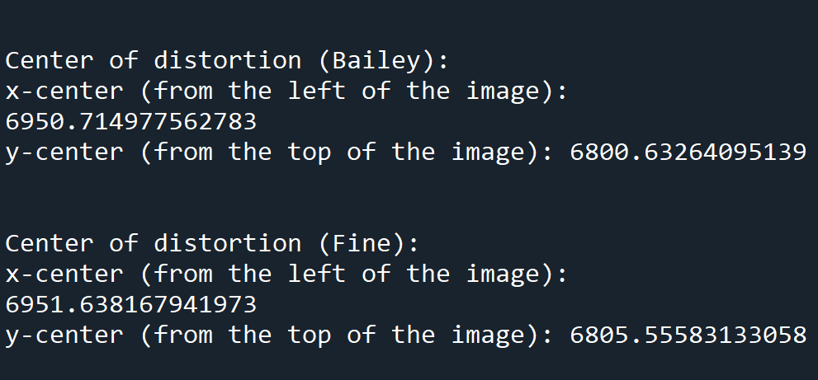

We have an issue with how long to distortion correction is going to take.
We have 14000 projections, each has to be corrected. Current method takes 18.2 seconds on Nis computer. This will alone take three days.
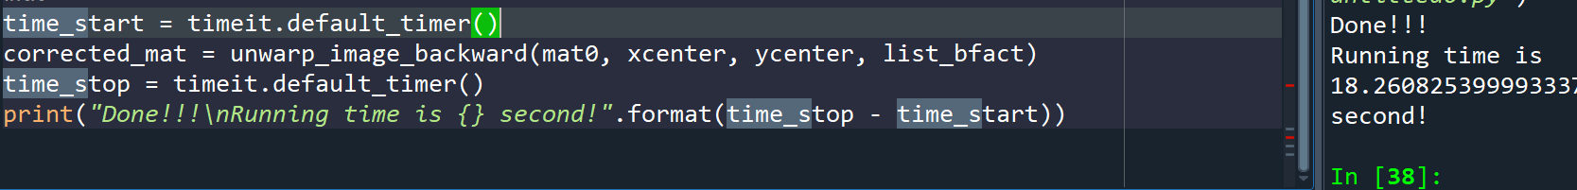

We are down to 4 seconds now
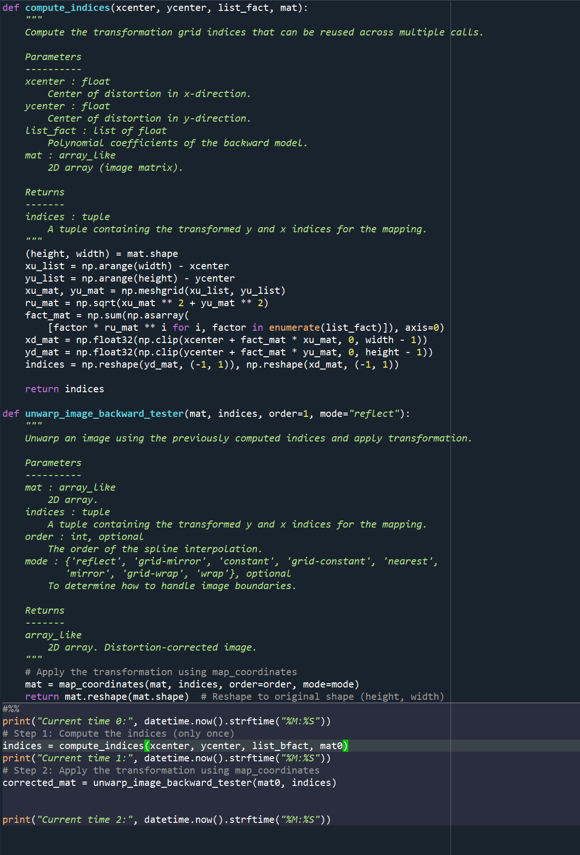

x