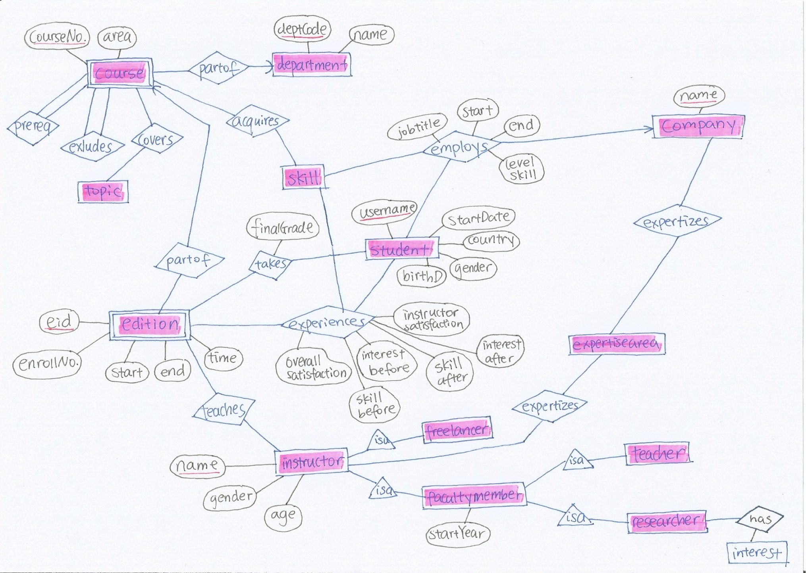

**CEA Database Schema**

**Department**(dept_code, name)

**Course**(dept_code, courseno, area)

Course.dept_code  Department.dept_code

**Covers**(dept_code, courseno, topic)

(Covers.depCode, Covers.courseNo)  (Course.depCode, Course.courseNo)

**Acquires**(dept_code, courseno, skill)

(Acquires.depCode, Acquires.courseNo)  (Course.depCode, Course.courseNo)

**Prereq**(dept_code, courseno, dept_code_exc, courseno_exc)

(Prereq.dept_code, Prereq.courseno)  (Course.dept_code, Course.courseno)

(Prereq.dept_code_exc, Prereq.courseno_exc)  (Course.dept_code, Course.courseno)

**Excludes**(dept_code, courseno, dept_code_exc, courseno_exc)

(Excludes.dept_code, Prereq.courseno)  (Course.dept_code, Course.courseno)

(Excludes.dept_code_exc, Excludes.courseno_exc)  (Course.dept_code, Course.courseno)

**Edition**(eid, dept_code, courseno, start_date, end_date, offer_time, enrollno)

(Edition.dept_code, Edition.courseno)  (Course.dept_code, Course.courseno)

//******* eid here is the primary key for course editions that we added here because we need to refer to this table a lot, eid can make it easier to refer to rather than typing all (dept_code, courseno, start_date, end_date, offer_time). Type of eid is formed by its *dept_code+courseno+season(F/S/Y based on start and end date)+offer_time(M/D/E based on time of the day)*: like CSC343FM/CSC309YE and it is unique. ********//

**Student**(sid, birth_month, birth_year, gender, country, start_month, start_year)

**Takes**(sid, eid, final_grade)

Takes.sid ⊆ Student.sid

Takes.eid ⊆ Edition.eid

**Experiences**(sid, eid, skill, skillBefore, skillAfter, overallSat, instrSat,

InterestBefore, InterestAfter)

(Experiences.sid, Experiences.eid) ⊆ (Takes.sid, Takes.eid)

**Instructor**(name, gender, age)

**Expertises_instr**(instr_name, expertise_area)

Expertises_instr.instrName ⊆ Instructor.name

**Freelancer**(name)

Freelancer.name ⊆ Instructor.name

**FacultyMember**(name, start_year)

FacultyMember.name ⊆ Instructor.name

**FacultyTeacher**(name)

[FacultyTeacher.name ⊆ Instructor.name]

**FacultyResearcher**(name)

FacultyResearcher.name ⊆ Instructor.name

**InterestedIn**(researcher_name, researcher_int)

InterestedIn.researcher_name ⊆ FacultyResearcher.name

**Teaches**(instr_name, eid)

Teaches.instr_name ⊆ Instructor.name

Teaches.eid ⊆ Edition.eid

**Employs**(company_name, sid, jobtitle, start_date, end_date, skill, sklevel)

Employs.sid ⊆ Student.sid

**Expertises_comp**(company_name, expertise_area)