**LUDUM DARE 41**

**THEME: Combine 2 incompatible genres**

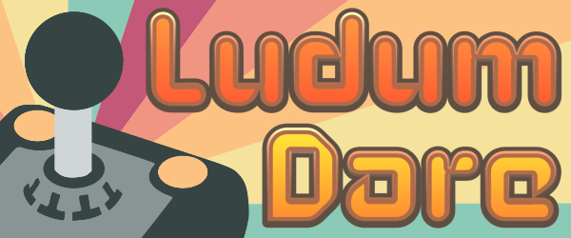

***general ideas***

***idea 1 :***

**Genre 1:**

*Platformer*

**Genre 2**

Fighting

**Story / story behind idea:**

You are a …. in a …. world where you have to fight enemies in a fighting genre like way.

With each fight you can progress a little further through the platformer like level

**Links applicable**

**https://en.wikipedia.org/wiki/Super_Smash_Bros.**

[**https://en.wikipedia.org/wiki/Platform_game**](https://en.wikipedia.org/wiki/Platform_game)

**idea 2:**

**Genre 1:**

Text bases game

**Genre 2:**

Shooter

**Story / Story behing idea:**

You are too complete a shooter game type level using a text based interface.

With text you are able to aim and or tell the player object where too shoot.

**Links applicable**

[**https://en.wikipedia.org/wiki/Text-based_game**](https://en.wikipedia.org/wiki/Text-based_game)

**https://en.wikipedia.org/wiki/Shooter_game**

**Idea 3:**

**Genre 1:**

Turned based

**Genre 2:**

Tower Defense

**Story / Story behind idea**

Your folks have to defend their town against angry Romans.

Each Turn your allowed to place a couple defensive or maybe offensive structures.

After each turn the game will spawn enemies these follow try and go for your town while your defense structures go ham on them.

**links applicable**

**https://en.wikipedia.org/wiki/Tower_defense**

**Final idea:**

Ludum dare theme:

Combine 2 incompatible genres

My idea

You are a …. in a …. world where you have to fight enemies in a fighting genre like way.

With each fight you can progress a little further through the platformer like level

Genre 1:

Platformer

Genre 2:

Fighting

***TODO :***

features :

- Base world ← in progess

- Can use mouse to aim and shoot

- Has a basic ability

- Basic enemy

- Upgrades?

done :

- Can use W,A,D to move – Note: can be fine tuned

CONTROLS

WAD: MOVE CHARACTER

LEFT CLICK : USE ABILITY

MOVE MOUSE: AIM ABILITY

SPACE : ACTIVATE ABILITY