Node.js Notes

npm install –g express

npm install –g express-generator

express name_of_app – creates app

next – cd name_of_app && npm install

to start – node app (may not work)

alternate to start – npm start

npm init – creates package file (empty)

Node Commands – type node and then file name or node to enter command mode

global –

process -

modules are units of functionality.

require – allows loading modules

nodejs.org/api – to get list of all modules

Instead of string concatenation

`Hello ${user.username} !`

Arrow Function () => does not bind this keyword or arguments array

module.exports.addNote = () => {};

//module.exports.addNote = function (){};

Requiring node packages

Npm install xxx – save will write value to jason config (save)

For require use the name from the jason file

const _ = require('lodash');

## NODEMON

Auto Restart Of App -- nodemon

* Command line util executed from terminal
* Need to tweek install command
  + npm install nodemon –g
  + to ‘run’ app - nodemon app.js (vs node app.js)
  + ctrl c to shut down

npm install [yargs@4.7.1](mailto:yargs@4.7.1) –save for parsing

* nodemon server.js –e js,hbs -- runs nodemon and watches for changes in all js & hbs extentions

## JSON stuff

To convert object to string - JSON.stringify(obj)

To convert string (in correct format) to JSON Obj – JSON.parse(string)

Format = ‘{“name”: “Darth”, “age”:25}’

## Express

Expressjs.com for the site

Init – to generate package.json

npm install express –save

create server.js file

const express = require('express');

var app = express(); //creates app

//route handlers

app.get('/', (req, res)=>{

res.send('hello express');

});

app.listen(3000);

app.get(‘url’, function(req, res)); -- always need req – request & res - response

app.listen(3000) binds to port 3000 and starts listener…

nodemon server.js

referencing static pages in a diff folder

app.use(express.static(__dirname + '/public'));

Handlebars view engine

handlebarsjs.com npmjs.com/package/hbs

npm install hbs –save

app.use()

## GIT

Installing GIT goto - git-scm.com

* git init - executed from root of project creates a .git directory inside of folder
* git status – lists untracked files
* git add ‘file name’ adds file to initial commit
* git add ‘dir/’ – for adding a directory

in root add .getignore file and list files / directories to ignore.

Commit – must have change and create message

* git commit –m ‘some message here’ -m for message

To get back files???

## Pushing local repository to github

SSH Keys – designed to communicate between two computers

Use GetBash window for windows machine (only works in GetBash)git.

1 Check for existing SSH key

* ls – al ~/.ssh to find file

2 To generate

* ssh-keygen –t rsa –b 4096 –C ’nigeldkat@hotmail.com’
  + Creates files
    - Id_rsa – do not give out
    - Id_rsa.pub – public to share

3 Start SSH Agent

* eval “$(ssh-agent -s)” -- start agent
  + this should return Agent pid value

4 Tell agent where key lives

* ssh-add ~/.ssh/id_rsa -- tell where key is
  + returns Identity Added

## Registering in GitHub

Create new key

* Profile
* New SSH
* Clip < ~/.ssh/id_rsa.pub to copy public key to clipboard and paste in github

To confirm from window

* ssh –T [git@github.com](mailto:git@github.com)
  + reply ‘the authentic… of host can not be confirmer’
  + YES
  + Reply hi xxxx

Go back to home page

* Chose Create New Repository
  + Git will create commands to run
    - git remote add origin https://github.com/nigeldkat/node-course-2-web-server.git
    - git push -u origin master

second command will be used a lot to push code. First command creates remote

After making changes…

* git status – shows changes
* get add . – stages changes
* git commit –m ‘setup start script’ – commits changes
* git push – pushes to github

## Deploy to heroku.com

Create account.

Download stuff from toolbelt.heroku.com for deployment and install.

heroku –-help for info

TO login locally

* heroku login

To add keys

* heroku keys:add

To show keys on account

* heroku keys

To remove

* heroku keys remove emailrelated

To test

* ssh –v [git@heroku.com](mailto:git@heroku.com)
  + look to see ‘Authentication succeeded (publickey)

To deploy from git

* heroku create – creates new project and remote to heroku
  + https://serene-wave-14812.herokuapp.com/ | https://git.heroku.com/serene-wave-14812.git
* git push heroku – push to heroku
  + https://serene-wave-14812.herokuapp.com/ deployed to Heroku
* heroku open – opens app

## Code Changes Prior to Deployment

Mod package.json

"scripts": {

"test": "echo \"Error: no test specified\" && exit 1",

"start": "node server.js"

},

Mod in startup code

const port = process.env.PORT || 3000; //get environment var or defaults if none found

app.listen(port, ()=> {

console.log(`Server is up on port ${port}`);

});

## MongoDB

Installing locally

* MongoDB.com
* <https://www.mongodb.com/download-center#community>

Running server

* Use command prompt (not git bash) C:\Program Files\MongoDB\Server\3.6\bin
* Create data directory (if first time setting up)
* C:\Program Files\MongoDB\Server\3.6\bin>mongod.exe --dbpath C:\Users\vogelr\Documents\MongoDB-Data
* If successful get
  + waiting for connections on port 27017

Connecting

* Use command prompt (not git bash) C:\Program Files\MongoDB\Server\3.6\bin
* Run mongo.exe

Simple test

> db.Todos.insert({text: 'create something'})

WriteResult({ "nInserted" : 1 })

>

> db.Todos.find()

{ "_id" : ObjectId("5aa7d6333ad82208064c90cb"), "text" : "create something" }

>

## RoboDB

Install from robomongo.org

Default steps to connect to new db

## SQL db vs NoSQL db

* SQL DB
  + Tabel
    - Row
      * Column - all rows have same columns
* No SQL DB
* Collection
  + Document
    - Field or Properties – can vary

## Connecting Node to MongoDB

Node mongodb native

<https://github.com/mongodb/node-mongodb-native>

npm install mongodb –save

## Mongoose

Mongoose.js.com

* Npm install mongoose --save

## Postman

Getpostman.com

For post

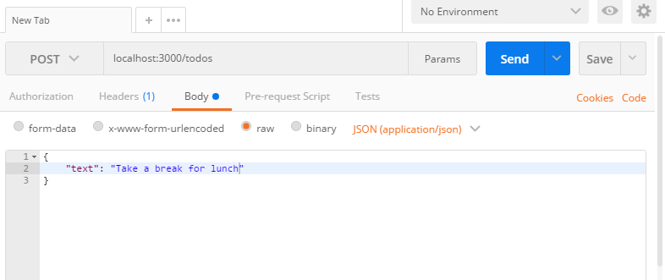

## Body-Parser

Creates Jason npm I body-parser

