

SC5010 Introduction to Data Analysis

TEL2 Group 1

Group Member Name | Matriculation Number | Contributions
Brad Lee | U2130355E | 25%
Cheng Jun Long Brandon | U2222813C | 25%
Nicolas Chan Han Hui | U2230785E | 25%
Nigel Max Wee Yaohan | U2221718B | 25%

Table of Contents
1. Introduction 3
2. Data Description 5
3. Data Preprocessing 5
3.1 Handling Invalid or Zero Values 5
3.2 Outlier Detection and Removal 6
3.3 Feature Scaling 6
3.4 Class Imbalance Handling 7
4. Model Selection & Training 7
5. Hyperparameter Tuning 9
5.1 Tuned Models and Search Spaces 9
5.2 Tuned Performance Summary 10
5.3 ROC Curve Analysis 10
6. Model Interpretation 11
6.1 Decision Tree Visualization 11
6.2 Feature Importance Analysis 12
7. Unsupervised Analysis 13
7.2 Cluster Interpretation and Diabetes Risk 15
8. Insights & Conclusions 15
9. Future Works 16
References 18
Appendix 19

Introduction
Diabetes is a growing public health concern that significantly increases the risk of cardiovascular disease, kidney failure, and other complications. Early detection is critical, particularly for identifying pre-diabetic individuals who are at elevated risk but may still benefit from timely intervention.
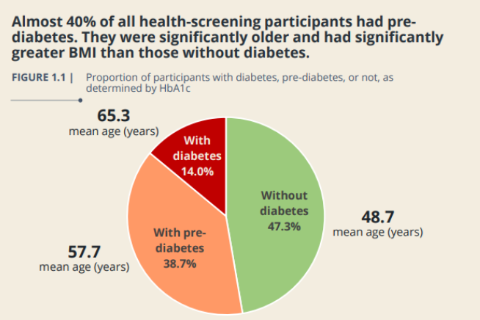
Figure 1.1: Proportion of Participants by Diabetes Status and Corresponding Mean Ages [1]
According to recent NUS IPR health screening data [1], almost 40% of participants were found to have pre-diabetes, and 14% had diabetes, as determined by HbA1c levels (Figure 1.1). Notably, participants with diabetes or pre-diabetes were on average significantly older and had higher BMI than those without the condition — reinforcing the link between metabolic health indicators and diabetes risk.
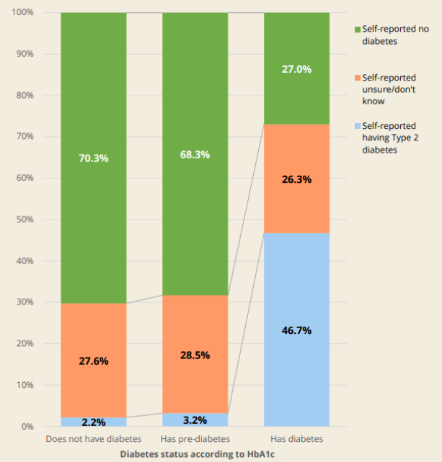
Figure 1.2: Self-Reported Diabetes Awareness vs. Actual Diabetes Status (HbA1c-Based) [1]
Furthermore, Figure 1.2 highlights that a substantial proportion of individuals with diabetes were unaware of their condition: only 46.7% self-reported having Type 2 diabetes, while over 50% either did not know or incorrectly believed they were non-diabetic. This gap underscores the importance of tools that can proactively identify at-risk individuals.
With the increasing availability of medical data, machine learning (ML) offers promising tools for building predictive models that can assist in early identification of diabetes risk. These models can uncover complex patterns in patient data and provide fast, data-driven predictions to support clinical decision-making.
This project aims to develop and evaluate classification models for diabetes prediction using the Pima Indians Diabetes Database, a commonly used benchmark dataset. The study focuses on:
- Improving predictive performance through data preprocessing,
- Identifying the most effective ML classification models for this task, and
- Interpreting model predictions using feature importance and clustering to uncover patient subgroups for potential risk stratification.

Data Description
This study uses the Pima Indians Diabetes Database [2], a well-established dataset from the UCI Machine Learning Repository. It contains 768 records of female patients aged 21 years and older of Pima Indian heritage, a population known to be at high risk for Type 2 diabetes.
Each record includes 8 clinical input features and 1 binary outcome variable, as follows:
Feature | Description
Pregnancies | Number of times the patient has been pregnant
Glucose | Plasma glucose concentration 2 hours after an oral glucose tolerance test
BloodPressure | Diastolic blood pressure (mm Hg)
SkinThickness | Triceps skinfold thickness (mm)
Insulin | 2-hour serum insulin (μU/mL)
BMI | Body mass index (weight in kg/(height in m²))
DiabetesPedigreeFunction | A function representing family history of diabetes
Age | Patient’s age in years
Outcome | Target variable: 1 = diabetic, 0 = non-diabetic

The dataset is widely used for benchmarking binary classification algorithms and provides a balanced mix of physiological and lifestyle-related indicators. However, some features such as Insulin and SkinThickness contain zero values, which may represent missing or biologically implausible entries, making data preprocessing a critical step for improving model reliability.

Data Preprocessing
To ensure the accuracy and robustness of our predictive models, several preprocessing steps were applied to clean and prepare the dataset:

Handling Invalid or Zero Values
Certain physiological measurements (including Insulin, SkinThickness, BMI, and Glucose) contained zero values, which are biologically implausible and likely represent missing data. Instead of removing these samples, we replaced the zero values with the median of each feature, calculated separately for diabetic and non-diabetic groups (i.e., outcome-specific median imputation).

Outlier Detection and Removal
We applied a combination of Z-score and Interquartile Range (IQR) filtering to detect and remove extreme outliers:
- Z-score filtering (threshold = ±3) was applied to features that were approximately normally distributed, as determined by skewness values close to zero.
- IQR filtering (threshold = 1.5 × IQR) was used for skewed features that exhibited a higher number of extreme values.
This hybrid approach allowed us to tailor outlier detection to the distribution of each feature, preserving useful data while minimizing the impact of anomalies.
After outlier removal, the dataset was reduced from 768 to 667 valid samples.

Feature Scaling
Since many machine learning algorithms are sensitive to feature magnitude — especially distance-based models like K-Nearest Neighbors and Support Vector Machines — we applied feature scaling to standardize the input data.
Several scaling techniques were evaluated, including:
- Min-Max Scaler [3] (scales values to a [0, 1] range),
- Robust Scaler [4] (based on median and IQR, resistant to outliers), and
- Hybrid approaches tailored to specific features.
After comparison, we found that StandardScaler [5], which transforms features to have a mean of 0 and standard deviation of 1, consistently produced the best overall performance across models.
To avoid data leakage, the scaler was fit only on the training data, and the same transformation was applied to the test set.

Class Imbalance Handling
The dataset exhibited a mild class imbalance, with approximately 65% non-diabetic (class 0) and 35% diabetic (class 1) samples. Imbalanced datasets can lead to biased models that favor the majority class, especially in medical contexts where correctly identifying the minority class (diabetic patients) is critical.
To address this, we applied the Synthetic Minority Over-sampling Technique (SMOTE) [6] to the training set only. SMOTE generates synthetic samples for the minority class by interpolating between existing samples, helping the model better learn the minority decision boundary.
After applying SMOTE, the training set was fully balanced, with a 50:50 ratio between diabetic and non-diabetic classes. This improved model generalization and reduced bias toward the majority class in our evaluation metrics.

Model Selection & Training
To evaluate the effectiveness of different machine learning algorithms in predicting diabetes, we tested a total of 10 classification models, ranging from simple linear methods to advanced ensemble techniques. All models were trained on the preprocessed and SMOTE-balanced training set and evaluated on the scaled test set using a consistent set of performance metrics.
The following 10 classification models were evaluated to determine the most effective approach for diabetes prediction:
- Logistic Regression
- Support Vector Machine (SVM)
- K-Nearest Neighbors (kNN)
- Decision Tree
- Naive Bayes
- Multi-layer Perceptron (ANN)
- Random Forest
- AdaBoost
- Gradient Boosting
- XGBoost
To establish a fair baseline, each model was initially trained using default hyperparameters provided by the scikit-learn (or XGBoost) implementation. This allowed for a consistent comparison of model performance before fine-tuning.
We assessed each model using the following classification metrics:
- Accuracy – overall correctness of the model
- Precision – proportion of positive predictions that were correct
- Recall – proportion of actual positives correctly identified
- F1-score – harmonic mean of precision and recall
- AUC (Area Under ROC Curve) – the model's ability to distinguish between classes
Given the medical context of the task, recall and F1-score were prioritized to reduce false negatives while maintaining overall balance.
Table 4.1: Performance Comparison of 10 Machine Learning Models on the Diabetes Test Set, Sorted by F1-Score.
Model | Accuracy | Precision | Recall | F1-Score | AUC
AdaBoost | 0.925373 | 0.923077 | 0.837209 | 0.878049 | 0.961283
Random Forest | 0.91791 | 0.880952 | 0.860465 | 0.870588 | 0.949655
XGBoost | 0.91791 | 0.921053 | 0.813953 | 0.864198 | 0.967544
Gradient Boosting | 0.910448 | 0.897436 | 0.813953 | 0.853659 | 0.967289
ANN (MLPClassifier) | 0.902985 | 0.875 | 0.813953 | 0.843373 | 0.92231
SVM | 0.88806 | 0.804348 | 0.860465 | 0.831461 | 0.90161
Naive Bayes | 0.880597 | 0.787234 | 0.860465 | 0.822222 | 0.917199
kNN | 0.873134 | 0.782609 | 0.837209 | 0.808989 | 0.907105
Logistic Regression | 0.865672 | 0.777778 | 0.813953 | 0.795455 | 0.89931
Decision Tree | 0.850746 | 0.794872 | 0.72093 | 0.756098 | 0.816509

Among the 10 models evaluated, ensemble-based methods demonstrated superior performance.
As shown in Table 4.1, the top 3 models based on F1-score and AUC were:
- AdaBoost (F1 = 0.878, AUC = 0.961)
- Random Forest (F1 = 0.871, AUC = 0.950)
- XGBoost (F1 = 0.864, AUC = 0.968)
These models consistently achieved high recall and balanced precision, making them particularly well-suited for minimizing false negatives in a medical context.

Hyperparameter Tuning
After identifying AdaBoost, Random Forest, and XGBoost as the top-performing models from the baseline comparison, we proceeded to fine-tune their hyperparameters to further improve predictive performance.
To ensure a consistent and efficient search, we used Bayesian Optimization via the BayesSearchCV function from the scikit-optimize library [7]. Unlike grid or random search, Bayesian optimization uses past evaluation results to model the performance landscape and select the next set of parameters more intelligently.
A 5-fold Stratified Cross-Validation was used for all tuning procedures, and AUC (Area Under the ROC Curve) was chosen as the primary scoring metric.

Tuned Models and Search Spaces
- AdaBoost
  - Tuned: n_estimators, learning_rate
  - Best Validation AUC: 0.9582
- Random Forest
  - Tuned: n_estimators, max_depth, min_samples_split, min_samples_leaf, max_features, bootstrap, min_impurity_decrease, max_leaf_nodes
  - Best Validation AUC: 0.9636
- XGBoost
  - Tuned: n_estimators, max_depth, learning_rate, subsample, colsample_bytree
  - Best Validation AUC: 0.9694

Tuned Performance Summary
Table 5.1: Performance Comparison of Top 3 Models Before and After Hyperparameter Tuning
Model | Accuracy | Precision | Recall | F1-Score | AUC
AdaBoost | 0.925373 | 0.923077 | 0.837209 | 0.878049 | 0.961283
Random Forest | 0.91791 | 0.880952 | 0.860465 | 0.870588 | 0.949655
XGBoost | 0.91791 | 0.921053 | 0.813953 | 0.864198 | 0.967544
Tuned AdaBoost | 0.932836 | 0.925 | 0.860465 | 0.891566 | 0.967289
Tuned Random Forest | 0.925373 | 0.883721 | 0.883721 | 0.883721 | 0.960133
Tuned XGBoost | 0.91791 | 0.921053 | 0.813953 | 0.864198 | 0.971122

After tuning, all three models showed improvement, with Random Forest achieving the highest recall (0.884) and F1-score (0.884), alongside an AUC of 0.960, making it the final model selected for further interpretation and analysis.
A full comparison of the tuned results is provided in Table 5.1.

ROC Curve Analysis
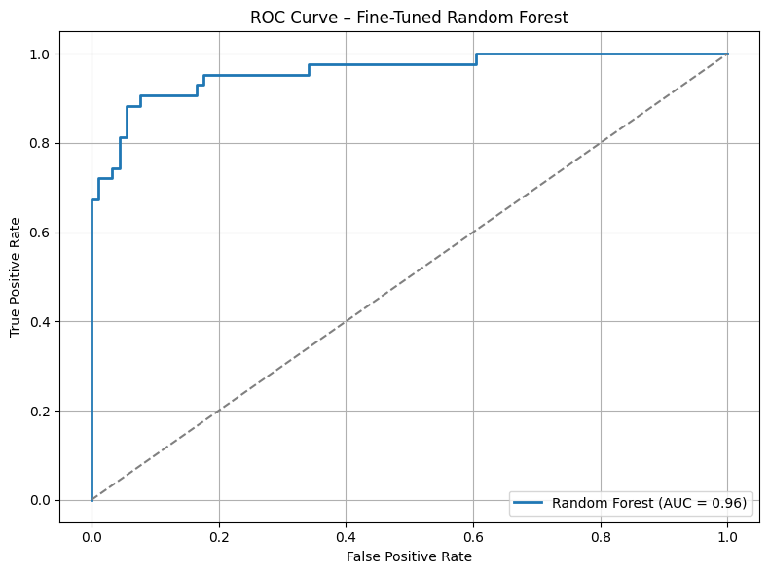
Figure 5.1: ROC Curve of the Fine-Tuned Random Forest Model (AUC = 0.960)
The Receiver Operating Characteristic (ROC) curve illustrates the trade-off between sensitivity (true positive rate) and specificity (1 - false positive rate) at various classification thresholds.
As shown in Figure 5.1, the Random Forest model achieved an AUC of 0.960, with the curve closely hugging the top-left corner. This reflects the model’s excellent ability to distinguish between diabetic and non-diabetic cases across thresholds, a critical property for clinical prediction tasks.

Model Interpretation

Decision Tree Visualization
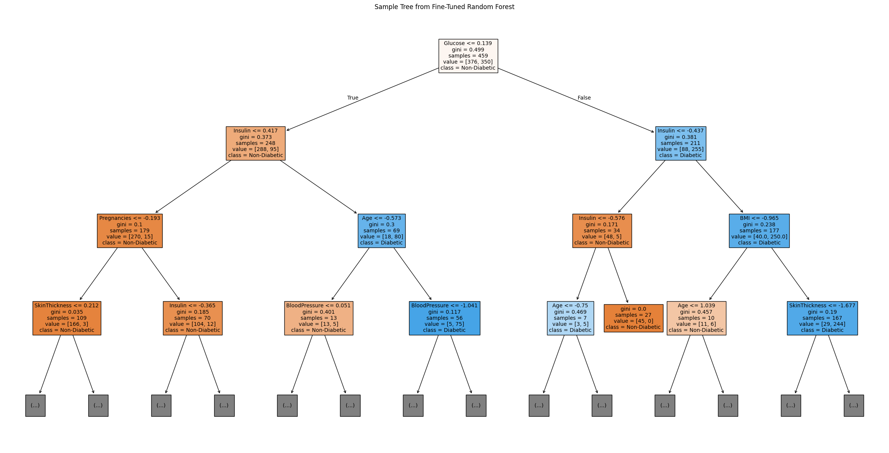
Figure 6.1: Visualization of a Single Decision Tree from the Fine-Tuned Random Forest Illustrates how features such as Glucose, BMI, and Age are used for node splitting and prediction, providing insight into the model's internal decision logic.
Although Random Forest is an ensemble of many trees, we visualized a single representative decision tree to illustrate how individual predictions are made (Figure 6.1).
This tree shows how features such as Glucose, BMI, and Age influence node splitting and class decisions. While it doesn’t capture the full complexity of the ensemble, it provides insight into the model’s internal logic.

Feature Importance Analysis
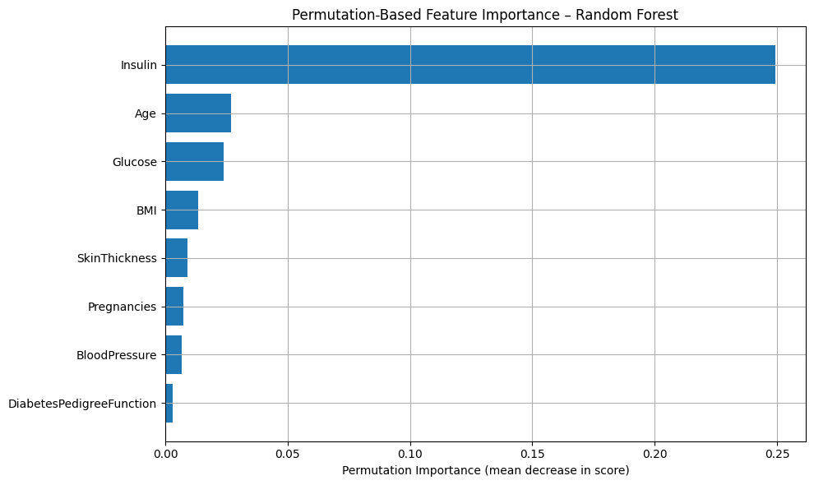
Figure 6.2: Permutation-Based Feature Importance of the Fine-Tuned Random Forest Model
Permutation-Based Importance [8] (Figure 6.2): This method ranks features based on how much shuffling them reduces the model's performance. Insulin, Age, and Glucose were the top features based on AUC drop.

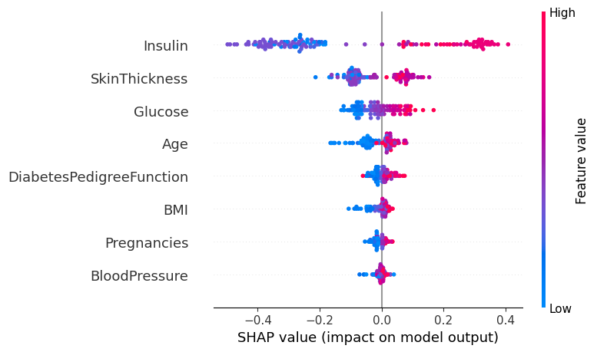
Figure 6.3: SHAP Summary Plot for the Fine-Tuned Random Forest Model. Visualizes the impact of each feature on individual predictions.
SHAP Values [9] (Figure 6.3): SHAP provides a more detailed breakdown of how each feature affects predictions at the individual level.
Notably, Insulin showed a clear separation: high values consistently pushed predictions toward the diabetic class, while low values reduced the likelihood of a positive prediction. This directional effect was also observed, to a lesser extent, for Glucose and Skin Thickness.

Unsupervised Analysis
To complement our supervised learning approach, we applied unsupervised clustering on the top features identified by our model (Insulin, Glucose, and Skin Thickness) to explore underlying patient groupings and support risk-based stratification.

  - KMeans Clustering
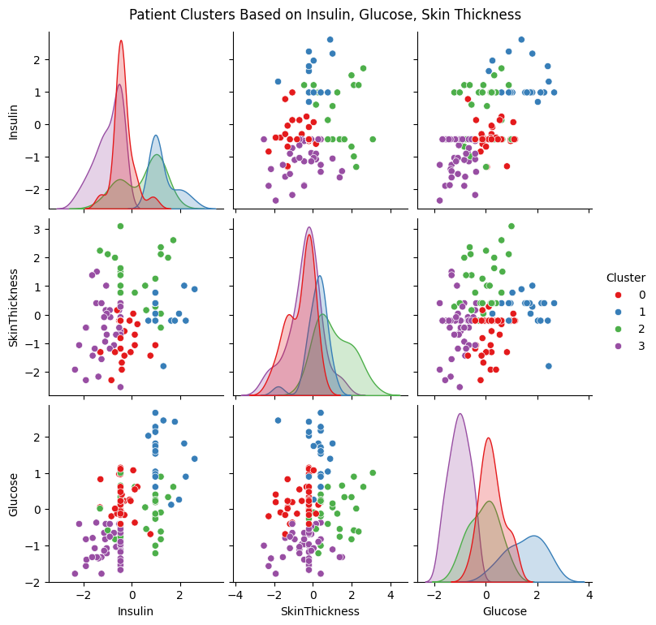
Figure 7.1: KMeans Clustering Results Using Top 3 Features (Insulin, Glucose, Skin Thickness). Shows 4 distinct clusters formed based on metabolic indicators. Initial separation is visible, particularly along Insulin and Glucose dimensions.
We applied the KMeans algorithm with k = 4 clusters on the test set using the scaled values of the top 3 features. The choice of k = 4 was informed by prior testing using the Elbow and Silhouette methods, which indicated that this value offered a good balance between cluster compactness and separation.
As visualized in Figure 7.1, the clusters showed reasonable separation, particularly along Insulin and Glucose dimensions. These groupings suggest that distinct patient profiles exist based on metabolic indicators, even without access to labels.

Cluster Interpretation and Diabetes Risk
To assess clinical relevance, we mapped the true diabetes outcomes back onto each cluster. The results are summarized in Table 7.1:
Cluster | Count | Diabetes Rate | Interpretation
0 | 37 | 13.50% | Likely non-diabetic cluster with relatively normal metabolic indicators
1 | 22 | 86.40% | Likely diabetic patients with elevated Glucose and Insulin (possibly insulin-resistant group)
2 | 30 | 53.30% | Mixed-risk group, possibly pre-diabetics with elevated Insulin with moderate Glucose
3 | 45 | 6.70% | Very low-risk cluster, metabolically healthy patients
Table 7.1: Cluster-Level Summary of Diabetes Rates and Interpretations

As shown in the Glucose vs. Insulin scatter plot (Figure 7.1), Cluster 1 dominates the upper-right region (high Glucose and Insulin), aligning with its high diabetes rate.
In contrast, Cluster 3 is concentrated in the lower-left, reflecting healthy metabolic profiles. Cluster 0 is more centralized, suggesting average risk, while Cluster 2 spans moderate values, potentially indicating transitional or pre-diabetic states.

Insights & Conclusions
This study demonstrated the effectiveness of using machine learning for early diabetes prediction, supported by both performance metrics and interpretability analyses. The key insights are as follows:
Robust data preprocessing (including outlier handling, outcome-specific median imputation, scaling, and SMOTE balancing) played a crucial role in enabling accurate model performance.

Out of 10 models evaluated, the top 3 were ensemble methods: AdaBoost, Random Forest, and XGBoost. After hyperparameter tuning, Random Forest was selected as the final model for its strong balance of performance and interpretability, achieving:
- F1-score: 0.884
- Recall: 0.884
- AUC: 0.960
Model interpretation using permutation importance and SHAP values revealed Insulin, Skin Thickness, and Glucose as the most influential features in diabetes prediction. SHAP also provided individual-level insights into how these features contributed to model output.
KMeans clustering on the top 3 features uncovered 4 distinct patient groups, with diabetes rates ranging from 6.7% to 86.4%, highlighting the potential for targeted risk stratification based on metabolic profiles.
In conclusion, our approach not only achieved high predictive performance but also provided interpretable insights that could support personalized screening and early intervention in clinical settings.

Future Works
- Larger and More Diverse Datasets
Deep learning models such as neural networks typically require large amounts of data to generalize well. While our dataset was sufficient for traditional ML models, future work could involve training on larger, more diverse datasets to unlock the potential of deep learning architectures and improve model robustness across different populations.
- Domain-Specific Feature Engineering
We explored clinically informed feature transformations, such as categorizing Glucose, BMI, Blood Pressure, and Insulin into medically defined categories. For example:
- Glucose values were grouped into:
  - Normal: < 100
  - Prediabetes: 100–125
  - Diabetes: ≥ 126
- BMI values were grouped into:
  - Underweight: < 18.5
  - Healthy: 18.5–24.9
  - Overweight: 25.0–29.9
  - Obese: ≥ 30
However, these engineered categorical features did not lead to performance improvements, suggesting that the ensemble models were already effective at extracting relevant patterns from the raw continuous values. This highlights the strength of tree-based models in handling numerical clinical data without requiring manual binning or domain-specific discretization.

References
[1] “Diabetes Perception Report - Perception of Health Screening Participants in Singapore (2024) - NUS Institute for the Public at Risk - Diabetes SG.” Accessed: Apr. 30, 2025. [Online]. Available: https://www.diabetes.org.sg/resource/diabetes-perception-report-perception-of-health-screening-participants-in-singapore-2024-nus-institute-for-the-public-at-risk/
[2] “Pima Indians Diabetes Database.” Accessed: Apr. 30, 2025. [Online]. Available: https://www.kaggle.com/datasets/uciml/pima-indians-diabetes-database
[3] “MinMaxScaler,” scikit-learn. Accessed: Apr. 30, 2025. [Online]. Available: https://scikit-learn/stable/modules/generated/sklearn.preprocessing.MinMaxScaler.html
[4] “RobustScaler,” scikit-learn. Accessed: Apr. 30, 2025. [Online]. Available: https://scikit-learn/stable/modules/generated/sklearn.preprocessing.RobustScaler.html
[5] “StandardScaler,” scikit-learn. Accessed: Apr. 30, 2025. [Online]. Available: https://scikit-learn/stable/modules/generated/sklearn.preprocessing.StandardScaler.html
[6] “SMOTE — Version 0.13.0.” Accessed: Apr. 30, 2025. [Online]. Available: https://imbalanced-learn.org/stable/references/generated/imblearn.over_sampling.SMOTE.html
[7] “skopt.BayesSearchCV — scikit-optimize 0.8.1 documentation.” Accessed: Apr. 30, 2025. [Online]. Available: https://scikit-optimize.github.io/stable/modules/generated/skopt.BayesSearchCV.html
[8] “4.2. Permutation feature importance,” scikit-learn. Accessed: Apr. 30, 2025. [Online]. Available: https://scikit-learn/stable/modules/permutation_importance.html
[9] “Welcome to the SHAP documentation — SHAP latest documentation.” Accessed: Apr. 30, 2025. [Online]. Available: https://shap.readthedocs.io/en/latest/

Appendix
GitHub Repo: https://github.com/nigelmaxwee/sc5010-introduction-to-data-analysis

