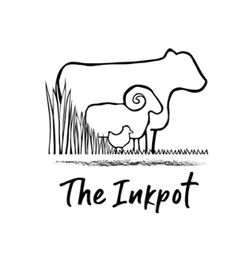 The Inkpot Organic Farm
Organic, 100% Pastured Beef
Price List 2020

Highgate Farm Cottage, Gorse Drove, Scredington, Lincolnshire, NG34 0AH
www.the-inkpot.com
hannah_thorogood@hotmail.com
0780 181 40 86

Why Inkpot Beef?
This is the first Inkpot beef, from our pedigree Lincoln Red herd. They live a healthy, high welfare, friendly life, only ever eat grass and hay and are raised to organic standards so no sprays are used and no routine medicines. The herd, along with the sheep, are moved on to fresh pastures every day, all year round, leaving at least three months for the grass to re-grow. This system is a regenerative grazing technique which builds soil, creates habitat and sequesters more carbon from the atmosphere and into the soil, than any tree-based system. It also creates the perfect conditions for soil bacteria called methanotropes, which breathe in more methane than the cows produce and poo it into the soil as carbon. By buying this beef, you are supporting a small family farm, a local abattoir and helping to reverse climate change!

Cut | Price per kg | Average size | Average price
Beef mince | £10 | 500g | £5
Diced stewing steak | £12.50 | 500g | £6
Steak for stir fry | £15 | 320g | SOLD OUT
Rump steak | £25 | 660g | £17
2 Sirloin steaks | £30 | 530g | £16
2 Fillet steaks | £40 | 385g | SOLD OUT
2 Rib eye steaks | £30 | 665g | SOLD OUT
Shin of beef | £12 | 710g | £8
Beef skirt | £12 | 500g | SOLD OUT
Beef roasting joints | £15 | 1kg | £15
Brisket joint | £10 | 1.2kg | SOLD OUT
Leg top joint | £15 | 1.1kg | SOLD OUT
Rolled back rib joint | £18 | 1.6kg | SOLD OUT
Blade eye joint | £15 | 1kg | SOLD OUT
Liver | £10 | 400g | SOLD OUT
Kidney | £10 | 520g | SOLD OUT
Ox tail | £10 | 1kg | SOLD OUT
Ox tongue | £10 | 1.22kg | SOLD OUT
Ox heart | £10 | 1.66kg | SOLD OUT
Bones | £2.95 | - | -

How do I get my beef?
You can pick up from the farm at a pre-arranged time and see the happy cows for yourself, or we can deliver anywhere in the country.
See overleaf for prices, which we have price compared with local butchers, other pasture fed and organic producers, and the supermarkets.

How much beef do I want?
Loads! Help us to empty our freezer! Order enough to last you for the next year, as we won’t have any more Beef or Hogget now until next year (you can of course order your Christmas turkey though) We have set out prices for individual packets of a variety of cuts overleaf. Or tell me your budget and I can give you a selection. Beef ‘boxes’ start at £40 with a bit of mince, stewing steak, steak and a joint and go up to £80, £120, £160 or whatever your budget dictates.

Thank you so much for ordering from the Inkpot, unlike the big shops, every £1 spent on Inkpot produce really makes a difference to us and goes directly into supporting a small-scale farm, serious about our ethics.

Please feel free to get in touch with any questions

Hannah 0780 181 4086.

