Learning outcome 2: Design Database
2.1 Description of database schema
- Introduction of database schema
A database schema defines how data is organized within a relational database. This is inclusive of logical constraints such as, table names, fields, data types, and the relationships between these entities.
A database schema can also be defined as the skeleton structure that represents the logical view of the entire database.
The importance of a database schema lies in its ability to outline the logical layout of a database and keep data organized. It helps users identify which tables, columns, and relationships exist between objects, enabling them to efficiently access, query, or modify data.
A database schema outlines how key elements in a relational database, such as tables and records, are organized and connected with each other.
- Types of database schema
There are three main types of database schemas:
- Conceptual database schema: This is a high-level overview of what your database will contain, how the data will be organized and the rules the data will follow.
Conceptual models are usually created as part of the process of gathering initial project requirements.
A conceptual schema focuses on the main concepts and their relationships. It doesn’t dig into any of the details and is thus insufficient to build a database.
- Logical database schema: This schema clearly defines all the elements within the database and any related information, such as field names, entity relationships, integrity constraints and table names.
A logical database schema states the logical rules or constraints that dictate how the elements within a database interact.
- Physical database schema:
A physical schema combines contextual and logical information while adding technical requirements. It contains the syntax needed to create data structures within the disk storage.
Both logical and physical schemas include a primary key that serves as a unique identifier for every entry in the table.

Benefits of database schemas
Some key benefits of database schemas include:
- Access and security: Database schema design helps organize data into separate entities, making it easier to share a single schema within another database.

Administrators can also control access through database permissions, adding another layer of security for more proprietary data.

- Organization and communication: Documentation of database schemas allow for more organization and better communication among internal stakeholders. Since it provides a common source of truth, it enables users to understand the logical constraints and methods of aggregation across tables.

- Integrity: This organization and communication also helps to ensure data validity. For example, it can help administrators manage normalization processes to avoid data duplication. It can also assist in monitoring compliance of the constraints in the schema's database design, enabling adherence to ACID properties (atomicity, consistency, isolation, durability).

- Data abstraction levels
Data abstraction is the method of hiding the unimportant details that are present in the database from the end users to make the accessing of data easy and secure.
Data Abstraction can also be defined as the process of hiding unwanted or irrelevant details from the end user.
It provides a different view and helps in achieving data independence which is used to enhance the security of data.

Mainly there are three levels of abstraction for DBMS, which are as follows:
- Physical or Internal Level
- Logical or Conceptual Level
- View or External Level

The following diagram will give you a clear view of how the implementation is done.
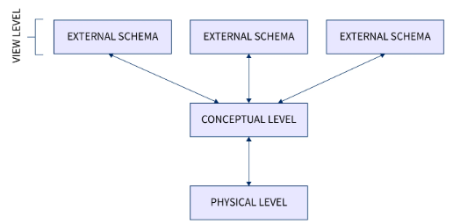
Let us discuss each level in detail.

Physical or Internal Level
It is the lowest level of abstraction for DBMS, which defines how the data is actually stored, it defines data-structures to store data and access methods used by the database.
Actually, it is decided by developers or database application programmers how to store the data in the database.
So, overall, the entire database is described in this level that is physical or internal level. It is a very complex level to understand.

For example, customer's information is stored in tables and data is stored in the form of blocks of storage such as bytes, gigabytes etc.

Logical or Conceptual Level
Logical level is the intermediate level or next higher level. It describes what data is stored in the database and what relationship exists among those data. It tries to describe the entire or whole data because it describes what tables to be created and what are the links among those tables that are created.
It is less complex than the physical level. Logical level is used by developers or database administrators (DBA). So, overall, the logical level contains tables (fields and attributes) and relationships among table attributes.

View or External Level

This level tells the application about how the data should be shown to the user.
It is the highest level. In view level, there are different levels of views and every view only defines a part of the entire data.
View level can be used by all users (all levels' users). This level is the least complex and easy to understand.
For example, a user can interact with a system using GUI that is view level and can enter details at GUI or screen and the user does not know how data is stored and what data is stored, this detail is hidden from the user.

- Types of data independence
Data Independence means the ability of the data to change the schema at one level of the database without having to change the schema at the next higher level.
In simple words, we can say that Data independence is a property of a database that allows the User or Database Administrator to change the schema at one level without affecting the data or schema at another level.
There are two levels of data independence based on three levels of abstraction.
These are as follows: Physical Data Independence and Logical Data Independence
- Physical Data Independence
It can be defined as the ability to change the physical level without affecting the logical or Conceptual level.
Physical data independence gives us the freedom to modify the Storage device, File structure, location of the database, etc. without changing the definition of conceptual or view level.
For example, if we take the database of the banking system and we want to scale up the database by changing the storage size and also want to change the file structure, we can do it without affecting any functionality of logical schema.
Below changes can be done at the physical layer without affecting the conceptual layer -
- Changing the storage devices like SSD, hard disk and magnetic tapes, etc.
- Changing the access technique and modifying indexes.
- Changing the compression techniques or hashing algorithms.
- Logical Data Independence
It is a property of a database that can be used to change the logic behind the logical level without affecting the other layers of the database.
Logical data independence is usually required for changing the conceptual schema without having to change the external schema or application programs.
It allows us to make changes in a conceptual structure like adding, modifying, or deleting an attribute in the database.

Importance of Data Independence:

- Ability of improving performance
- Alterations in data structure does not requires alterations in application programs
- Implementation details can be hidden from the users
- Affordable prices of maintaining system
- Providing the best services to the users
- Permit users to focus on general structure
- Improvement of security

2.2 Design of conceptual database schema
- Description of conceptual database schema
A conceptual schema is a design model used to plan out or visually represent the structure of information contained in a database or other computer system entity.
It acts to delineate the specific entities in the system, along with their attributes, and the relationships between various entities. The purpose of a conceptual schema is to provide a higher-level order to a computing system.

- Entity relationship diagram (ERD)
- Description of ERD
An Entity Relationship (ER) Diagram is a type of flowchart that illustrates how “entities” such as people, objects or concepts relate to each other within a system.

Relationship between entities may be one to one, one to many, many to one and many to many.
In ERD relationship can be implemented via cardinality or ordinality.

- Components of ERD
ER diagrams or ERD’s are composed of three main elements: entities, attributes, and relationships.
- Entities - typically displayed in a rectangle, entities can be represented by objects, persons, concepts, or events that contain data.
- Attributes - displayed in a circle or an oval, the attributes refer to the characteristics of an entity. They can be categorized as simple, composite, or derived, and an object can have one or multiple attributes.
- Relationships - illustrate how two or more entities interact with each other. They are displayed as labels placed on the lines connecting the objects.

Symbols Used in ER Diagrams
- Rectangles: This Entity Relationship Diagram symbol represents entity types
- Ellipses: This symbol represents attributes.
- Diamonds: This symbol represents relationship types.
- Lines: It links attributes to entity types and entity types with other relationship.
- Primary key: Here, it underlines the attributes.
- Double Ellipses: Represents multi-valued attributes.
- Dashed Ellipses: Represents a derived attribute.

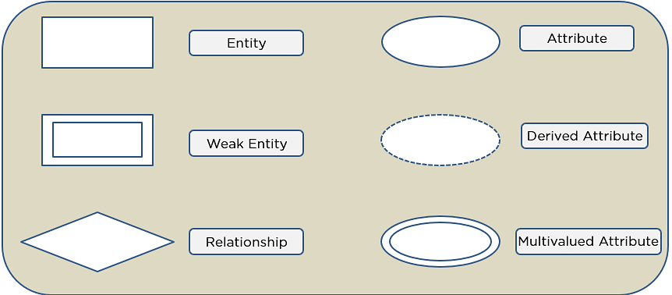
- Entity
- Entity
An entity is something that exists separately from other things and has a clear identity of its own.

Strong Entity
Strong Entity is independent to any other entity in the schema. A strong entity always has a primary key.
In ER diagram, a strong entity is represented by rectangle. Relationship between two strong entities is represented by a diamond. A set of strong entities is known as strong entity set.

Weak Entity
Weak entity is dependent on strong entity and cannot exists without a corresponding strong. It has a foreign key, which relates it to a strong entity.
A weak entity is represented by double rectangle. Relationship between a strong entity and a weak entity is represented by double diamond. The foreign key is also called a partial discriminator key.

Difference between Strong and Weak Entity
S.No. | Strong Entity | Weak Entity
1 | It is independent in nature. | It depends on another strong entity.
2 | Strong entity always have one primary key. | Weak entity have a foreign key referencing primary key of strong entity.
3 | It has a primary key. | It does not have any primary key.
4 | It is depicted by a sole rectangle. | It is depicted by a dual rectangle.
5 | The connection between two strong entities is shown by a sole diamond. | The connection between a weak and a strong entity is shown by a dual diamond.

Example for weak and strong entities in ERD.
  - In the ER diagram, we have two entities Employee and Dependents.
  - Employee is a strong entity because it has a primary key attribute called Employee number (Employee_No) which is capable of uniquely identifying all the employee.
  - Unlike Employee, Dependents is weak entity because it does not have any primary key.
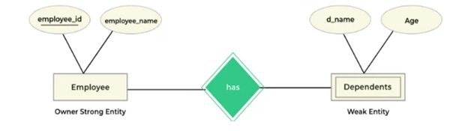
- Attribute
An attribute is a property or characteristic of an entity. An entity may contain any number of attributes.
In an Entity-Relation model, attributes are represented in an elliptical shape.
There are several different types of attributes and they each do a different job in database design. Each attribute also has some inherent limitations on the values that it can contain, regardless of type.
There are six types of attributes: Simple, Composite, Single-valued, Multi-valued, Derived and key attribute.
These are explained as following below.
- Simple attribute:
Simple attributes are those attributes which cannot be divided further.

Example:
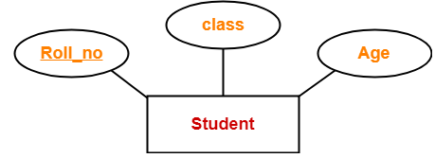
Here, all the attributes are simple attributes as they cannot be divided further.

- Composite attribute:
Composite attributes are those attributes which are composed of many other simple attributes.

Example:
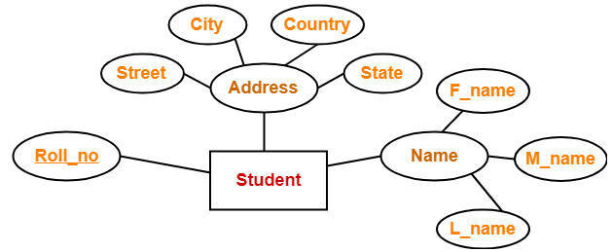
Here, the attributes “Name” and “Address” are composite attributes as they are composed of many other simple attributes.

- Single-valued attribute:
Single valued attributes are those attributes which can take only one value for a given entity from an entity set.
Example:
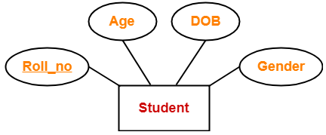
Here, all the attributes are single valued attributes as they can take only one specific value for each entity.

- Multi-valued attribute:
Multi-valued attributes are those attributes which can take more than one value for a given entity from an entity set.

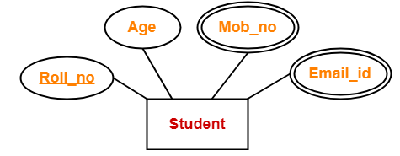

Here, the attributes “Mob_no” and “Email_id” are multi valued attributes as they can take more than one values for a given entity.

- Derived attribute:
Derived attributes are those attributes which can be derived from other attribute(s).

Example
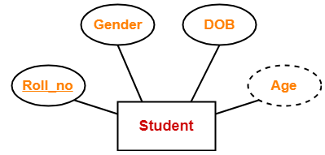
Here, the attribute “Age” is a derived attribute as it can be derived from the attribute “DOB”.

6. Key Attributes-
Key attributes are those attributes which can identify an entity uniquely in an entity set.

Example-
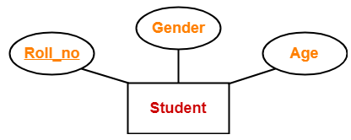
Here, the attribute “Roll_no” is a key attribute as it can identify any student uniquely.

- Define relationships
A relationship is a connection or association between two or more entities that expresses how they interact or depend on each other.
Relationship between entities may be one to one, one to many, many to one or many to many.

- Create an ERD

Cardinality and ordinality
Cardinality is the degree of relationship, which determines how many instances of an entity relate to instances of another entity.

It refers to the maximum number of times an instance in one entity can relate to instances of another entity. Ordinality, on the other hand, is the minimum number of times an instance in one entity can be associated with an instance in the related entity.

The styling of a line and its endpoint, according to the chosen notation style, shows cardinality and ordinality.
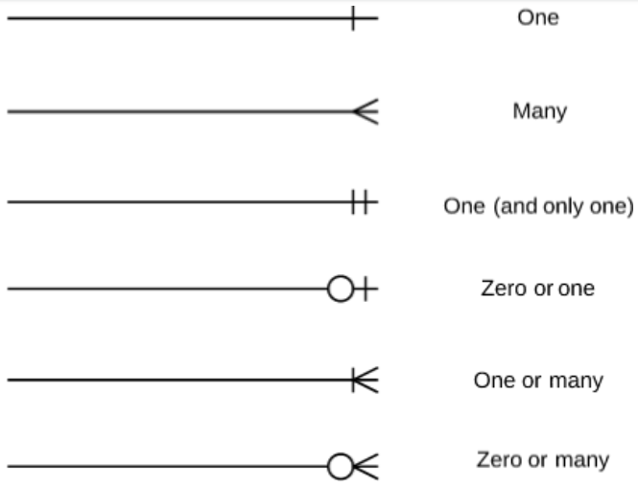

How to draw a basic ER diagram

Identify the components
Entity-relationship diagrams are incredibly useful, and you can easily create one of your own by following these simple steps.

1. Determine the entities: Entities are typically nouns such as car, bank, student, or product.
In an ER Diagram, entities are the most important parts.

2. Identify the relationships: Relationships highlight how entities interact with each other.

3. Cardinality Identification
You have to identify and add cardinality by showing how many instances in one entity participate in relation with other entities in another relation.
4. Identify attributes: Initially, it's important to identify the attributes without mapping them to a particular entity.
Once, you have a list of Attributes, you need to map them to the identified entities. Ensure an attribute is to be paired with exactly one entity.
Once the mapping is done, identify the primary Keys. If a unique key is not readily available, create one.

4. Complete the diagram
Organizing the ERD in a logical way is incredibly important to increase comprehension. The main purpose of entity-relationship diagrams is to model a complex database, so learning how to create simple, logical ERDs is key.

Here are some best practice or example for Developing Effective ER Diagrams.
- Eliminate any redundant entities or relationships
- You need to make sure that all your entities and relationships are properly labeled
- There may be various valid approaches to an ER diagram. You need to make sure that the ER diagram supports all the data you need to store
- You should assure that each entity only appears a single time in the ER diagram
- Name every relationship, entity, and attribute are represented on your diagram
- Never connect relationships to each other
Example:
In a university, a Student enrolls in Courses. A student must be assigned to at least one or more Courses. Each course is taught by a single Professor. To maintain instruction quality, a Professor can deliver only one course.
Construct Entity Relationship Diagram for the situation.

Step 1: Entity Identification
We have three entities:
- Student
- Course
- Professor
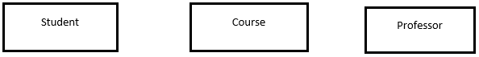

Step 2: Relationship Identification
We have the following two relationships
- The student is assigned a course
- Professor delivers a course
Student
Course
Professor
Assigned
Delivers

Step 3: Cardinality Identification
For them problem statement we know that,
- A student can be assigned multiple courses
- A Professor can deliver only one course
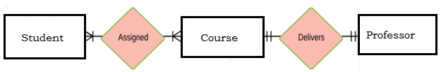

Step 4: Identify Attributes
It's important to identify the attributes without mapping them to a particular entity.
Once, you have a list of Attributes, you need to map them to the identified entities. Ensure an attribute is to be paired with exactly one entity.
Once the mapping is done, identify the primary Keys. If a unique key is not readily available, create one.
Entity | Primary Key | Attribute
Student | Student_ID | StudentName
Professor | Employee_ID | ProfessorName
Course | Course_ID | CourseName
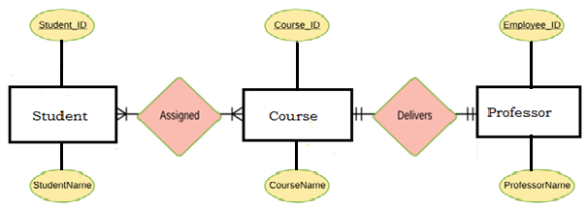
For Course Entity, attributes could be Duration, Credits, Assignments, etc.
For the sake of ease, we have considered just one attribute.

Step 5: Create the ERD Diagram
A more modern representation of Entity Relationship Diagram Example
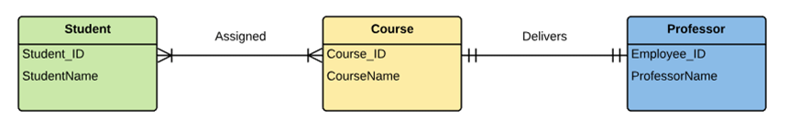
- Draw an ERD (MS-Visio, Draw-Max)

How to Make a ER Diagram?
Step 1: Install and enable EdrawMax from your computer, and navigate to [New] > [Database Modeling]. You can see all the pre-made tempaltes of ER Diagrams.
Step 2: Open and modify an ERD template selected from the gallery, or you can create a new one with ERD symbols provided by EdrawMax. The handy and powerful editing and formatting tools will also give you great help to create the diagram in minutes.
Step 3: When you have made your ERD in EdrawMax, you can save and export the drawing to graphics(JPG, PNG), PDF, SVG, Visio vsdx file format, editable MS Office file format, and HTML.

2.3 Design of logical database schema
- Description of logical database schema
This schema clearly defines all the elements within the database and any related information, such as field names, entity relationships, integrity constraints and table names.

- Table constraints
Constraints are the rules enforced on data columns on a table. These are used to limit the type of data that can go into a table. This ensures the accuracy and reliability of the data in the database.

Constraints can either be column level or table level. Column level constraints are applied only to one column whereas table level constraints are applied to the entire table.

- Primary key
A primary key is a column or a set of columns designated to uniquely identify each table record. Value(s) in specified column(s) must be unique for each row in a table.
A primary key is used as a unique identifier to quickly parse data within the table. A table cannot have more than one primary key.
A primary key’s main features are:
- It must contain a unique value for each row of data.
- t cannot contain null values.
- Every row must have a primary key value
- Foreign key
A foreign key is a column or a set of columns in a table whose values correspond to the values of the primary key in another table.
In order to add a row with a given foreign key value, there must exist a row in the related table with the same primary key value.

Difference between Primary key and Foreign key in Database
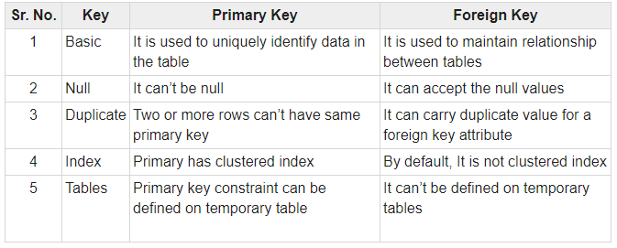

- Unique
A unique key is a set of one or more than one fields/columns of a table that uniquely identify a record in a database table.
The unique key has the following characteristics:
- There can be multiple unique keys defined on a table.
- Unique Keys result in NONCLUSTERED Unique Indexes by default.
- One or more columns make up a unique key.
- Column may be NULL, but on one NULL per column is allowed.

At this point you have a sense of the difference between a primary and unique key, but let’s summarize the differences in the following table:
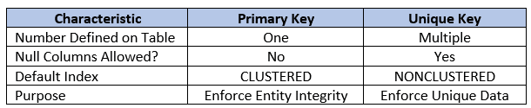

- Check
The CHECK constraint is used to limit the value range that can be placed in a column.
If you define a CHECK constraint on a single column it allows only certain values for this column.
If you define a CHECK constraint on a table, it can limit the values in certain columns based on values in other columns in the row.

- Not null
The NOT NULL constraint enforces a column to NOT accept NULL values. This enforces a field to always contain a value, which means that you cannot insert a new record, or update a record without adding a value to this field.
- Default constraint
It provides a default value for a column when none is specified.

2.4 Optimization of database
- Data normalization
Normalization is a database design technique that reduces data redundancy and eliminates issues caused by anomalies while performing Insertions, Updates and Deletions.

Normalization can also be defined as the process of organizing the data in the database.

Normalization is used to minimize the redundancy from a relation or set of relations and it is also used to eliminate the undesirable characteristics like Insertion, Update and Deletion Anomalies.

Normalization divides the larger table into the smaller table and links them using relationship.

The purpose of Normalization in SQL is to eliminate redundant (repetitive) data and ensure data is stored logically.

What is 1NF 2NF and 3NF?
1NF, 2NF, and 3NF are the first three types of database normalization. They stand for first normal form, second normal form, and third normal form, respectively.
There are also BCNF (Boyce-Codd Normal Form), 4NF (fourth normal form) and 5NF (fifth normal form). There’s even 6NF (sixth normal form), but the commonest normal form you’ll see out there is 3NF (third normal form).
All the types of database normalization are cumulative; meaning each one builds on top of those beneath it. So all the concepts in 1NF also carry over to 2NF, and so on.
In this section we are going to discuss on, First normal form (1NF), Second normal form (2NF) and Third normal form (3NF).
  - First normal form (1NF)
For a table to be in the first normal form, it must meet the following criteria:
- a single cell must not hold more than one value (atomicity)
- there must be a primary key for identification
- no duplicated rows or columns

  - Second normal form (2NF)
A table is said to be in 2NF if it meets the following criteria:
- it’s already in 1NF
- has no partial dependency. That is, all non-key attributes are fully dependent on a primary key.

  - Third normal form (3NF)
When a table is in 2NF, it eliminates repeating groups and redundancy, but it does not eliminate transitive partial dependency.
This means a non-prime attribute (an attribute that is not part of the candidate’s key) is dependent on another non-prime attribute. This is what the third normal form (3NF) eliminates.

So, for a table to be in 3NF, it must:
- be in 2NF
- have no transitive partial dependency.

Database Normalization With Examples
Database Normalization Example can be easily understood with the help of a case study. Assume, a video library maintains a database of movies rented out. Without any normalization in database, all information is stored in one table as shown below. Let’s understand Normalization database with normalization example with solution:
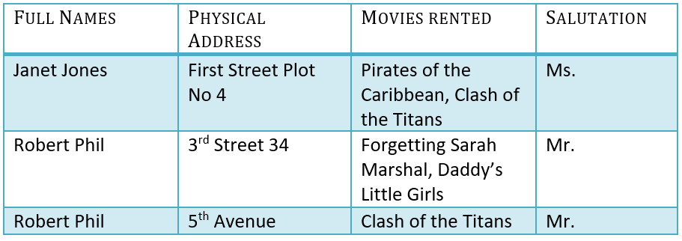
Here you see Movies Rented column has multiple values. Now let’s move into 1st Normal Forms:

1NF (First Normal Form) Rules
- Each table cell should contain a single value.
- Each record needs to be unique.
The above table in 1NF-

1NF Example
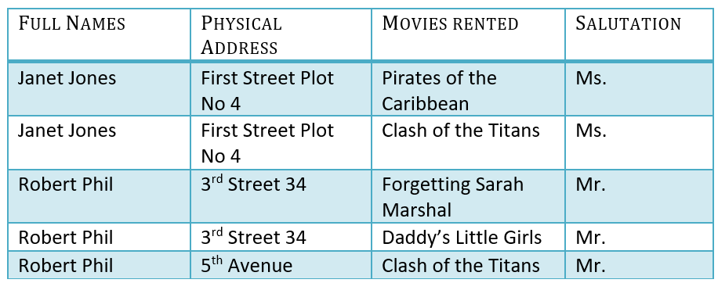

Example of 1NF in DBMS
Before we proceed let’s understand a few things

What is a KEY in SQL
A KEY in SQL is a value used to identify records in a table uniquely. An SQL KEY is a single column or combination of multiple columns used to uniquely identify rows or tuples in the table. SQL Key is used to identify duplicate information, and it also helps establish a relationship between multiple tables in the database.
Note: Columns in a table that are NOT used to identify a record uniquely are called non-key columns.

What is a Primary Key?

Primary Key in DBMS
A primary is a single column value used to identify a database record uniquely.
It has following attributes
- A primary key cannot be NULL
- A primary key value must be unique
- The primary key values should rarely be changed
- The primary key must be given a value when a new record is inserted.

What is Composite Key?
A composite key is a primary key composed of multiple columns used to identify a record uniquely
In our database, we have two people with the same name Robert Phil, but they live in different places.
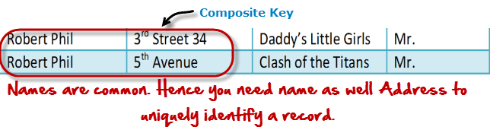
Composite key in Database
Hence, we require both Full Name and Address to identify a record uniquely. That is a composite key.
Let’s move into second normal form 2NF

2NF (Second Normal Form) Rules
- Rule 1- Be in 1NF
- Rule 2- Single Column Primary Key that does not functionally dependent on any subset of candidate key relation
It is clear that we can’t move forward to make our simple database in 2nd Normalization form unless we partition the table above.

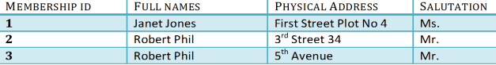
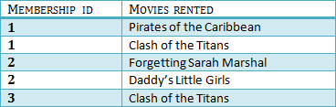
We have divided our 1NF table into two tables viz. Table 1 and Table2. Table 1 contains member information. Table 2 contains information on movies rented.
We have introduced a new column called Membership_id which is the primary key for table 1. Records can be uniquely identified in Table 1 using membership id
Database Foreign Key
In Table 2, Membership_ID is the Foreign Key
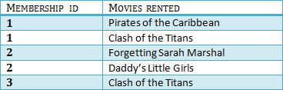

Foreign Key in DBMS
Foreign Key references the primary key of another Table! It helps connect your Tables
- A foreign key can have a different name from its primary key
- It ensures rows in one table have corresponding rows in another
- Unlike the Primary key, they do not have to be unique. Most often they aren’t
- Foreign keys can be null even though primary keys can not
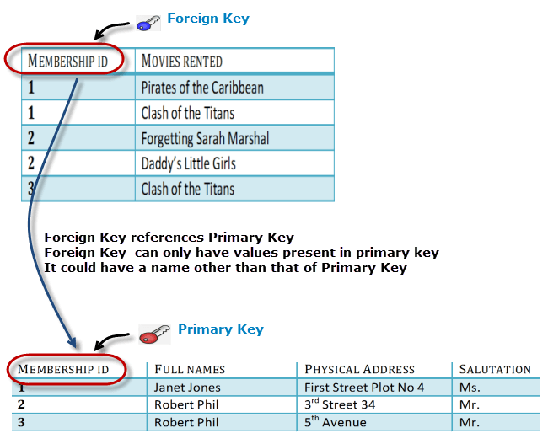
3NF (Third Normal Form) Rules
- Rule 1- Be in 2NF
- Rule 2- Has no transitive functional dependencies
To move our 2NF table into 3NF, we again need to again divide our table.

3NF Example
Below is a 3NF example in SQL database:
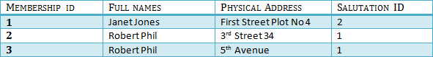
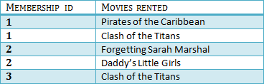
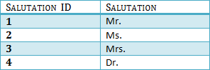

We have again divided our tables and created a new table which stores Salutations.
There are no transitive functional dependencies, and hence our table is in 3NF
In Table 3 Salutation ID is primary key, and in Table 1 Salutation ID is foreign to primary key in Table 3
Now our little example is at a level that cannot further be decomposed to attain higher normal form types of normalization in DBMS. In fact, it is already in higher normalization forms.

