Learning outcome 3: Implement Database
3.1 Description to SQL
- Introduction of SQL
SQL stands for Structured Query Language.
SQL is a database computer language for storing, manipulating and retrieving data stored in a relational database.

SQL is the standard language for Relational Database System and all Relational Database Management Systems (RDBMS) like MySQL, MS Access, Oracle, Sybase, Informix, Postgres and SQL Server use SQL as their standard database language.

SQL is widely popular because it can execute queries against a database, retrieve data , insert records, update records, delete records from a database, create new databases, create new tables in a database, create stored procedures in a database, create views in a database and set permissions on tables, procedures, and views.

- SQL sub-languages
SQL Commands
The standard SQL commands to interact with relational databases are CREATE, SELECT, INSERT, UPDATE, DELETE and DROP, etc.

SQL commands are grouped into below major categories (sublanguages) depending on their functionality:

- Data Definition Language (DDL)
- Data Manipulation Language (DML)
- Transaction Control Language (TCL)
- Data Control Language (DCL)
- Data Query Language (DQL)

- Description of SQL commands per sublanguage

1. Description of Data Definition Language commands:
Data definition language (DDL) refers to the set of SQL commands that can create and manipulate the structures of a database objects and database itself.
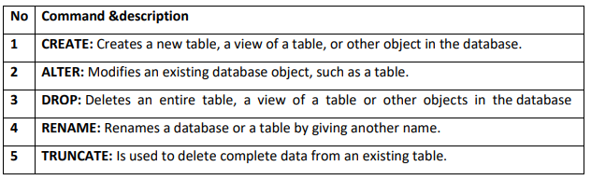

2. Data Manipulation Language commands:
DML commands work on records in a table. These are basic operations we perform on data such as inserting new records, deleting unnecessary records, and updating existing records.
Below are listed command under DML
No | Command & description
1 | INSERT: Creates a record.
2 | UPDATE: Modifies records.
3 | DELETE: Deletes records.

3. Data Control Language commands
These are used by the database administrator to grant or revoke privileges to users of the RDBMS.

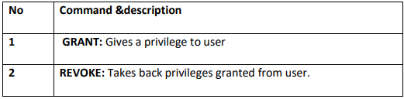
4. Transaction Control Language (TCL):
The commands of SQL that are used to control the transactions made against the database.
Below are listed command under TCL.

No | Command & description
1 | COMMIT: used to save changes invoked by a transaction to the database
2 | ROLLBACK: is used to undo the transactions that have not been saved in database.
3 | SAVEPOINT: is a point in a transaction in which you can roll the transaction back to a certain point without rolling back the entire transaction.
C.5. Data Query Language (DQL):
This command is used to select the data from database tables; view, synonyms and sequence etc.
Below are listed command under DQL
Command | description
SELECT | Is used to retrieve records from one or more tables in your SQL database.
NOTE: TCL Commands (COMMIT, ROLLBACK, SAVEPOINT) are used for only DML Commands (INSERT, UPDATE, DELETE) while DDL, DCL commands are Auto-committed.

- SQL Operators
Introduction
An operator is a reserved word or a character that is used to query our database in a SQL expression. To query a database using operators, we use a WHERE clause.
Operators are necessary to define a condition in SQL, as they act as a connector between two or more conditions. The operator manipulates the data and gives the result based on the operator’s functionality.

Types of Operator in SQL
SQL supports following types of operators: Arithmetic Operators, Assignment operators, Compound Operators, Logical Operators, and Bitwise Operators.
- Arithmetic operations
These operators are used to perform operations such as addition, multiplication, subtraction etc.

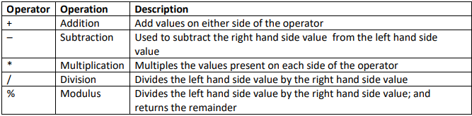
Examples:

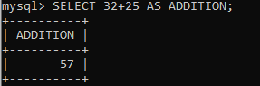
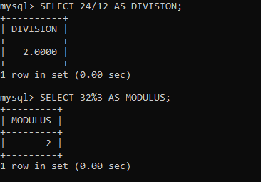

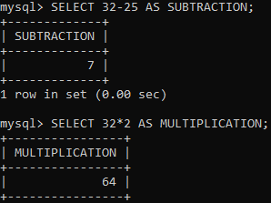

- Comparison operators
A comparison (or relational) operator is a mathematical symbol which is used to compare two values.
Comparison operators are used in conditions that compares one expression with another. The result of a comparison can be TRUE, FALSE, or UNKNOWN (an operator that has one or two NULL expressions returns UNKNOWN).
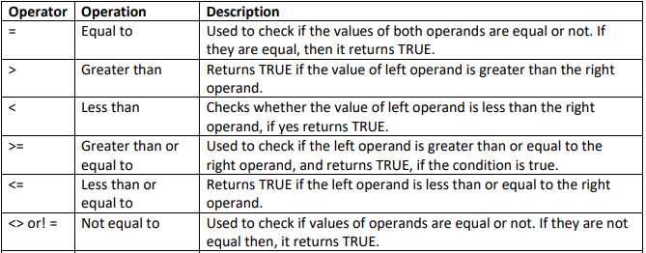
Example: For your better understanding, I will consider the following table CUSTOMER to perform various operations.

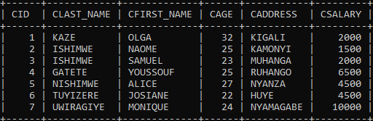

Example1. [Use equal to] (=):
SELECT * FROM CUSTOMER WHERE CSALARY=2000;
OUTPUT:
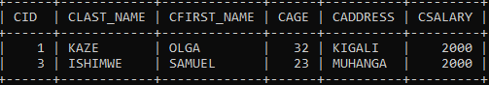

Example2. [Not Equal to] (<>):
SELECT * FROM CUSTOMER WHERE CSALARY < >2000;

OUTPUT:
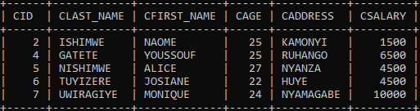

- Assignment operators
The assignment operator (=) in SQL Server is used to assign the values to a variable. The equal sign (=) is the only Transact-SQL assignment operator.

In the following example, we create @MyCounter variable and then the assignment operator sets @MyCounter variable to a value i.e. 1.

DECLARE @MyCounter INT;
SET @MyCounter = 1;

- Logical operators
The logical operators are used to perform operations such as ALL, ANY, NOT, BETWEEN etc.
Logical operators separate two or more conditions in the WHERE clause of an SQL statement.

Here is a list of all the logical operators available in SQL.
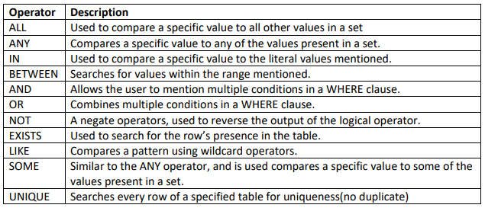

The different logical operators are shown below:

1. ALL OPERATOR
It is used to compare a value with every value in a list or returned by a query.
Must be preceded by =, !=, >, < ,<=, or >= evaluates.
ALL operators in the MySQL query are used to extract all tuples or records of the select statement.
ALL keyword is also used to make a comparison of a value with each and every data in another set of output from a subquery.
- The ALL operator outputs true if and only if the complete subqueries will satisfy the condition. ALL operator is headed by a comparison operator and will output true if all of the values of the subquery will fulfill the condition.
- ALL is always used in combination with select, where, having clause of the MySQL.
- ALL is used to select all records or rows of a select query. It compares the value of every value in a list or results from a query.
For example, ALL means either greater than every value, means greater than the maximum value, less than every value or equal to ever value. Suppose ALL >(1, 2, 3) means greater than 3, ALL < (1,2,3) means less than 1.
Consider the CUSTOMER table as shown below:

Syntax of ALL operators
select All column_name1, column_name2 from table name where condition

mysql> SELECT ALL CID, CLAST_NAME, CADDRESS FROM CUSTOMER;

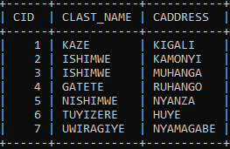

Below is the syntax of ALL operators with having or where clause:
select column_name1,column_name2 from table_name comparison operator ALL(select column_name from table_name where condition);
EXAMPLE 1:
mysql> select CID, CLAST_NAME, CSALARY FROM CUSTOMER where CSALARY< ALL(select CSALARY FROM CUSTOMER WHERE CSALARY>2000);

THE OUTPUT WILL BE:
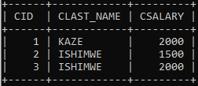
EXAMPLE 2:
select CID, CLAST_NAME, CSALARY FROM CUSTOMER where CSALARY<=ALL(select CSALARY FROM CUSTOMER WHERE CSALARY>2000);

THE OUTPUT WILL BE:
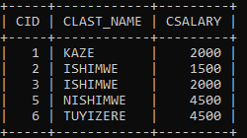

2. ANY OPERATOR
EXAMPLE 1:
SELECT * FROM CUSTOMER WHERE CAGE>ANY (SELECT CAGE FROM CUSTOMER WHERE CAGE> 22);
THE OUTPUT WILL BE:

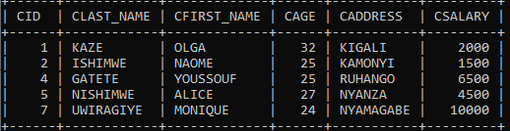

EXAMPLE 2:
Consider two tables customer and orders:
CUSTOMER:
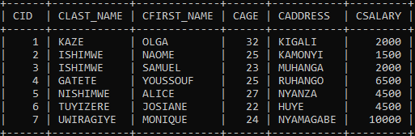

ORDERS:
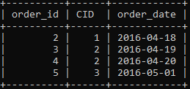

Syntax: SELECT num_value FROM table1 WHERE experession ANY (SELECT num_val FROM table2);

mysql>SELECT * FROM CUSTOMER WHERE CID> ANY(SELECT CID FROM ORDERS WHERE CID>2);

THE OUTPUT WILL BE:
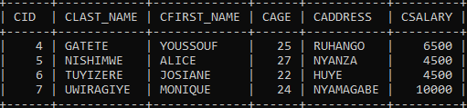

3. IN, NOT IN
These operators in SQL are used with SELECT, UPDATE and DELETE statements/queries to select, update and delete only particular records in a table those meet the condition given in WHERE clause and conditions given in IN, NOT IN operators.
I.e. it filters records from a table as per the condition. Syntax for SQL IN & NOT IN operators are given below.

SYNTAX FOR AND, OR OPERATORS IN SQL:
SELECT column_name(s)FROM table_name WHERE Where [condition] IN (value1, value2, ...);
OR:
SELECT column_name(s) FROM table_name WHERE Where [condition] IN (SELECT STATEMENT);

Where [condition] should be in the following format:
[column_name] [Operator] [Value];
Where,
column_name: Any one of the column names in the table.
Operator: Any one of the following (>, <, =, >=, <=, NOT, LIKE etc)
Value: User defined value.

The following SQL statement selects all customers that are located in "Germany", "France" or "UK":

Examples:
(1) SELECT * FROM Customers WHERE Country IN ('Germany', 'France', 'UK');
(2) select * from customer where cage IN (18,22,25);

OUTPUT WILL BE:
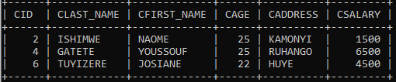

4. The SQL BETWEEN, NOT BETWEEN Operators

The BETWEEN operator selects values within a given range. The values can be numbers, text, or dates.
The BETWEEN operator is inclusive: begin and end values are included.

BETWEEN Syntax:
SELECT column_name(s) FROM table_nameWHERE column_name BETWEEN value1 AND value2;

Examples:
The following SQL statement selects all products with a price between 10 and 20:
SELECT * FROM Products WHERE Price BETWEEN 10 AND 20;

NOT BETWEEN Syntax:
SELECT column_name(s) FROM table_nameWHERE column_name NOT BETWEEN value1 AND value2;
Please consider the following table with few records as given below.
Table name (for example): student
Column names in this table: Student_ID, Student_name, City and Age

Available records: 4 rows

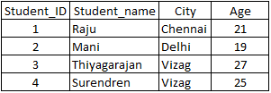

EXAMPLE1: HOW TO USE BETWEEN…AND IN A WHERE CLAUSE IN SELECT QUERIES
SQL query:
SELECT Student_ID, Student_name, City, Age from student
WHERE Age BETWEEN 19 AND 25;
SQL query Output:
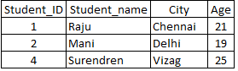

EXAMPLE2:

HOW TO USE NOT BETWEEN…AND IN WHERE CLAUSE IN SELECT QUERIES
SQL query:
SELECT Student_ID, Student_name, City, Age from student WHERE Age NOT BETWEEN 19 AND 25;
SQL query Output:
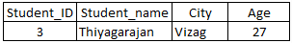

5. AND, OR, NOT OPERATORS
The WHERE clause can be combined with AND, OR, and NOT operators.
The AND and OR operators are used to filter records based on more than one condition:
- The AND operator displays a record if all the conditions separated by AND are TRUE.
- The OR operator displays a record if any of the conditions separated by OR is TRUE.
- The NOT operator displays a record if the condition(s) is NOT TRUE.

AND Syntax
SELECT column1, column2, ...FROM table_name WHERE condition1 AND condition2 AND condition3 ...;

OR Syntax
SELECT column1, column2, ...FROM table_name WHERE condition1 OR condition2 OR condition3 ...;

NOT Syntax
SELECT column1, column2, ...FROM table_name WHERE NOT condition;
EXAMPLES:

AND Example
The following SQL statement selects all fields from "Customers" where country is "Germany" AND city is "Berlin":

SELECT * FROM Customers WHERE Country='Germany' AND City='Berlin';

(b) OR Example
The following SQL statement selects all fields from "Customers" where country is "Germany" OR "Spain":
SELECT * FROM Customers WHERE Country='Germany' OR Country='Spain';

(c) NOT Example
The following SQL statement selects all fields from "Customers" where country is NOT "Germany":

SELECT * FROM Customers WHERE NOT Country='Germany'

Note: You can also combine the AND, OR and NOT operators.

Examples:
1. The following SQL statement selects all fields from "Customers" where country is "Germany" AND city must be "Berlin" OR "München" (use parenthesis to form complex expressions):

SELECT * FROM Customers WHERE Country='Germany' AND (City='Berlin' OR City='München');
2. The following SQL statement selects all fields from "Customers" where country is NOT "Germany" and NOT "USA":
SELECT * FROM Customers WHERE NOT Country='Germany' AND NOT Country='USA';

6. LIKE operator
The SQL LIKE operator is used to find matches between a character string and a specified pattern.

This operator is most commonly used in conjunction with two other SQL operators, WHERE and SELECT, to search for a value in a column.
A wildcard is the pattern that specifies the search criteria.
The SQL LIKE operator uses two wildcards, either independently or in conjunction.

These wildcards are:
- Percentage symbol (%), represents zero, one, or multiple characters.
- Underscore symbol ( _ ), represents a single character.

Note: MS Access uses an asterisk (*) instead of the percent sign (%), and a question mark (?) instead of the underscore (_).

Syntax:
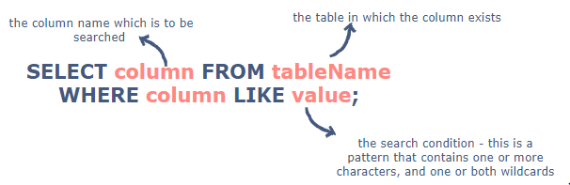
LIKE Operator | Description
WHERE CustomerName LIKE 'a%' | Finds any values that start with "a"
WHERE CustomerName LIKE '%a' | Finds any values that end with "a"
WHERE CustomerName LIKE '%or%' | Finds any values that have "or" in any position
WHERE CustomerName LIKE '_r%' | Finds any values that have "r" in the second position
WHERE CustomerName LIKE 'a_%' | Finds any values that start with "a" and are at least 2 characters in length
WHERE CustomerName LIKE 'a%' | Finds any values that start with "a" and are at least 3 characters in length
WHERE ContactName LIKE 'a%o' | Finds any values that start with "a" and ends with "o"
Here are some examples showing different LIKE operators with '%' and '_' wildcards:

SQL LIKE Examples:
- The following SQL statement selects all customers with a CustomerName starting with "a":
SELECT * FROM Customers WHERE CustomerName LIKE 'a%';

- The following SQL statement selects all customers with a CustomerName ending with "a":
SELECT * FROM Customers WHERE CustomerName LIKE '%a';

- The following SQL statement selects all customers with a CustomerName that have "or" in any position:
SELECT * FROM Customers WHERE CustomerName LIKE '%or%';
- The following SQL statement selects all customers with a CustomerName that have "r" in the second position:
SELECT * FROM Customers WHERE CustomerName LIKE '_r%';
- The following SQL statement selects all customers with a CustomerName that starts with "a" and are at least 3 characters in length:
SELECT * FROM Customers WHERE CustomerName LIKE 'a_ _%';
- The following SQL statement selects all customers with a ContactName that starts with "a" and ends with "o":
SELECT * FROM Customers WHERE ContactName LIKE 'a%o';
- The following SQL statement selects all customers with a CustomerName that does NOT start with "a":
SELECT * FROM Customers WHERE CustomerName NOT LIKE 'a%';

7. The SQL EXISTS Operator
The EXISTS operator is used to test for the existence of any record in a subquery.
The EXISTS operator returns TRUE if the subquery returns one or more records.

EXISTS Syntax
SELECT column_name(s) FROM table_name WHERE EXISTS (SELECT column_name FROM table_name WHERE condition);
Example1:
SELECT cid,cage from customer where exists (select csalary from customer where csalary=2000);
Output:
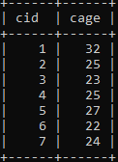

Example2:
SELECT cid,cage from customer where exists (select csalary from customer where csalary>200000);

Output:

8. Some operator
It evaluates the condition between the outer and inner tables and evaluates to true if the final result returns any one row. If not, then it evaluates to false.

- The SOME and ANY comparison conditions are similar to each other and are completely interchangeable.
- SOME must match at least one row in the subquery and must be preceded by comparison operators.

Syntax:
SELECT column_name(s) FROM table_name WHERE expression comparison_operator SOME (subquery);

EXAMPLE:
SELECT * FROM CUSTOMER WHERE CAGE>SOME(SELECT CAGE FROM CUSTOMER WHERE CAGE> 22);

Output:
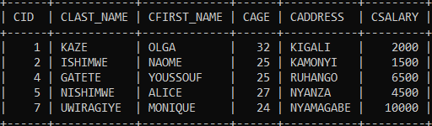

9. UNIQUE operator
The SQL UNIQUE Operator is used to check whether the sub-query has any duplicate values in the result. It returns true if the sub-query has no duplicate values, else returns false.

Syntax:
The syntax for using UNIQUE operator is given below:
SELECT table1.colum FROM table1 WHERE UNIQUE (SELECT table2.column FROM table2
WHERE table1.column = table2.column);

Example:
Consider a database containing tables called Employee and Contact_Info with the following records:
Table 1: Employee table
EmpID | Name | City | Age | Salary
1 | John | London | 25 | 3000
2 | Marry | New York | 24 | 2750
3 | Jo | Paris | 27 | 2800
4 | Kim | Amsterdam | 30 | 3100
5 | Ramesh | New Delhi | 28 | 3000
6 | Huang | Beijing | 28 | 2800

Table 2: Contact_Info table
Phone_Number | EmpID | Address | Gender
+1-80XXXXX000 | 2 | XXX, Brooklyn, New York, USA | F
+33-14XXXXX01 | 3 | XXX, Grenelle, Paris, France | M
+31-20XXXXX19 | 4 | XXX, Geuzenveld, Amsterdam, Netherlands | F
+86-10XXXXX458 | 6 | XXX, Yizhuangzhen, Beijing, China | M
+65-67XXXXX4 | 7 | XXX, Yishun, Singapore | M
+81-35XXXXX72 | 8 | XXX, Koto City, Tokyo, Japan | M
To find all the employees whose contact information is updated in the Contact_Info table, the below mentioned SQL code can be used.

SELECT Employee.EmpID, Employee.Name FROM Employee WHERE UNIQUE (SELECT Contact_Info.EmpID FROM Contact_Info WHERE Employee.EmpID = Contact_Info.EmpID);

This will produce the following result:
EmpID | Name
2 | Marry
3 | Jo
4 | Kim
6 | Huang

- Membership operators
Membership operators are operators used to validate the membership of a value.
It tests for membership in a sequence, such as strings, lists, or tuples.
Set-membership tests: IN, NOT IN.

SELECT column1, column2....columnN FROM table_name WHERE column_name IN (val-1, val-2,...val-N); SQL NOT IN Clause Page 20 of 146 SELECT column1, column2....columnN FROM table_name WHERE column_name NOT IN (val-1, val-2,...val-N); EXAMPLE: / try it by yourself to see the result SELECT*FROM CUSTOMER WHERE CAGE NOT IN ('32','22');

- Identity operators
An identity column of a table is a column whose value increases automatically.
The value in an identity column is created by the server. A user generally cannot insert a value into an identity column.

Syntax:
IDENTITY [(seed, increm ent)]

Arguments:
1. Seed: Starting value of a column. The default value is 1.
2. Increment: It specifies the incremental value that is added to the identity column value of the previous row. The default value is 1.

The following shows an Identity property when the table is created:
Create Table Person ( PersonId int identity (1, 1), Name nvarchar (20) );
- Operator precedence+
Precedence is the order in which Database software evaluates different operators in the same expression.
When evaluating an expression containing multiple operators, it evaluates operators with higher precedence before evaluating those with lower precedence

In general, the operators’ precedence follows the same rules as in the high school math. The order of the precedence is indicated in the following table.

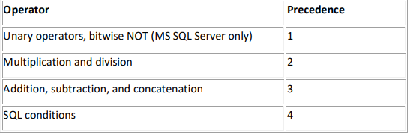

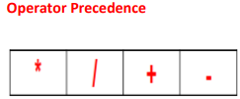
- Multiplication and division take priority over addition and subtraction.
- Operators of the same priority are evaluated from left to right.
- Parentheses are used to force prioritized evaluation and to clarify statements.

3.2. Application of DDL commands
- CREATE command
Application of " Create database and Create table" commands
  - Create database
i) To create a new database, the SQL query used is CREATE DATABASE
The Syntax is:
Create database database-name;

Always database name should be unique within the RDBMS.
Example of a query to create a database called SCHOOL, In MYSQL, it will look like the following:

Creating a database does not select it for use; you must do that explicitly. To make menagerie the current database, use one of these statement:
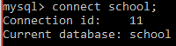

OR
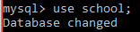

  - Create table
Creating the database is the easy part, but at this point it is empty if no table created,
as SHOW TABLES tells us:

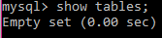

After creating a database and entering in database, there is a need now to create a table.
Creating a table involves naming the table and defining its columns and each column’s data type.
The SQL CREATE TABLE statement is used to create a new table.

The basic syntax of CREATE TABLE statement is as follows:
Create table table_name (column1 datatype, column2 datatype, column3 datatype, .....column datatype);

Then in brackets comes the list defining each column in the table and what sort of data type it is.
The following SQL query creates a “Customers” table with 6 columns, and thereafter, when the table was successfully created, the message “Query OK, o rows affected (0.48 sec)” is displayed.
See below.
The user can verify if the table has been created successfully by looking at the message displayed by the SQL server, otherwise he/she can use DESC command as follows:
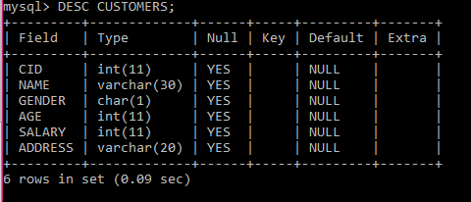
Now, “Customers” table is created and available in database. It can be used to store required information related to “Customers”. Notice that DESC is the same as DESCRIBE.
Create Table Using another Table: A copy of an existing table can be created using a combination of the CREATE TABLE statement and the SELECT statement. The new table has the same column definitions. All columns or specific columns can be selected.
When you create a new table using existing table, new table would be populated using existing values in the old table. The basic syntax for creating a table from another table is as follows:
Example: To create a table called SALARY having the same attributes like table “Customers”, write Create table salary like “Customers”;
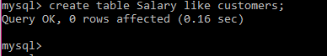
The structure of SALARY is displayed in the following interface.
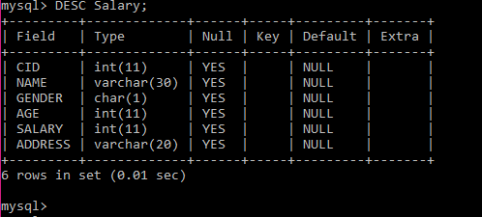

Description of SQL constraints:
Constraints are the rules enforced on data columns on a table. These are used to limit the type of data that can go into a table. This ensures the accuracy and reliability of the data in the database.

Constraints can be either column level or table level. Column level constraints are applied only to one column whereas table level constraints are applied to the entire table.
Constraints are:
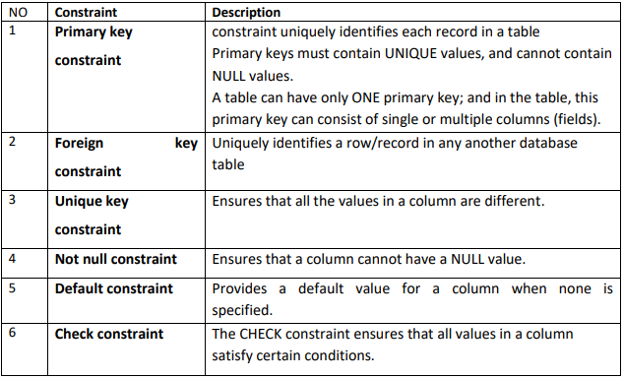

- SQL - ALTER TABLE Command
The SQL ALTER TABLE command is used to add, delete or modify columns in an existing table.
You should also use the ALTER TABLE command to add and drop various constraints on an existing table.

Below is table of some syntax for SQL ALTER TABLE:
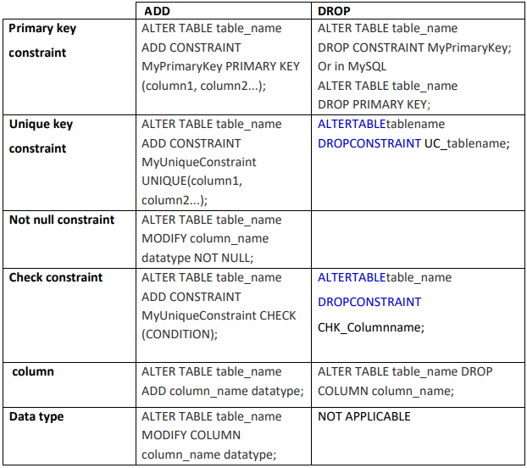

  - Execution of SQL constraints:

- Add/drop primary key constraint

A.1. SQL PRIMARY KEY on create table

PRIMARY KEY CONSTRAINT
MySQL | MYSQL,SQL Server / Oracle | MySQL/SQL Server / Oracle
PRIMARY KEY constraint on single column |  | PRIMARY KEY constraint on multiple columns
CREATE TABLE Persons  (ID int NOT NULL, LastName varchar(255) NOT NULL,  FirstName varchar(255), Age int,  PRIMARY KEY (ID) ); | CREATE TABLE Persons ( ID int NOT NULL PRIMARY KEY, LastName varchar(255) NOT NULL, FirstName varchar(255), Age int ); | CREATE TABLE Persons (ID int NOT NULL,  LastName varchar(255) NOT NULL,  FirstName varchar(255),Age int,  CONSTRAINT PK_Person PRIMARY KEY  (ID, LastName) );

Note: In the example above at the right, there is only ONE PRIMARY KEY (PK_Person). However, the VALUE of the primary key is made up of TWO COLUMNS (ID + LastName).

A.2.SQL PRIMARY KEY on ALTER TABLE

The following commands are used when the table is already created.

ADD
MySQL / SQL Server / Oracle On  single column | MySQL / SQL Server / Oracle On  multiple columns
ALTER TABLE Persons ADD PRIMARY KEY (ID); | ALTER TABLE Persons ADD CONSTRAINT PK_Person  PRIMARY KEY (ID, LastName);
Note: If you use ALTER TABLE to add a primary key, the primary key column(s) must have been declared to not contain NULL values (when the table was first created).

A.3.DROP a PRIMARY KEY Constraint
To drop a PRIMARY KEY constraint, use the following SQL:
DROP
MYSQL | SQL Server / Oracle
ALTER TABLE Persons DROP PRIMARY KEY; | ALTER TABLE Persons DROP  CONSTRAINT PK_Person;

- Add/drop foreign key constraint
The FOREIGN KEY constraint is used to prevent actions that would destroy links between tables.
A FOREIGN KEY is a field (or collection of fields) in one table, that refers to the PRIMARY KEY in another table.
The table with the foreign key is called the child table, and the table with the primary key is called the referenced or parent table.
Look at the following two tables:

Persons Table
PersonID | LastName | FirstName | Age
1 | Hansen | Ola | 30
2 | Svendson | Tove | 23
3 | Pettersen | Kari | 20

Orders Table
OrderID | OrderNumber | PersonID
1 | 77895 | 3
2 | 44678 | 3
3 | 22456 | 2
4 | 24562 | 1

Notice that the "PersonID" column in the "Orders" table points to the "PersonID" column in the "Persons" table.

The "PersonID" column in the "Persons" table is the PRIMARY KEY in the "Persons" table.
The "PersonID" column in the "Orders" table is a FOREIGN KEY in the "Orders" table.

The FOREIGN KEY constraint prevents invalid data from being inserted into the foreign key column, because it has to be one of the values contained in the parent table.

B.1 SQL FOREIGN KEY on CREATE TABLE
The following SQL creates a FOREIGN KEY on the "PersonID" column when the "Orders" table is created:
  - In MySQL:
CREATE TABLE Orders (OrderID int NOT NULL,OrderNumber int NOT NULL,PersonID int,
PRIMARY KEY (OrderID), FOREIGN KEY (PersonID) REFERENCES Persons(PersonID));
  - In MYSQL,SQL Server / Oracle
CREATE TABLE Orders ( OrderID int NOT NULL PRIMARY KEY, OrderNumber int NOT NULL,
PersonID int FOREIGN KEY REFERENCES Persons(PersonID));

B.2 SQL FOREIGN KEY on ALTER TABLE
To create a FOREIGN KEY constraint on the "PersonID" column when the "Orders" table is already created, use the following SQL:
  - MySQL / SQL Server / Oracle
ALTER TABLE Orders ADD FOREIGN KEY (PersonID) REFERENCES Persons(PersonID);

B.3 DROP a FOREIGN KEY Constraint
To drop a FOREIGN KEY constraint, use the following SQL:
  - MySQL:
ALTER TABLE Orders DROP FOREIGN KEY FK_PersonOrder;
  - SQL Server / Oracle
ALTER TABLE Orders DROP CONSTRAINT FK_PersonOrder;

- Add/drop unique key constraint
The UNIQUE constraint ensures that all values in a column are different.
Both the UNIQUE and PRIMARY KEY constraints provide a guarantee for uniqueness for a column or set of columns.
A PRIMARY KEY constraint automatically has a UNIQUE constraint.

Primary key will not accept NULL values whereas Unique key can accept NULL values. A table can have only one primary key whereas there can be multiple unique key on a table.

C.1 SQL UNIQUE Constraint on CREATE TABLE
The following SQL creates a UNIQUE constraint on the "ID" column when the "Persons" table is created:
- SQL Server / Oracle / MS Access:
CREATE TABLE Persons (ID int NOT NULL UNIQUE, LastName varchar(255) NOT NULL,
FirstName varchar(255), Age int );
- MySQL:
CREATE TABLE Persons ( ID int NOT NULL, LastName varchar(255) NOT NULL,
FirstName varchar(255), Age int, UNIQUE (ID));

To name a UNIQUE constraint, and to define a UNIQUE constraint on multiple columns, use the following

SQL syntax:
  - MySQL / SQL Server / Oracle
CREATE TABLE Persons ( ID int NOT NULL, LastName varchar(255) NOT NULL, FirstName varchar(255), Age int, CONSTRAINT UC_Person UNIQUE (ID,LastName));

C2. SQL UNIQUE Constraint on ALTER TABLE

To create a UNIQUE constraint on the "ID" column when the table is already created, use the following SQL:
  - MySQL / SQL Server / Oracle / MS Access:
ALTER TABLE Persons ADD UNIQUE (ID);
To name a UNIQUE constraint, and to define a UNIQUE constraint on multiple columns, use the following SQL syntax:
  - MySQL / SQL Server / Oracle:
ALTER TABLE Persons ADD CONSTRAINT UC_Person UNIQUE (ID,LastName);

C.3 DROP a UNIQUE Constraint
To drop a UNIQUE constraint, use the following SQL:
  - MySQL:
ALTER TABLE Persons DROP INDEX UC_Person;

  - SQL Server / Oracle / MS Access:
ALTER TABLE Persons DROP CONSTRAINT UC_Person;
- add /drop not null constraint

By default, a column can hold NULL values.
The NOT NULL constraint enforces a column to NOT accept NULL values.

This enforces a field to always contain a value, which means that you cannot insert a new record, or update a record without adding a value to this field.

D1. SQL NOT NULL on CREATE TABLE
The following SQL ensures that the "ID", "LastName", and "FirstName" columns will NOT accept NULL values when the "Persons" table is created:
Example:
CREATE TABLE Persons (ID int NOT NULL, LastName varchar(255) NOT NULL, FirstName varchar(255) NOT NULL,Age int );

D2. SQL NOT NULL on ALTER TABLE
To create a NOT NULL constraint on the "Age" column when the "Persons" table is already created, use the following SQL:
ALTER TABLE Persons MODIFY Age int NOT NULL;

D3. DROP NOT NULL CONSTRAINT
In this tutorial, we are going to see how to drop not null constraint in MySQL. To remove the constraint NOT NULL for a column in MySQL, use the statement ALTER TABLE … MODIFY and reformulate the column definition by removing the NOT NULL attribute.

Syntax:
Here is the syntax to remove the constraint NOT NULL for a column in MySQL
ALTER TABLE table_Name MODIFY columnName DATA_TYPE;

Example :
Here is an example to remove the constraint NOT NULL for the column “Name” of the “Employee” table:
ALTER TABLE Employee MODIFY Name VARCHAR (20);
To make sure you don’t miss anything, you can use the statement SHOW CREATE TABLE to display the full definition of the column:
SHOW CREATE TABLE Employee;
- Add/drop default constraint
The DEFAULT constraint is used to set a default value for a column.
The default value will be added to all new records, if no other value is specified.

E1. SQL DEFAULT on CREATE TABLE

The following SQL sets a DEFAULT value for the "City" column when the "Persons" table is created:
My SQL / SQL Server / Oracle
CREATE TABLE Perss ( ID int NOT NULL, LastName varchar(40) NOT NULL, FirstName varchar(20),
Age int, City varchar(25) DEFAULT 'Sandnes');

E2. SQL DEFAULT on ALTER TABLE
To create a DEFAULT constraint on the "City" column when the table is already created, use the following SQL:
- MySQL:
ALTER TABLE Persons ALTER City SET DEFAULT 'Sandnes';

- SQL Server:
ALTER TABLE Persons ADD CONSTRAINT df_City DEFAULT 'Sandnes' FOR City;

- Oracle:
ALTER TABLE Persons MODIFY City DEFAULT 'Sandnes';

E3. DROP a DEFAULT Constraint
To drop a DEFAULT constraint, use the following SQL:
- MySQL:

ALTER TABLE Persons ALTER City DROP DEFAULT;
- SQL Server / Oracle:
ALTER TABLE Persons ALTER COLUMN City DROP DEFAULT;

- Add/drop check constraint

The CHECK constraint is used to limit the value range that can be placed in a column.
If you define a CHECK constraint on a column it will allow only certain values for this column.
If you define a CHECK constraint on a table it can limit the values in certain columns based on values in other columns in the row.

F1. SQL CHECK on CREATE TABLE
The following SQL creates a CHECK constraint on the "Age" column when the "Persons" table is created. The CHECK constraint ensures that the age of a person must be 18, or older:
- MySQL:
CREATE TABLE P (ID int NOT NULL,LastName varchar(255) NOT NULL,FirstName varchar(255),Age int, CHECK (Age>=18));
- SQL Server / Oracle
CREATE TABLE Persons (ID int NOT NULL,LastName varchar(255) NOT NULL,FirstName varchar(255),Age int CHECK (Age>=18));
NOTE: To allow naming of a CHECK constraint, and for defining a CHECK constraint on multiple columns, use the following SQL syntax:
- MySQL / SQL Server / Oracle
CREATE TABLE Persons (ID int NOT NULL,LastName varchar(255) NOT NULL,FirstName varchar(255),Age int,City varchar(255),
CONSTRAINT CHK_Person CHECK (Age>=18 AND City='Sandnes'));

F2.SQL CHECK on ALTER TABLE
To create a CHECK constraint on the "Age" column when the table is already created, use the following SQL:
- MySQL / SQL Server / Oracle
ALTER TABLE Persons ADD CHECK (Age>=18);
NOTE: To allow naming of a CHECK constraint, and for defining a CHECK constraint on multiple columns, use the following SQL syntax:
- MySQL / SQL Server
ALTER TABLE Persons ADD CONSTRAINT CHK_PersonAge CHECK (Age>=18 AND City='Sandnes');

F3. DROP a CHECK Constraint
To drop a CHECK constraint, use the following SQL
- MySQL:
ALTER TABLE Persons DROP CHECK CHK_PersonAge;

- SQL Server / Oracle
ALTER TABLE Persons DROP CONSTRAINT CHK_PersonAge;

- ALTER Table

ALTER TABLE Statement
The ALTER TABLE statement is used to add, delete, or modify columns in an existing table.
The ALTER TABLE statement is also used to add and drop various constraints on an existing table.

ALTER TABLE - ADD Column
To add a column in a table, use the following syntax:
ALTER TABLE table_name ADD column_name datatype;
The following SQL adds an "Email" column to the "Customers" table:

Example
ALTER TABLE Customers ADD Email varchar(255);

ALTER TABLE - DROP COLUMN
To delete a column in a table, use the following syntax (notice that some database systems don't allow deleting a column):
ALTER TABLE table_name DROP COLUMN column_name;
The following SQL deletes the "Email" column from the "Customers" table:

Example
ALTER TABLE Customers DROP COLUMN Email;

ALTER TABLE - MODIFY COLUMN
To change the data type of a column in a table, use the following syntax:
ALTER TABLE table_name MODIFY COLUMN column_name datatype;

- DROP
This command deletes the information of the table or the database, and it removes the entire structure/schema of the table or the entire database.
By Using the DROP statement, the objects are permanently deleted or lost from a database, and they cannot be rolled back.
Whenever an object is deleted, its description is deleted from the catalog, and any packages that reference the object are invalidated.
- Database
The DROP DATABASE statement is used to drop an existing SQL database.

Syntax:
DROP DATABASE databasename;
Note: Be careful before dropping a database. Deleting a database will result in loss of complete information stored in the database!

DROP DATABASE Example
The following SQL statement drops the existing database "testDB":

Example
DROP DATABASE testDB;
Tip: Once a database is dropped, you can check it in the list of databases with the following SQL command:
SHOW DATABASES;

- Table
The DROP TABLE statement is used to drop an existing table in a database.

Syntax
DROP TABLE table_name;
Note: Be careful before dropping a table. Deleting a table will result in loss of complete information stored in the table!

MySQL DROP TABLE Example
The following SQL statement drops the existing table "Shippers":

Example
DROP TABLE Shippers;

- TRUNCATE Table
The TRUNCATE statement in MySQL removes the complete data without removing its structure. It is a part of DDL or data definition language command. Generally, we use this command when we want to delete an entire data from a table without removing the table structure.
The TRUNCATE command works the same as a DELETE command without using a WHERE clause that deletes complete rows from a table. However, the TRUNCATE command is more efficient as compared to the DELETE command because it removes and recreates the table instead of deleting single records one at a time.
The following points must be considered while using the TRUNCATE command:
- We cannot use the WHERE clause with this command so that filtering of records is not possible.
- We cannot rollback the deleted data after executing this command because the log is not maintained while performing this operation.
- We cannot use the truncate statement when a table is referenced by a foreign key or participates in an indexed view.
- The TRUNCATE command doesn't fire DELETE triggers associated with the table that is being truncated because it does not operate on individual rows.

Syntax
The following syntax explains the TRUNCATE command to remove data from the table:
TRUNCATE [TABLE] table_name;
Example:
mysql> TRUNCATE TABLE customer;

- MODIFY
- Database
SQL ALTER DATABASE is an essential statement to modify the properties of an existing database in a Relational Database Management System (RDBMS). This statement is helpful if you want to rename a database, change its composition, or modify file properties.
- Table
The modify command is used when we have to modify a column in the existing table, like adding a new one, modifying the datatype for a column, and dropping an existing column.
By using this command, we have to apply some changes to the result set field.

) Add a new column to the existing table
ALTER TABLE and ADD COLUMN statement is used to add one or more new columns to an existing table.
a) Add a single column to a table.
Syntax:
ALTER TABLE <table_name> ADD COLUMN <new_column_name> <Datatype> [CONSTRAINTS];

Example
ALTER TABLE csharpcorner_mvps ADD COLUMN MVPKitStatus INT;

Note: Use the “DESCRIBE” command to check the result from the ALTER TABLE ADD statement

b) Add multiples column to a table.
Syntax
ALTER TABLE employees
ADD COLUMN date_of_birth DATE NOT NULL,
ADD COLUMN department VARCHAR(50) DEFAULT 'IT',
ADD COLUMN salary DECIMAL(10,2) NOT NULL;

Example.
ALTER TABLE csharpcorner_mvps
ADD COLUMN Country VARCHAR(50),
ADD COLUMN Description VARCHAR(250);

Note. Use the “DESCRIBE” command to check the result from the ALTER TABLE ADD statement.

ALTER TABLE MODIFY statement is used to modify one or more columns to an existing table.
a) Modify a single column in a table
Syntax
ALTER TABLE employees
MODIFY employee_name VARCHAR(100);

Example.
ALTER TABLE csharpcorner_mvps
MODIFY MVPKitStatus VARCHAR(100);

Note.
Use the “DESCRIBE” command to check the result from the ALTER TABLE MODIFY statement.
b) Modify multiple columns in a table
Syntax
ALTER TABLE employees
MODIFY employee_name VARCHAR(100),
MODIFY salary DECIMAL(10,2);

Example.
ALTER TABLE csharpcorner_mvps
MODIFY MVPAddress VARCHAR(250) NOT NULL,
MODIFY MVPKitStatus VARCHAR(100) NOT NULL,
MODIFY Description VARCHAR(221);
SQL
Copy
Note.
Use the “DESCRIBE” command to check the result from the ALTER TABLE MODIFY statement.

3) DROP a Column
ALTER TABLE DROP COLUMN statement is used to drop the column(s) in a table.
Syntax
ALTER TABLE employees DROP COLUMN date_of_birth;

Example.
ALTER TABLE csharpcorner_mvps DROP COLUMN Country;

Note. Use the “DESCRIBE” command to check the result from the ALTER TABLE DROP statement.
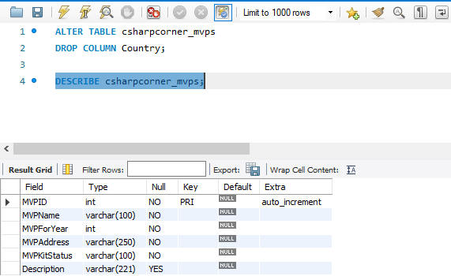

4) Change Column name
To rename a column in a table, use the following statement.
Syntax
ALTER TABLE employees CHANGE COLUMN emp_name employee_name VARCHAR(100);

Example.
ALTER TABLE STUDENT CHANGE COLUMN SEX GENDER CHAR;

Note. Use the “DESCRIBE” command to check the result from the ALTER TABLE CHANGE statement.

3.3 Application of DML commands
- INSERT
The INSERT INTO statement is used to insert new records in a table.

INSERT INTO Syntax:
It is possible to write the INSERT INTO statement in two ways:
1. Specify both the column names and the values to be inserted:
INSERT INTO table_name (column1, column2, column3, ...) VALUES (value1, value2, value3, ...);

Example:
INSERT INTO Customers (CustomerName, ContactName, Address, City, PostalCode, Country)
VALUES ('Cardinal', 'Tom B. Erichsen', 'Skagen 21', 'Stavanger', '4006', 'Norway');

2. If you are adding values for all the columns of the table, you do not need to specify the column names in the SQL query.
However, make sure the order of the values is in the same order as the columns in the table. Here, the INSERT INTO syntax would be as follows:
INSERT INTO table_name VALUES (value1, value2, value3, ...);

Example:
INSERT INTO Customers VALUES ('Cardinal', 'Tom B. Erichsen', 'Skagen 21', 'Stavanger', '4006', 'Norway');

Insert Data Only in Specified Columns
It is also possible to only insert data in specific columns.
The following SQL statement will insert a new record, but only insert data in the "CustomerName", "City", and "Country" columns (CustomerID will be updated automatically):

Example
INSERT INTO Customers (CustomerName, City, Country) VALUES ('Cardinal', 'Stavanger', 'Norway');

- UPDATE
The UPDATE statement is used to modify the existing records in a table.

UPDATE Syntax:
UPDATE table_name SET column1 = value1, column2 = value2, ... WHERE condition;
Note: Be careful when updating records in a table!
The WHERE clause specifies which record(s) that should be updated. If you omit the WHERE clause, all records in the table will be updated!
The following SQL statement updates the first customer (CustomerID = 1) with a new contact person and a new city.

Example
UPDATE Customers SET ContactName = 'Alfred Schmidt', City = 'Frankfurt'
WHERE CustomerID = 1;

UPDATE Multiple Records
It is the WHERE clause that determines how many records will be updated.
The following SQL statement will update the PostalCode to 00000 for all records where country is "Mexico":

Example
UPDATE Customers SET PostalCode = 00000 WHERE Country = 'Mexico';

- DELETE
The DELETE statement is used to delete existing records in a table.

DELETE Syntax
DELETE FROM table_name WHERE condition;
Note: Be careful when deleting records in a table! Notice the WHERE clause in the DELETE statement.
The WHERE clause specifies which record(s) should be deleted. If you omit the WHERE clause, all records in the table will be deleted!

SQL DELETE Example:
The following SQL statement deletes the customer "Alfreds Futterkiste" from the "Customers"
DELETE FROM Customers WHERE CustomerName='Alfreds Futterkiste';

Delete All Records
It is possible to delete all rows in a table without deleting the table. This means that the table structure, attributes, and indexes will be intact:
DELETE FROM table_name;
The following SQL statement deletes all rows in the "Customers" table, without deleting the table:

Example
DELETE FROM Customers;

- CALL
Stored procedures are sub routines, segment of SQL statements which are stored in SQL catalog. These procedures contain IN and OUT parameters, or both. They may return result sets in case you use SELECT statements; they can return multiple result-sets.
- Syntax in MYSQL
DELIMITER
CREATE PROCEDURE ProcedureName()
BEGIN
SQL STATEMENT
END
DELIMITER
EXAMPLE
Consider the table BOOKS below:
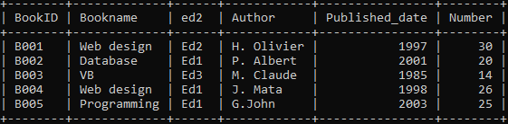
Now we are going to create a procedure and call it mine.
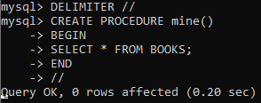

The call statement of MySQL is used to invoke/call a stored procedure.

Syntax
Following is the syntax of the CALL statement in MySQL
CALL procedure_name(parameter[param1, param2, ...])
Where procedure_name is the name of an existing procedure you need to call and param1 and param2... are the list of parameters accepted by the procedure (if it accepts any).
The CALL statement invokes a stored procedure that was defined previously with CREATE PROCEDURE . Stored procedures that take no arguments can be invoked without parentheses.

Calling a stored procedure with parameters
Suppose we have created a table named Emp in the database using the CREATE statement and inserted three records in it as shown below −
CREATE TABLE Emp (
Name VARCHAR(255),
Salary INT,
Location VARCHAR(255));
Assume we have created a stored procedure InsertData which accepts the name, salary and location values and inserts them as a record into the above create (Emp) table.
DELIMITER //
Create procedure InsertData (
IN name VARCHAR(30),
IN sal INT,
IN loc VARCHAR(45))
BEGIN
INSERT INTO Emp(Name, Salary, Location) VALUES (name, sal, loc);
END //
DELIMITER ;
Following statement calls the above created stored procedure
CALL InsertData ('Raju', 35000, 'Bangalore');
CALL InsertData ('Raman', 45000, 'Vishakhapatnam');
CALL InsertData ('Rahman', 55000, 'Hyderabad');

Verification
Once you call the procedure by passing the required values you can verify the contents of the Emp table as shown below −
SELECT * FROM EMP;
The above query produces the following output −
Name | Salary | Location
Raju | 35000 | Bangalore
Raman | 45000 | Visakhapatnam
Rahman | 55000 | Hyderabad

Calling a stored procedure without parameters
While calling a stored procedure that doesn't accepts any arguments, we can omit the parenthesis as shown below:

Assume we have created another procedure with name getData that retries the contents of the table EMP
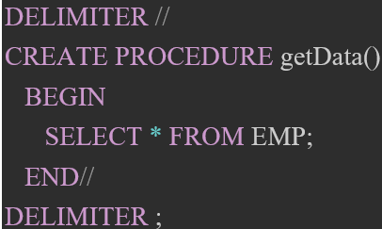
Since this procedure doesn't accept arguments you can call this procedure by omitting the parameters as shown below

Output
Following is the output of the above query

Name | Salary | Location
Raju | 35000 | Bangalore
Raman | 45000 | Visakhapatnam
Rahman | 55000 | Hyderabad

- LOCK

MySQL LOCK TABLES Statement
The following is the syntax that allows us to acquire a table lock explicitly:
LOCK TABLES table_name [READ | WRITE];

In the above syntax, we have specified the table name on which we want to acquire a lock after the LOCK TABLES keywords. We can specify the lock type, either READ or WRITE.
We can also lock more than one table in MySQL by using a list of comma-separated table's names with lock types. See the below syntax:
LOCK TABLES tab_name1 [READ | WRITE], tab_name2 [READ | WRITE],...... ;

Example:
LOCK TABLE info_table READ;

Write Locks
The following are the features of a WRITE lock:
- It is the session that holds the lock of a table and can read and write data both from the table.
- It is the only session that accesses the table by holding a lock. And all other sessions cannot access the data of the table until the WRITE lock is released.

mysql> LOCK TABLE info_table WRITE;

MySQL UNLOCK TABLES Statement
The following is the syntax that allows us to release a lock for a table in MySQL:
mysql> UNLOCK TABLES;

3.4 Application of DQL Command
- SELECT
The SELECT statement in MySQL is used to fetch data from one or more tables. We can retrieve records of all fields or specified fields that match specified criteria using this statement.

SELECT Statement Syntax:
The general syntax of this statement to fetch data from tables are as follows:
SELECT field_name1, field_name 2,..., field_nameN FROM table_name1, WHERE condition;

Syntax for all fields:
SELECT * FROM tables WHERE conditions;

The SELECT statement uses the following parameters:

Parameter Name | Descriptions
field_name(s) or * | It is used to specify one or more columns to returns in the result set. The asterisk (*) returns all fields of a table.
table_name(s) | It is the name of tables from which we want to fetch data.
WHERE | It is an optional clause. It specifies the condition that returned the matched records in the result set.

Example:
1. If we want to retrieve a single column from the table, we need to execute the below query:
SELECT Name FROM employee_detail;
2. If we want to query multiple columns from the table, we need to execute the below query:
SELECT Name, Email, City FROM employee_detail;
3. If we want to fetch data from all columns of the table, we need to use all column's names with the select statement. Specifying all column names is not convenient to the user, so MySQL uses an asterisk (*) to retrieve all column data as follows:
SELECT * FROM employee_detail;

The MySQL SELECT DISTINCT Statement
The SELECT DISTINCT statement is used to return only distinct (different) values.
Inside a table, a column often contains many duplicate values; and sometimes you only want to list the different (distinct) values.
SELECT DISTINCT Syntax
SELECT DISTINCT column1, column2, ... FROM table_name;

SELECT Example Without DISTINCT
The following SQL statement selects all (including the duplicates) values from the "Country" column in the "Customers" table:
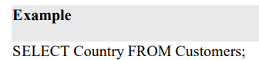
Now, let us use the SELECT DISTINCT statement and see the result.
SELECT DISTINCT Examples
The following SQL statement selects only the DISTINCT values from the "Country" column in the "Customers" table:
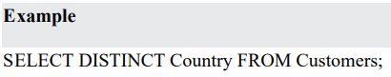
The following SQL statement counts and returns the number of different (distinct) countries in the "Customers" table:
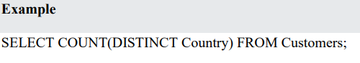
- SQL aggregate function
An aggregate function in SQL performs a calculation on multiple values and returns a single value.
An aggregate function in SQL returns one value after calculating multiple values of a column. We often use aggregate functions with the GROUP BY and HAVING clauses of the SELECT statement.
An aggregate function ignores NULL values when it performs the calculation, except for the count function.

There are 5 types of SQL aggregate functions:
- AVG: calculates the average of a set of values.
- SUM: calculates the sum of values.
- MIN: gets the minimum value in a set of values.
- MAX: gets the maximum value in a set of values.
- COUNT: counts rows in a specified table or view.
Example:
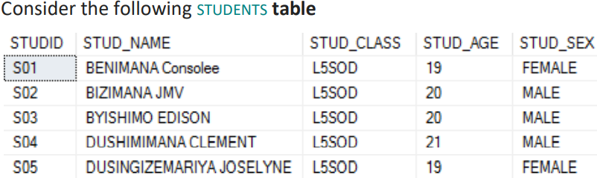

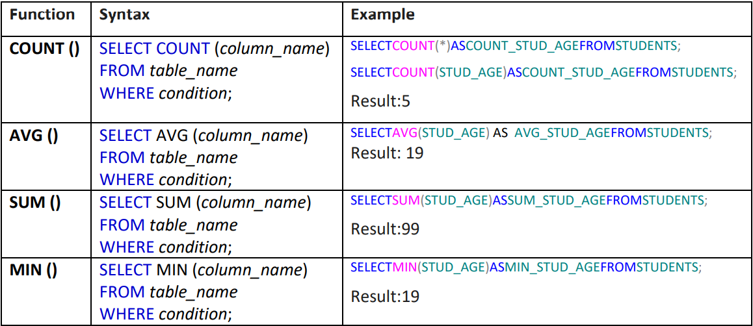
- SQL clause
- SQL clause helps us to retrieve a set or bundles of records from the table.
- SQL clause helps us to specify a condition on the columns or the records of a table.

Different clauses available in the Structured Query Language are as follows:
1. WHERE CLAUSE
2. GROUP BY CLAUSE
3. HAVING CLAUSE
4. ORDER BY CLAUSE

1. WHERE CLAUSE
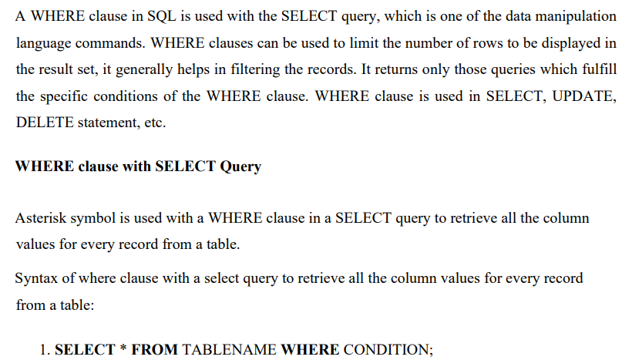
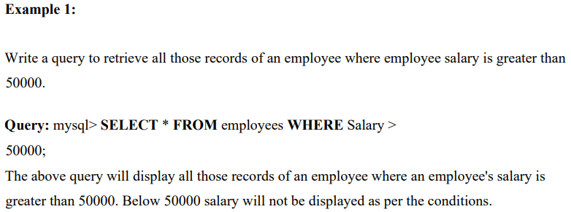

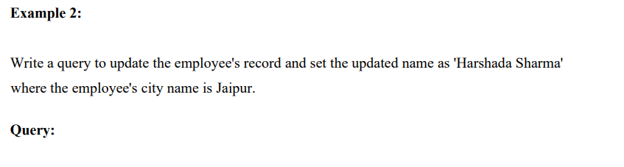mysql> UPDATE employees SET Name = "Harshada Sharma" WHERE City = "Jaipur";
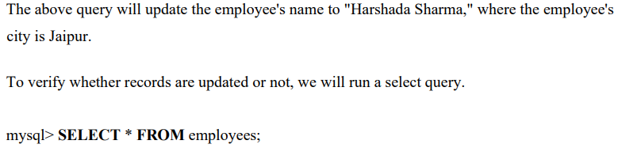
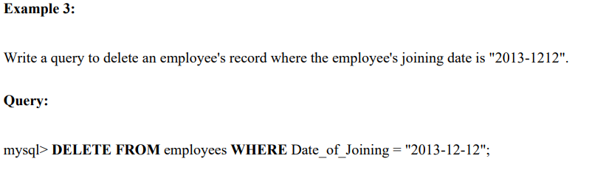
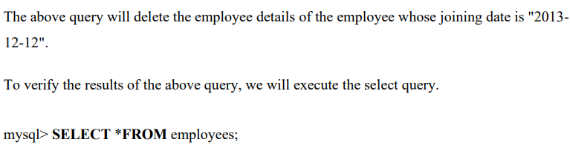

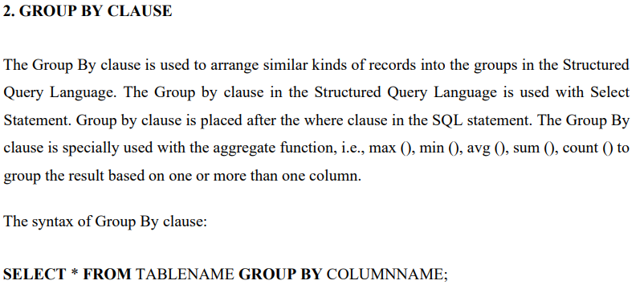
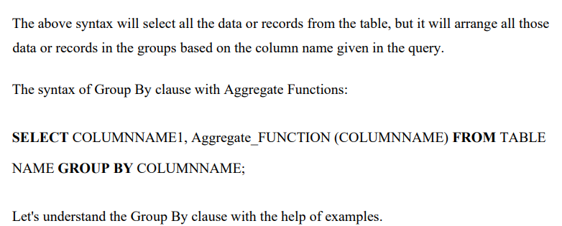
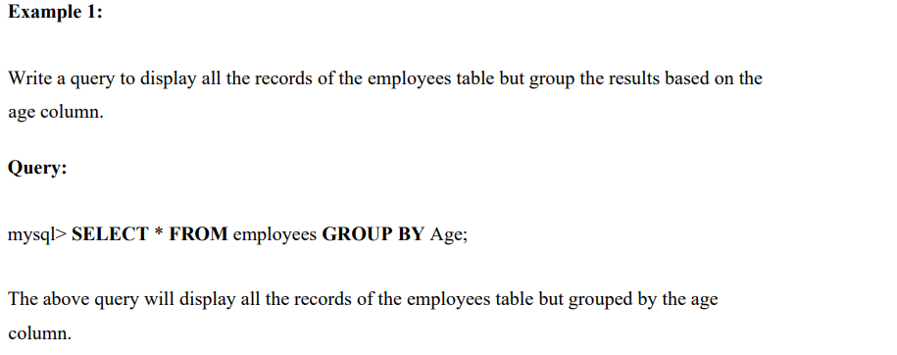
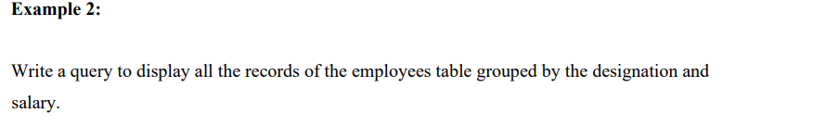
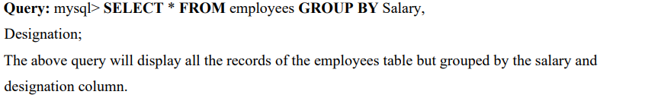

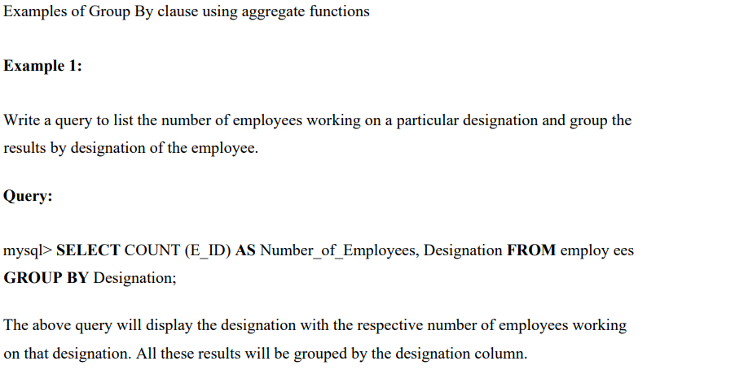
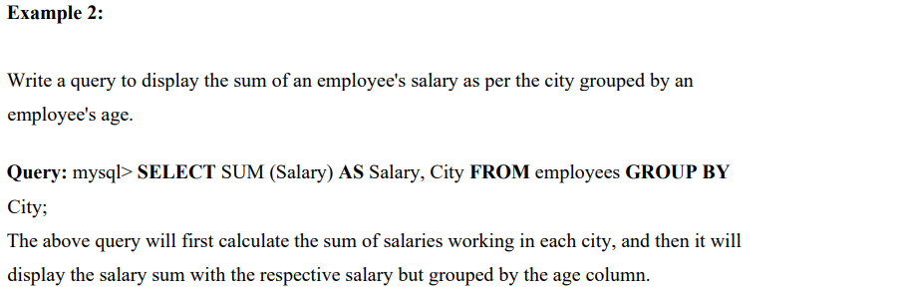
3. HAVING CLAUSE
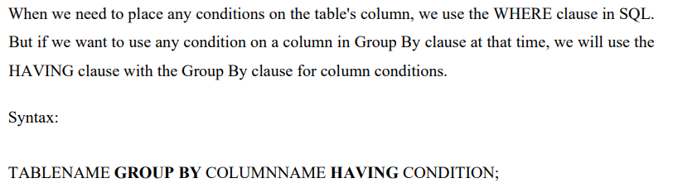
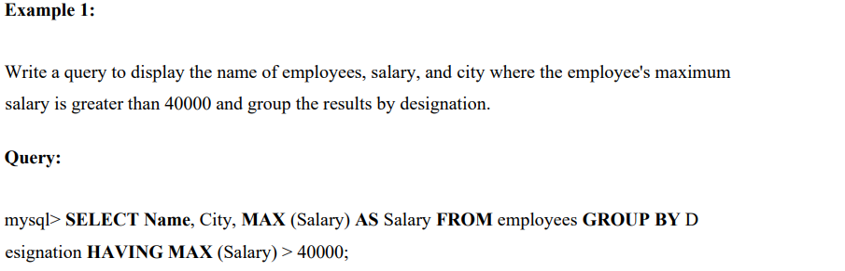
Example 2:

4. ORDER BY CLAUSE
Whenever we want to sort anything in SQL, we use the ORDER BY clause.
The ORDER BY clause in SQL will help us to sort the data based on the specific column of a table.
As we all know, sorting means either in ASCENDING ORDER or DESCENDING ORDER. In the same way, ORDER BY CLAUSE sorts the data in ascending or descending order as per our requirement. The data will be sorted in ascending order whenever the ASC keyword is used with ORDER by clause, and the DESC keyword will sort the records in descending order.
By default, sorting in the SQL will be done using the ORDER BY clause in ASCENDING order if we didn't mention the sorting order.
Syntax of ORDER BY clause without asc and desc keyword:
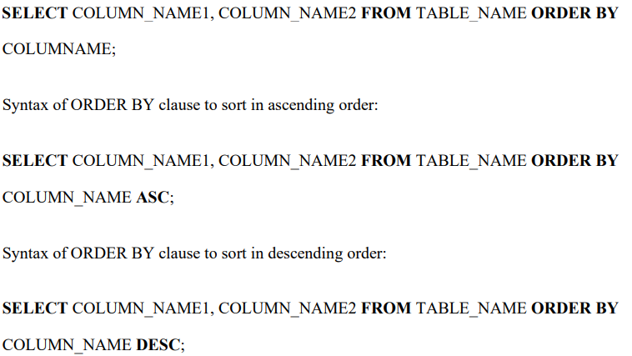
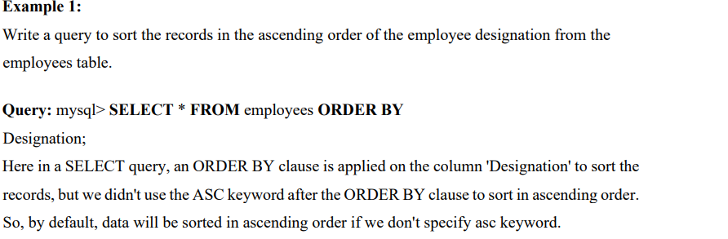
Example 2:
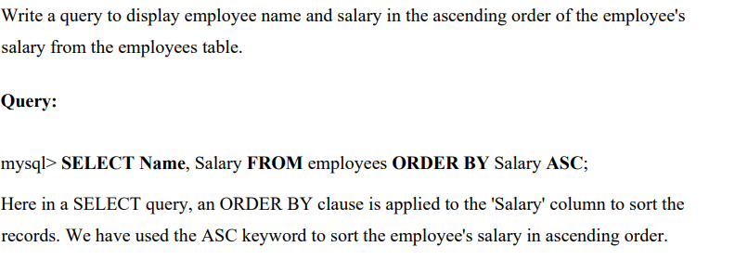
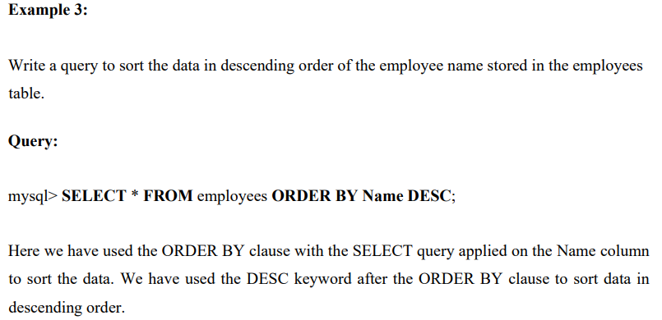

Application of DCL commands

DCL commands are used to manage database security and access control.

The two primary DCL commands are:
• GRANT: Used to grant specific privileges to database users or roles.
• REVOKE: Used to revoke previously granted privileges.
Some common privileges include:
- `ALL PRIVILEGES`: The user is granted all privileges except GRANT OPTION and PROXY.
- `ALTER`: The user can change the structure of a table or database.
- `CREATE`: The user can create new databases and tables.
- `DELETE`: The user can delete rows in a table.
- `INSERT`: The user can add rows to a table.
- `SELECT`: The user can read rows from a table.
- `UPDATE`: The user can update rows in a table.

- GRANT Statement
The grant statement enables system administrators to assign privileges and roles to the MySQL user accounts so that they can use the assigned permission on the database whenever required.

Syntax
The following are the basic syntax of using the GRANT statement:
GRANT privilege_name(s) ON object TO user_account_name;

Parameter Explanation
In the above syntax, we can have the following parameters:
Parameter Name | Descriptions
privilege_name(s) | It specifies the access rights or grant privilege to user accounts. If we want to give multiple privileges, then use a comma operator to separate them.
object | It determines the privilege level on which the access rights are being granted. It means granting privilege to the table; then the object should be the name of the table.
user_account_name | It determines the account name of the user to whom the access rights would be granted.

Example:
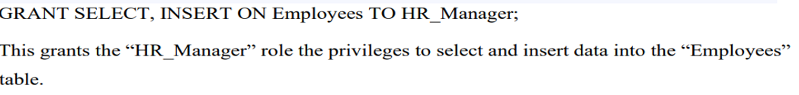
- REVOKE statement
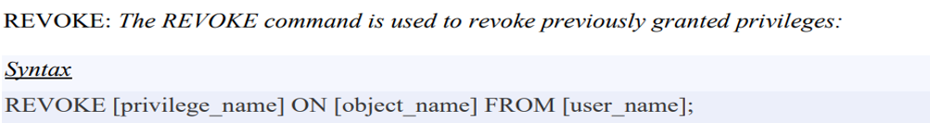
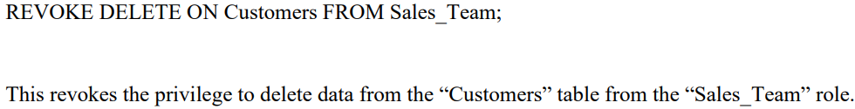

3.6 Application of TCL commands
- Database transaction control:
What is a transaction?
A transaction, in the context of a database, is a logical unit that is independently executed for data retrieval or updates.

A database transaction is a series of one or more operations executed as a single atomic unit of work.

Experts talk about a database transaction as a “unit of work” that is achieved within a database design environment.

The effects of all the SQL statements in a transaction can be either all committed (applied to the database) or all rolled back (undone from the database), insuring data consistency.

Transactions have the following four standard properties, usually referred to by the acronym
ACID.

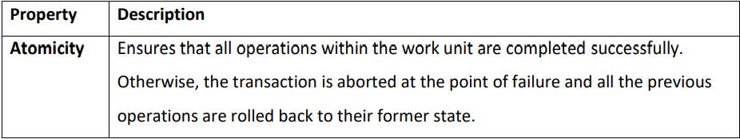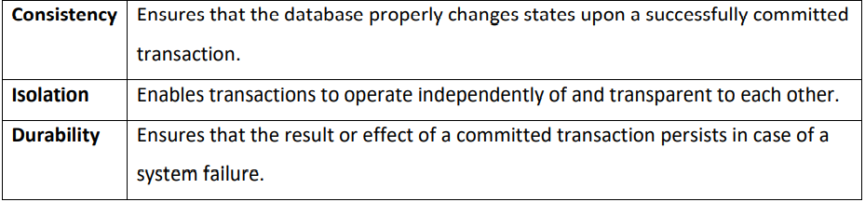

The following commands are used to control transactions but we are going to focus on the first three.
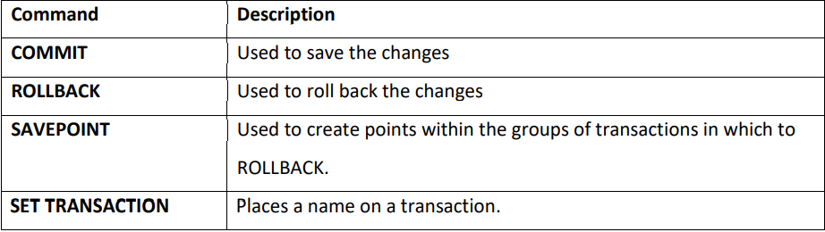

Transactional control commands are only used with the DML Commands such as INSERT, UPDATE and DELETE only.

They cannot be used while creating tables or dropping them because these operations are automatically committed in the database.

- COMMIT
The COMMIT Command The COMMIT command is the transactional command used to save changes invoked by a transaction to the database.
The COMMIT command is the transactional command used to save changes invoked by a transaction to the database. The COMMIT command saves all the transactions to the database.

The syntax for the COMMIT command is as follows.
COMMIT;
Example Consider the CUSTOMER table having the following records.
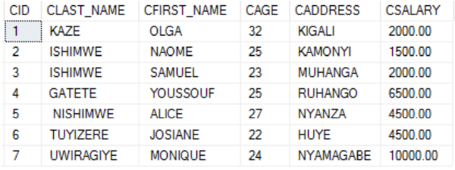
Following is an example which would delete those records from the table which have age = 24 and then COMMIT the changes in the database.

BEGIN / START TRANSACTION
DELETE FROM CUSTOMER WHERE CAGE= 24;
COMMIT;

- ROLLBACK
The ROLLBACK command is the transactional command used to undo transactions that have not already been saved to the database.
This command can only be used to undo transactions since the last COMMIT or ROLLBACK command was issued.
The syntax for a ROLLBACK command is as follows
ROLLBACK;
Example: Consider the CUSTOMER table having the following records
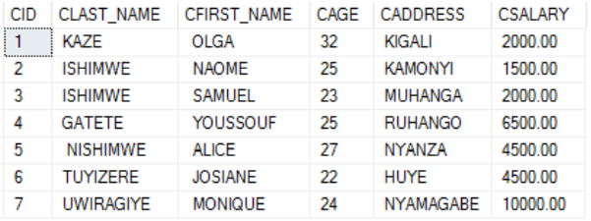
Following is an example, which would delete those records from the table which have the age = 24 and then ROLLBACK the changes in the database.
BEGIN / START TRANSACTION
DELETE FROM CUSTOMER WHERE CAGE= 24;
ROLLBACK;

Thus, the delete operation would not impact the table and the SELECT statement would produce the following result.
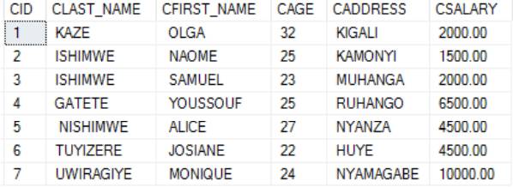

- SAVEPOINT
A SAVEPOINT is a point in a transaction when you can roll the transaction back to a certain point without rolling back the entire transaction.

The syntax for a SAVEPOINT command is as shown below.
SAVEPOINT SAVEPOINT_NAME;
This command serves only in the creation of a SAVEPOINT among all the transactional statements.
The ROLLBACK command is used to undo a group of transactions.
The syntax for rolling back to a SAVEPOINT is as shown below.
ROLLBACK TO SAVEPOINT_NAME;
Following is an example where you plan to delete the three different records from the CUSTOMER table.
You want to create a SAVEPOINT before each delete, so that you can ROLLBACK to any SAVEPOINT at any time to return the appropriate data to its original state.

- SET Transaction
The SET TRANSACTION Statement in MYSQL is used to set the values to the characteristics of the current transaction such as transaction isolation level and access mode.
Use the SET TRANSACTION statement to establish the current transaction as read-only or read/write, establish its isolation level, assign it to a specified rollback segment, or assign a name to the transaction.
A transaction implicitly begins with any operation that obtains a TX lock:
- When a statement that modifies data is issued
- When a SELECT ... FOR UPDATE statement is issued
- When a transaction is explicitly started with a SET TRANSACTION statement or the DBMS_TRANSACTION package
Issuing either a COMMIT or ROLLBACK statement explicitly ends the current transaction.
The operations performed by a SET TRANSACTION statement affect only your current transaction, not other users or other transactions.

Your transaction ends whenever you issue a COMMIT or ROLLBACK statement.

- SET Constraints
What is a SQL constraint?
SQL constraints are rules that allow data to be entered into a table only if it meets the predefined conditions.

They are part of your database schema, the broader set of rules that governs your database.
Constraints are used to limit the type of data that can go into a table. This ensures the accuracy and reliability of the data in the table. If there is any violation between the constraint and the data action, the action is aborted.
Constraints can be column level or table level. Column level constraints apply to a column, and table level constraints apply to the whole table.
The following constraints are commonly used in SQL:
- NOT NULL: Ensures that a column cannot have a NULL value
- UNIQUE: Ensures that all values in a column are different
- PRIMARY KEY: A combination of a NOT NULL and UNIQUE. Uniquely identifies each row in a table
- FOREIGN KEY: Prevents actions that would destroy links between tables
- CHECK: Ensures that the values in a column satisfies a specific condition
- DEFAULT: Sets a default value for a column if no value is specified
- CREATE INDEX: Used to create and retrieve data from the database very quickly

END OF LO 3

