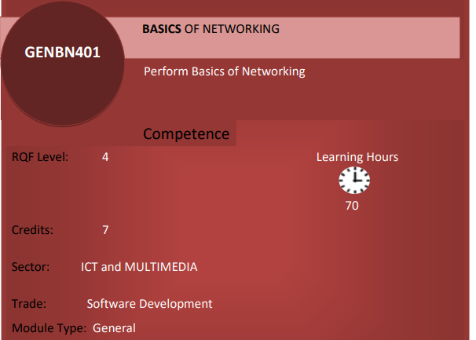

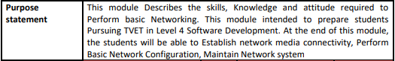

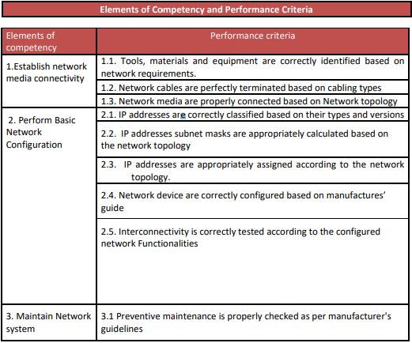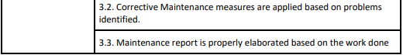

LO 1: Establish network media connectivity
1.1. Identification of Network requirements.
A. Description of network concepts and technologies
- Basic definitions
- Network: A network is a collection of computers and devices that are connected together to enable communication and data exchange.

- Nodes: Nodes are devices that are connected to a network. These can include computers, Servers, Printers, Routers, Switches, and other devices.

- Protocol: A protocol is a set of rules and standards that govern how data is transmitted over a network.
Examples of protocols include TCP/IP, HTTP, and FTP.

- Topology: Network topology refers to the physical and logical arrangement of nodes on a network.
The common network topologies include bus, star, ring, mesh, and tree.
- A network service provider (NSP): It is a company owns, operates and sells access to Internet backbone infrastructure and services.
The primary customers of NSPs are other service providers, including internet service providers (ISPs), which, in turn, sell internet access to businesses and consumers.

- Service Provider Networks: These types of Networks give permission to take Network Capacity and Functionality on lease from the Provider.

- IP Address: An IP address is a unique numerical identifier that is assigned to every device on a network. I
P addresses are used to identify devices and enable communication between them.
- DNS: The Domain Name System (DNS) is a protocol that is used to translate human-readable domain names (such as www.google.com) into IP addresses that computers can understand.

- Firewall: A firewall is a security device that is used to monitor and control incoming and outgoing network traffic.
Firewalls are used to protect networks from unauthorized access and other security threats.

- Network classifications
- CLASSIFYING NETWORK BY GEOGRAPHICAL AREA (size)
There are mainly five types of Computer Networks based on geographical area
- Personal Area Network (PAN)
- Local Area Network (LAN)
- Campus Area Network (CAN)
- Metropolitan Area Network (MAN)
- Wide Area Network (WAN)
- Global Area Network (GAN)
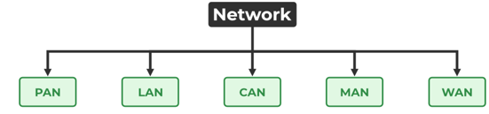

Let’s discuss about types of computer networks:

1. Personal Area Network (PAN)
PAN (Personal Area Network) is a computer network formed around a person.
It generally consists of a computer, mobile, or personal digital assistant and any other devices.

Characteristics of PAN
Below are the main characteristics of PAN:
- It is mostly personal devices network equipped within a limited area.
- Allows you to handle the interconnection of IT devices at the surrounding of a single user.

Advantages of PAN
Here are the important pros/benefits of PAN network:
- PAN networks are relatively secure and safe
Disadvantages of PAN
- It may establish a bad connection to other networks at the same radio bands.
- Distance limits.

2. Local Area Network (LAN)
A Local Area Network (LAN) is a group of computer and peripheral devices which are connected in a limited area such as school, laboratory, home, and office building.
It is a widely useful network for sharing resources like files, printers, games, and other application.
It is a network which consists of less than 5000 interconnected devices across several buildings.

Characteristics of LAN
Here are the important characteristics of a LAN network:
- It is a private network, so an outside regulatory body never controls it.
- LAN operates at a relatively higher speed compared to other WAN systems.
- There are various kinds of media access control methods like token ring and ethernet.

Advantages of LAN
- Computer resources like hard-disks, DVD-ROM, and printers can share local area networks. This significantly reduces the cost of hardware purchases.
- You can use the same software over the network instead of purchasing the licensed software for each client in the network.
- Data of all network users can be stored on a single hard disk of the server computer.
- You can easily transfer data and messages over networked computers.
- It will be easy to manage data at only one place, which makes data more secure.
- Local Area Network offers the facility to share a single internet connection among all the LAN users.

Disadvantages of LAN
Here are the cons/drawbacks of LAN:
- The initial cost of installing Local Area Networks is quite high.
- The LAN admin can check personal data files of every LAN user, so it does not offer good privacy.
- Unauthorized users can access critical data of an organization in case LAN admin is not able to secure centralized data repository.
- Local Area Network requires a constant LAN administration as there are issues related to software setup and hardware failures

3. Campus Area Network (CAN)
This is a type of computer network that is usually used in places like a school or colleges.
CAN is bigger than a LAN but smaller than a MAN.

This network covers a limited geographical area that is, it spreads across several buildings within the campus.
Examples of CAN are networks that cover schools, colleges, buildings, etc.

Advantages of Campus Area Network
Here are some of the advantages of CAN:
- High-speed connectivity: CANs provide fast and reliable connectivity for devices within the network.
- Cost-effective: Compared to Wide Area Networks (WANs), CANs are less expensive to maintain and set up.
- Scalability: CANs can easily be scaled up or down as needed, making them a flexible solution per the changing network needs.
- Enhanced security: CANs typically employ advanced security measures, such as firewalls, IDS, etc., in order to protect against unauthorized access and data breaches.
- Centralized management: With a CAN, network administrators can manage all connected devices from a central location. Thus, simplifying network management and troubleshooting.

Disadvantages of Campus Area Network
Here are some of the disadvantages of CAN:
- Limited range: CANs are designed to cover a relatively small geographical area.
Hence they are not suitable for organizations with widely dispersed locations.

- Dependency on infrastructure: CANs generally rely on physical infrastructure, such as cables or Wi-Fi access points, to connect devices. Hence, if any infrastructure disruption occurs, it will impact network performance and connectivity.
- Single point of failure: As we know, CANs are centralized networks. Hence, any failure of the central network component, such as a router or switch, can cause the entire network to go down.
- Cost: While CANs are generally less expensive than wide area networks (WANs), they can still be costly to set up and maintain, particularly for smaller organizations with limited budgets.
4. Metropolitan Area Network (MAN)
This is the type of computer network that connects computers over a geographical distance through a shared communication path over a city, town, or metropolitan area.

Characteristics of MAN
- It mostly covers towns and cities in a maximum.
- Mostly used medium is optical fibers, cables
- Data rates adequate for distributed computing applications.

Advantages of MAN
Here are the pros/benefits of MAN network:
- It offers fast communication using high-speed carriers, like fiber optic cables.
- It provides excellent support for an extensive size network and greater access to WANs.
- The dual bus in MAN network provides support to transmit data in both directions concurrently.

Disadvantages of MAN
Here are drawbacks/cons of using the MAN network:
- You need more cable to establish MAN connection from one place to another.
- In MAN network it is tough to make the system secure from hackers

5. WAN (Wide Area Network):

A Wide Area Network is a network that extends over a large geographical area such as states or countries.

Characteristics of WAN
Below are the characteristics of WAN:
- The software files will be shared among all the users; therefore, all can access to the latest files.
- Any organization can form its global integrated network using WAN.

Advantages of WAN
Here are the benefits/pros of WAN:
- WAN helps you to cover a larger geographical area. Therefore business offices situated at longer distances can easily communicate.
- Contains devices like mobile phones, laptop, tablet, computers, gaming consoles, etc.
- WLAN connections work using radio transmitters and receivers built into client devices.
6. Global Area Network (GAN): A network that covers a global or international scale, often using satellite links and undersea cables. The internet can be considered a GAN.

Disadvantages of WAN
Here are the drawbacks/cons of WAN network:
- The initial setup cost of investment is very high.
- It is difficult to maintain the WAN network. You need skilled technicians and network administrators.
- There are more errors and issues because of the wide coverage and the use of different technologies.
- It requires more time to resolve issues because of the involvement of multiple wired and wireless technologies.
- Offers lower security compared to other types of network in computer.

Other Types of Computer Networks
Apart from above mentioned computer networks, here are some other important types of networks:
- WLAN (Wireless Local Area Network)
- Storage Area Network
- System Area Network
- Home Area Network
- POLAN- Passive Optical LAN
- Enterprise private network
- Virtual Area Network

Classification of Computer Network on basis of Architecture
Two of the most widely used types of network architecture are: Peer-to-Peer Network and Client/Server Network.

1. Peer-to-Peer Network :
In the simplest terms, a peer-to-peer network is a network created whenever two or more devices (usually a computer) are connected and share resources.
This model does not differentiate the clients and the servers, in this each and every node is itself client and server.
In Peer-to-Peer Network, Each and every node can do both request and respond for the services. It can be said that each of computers on P2P network usually becomes file server even as client also. In this architecture, system is generally decomposed into various computational nodes that contain the same and equivalent capabilities, abilities, and responsibilities.
Each and every computer in this network are treated same and equally and might send even receive message directly.
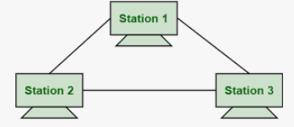

2. Client/Server Network :
It is a network model or architecture between a client and the server where the client sends a request, and the job of the server is to fulfil whatever the client’s request is.
In Client-Server Network, Clients and server are differentiated, specific server and clients are present.
In Client-Server Network, Centralized server is used to store the data because its management is centralized. In Client-Server Network, Server respond the services, which is request by Client.
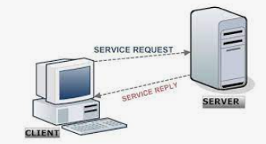
Difference between a Client and Server
A client is a computer that connects to a server in order to access resources or services. A server is a powerful computer that provides those resources or services to client.
- Network benefits
Main benefits of networks include:
1. File sharing: you can easily share data between different users, or access it remotely if you keep it on other connected devices.
2. Resource sharing: All computers in the network can share resources such as printers, fax machines, modems, and scanners.
3. Sharing a single internet connection: It is cost-efficient and can help protect your systems if you properly secure the network.
4. Increasing storage capacity: you can access files and multimedia, such as images and music, which you store remotely on other machines or network-attached storage devices.
5. Staff, suppliers and customers can share information and get in touch more easily.

- Advantages of computer network
Some of the main advantages of Computer Networking are discussed below:
- Central Storage of Data: Files can be stored on a central node (the file server) that can be shared and made available to every user in an organization.

- Connectivity: There is a negligible range of abilities required to connect to a modern computer network. The ease of joining makes it workable for even youthful kids to start exploring the data.
- Faster Problem-solving: Since an extensive procedure is disintegrated into a few littler procedures and each is taken care of by all the associated gadgets, an explicit issue can be settled in lesser time.
- Reliability: Reliability implies backing up information. Due to some reason equipment crashes, and so on.
- Flexible: This innovation is known to be truly adaptable, as it offers clients the chance to investigate everything about fundamental things, for example, programming without influencing their usefulness.
- Security through Authorization: Security and protection of information are additionally settled through the system. As just the system clients are approved to get to specific records or applications, no other individual can crack the protection or security of information.
- Storage capacity: Since you will share data, records, and assets with other individuals, you need to guarantee all information and substance are legitimately put away in the framework. With this systems administration innovation, you can do most of this with no issue, while having all the space you require for capacity.

- Disadvantages of computer network
Some of the main disadvantages of Computer Networking are discussed below:
- Expensive: Execution of the network can be expensive in the case of an initial setup, as the wires and the cost of the cable are high and sometimes equipment is also costly.

- Virus and Malware: Computer Networking can lead to the spreading of viruses to another computer through the network.

- Management of the network: Management of the Network is quite difficult as it requires skilled persons to handle that large network. It requires training of people who are employed in this work.

- Loss of Information: In case of a crash of the Computer Network, it can lead to the loss of information or not being able to access information for some time.

- The system can be Hacked: In the case of Wide Area Networks(WAN), there is a threat of Hacking of the System. Some security features should be added to prevent such things.

- Application of network
Some of the applications of Computer Networking are discussed below:
- Resource Sharing: Resource Sharing is one of the important applications of Computer Networking.
You can share a single software among Multiple users. We can also share Hardware Devices via this technique.
- Communication: Communication Medium means various ways through which we can communicate like Email Calls, broadcasts, etc.
- Home Applications: Home Applications are an important application of Computer Networking.
Examples are User-to-User Communication, Entertainment, E-Commerce, etc.
- Business Applications: Business Application is also an important application of Computer Networking. Almost all companies are doing business online with the help of Computer Networking.
- Social Media: Social Media is one of the recent and widely used applications of Computer Networking. It helps people in getting news, feed, current trending topics of all types, etc.
- Access to Remote Information: Computer Networking helps in accessing remote information from the end-users.
For Example. details required for train tickets, plane tickets, etc.
- Cloud Computing: Computer Networking has facilitated the development of cloud computing, which allows users to store and access data and applications from remote servers via the internet.
- Virtualization: Networking technologies also enable virtualization, which allows multiple virtual machines to run on a single physical machine, improving resource utilization and reducing costs.
- Online Education: Computer Networking has revolutionized education by providing online learning platforms, distance education, and virtual classrooms.
- Remote Working: Networking technologies have enabled remote working, allowing employees to work from home or other locations outside of the office.
This has become especially important during the COVID-19 pandemic.
- E-commerce: Computer Networking has facilitated the growth of e-commerce by allowing businesses to sell their products and services online and reach a global market.
- Telemedicine: Networking technologies have also enabled telemedicine, allowing doctors and healthcare providers to provide remote medical consultations and diagnosis to patients in remote locations.
- Real-time Collaboration: Networking technologies enable real-time collaboration, allowing people to work together on projects and share information in real-time, no matter where they are located.
- Entertainment: Computer Network provides many sources of entertainment to people.
For example, we can play different types of games, see movies, and listen to music. We can also make new friends on the internet.

- Network technologies
Network technology refers to a collection of technologies used for data transmission across computer networks.
It enables communication and data transmission between computers, facilitating connectivity over the Internet or other network.
Network technologies have long been segmented into two broad categories: wired and wireless networks.
- Wired Networks
A wired network is one where the devices in the network are connected using cables.
It uses cables to connect devices, such as laptop or desktop computers, to the Internet or another network.

These are typically reserved for fixed-location applications where mobility isn’t a prime concern.
They offer high reliability and can often support larger data transfer rates, making them ideal for infrastructure-heavy environments like corporate offices or server rooms.
- Wireless Networks
Wireless networks are computer networks that are not connected by cables of any kind, they use wireless data connections between network nodes.
A wireless network refers to a computer network that makes use of Radio Frequency (RF) connections between nodes in the network

Difference Between Wired and Wireless Networks
 | Factors | Wired Networks | Wireless Networks
1. | Connectivity | Wired networks use physical cables to connect devices together. | Wireless networks use radio waves (Wi-Fi) or infrared signals (Bluetooth) to connect devices without cables.
2. | Security | Wired networks are generally considered to be more secure than wireless networks. | Wireless networks are considered less secure than wired networks.
3. | Speed | Wired networks typically offer faster and more stable speeds than wireless networks. | Speed of wireless networks are typically slow and less stable as compared to wire networks.
4. | Mobility / Flexibility | Wired networks provide less mobility or flexibility than wireless networks, as devices must be connected to cables. | Wireless networks provide greater mobility and flexibility than wired networks, as devices can connect from anywhere within range of the wireless signal.
5. | Cost | Wired networks can be more expensive to set up initially. | Wireless networks may have lower initial costs.
6. | Setup and maintenance | Wired networks generally require more time and effort to set up and maintain. | Wireless networks are typically easier to set up, but may require more maintenance.
7. | Network range | Wired networks have a greater range than wireless networks. | Wireless networks have a shorter range than wired networks.
8. | Interference | Wired networks are less susceptible to interference from other wireless signals than wireless networks. | Wireless networks are more susceptible to interference from other wireless signals than wired networks.

- Network topology types
A Network Topology is the arrangement with which computer systems or network devices are connected to each other. It may define both physical and logical aspect of the network.
There are various types of network topology in a computer network, such as:
- Bus Topology
- Ring Topology
- Mesh Topology
- Tree Topology
- Star Topology
- Hybrid Topology

Description of network topologies
- Bus Topology
Bus topology is a type of network topology in which all devices are connected to a single cable called a "bus."

Bus Topology is alternatively mentioned as line topology

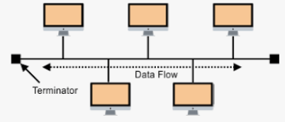
Note:
Terminators are placed at both endpoints of the backbone cable in a bus topology network to prevent signal reflection.

Signal reflection can cause data transmission errors and reduce overall network performance.
Hence, terminators are placed at the ends of the cable to improve network performance.

Advantages of Bus Topology:
- It is the easiest network topology for connecting peripherals or computers in a linear fashion.
- It works very efficiently well when there is a small network.
- The length of cable required is less than a star topology.
- It is easy to connect or remove devices in this network without affecting any other device.
- Very cost-effective as compared to other network topology i.e. mesh and star
- It is easy to understand topology.
- Easy to expand by joining the two cables together.

Disadvantages of Bus Topology :
- Bus topology is not great for large networks.
- Identification of problems becomes difficult if the whole network goes down.
- Troubleshooting individual device issues is very hard.
- Terminators are required at both ends of the main cable.
- Additional devices slow the network down.
- If the main cable is damaged, the whole network fails or splits into two.
- This network topology is very slow as compared to other topologies.

- Ring Topology
Ring topology is a type of network configuration where devices are connected in a circular manner, forming a closed loop.

To create a circular network model, each host machine connects to the other two devices in a ring topology.
When one host tries to send a message or to communicate with a non-adjacent host, the data moves through all the intermediate hosts to reach the desired host.
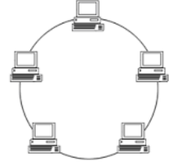

To create a circular network model, each host machine connects to the other two devices in a ring topology.
When one host tries to send a message or to communicate with a non-adjacent host, the data moves through all the intermediate hosts to reach the desired host.

Advantages of a ring topology
- All data flows in one direction, reducing the chance of packet collisions.
- A network server is not needed to control network connectivity between each workstation.
- Data can transfer between workstations at high speeds.
- Additional workstations can be added without impacting performance of the network.

Disadvantages of a ring topology
- All data being transferred over the network must pass through each workstation on the network, which can make it slower than a star topology.
- The entire network will be impacted if one workstation shuts down.
- The hardware needed to connect each workstation to the network is more expensive than Ethernet cards and hubs/switches.

- Star Topology
Star topology is a network topology in which each network component is physically connected to a central node such as a router, hub or switch.
Every node connects to a central network device in this configuration, like a hub, switch, or computer.

The central network device acts as a server, and the peripheral devices act as clients.

In a star topology setup, either a coaxial or a network cable with an RJ-45 connector is used, depending on each device's network card type.
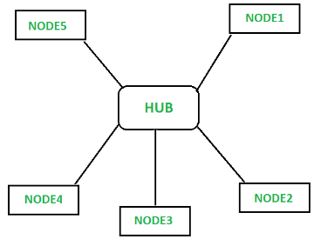
There technically is no limit to how many computers can connect in a star topology. However, network performance can decrease as more computers are connected, resulting in slower network speeds.

Advantages of star topology
- Centralized management of the network through the use of the central computer, hub, or switch.
- Easy to add another computer to the network.
- If one computer on the network fails, the rest of the network continues to function normally.

Disadvantages of star topology
- It may have a higher cost to implement, especially when using a switch or router as the central network device.
- The central network device determines the performance and number of nodes the network can handle.
- If the central computer, hub, or switch fails, the entire network goes down, and all computers are disconnected from the network.
- Mesh Topology
A mesh topology is a type of computer network in which each node (computer or other device) is connected to any other nodes in the network.

This type of network is often used in large organizations or companies because it can handle a large amount of data traffic and can be easily expanded.
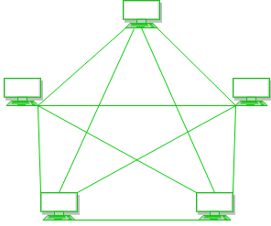

There are two variations: full mesh (all devices connect to all others) and partial mesh (only some devices connect to all others).

1. Full Mesh Topology :
All the nodes within the network are connected with every other. If there are n number of nodes during a network, each node will have an n-1 number of connections.
A full mesh provides an excellent deal of redundancy, but because it is prohibitively expensive to implement, it’s usually reserved for network backbones.
2. Partial Mesh Topology :
The partial mesh is more practical as compared to the full mesh. In a partially connected mesh, all the nodes aren’t necessary to be connected with one another during a network.
Advantages of Mesh Topology :
- Failure during a single device will not break the network.
- There is no traffic problem as there is a dedicated point to point links for every computer.
- This topology provides multiple paths to succeed in the destination and tons of redundancy.
- It provides high privacy and security.
- Data transmission is more consistent because failure doesn’t disrupt its processes.
- Adding new devices will not disrupt data transmissions.
- A mesh doesn’t have a centralized authority.

Disadvantages of Mesh Topology:
- It is costly as compared to the opposite network topologies i.e. star, bus, point-to-point topology.
- Installation is extremely difficult in the mesh.
- Power requirement is higher as all the nodes will need to remain active all the time and share the load.
- The cost to implement mesh is above other selections.
- Maintenance needs are challenging with a mesh.

- Tree Topology
A tree topology is a special type of structure where many connected elements are arranged like the branches of a tree.

For example, tree topologies are frequently used to organize the computers in a corporate network, or the information in a database.

In a tree topology, there can be only one connection between any two connected nodes.
Because any two nodes can have only one mutual connection, tree topologies create a natural parent and child hierarchy.
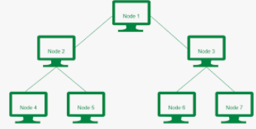

Benefits of Tree Topology
There are several benefits to using tree topology compared to other network topologies, including:
- It can accommodate a large number of nodes.
- It allows for easy expansion.
- Moreover, tree topologies offer high scalability and can be conveniently reconfigured.

Limitations of Tree Topology
- Troubleshooting can be challenging in a tree topology since each node is linked to multiple other nodes, making it difficult to pinpoint the location of the issue.
- Compared to other topologies like star or mesh, tree topology can be less reliable as there are more potential points of failure. If one node fails, it can disrupt the entire network.
- Implementing a tree topology can be more costly as it requires more cabling and equipment than other topologies.
- Hybrid Topology
Hybrid topology is a type of network topology in which two or more different topologies are integrated or combined to lay out a network.
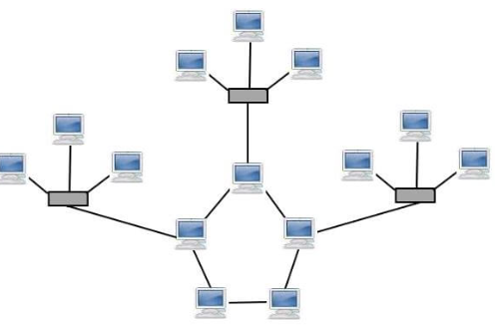

Types of Hybrid Topology
Hybrid Topology is of various types that are listed below. Like different network topologies, hybrid topology is also similar as it also depends on the IP Address. Some types of Hybrid Topology are:
- Star-Ring Hybrid Topology
- Star-Bus Hybrid Topology

1. Star-Ring Hybrid Topology
Star-Ring Hybrid Topology is the mixture or combination of Star Topology and Ring Topology. In Star-Ring Hybrid topology, star topologies are joined to each other via a ring in a wired connection. In Star-Ring Topology, the flow of data can be unidirectional or bidirectional.
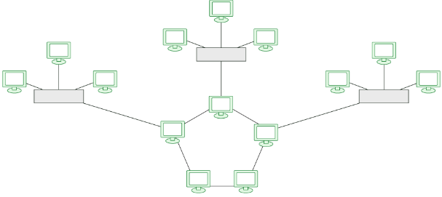

2. Star-Bus Hybrid Topology
Star Bus Hybrid Topology is a combination of Star Topology and Bus Topology. Here, the star networks are connected to the cable of the Bus Topology. In the figure mentioned below, you can easily get to know how Star and Bus are interconnected in Star Bus Hybrid Topology.
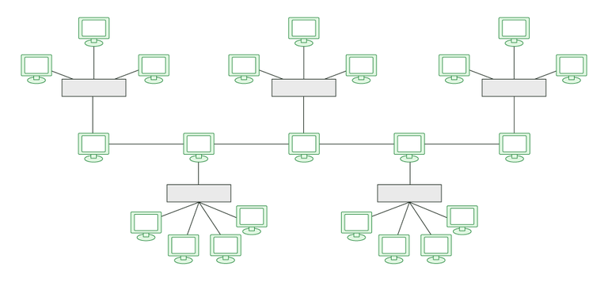

Advantages of Hybrid Topology
- This type of topology combines the benefits of different types of topologies in one topology.
- Can be modified as per requirement.
- It is extremely flexible.
- It is very reliable.
- It is easily scalable as Hybrid networks are built in a fashion which enables easy integration of new hardware components.
- Error detecting and troubleshooting are easy.
- Handles a large volume of traffic.
- It is used to create large networks.
- The speed of the topology becomes fast when two topologies are put together.

Disadvantages of Hybrid Topology
- It is a type of network expensive.
- The design of a hybrid network is very complex.
- There is a change in the hardware to connect one topology with another topology.
- Usually, hybrid architectures are larger in scale so they require a lot of cables in the installation process.
- Hubs which are used to connect two distinct networks are very costly. And hubs are different from usual hubs as they need to be intelligent enough to work with different architectures.
- Installation is a difficult process.

- Network components
A network component is a hardware or software piece that plays a specific role in connecting devices and ensuring data flow within a network.
Computer networks consist of various components that work together to facilitate communication, data sharing, and resource access among connected devices. These components can be categorized into several broad categories:

For example, routers, switches, access points, and network interface cards.

Types of network components
For simplicity of explanation and understanding, we have divided or grouped various network components into two categories in this article, such as:
- Hardware components
- Software components

1. Hardware Components
- Servers: Servers are high-configuration computers that manage the resources of the network.
The network operating system is typically installed in the server and so they give user accesses to the network resources. Servers can be of various kinds: file servers, database servers, print servers etc.
- Clients:Clients are computers that request and receive service from the servers to access and use the network resources.
- Peers:Peers are computers that provide as well as receive services from other peers in a workgroup network.
- Transmission Media: Transmission media are the channels through which data is transferred from one device to another in a network.
Transmission media may be guided media like coaxial cable, fibre optic cables etc; or maybe unguided media like microwaves, infra-red waves etc.

- Connecting Devices: Connecting devices act as middleware between networks or computers, by binding the network media together.

Some of the common connecting devices are:
a. Routers
b. Bridges
c. Hubs
d. Repeaters
e. Gateways
f. Switches

Description of Some of the common connecting devices are:
a. Routers
The router is a network component that is mainly used to send or receive data on the computer network.
The router is designed to receive, analyze, and forward data packets between computer networks.

The process of forwarding data packets from the source to the destination is referred to as Routing.
The main responsibilities of the router are receiving data packets, analyzing them, and then forwarding the data packets among the connected computer networks.
Whenever any data packet arrives, then first of all the router inspects the destination address and then consults with its routing tables in order to decide the optimal route and then transfers the packet along this route towards the destination.
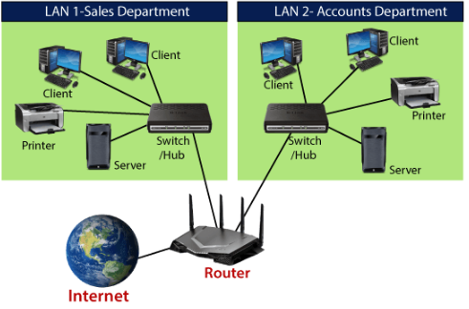
b. Bridges
A bridge is a network device that connects multiple subnetworks to create a single network. It provides interconnection with other computer networks that use the same protocol.
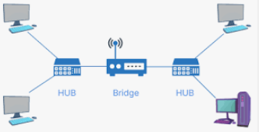
c. Hubs
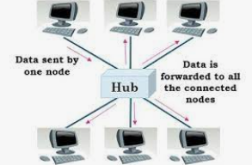

Types of Hubs

Initially, hubs were passive devices. However, with development of advanced technology, active hubs and intelligent hubs came into use.
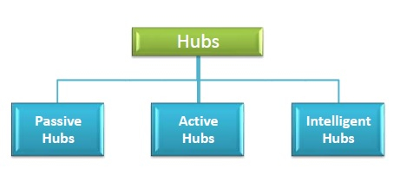
- Passive Hubs:Passive hubs connects nodes in a star configuration by collecting wiring from nodes. They broadcast signals onto the network without amplifying or regenerating them.
As they cannot extend the distance between nodes, they limit the size of the LAN.

- Active Hubs: Active hubs amplify and regenerate the incoming electrical signals before broadcasting them.
They have their own power supply and serves both as a repeater as well as connecting centre.
Due to their regenerating capabilities, they can extend the maximum distance between nodes, thus increasing the size of LAN.

- Intelligent Hubs: Intelligent hubs are active hubs that provide additional network management facilities. They can perform a variety of functions of more intelligent network devices like network management, switching, providing flexible data rates etc.

d. Switches
A network switch is a device that connects computers together into a local area network (LAN).
Network switches allow multiple devices to communicate with each other over a single cable.

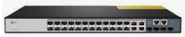
What is the main difference between a hub and a switch?
- Generally, a switch is much faster than a hub and reduces collisions/retransmissions.
- Switches send traffic only to the destination device/port, while hubs broadcast the data to all ports. If you have a choice, a switch will provide more reliable and faster transfers of data.

e. Repeaters
In computer networks, a repeater is a device that amplifies and regenerates signals as they pass through the network.
The primary purpose of a repeater is to extend the distance of a network by increasing the strength and quality of signals over long distances or through dense blocks.

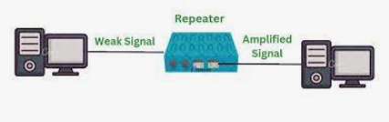

f. Gateways

A gateway in networking is a hardware device or software program that serves as a bridge between two different networks, allowing data to flow from one to the other.

It acts as a “gate” between networks, and it may be used to connect a local network to the internet or to link a local network to another local network (often of a different type).

2. Software Components
- Networking Operating System: Network Operating Systems is typically installed in the server and facilitate workstations in a network to share files, database, applications, printers etc.
- Protocol Suite: A protocol is a rule or guideline followed by each computer for data communication.
Protocol suite is a set of related protocols that are laid down for computer networks.

- Materials
In networking, materials refer to the physical components and resources used to build and maintain the network infrastructure.
These materials are essential for establishing connections, ensuring proper organization, and supporting network operations.

- Network Cables
Networking cable is a piece of networking hardware used to connect one network device to other network devices or to connect two or more computers together.

Network cabling is the process of connecting devices to an Internet source.

Types of network cables
Coaxial cables, twisted pair cables, and Fiber optic cables are the three main types of network cables used in communication systems. Each of them is different and suitable for various applications.

Coaxial cable
Coaxial cable is a type of copper cable specially built with a metal shield and other components engineered to block signal interference.

Cable TV companies to connect their satellite antenna facilities to customer homes and businesses primarily use a coaxial or coax cable.

This cable contains a conductor, insulator, braiding, and sheath. The sheath covers the braiding, the braiding covers the insulation, and the insulation covers the conductor.
The following image shows these components.
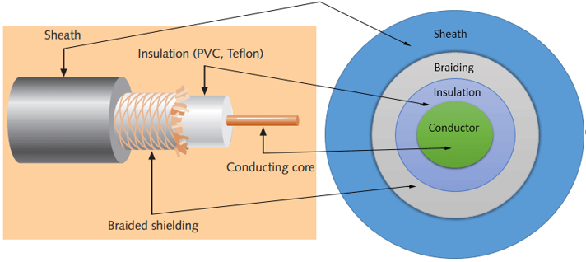

Sheath
This is the outer layer of the coaxial cable. It protects the cable from physical damage.

Braided shield
This shield protects signals from external interference and noise. This shield is built from the same metal that is used to build the core.

Insulation
Insulation protects the core. It also keeps the core separate from the braided shield. Since both the core and the braided shield use the same metal, without this layer, they will touch each other and create a short-circuit in the wire.

Conductor
The conductor carries electromagnetic signals. Based on conductor, a coaxial cable can be categorized into two types; single-core coaxial cable and multi-core coaxial cable.
A single-core coaxial cable uses a single central metal (usually copper) conductor, while a multi-core coaxial cable uses multiple thin strands of metal wires. The following image shows both types of cable.
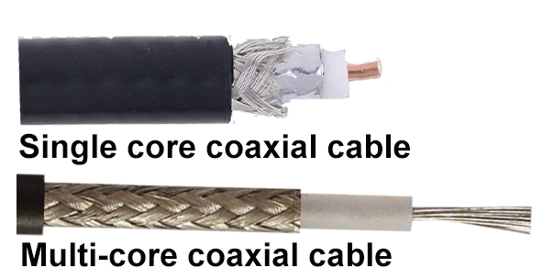
- Twisted pair cable
Twisted pair is a copper wire cable in which two insulated copper wires are twisted around each other to reduce interference or crosstalk.
It is made by putting two separate insulated wires together in a twisted pattern and running them parallel to each other, which helps to reduce crosstalk or electromagnetic induction between pairs of wires.
According to whether the cable has a shielding layer, there are two common types of twisted pair cables:
Shielded twisted pair (STP) cable and unshielded twisted pair (UTP) cable. STP cable is available for Token Ring networks, while the UTP cable is more suitable for Ethernet networks.
- Shielded Twisted Pair (STP) Cable: In STP the wires are covered by a copper braid covering or a foil shield, this foil shield adds a layer that protects it against interference leaking into and out of the cable. Hence, they are used for longer distances and higher transmission rates.

- Unshielded Twisted Pair (UTP) Cable: Unshielded twisted pair cable is one of the most commonly used cables in computer networks at present time. UTP consists of two insulated copper wires twisted around one another, the twisting of wires helps in controlling interference.
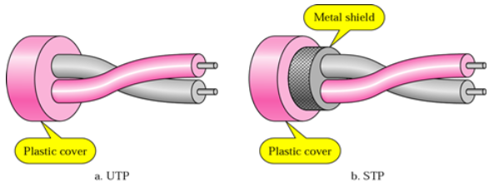
3. Fiber optic cables
This cable is different from the other two cables. The other two cables had an insulating material outside and the conducting material like copper inside.

The optic cable uses light to transmit the information from one place to another. There are two types of fiber optic cables available, One is single-mode (100BaseBx) another one is Multimode (100BaseSX).

Single-mode cables are used for long distance transmission and at a high cost whereas the multimode cables are used for short distance transmission at a very low cost. The optic cables are easy to maintain and install.

Types of Fiber Optics:
- SMF (Single-mode fiber) (100BaseBx) : it uses one single ray of light to transmit data, it is used for long-distance transmission.
- MMF (Multi-mode Fiber) (100BaseSX): it uses multiple light rays to transmit data, it is comparatively less expensive.

Parts of Fibre Optic Cables
The fibre optic cables are mainly made of four parts, they are listed below.
- Core
- Cladding
- Buffer
- Jacket
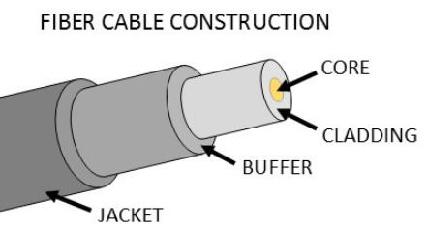
Core: The core is the inner part of the optical fibre. It is the medium, which allows the light to pass through it. The core region has the highest refractive index in the optical fibre.
Cladding: Cladding is the substance that is covered over the core of the optical fibre. It has a lower refractive index while compared to the core of the fibre.
Buffer: The Buffer is the moisture substance that is coated over the surface of the cladding. They are mainly used to provide flexibility to the optical fibre’s core and cladding.
Jacket: The jacket is the outer surface of the optical fibre. They act as a shield for protecting the inner part of the fibre.

Advantages Of Using Fiber-Optic Cabling
The use of fiber-optic cabling offers some big advantages in today’s technologically advancing world and the main ones over copper are set out below.
- Bandwidth :One of the main benefits of using fiber-optic cable is the extremely high bandwidth that it can offer, which is far greater than any of the different categories of copper cable capabilities.
- Distance: Fiber-optic cables are capable of transmitting data over very long distances with a minimal amount of power loss.
- Security: Data security is a huge concern in the communications market and as fiber-optics transfer signals via light, there is no way that the data can be tapped into.
- Size: Fiber-optic cable is a much smaller diameter than coaxial cable and this means there is more space in the transmission.
- Weight: As fiber-optic cables are thinner and made of glass or plastic, they are much lighter and easier to install.
- Future Growth: It is easy to add new equipment to an existing fiber-optic cable infrastructure to accommodate an increase in bandwidth.

Disadvantages Of Using Fiber-Optics
Even though there are some great pros of using fiber-optic transmission, the disadvantages do need to be taken into account.

- Fragility: As fiber-optic cables normally consist of glass they are much more fragile compared to other electrical wires.
- Installation: Fiber-Optic cables are much more difficult to install and can easily get damaged during the process. If you bend a fiber-optic cable too much it will break and also they are not easy to splice.

- Attenuation and Dispersion: As the signal is transmitted over longer distances, the power of the light signal will be attenuated or reduced.
Attenuation is a lot lower for fiber-optic cables compared to the other types of cable. Also, fiber-optics can be affected by dispersion which is when the signal is spread over time.
- Cost: Even though the cost of a fiber-optic cabling installation has dropped dramatically over the last couple of years, it is still a much higher outlay than when installing a structured networking system using other types of cables.

- Cable management
Cable Management is a term used to describe how a cable network is set up. Cable management involves organizing your cables and hardware to be easily identifiable and troubleshot.

- Trunk
Cable trunking is a system used to organize and protect electrical cables or wires in buildings or industrial settings.
It can also be defined as an enclosure usually with a rectangular cross section, and with one removable or hinged side, that is used to protect cables and provide space for other electrical equipment.
They make electrical ducting and cable trunking for concealing and securing cabling.
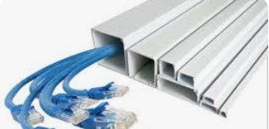

Cable trunk may come in different forms such as:
- Flexible cable trunking is made from polypropylene.
- Plastic
- Timber
- and stainless steel

- Connectors
A connector is a device that terminates a segment of cabling or provides an entry point for network devices such as computers, hubs and routers.
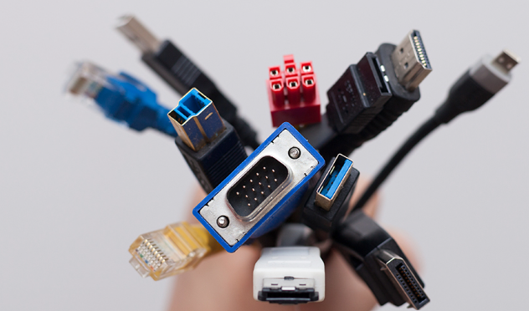
With all the different types of cabling come a number of different cable connectors. This section takes a look at the most common cabling connectors.

Registered Jack 45 (RJ45)
The cable connector that is found on almost all UTP and STP cables is a Registered Jack 45 which is mostly commonly referred to as RJ45. This type of connector resembles the older RJ11 connectors that most people are familiar with from wired telephones.
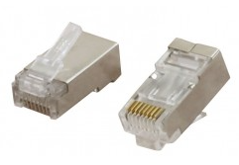

Straight Tip (ST)
The Straight Tip (ST) connector is often seen on the end of a multi-mode cable; it has been commonly seen along with the SC connector for the last 20 years but is being slowly replaced by multi-fiber connectors (LC and MTP).
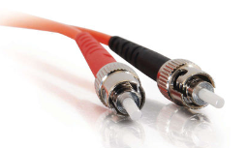

Subscriber Connector (SC)
The Subscriber Connector (SC) can be seen commonly on MMF or SMF; as with SC connectors, the ST connector is slowly being replaced by multi-fiber connectors.
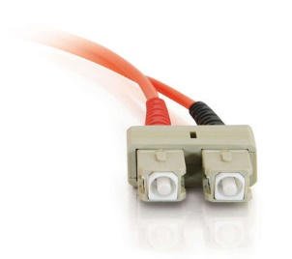

Lucent Connector (LC)
The Lucent Connector (LC) was developed for high-density deployments where multiple fibers would be terminated within a confined space. Unlike the SC and ST connectors, the LC connector is always duplex connecting a pair of fibers at a time.
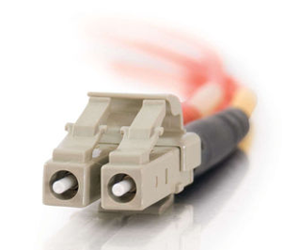

Multi-fiber Push On (MPO)
The Multi-fiber Push On (MPO) connector is another duplex connector that offers an easy options for connection. As the name suggests, it was designed to be able to be connected multiple times without the creation of any potential connector issues.
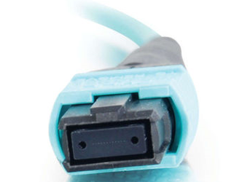
- Cable Ties
A cable tie (also known as a hose tie, zip tie, or tie wrap) is a type of fastener for holding items together, primarily electrical cables and wires.
A cable tie can also be defined as a narrow piece of plastic that can be tied around separate things to hold them together.

- Cable clips
A cable clip is a device that manages wires and cables and secures them to a fixed point on a surface, like a wall, ceiling or floor.


- Cable Sockets
A socket is the fixed product that is attached, usually to a wall or floor, the plug is inserted into.

A socket can also be defined as a a device or point in a wall where you can connect electrical equipment to the power supply.

Cable Sockets are electrical devices that a plug or bulb fits into to make an electrical connection.
Plugs and sockets are coated in hard plastics which are good insulators, preventing the transmission of electricity.

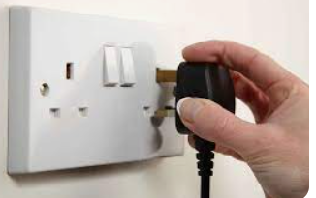

- Wall plugs
A wall plug is an electrical outlet permanently mounted on a wall.
For example it allows screws to be fitted into masonry walls.
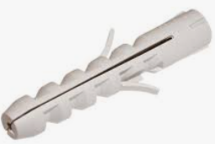

- Tools
A tool is a device, especially one held in the hand, used to carry out a particular function.
A tool is any mechanical device that cuts, turns, grabs, attaches, or provides some other useful function.

- Cutting Tools
Cable cutters are designed to cut various cables, especially electrical cables. The handle of the cable cutter is often insulated to avoid electrical shocks.

This cutter features a sharp blade to cleanly cut cables without destroying the cable construction.

They are mainly used to cut various wires but can also be used to cut materials like plastic and thin metal.
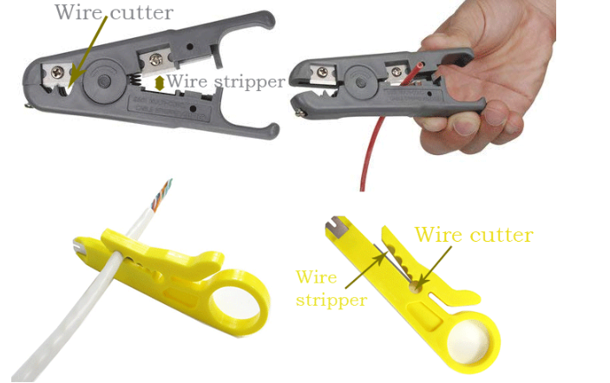

- Stripping tools
A wire stripper is a tool designed to remove the protective covering (jacket) from a cable to expose the inner wires.
A wire stripper tool can also be defined as a small hand-held tool that is used to remove the insulation from electric wires.
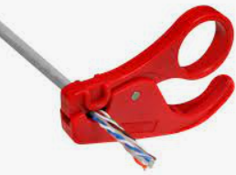

- Drilling Tools
Drilling tools are end-cutting tools designed for producing holes in a workplace.

- Fixing Tool
It is a mechanical tool used to attach one thing to another.


- Patching Tools
Patching tools means to repair something, especially in a simple and temporary way.

A patch management tool is a software that identifies, tests, deploys, and installs software patches (or updates) to computers either manually or via automated methods.
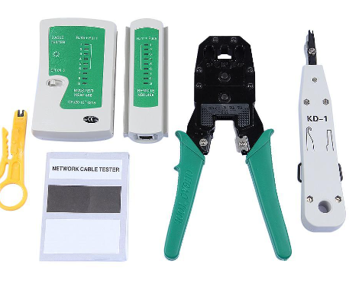

- Crimping tools
This tool is used to attach the connectors to the cable. Typically, this tool also includes a wire-cutter and wire-stripper. So if you buy a crimp tool, you don't have to buy a wire-cutter and wire-stripper separately.
The following image shows a crimping device equipped with a wire-stripper and wire-cutter.
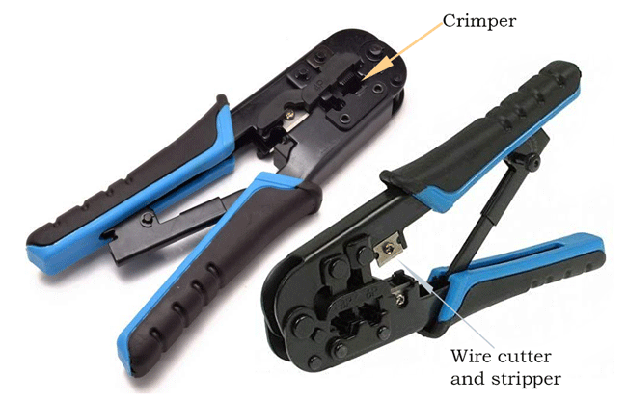

- Testing tool

Network testing tools are a collection of tools that aid in measuring the performance of various aspects of a network.

Network & Cable Testers

- Equipment
Equipment are the necessary items for a particular purpose.

- Computer
A computer is a machine that can be programmed to carry out sequences of arithmetic or logical operations (computation) automatically.

- Inverter
Inverter is a device for converting direct current into alternating current.

- UPS
An uninterruptible power supply (UPS) is a device that allows a computer to keep running for at least a short time when incoming power is interrupted.

- Switch
A network switch connects devices in a network to each other, enabling them to talk by exchanging data packets.

A switch, in the context of networking, is a high-speed device that receives incoming data packets and redirects them to their destination on a local area network (LAN).

- Glue gun
A Glue gun is a usually gun-shaped electric tool used for melting and applying sticks of adhesive.

Glue guns are a popular tool used everywhere from workshops, warehouses, schools, homes, and more.

- Rack
A network rack, also known as a network equipment rack or network cabinet, is a specialized type of rack or cabinet designed to house and organize networking equipment and related hardware in data centers, server rooms, etc.

- Brackets
In computing, a bracket is a punctuation mark used to enclose groups of characters, such as code statements or mathematical expressions.

In networking protocols, brackets are sometimes used to enclose optional parameters or to show that a parameter is needed.
For example, [username]@[hostname] in an email address or https://www.example.com/path/?q= [search term] in a URL.

- Patch panel
A patch panel is a piece of hardware with multiple ports that helps organize a group of cables.
It serves as a part of a LAN, where it connects multiple computers to each other and the outside world.
Basically, according to the cables connected, there are two types of networking patch panel: Ethernet patch panel and fiber optic patch panel. Ethernet patch panel, also called copper patch panel, provides interconnections for Ethernet applications in local area network.
- Repeater
In computer networks, a repeater is a device that amplifies and regenerates signals as they pass through the network.

The primary purpose of a repeater is to extend the distance of a network by increasing the strength and quality of signals over long distances or through dense blocks.

- Regenerator
A regenerator in a telecommunications context is a type of repeater that is used in copper line or optical fiber line transmission systems.
The regenerator is a device that regenerates attenuated signals. A regenerator or amplifier is needed when, due to the long distance between multiplexers, the signal level in the fiber gets attenuated and becomes too low to drive a receiver.
A digital signal travelling a significant distance will become weaker and distorted and require periodic help to continue its journey successfully. This is done with help of regenerators or repeaters.
Repeaters vs regenerators
The repeater amplifies the signal including the noise but the regenerator removes the noise so it's a more useful device.

1.2 Termination of Network cables
A. Network cables installation types.
- Open-Wire
Open-wire construction consists of uninsulated conductors on insulators which are mounted on poles or structures.
The conductor may be bare or it may have a thin covering for protection from corrosion or abrasion.

- Aerial Above-Grounds Conduits
Aerial cable consists of fully insulated conductors suspended above the ground.
Aerial cable consists of suspended above the ground. This type of installation is used increasingly, generally for replacing open wiring, where it provides greater safety and reliability and requires less space.
Properly protected cables are not a safety hazard and are not easily damaged by casual contact.
- Underground
Underground ducts are used where it is necessary to provide a high degree of safety and mechanical protection, or where above-ground conductors would be unattractive.
- Underwater
Submarine cable is used only when no other can be used. It supplies circuits that must cross expanses of water or swampy terrain.

- built-in network cable installations are more permanent, fully concealed within the structure, and offer a high level of aesthetics but are less accessible for maintenance.

- Semi-built-in installations are less permanent, offer some concealment, provide easier accessibility for cable management, and maintain a balance between aesthetics and practicality.

B. Network cables Trunking materials
Trunking refers to an enclosure that protects cables. In most cases, it is rectangular or square in shape and has a lid that can be removed.
They are used to organize and protect electrical cables and wires.
- Plastic
Plastic trunking is a type of cable management system that is made of durable plastic material that can withstand various environmental conditions and can be easily installed on walls or ceilings using screws or adhesive tapes.

- Wood
Wood trunking is a type of cable management system that is made of main substance of the trunk or branches of a tree or shrub, used for fuel or timber.
- Stainless
Stainless trunking is a type of cable management system that is made metal based materials.
C. Cable termination
- twisted pair cabling
Twisted pair cable is special type cabling that is used in telephone communication and Ethernet network. The twisted pair cable is a commonly used cable in the Local Area Network (LAN). It also connects network nodes to network devices or interconnection network devices.
- Fiber-optic cabling
Fiber optics is a technology that uses optical fibers to transmit data as light signals, delivering high bandwidth, electromagnetic immunity, and low signal loss. What are the Components of an Optical Fiber? The main components of an optical fiber are the core, cladding, and jacket
- Coaxial cabling
A Coaxial cable also known as coax is a type of electrical wire that is used for the transmission of radio, TV, and internet signal. It is made up of a core central copper cable and insulators that protect it from electromagnetic interference (EMI) and other environmental factors.
The main areas where the cable is mostly used include the following. When connecting your TV to a satellite connection or even a normal TV signal a coaxial cable is used to link the TV and the aerial receiver.
1.3 Connection of Network Media
- Labelling
Labels can be used to mark each cable, port, and device on your network with the relevant information.
Labeling cables is considered as a critical part in data center management, which allows for easier identification and quicker isolation of cables.

A properly labeled cabling system could benefit installers with increased efficiency, profitability and reliability.

- Patching and Tagging
Patching and tagging are key concepts in network management, each serving different purposes in maintaining and organizing network connections and traffic.

Patching in networking refers to the physical process of connecting network devices or segments using cables. This step involves creating connections between various network components such as switches, routers, servers, and computers.

The purpose of patching is to establish physical communication paths between network devices and to facilitate data exchange across the network by linking devices to switches or routers.

- Tagging
Tagging in networking involves adding metadata or identifiers to network packets to manage and differentiate traffic. This metadata helps network devices understand and properly handle the packets based on their tags.

The purpose of tagging is to provide additional information about the packets for routing and processing, another purpose is to ensure that network devices handle packets according to their specific attributes or requirements.

Patching deals with physical connections, establishing how devices are linked together in a network. Tagging involves adding logical identifiers to packets, helping devices manage and route traffic effectively.

Patching connects network devices to enable physical data transmission. Tagging helps manage and process data packets based on additional metadata, improving traffic handling and efficiency.

The purpose of tagging is to provide additional information about the packets for routing and processing, another purpose is to ensure that network devices handle packets according to their specific attributes or requirements.

Key Differences between tagging and Patching
- Patching deals with physical connections, establishing how devices are linked together in a network. Tagging involves adding logical identifiers to packets, helping devices manage and route traffic effectively.
- Patching connects network devices to enable physical data transmission. Tagging helps manage and process data packets based on additional metadata, improving traffic handling and efficiency.

- Provide us build design
Build design involves creating a detailed plan that covers the network's physical and logical aspects, ensuring that all components work together efficiently and securely. This design serves as a roadmap for the implementation and management of the network, helping to ensure that it meets organizational needs and performance standards.
The elements to consider while Build design of network:
1. Network Topology Design
Network topology refers to the arrangement of various elements (links, nodes, etc.) in a computer network. This section includes diagrams and explanations of how different network devices are connected and interact with each other.
Example: A diagram showing a star topology where all computers are connected to a central switch. The design will specify connections, including routers, switches, and endpoints.
2. IP Addressing Scheme
This section details how IP addresses will be assigned across the network. It includes the plan for subnetting, IP address ranges for different segments, and the assignment of IP addresses to devices.
Example: A table listing IP address ranges for different subnets, such as “192.168.1.0/24 for Office Network” and “192.168.2.0/24 for Guest Network.” It also specifies reserved addresses for routers and servers.
3. Device Configuration
Details on the configuration of network devices such as routers, switches, and firewalls. This includes the setup of IP addresses, VLANs (if applicable), routing protocols, and security settings.
Example: Instructions for configuring a router with an IP address of 192.168.1.1, subnet mask of 255.255.255.0, and specific routing protocols like OSPF or EIGRP.
4. Cabling and Connectivity
Specifies the types of cables and connectors used, along with their routes and connections. This section ensures that all devices are properly interconnected. Example: A schematic showing the paths for Ethernet cables, including connections between switches and computers, and any necessary patch panels or cable management systems.

5. Security Measures
Outlines the security protocols and measures to be implemented in the network. This includes firewall rules, access controls, and encryption standards.
Example: Details on setting up firewall rules to block unauthorized access, configuring VPNs for secure remote access, and implementing network segmentation for sensitive data protection.
6. Redundancy and Failover Plans for ensuring network reliability and availability. This includes redundant connections, backup systems, and failover strategies to maintain network functionality in case of device or link failures.
Example: A plan for redundant internet connections with failover mechanisms, such as a backup ISP, and details on implementing redundant power supplies for critical network devices.
7. Performance Considerations Addresses the performance requirements of the network, including bandwidth, latency, and Quality of Service (QoS) configurations to prioritize critical applications. Example: Specifications for bandwidth allocation and QoS policies to ensure that video conferencing and VoIP traffic receive higher priority compared to regular data traffic.
8. Documentation and Maintenance
Provides guidance on documenting the network configuration and maintaining the network. This includes updates, troubleshooting procedures, and contact information for support.

Example: A maintenance schedule with regular checks and updates, and a troubleshooting guide for common issues, along with contact details for network support personnel.

Steps and processes for performing labelling, patching, tagging and Build design:

a. Labeling
1. Prepare Labels:
➢ Obtain a label maker or label stickers.
➢ Decide on a clear and consistent labeling scheme for all devices and cables (e.g., “Router-01,” “Switch-01,” “PC-01”).

2. Label Devices:
➢ Label the router, switch, each computer, and network printer with their respective identifiers.
➢ For instance, stick “Router-01” on the router, “Switch-01” on the switch, and “Printer-01” on the network printer.

3. Label Cables:
➢ Attach labels to both ends of each Ethernet cable to indicate the devices they connect (e.g., “PC-01 to Switch-01 Port 1”).
➢ Ensure that the labels are easily visible and durable.

4. Documentation:
➢ Create a labeling chart or document detailing each device’s label and its function or connection (e.g., “PC-01” connects to “Switch-01 Port 1”).

b. Patching and Tagging
1. Connect Devices:
➢ Plug one end of an Ethernet patch cable into the network port of each computer and the network printer.
➢ Plug the other end of the cable into the appropriate port on the switch. 2. Ensure Correct Connections:
➢ Double-check that each device is connected to the correct port on the switch as per your labeling chart.
➢ For instance, connect “PC-01” to Port 1 on “Switch-01,” and “PC-02” to Port 2. 3. Tag Network Connections:
➢ If applicable, add tags or identifiers to network ports on the switch and router.
➢ Ensure tags correspond with your documentation for easy identification.

4. Verify Connectivity:
➢ Ensure that each device can establish a connection through the switch.
➢ Test connectivity by checking that each computer can communicate with the network printer and other devices.

3. Build Design
1. Create Network Topology Diagram:
➢ Draw a visual representation of the network layout, showing the router at the center, connected to the switch, which in turn connects to each computer and the network printer.
➢ Use network design software or manual drawing for this purpose.

2. Develop IP Addressing Scheme:
➢ Allocate IP addresses to each device based on the subnet. For example: ▪ Router: 192.168.1.1 ▪ PC-01: 192.168.1.2 ▪ PC-02: 192.168.1.3 ▪ Printer: 192.168.1.4
➢ Document the IP address for each device in your design.

3. Document Cabling and Connectivity:
➢ Create a detailed diagram showing how cables are routed between devices.
➢ Include information on cable lengths, types, and connection points.

4. Write Configuration Instructions:
➢ Prepare detailed instructions for configuring the router and switch: ▪ Router configuration (e.g., setting IP address 192.168.1.1, configuring DHCP if needed). ▪ Switch configuration (e.g., setting up ports, VLANs if required).

5. Include Security and Maintenance Guidelines:
➢ Document recommended security settings (e.g., setting up firewall rules, access controls).
➢ Outline maintenance procedures (e.g., regular checks, firmware updates).

6. Review and Finalize:
➢ Review all documentation and designs for accuracy.
➢ Make sure that all devices are correctly labeled, connected, and configured as per the build design.

Points to Remember
• Labelling in Networking refers to the practice of assigning identifiable names or tags to network components, connections, and configurations to facilitate management, troubleshooting, and documentation. This can include: Cable Labelling, Device Labelling, Port Labelling, Patch Panel Labelling.

• Patching in networking refers to the physical process of connecting network devices or segments using cables. This step involves creating connections between various network components such as switches, routers, servers, and computers.

• Tagging in networking involves adding metadata or identifiers to network packets to manage and differentiate traffic. This metadata helps network devices understand and properly handle the packets based on their tags.

• Build design involves creating a detailed plan that covers the network's physical and logical aspects, ensuring that all components work together efficiently and securely. This design serves as a roadmap for the implementation and management of the network, helping to ensure that it meets organizational needs and performance standards.

• Steps and processes for performing labelling, patching, tagging and Build design

Learning outcome 1 end assessment
Part 1: Choose the correct answer
1. Which network topology connects all devices to a single central hub?
a) Star b) Ring
c) Bus d) Mesh
2. What type of cable is commonly used for high-speed internet connections and has a high resistance to interference?
a) Coaxial b) Twisted pair
c) Fiber optic d) HDMI
3. Which network device amplifies signals to extend the range of a network?
a) Switch b) Router
c) Repeater d) Hub
4. What is the primary benefit of using fiber optic cables over copper cables?
a) Higher cost
b) Higher speed and bandwidth
c) Shorter distance coverage
d) Greater electrical interference
5. Which tool is used to remove the insulation from network cables?
a) Crimping tool
b) Stripping tool
c) Cutting too
d) Drilling tool
6. In a network, what device is used to connect different network segments and route data between them?
a) Switch
b) Router
c) Repeater
d) Hub
7. What type of network cabling is suitable for outdoor installations?
a) Coaxial
b) Fiber optic
c) Twisted pair
d) Coaxial and twisted pair
8. Which network topology requires that each device is connected to exactly two other devices?
a) Star
b) Mesh
c) Ring
d) Bus
9. Which of the following is a common connector type for twisted pair cables?
a) RJ45 b) LC
c) SC d) ST
10. What is the purpose of a network patch panel?
a) To amplify network signals
b) To connect and organize cables
c) To manage network traffic
d) To provide power to devices
11. Which network topology involves all devices being connected in a straight line?
a) Star b) Mesh
c) Bus d) Ring

12. Which of the following is a disadvantage of a bus topology?
a) High cost
b) Difficult to install
c) If one cable fails, the entire network goes down
d) High redundancy
13. Which tool is used to test the continuity of network cables?
a) Crimping tool b) Testing tool
c) Stripping tool d) Cutting tool

14. What material is commonly used for trunking in network cable installations?
a) Wood b) Plastic
c) Metal d) Fabric

15. Which type of network cable is best suited for high-speed data transmission over long distances?
a) Coaxial b) Twisted pair
c) Fiber optic d) HDMI

Part 2:
Match the network components in column1 with their corresponding function in column2, and write the letter corresponding to the correct function.
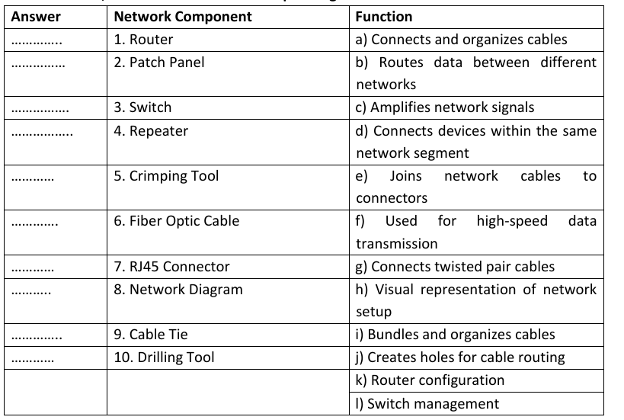
Part 3: Answer the following questions by using True or False according to the statements
1. Network cables with twisted pair configurations are less susceptible to interference.
2. Fiber optic cables are commonly used for short-distance connections due to their high cost.
3. A network hub operates by sending data to all devices connected to it.
4. A switch can improve network performance by reducing data collisions.
5. Coaxial cables are the most suitable for high-speed internet connections.
6. The RJ45 connector is used for fiber optic cables.
7. Cable ties are used to secure and organize cables.
8. Patching refers to connecting different networks through a patch panel.
9. A UPS provides backup power to network equipment during outages.
10. Tagging is the process of assigning labels to network devices and cables.
11. A router is used to connect different networks and route data between them.
12. Crimping tools are used for testing the continuity of network cables.
13. The main advantage of using coaxial cables is their flexibility and ease of installation.
14. Open-wire network installations are typically used for outdoor aerial connections.
15. Fiber optic cables are resistant to electromagnetic interference.
16. Drilling tools are used to remove insulation from network cables.
17. Network topology refers to the physical or logical layout of a network.
18. A patch panel is used to split a network connection into multiple connections.
19. Network labeling helps in identifying and managing network devices and cables.
20. Plastic trunking materials are less durable than metal trunking materials.
END OF LO1

