Name: | Class:

①Write . Mark / 5

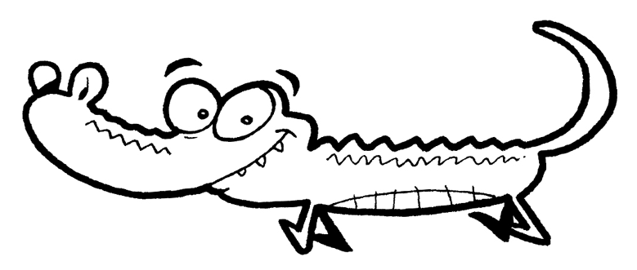
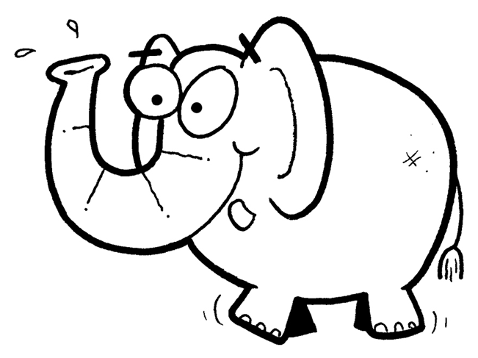
❶ c r o c o d i l e ❷ _ _ _ _ _ _ _ _
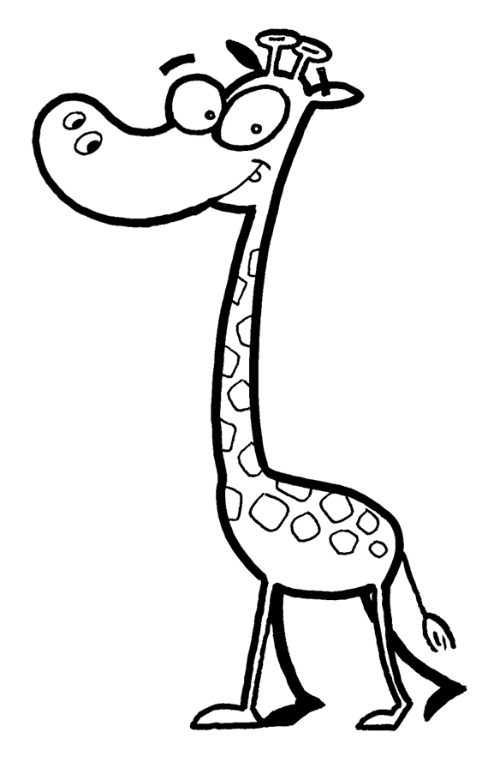

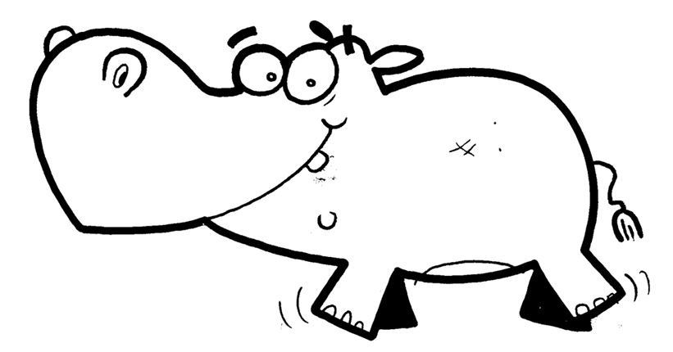
❸ _ _ _ _ _ ❹ _ _ _ _ _ _ _

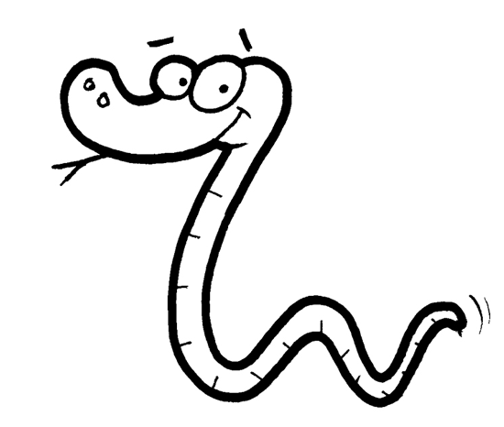
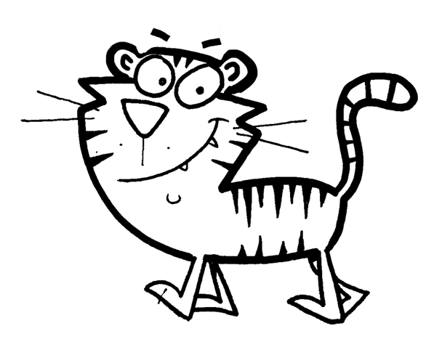

❺ _ _ _ _ _ ❻ _ _ _ _ _

②Look and circle. Mark / 5

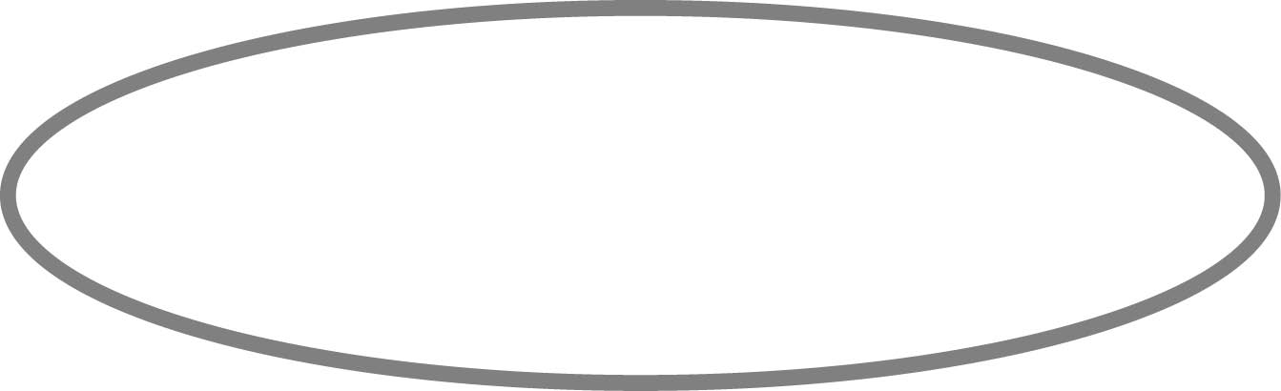
❶ They ’ve / haven’t got hands. ❷ They ’ve / haven’t got feet.
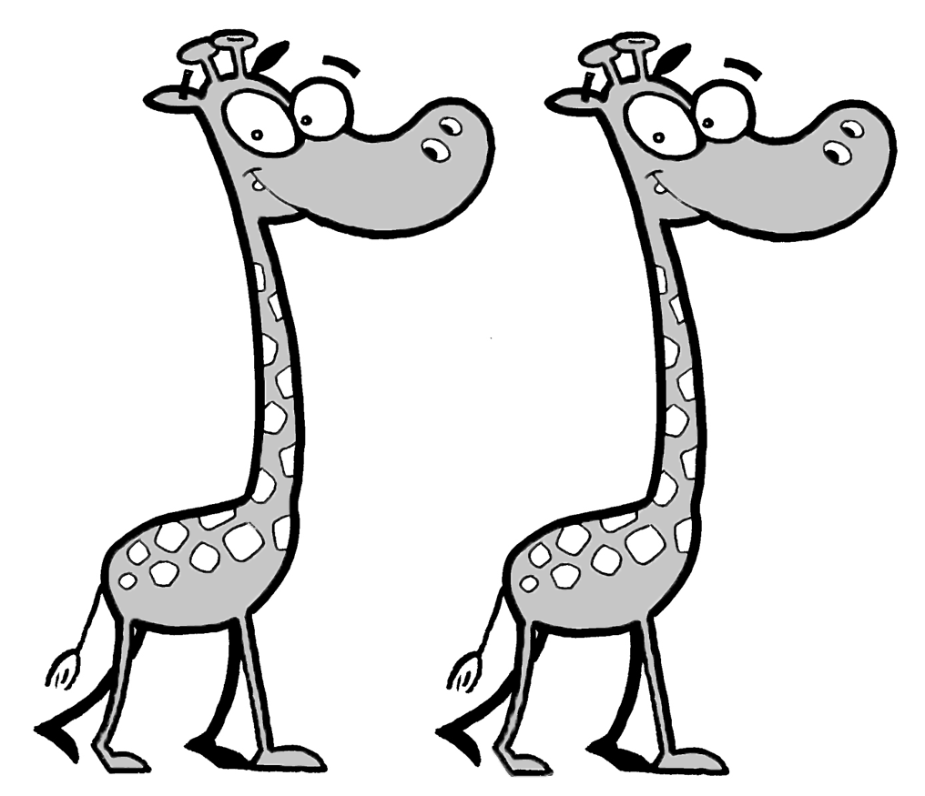
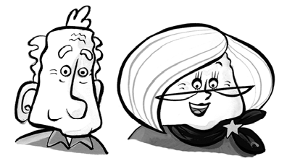

❸ They ’ve / haven’t got teeth. ❹ They ’ve / haven’t got legs.
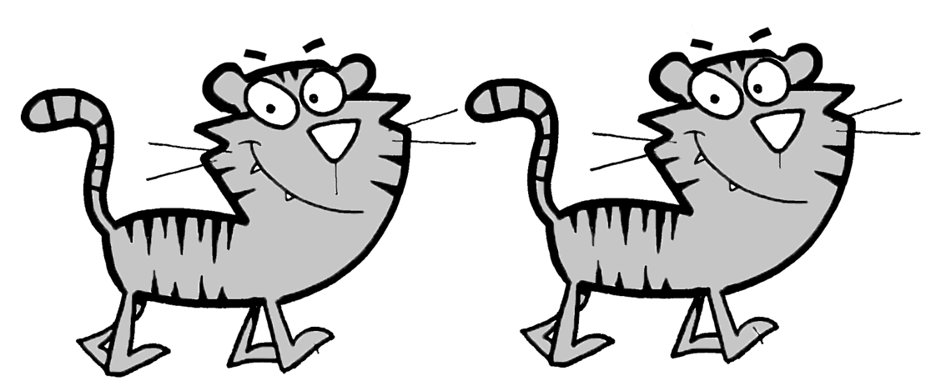
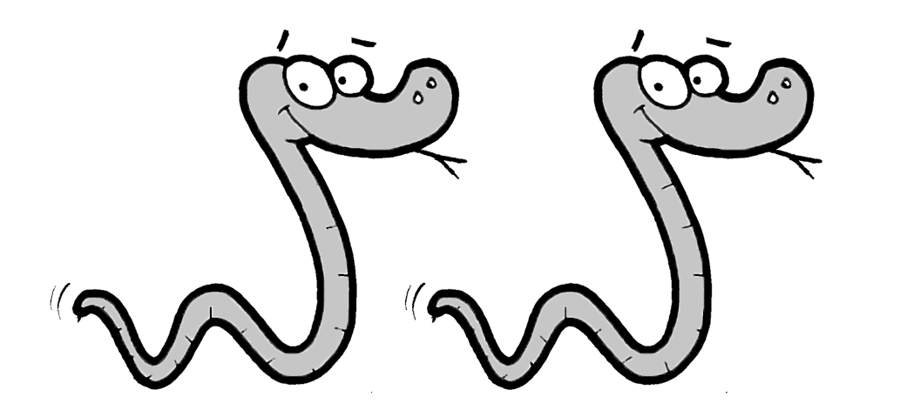

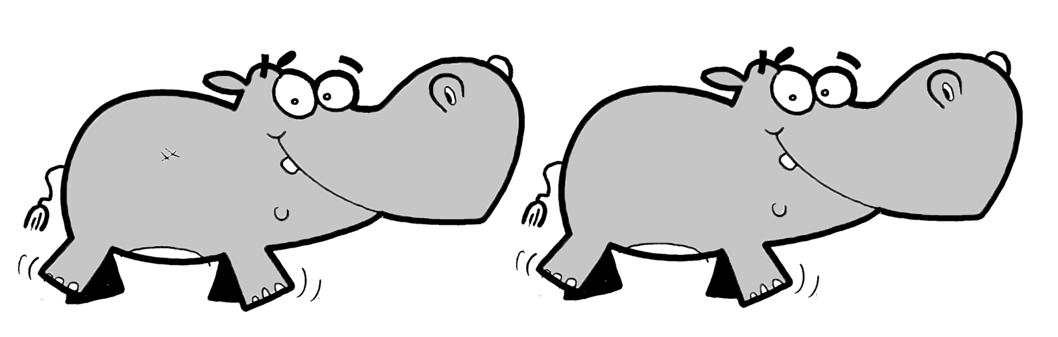
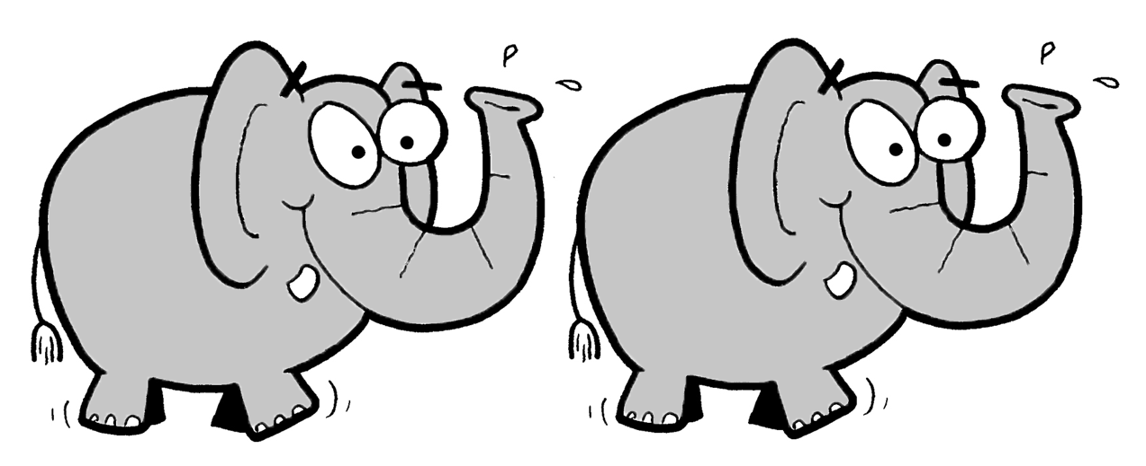
❺ They ’ve / haven’t got arms. ❻ They ’ve / haven’t got tails.

Total unit mark / 10

