NAME : NISHITA MANAHRSINH SOLANKI
ROLL NO.: 22BCE211
SUBJECT : CN AND DEVOPS
PRACTICAL – 4

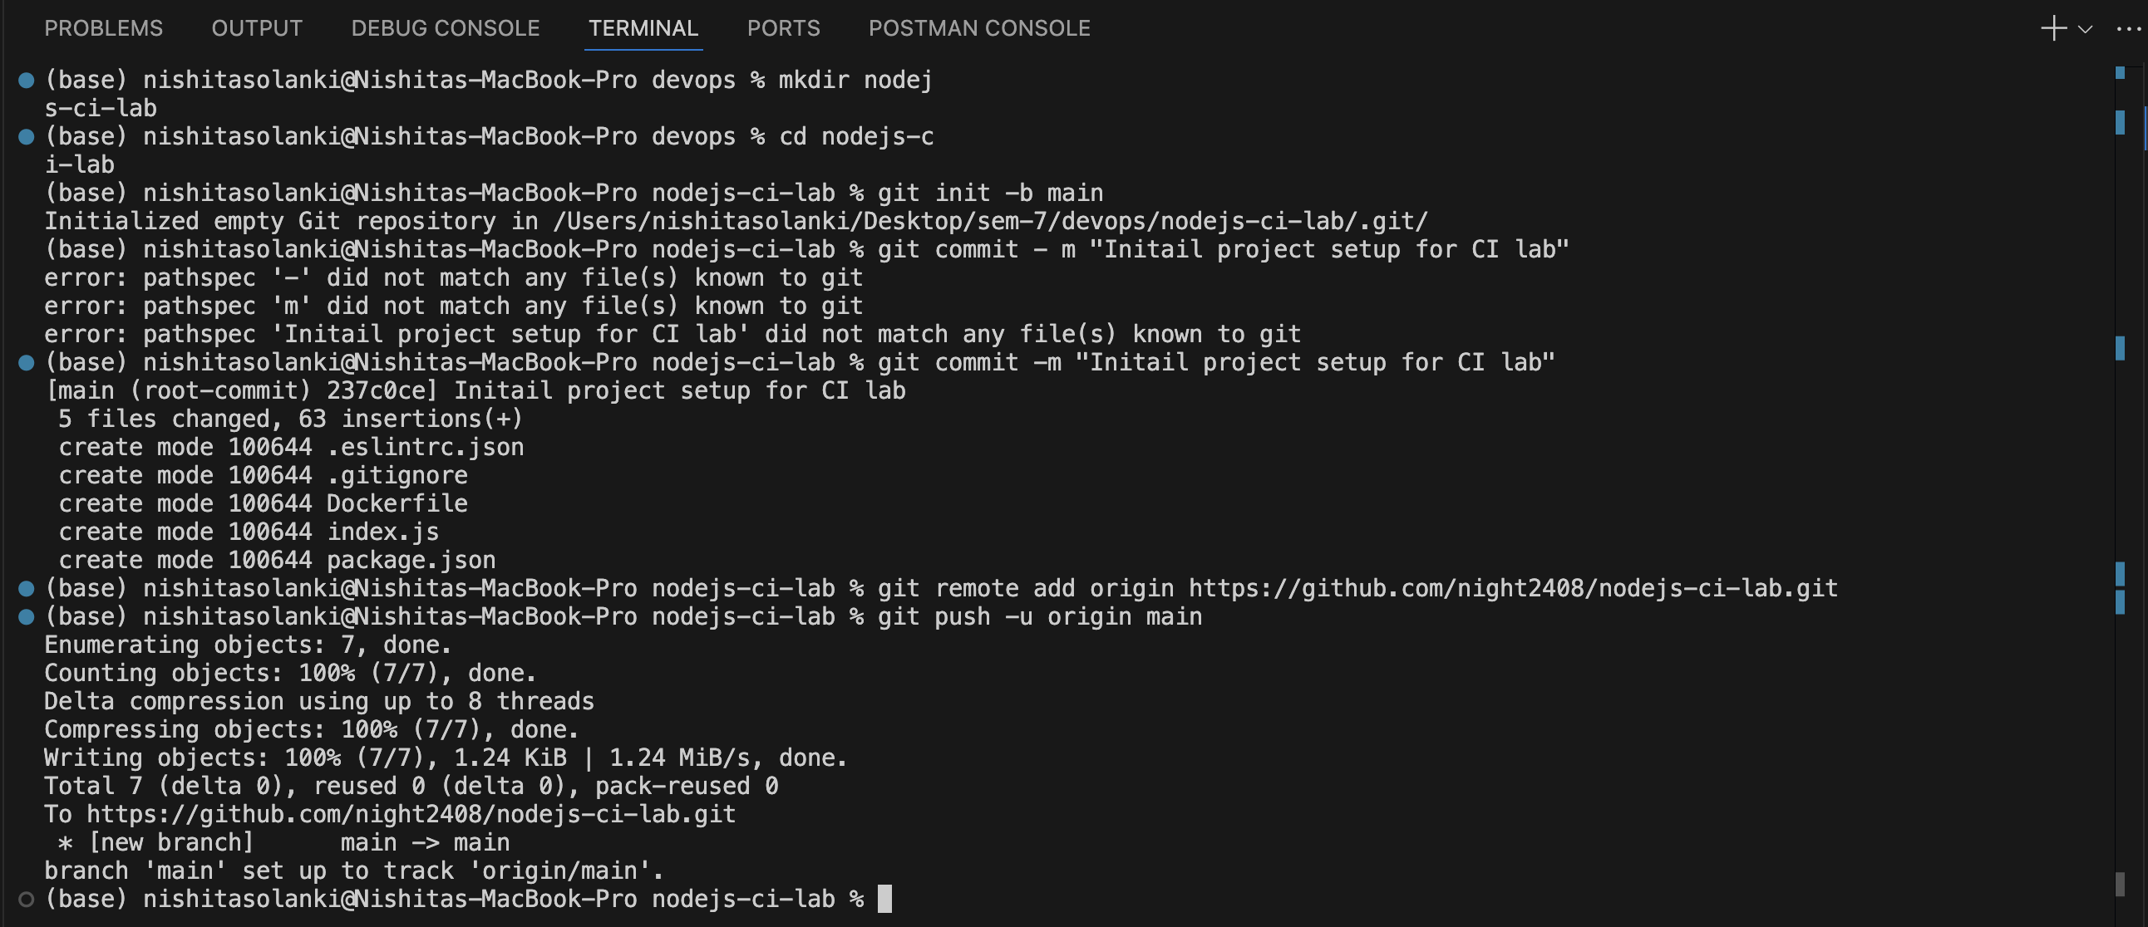

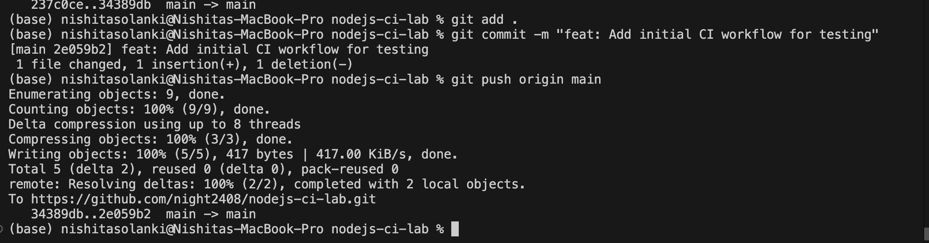

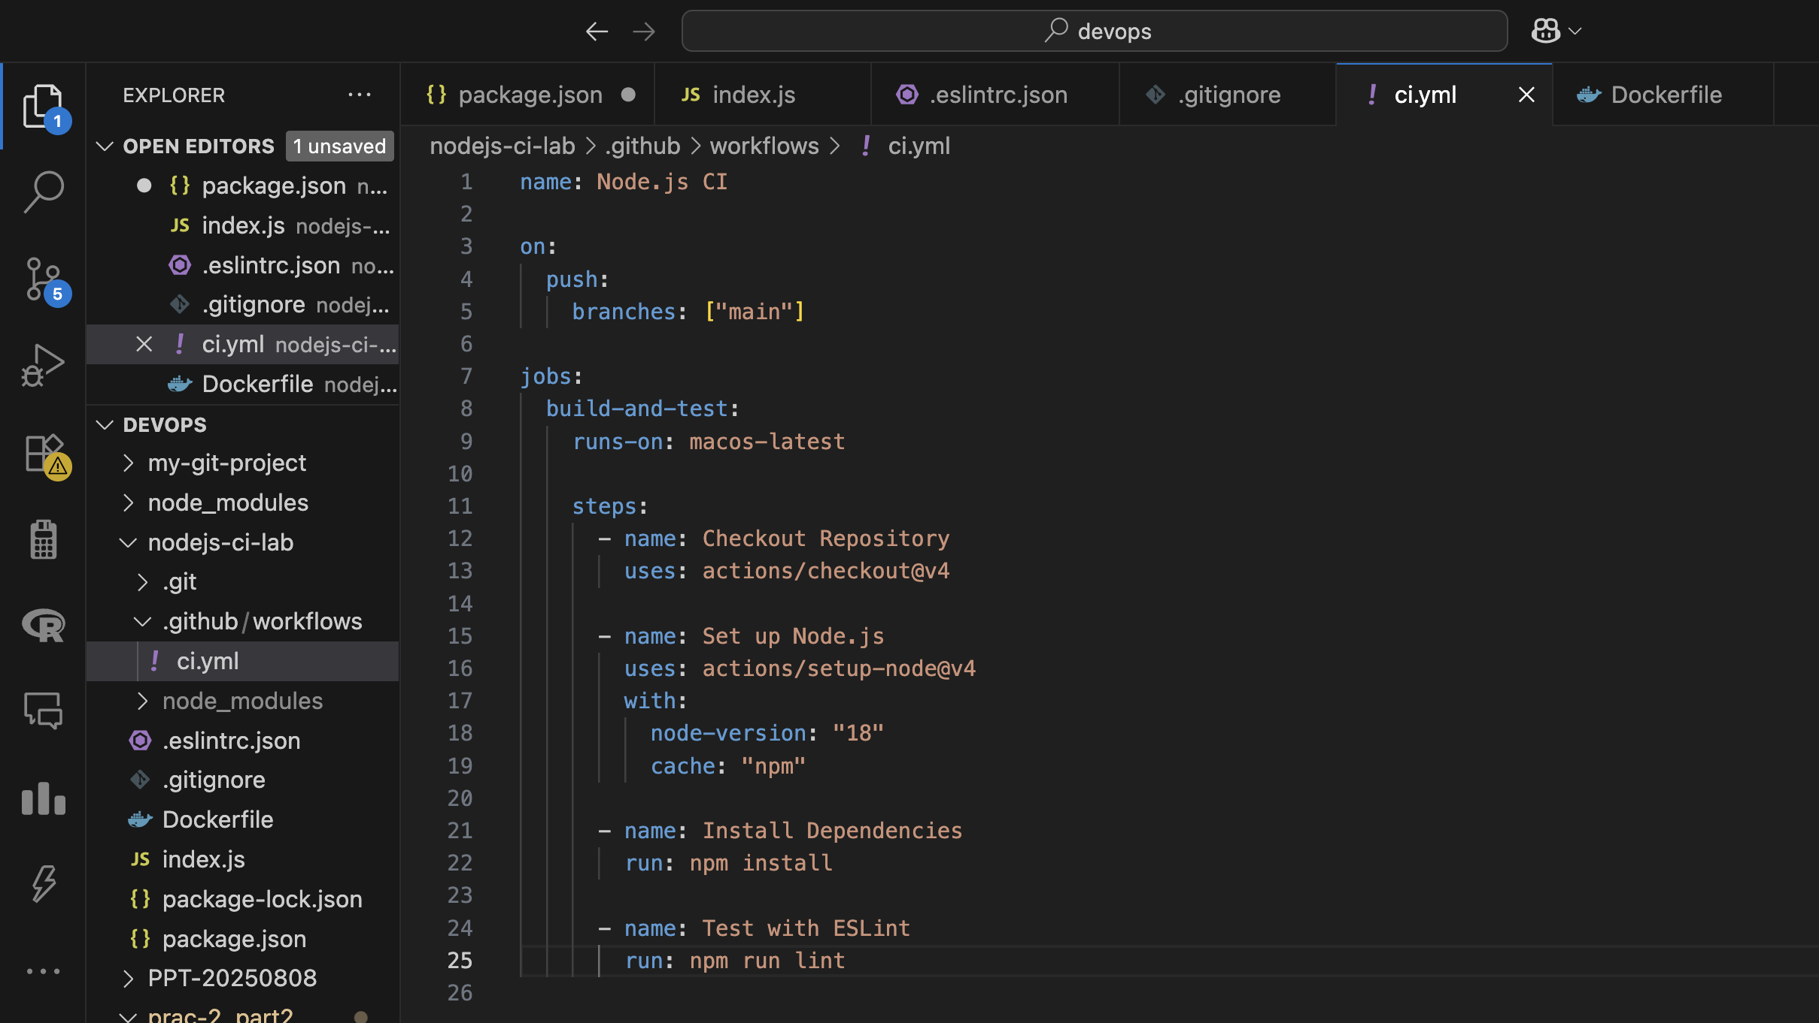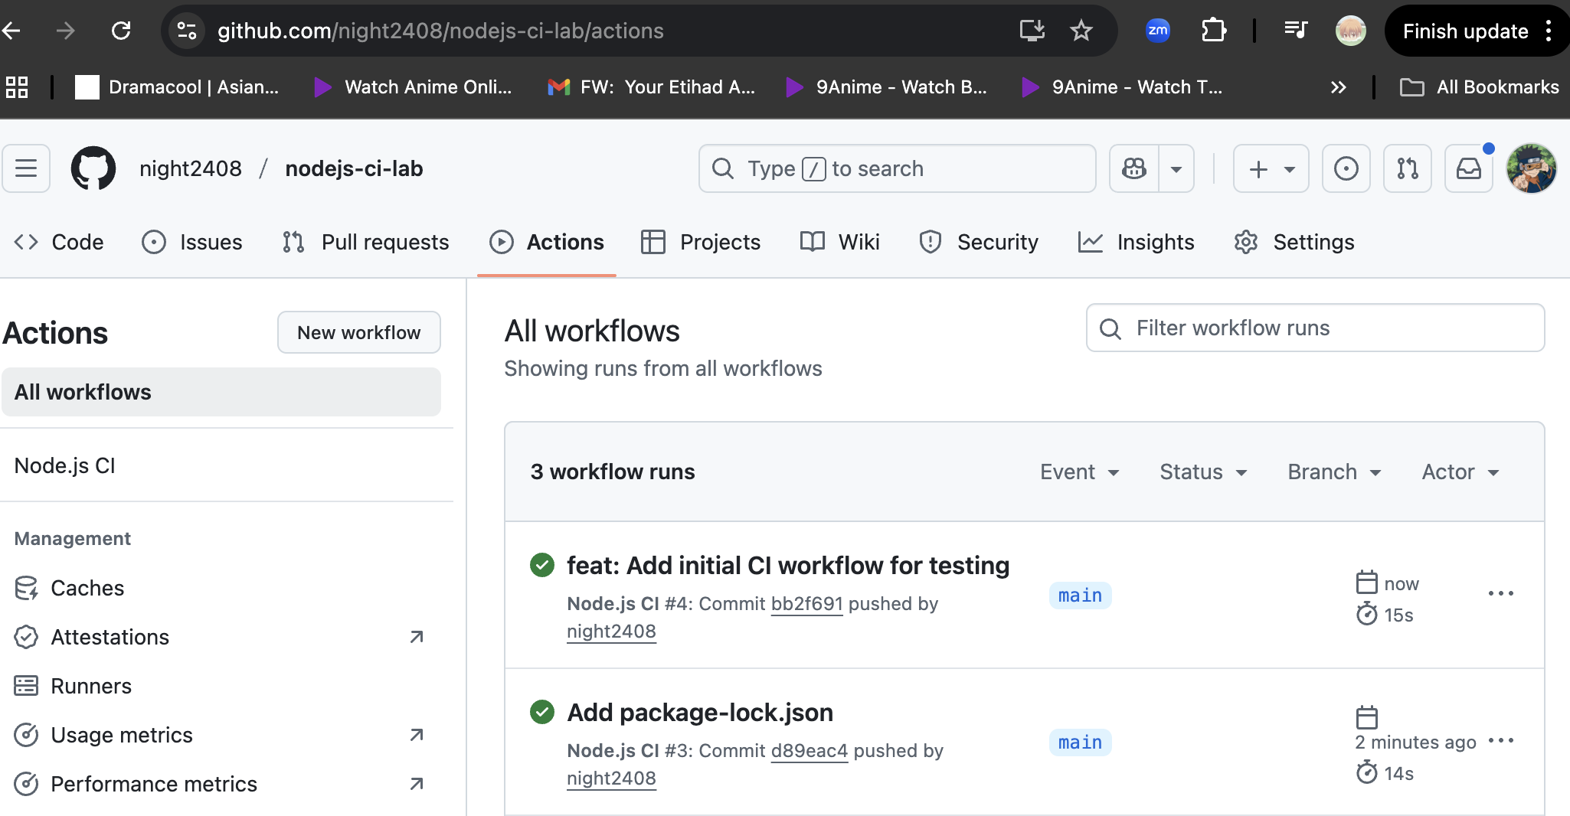

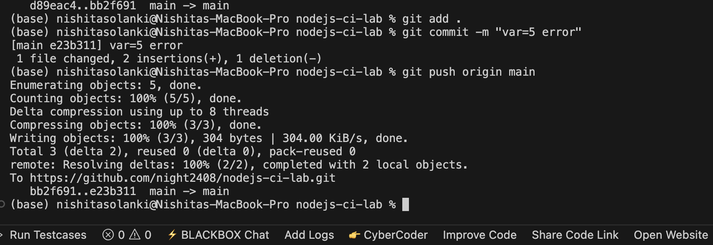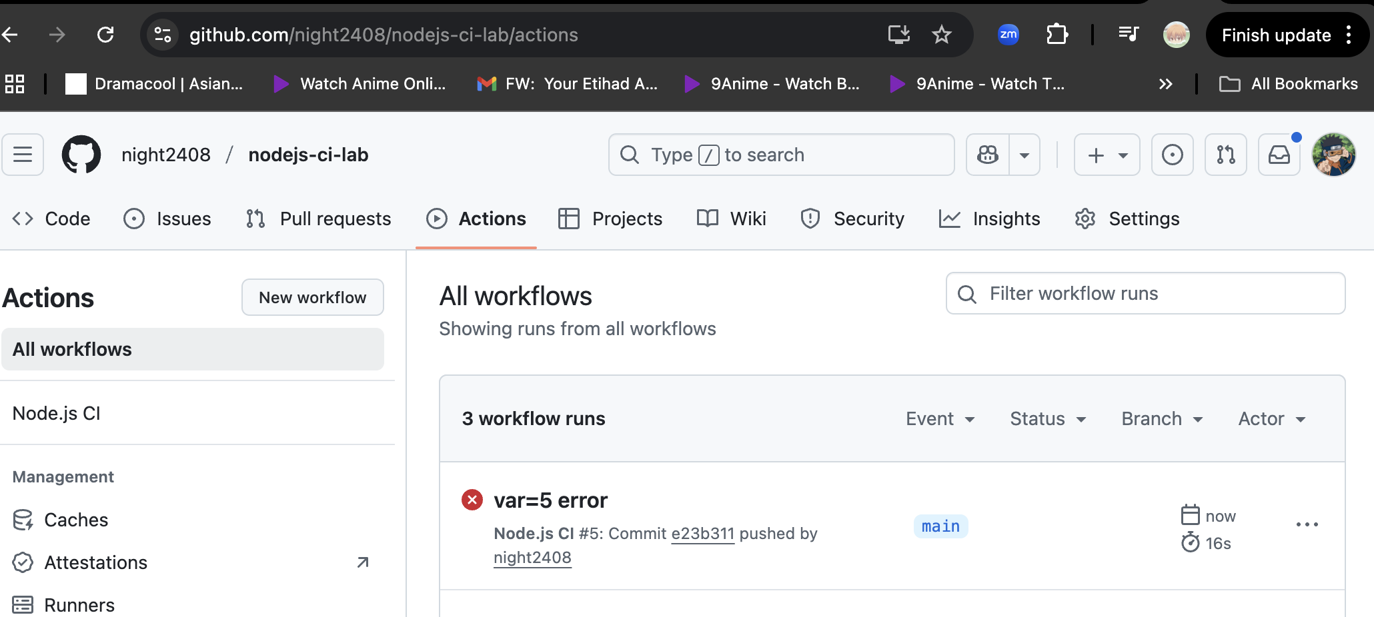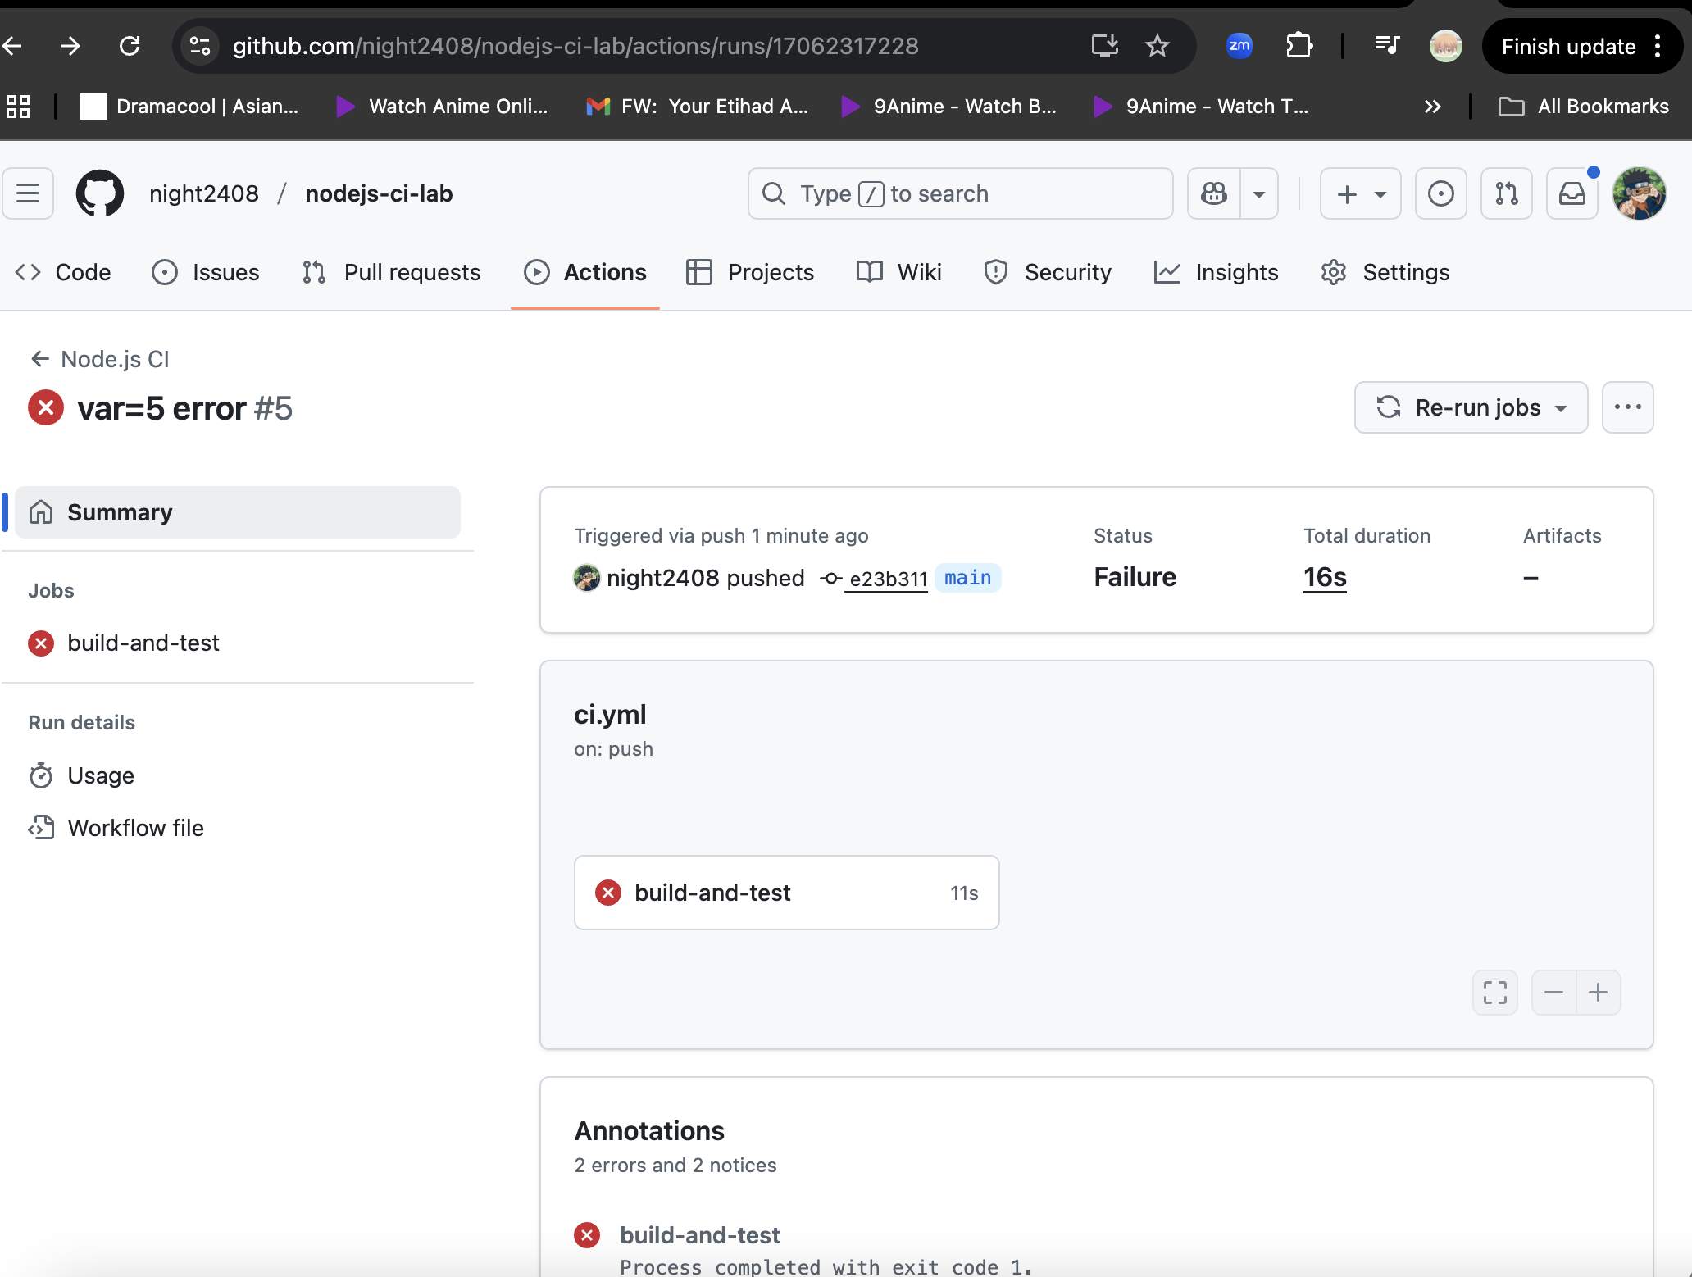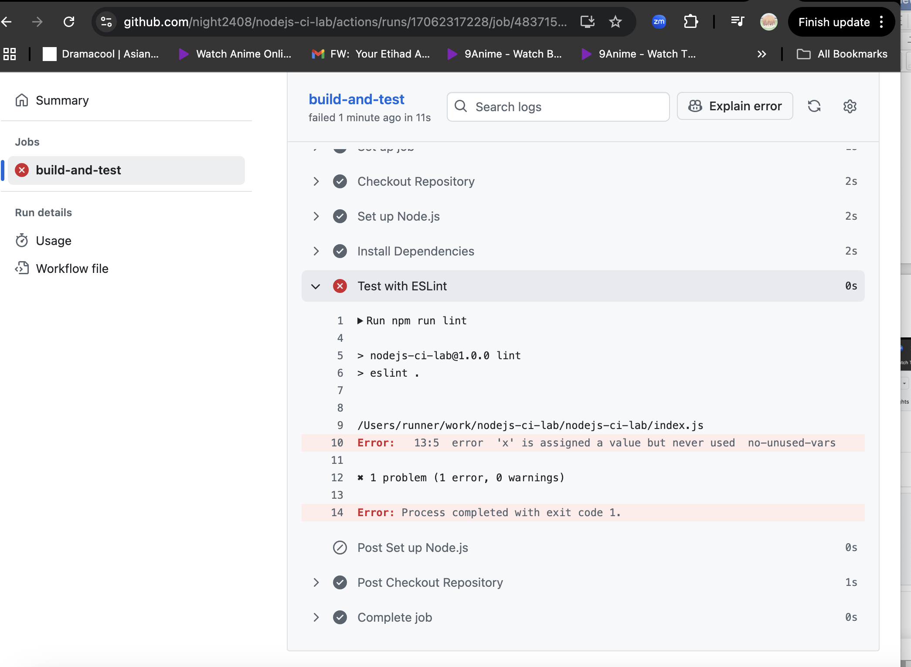

3.

# name: Node.js CI

# on:
# push:
# branches: ["main"]

# jobs:
# build-and-test:
# runs-on: macos-latest

# steps:
# - name: Checkout Repository
# uses: actions/checkout@v4

# - name: Set up Node.js
# uses: actions/setup-node@v4
# with:
# node-version: "18"
# cache: "npm"

# - name: Install Dependencies
# run: npm install

# - name: Test with ESLint
# run: npm run lint

name: Node.js CI

on:
push:
branches: ["main"]

jobs:
build-and-test:
runs-on: ubuntu-latest
permissions:
contents: read
packages: write

steps:
- name: Checkout Repository
uses: actions/checkout@v4

- name: Set up Node.js
uses: actions/setup-node@v4
with:
node-version: "18"
cache: "npm"

- name: Install Dependencies
run: npm ci

- name: Test with ESLint
run: npm run lint

- name: Log in to GitHub Container Registry
uses: docker/login-action@v3
with:
registry: ghcr.io
username: ${{ github.actor }}
password: ${{ secrets.GITHUB_TOKEN }}

- name: Build and Push Docker Image
uses: docker/build-push-action@v5
with:
context: .
push: true
tags: ghcr.io/${{ github.repository_owner }}/nodejs-ci-lab:${{ github.sha }}

