NAME : NISHITA MANHARSINH SOLANKI
ROLL NO: 22BCE211
COURSE: Cloud Native Applications and DevOps

PRACTICAL 7
AIM: Prometheus
Steps: -
Task 1. Create a Docker repository
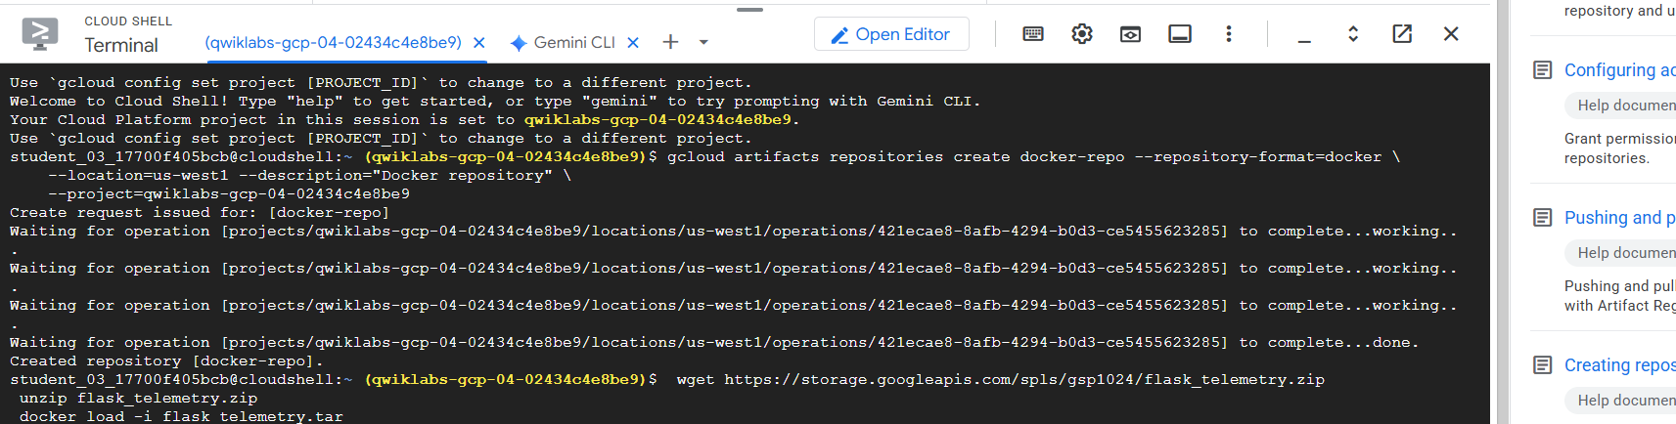
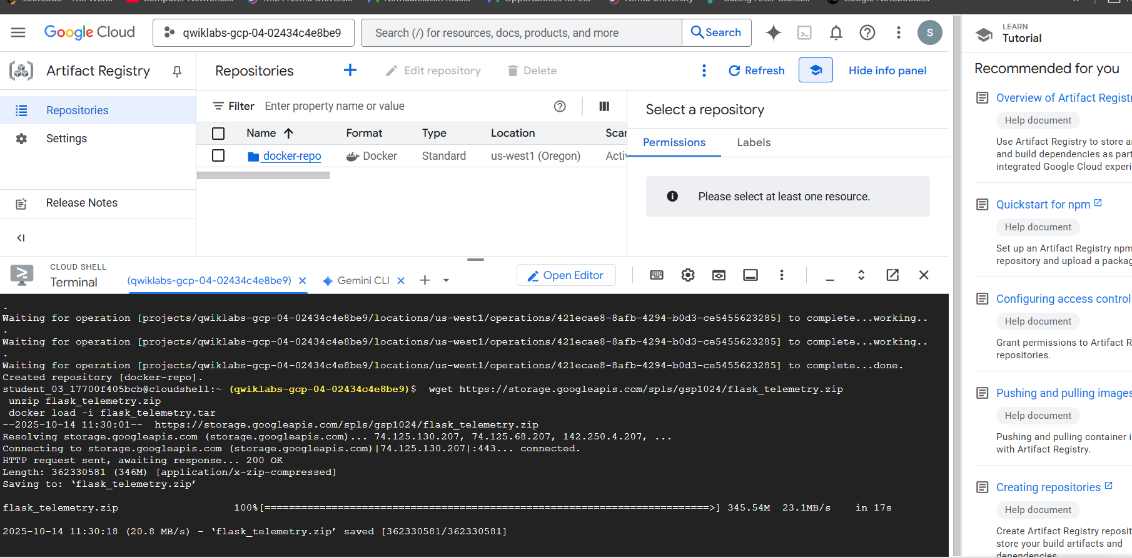

Task 2. Setup a Google Kubernetes Engine cluster

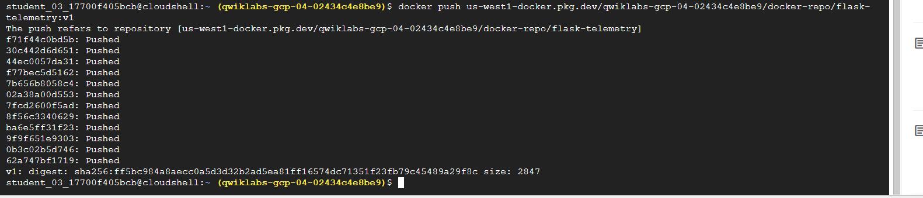
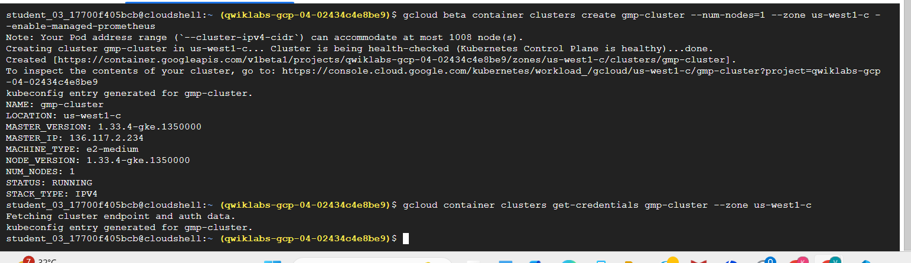

Task 3. Deploy the Prometheus service

Task 4. Deploy the application
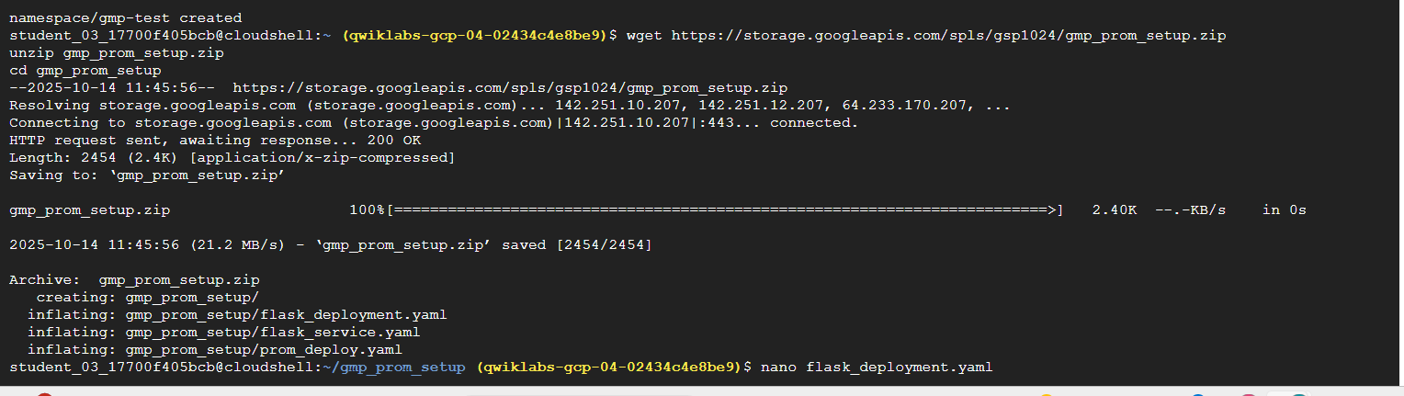
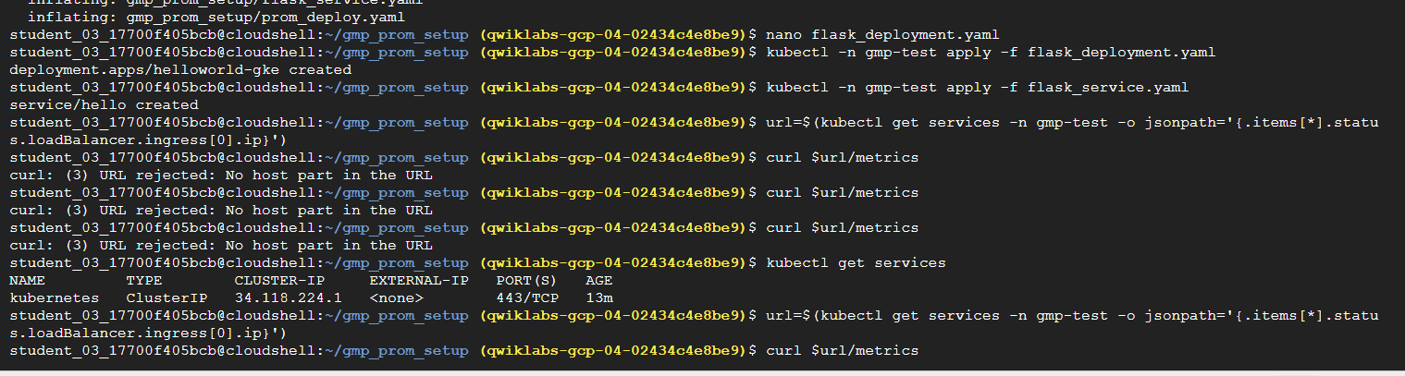
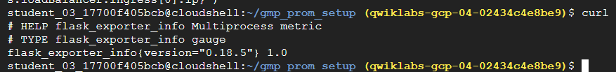
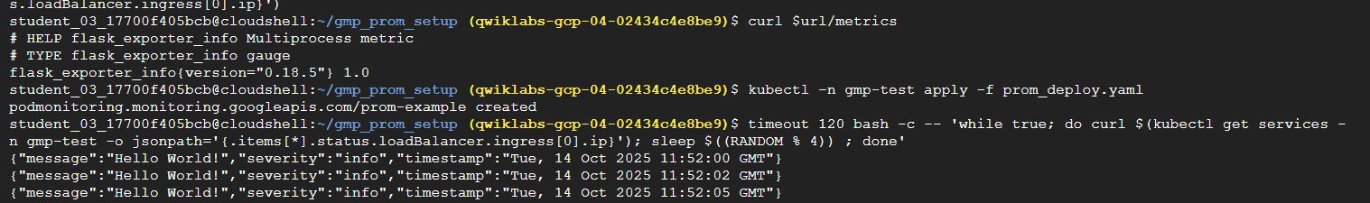

Task 5. Observe the app via metrics
