NAME : NISHITA MANHARSINH SOLANKI

ROLL NO.: 22BCE211

BATCH – D-1

PRACTCIAL – 6 TERRAFORM

Task 1. Verify a Terraform installation
Terraform comes pre-installed in Cloud Shell.
- Open a new Cloud Shell tab, and run the following command to verify that Terraform is available:
terraform

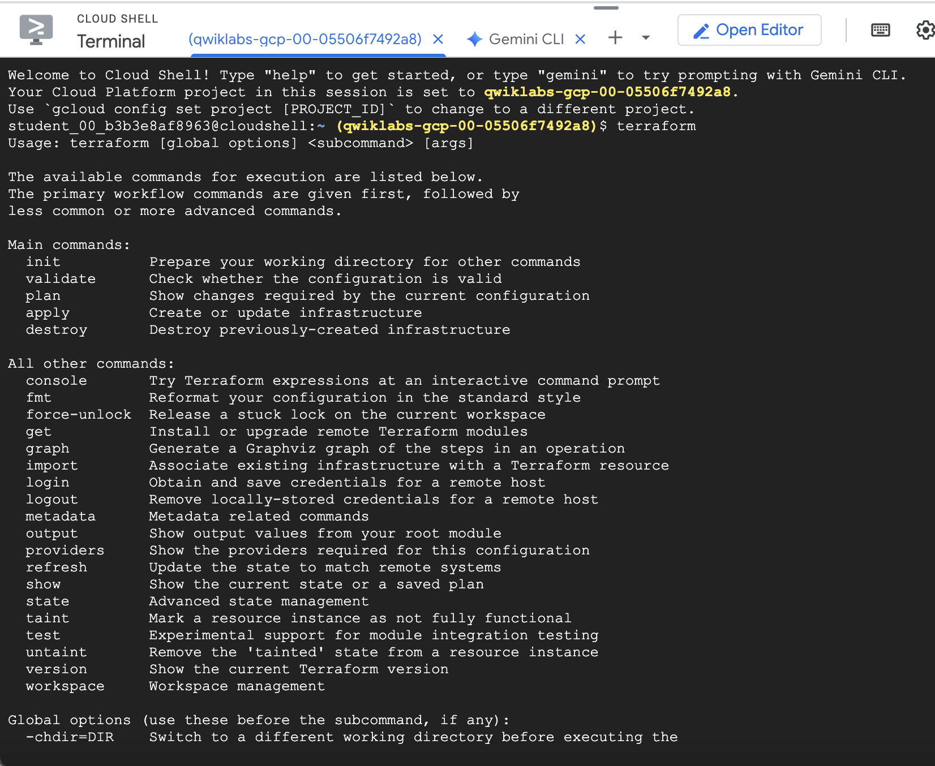

Task 2. Build the infrastructure
With Terraform installed, you can immediately start creating some infrastructure.

Configuration
The set of files used to describe infrastructure in Terraform is simply known as a Terraform configuration. In this section, you will write your first configuration to launch a single VM instance. The format of the configuration files can be found in the Terraform Language Documentation. We recommend using JSON for creating configuration files.
- In Cloud Shell, enable the Gemini for Google Cloud API with the following command:
gcloud services enable cloudaicompanion.googleapis.com
Copied!
- Create an empty configuration file named instance.tf with the following command:
touch instance.tf
Copied!
- Click Open Editor on the Cloud Shell toolbar.
To switch between Cloud Shell and the code editor, click Open Editor or Open Terminal as required, or click Open in a new window to leave the Editor open in a separate tab.

Enable Gemini Code Assist in the Cloud Shell IDE
You can use Gemini Code Assist in an integrated development environment (IDE) such as Cloud Shell to receive guidance on code or solve problems with your code. Before you can start using Gemini Code Assist, you need to enable it.
- In Cloud Shell, enable the Gemini for Google Cloud API with the following command:
gcloud services enable cloudaicompanion.googleapis.com
Copied!
- Click Open Editor on the Cloud Shell toolbar.
Note: To open the Cloud Shell Editor, click Open Editor on the Cloud Shell toolbar. You can switch between Cloud Shell and the code Editor by clicking Open Editor or Open Terminal, as required.
- In the left pane, click the Settings icon, then in the Settings view, search for Gemini Code Assist.
- Locate and ensure that the checkbox is selected for Geminicodeassist: Enable, and close the Settings.
- Click Cloud Code - No Project in the status bar at the bottom of the screen.
- Authorize the plugin as instructed. If a project is not automatically selected, click Select a Google Cloud Project, and choose qwiklabs-gcp-00-05506f7492a8.
- Verify that your Google Cloud project (qwiklabs-gcp-00-05506f7492a8) displays in the Cloud Code status message in the status bar.
- From the file Explorer, double-click instance.tf to open the instance.tf file. This action enables Gemini Code Assist, as indicated by the presence of the icon in the upper-right corner of the editor.
- To generate new code, click the Gemini Code Assist: Smart Actions icon and select /generate.
Alternatively, you can press CTRL+I (for Windows and Linux) or CMD+I (for macOS) to open the Gemini Code Assist window, and select /generate to generate new code.

Use Gemini Code Assist to generate a Terraform resource
In this section, you explore how to use Gemini Code Assist to generate a Terraform resource, such as a VM in this instance.
- Paste the following provided prompt into the Gemini Code Assist inline text box.
Generate the Terraform configuration for a Google Compute Engine virtual machine, saving it to instance.tf, based on the following specifications:

* Project ID: qwiklabs-gcp-00-05506f7492a8
* VM Name: terraform
* Machine Type: e2-medium
* Deployment Zone: us-central1-a
* Boot Disk: Debian 12
* Network: Default network
Copied!
The code in the inline text box should resemble the following code block.
/generate Generate the Terraform configuration for a Google Compute Engine virtual machine, saving it to instance.tf, based on the following specifications: * Project ID: qwiklabs-gcp-00-05506f7492a8 * VM Name: terraform * Machine Type: e2-medium * Deployment Zone: us-central1-a * Boot Disk: Debian 12 * Network: Default network
Copied!
- Press Enter to generate code used to launch a VM instance using Terraform. When prompted in the Gemini Diff view, click Accept.
- In the instance.tf file, view the generated code.
This is a complete configuration that Terraform is ready to apply. The general structure should be intuitive and straightforward.
Once you accept Gemini Code Assist's recommendation, the resulting instance.tf file should resemble the following.
Generated file contents:

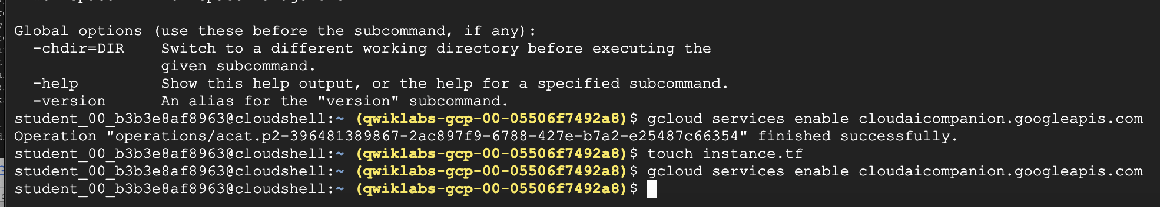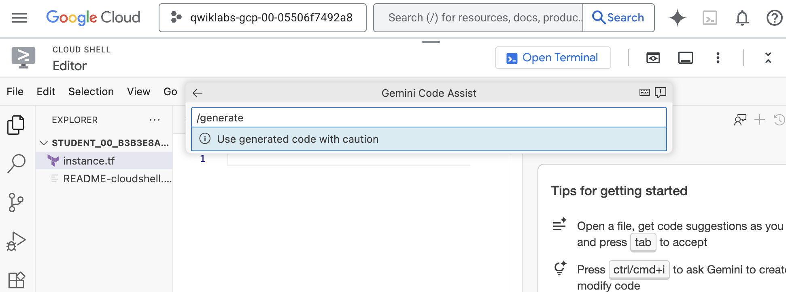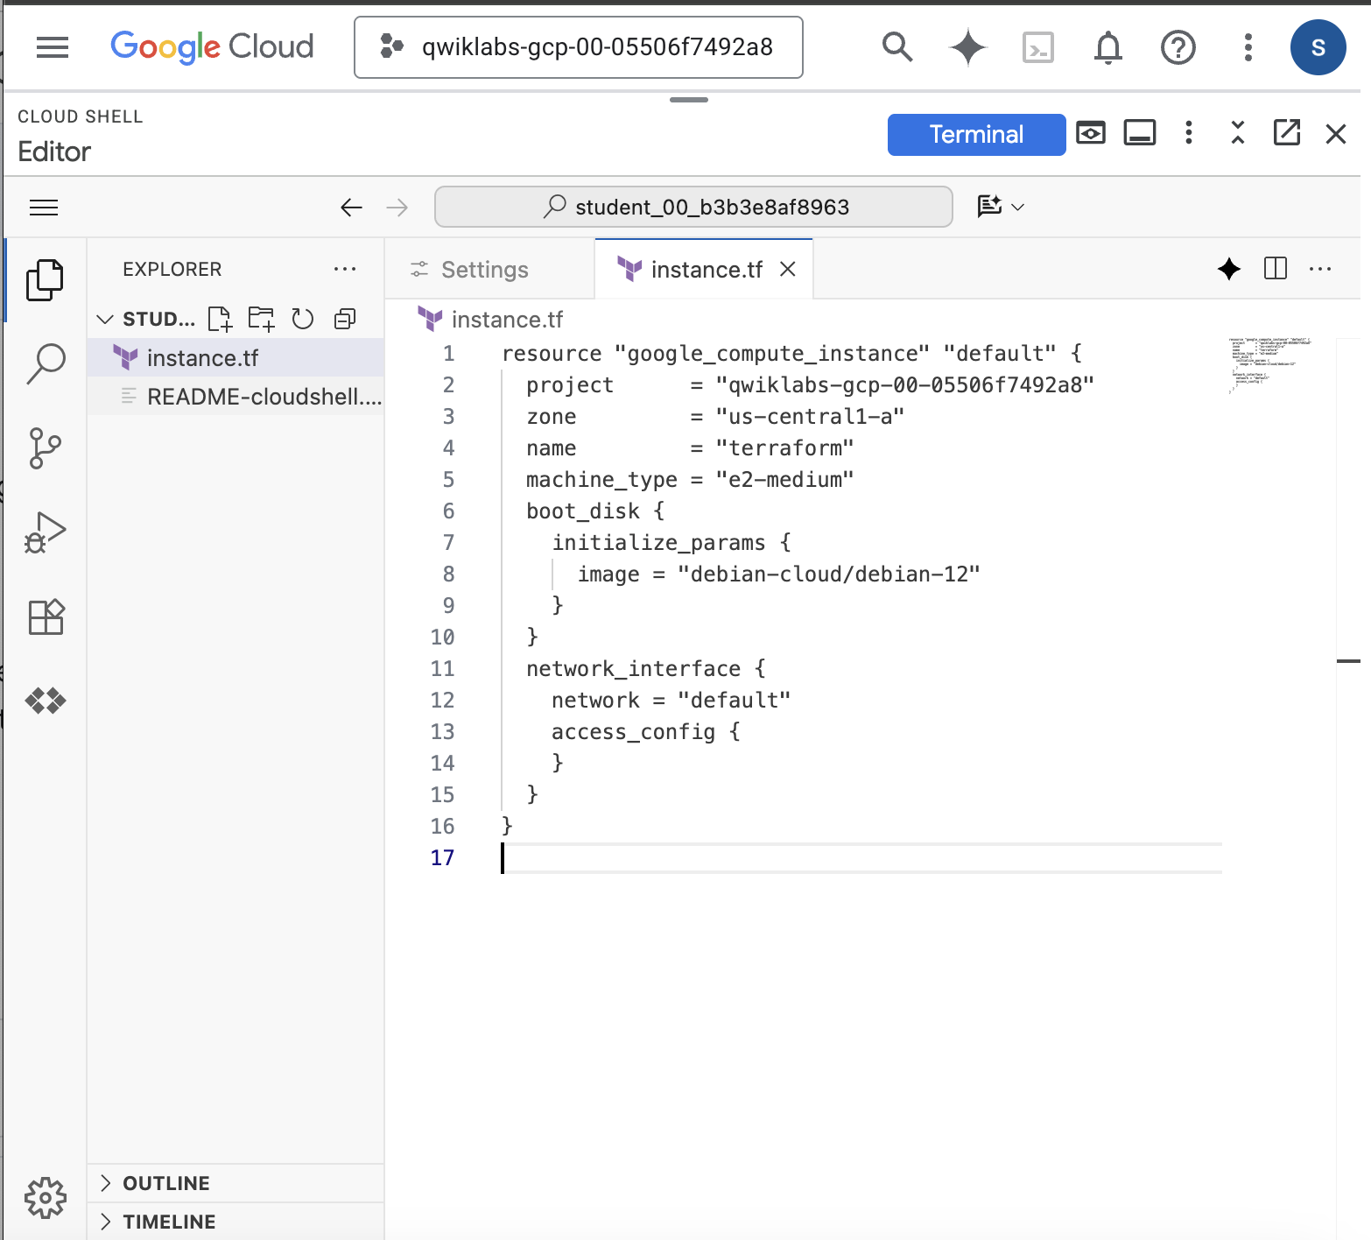

Initialization
The first command to run for a new configuration—or after checking out an existing configuration from version control—is terraform init. This will initialize various local settings and data that will be used by subsequent commands.
Terraform uses a plugin-based architecture to support the numerous infrastructure and service providers available. Each "provider" is its own encapsulated binary that is distributed separately from Terraform itself. The terraform init command will automatically download and install any provider binary for the providers to use within the configuration, which in this case is just the Google provider.
- Download and install the provider binary:
terraform init
Copied!
The Google provider plugin is downloaded and installed in a subdirectory of the current working directory, along with various other book keeping files. You will see an "Initializing provider plugins" message. Terraform knows that you're running from a Google project, and it is getting Google resources.
Installing hashicorp/google v6.47.0...
Note: Your version number may be higher.
The output specifies which version of the plugin is being installed and suggests that you specify this version in future configuration files to ensure that terraform init will install a compatible version.
- Create an execution plan:
terraform plan
Copied!
Terraform performs a refresh, unless explicitly disabled, and then determines what actions are necessary to achieve the desired state specified in the configuration files. This command is a convenient way to check whether the execution plan for a set of changes matches your expectations without making any changes to real resources or to the state. For example, you might run this command before committing a change to version control, to create confidence that it will behave as expected.
Note: The optional -out argument can be used to save the generated plan to a file for later execution with terraform apply.

Apply changes
- In the same directory as the instance.tf file you created, run this command:
terraform apply
The resulting output shows the Execution Plan, which describes the actions Terraform will take in order to change real infrastructure to match the configuration. The output format is similar to the diff format generated by tools like Git.
There is a + next to google_compute_instance.terraform, which means that Terraform will create this resource. Following that are the attributes that will be set. When the value displayed is <computed>, it means that the value won't be known until the resource is created.

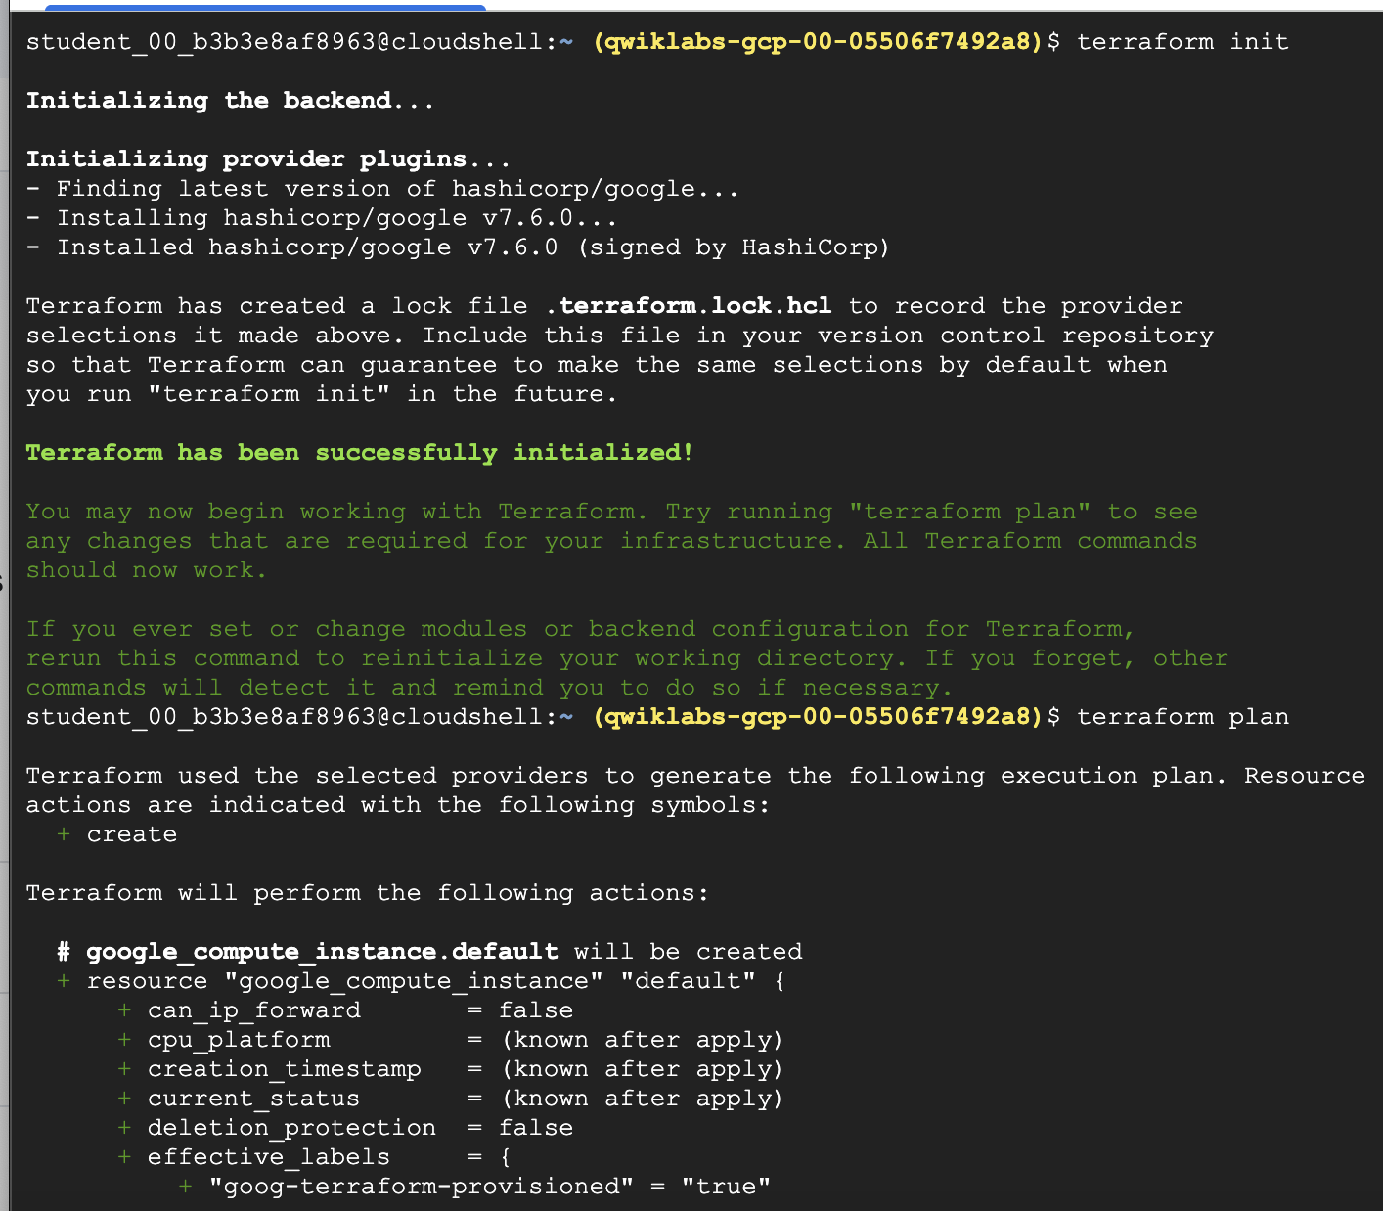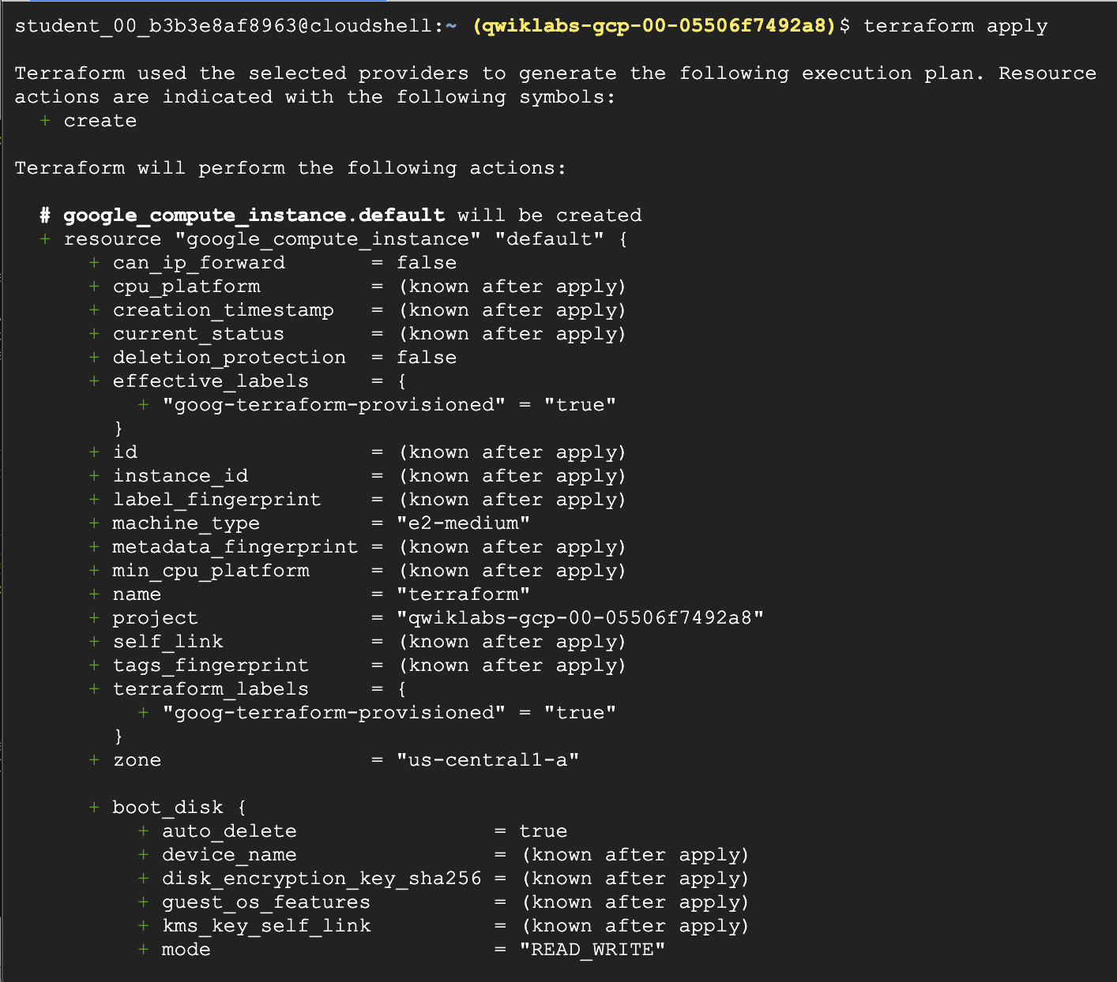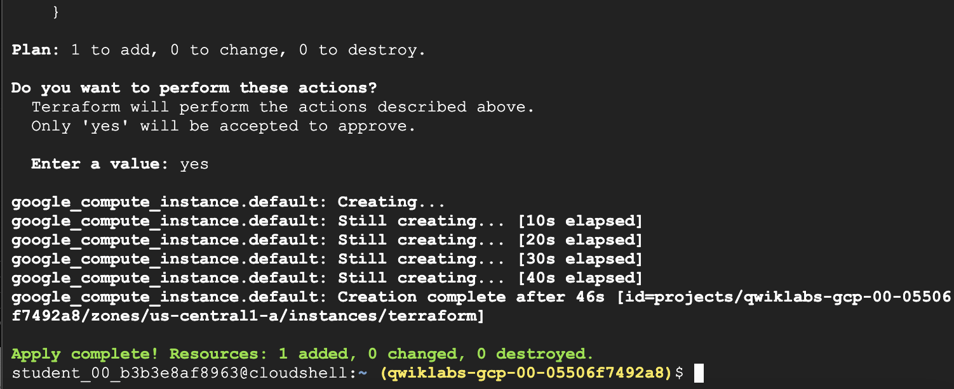
- In the Google Cloud console, on the Navigation menu, click Compute Engine > VM instances. The VM instances page opens and the VM instance you just created displays in the VM instances list.
Terraform has written some data into the terraform.tfstate file. This state file is extremely important: it keeps track of the IDs of created resources so that Terraform knows what it is managing.
- In Cloud Shell, run the following command to inspect the current state:
terraform show
Copied
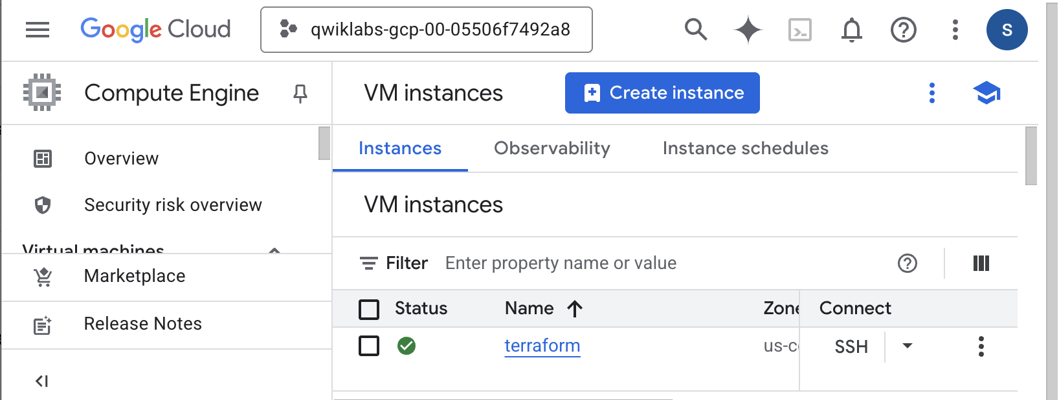
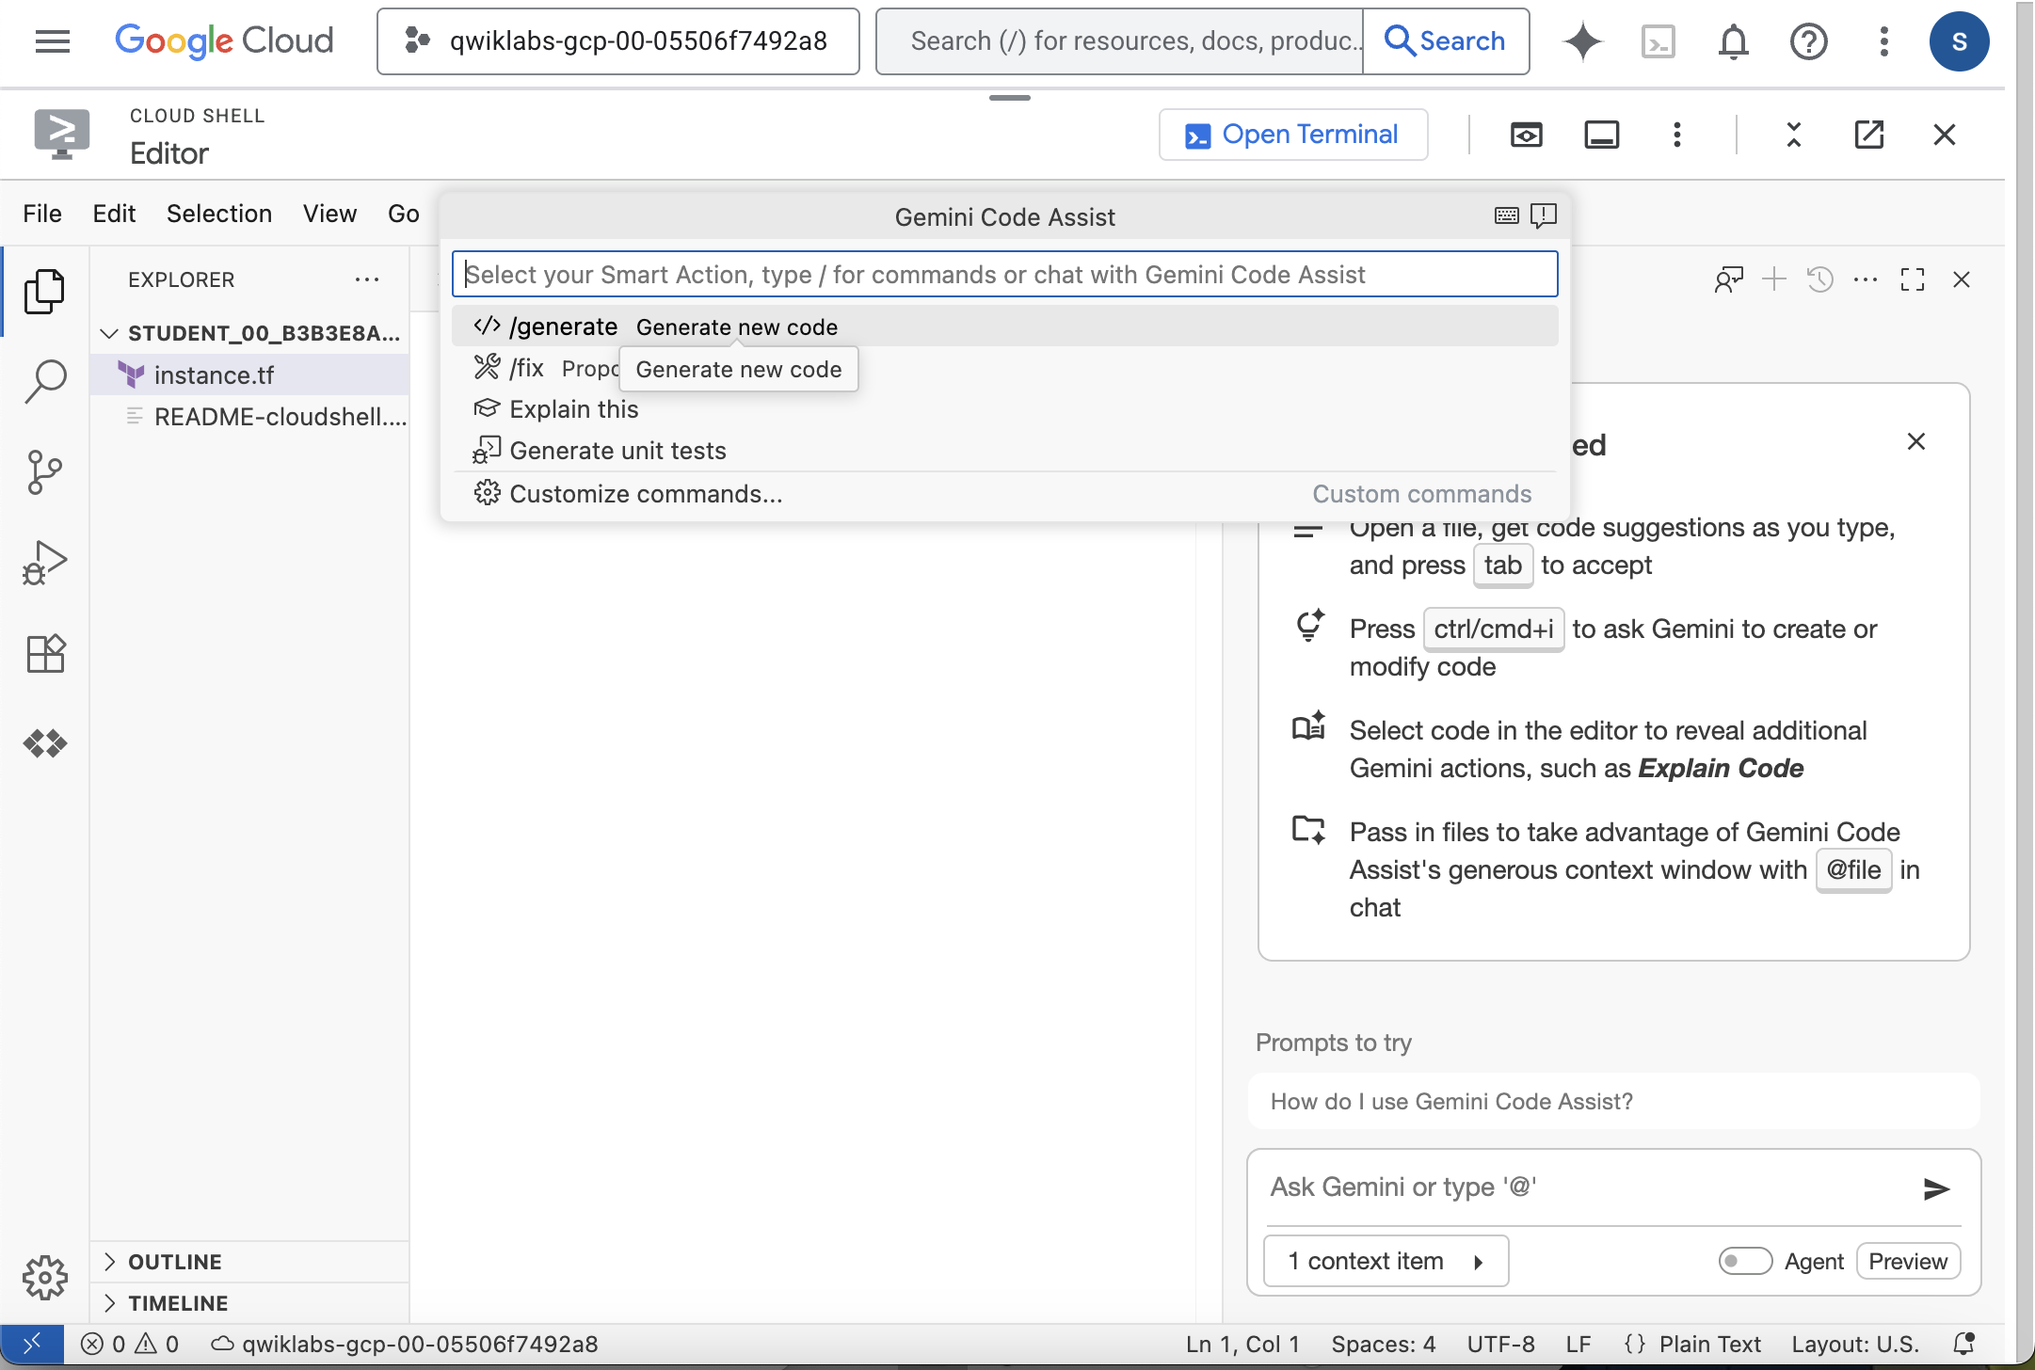

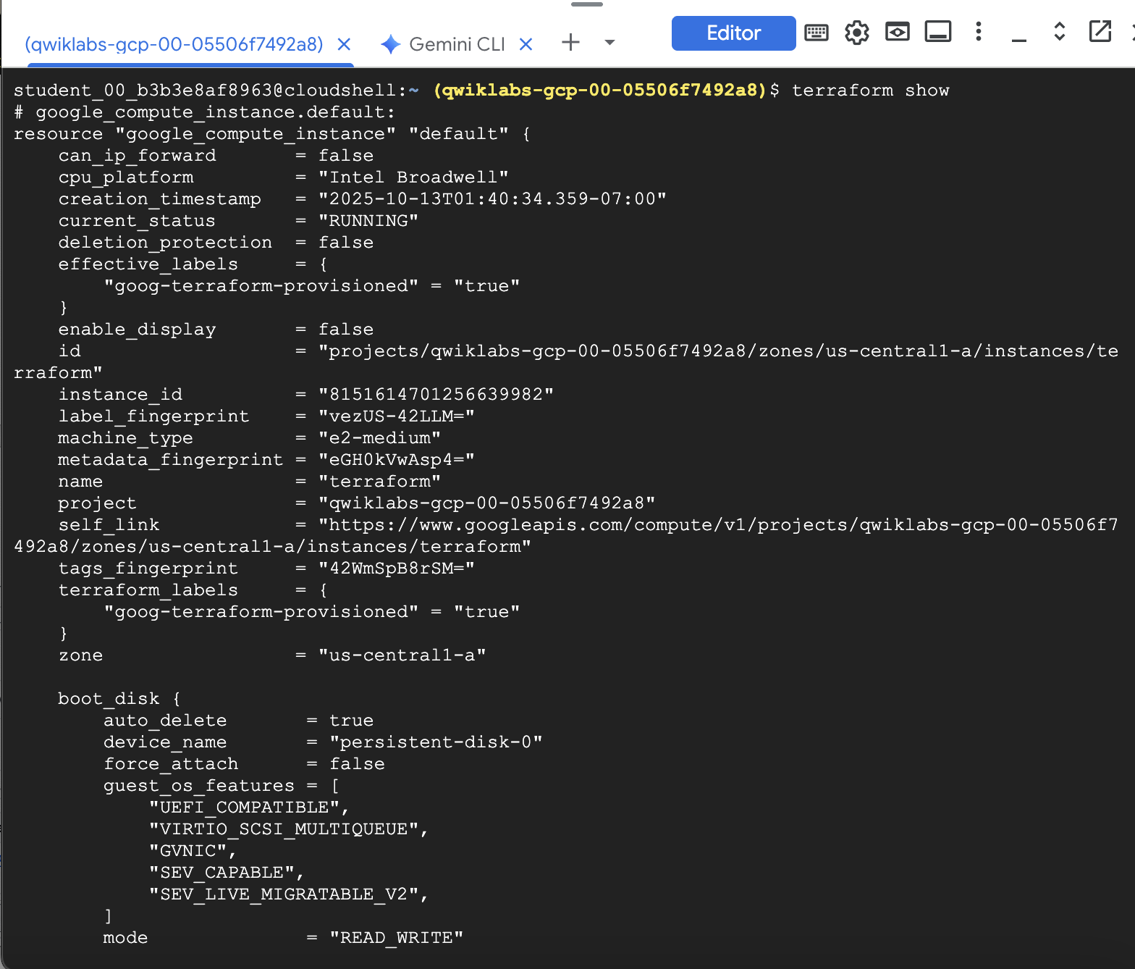

Task 1. Build infrastructure
Terraform comes pre-installed in Cloud Shell. With Terraform already installed, you can dive right in and create some infrastructure.
Start by creating your example configuration to a file named main.tf. Terraform recognizes files ending in .tf or .tf.json as configuration files and loads them when it runs.
- Create the main.tf file:
touch main.tf
Copied!
- Click the Open Editor button on the toolbar of Cloud Shell. (You can switch between Cloud Shell and the code editor by using the Open Editor and Open Terminal icons as required, or click the Open in new window button to leave the Editor open in a separate tab).
- In the Editor, add the following content to the main.tf file.
terraform {
required_providers {
google = {
source = "hashicorp/google"
version = "3.5.0"
}
}
}

provider "google" {

project = "qwiklabs-gcp-03-17dd5e37c27d"
region = "europe-west1"
zone = "europe-west1-b"
}

resource "google_compute_network" "vpc_network" {
name = "terraform-network"
}
Copied!
Note: To use this snippet with Terraform 0.12, remove the terraform {} block.
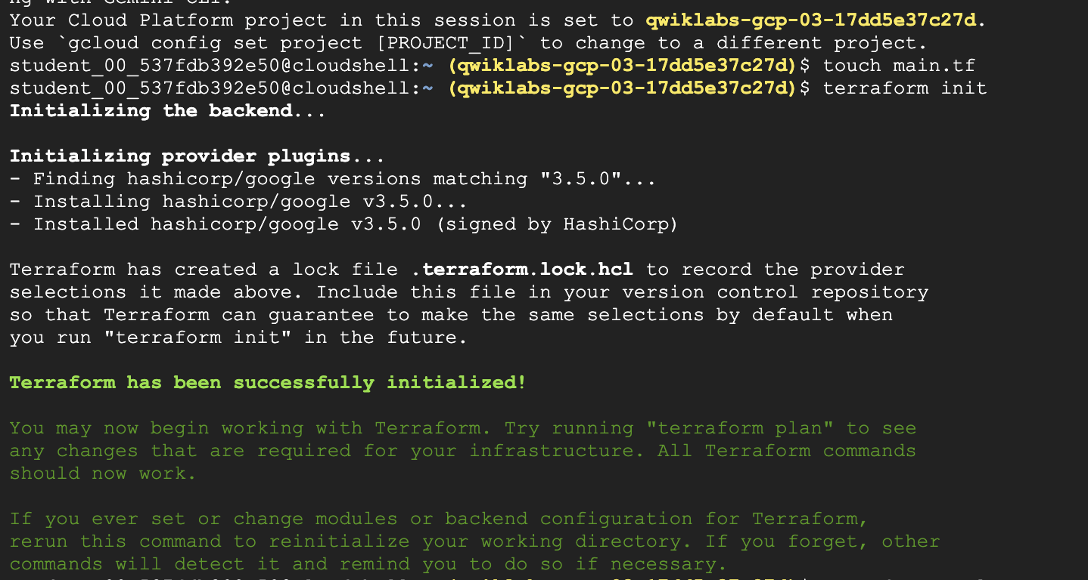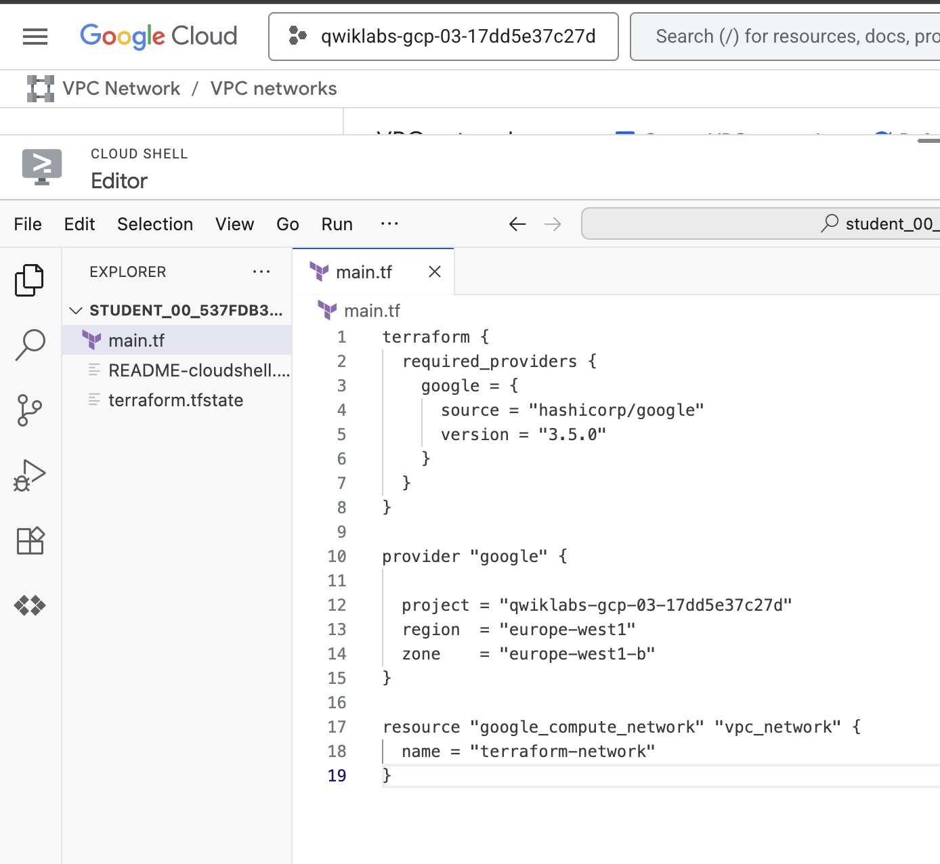

Terraform block
The terraform {} block is required so Terraform knows which provider to download from the Terraform Registry. In the configuration above, the google provider's source is defined as hashicorp/google which is shorthand for registry.terraform.io/hashicorp/google.
You can also assign a version to each provider defined in the required_providers block. The version argument is optional, but recommended. It is used to constrain the provider to a specific version or a range of versions in order to prevent downloading a new provider that may possibly contain breaking changes. If the version isn't specified, Terraform automatically downloads the most recent provider during initialization.
To learn more, on the HashiCorp Terraform website, refer to the Provider Requirements.

Providers
The provider block is used to configure the named provider, in this case google. A provider is responsible for creating and managing resources. Multiple provider blocks can exist if a Terraform configuration manages resources from different providers.

Initialization
The first command to run for a new configuration—or after checking out an existing configuration from version control—is terraform init, which initializes various local settings and data that is used by subsequent commands.
- Initialize your new Terraform configuration by running the terraform init command in the same directory as your main.tf file:
terraform init
Copied!

Creating resources
- Apply you configuration now by running the command terraform apply:
terraform apply
Copied!
The output has a + next to resource "google_compute_network" "vpc_network", meaning that Terraform will create this resource. Beneath that, it shows the attributes that will be set. When the value displayed is (known after apply), it means that the value won't be known until the resource is created.
If the plan was created successfully, Terraform will now pause and wait for approval before proceeding. If anything in the plan seems incorrect or dangerous, it is safe to abort here with no changes made to your infrastructure.
If terraform apply failed with an error, read the error message and fix the error that occurred.
- The plan looks acceptable here, so type yes at the confirmation prompt, and press ENTER to proceed.
Executing the plan takes a few minutes since Terraform waits for the network to be created successfully:
# ...
Enter a value: yes

google_compute_network.vpc_network: Creating...
google_compute_network.vpc_network: Still creating... [10s elapsed]
google_compute_network.vpc_network: Still creating... [20s elapsed]
google_compute_network.vpc_network: Still creating... [30s elapsed]
google_compute_network.vpc_network: Still creating... [40s elapsed]
google_compute_network.vpc_network: Still creating... [50s elapsed]
google_compute_network.vpc_network: Creation complete after 58s [id=terraform-network]

Apply complete! Resources: 1 added, 0 changed, 0 destroyed.
After this, Terraform is all done! You can go to the Cloud console to see the network you have provisioned.
- In the Google Cloud console, from the Navigation menu, navigate to VPC network. You should see the terraform-network has been provisioned.
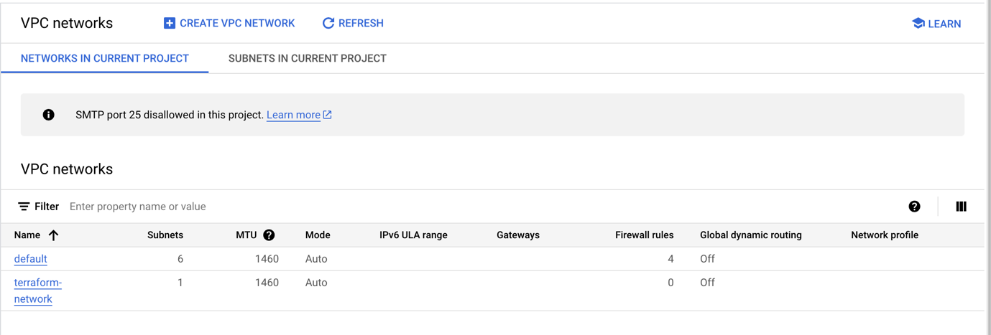
- In Cloud Shell, run the terraform show command to inspect the current state:
terraform show
Copied!
These values can be referenced to configure other resources or outputs, which are covered later in this lab.
Click Check my progress to verify the objective.
Assessment Completed!

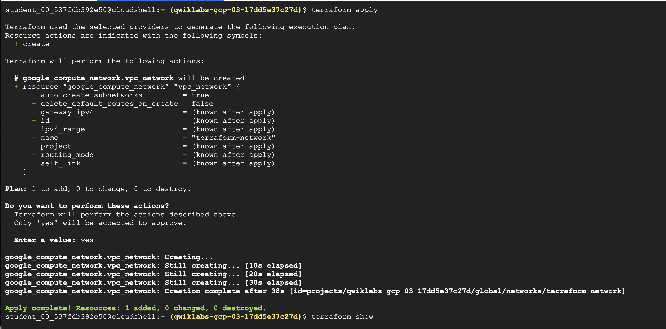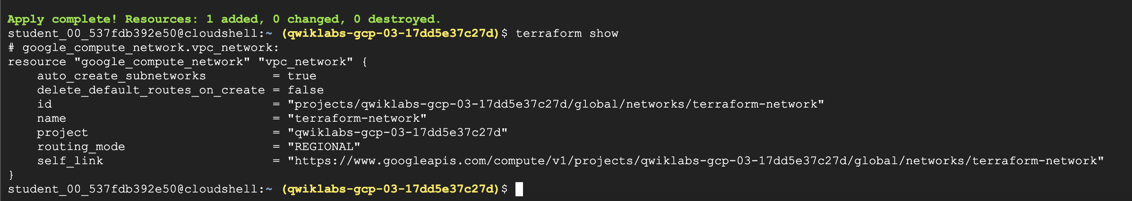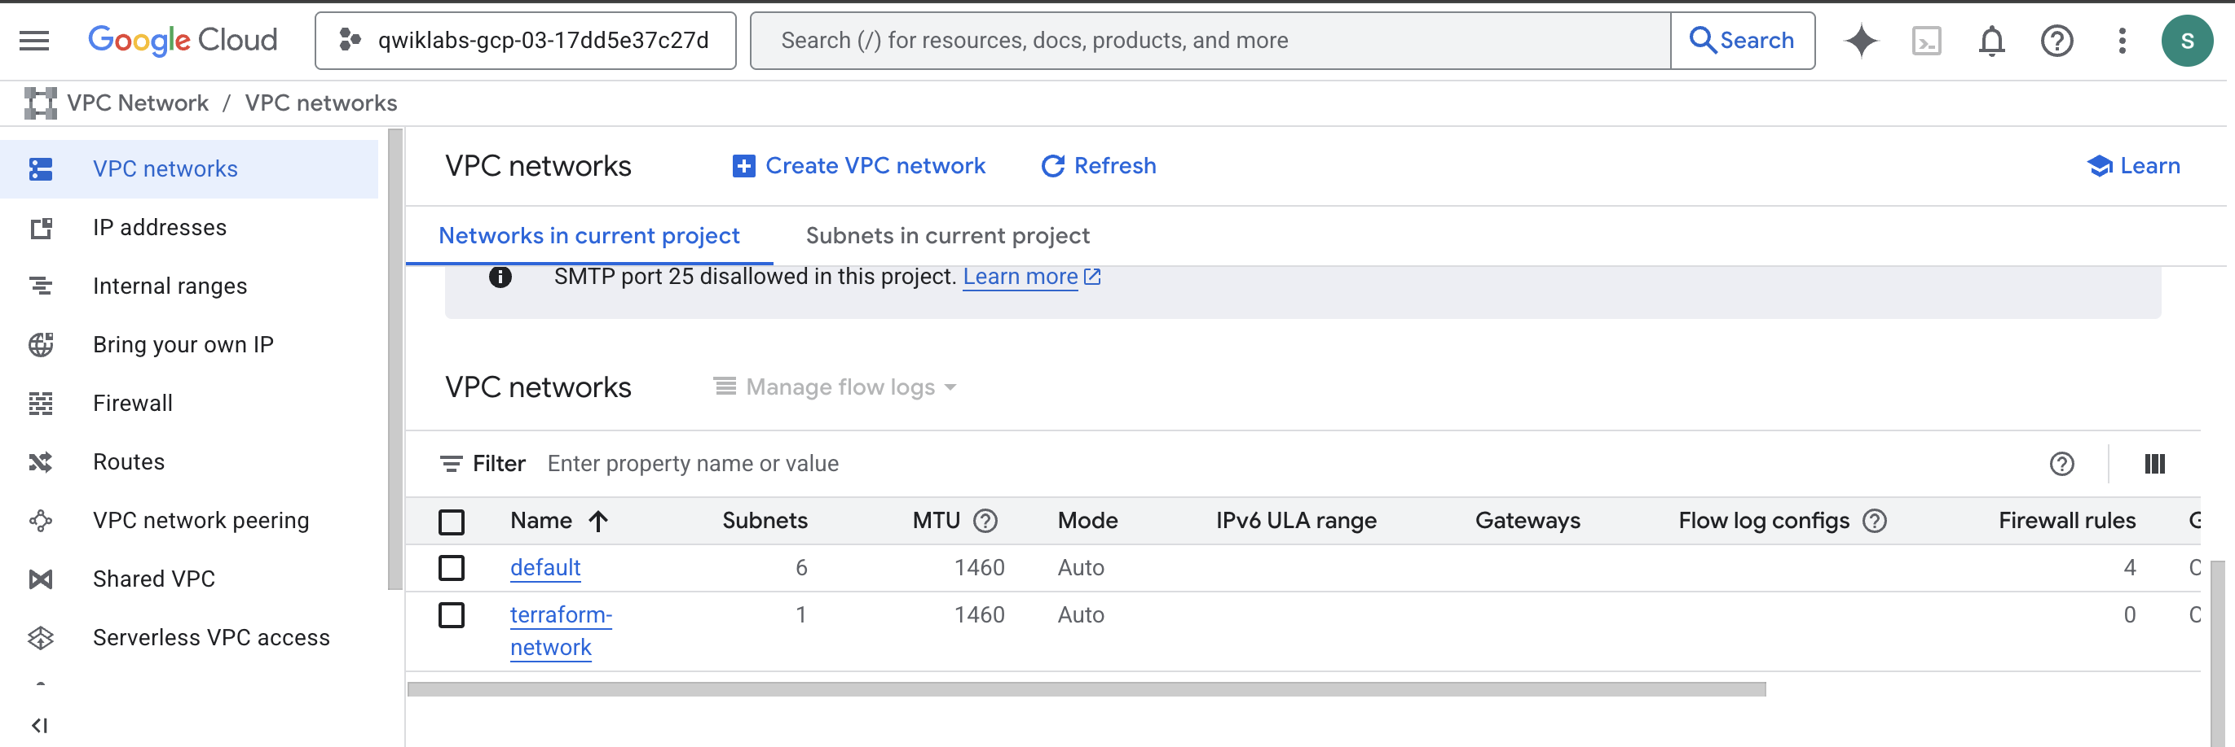

Task 3. Create resource dependencies
In this section, you learn more about resource dependencies and how to use resource parameters to share information about one resource with other resources.
Real-world infrastructure has a diverse set of resources and resource types. Terraform configurations can contain multiple resources, multiple resource types, and these types can even span multiple providers.
In this section, you are shown a basic example of how to configure multiple resources and how to use resource attributes to configure other resources.
- Run the following command to recreate your network and instance:
terraform apply
Copied!
After you respond to the prompt with yes, the resources are created.

Assign a static IP address
- Now run the following to add to your configuration and assign a static IP to the VM instance in main.tf:
resource "google_compute_address" "vm_static_ip" {
name = "terraform-static-ip"
}
Copied!
This should look familiar from the earlier example of adding a VM instance resource, except this time you're creating a "google_compute_address" resource type. This resource type allocates a reserved IP address to your project.
- Next, run terraform plan:
terraform plan
Copied!
You can see what will be created with terraform plan:
$ terraform plan
Refreshing Terraform state in-memory prior to plan...
The refreshed state will be used to calculate this plan, but will not be
persisted to local or remote state storage.

google_compute_network.vpc_network: Refreshing state... [id=terraform-network]
google_compute_instance.vm_instance: Refreshing state... [id=terraform-instance]

------------------------------------------------------------------------

An execution plan has been generated and is shown below.
Resource actions are indicated with the following symbols:
+ create

Terraform will perform the following actions:

# google_compute_address.vm_static_ip will be created
+ resource "google_compute_address" "vm_static_ip" {
+ address = (known after apply)
+ address_type = "EXTERNAL"
+ creation_timestamp = (known after apply)
+ id = (known after apply)
+ name = "terraform-static-ip"
+ network_tier = (known after apply)
+ project = (known after apply)
+ region = (known after apply)
+ self_link = (known after apply)
+ subnetwork = (known after apply)
+ users = (known after apply)
}

Plan: 1 to add, 0 to change, 0 to destroy.

------------------------------------------------------------------------

Note: You didn't specify an "-out" parameter to save this plan, so Terraform can't guarantee that exactly these actions will be performed if
"terraform apply" is subsequently run.
Unlike terraform apply, the plan command will only show what would be changed, and never actually apply the changes directly. Notice that the only change you have made so far is to add a static IP. Next, you need to attach the IP address to your instance.
- Update the network_interface configuration for your instance like so:
network_interface {
network = google_compute_network.vpc_network.self_link
access_config {
nat_ip = google_compute_address.vm_static_ip.address
}
}
Copied!
The access_config block has several optional arguments, and in this case you'll set nat_ip to be the static IP address. When Terraform reads this configuration, it will:
- Ensure that vm_static_ip is created before vm_instance
- Save the properties of vm_static_ip in the state
- Set nat_ip to the value of the vm_static_ip.address property
- Run terraform plan again, but this time, save the plan:
terraform plan -out static_ip
Copied!
Saving the plan this way ensures that you can apply exactly the same plan in the future. If you try to apply the file created by the plan, Terraform will first check to make sure the exact same set of changes will be made before applying the plan.
In this case, you can see that Terraform will create a new google_compute_address and update the existing VM to use it.
- Run terraform apply "static_ip" to see how Terraform plans to apply this change:
terraform apply "static_ip"
Copied!
As shown above, Terraform created the static IP before modifying the VM instance. Due to the interpolation expression that passes the IP address to the instance's network interface configuration, Terraform is able to infer a dependency, and knows it must create the static IP before updating the instance.
Click Check my progress to verify the objective.
Assessment Completed!
Create resource dependencies
Assessment Completed!

Explore implicit and explicit dependencies
By studying the resource attributes used in interpolation expressions, Terraform can automatically infer when one resource depends on another. In the example above, the reference to google_compute_address.vm_static_ip.address creates an implicit dependency on the google_compute_address named vm_static_ip.
Terraform uses this dependency information to determine the correct order in which to create and update different resources. In the example above, Terraform knows that the vm_static_ip must be created before the vm_instance is updated to use it.
Implicit dependencies via interpolation expressions are the primary way to inform Terraform about these relationships, and should be used whenever possible.
Sometimes there are dependencies between resources that are not visible to Terraform. The depends_on argument can be added to any resource and accepts a list of resources to create explicit dependencies for.
For example, perhaps an application you run on your instance expects to use a specific Cloud Storage bucket, but that dependency is configured inside the application code and thus not visible to Terraform. In that case, you can use depends_on to explicitly declare the dependency.
- Add a Cloud Storage bucket and an instance with an explicit dependency on the bucket by adding the following to main.tf:
# New resource for the storage bucket our application will use.
resource "google_storage_bucket" "example_bucket" {
name = "<UNIQUE-BUCKET-NAME>"
location = "US"

website {
main_page_suffix = "index.html"
not_found_page = "404.html"
}
}

# Create a new instance that uses the bucket
resource "google_compute_instance" "another_instance" {
# Tells Terraform that this VM instance must be created only after the
# storage bucket has been created.
depends_on = [google_storage_bucket.example_bucket]

name = "terraform-instance-2"
machine_type = "e2-micro"

boot_disk {
initialize_params {
image = "cos-cloud/cos-stable"
}
}

network_interface {
network = google_compute_network.vpc_network.self_link
access_config {
}
}
}
Copied!
Note: Storage buckets must be globally unique. Because of this, you need to replace UNIQUE-BUCKET-NAME with a unique, valid name for a bucket. Using your name and the date is usually a good way to guess a unique bucket name.
You may wonder where in your configuration these resources should go. The order that resources are defined in a terraform configuration file has no effect on how Terraform applies your changes. Organize your configuration files in a way that makes the most sense for you and your team.
- Now run terraform plan and terraform apply to see these changes in action:
terraform plan
terraform apply
Copied!
Click Check my progress to verify the objective.
Assessment Completed!
Create a bucket dependent instance
Assessment Completed!
- Before moving on, remove these new resources from your configuration and run terraform apply once again to destroy them. You won't use the bucket or the second instance any further in this lab.

Task 4. Provision infrastructure
The compute instance you launched at this point is based on the Google image given, but has no additional software installed or configuration applied.
Google Cloud allows customers to manage their own custom operating system images. This can be a great way to ensure that the instances you provision with Terraform are pre-configured based on your needs. Packer is the perfect tool for this and includes a builder for Google Cloud.
Terraform uses provisioners to upload files, run shell scripts, or install and trigger other software like configuration management tools.

Define a provisioner
- To define a provisioner, modify the resource block defining the first vm_instance in your configuration to look like the following:
resource "google_compute_instance" "vm_instance" {
name = "terraform-instance"
machine_type = "e2-micro"
tags = ["web", "dev"]

provisioner "local-exec" {
command = "echo ${google_compute_instance.vm_instance.name}: ${google_compute_instance.vm_instance.network_interface[0].access_config[0].nat_ip} >> ip_address.txt"
}

# ...
}
Copied!
This adds a provisioner block within the resource block. Multiple provisioner blocks can be added to define multiple provisioning steps. Terraform supports many provisioners, but for this example you are using the local-exec provisioner.
The local-exec provisioner executes a command locally on the machine running Terraform, not the VM instance itself. You're using this provisioner versus the others so we don't have to worry about specifying any connection info right now.
This also shows a more complex example of string interpolation than you've seen before. Each VM instance can have multiple network interfaces, so refer to the first one with network_interface[0], count starting from 0, as most programming languages do. Each network interface can have multiple access_config blocks as well, so once again you specify the first one.
- Run terraform apply:
terraform apply
Copied!
At this point, the output may be confusing at first.
Terraform found nothing to do - and if you check, you'll find that there's no ip_address.txt file on your local machine.
Terraform treats provisioners differently from other arguments. Provisioners only run when a resource is created, but adding a provisioner does not force that resource to be destroyed and recreated.
- Use terraform taint to tell Terraform to recreate the instance:
terraform taint google_compute_instance.vm_instance
Copied!
A tainted resource will be destroyed and recreated during the next apply.
- Run terraform apply now:
terraform apply
Copied!
- Verify everything worked by looking at the contents of the ip_address.txt file.
It contains the IP address, just as you asked.

Failed provisioners and tainted resources
If a resource is successfully created but fails a provisioning step, Terraform will error and mark the resource as tainted. A resource that is tainted still exists, but shouldn't be considered safe to use, since provisioning failed.
When you generate your next execution plan, Terraform will remove any tainted resources and create new resources, attempting to provision them again after creation.

Destroy provisioners
Provisioners can also be defined that run only during a destroy operation. These are useful for performing system cleanup, extracting data, etc.
For many resources, using built-in cleanup mechanisms is recommended if possible (such as init scripts), but provisioners can be used if necessary.
This lab won't show any destroyed provisioner examples. If you need to use destroy provisioners, please refer to the provisioners documentation.

Main.tf

terraform {
required_providers {
google = {
source = "hashicorp/google"
version = "3.5.0"
}
}
}

provider "google" {
project = "qwiklabs-gcp-03-f17a8f6b2b6f"
region = "us-east1"
zone = "us-east1-c"
}

# Create a VPC network
resource "google_compute_network" "vpc_network" {
name = "terraform-network"
}

# Reserve a static external IP
resource "google_compute_address" "vm_static_ip" {
name = "terraform-static-ip"
region = "us-east1"
}

# Create the first VM instance with the static IP attached
resource "google_compute_instance" "vm_instance_1" {
name = "terraform-instance-1"
machine_type = "e2-micro"
zone = "us-east1-c"

boot_disk {
initialize_params {
image = "cos-cloud/cos-stable"
}
}

network_interface {
network = google_compute_network.vpc_network.self_link
access_config {
nat_ip = google_compute_address.vm_static_ip.address
}
}

tags = ["web", "dev"]

# Save the VM IP to a local file
provisioner "local-exec" {
command = "echo ${self.name}: ${self.network_interface[0].access_config[0].nat_ip} >> ip_address.txt"
}
}

# Create a globally unique storage bucket
resource "google_storage_bucket" "example_bucket" {
name = "terraform-example-bucket-12345" # Must be globally unique
location = "US"

website {
main_page_suffix = "index.html"
not_found_page = "404.html"
}
}

# Create a second VM instance that depends on the storage bucket
resource "google_compute_instance" "vm_instance_2" {
depends_on = [google_storage_bucket.example_bucket]

name = "terraform-instance-2"
machine_type = "e2-micro"
zone = "us-east1-c"

boot_disk {
initialize_params {
image = "cos-cloud/cos-stable"
}
}

network_interface {
network = google_compute_network.vpc_network.self_link
access_config {
# Ephemeral external IP (no static IP)
}
}

tags = ["web", "dev"]
}

