NAME : NISHITA MANHASINH SOLANKI
ROLL NO.: 22BCE211
SUBJECT : DEVOPS
PRACTICAL – 5 KONG AND NGNIX

- NGNIX
Ngnix.conf
events {}

http {
server {
listen 80;

# route /users -> user service
location /users {
proxy_pass http://user-service:3001;

}

# route /posts -> post service
location /posts {
proxy_pass http://post-service:3002;

}
}
}

Docker-compose.yml
# version: "3.8"
services:
user-service:
build: ./user_service
container_name: user-service
ports:
- "3001:3001"
networks:
- my-network

post-service:
build: ./post_service
container_name: post-service
ports:
- "3002:3002"
networks:
- my-network

nginx:
image: nginx:latest
container_name: nginx-proxy
ports:
- "80:80"
volumes:
- ./nginx/nginx.conf:/etc/nginx/nginx.conf:ro
depends_on:
- user-service
- post-service
networks:
- my-network

networks:
my-network:

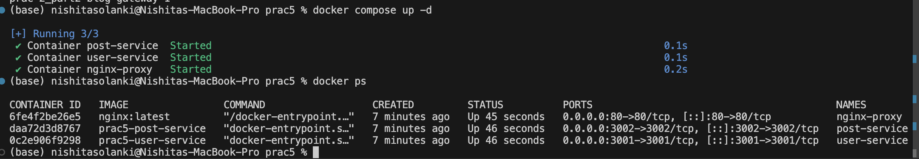

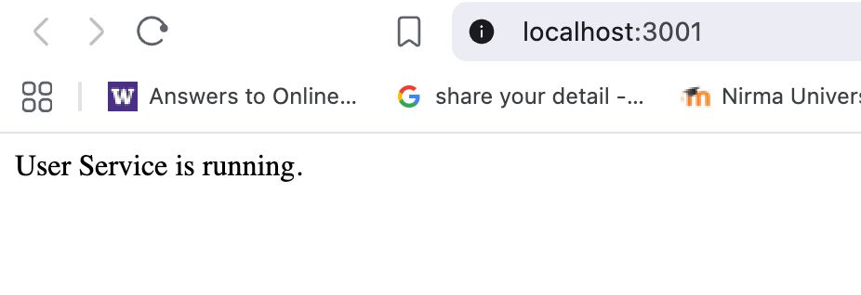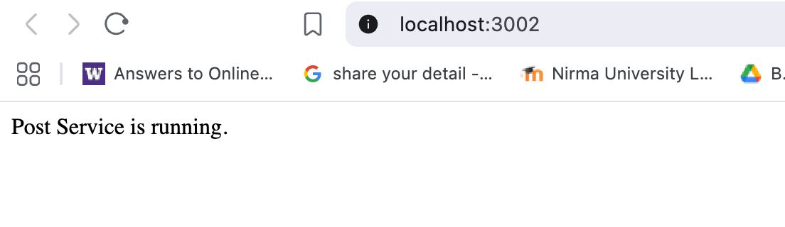

- Kong
Kong.yml
_format_version: "3.0"
services:
- name: user-service
url: http://users-backend-service:3001
routes:
- name: user-route
paths:
- /api/v1/users
- name: post-service

url: http://post-backend-service:3002
routes:
- name: post-route
paths:
- /api/v1/posts

Docker-compose.kong.yml

version: "3.8"

services:
user-service:
build: ./user_service
container_name: users-backend-service
ports:
- "3001:3001" # host:container
networks:
- my-network

post-service:
build: ./post_service
container_name: post-backend-service
ports:
- "3002:3002" # host:container
networks:
- my-network

kong:
image: kong:3.6
environment:
KONG_DATABASE: "off"
KONG_DECLARATIVE_CONFIG: /kong.yml
KONG_PROXY_LISTEN: 0.0.0.0:8000
KONG_ADMIN_LISTEN: 0.0.0.0:8001
ports:
- "8000:8000" # Public gateway
- "8001:8001" # Admin API (optional)
volumes:
- ./kong.yml:/kong.yml:ro
networks:
- my-network

networks:
my-network:
driver: bridge

