Google Kubernetes Engine: Qwik Start

Task 1. Set a default compute zone
Set the default compute region:
gcloud config set compute/region us-west1

Set the default compute zone:
gcloud config set compute/zone us-west1-c

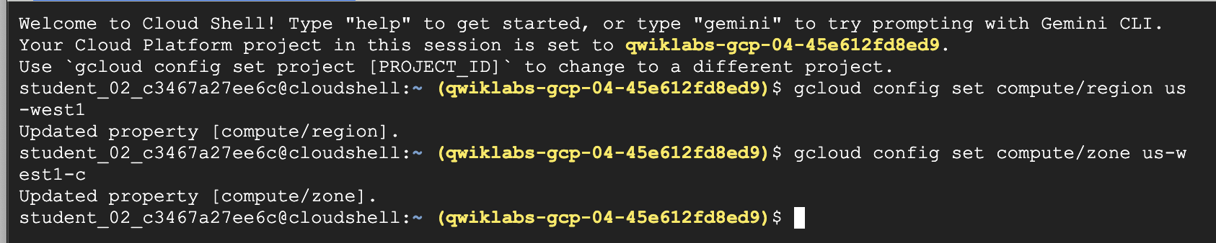

Task 2. Create a GKE cluster
Create a cluster: gcloud container clusters create --machine-type=e2-medium --zone=us-west1-c lab-cluster
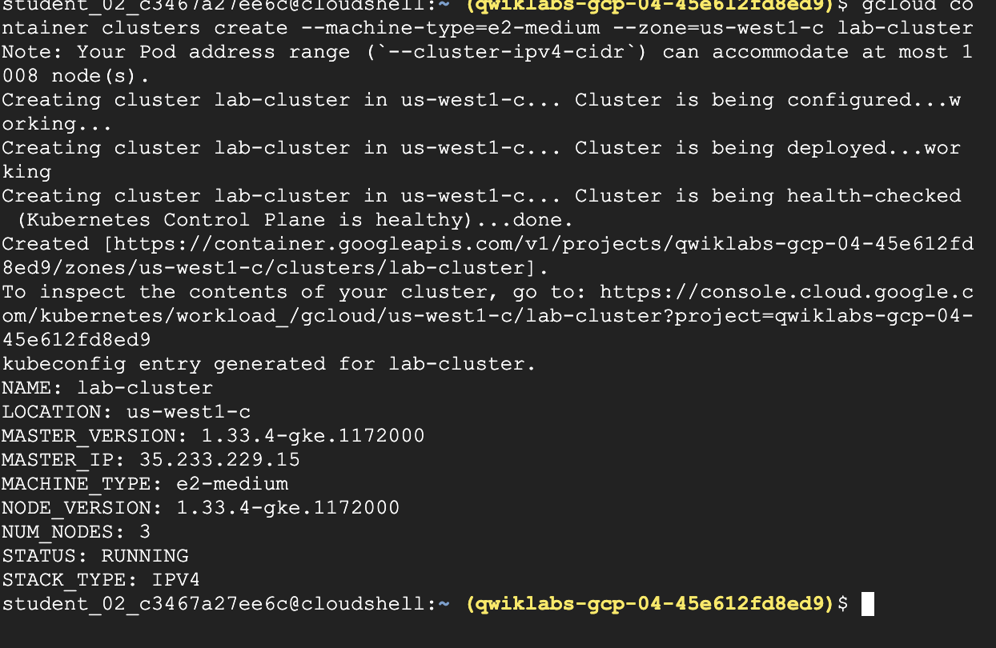

Task 3. Get authentication credentials for the cluster
Authenticate with the cluster:
gcloud container clusters get-credentials lab-cluster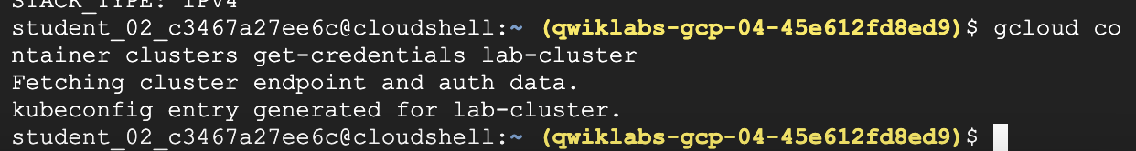

Task 4. Deploy an application to the cluster
You can now deploy a containerized application to the cluster. For this lab, you'll run hello-app in your cluster.
GKE uses Kubernetes objects to create and manage your cluster's resources. Kubernetes provides the Deployment object for deploying stateless applications like web servers. Service objects define rules and load balancing for accessing your application from the internet.
- To create a new Deployment hello-server from the hello-app container image, run the following kubectl create command:
kubectl create deployment hello-server --image=gcr.io/google-samples/hello-app:1.0

To create a Kubernetes Service, which is a Kubernetes resource that lets you expose your application to external traffic, run the following kubectl expose command:
kubectl expose deployment hello-server --type=LoadBalancer --port 8080
In this command:
- --port specifies the port that the container exposes.
- type="LoadBalancer" creates a Compute Engine load balancer for your container.
To inspect the hello-server Service, run kubectl get:
kubectl get service

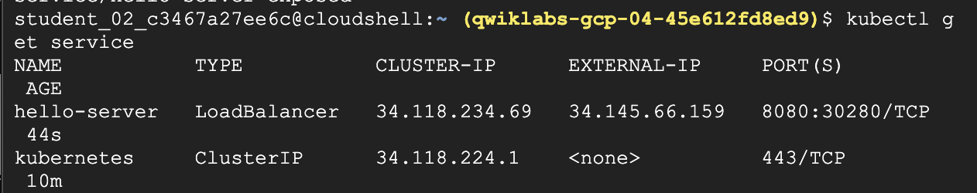
To view the application from your web browser, open a new tab and enter the following address, replacing [EXTERNAL IP] with the EXTERNAL-IP for hello-server.
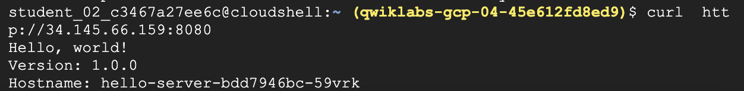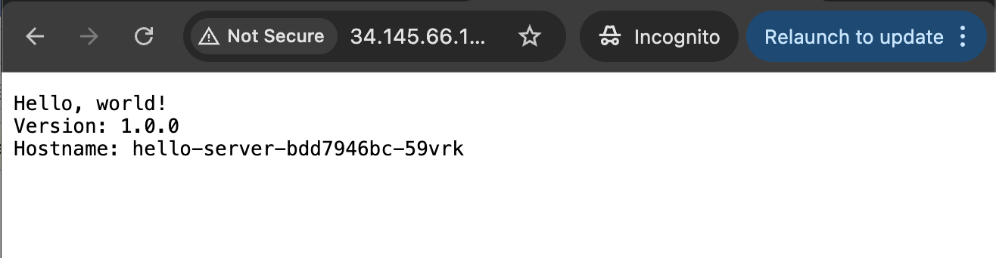

Task 5. Delete the cluster
To delete the cluster, run the following command:
gcloud container clusters delete lab-cluster

When prompted, type Y and press Enter to confirm.
Deleting the cluster can take a few minutes. For more information, refer to the Google Kubernetes Engine (GKE) article on Deleting a cluster.

