ROLL NO: 22BCE157
COURSE: Cloud Native Applications and DevOps
DATE: 15/07/2025
PRACTICAL 2
AIM: Develop two RESTful microservices using Spring Boot (Java) and Node.js (JavaScript).
Steps: -
- Check version of node
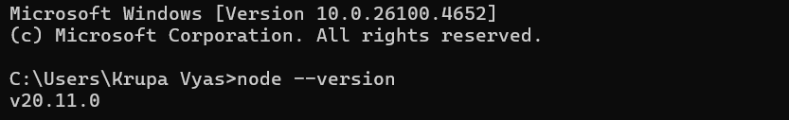
- npm init -y
- npm install express
- npm install -- save-dev nodemon
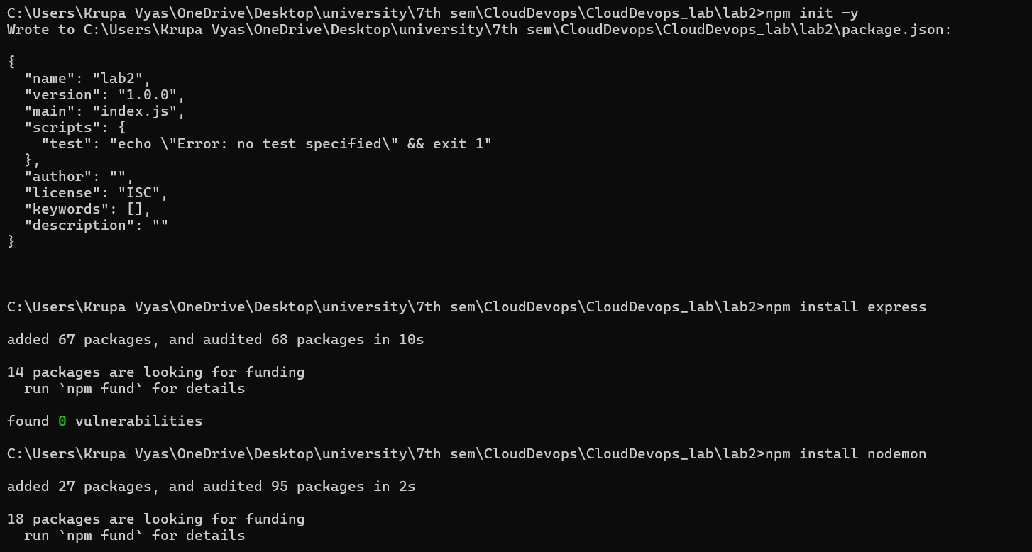
- "scripts": {"start": "nodemon start",}
- npm start

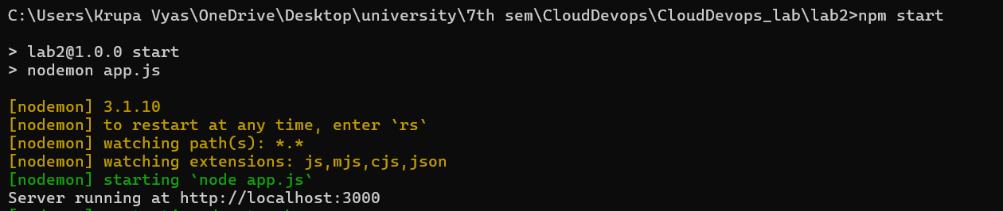
- create a basic app.js with GET method
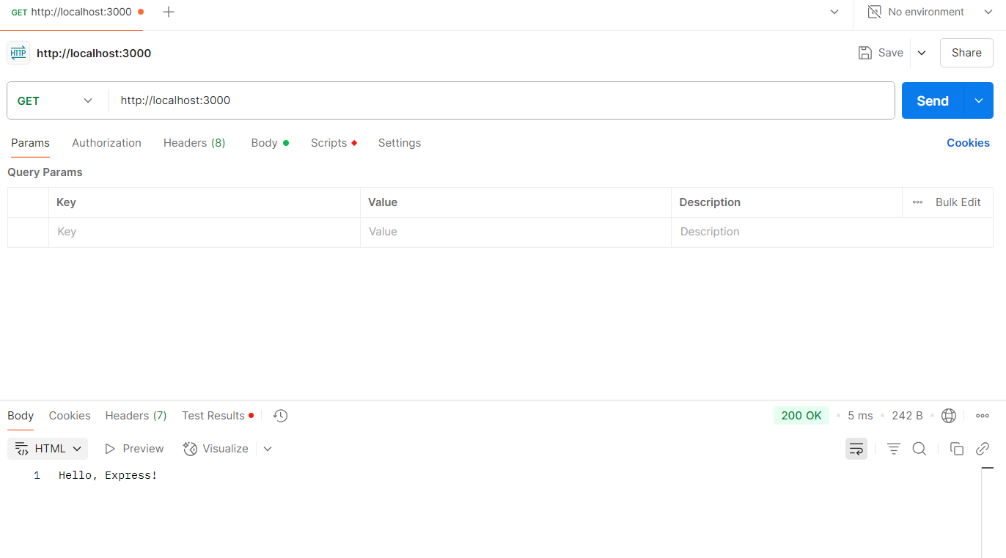
- Post method to create a new user /users

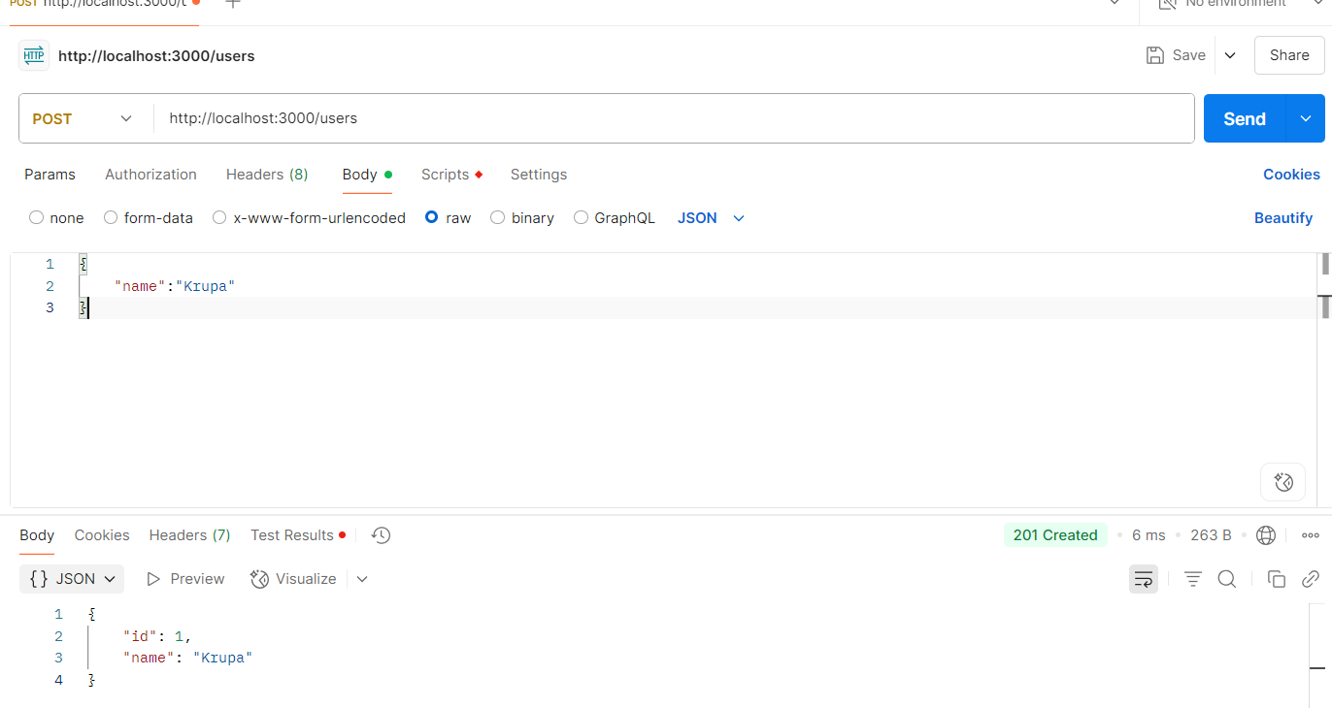
- Get method to retrieve the users created
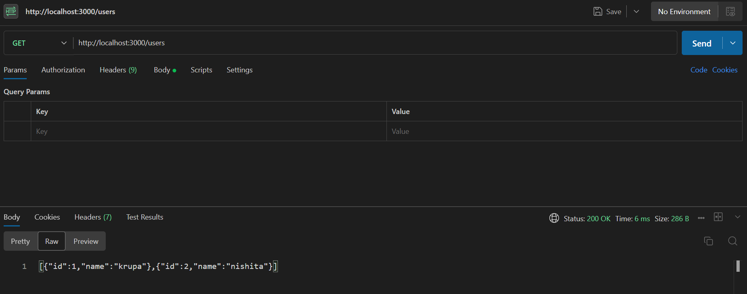

- POST method to create a post.
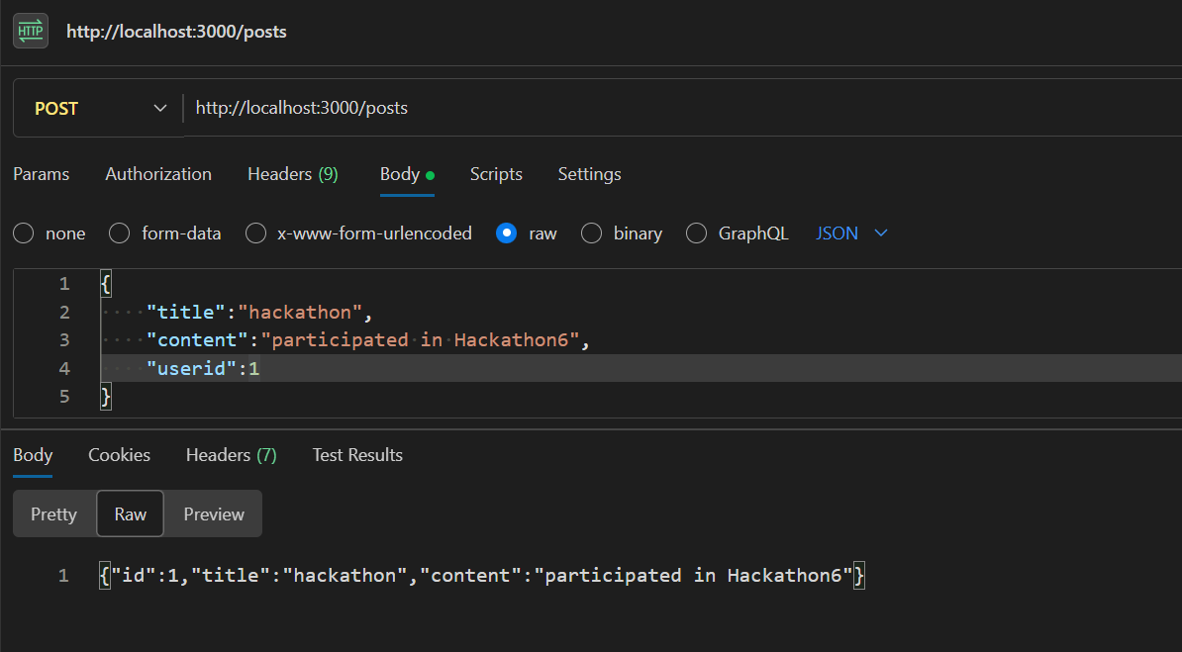
- GET method to get the post

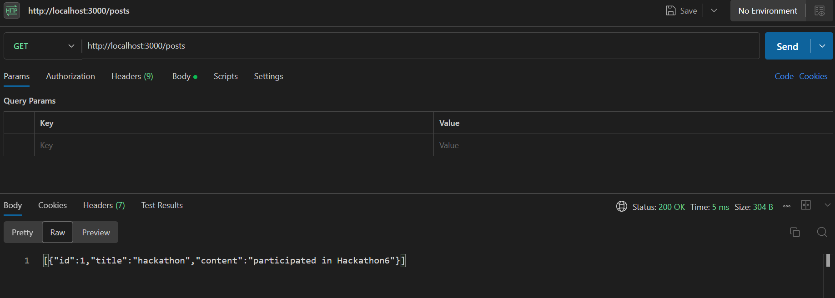12) PUT method to updated the post
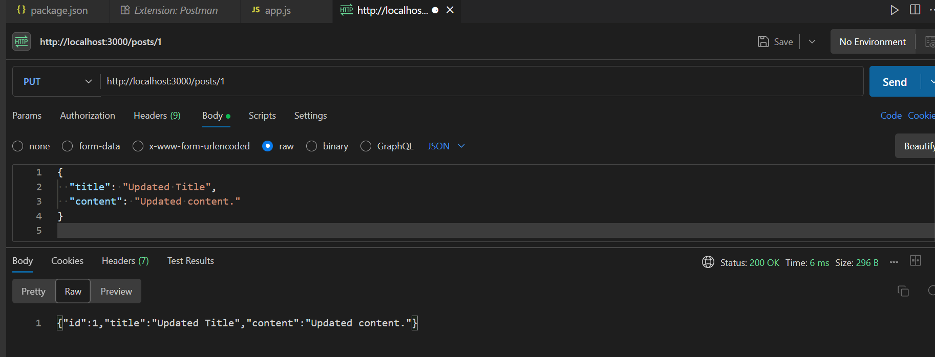
13) PUT method to delete the post.
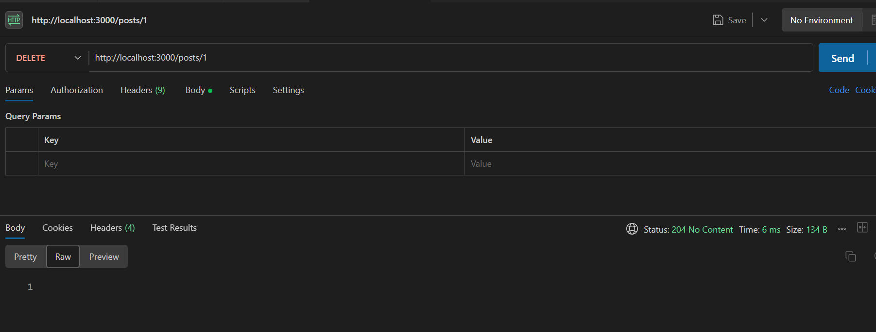
14) Checking if post got deleted
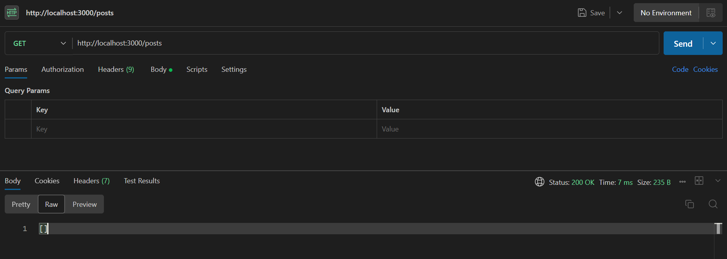

Blog App in Microservices:

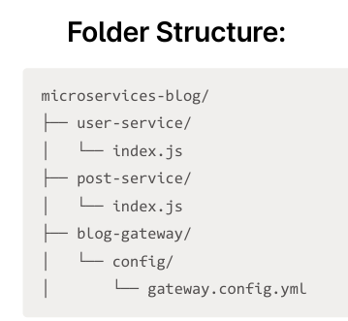
Initialise npm and install express for user and post microservice.
STEPS-
- npm init -y
- npm install express
- repeat this for user-service and post service
- start both the servers
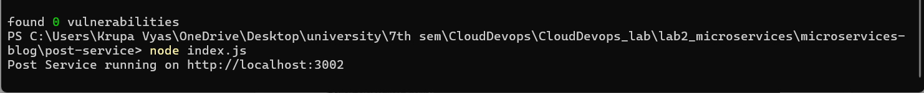
- npm install -g express-gateway
- eg create gateway
- blog-gateway
- select default – proxy
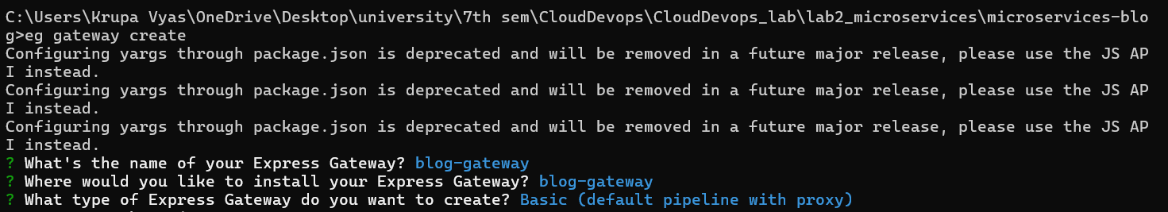
- npm start
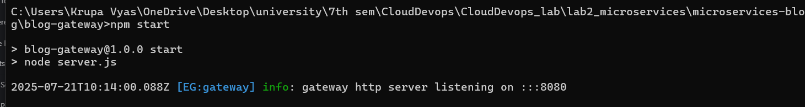
- using post method create a new user.
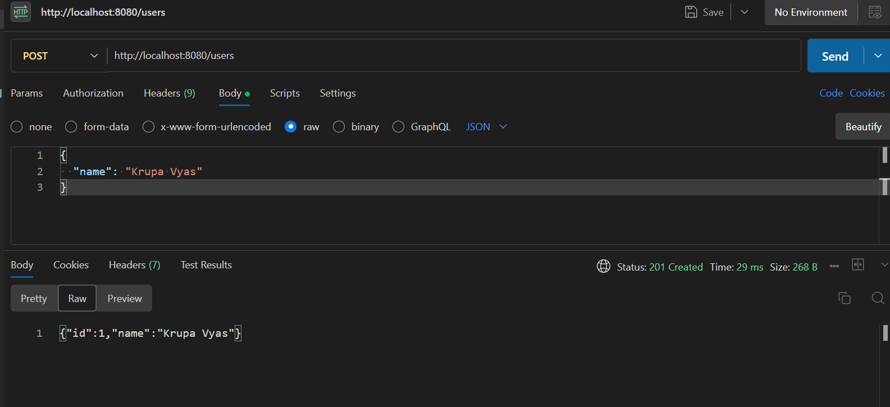
- using GET method retrieve the user.
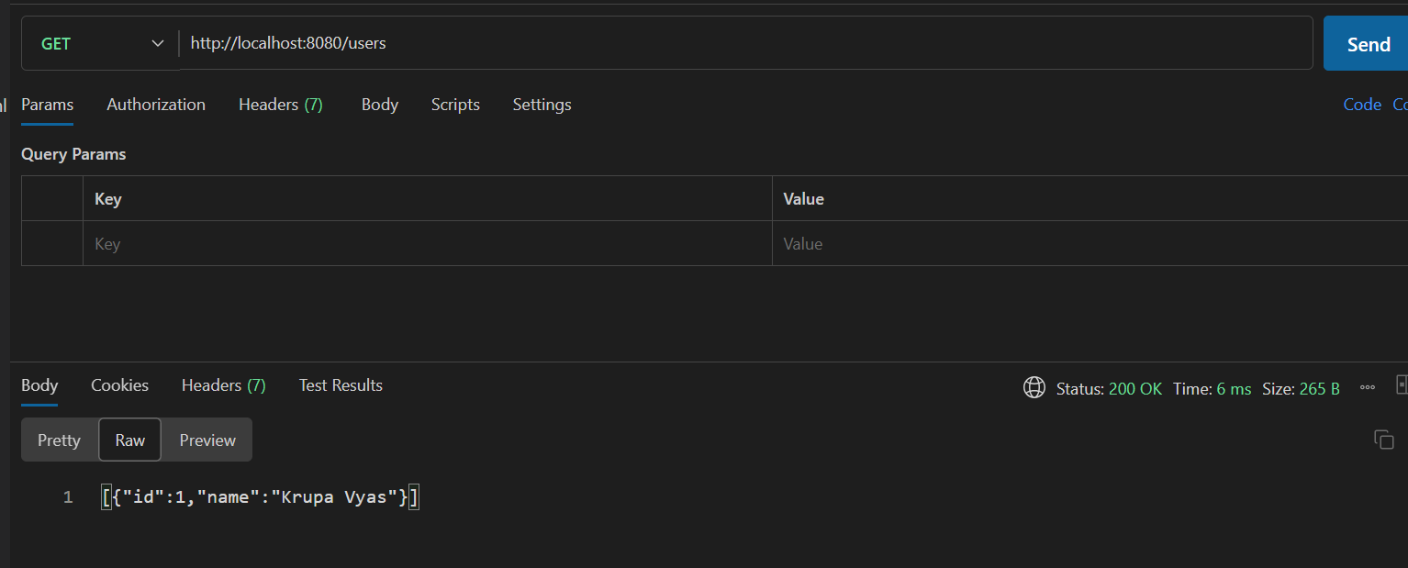
- using the POST method post a blog-post
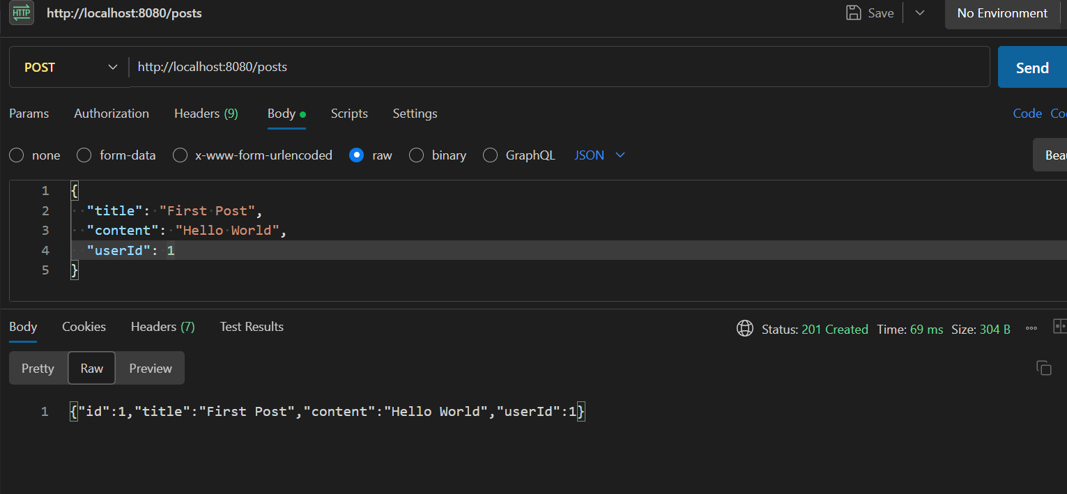
- using the GET method retrieve the blog-post

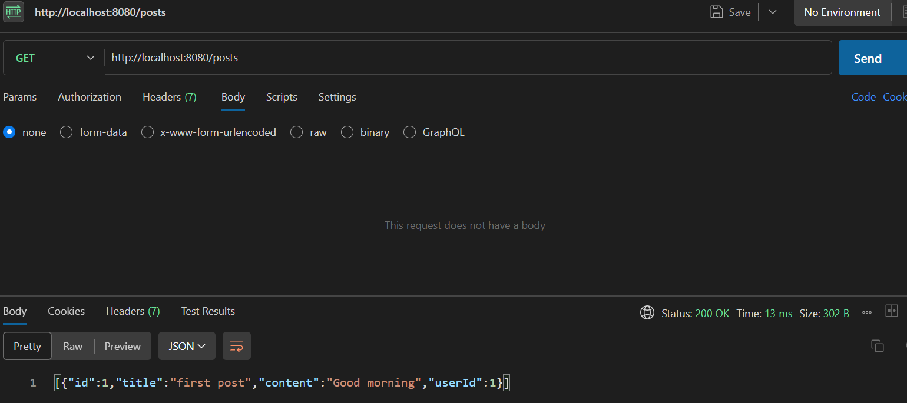
- using the PUT method to update the post
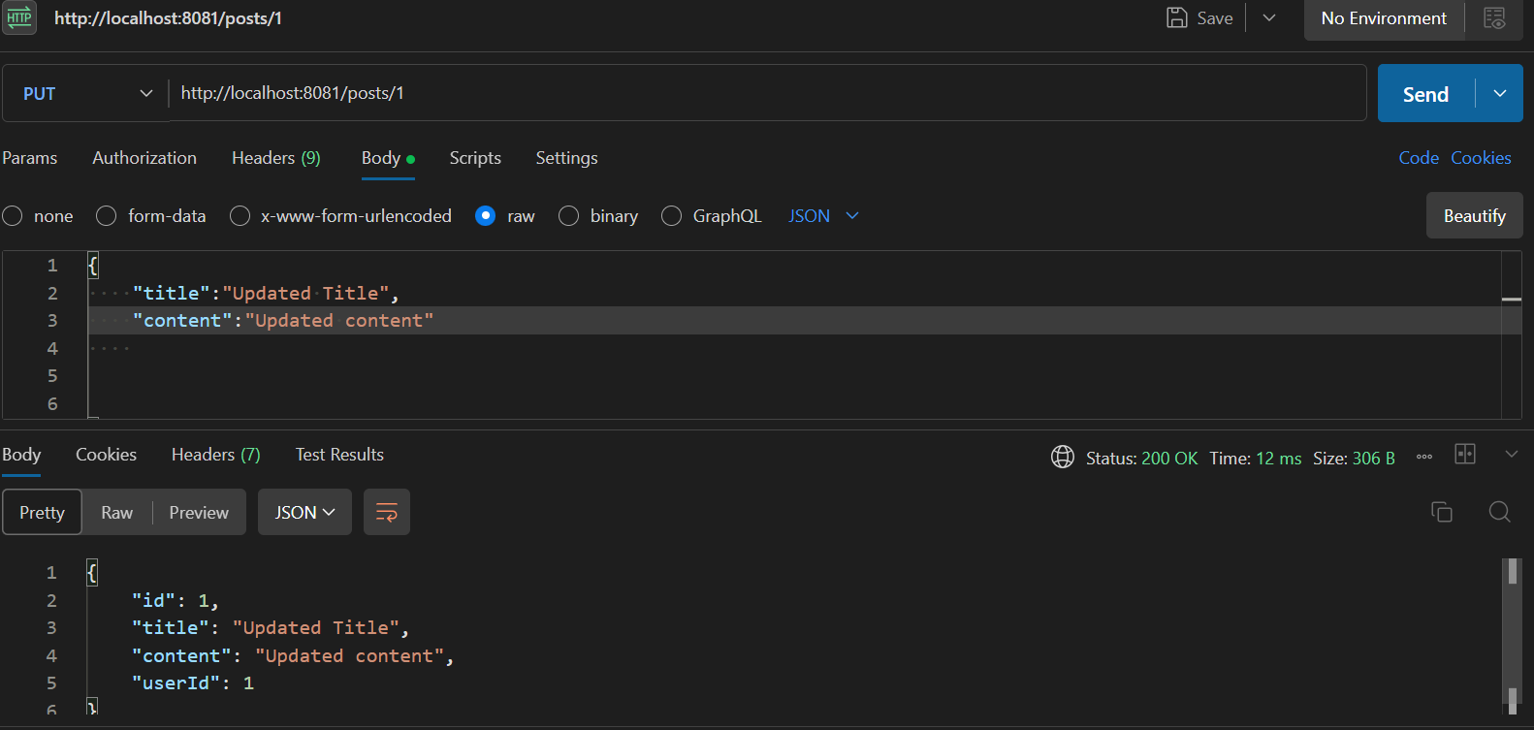
- using DELETE method to delete the post
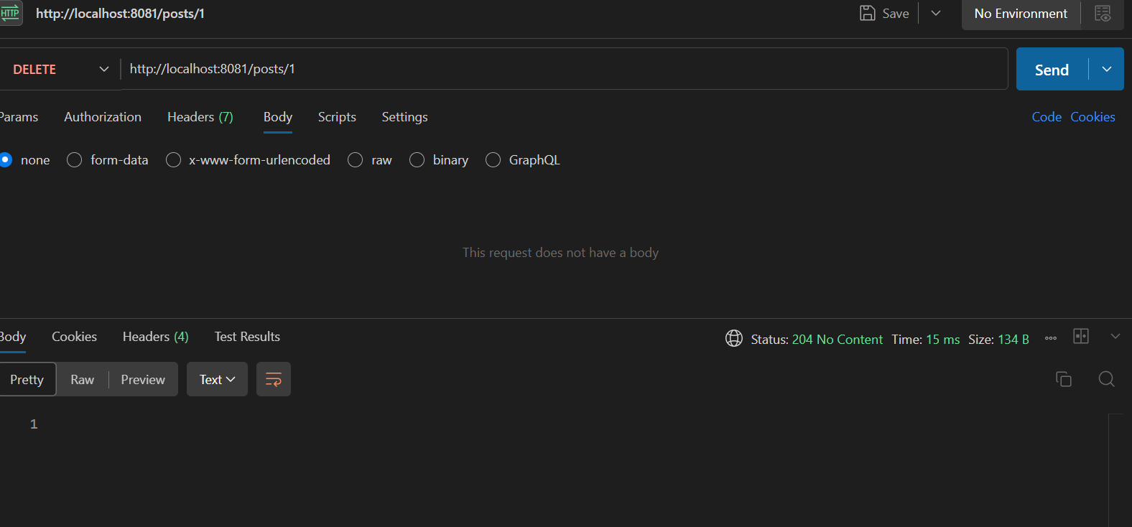
The post is deleted hence Get request prints empty array

