Poké Checker

Trevor Klinkenberg

University of Missouri – Kansas City

Vision Statement

When playing a Pokémon game I constantly find myself pausing the game and having to look up a Pokémon by name, just to get it’s type. Once this is done, I have to then cross reference a giant grid of type matchups to see what the most effective strategy is to win against that Pokémon. The Poké Checker will eliminate this tedious process by presenting the user with instant access to a Pokémon database that has the weakness and strengths of each Pokémon through a simple quick lookup.
For the First release all 800+ Pokémon should be available in the database alongside their type weakness and strengths. A simple search functionality should bring up any Pokémon and present the user with this data in a clean, concise manner.
Future development should include more aesthetic features, including pictures of the types and the Pokémon itself. Including additional data would be convenient like the Base Stats of the Pokémon, it’s Evolution line and how they evolve (what level, by trade or by item). Additionally, an ideal move list would be convenient to add based on data gathered from the competitive meta. I would also like to implement a predicted search so that the whole name does not have to be typed and the user would be presented with suggestions as they type.

Requirements
The Poké Checker will need a complete database of the 800+ Pokémon that have been introduced in the series so far, Support for many of which have multiple types. This will then need to be cross referenced with a type matchup functionality that will check for strengths and weaknesses of the Pokémon. Additionally, extra edge cases will need to be created for special scenarios where types have no effect, or a certain type mix makes traditional matchups ineffective.

Actor | Goal
Trevor Klinkenberg | I want a Friendly GUI that presents clear quick information
Trevor Klinkenberg | I want to be able to search for any of the 800+ pokemon
Trevor Klinkenberg | I want to see what Pokemon I searched for is strong and weak against, as well as what type(s) it is
Trevor Klinkenberg | I want to know what the evolutionary steps are of the pokemon and what levels or special requirements it needs to evolve.
Trevor Klinkenberg | I want to know what the Base stats are of the pokemon I searched for
Trevor Klinkenberg | I want the app to offer suggestions as I type the pokemon name.
Trevor Klinkenberg | I want to be able to click on the picture of a pokemon in an evolution line and see that pokemon’s information.

Product Backlog
This will be updated throughout the semester as new PBIs are added, larger items are broken into smaller ones, and completed items removed.

Story ID | Story | Story Points  (in est. hours) | Priority | Status
001 | Search Bar | 2 | N/A | Done
002 | Database Creation | 3 | N/A | Done
013 | Data Entry | 8 | N/A | Done
014 | UI integration | 5 | N/A | Done
003 | Type Matchup Logic | 10 | N/A | Done
004 | Evolution Database Design | 10 | N/A | N/A  (Removed, completed with UID 013)
005 | Type Database Design | 10 | N/A | N/A  (Removed, completed with UID 013)
006 | UI Functionality | 30 | N/A | Done
007 | Search Button | 2 | N/A | Done
008 | Pokemon Picture | 3 | N/A | Done
009 | Evolution Line UI/Selectable | 4 | N/A | Done
010 | Base Stats UI | 3 | 99
011 | Weakness UI | 2 | N/A | Done
012 | Strength UI | 2 | N/A | Done
015 | Gather Picture Data | 8 | 1
016 | CSV Import | 5 | N/A | Done
017 | Base Stats Database | 5 | 99
018 | Base Stats Data entry | 12 | 99
019 | Evolution Text boxes | 3 | N/A | Done
020 | Clickable Evolution Images | 5 | 90
021 | Dark mode option | 5 | 99
022 | Text Wrapping for Weakness / Strength text boxes. | 3 | 2

Sprint #1

Sprint Backlog
Story ID | Story / Task | Estimated  Hours | Actual  Hours
001 | Search Bar | 2 | 2
007 | Search Button | 2 | 2
008 | Pokemon Picture | 3 | 1
009 | Evolution Line UI/Selectable | 4 | 2
010 | Base Stats UI | 3 | N/A
011 | Weakness UI | 2 | 2
012 | Strength UI | 2 | 2

Review

UI was created, Base stats was not implemented. Hidden fields created for future use.

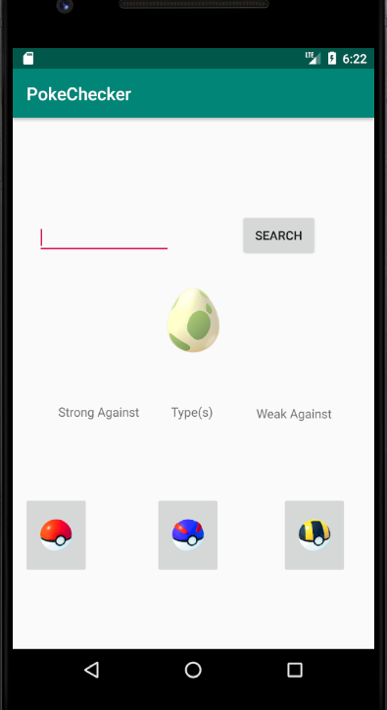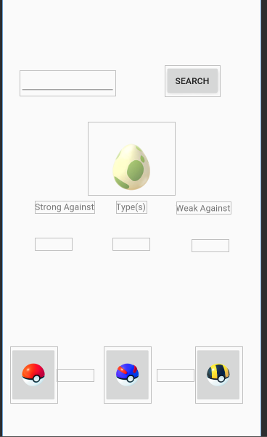

Retrospective
UI design went well, was able to successfully implement. Had difficulty in any reliable UI testing code. That was thrown out for manual tests. Was unable to implement a Base stats UI, this was felt that it needed to be implemented later as it is a stretch goal feature to be implemented if there is enough time.

Sprint #2

Sprint Backlog
Story ID | Story / Task | Estimated  Hours | Actual  Hours
002 | Database Creation | 3 | 3
013 | Data Entry | 8 | 12

Review
All data entry complete put in a CSV file ready for import into the database. No pictures of functionality for this sprint since it is was all data entry into the CSV file and backend work of creating the database classes. This has no noticeable functionality from the front end.

Retrospective
The data entry took a significant amount of time. This was expected however and estimated appropriately, so not much work was done on the application itself. However now that the heavy load of data is created I anticipate much more ramp up of functionality in the next few sprints. Not a lot of testing code was created for the database since no functionality was implemented on it. Would like to create much more testing code in future sprints.

Sprint #3

Sprint Backlog
Story ID | Story / Task | Estimated  Hours | Actual  Hours
016 | CSV Import | 5 | 7
014 | UI / DB integration | 5 | N/A
006 | UI Functionality | 3 | N/A

Review

I was able to convert the CSV into a database format. I was not able to do this natively through the application. I was able to do this externally by importing the CSV into SQL-Lite and saving as a .db file.

UI integration and functionality was not done due to complexity and external factors.

Retrospective
The CSV import took a longer amount of time than anticipated due to unfamiliarity with the coding environment and SQL integration. Additionally external factors played a severe role in hampering progress this sprint. The Coronavirus pandemic and social isolation/quarantine forced a new paradigm in my life that required my attention external to the project. Adjusting to work from home, remote schooling and taking care of my children's remote schooling made this project take a lesser role.

Sprint #4

Sprint Backlog
Story ID | Story / Task | Estimated  Hours | Actual  Hours
014 | UI / DB integration | 5 | 7
006 | UI Functionality | 7 | 5

Review

There was a significant amount of time spent with tweaking the Database due to Schema import issues. Once this was resolved the act of pulling data went extremely quickly. Search functionality now correctly presents all data needed as show in the screenshots. However, during development it was noticed that text boxes were missing for the names of the pokemon. This has been added to the backlog to work on next sprint.

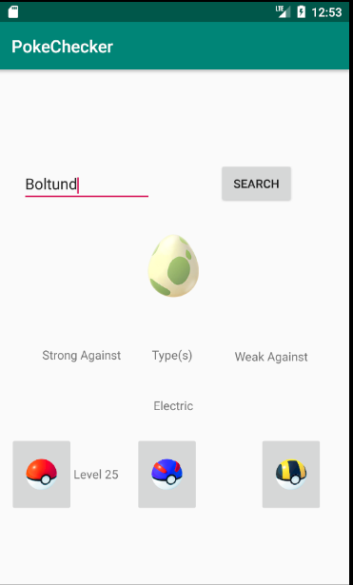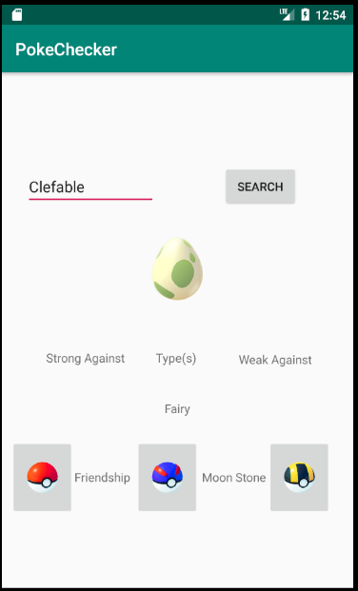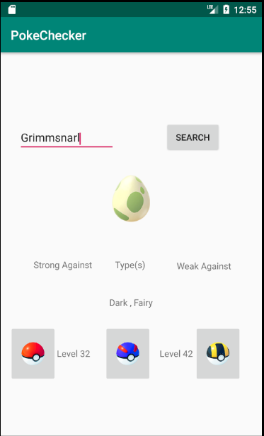

Retrospective
Overall this sprint went well with what time I had to work on the project. Home life has been difficult to find time on the project due to quarantine and not having a solitary place to do my work. Constant disruptions are a fact of life now so that I can assist my family in what they need to accomplish for the children’s school and work from home. Budgeting time has become a greater need and I will be planning dedicated development time during the next sprint for work on the project.

Sprint #5

Sprint Backlog
Story ID | Story / Task | Estimated  Hours | Actual  Hours
019 | Evolution Text boxes | 3 | 3
003 | Type Matchup Logic | 10 | 8

Review

All tasks were finished for this sprint. Type matchup logic was easier to implement then expected. By doing two switch statements this provided a fast lookup O(n) for strength and weakness. Coupled with single table lookup performance was better then expected. However, due to an oversight it was noticed that ½ damage scenarios did not have a UI element. This has been added to the backlog and will most likely have to be implemented in future releases. Additionally UI issues were noticed when the Strength or weakness list is too large. This has been added to the backlog.

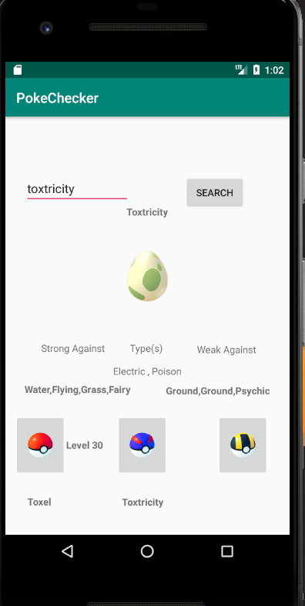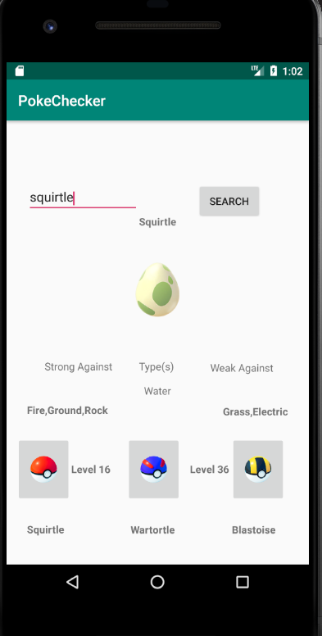

Retrospective
Reserved times for development during this sprint helped productivity quite a bit. I was able to preserve burndown back to the usual metric with this method.

Sprint #6

Sprint Backlog
Story ID | Story / Task | Estimated  Hours | Actual  Hours
015 | Gather Picture Data | 8
022 | Text Wrapping for Weakness / Strength text boxes. | 5

Review

[Screenshots, etc go here. This is where you discuss the product, describing what was done this sprint (potentially shippable product increment) and what was planned for the sprint but was not done. ]

Retrospective
[This is where you discuss the process. What went well (and are you planning to do more of that?) What didn’t go so well (and do you have a way to do less of that)? What changes are you planning to make in how you plan & carry out the next sprint?]

