1. Compute Histogram for image recognition (50pts)

Data set: the NWPU aerial data set contains approximately 45 categories of 700 images for each category in 256x256 RGB format. The data set can be downloaded from:

<https://umkc.box.com/s/fxvzh5qq2tiob6eklfxfwn89kg3e1io1>

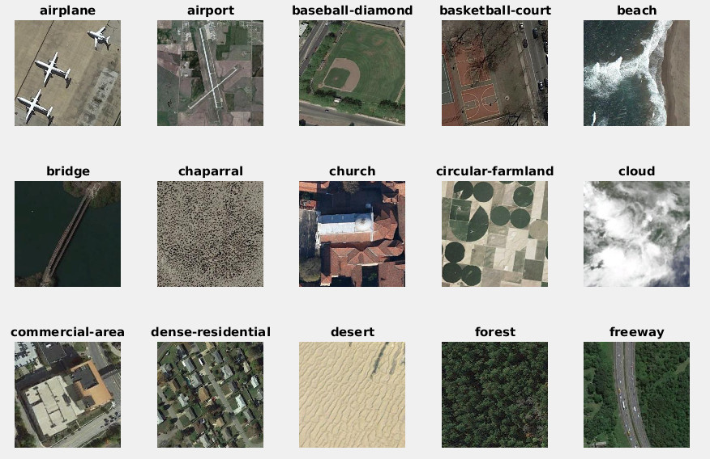

For HW-1, let us just take the first 15 classes (shown above) from the full data set, and 100 images per class and form a data set of 1500 images with 15 labels. Objectives are,

1. compute a HSV kmeans model with total number of entry K=64, b) for each image compute a color histogram, c) use Euclidean, and KL Distances to measure the similarity between two images, i.e, have a matlab/python function,[d]=getHSVDistance(im1, im2, t); where t is the table from Kmeans. d) randomly select 400 images from the data set, and compute its 1-NN label prediction from histogram distance and plot its confusion map.
2. Homograph estimation: use the SVD to solve the over-fitting Ah=0 as covered in class. Use the sample code as template: <http://www.vlfeat.org/applications/sift-mosaic-code.html,> compute homograph for the following two images:

|  |  |
| --- | --- |
| p1 | p2 |

First compute SIFT and SIFT matches, then select good matches to solve homography.