Homework-4: Classification of the remote sensing data set

Data set: the NWPU aerial data set contains approximately 45 categories of 700 images for each category in 256x256 RGB format. The data set can be downloaded from:

<https://umkc.box.com/s/fxvzh5qq2tiob6eklfxfwn89kg3e1io1>

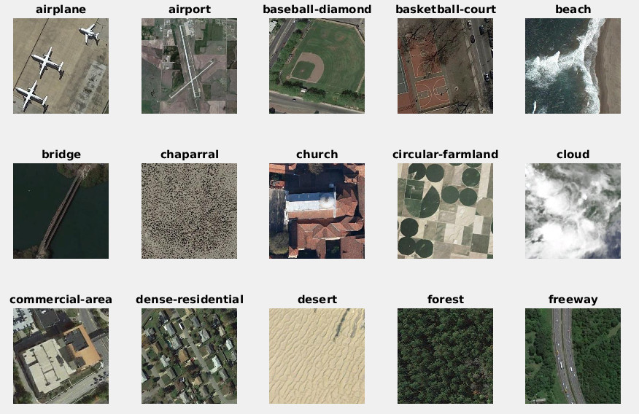

Figure 1. Examples of the images and labels

More details of the dataset can be found at:

<http://www.escience.cn/people/JunweiHan/NWPU-RESISC45.html>

For the HW-4 and Project, we only deal with the first 15 categories shown in Fig. 1 here. The data set should be partitioned into training (500 images), validation (100 images), and test (100 images) for each category.

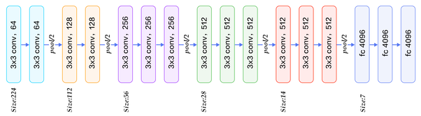

fc1

fc2

fc3

1. Use pretrained VGG16 network FC features, find its low dimension embedding of fc1, fc2, and fc3 via PCA+LDA, and compute baseline accuracy with 1-NN classifier, plot the 100x100 affinity map also : (50pts)
2. Use (PCA +) Laplacian embedding and 1 vs the rest SVM and compute the top-1 accuracy for fc1, fc2 and fc3, find out which combination gives the best results. (50pts)