Contents

**ADD ANY DESCRIPTION HERE // SWATHI** 3

**Implementation Screenshots** 3

**Sample Code** 7

**Technologies used** 11

**Setting up the project locally** 11

**Prerequisites** 11

**Getting Started** 12

**Running the Server** 12

# **ADD ANY DESCRIPTION HERE // SWATHI**

# **Implementation Screenshots**

**1. Landing Page**

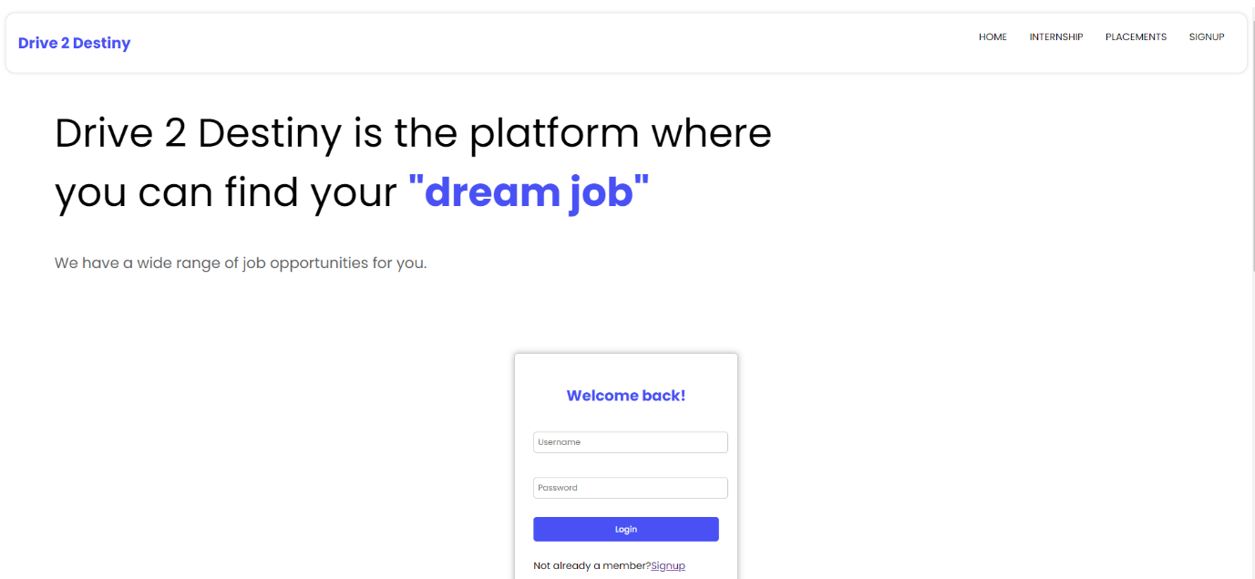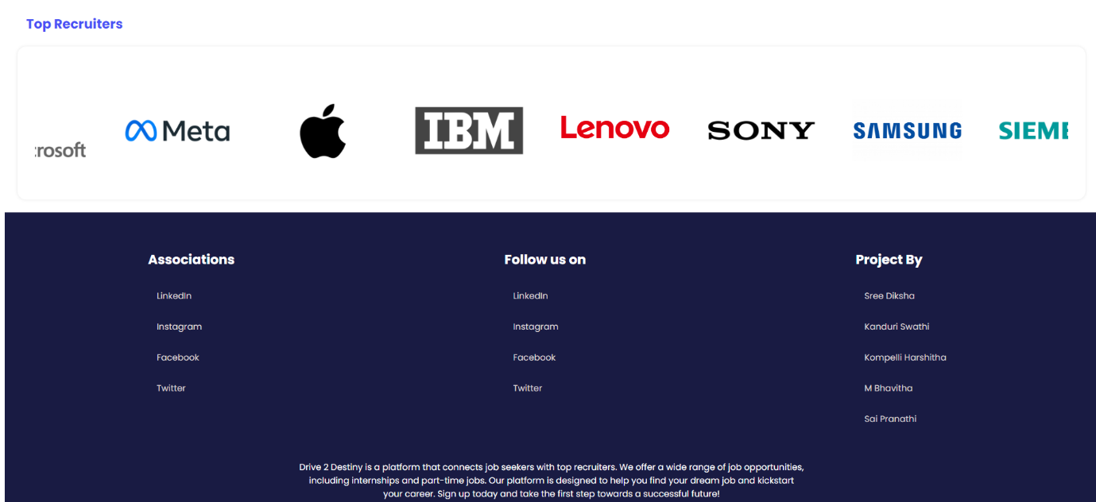

**2. Internship page**

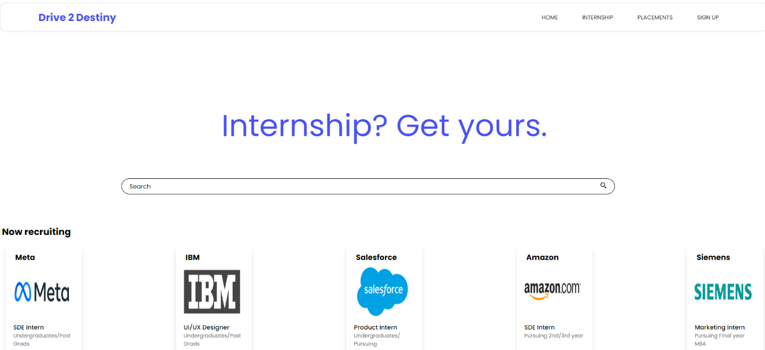

3. Placements page

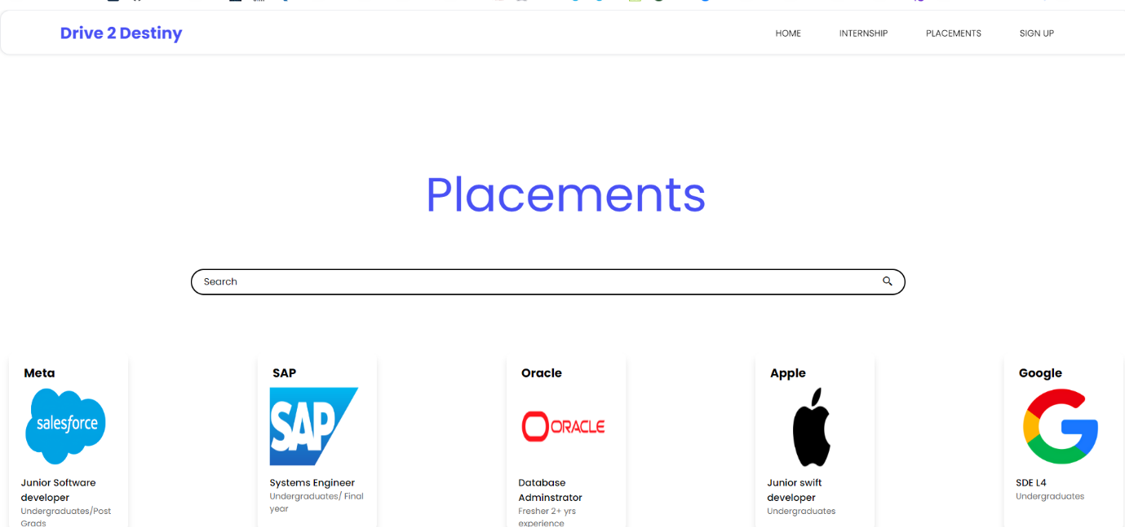

**4. Sign Up (with example)**

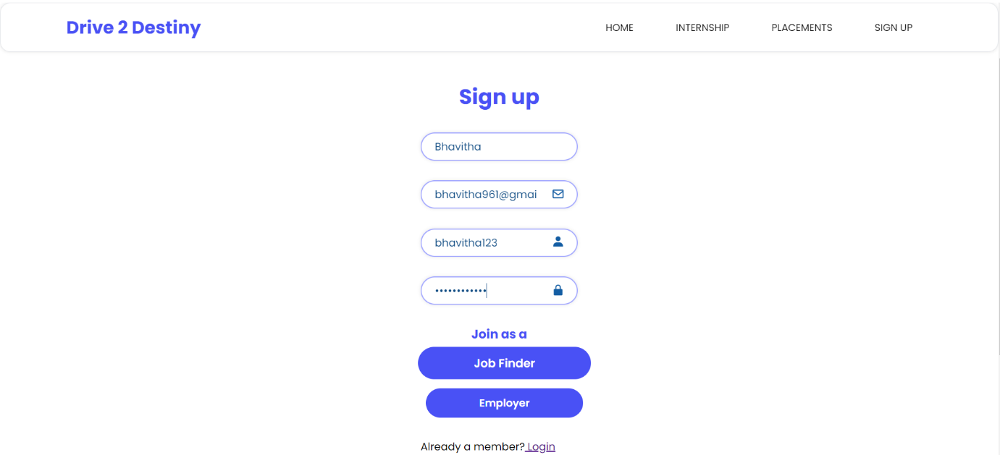

**5. After login as Job Finder**

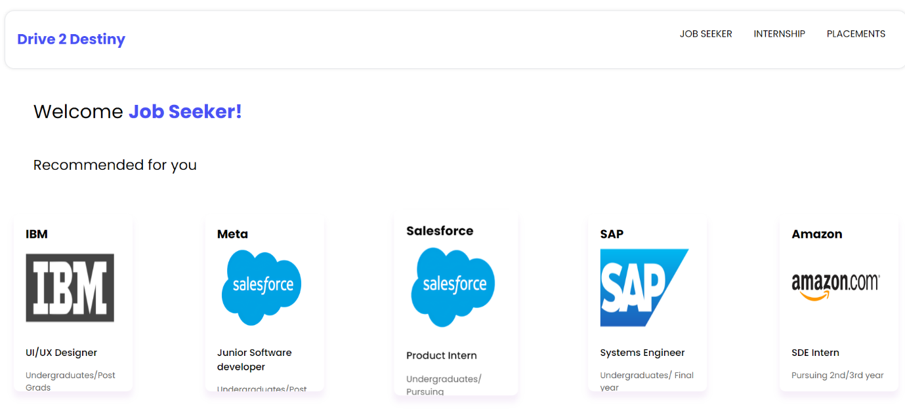

**6. After login as Employer**

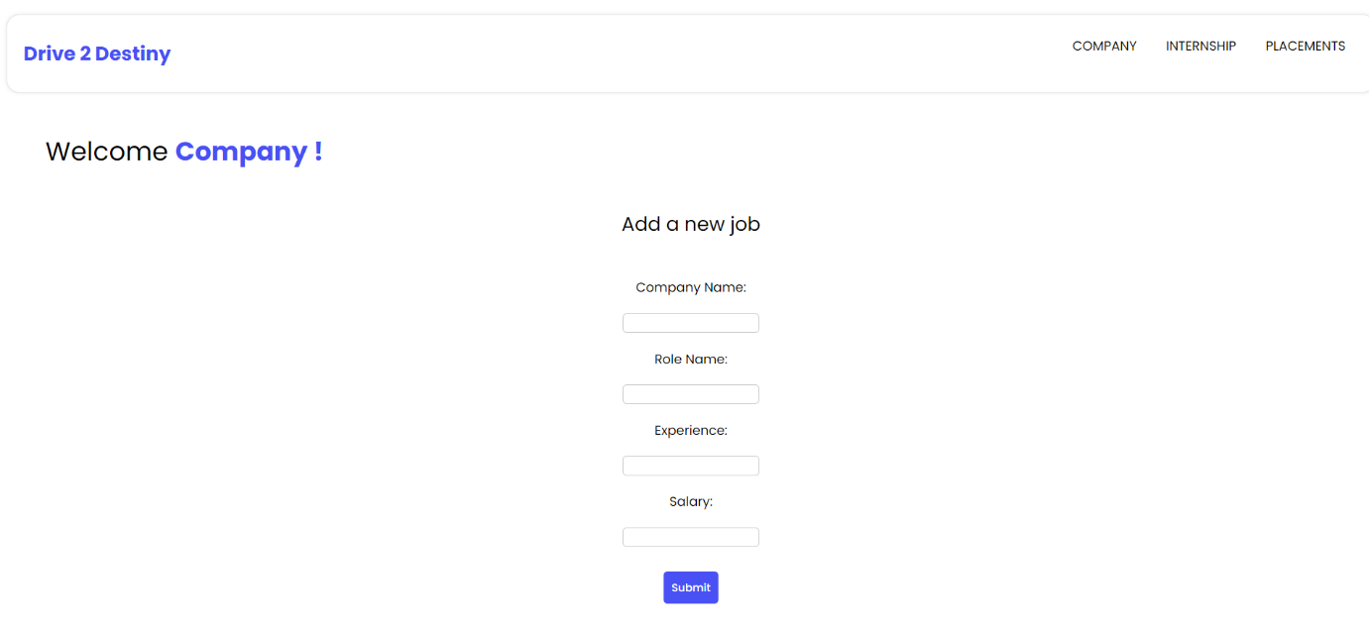

# **Sample Code**

GitHub Repository link : <https://github.com/nightcoder26/SWE-LAB>

Folder structure:



signup.html (Main form code)

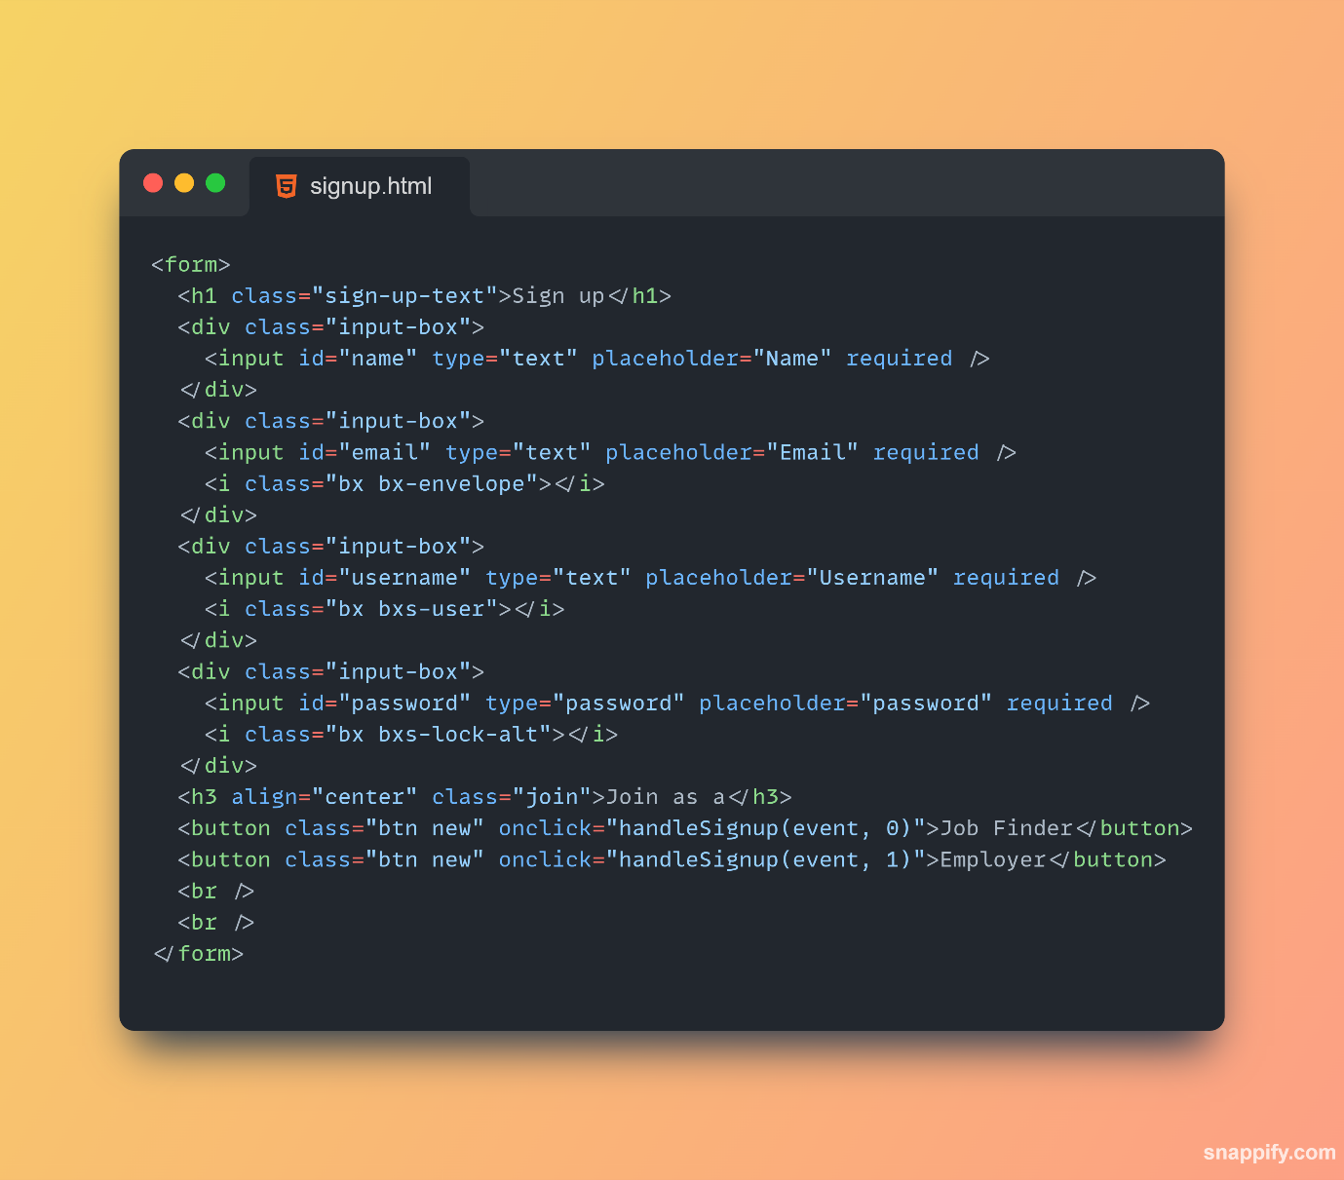

signup.css

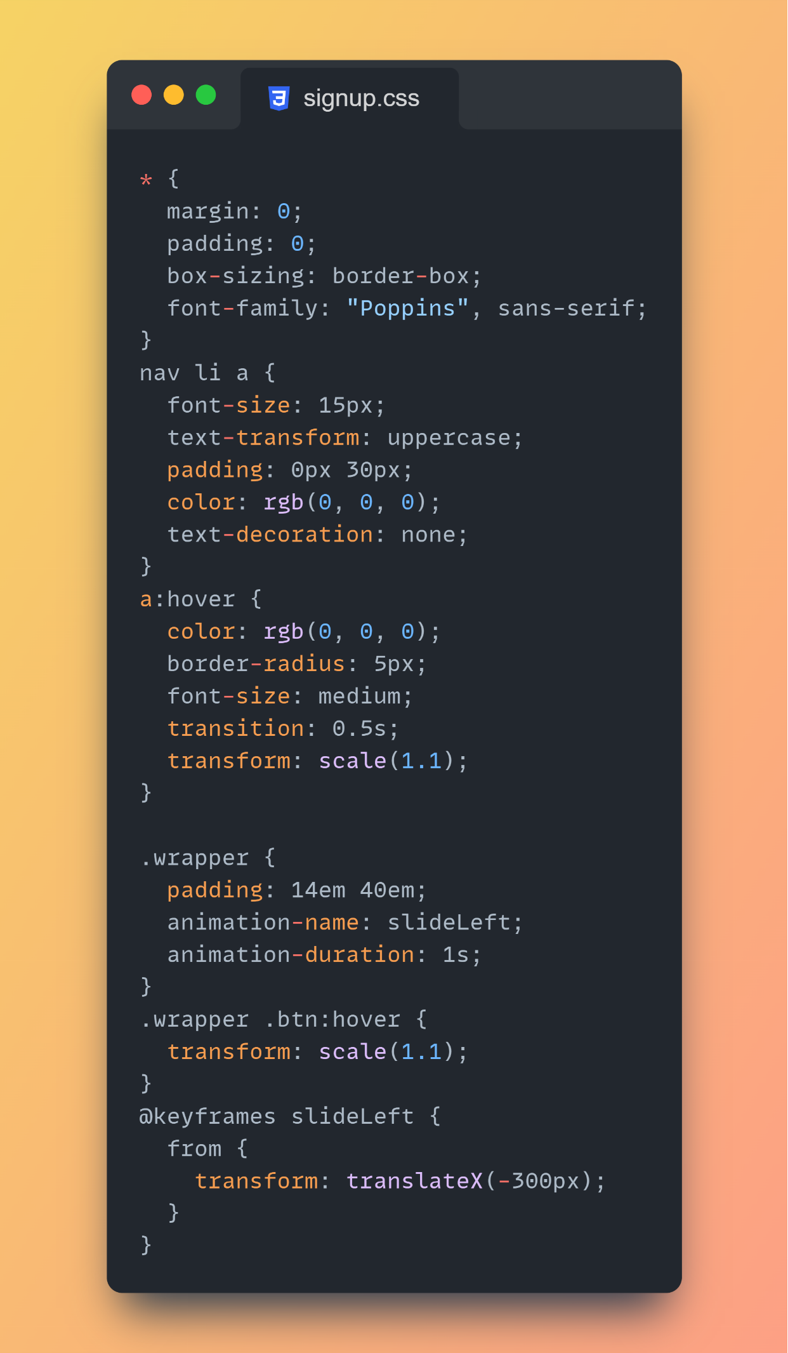

script.js

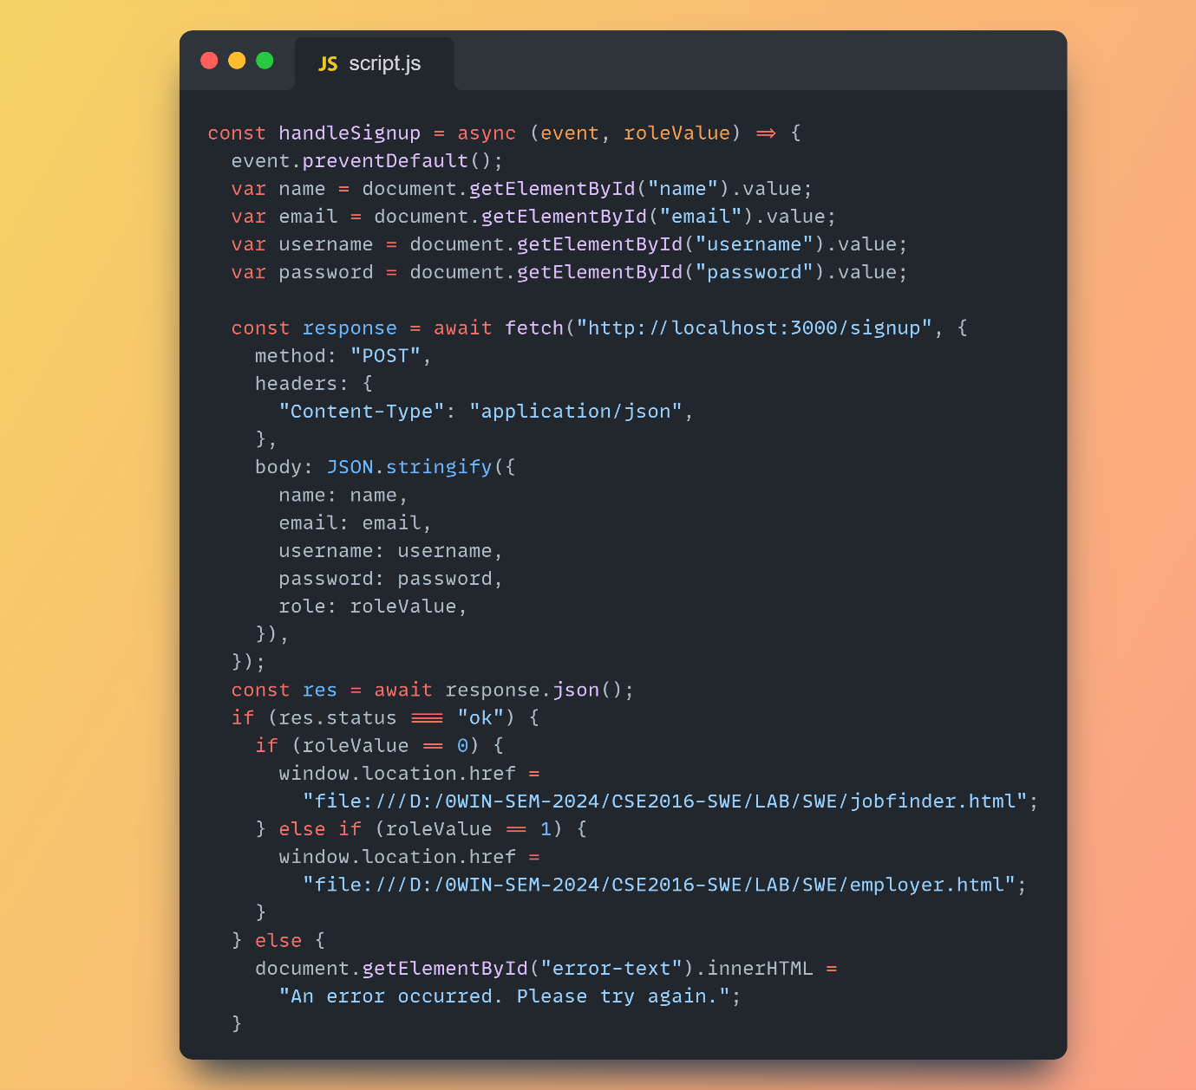

# **Technologies used**

Front-end : HTML, CSS, JavaScript, Google Fonts, Flexbox

Back-end : Node.js , Express.js, Nodemon

# **Setting up the project locally**

## **Prerequisites**

Before getting started, ensure you have the following installed on your system:

1. **Node.js**: Make sure you have Node.js installed. You can download and install it from [here](https://nodejs.org/).

## **Getting Started**

1. **Clone the Repository**: Clone the Drive 2 Destiny repository to your local machine:

git clone https://github.com/nightcoder26/SWE-LAB.git

1. **Navigate to the Backend Directory**: Move into the backend directory of the project:

cd backend

1. **Install Dependencies**: Use npm (Node Package Manager) to install the required dependencies:

npm install

## **Running the Server**

1. **Start the Server**: Once the dependencies are installed, you can start the server:

nodemon app.js

1. **Access the Backend**: The server should now be running locally on port 3000 by default. You can open [http://localhost:3000](http://localhost:3000/) You can access the backend API endpoints using tools like Postman or by making HTTP requests.