Installing Omarchy in Oracle VirtualBox
This guide covers the VirtualBox configuration and post-install fixes needed to run Omarchy correctly in an Oracle VirtualBox virtual machine.

1. Configure the VirtualBox VM
Before booting the installed Omarchy system, power off the virtual machine and open:
VirtualBox Manager → Select the VM → Settings → Display
Configure the display settings as follows:
- Graphics Controller: VMSVGA
- Video Memory: 128 MB
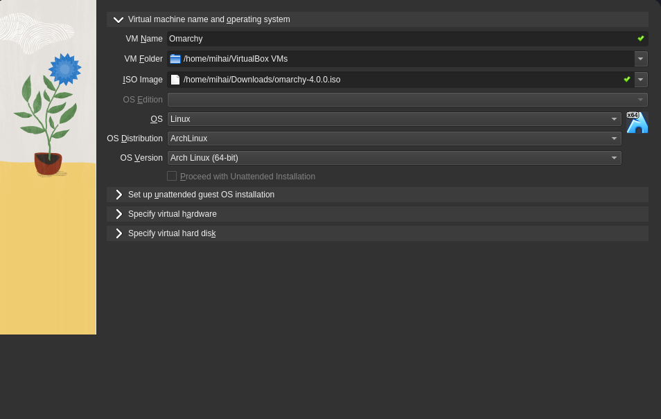
- Enable 3D Acceleration: Enabled
The 3D acceleration setting is particularly important. Without it, Hyprland cannot initialize OpenGL correctly. This causes EGL to fail and Hyprland to crash when SDDM attempts to automatically log in, resulting in a black screen.

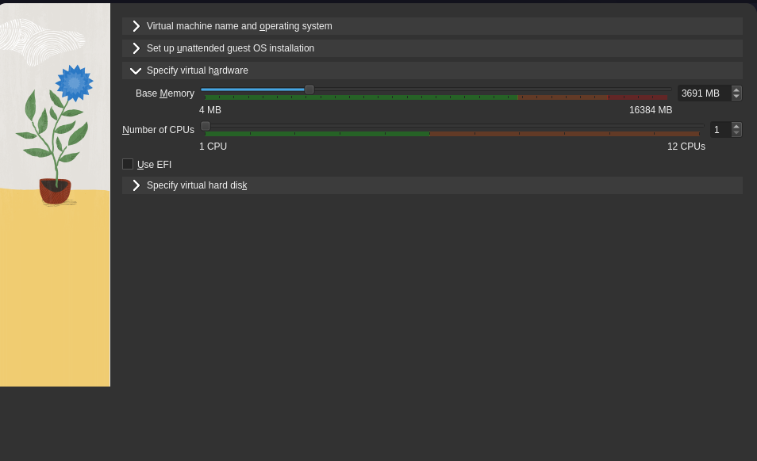

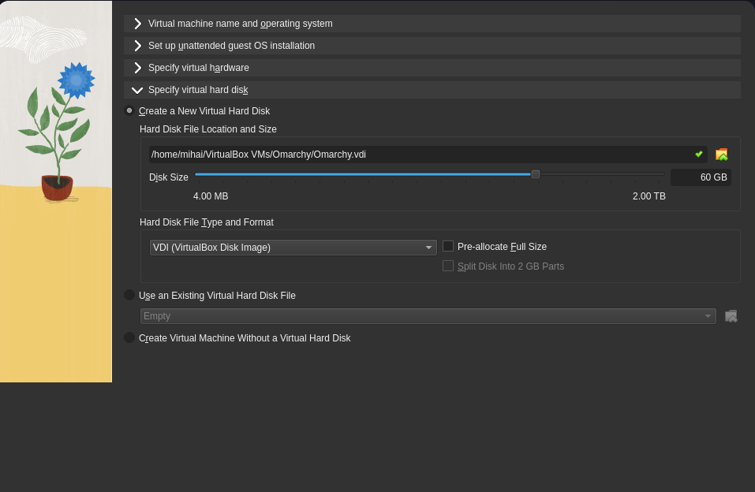
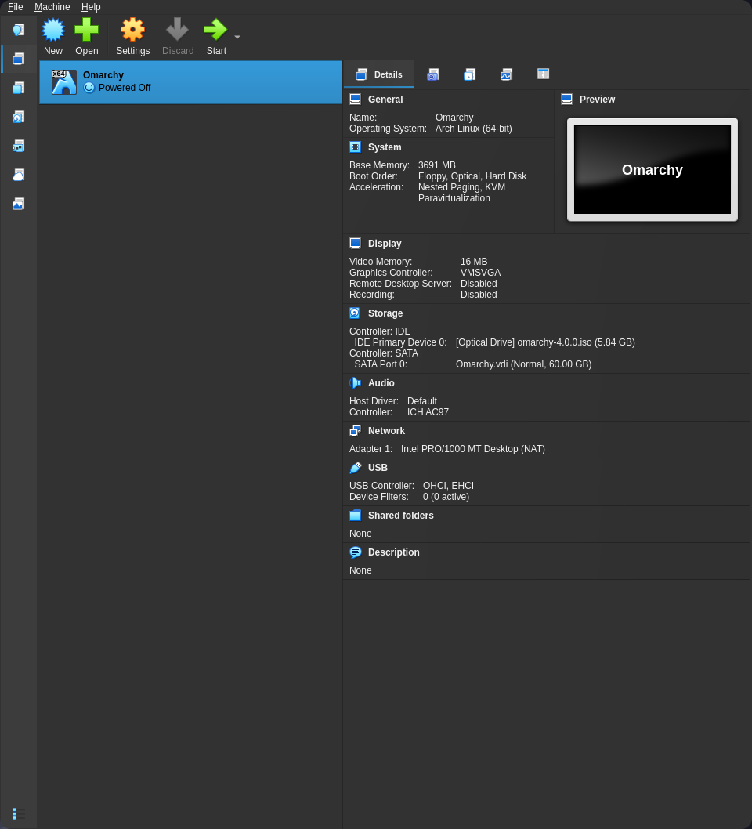

2. Boot Omarchy
Boot the Omarchy installation normally.
If the VM reaches the Omarchy desktop, continue with the guest integration setup below.
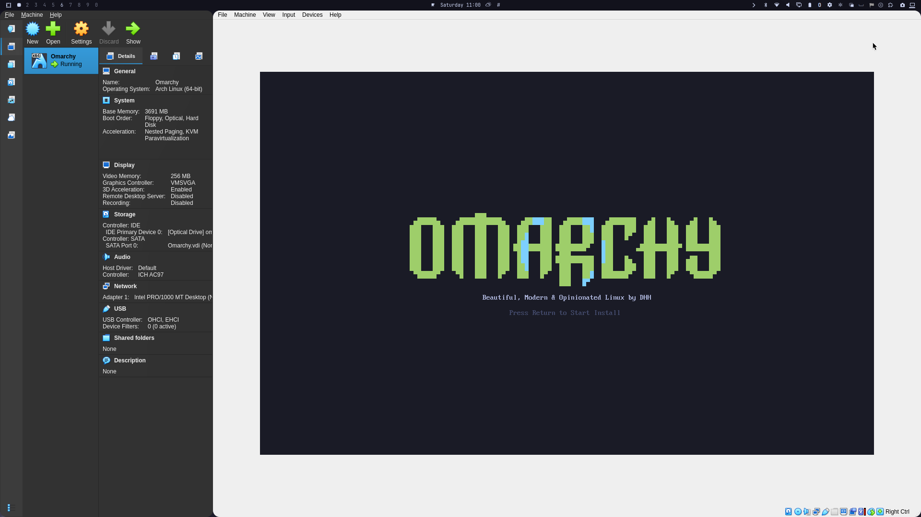

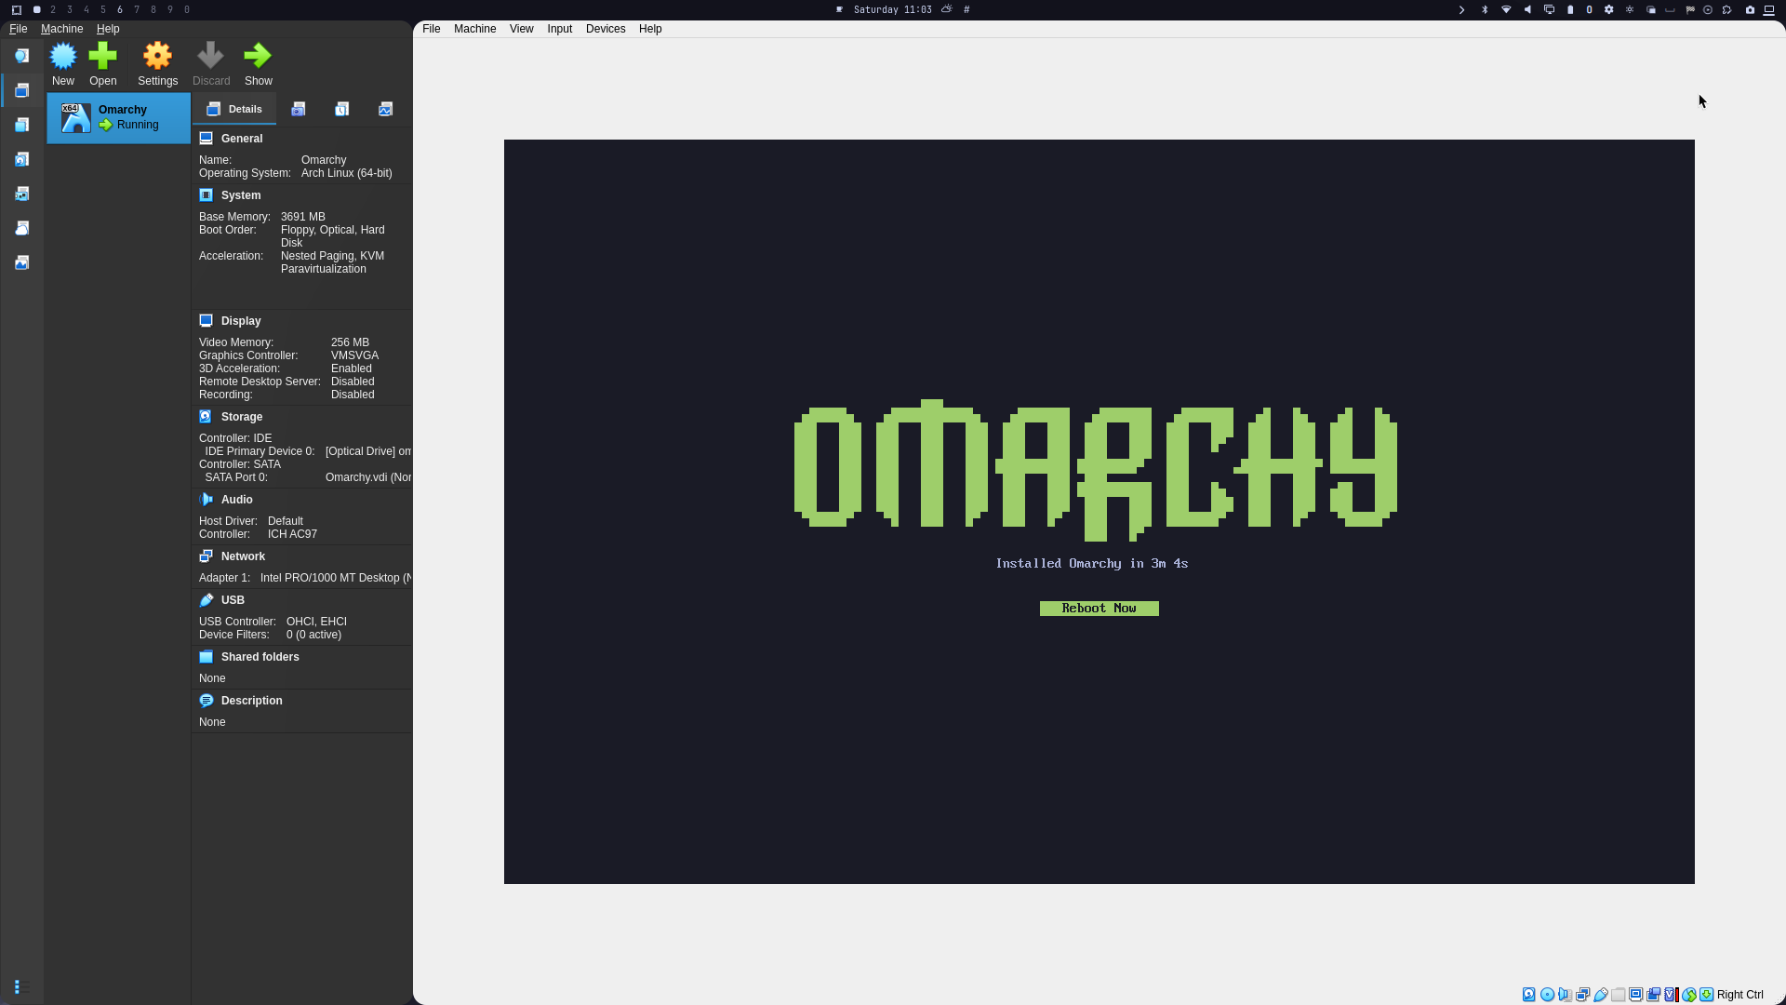
If you get a black screen after disk decryption, return to the VirtualBox Display settings and make sure:
- VMSVGA is selected
- Video memory is set to 128 MB
- 3D acceleration is enabled

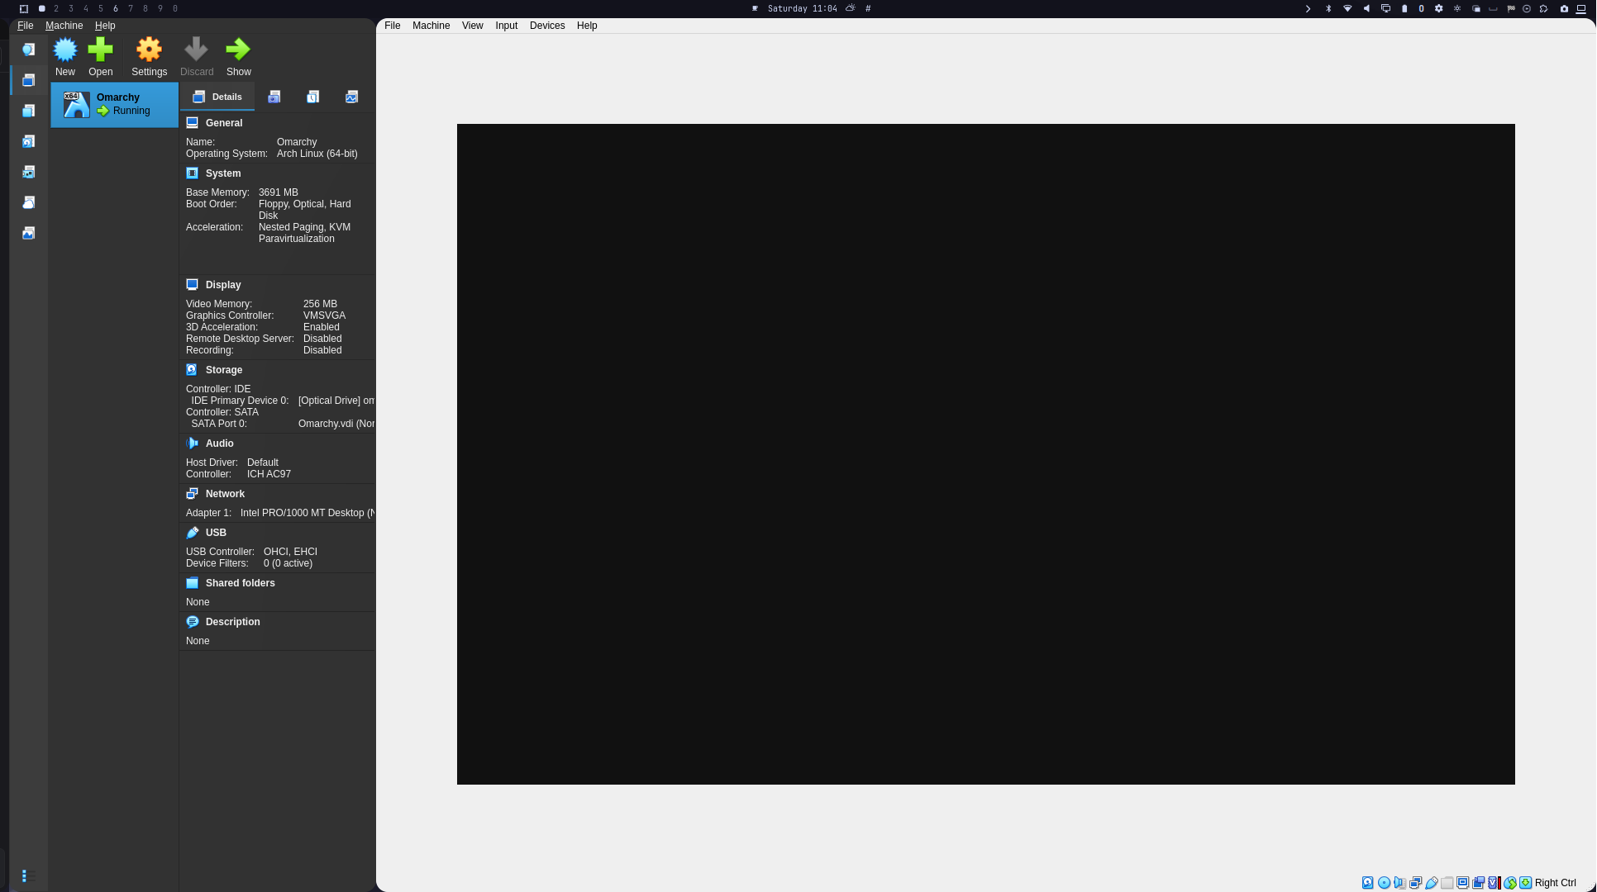
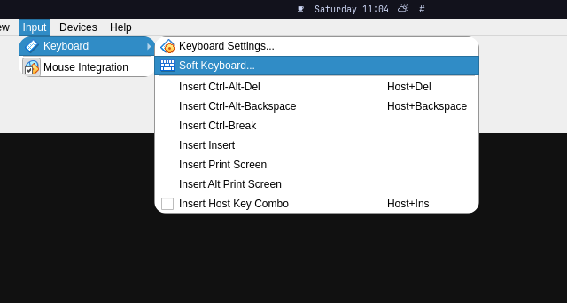

Switch to TTY using CTRL+ALT+F3 from the Soft Keyboard, login then continue:

3. Install VirtualBox Guest Additions
Once Omarchy is running, install the VirtualBox guest utilities.
omarchy pkg add virtualbox-guest-utils # also add nano if nvim not your thing :)
sudo systemctl enable --now vboxservice.service
The guest utilities also allow the VM display to resize automatically when the VirtualBox window is resized.

4. Fix the Omarchy Shell / Quickshell
After enabling 3D acceleration, you may encounter another VirtualBox-specific problem.
Hyprland may start successfully, but the Omarchy shell can fail to launch. The underlying issue is VirtualBox's VMSVGA 3D graphics stack and its GPU buffer sharing.
Typical errors include:
wl_display#1: error 1: invalid arguments for wl_surface#41.attach
WARN: The Wayland connection experienced a fatal error: Invalid argument
Quickshell may crash repeatedly, after which the Omarchy shell supervisor gives up. This results in Hyprland running without the normal Omarchy bar and desktop shell.

Force GL clients to use software rendering
Edit:
~/.config/hypr/hyprland.lua
Immediately after the bootstrap dofile, add:
-- VirtualBox VMSVGA 3D breaks GPU buffer sharing (clients crash with
-- "invalid arguments for wl_surface.attach"), so render GL clients on CPU.
hl.env("LIBGL_ALWAYS_SOFTWARE", "1")
This forces OpenGL clients to use llvmpipe/software rendering instead of the problematic VirtualBox GPU buffer path.

5. Reload the Omarchy Shell
Run omarchy restart shell

You can verify that the shell is working with:
hyprctl layers
The omarchy-bar layer should be present.
The Hyprland configuration should also be free of errors:
hyprctl configerrors
The tested configuration had no errors, with quickshell running successfully and the Omarchy bar rendered.

6. Backup
Before modifying the Hyprland configuration, keep a backup of:
~/.config/hypr/hyprland.lua
For example:
~/.config/hypr/hyprland.lua.bak.<timestamp>
This makes it easy to restore the original configuration if necessary.

7. Reverting the VirtualBox Workaround
If a future Mesa or VirtualBox update fixes the VMSVGA GPU buffer-sharing problem, the software-rendering workaround can be removed.
Delete the three lines added to:
~/.config/hypr/hyprland.lua
Then restart the Hyprland session.
This allows GL clients to attempt hardware rendering again.

8. Expected Limitations
Running Omarchy inside VirtualBox has a performance tradeoff.
Because GL clients are forced to use CPU rendering:
- Animations may be slower.
- GPU-accelerated applications may perform worse than on bare metal.
- The setup is nevertheless usable inside a VM.
The initial display may also appear very small, such as approximately 640×678. Once the VirtualBox guest utilities are installed, resizing the VirtualBox window should automatically adjust the guest display resolution.

Quick Setup Summary

VirtualBox
Graphics Controller: VMSVGA
Video Memory: 128 MB
3D Acceleration: Enabled

Inside Omarchy
~/install-vbox-guest.sh
If the Omarchy shell crashes, add to:
~/.config/hypr/hyprland.lua
hl.env("LIBGL_ALWAYS_SOFTWARE", "1")
Then launch:
omarchy restart shell
Verify:
hyprctl configerrors
hyprctl layers
The result should be a functional Omarchy desktop with the Omarchy shell and bar running correctly inside VirtualBox.
Troubleshooting:
Resolution stuck at 960x488

**Fix:** Edit `~/.config/hypr/monitors.lua` — uncommented the specific-monitor
line for `Virtual-1`:

```lua
hl.monitor({ output = "Virtual-1", mode = "1920x1080@60", position = "0x0", scale = 1 })
```
- Applied instantly via `hyprctl reload`; `hyprctl configerrors` clean.
- Available modes listed with `hyprctl monitors all`.

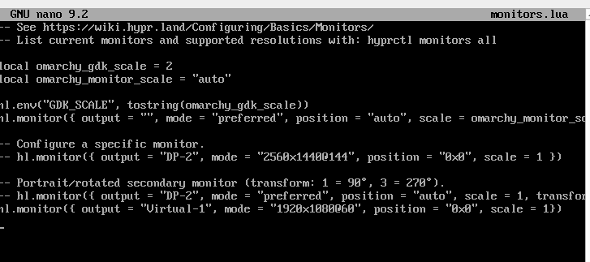

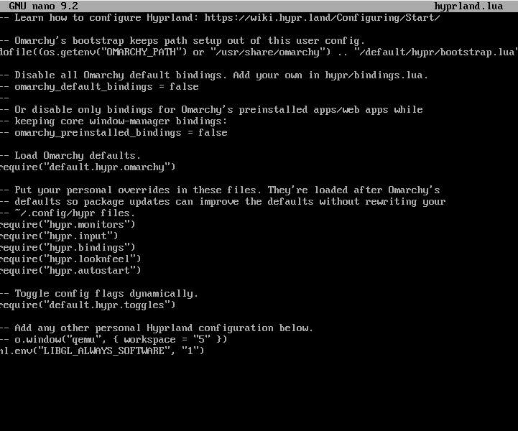
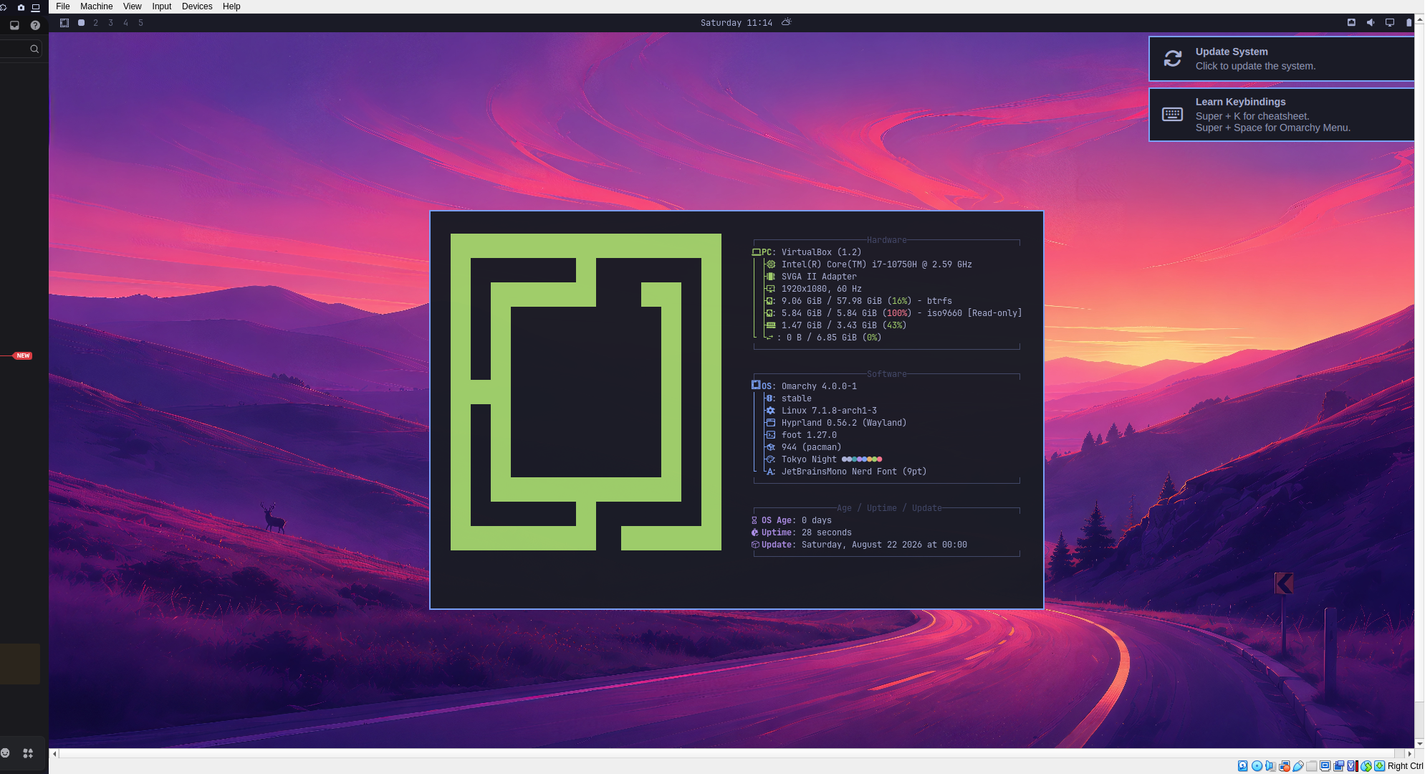
Confirming this works, and adding the diagnosis in case it helps someone land here from a search.
Setup: Omarchy 4.0.2, kernel 7.1.9-arch1-2, Hyprland 0.56.2, VirtualBox on a Windows 11 Pro host, 12 GB RAM / 6 vCPU, UEFI.

Symptom: after install, logging in gives a black screen with only the mouse pointer. Ctrl+Alt+F3 into a TTY works fine.

Diagnosis
/tmp/hypr and $XDG_RUNTIME_DIR/hypr were both missing, so Hyprland was never reaching a running state.
Running Hyprland by hand from the TTY crashed with signal 6 (ABRT) immediately after Creating the AsyncResourceGatherer! — i.e. at GPU/EGL init.
journalctl -b | grep -i vmwgfx showed a repeating [drm:vmw_msg_ioctl] [vmwgfx] *ERROR* Failed to open channel.
No usable OpenGL, and Hyprland (Aquamarine) aborts instead of falling back.

Fix
All three parts together:

VM Settings → Display: Graphics Controller VMSVGA, Video Memory 128 MB, 3D Acceleration enabled.
Guest utilities inside the VM:
sudo pacman -Syu virtualbox-guest-utils
sudo systemctl enable --now vboxservice
Force software GL. Omarchy 4.x uses ~/.config/hypr/hyprland.lua, not hyprland.conf — edits to the .conf are silently ignored. Add right after the dofile(... bootstrap.lua) line:
hl.env("LIBGL_ALWAYS_SOFTWARE", "1")
One-liner:
sed -i '/bootstrap.lua/a hl.env("LIBGL_ALWAYS_SOFTWARE", "1")' ~/.config/hypr/hyprland.lua
Reboot, and the desktop comes up.

Dead ends, so nobody repeats them
Disabling 3D Acceleration. Modern Hyprland needs a working GL context; turning it off guarantees the crash.
WLR_RENDERER=pixman / WLR_NO_HARDWARE_CURSORS=1. wlroots-era variables; Hyprland >= 0.42 uses Aquamarine and ignores them.
Blacklisting vmwgfx to fall back to simpledrm. Not needed once the guest utils are in.
Two gotchas while debugging
Omarchy's default shell is Nushell, where echo 'x' >> file does not append like in bash — it fails and leaves no file. Use sed/tee when following bash-style instructions.
VirtualBox bidirectional clipboard does not work in a TTY, only inside the graphical session, so expect to type by hand.
If the resolution ends up stuck small, uncomment the Virtual-1 line in ~/.config/hypr/monitors.lua and set e.g. 1920x1080@60.

One caveat on rigor: I applied steps 2 and 3 together, so I did not isolate which of the two is strictly required — the combination is what I can confirm works.

