# Lab 1 - HTML5, CSS3, JS, BOOTSTRAP, TWITTER

# Tweet Ticker

Tweets are provided in JSON format in the file tweetsFromTwitter.json.

‘tweetsFromTwitter.json’ is an array of tweet objects of the form [{tweet1},{tweet2},{tweet3},.. ,{tweet150}].

Open tweets.json in a code editor to understand the format of tweets

Read up on JSON to refresh your memories; Read: <http://json.org/>

Read up on the twitter feed data format entities: <https://dev.twitter.com/docs/entities>

Read up on Bootstrap: <http://getbootstrap.com/>

Create a Tweet Ticker, which will show tweets from the JSON file, 5 tweets at a time and will slowly cycle through the tweets every three seconds.

Use CSS3 transitions and animations (or jQuery animations, etc) to make the tweets cycle through the ticker smoothly.

Make the site responsive and clean using Bootstrap

Your example should not look ‘exactly’ as this example – make it your own

As always – remember the readme

Save your lab1 folder under websys, zip it up according to convention and upload it to LMS when completed

Work with your group – but remember…

Submissions are your own – no group submissions

Remember the README.md – or no Credit

Example:

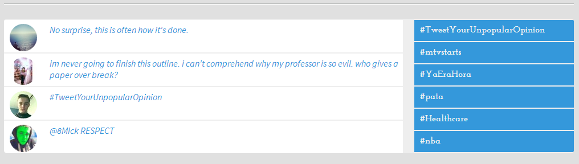

You will be graded on the following;

Formatting and coding style : 10

Objective 1 – Processing JSON : 10

Objective 2 – Displaying output : 10

Creativity/Coding style : 10

Documentation/Read.me : 10