# Lab 6 – node.js and tweets.json to CSV

In this lab we are going to build on the node server we built in lab 5 to allow exporting the tweets in json and csv format.

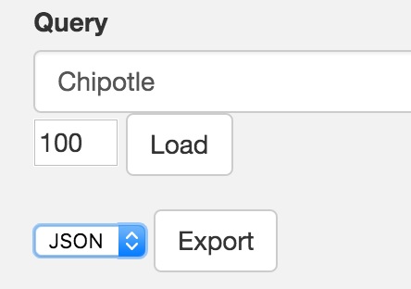Your site should display a simple html form with a dropdown with choices for json or csv, and a button labeled Export:

* When Export is selected,
* You will export the json file as in lab 5 if json is selected
* You will export the csv file if csv is selected – use the same name, but with the appropriate extension (“*convention*-tweets.csv”)

Your file should contain the following fields:

{

"created_at": "",

"id": "",

"text": "",

"user_id": "",

"user_name": "",

"user_screen_name": "",

"user_location": "",

"user_followers_count": "",

"user_friends_count": "",

"user_created_at": "",

"user_time_zone": tweet.user.time_zone,

"user_profile_background_color": "",

"user_profile_image_url": "",

"geo": "",

"coordinates": "",

"place": ""

};

Make sure you allow for error handling – for example: if the tweets file exists – overwrite it and inform the user.

Be sure to include a header row in your CSV file, use a comma as your delimiter and surround text fields with double quotes.

So: When the server is running, the user goes to <http://localhost:3000/> (for example) - and gets a page with a header, a message and two buttons.

While not required, you can (and should) build off of your existing lab 5 form. However, it will need to modified to export the file only when Export is selected and only in the appropriate format.

Remember to inform the user of what is happening – yes this is vague – use your judgment.

(Remember creativity points!)

The goal here is to practice with node.js and reading and writing data. Converting data as well as working with forms and functions in your pages.

**NOTE:** Since both the back-end and front-end have access to the list of tweets, you need to think about where you would implement the conversion to CSV. Consider the pros and cons of putting the conversion function in the node server as opposed to adding it to an Angular controller and answer the following question as part of the assignment:

**Q:** Where would it be better to place the CSV conversion code, in the node server or in an Angular controller? Why?

Answer in your README.md file

Have fun! You have just built an ETL application!

Here is an example of three lines from my converted file – note the header row.

"created_at","id","text","user_id","user_name","user_screen_name","user_location","user_followers_count","user_friends_count","user_created_at","user_time_zone","user_profile_background_color","user_profile_image_url","geo","coordinates","place"

"Thu Dec 19 23:34:57 +0000 2013","413814742860714000","فرصتكـم لزيـادة متابعينكـم: @RT_FF5فولومي فولوباك ◙ريتويـت لهـذه التغريـدة ◙ضيفـوا مـن يقــوم بالريتويـت ◙ضيفـوا مــن يضيفكـم 168","1664157169","قروب زيادة متابعين","RT_FF5","","6945","4429","Mon Aug 12 04:24:01 +0000 2013","Hawaii","C0DEED","http://pbs.twimg.com/profile_images/378800000671897188/e8dde27dd300c06002cd06f1ab0352b0_normal.jpeg","null","null","null"

"Thu Dec 19 23:34:57 +0000 2013","413814742860693500","""@_kaedawg: Bitches be mad …""","599909355","ke gotti.","bigdaddyke___","","2212","1612","Tue Jun 05 04:49:53 +0000 2012","Atlantic Time (Canada)","DBE9ED","http://pbs.twimg.com/profile_images/412713408895528960/3Ly1vN4I_normal.jpeg","null","null","null"

You will be graded on the following;

Objective 1 – HTML Form : 10

Objective 2 – File conversion : 10

Creativity : 10

Question (Server or Client) : 10

Documentation/Read.me : 10