Sleeve Instructions

1. 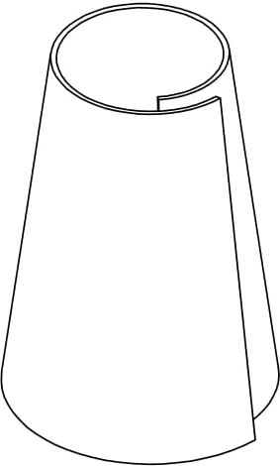. Sipnal sleeves must follow the rules outlined in Game Manual Part 1 , section 7.5
2. Place vision content (images, etc.) in the white trapezoidal areas of the template, and Team

# number in the designated Team number areas on the template.

* + Team Sipnal Sleeves must be fully completed (with vision content and Team numbers) prior to arriving at the Competition. Please refer to rule <SS04>

1. Cut out the perimeter of the Signal Sleeve, including the tab
2. Curl the Signal Sleeve into a cone with the tab under the far side of the template.

S. The Sipnal Sleeve must be connected at each end

# l . Any tape or adhesive may be used to connect the ends as long as the method used does not damage the Signal.

IMPORTANT NOTE: Due to the fragile construction of the Signal Sleeve, damage should be anticipated

# during normal gameploy. Teams should bring multiple copies of the Signal Sleeve to the competition.

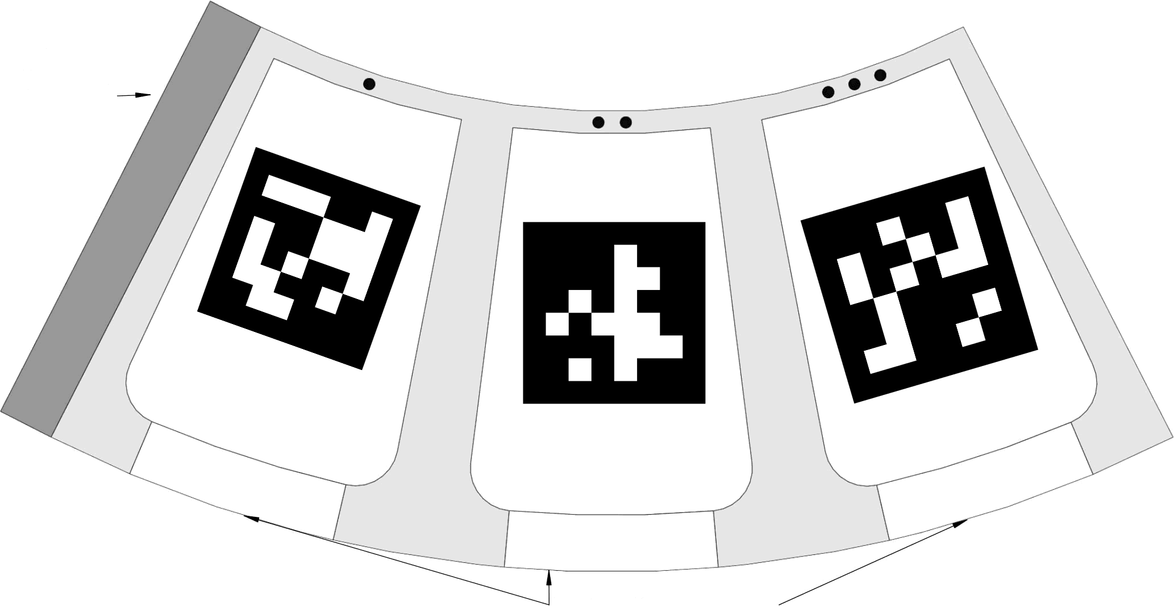

PLACE TAB UNDER FAR SIDE

**ID : 9**

**ID : 3**

**ID : 7**

**THREE**

**ONE**

**TWO**

**20871**

**20871**

**20871**