**Réplication**

# introduction_to_replication

**Step 1: Start the mongod instances**

1. start creating a directory data and three subdirectories db1, db2, and db3 in the terminal.

1. Open the mongodb configuration file mongod.conf in a text editor and enable the replication by adding the following lines:

replication:

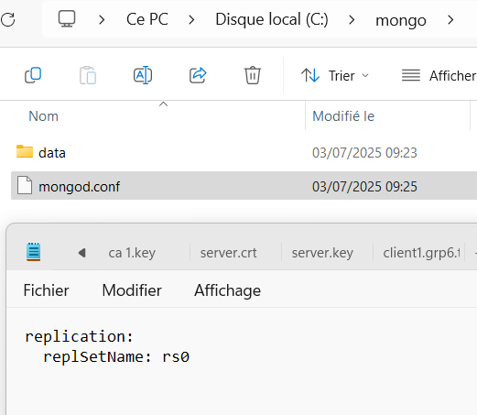 replSetName: 'rs0'

1. Start a first mongod instance on port 27017, using the db1 directory for the data files and the mongod.conf file for the configuration. Take a look to the flags --replSet and –port

**& "C:\Program Files\MongoDB\Server\8.0\bin\mongod.exe" --port 27017 --dbpath C:\mongo\data\db1 --replSet rs0 --config C:\mongo\mongod.conf**

1. Start a second mongod instance on port 27018, using the db2 directory for the data files and the mongod.conf file for the configuration.

**& "C:\Program Files\MongoDB\Server\8.0\bin\mongod.exe" --port 27018 --dbpath C:\mongo\data\db2 --replSet rs0 --config C:\mongo\mongod.conf**

1. Start a third mongod instance on port 27019, using the db3 directory for the data files and the mongod.conf file for the configuration.

**& "C:\Program Files\MongoDB\Server\8.0\bin\mongod.exe" --port 27019 --dbpath C:\mongo\data\db3 --replSet rs0 --config C:\mongo\mongod.conf**

**Step 2: Connect to one of the mongod instances**

1. Connect to the first mongod instance on port 27017 using the mongo or mongosh shell.



1. Initialize the replica set.

1. Add the second and third mongod instances to the replica set.



1. Verify that the replica set is working correctly. hint: rs.status()

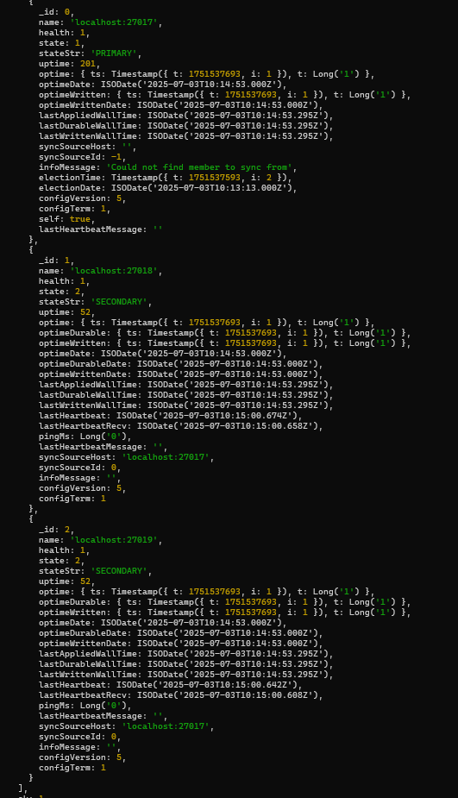

**Step 3: Create a database and insert data**

1. Create a database named GameOfThrones.

1. Create a collection named characters.
2. Insert the following documents into the collection:

{ name: 'Jon Snow', age: 25, house: 'Stark' }

{ name: 'Daenerys Targaryen', age: 23, house: 'Targaryen' }

{ name: 'Tyrion Lannister', age: 30, house: 'Lannister' }

**Step 4: Verify the replication**

1. Connect to the second mongod instance on port 27018 using
2. the mongo or mongosh shell.

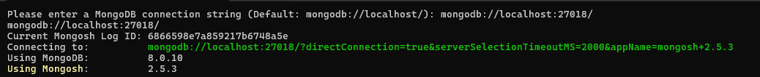

1. Une image contenant texte, capture d’écran, Police

   Le contenu généré par l’IA peut être incorrect.Query the GameOfThrones database and the characters collection to verify that the data has been replicated.
2. Can you read the data ? Can you write the data ?

I can read but not write because the secondary instance are in only read

1. Connect to the third mongod instance on port 27019 using

the mongo or mongosh shell.

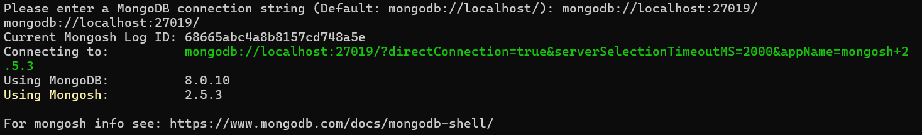

1. Une image contenant texte, capture d’écran, Police, logiciel

   Le contenu généré par l’IA peut être incorrect.Query the GameOfThrones database and the characters collection to verify that the data has been replicated.
2. Can you read the data ? Can you write the data ?

I can read but not write because the secondary instance are in only read

**Step 5: Shutdown the first mongod instance**

1. Shutdown the first mongod instance on port 27017.OK
2. Verify that the second mongod instance has been elected as the new primary. OK
3. Verify that the third mongod instance is still a secondary.OK

**Step 6: Cleanup**

1. Shutdown the second and third mongod instances.OK
2. Delete the db1, db2, and db3 directories.OK

**Exercise: Setting Up MongoDB Sharding on Localhost**

**Objective:**

The objective of this exercise is to set up MongoDB sharding on localhost. In this exercise, you will set up a sharded cluster on your local machine. You will use the mongod command to start multiple mongod instances, each running on a different port. You will then connect to the config server and shard servers to initialize the sharding setup.

**Setup :**

1. Create a new database named sharding_db.
2. Create a new collection named realEstate in the sharding_db database.
3. Import the csv file from the data directory into the MongoDB database.

**Instructions:**

1. create a directory data and three subdirectories configdb, shard1, and shard2 in the terminal.

1. Start two mongod instances on ports 27018 and 27019, using the shard1 and shard2 directories for the data files respectively. Use the mongod_shard.conf file for the configuration. Take a look at the --shardsvr flag.
2. Start the config server on port 27017, using the configdb directory for the data files. Take a look at the --configsvr flag.
3. Connect to the config server using the MongoDB shell.
4. Initialize the config server. Take a look at the sh.addShard() command.
5. Enable sharding for a specific database. Take a look at the sh.enableSharding() command.
6. Shard a collection within the database. Take a look at the sh.shardCollection() command.
7. Verify that the sharding setup is working correctly by running the following command in the MongoDB shell:

sh.status()

1. Get the number of chunks in the realEstate collection using the following command:

db.realEstate.getShardDistribution()

1. Verify that the data is distributed across the shards by running the following command:

db.realEstate.find().explain("executionStats")

1. Verify that the data is being distributed across the shards by inserting new documents into the realEstate collection and checking the distribution.
2. Clean up the sharded cluster by removing the shards and config server. Take a look at the sh.removeShard() and sh.removeShardTag() commands.
3. Stop the mongod instances and config server.