**HCMC UNIVERSITY OF TECHNOLOGY AND EDUCATION**

**FACULTY FOR HIGH-QUALITY TRAINING**

**US Department of SOFTWARE TECHNOLOGY**



***HCMUTE Hotel Management***

***Lecturer: Nguyen Thanh Son***

*Group 02*

Member:

* Nguyen Tan Thanh – 181100046
* Hoang Ngoc Bao Tran - 18110057
* Phan Ngoc Bao Tuyen – 18110062
* Bui Huu Luan - 19110088

*HCMC May 11, 2022*

**Table of contents**

*PREFACE* 5

Chapter 1 - Overview 6

1.1 General introduction of the hotel 6

1.2 Introduce the problem to be solved and the implementation process 6

Chapter 2 - Defining and Modeling Software Requirements 9

2.1 Survey of the current situation 9

2.2 Classify and tabulate software requirements responsibilities 11

2.3 Data flow diagram of each request: 20

Chapter 3 - System Design 32

3.1 System Architecture 32

3.2 Description of the components in the system 32

Chapter 4 - Data Design 34

4.1 Algorithm for logic diagramming 34

4.1.1 Step 1: Consider the request to make a list of rooms 34

4.1.2 Step 2: Consider the request for a room rental voucher 36

4.1.3 Step 3: Consider room search request 38

4.1.4 Step 4: Consider payment invoice request 40

4.1.5 Step 5: Consider the request for monthly report 42

4.1.6 Step 6: Consider the request for regulation change 44

4.2 Complete Logic Diagram 45

4.3 List of data tables (tables) in the diagram forty six

4.4 Description of each data table 47

4.4.1 Table of ACCESS 47

4.4.2 Pound Bill 47

4.4.3 BillDetails Table 48

4.4.4 BookRoom Table 48

4.4.5 Customer Table 48

4.4.6 Table CustomerType 49

4.4.7 Job Board 49

4.4.8 Parameter Table 49

4.4.9 ReceiveRoom Table 50

4.4.10 Table ReceiveRoomDetails 50

4.4.11 Table REPORT 50

4.4.12 Table Room 50

4.4.13 RoomType . Table 51

4.4.14 Service Table 51

4.4.15 Table ServiceType 51

4.4.16 Staff Table 51

4.4.17 StaffType Table 52

4.4.18 StatusBill . Table 52

4.4.19 StatusRoom Table 52

Chapter 5 - Interface Design 53

5.1 Connection diagram of screens 53

5.2 List of screens 53

5.3 Description of screens 56

5.3.1 Login screen 56

5.3.2 Main screen (Manager) 57

5.3.3 Personal information screen 59

5.3.4 Booking Screen 62

5.3.5 Reservation Details Screen 65

5.3.6 Check-in Screen sixty seven

5.3.7 Add Guest Check-in Screen 70

5.3.8 Check-in Details Screen 72

5.3.9 Room Change Screen 74

5.3.10 Customer Update Screen 76

5.3.11 Revenue Statistics Screen 78

5.3.12 Room Management Screen 79

5.3.13 Add Room Screen 81

5.3.14 Screen Room type 83

5.3.15 Employee management screen 84

5.3.16 Employee Add Screen eighty seven

5.3.17 Access Rights Screen 89

5.3.18 Employee Type Add/Edit Screen 91

5.3.19 Invoice Management Screen 92

5.3.20 Invoice Print Screen ninety four

5.3.21 Service Management Screen 95

5.3.22 Add Service Screen 97

5.3.23 Service Type Screen 99

5.3.24 Service Type Add Screen 100

5.3.25 Service Usage and Payment Screen 101

5.3.26 Customer management screen 103

5.3.27 Add Customer Screen 106

5.3.28 Regulation Screen 108

5.3.29 Introduction Screen 109

Chapter 6 – Installation and Testing 111

COMMENTS AND CONCLUSION 112

DEVELOPMENT 113

Acronyms and Terminology 114

APPENDIX 115

REFERENCES 117

Work assignment table 118

# *PREFACE*

Today, the hotel industry is booming, with new hotels opening all the time, particularly in major cities. As the scale and number of hotels grow, managers must adapt their methods and methods of managing hotel activities to be more effective, cost-effective, and labor-saving. With the rapid advancement of technology, particularly information technology, and its numerous applications in modern life, it has aided professionals in performing their duties effectively. on a computer Our work is then completed more quickly, accurately, and efficiently.

Hotel management software is one of many widely applied software today. Because tourism is currently one of the industries with the highest growth rate in the country and with the needs of development and more and more tourists, hotel and motel services are also increasingly popular.

Therefore, our group decided to choose the topic "**HCMUTE Hotel Management**" to be able to meet the application of information technology in business.

# Chapter 1 - Overview

# Acronyms and Terminology

|  |  |
| --- | --- |
| Acronyms | Explain |
| Database | Database |
| BM | Form |
| Decision | Regulations |
| PK | Primary key |
| FK | Foreign key (Foregin key) |
| ID card | Identity card |
| Tel | phone number |
| NV | Staff |

## General introduction of the hotel:

**The HCMUTE Hotel** newly built 3 star standard, next to the main road to the city center. Just a few minutes' walk, guests can reach exhibition centers, shopping, and entertainment near the hotel. It is the only hotel with a helipad at the rooftop that is qualified to meet the privacy needs of important guests and high-class businessmen.

**The HCMUTE Hotel** which has a total of 58 bedrooms with cozy space, following the gentle and luxurious classic trend, some rooms also have towels, slippers, flat screen TV, mirror, needle set. Hotel services include Wi-Fi in all rooms, 24-hour front desk, 24-hour room service, facilities for disabled guests, express check-in/check-out, recreational activities such as hot tub, gym. Fitness, outdoor swimming pool, treatment area, massage and beauty care in Thai style. The hotel includes restaurants with a capacity of 50 to 100 seats, with cozy atmosphere, experienced chefs. , elegant staff, always ready to serve many quintessential dishes of the four directions, buffet breakfast, European - Asian dishes and especially dishes with bold Vietnamese flavor, rich in nutritional value, satisfying satisfy the exquisite culinary taste of guests.

## Introduce the problem to be solved and the implementation process:

Currently, the hotel does not have a program to manage reservations and payments, but only uses Excel software to manage it, so it has encountered some difficulties:

* The procedures for booking, checking out or registering a room to be processed will take a long time.
* Causing difficulties in managing customer information, invoices, room registration forms as well as other services in the hotel.
* Hard to check room status, rooms need maintenance.

In order to meet the needs of information technology application for business activities and to reduce the time of searching and tracking hotel activities in management. The program "Hotel Management" was born to meet the above needs and problems.

|  |  |  |
| --- | --- | --- |
| STT | Work | Describe |
| 1 | Project Initialization | Build a team of members for the system |
| 2 | Build a plan | Create a plan  Risk prediction  Calculate cost |
| 3 | Development planning | Document the system and the project  Identify and assign tasks  Make a schedule  Follow up |
| 4 | Define requirements | Plan user interviews to determine business requirements.  Define and categorize software requirements. |
| 5 | Requirement modeling | Tabulate the responsibilities and plot the data flow for each requirement type. |
| 6 | Design | System design  Data Design   * Design the theme. |
| 7 | Setting | Program the system by writing code.  Manage versions  Translate |
| 8 | Test | Check the completed functions according to the requirements  Automatic generation of test datasets  Error detection. |

# Chapter 2 - Defining and Modeling Software Requirements

## 2.1 Survey of the current situation

**Professional status:**

* Room object(DBMS requirement)

The front desk staff, after receiving guests into the room, will track the guests through a piece of paper detailing the room plan and will mark the room. As for the guest's information, it will be recorded in the notebook, and the room map must be saved every day for reporting. Because customer information must always be captured, it causes many difficulties when customers have other needs.

**Current state of informatics:**

* **Hardware:**

+ Currently, the library has more than 10 desktop computers, with core i7 CPU configuration, 8GB RAM, 100GB hard drive capacity, DELL Full HD screen with keyboard and mouse. There is also a printer.

+ The network connection situation is relatively stable at the moment.

* **Software**:

+ Windows 7 Ultimate operating system.

The database management system is Microsoft SQL Server. There are also other software such as: Microsoft Visio, Visual Studio, Axure ...

+ Microsoft .NET Framework 3.5.

**2.2 Classify and tabulate software requirements responsibilities:**

**List of business requirements:**

|  |  |  |  |  |
| --- | --- | --- | --- | --- |
| STT | Request name | Form | Rule | Note |
| 1 | Make a list of rooms | BM1 | Decision1 |  |
| 2 | Make room rental vouchers | BM2 | QD2 |  |
| 3 | Room lookup | BM3 |  |  |
| 4 | Make a payment invoice | BM4 | Q4 |  |
| 5 | Make monthly report báo | BM5 |  |  |
| 6 | Change the rules |  | QD6 |  |

**Table of responsibilities and professional requirements:**

|  |  |  |  |  |
| --- | --- | --- | --- | --- |
| STT | Major | User | Software | Note |
| 1 | Make a list of rooms | Provide room information in the hotel | Check regulations and record room information | Allows to cancel, delete and re-update categories |
| 2 | Make room rental vouchers | Provide information for room rental vouchers | Check regulations and record information | Allows cancellation and re-updating of coupons |
| 3 | Room lookup | Provide information about the rooms | Search and output information |  |
| 4 | Make a payment invoice | Provide invoice information | Check and record information | Allow to cancel and update information again |
| 5 | Make monthly report | Provide reporting information | Calculate and output the results information |  |
| 6 | Rules change | Revise the rules | Check regulations and note changes | Allow to cancel, update and add rules |

**Quality requirements:**

* Evolution requirements:

List of evolution requirements:

|  |  |  |  |
| --- | --- | --- | --- |
| STT | Major | Parameters need to be changed | The value domain needs to be changed |
| 1 | Change the number of room types |  | Number of each room type |
| 2 | Change the unit price of room types |  | Unit price of each room type |
| 3 | Change the number of types of guests |  | Type of guest |
| 4 | Change the maximum number of guests in the room | Maximum number of guests |  |
| 5 | Surcharge rate change | Surcharge rate |  |
| 6 | Change the surcharge coefficient for foreign guests | Coefficient |  |

Table of responsibilities for evolution requirements:

|  |  |  |  |  |
| --- | --- | --- | --- | --- |
| STT | Major | User | Software | Note |
| 1 | Change the number of room types | Tell me how the room type increases or decreases | Record new value and change test method |  |
| 2 | Change the unit price of room types | Indicate the new unit price of each room type | Record new unit price and change inspection method |  |
| 3 | Change the number of types of guests | Indicate the type of guest changed | Record new value and change test method |  |
| 4 | Change the maximum number of guests in the room | Indicate the maximum number of guests | Record new value and change test method | Allow editing and re-updating |
| 5 | Surcharge rate change | Indicate the new surcharge rate | Record the new value and change the surcharge value during the calculation | Allow to update the surcharge rate |
| 6 | Change the surcharge coefficient for foreign guests | Indicate the new coefficient | Record new value and change value during processing | Allow editing |

* Handy requirements:

List of handy requirements:

|  |  |  |  |  |
| --- | --- | --- | --- | --- |
| STT | Major | Ease of learning | Ease of use | Note |
| 1 | Make a list of rooms | 2 minutes tutorial | There are captions with illustrations for employees |  |
| 2 | Make room rental vouchers | 2 minutes tutorial | There are captions with illustrations for employees |  |
| 3 | Room lookup | 1 minute tutorial | Easy lookup with customer understanding | Show full room information |
| 4 | Make a payment invoice | 2 minutes tutorial | There are captions with illustrations for employees |  |
| 5 | Make monthly report | 3 minutes tutorial | There are captions with illustrations for employees |  |
| 6 | Change the rules | 5 minutes tutorial | Determine the correctness of the request and not make mistakes |  |

Handy claim responsibility table:

|  |  |  |  |  |
| --- | --- | --- | --- | --- |
| STT | Major | User | Software | Note |
| 1 | Make a list of rooms | Read the user manual carefully | Comply with user requirements |  |
| 2 | Make room rental vouchers | Read the user manual carefully | Comply with user requirements |  |
| 3 | Room lookup | Read the user manual carefully | Comply with user requirements |  |
| 4 | Make a payment invoice | Read the user manual carefully | Comply with user requirements |  |
| 5 | Make monthly report | Read the user manual carefully | Comply with user requirements |  |
| 6 | Change the rules | Read the user manual carefully | Comply with user requirements | Determine the correctness |

* Effective requirements:

List of effective requirements:

|  |  |  |  |  |
| --- | --- | --- | --- | --- |
| STT | Major | Processing speed | Storage capacity | Note |
| 1 | Make a list of rooms | 30 minutes | 2KB/ 1 directory |  |
| 2 | Make room rental vouchers | 1 minute | 1KB / 1 vote |  |
| 3 | Room lookup | right away |  |  |
| 4 | Make a payment invoice | 1 minute | 2KB / 1 bill |  |
| 5 | Make monthly report | 2 Minutes | 10KB / 1 report |  |
| 6 | Change the rules | Update all within 5 minutes |  |  |

Table of responsibilities required for efficiency:

|  |  |  |  |  |
| --- | --- | --- | --- | --- |
| STT | Major | User | Software | Note |
| 1 | Make a list of rooms | Prepare room lists in advance | Perform directory re-recording |  |
| 2 | Make room rental vouchers | Be prepared for the information | Do exactly as required |  |
| 3 | Room lookup | Enter and process the information correctly | Do the right thing |  |
| 4 | Make a payment invoice | Enter and process the information correctly | Do the right thing |  |
| 5 | Make monthly report | Enter and process the information correctly | Do the right thing |  |
| 6 | Change the rules | Prepare the regulations in advance | Record the information that needs to be changed |  |

* Compatibility Requirements:

List of compatibility requirements:

|  |  |  |  |
| --- | --- | --- | --- |
| STT | Major | Related objects | Note |
| 1 | Make a list of rooms | Read and output Excel files | Independent version |
| 2 | Make room rental vouchers | Output to printer | Independent version |
| 3 | Make a payment invoice | Export to WinFax software | Independent version |
| 4 | Make monthly report | Read and export Excel files, WinFax software | Independent version |

Responsibilities table of compatibility requirements:

|  |  |  |  |  |
| --- | --- | --- | --- | --- |
| STT | Major | User | Software | Note |
| 1 | Make a list of rooms | Read and export to Excel or Word files | Do the right thing |  |
| 2 | Make room rental vouchers | Perform print job | Do the right thing |  |
| 3 | Make a payment invoice | Read and output Excel or Word files, WinFax software | Do the right thing |  |
| 4 | Make monthly report | Read and output Excel or Word files, WinFax software | Do the right thing |  |

**System Requirements:**

* Safety requirements:

List of safety requirements:

|  |  |  |  |
| --- | --- | --- | --- |
| STT | Major | Object | Note |
| 1 | Rehibilitate | List, room rental voucher, payment invoice, monthly report have been deleted |  |
| 2 | Real Cancellation | Lists, room vouchers, payment invoices, monthly reports that need to be canceled |  |
| 3 | Deletion is not allowed | Unprocessed catalogs, room vouchers, payment invoices, monthly reports |  |

Table of responsibilities for safety requirements:

|  |  |  |  |  |
| --- | --- | --- | --- | --- |
| STT | Major | User | Software | Note |
| 1 | Rehibilitate | Indicate that the list, room rental voucher, payment invoice, monthly report have been deleted | Rehibilitate |  |
| 2 | Real cancellation | Indicate the list, room vouchers, payment invoices, monthly reports that need to be canceled | Real cancellation |  |
| 3 | Deletion is not allowed | Indicate unprocessed catalogs, room vouchers, payment invoices, monthly reports | Do the right thing |  |

* Security Requirements:

List of security requirements:

|  |  |  |  |  |
| --- | --- | --- | --- | --- |
| STT | Major | System management | Board of manager | Management staff |
| 1 | Decentralization | X |  |  |
| 2 | Make a list of rooms |  |  | X |
| 3 | Make room rental vouchers |  |  |  |
| 4 | Search | X | X | X |
| 5 | Generate revenue reports |  |  | X |
| 6 | Change the rules | X |  |  |

Table of responsibilities for security requirements:

|  |  |  |  |  |
| --- | --- | --- | --- | --- |
| STT | User | Responsibility | Software | Note |
| 1 | System management | Indicate new users and permissions | Record and comply with requests |  |
| 2 | Board of manager | Provide username and password | Record and comply with requests | Changed password |
| 3 | Management staff | Provide username and password | Record and comply with requests | Password can be changed |
| 4 | Other |  |  | Common name |

## 2.3 Data flow diagram of each request:

Data flow diagram for room cataloging request:

Form 1 and regulation 1:

|  |  |  |  |  |  |
| --- | --- | --- | --- | --- | --- |
| BM1: | | Room Directory | | | |
| STT | Room | | Kind of room | Unit price | Note |
| 1 |  | |  |  |  |
| 2 |  | |  |  |  |

QD1: There are 3 types of rooms (A, B, C) with corresponding unit prices (150,000, 170,000, 200,000).

Diagram:

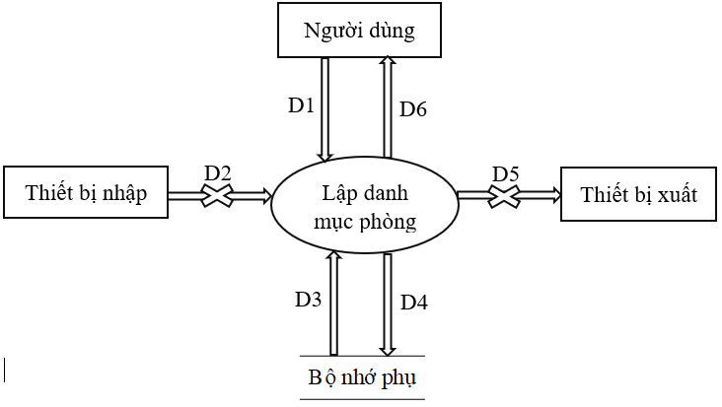

***Figure 2.3.1: Data flow diagram for room cataloging request***

Data streams:

D1: Room, room type, unit price, notes

D2: None

D3: List of information about QD1 from secondary memory (there are 3 types of rooms with corresponding unit prices)

D4: Save D1 and D3 to auxiliary memory

D5: None

D6: D4

Algorithm :

Step 1: Get D1 from user

Step 2: Connect to the database

Step 3: Read D3 from auxiliary memory

Step 4: Export D3 to the printer (if required)

Step 5: Close the database connection

Step 6: Finish

Data flow diagram for room status check request:

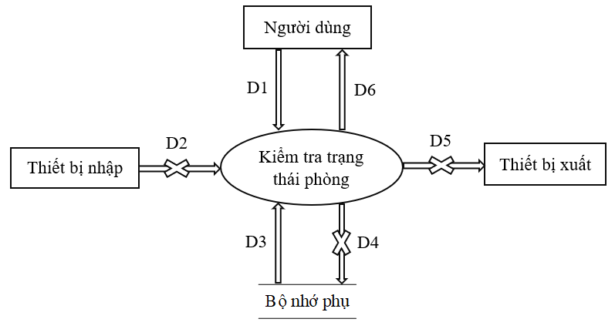

***Figure 2.3.2: Data flow diagram for room status check request***

Data streams:

D1: Room code and room type, time to check the room

D2: None

D3: Rental start date, rental end date, room availability (empty, occupied)

D4: None

D5: None

D6: Room is rented

Algorithm :

Step 1: Get D1 from user

Step 2: Connect to the database

Step 3: Read D3 from auxiliary memory

Step 4: Perform the check from D3. If the room is checked, it is returned to D6 (the room is rented) and if there are people, the room cannot be rented.

Step 5: Output D6 to the screen.

Step 6: Close the database connection.

Step 7: Finish

Data flow diagram for reservation request:

Form 2 and regulation 2:

|  |  |  |  |  |  |
| --- | --- | --- | --- | --- | --- |
| BM2: | | Room Rental Voucher | | | |
| Room: | | | | Lease start date: | |
| STT | Customer | | Type of Guest | ID card | Address |
| 1 |  | |  |  |  |
| 2 |  | |  |  |  |

Q2: There are 2 types of visitors (domestic and foreign). Each room has a maximum of 3 guests

Diagram :

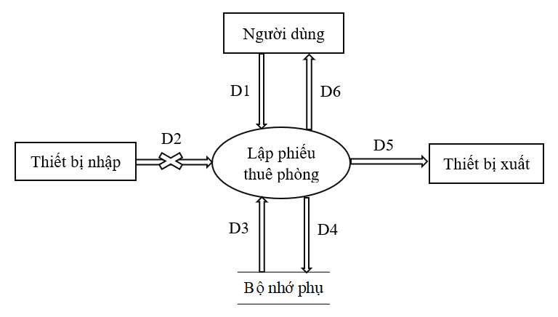

***Figure 2.3.3: Data flow diagram for room booking request***

Data streams:

D1: Room, rental start date, list of customers (name, type of customer, ID card, address)

D2: None.

D3: List of types of guests, maximum number of people in 1 room.

D4: D1+Rental date.

D5: D4

D6: D4

Algorithm :

Step 1: Get D1 from the user.

Step 2: Connect to the database

Step 3: Read D3 from auxiliary memory

Step 4: Check if the room is available or not

Step 5: Calculate the maximum number of people in a room

Step 6: If steps 3 and 4 are satisfied, go to step 7.

Step 7: Save D4 to secondary memory.

Step 8: Export D5 to the printer

Step 9: Export D6 to the user

Step 10: Close the database connection

Step 11: Finish

Data flow diagram for room lookup request:

Form 3:

|  |  |  |  |  |  |
| --- | --- | --- | --- | --- | --- |
| BM3: | | Room List | | | |
| STT | Room | | Kind of room | Unit price | Status |
| 1 |  | |  |  |  |
| 2 |  | |  |  |  |

Diagram :

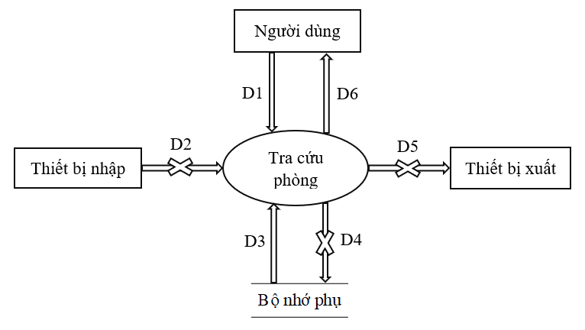

***Figure 2.3.4: Data flow diagram for room lookup request***

Data streams:

D1: List of rooms (name, room type, unit price, status)

D2: None

D3: List of customers that satisfy the search object (D1)

D4: None

D5: None

D6: Return search results to users

Algorithm:

Step 1: Get D1 from user

Step 2: Open connection with database

Step 3: Read D3 from auxiliary memory

Step 4: Export the search results (D6) to the user screen

Step 5: Close the database connection

Step 6: Finish.

Data flow diagram for payment invoicing request:

Form 4 and regulation 4:

|  |  |  |  |  |  |  |
| --- | --- | --- | --- | --- | --- | --- |
| BM4: | | Bill | | | | |
| Client/Agency: | | | | Address: | | |
|  | | | | Value: | | |
| STT | Room | | Number of Rental Days | | Unit price | Into money |
| 1 |  | |  | |  |  |
| 2 |  | |  | |  |  |

Q4: Room rate for 2 guests. 3rd guest surcharge 25%. Foreign guests (only need to have 1 in the room) multiply by 1.5

Diagram:

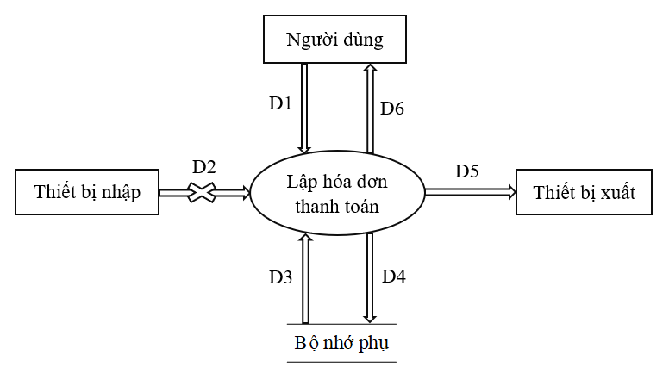

***Figure 2.3.5: Data Flow Diagram for Billing Requests***

Data streams:

D1: Customer/Agency, address, value, list of bills to pay for each room (room name, number of rental days, unit price, amount)

D2: None

D3: Read customer information from auxiliary memory

D4: D3+ corresponding room rate

D5: D4

D6: D4

Algorithm:

Step1: Get D1 from user

Step 2: Connect to the database

Step 3: Read D3 from auxiliary memory

Step 4: Get the current system date.

Step 5: Calculate the number of days the guest has stayed and calculate it

Step 6: Save D4 to secondary memory bộ

Step 7: Export D4 to the printer

Step 8: Output D4 to the user screen

Step 9: Close the database connection

Step 10: End the program

Data flow diagram for surcharge rate claim:

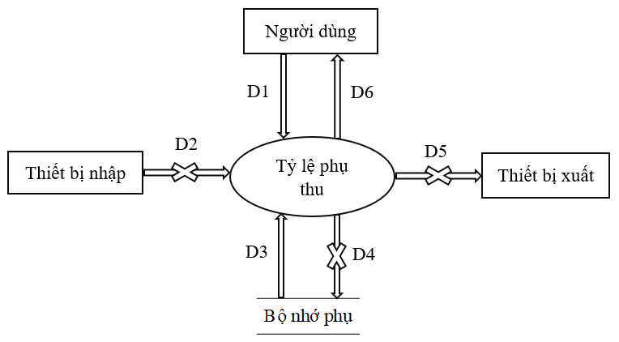

***Figure 2.3.6: Data flow diagram for dependency ratio request***

Data streams:

D1: Guest type

D2: None

D3: Read data from auxiliary memory (using billed customer surcharge rate)

D4: None

D5: None

D6: D3

Algorithm:

Step 1: Get D1 from the user.

Step 2: Connect to the database

Step 3: Read D3 from auxiliary memory

Step 4: Invoicing customers based on D3

Step 5: Close the database connection

Step 6: Finish

Data flow diagram for monthly reporting request:

Form 5:

|  |  |  |  |  |
| --- | --- | --- | --- | --- |
| BM5: | | Revenue Report By Room Type | | |
| Month: | | | | |
| STT | Kind of room | | Revenue | Ratio |
| 1 |  | |  |  |
| 2 |  | |  |  |

Diagram:

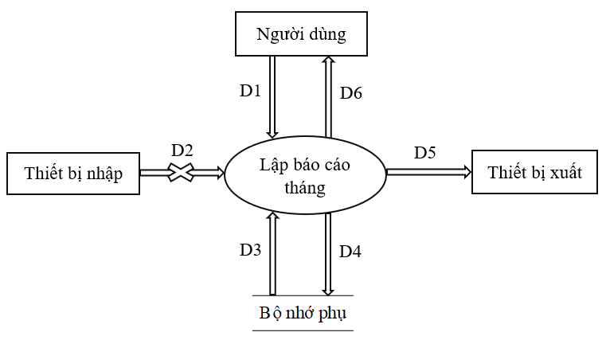

***Figure 2.3.7: Data flow diagram for monthly reporting requirements***

Data streams:

D1: Month

D2: None

D3: Read from memory the list of tenants for the month (rental period, number of rooms, ...)

D4: Revenue by room and room type, number of days of room rental and rate

D5: D4

D6: D4

Algorithm:

Step 1: Get D1 from user

Step 2: Connect to the database

Step 3: Read D3 from auxiliary memory

Step 4: Calculate the revenue by each room and each room type, the number of rental days, the rate based on D3

Step 5: Save D4 to secondary memory

Step 6: Export D4 to the printer

Step 7: Export D4 to the user screen

Step 8: Close the database connection

Step 9: End the program

Data flow diagram for the specified change request:

Rule 6:

QD6: Users can change the rules as follows:

+ Decision1: Change the quantity and unit price of the room types.

+ Decision2: Change the number of guests, the maximum number of guests in the room.

+ Decision4: Change the surcharge rate.

Diagram:

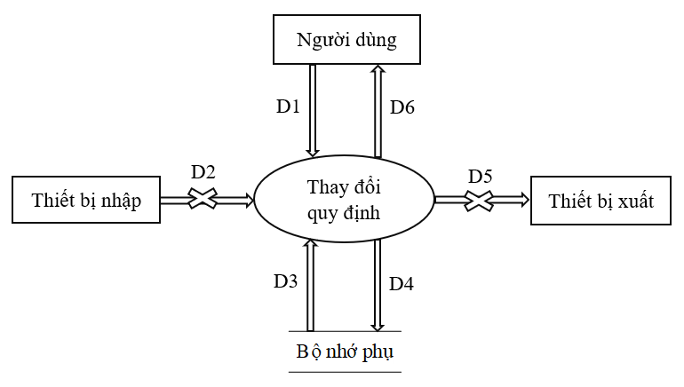

***Figure 2.3.8: Data flow diagram for regulatory change request***

Data streams:

D1: User changes rules by logging in with Admin rights

D2: None

D3: List of information that needs to be changed

D4: User changes from D3

D5: None

D6: D4

Algorithm:

Step 1: Get D1 from user

Step 2: Connect to the database

Step 3: Check login permission

Step 4: Read D3 from auxiliary memory

Step 5: User changes the rules

Step 6: Save D3 to secondary memory

Step 7: The message has been changed successfully for the user.

Step 8: Close the database connection

Step 9: End the program

# Chapter 3 - System Design

## 3.1 System Architecture

Hotel Management software is designed and built according to the Client - Server model.

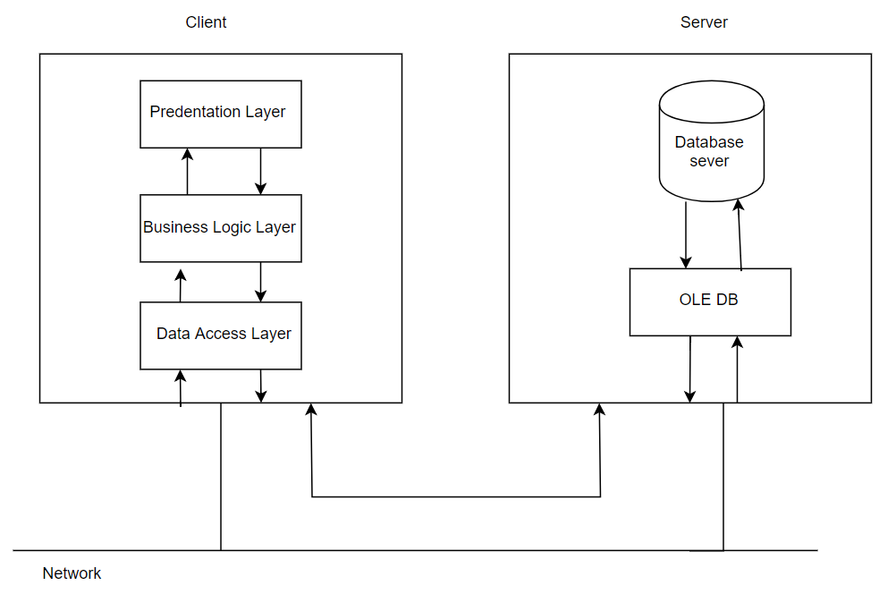

***Figure 3.1.1: Client – ​​Server model of hotel management system***

## 3.2 Description of the components in the system

|  |  |  |
| --- | --- | --- |
| STT | Ingredient | Explain |
| 1 | Presentation Layer | This class is responsible for communicating with the end user to collect data and display the results/data through elements in the user interface. |
| 2 | Business Logic Layer | This is the layer that handles the main data before it is displayed on the screen or processes the data before moving down to the Data Access Layer to save the data to the database. This is also the place to check constraints, business requirements, calculate, process requests and select results returned for Presentation Layers. |
| 3 | Data Access Layer | This layer performs the operations related to storing and retrieving the application's data such as reading, saving, updating the database. |
| 4 | OLE DB | OLE DB divided into client and server |

# Chapter 4 - Data Design

## 4.1 Algorithm for logic diagramming

### 4.1.1 Step 1: Consider the request to make a list of rooms

a. Design data with correctness:

Related forms:

|  |  |  |  |  |  |
| --- | --- | --- | --- | --- | --- |
| BM1: | | Room Directory | | | |
| STT | Room | | Kind of room | Unit price | Note |
| 1 |  | |  |  |  |
| 2 |  | |  |  |  |

Data flow diagram:

*See Figure 2.3.1

- New properties:

TenPhong (Name), LoaiPhong (RoomType), DonGia (Price), GhiChu

Data design:

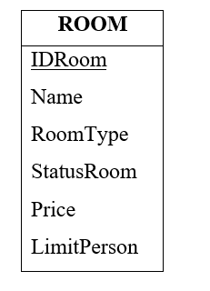

- Abstract properties: MaPhong (IDroom)

- Logic diagram:

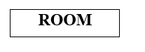

b. Design data with evolution:

- Relevant regulations:

QD1: There are 3 types of rooms (A, B, C) with corresponding unit prices (150,000, 170,000, 200,000).

Data flow diagram:

*See Figure 2.3.1

- New properties:

TenLouis Phong

Data design:

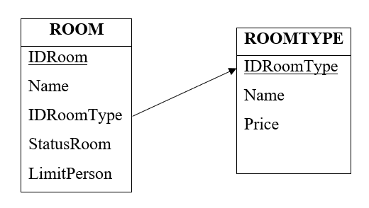

- Abstract properties:

MaLoaiPhong (IDRoomType)

- Logic diagram:

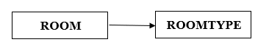

### 4.1.2 Step 2: Consider the request for a room rental voucher

a. Design data with correctness:

Related forms:

|  |  |  |  |  |  |
| --- | --- | --- | --- | --- | --- |
| BM2: | | Room Rental Voucher | | | |
| Room: | | | | Lease start date: | |
| STT | Customer | | Type of Guest | ID card | Address |
| 1 |  | |  |  |  |
| 2 |  | |  |  |  |

Data flow diagram:

*See Figure 2.3.2 and Figure 2.3.3

- New properties:

RightBatDauThue (DateCheckIn), TenPhong (Name), LoaiPhong (RoomType), ID card (Sex), DiaChi (Address)

Data design:



- Abstract properties:

MaPhieuThue (IDReceiveRoom), MaChiTietPhieuThue (IDReceiveRoomDetails), MaKhachHang (IDCustomer)

- Logic diagram:



b. Design data with evolution:

- Relevant regulations:

Q2: There are 2 types of visitors (domestic and foreign). Each room has a maximum of 3 guests

Data flow diagram:

* See figure 2.3.2 and figure 2.3.3

- New properties:

TenLoaiKhach (Name), SoKhachToiDa (LimitPerson)

Data design:



- Abstract properties:

MaLoaiKhach (IDRoomType)

- Logic diagram:



### 4.1.3 Step 3: Consider room search request

a. Design data with correctness:

Related forms:

|  |  |  |  |  |  |
| --- | --- | --- | --- | --- | --- |
| BM3: | | Room List | | | |
| STT | Room | | Kind of room | Unit price | Status |
| 1 |  | |  |  |  |
| 2 |  | |  |  |  |

Data flow diagram:

*See figure 2.3.4

- New properties:

Loai Phong (RoomType), ThoiGian, Tinh Trang Phong (StatusRoom)

Data design:



- Abstract properties:

- Logic diagram:



b. Design data with evolution:

### 4.1.4 Step 4: Consider payment invoice request

a. Design data with correctness:

Related forms:

|  |  |  |  |  |  |  |
| --- | --- | --- | --- | --- | --- | --- |
| BM4: | | Bill | | | | |
| Client/Agency: | | | | Address: | | |
|  | | | | Value: | | |
| STT | Room | | Number of Rental Days | | Unit price | Into money |
| 1 |  | |  | |  |  |
| 2 |  | |  | |  |  |

Data flow diagram:

*See figure 2.3.5

- New properties:

RightTraPhong (DateCheckOut), TongTien (TotalPrice)

Data design:



- Abstract properties:

MaHoaDon (IDBill), MaChiTietHoaDon(IDBillDetails)

- Logic diagram:



b. Design data with evolution:

- Relevant regulations:

Q4: Room rate for 2 guests. 3rd guest surcharge 25%. Foreign guests (only need to have 1 in the room) multiply by 1.5

Data flow diagram:

*See figure 2.3.6

- New properties:

TiLePhuThu (Value)

Data design:



- Abstract properties:

TenPhuThu (Name)

- Logic diagram:



### 4.1.5 Step 5: Consider the request for monthly report

a. Design data with correctness:

Related forms:

|  |  |  |  |  |
| --- | --- | --- | --- | --- |
| BM5: | | Revenue Report By Room Type | | |
| Month: | | | | |
| STT | Kind of room | | Revenue | Ratio |
| 1 |  | |  |  |
| 2 |  | |  |  |

Data flow diagram:

*See figure 2.3.7

- New properties:

Data design:



- Abstract properties:

- Logic diagram:



b. Design data with evolution:

### 4.1.6 Step 6: Consider the request for regulation change

a. Design data with correctness:

b. Design data with evolution:

- Relevant regulations:

QD6: Users can change the rules as follows:

+ Decision1: Change the quantity and unit price of the room types.

+ Decision2: Change the number of guests, the maximum number of guests in the room.

+ Decision4: Change the surcharge rate.

Data flow diagram:

*See figure 2.3.8

- New properties:

Data design:



- Abstract properties:

- Logic diagram:



## 4.2 Complete Logic Diagram

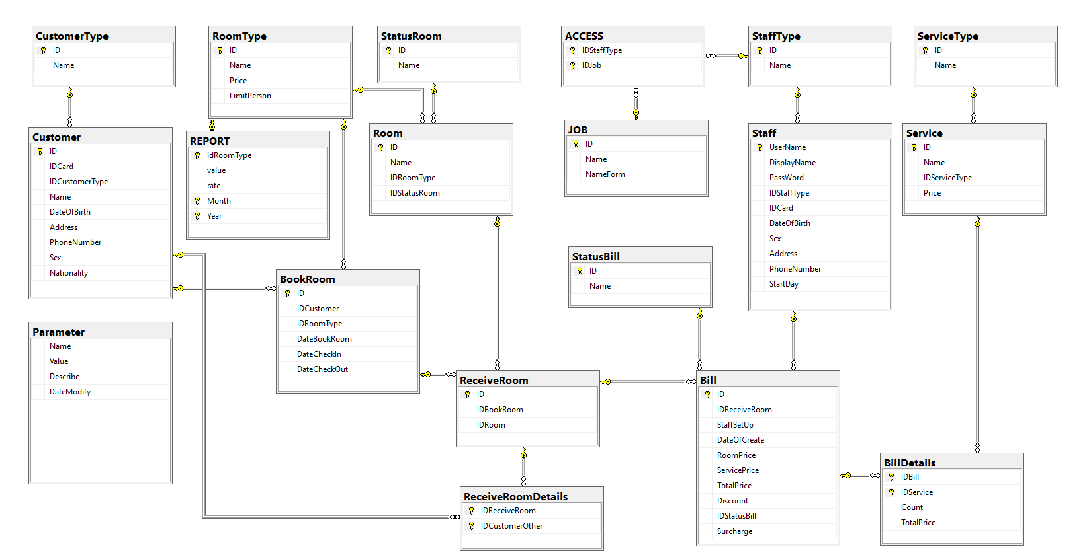

***Figure 4.2.1: Complete logic diagram of the hotel management system***

**Calculation:**

* Excess number of guests = Number of guests – Number of guests without surcharge
* Unit price = Unit price of room type + (Unit price of room type * Surcharge rate * Excess number of guests)
* Unit price = Unit price * 1.5

|  |  |
| --- | --- |
| Parameter name | Value |
| Maximum number of guests | 3 |
| Number of guests without surcharge | 2 |
| Surcharge rate | 0.25 |
| Additional documents | 1.5 |

## 4.3 List of data tables (tables) in the diagram

|  |  |  |
| --- | --- | --- |
| STT | Data table name | Explain |
| 1 | ACCESS | Access |
| 2 | BILL | Bill |
| 3 | BILLDETAILS | Invoice details |
| 4 | BOOKROOM | Book room |
| 5 | CUSTOMER | Customer |
| 6 | CUSTOMERTYPE | Customer Type |
| 7 | JOB | Position |
| 8 | PARAMETER | Parameters |
| 9 | RECEIVEROOM | Check in |
| ten | RECEIVEROOMDETAILS | Check-in details |
| 11 | REPORT | Report |
| twelfth | ROOM | Room |
| 13 | ROOMTYPE | Kind of room |
| 14 | SERVICE | Service |
| 15 | SERVICETYPE | Type of service |
| 16 | STAFF | Staff |
| 17 | STAFFTYPE | Employee Type |
| 18 | STATUSBILL | Invoice Status |
| 19 | STATUSROOM | Room Status |

## 4.4 Description of each data table

### 4.4.1 Table of ACCESS

|  |  |  |  |  |
| --- | --- | --- | --- | --- |
| STT | Properties | Datatypes | Constraint | Explain |
| 1 | IDStaffType | int | PK, FK, NOT NULL | Employee type code |
| 2 | IDJob | int | PK, FK, NOT NULL | Title code |

### 4.4.2 Pound Bill

|  |  |  |  |  |
| --- | --- | --- | --- | --- |
| STT | Properties | Datatypes | Constraint | Explain |
| 1 | ID | int | PK, NOT NULL | Code Bill |
| 2 | IDReceiveRoom | int | FK, NOT NULL | Check-in code |
| 3 | StaffSetUp | nvarchar(32) | FK, NOT NULL | Staff is set |
| 4 | DateOfCreate | smalldatetime | NULL | Date created |
| 5 | RoomPrice | money | NOT NULL | Room Rates |
| 6 | ServicePrice | money | NOT NULL | Service prices |
| 7 | Surcharge | money | NOT NULL | Surcharge |
| 8 | Discount | float | NOT NULL | Discount |
| 9 | TotalPrice | money | NOT NULL | Total amount |
| ten | IDStatusBill | int | FK, NOT NULL | Invoice status code |

### 4.4.3 BillDetails Table

|  |  |  |  |  |
| --- | --- | --- | --- | --- |
| STT | Properties | Datatypes | Constraint | Explain |
| 1 | IDBill | int | PK, FK, NOT NULL | Code Bill |
| 2 | IDService | int | PK, FK, NOT NULL | Service code |
| 3 | Count | int | NOT NULL | Amount |
| 4 | TotalPrice | money | NOT NULL | Total amount |

### 4.4.4 BookRoom Table

|  |  |  |  |  |
| --- | --- | --- | --- | --- |
| STT | Properties | Datatypes | Constraint | Explain |
| 1 | ID | int | PK, NOT NULL | Reservation code |
| 2 | IDCustomer | int | FK, NOT NULL | Customer's code |
| 3 | IDRoomType | int | FK, NOT NULL | Room type code |
| 4 | DateBookRoom | smalldatetime | NOT NULL | Booking date |
| 5 | DateCheckIn | smalldatetime | NOT NULL | Arrival date |
| 6 | DateCheckOut | smalldatetime | NOT NULL | Days to go |

### 4.4.5 Customer Table

|  |  |  |  |  |
| --- | --- | --- | --- | --- |
| STT | Properties | Datatypes | Constraint | Explain |
| 1 | ID | int | PK, NOT NULL | Customer's code |
| 2 | Name | nvarchar(40) | NOT NULL | Customer name |
| 3 | IDCard | int | UNIQUE, NOT NULL | ID card |
| 4 | IDCustomerType | int | FK, NOT NULL | Customer type code |
| 5 | DateOfBirth | smalldatetime | NOT NULL | Date of birth |
| 6 | Address | nvarchar(50) | NOT NULL | Address |
| 7 | PhoneNumber | int | NOT NULL | phone number |
| 8 | Sex | nvarchar(20) | NOT NULL | Sex |
| 9 | Nationality | nvarchar(20) | NOT NULL | nationality |

### 4.4.6 Table CustomerType

|  |  |  |  |  |
| --- | --- | --- | --- | --- |
| STT | Properties | Datatypes | Constraint | Explain |
| 1 | ID | int | PK, NOT NULL | Customer type code |
| 2 | Name | nvarchar(40) | NOT NULL | Name of customer type |

### 4.4.7 Job Board

|  |  |  |  |  |
| --- | --- | --- | --- | --- |
| STT | Properties | Datatypes | Constraint | Explain |
| 1 | ID | int | PK, NOT NULL | Function code |
| 2 | Name | nvarchar(40) | NOT NULL | Function name |
| 3 | FormName | nvarchar(40) | NOT NULL | Loaded screen name |

### 4.4.8 Parameter Table

|  |  |  |  |  |
| --- | --- | --- | --- | --- |
| STT | Properties | Datatypes | Constraint | Explain |
| 1 | Name | nvarchar(40) | PK, NOT NULL | Parameter name |
| 2 | Value | int | FK, NOT NULL | Value |
| 3 | Describe | nvarchar(100) | FK, NOT NULL | Describe |
| 4 | DateModify | smalldatetime | NULL | Last modified date |

### 4.4.9 ReceiveRoom Table

|  |  |  |  |  |
| --- | --- | --- | --- | --- |
| STT | Properties | Datatypes | Constraint | Explain |
| 1 | ID | int | PK, NOT NULL | Check-in code |
| 2 | IDBookRoom | int | FK, NOT NULL | Reservation code |
| 3 | IDroom | int | FK, NOT NULL | Room code |

### 4.4.10 Table ReceiveRoomDetails

|  |  |  |  |  |
| --- | --- | --- | --- | --- |
| STT | Properties | Datatypes | Constraint | Explain |
| 1 | IDReceiveRoom | int | PK, FK, NOT NULL | Check-in code |
| 2 | IDCustomerOther | int | PK, FK, NOT NULL | Other customer code |

### 4.4.11 Table REPORT

|  |  |  |  |  |
| --- | --- | --- | --- | --- |
| STT | Properties | Datatypes | Constraint | Explain |
| 1 | IDRoomType | int | PK, FK, NOT NULL | Room type code |
| 2 | Value | int | NOT NULL | Value |
| 3 | Rate | float | NOT NULL | Ratio |
| 4 | Month | int | PK, NOT NULL | Month |
| 5 | Year | int | PK, NOT NULL | Year |

### 4.4.12 Table Room

|  |  |  |  |  |
| --- | --- | --- | --- | --- |
| STT | Properties | Datatypes | Constraint | Explain |
| 1 | ID | int | PK, NOT NULL | Room code |
| 2 | Name | nvarchar(40) | NOT NULL | Room name |
| 3 | IDRoomType | int | FK, NOT NULL | Room type code |
| 4 | IDStatusRoom | int | FK, NOT NULL | Status code |

### 4.4.13 RoomType . Table

|  |  |  |  |  |
| --- | --- | --- | --- | --- |
| STT | Properties | Datatypes | Constraint | Explain |
| 1 | ID | int | PK, NOT NULL | Room type code |
| 2 | Name | nvarchar(40) | NOT NULL | Room type name |
| 3 | Price | money | NOT NULL | Room charge |
| 4 | LimitPerson | int | NOT NULL | Maximum number of people |

### 4.4.14 Service Table

|  |  |  |  |  |
| --- | --- | --- | --- | --- |
| STT | Properties | Datatypes | Constraint | Explain |
| 1 | ID | int | PK, NOT NULL | Service code |
| 2 | Name | nvarchar(40) | NOT NULL | service name |
| 3 | IDServiceType | int | FK, NOT NULL | Service Type Code |
| 4 | Price | money | NOT NULL | Service fee |

### 4.4.15 Table ServiceType

|  |  |  |  |  |
| --- | --- | --- | --- | --- |
| STT | Properties | Datatypes | Constraint | Explain |
| 1 | ID | int | PK, NOT NULL | Service Type Code |
| 2 | Name | nvarchar(40) | NOT NULL | Service Type Name |

### 4.4.16 Staff Table

|  |  |  |  |  |
| --- | --- | --- | --- | --- |
| STT | Properties | Datatypes | Constraint | Explain |
| 1 | UserName | nvarchar(32) | PK, NOT NULL | user name |
| 2 | DisplayName | nvarchar(40) | NOT NULL | Display name |
| 3 | Password | nvarchar(32) | NOT NULL | Room type code |
| 4 | IDStaffType | int | FK, NOT NULL | Status code |
| 5 | IDCard | int | UNIQUE, NOT NULL | ID card |
| 6 | DateOfBirth | date | NOT NULL | Date of birth |
| 7 | Sex | nvarchar(20) | NOT NULL | Sex |
| 8 | Address | nvarchar(50) | NOT NULL | Address |
| 9 | PhoneNumber | int | NOT NULL | phone number |
| ten | StartDay | date | NOT NULL | Date of entry to work |

### 4.4.17 StaffType Table

|  |  |  |  |  |
| --- | --- | --- | --- | --- |
| STT | Properties | Datatypes | Constraint | Explain |
| 1 | ID | int | PK, NOT NULL | Employee type code |
| 2 | Name | nvarchar(40) | NOT NULL | Employee type name |

### 4.4.18 StatusBill . Table

|  |  |  |  |  |
| --- | --- | --- | --- | --- |
| STT | Properties | Datatypes | Constraint | Explain |
| 1 | ID | int | PK, NOT NULL | Invoice status code |
| 2 | Name | nvarchar(40) | NOT NULL | Invoice status name |

### 4.4.19 StatusRoom Table

|  |  |  |  |  |
| --- | --- | --- | --- | --- |
| STT | Properties | Datatypes | Constraint | Explain |
| 1 | ID | int | PK, NOT NULL | Room status code |
| 2 | Name | nvarchar(40) | NOT NULL | Room status name |

# Chapter 5 - Interface Design

## 5.1 Connection diagram of screens

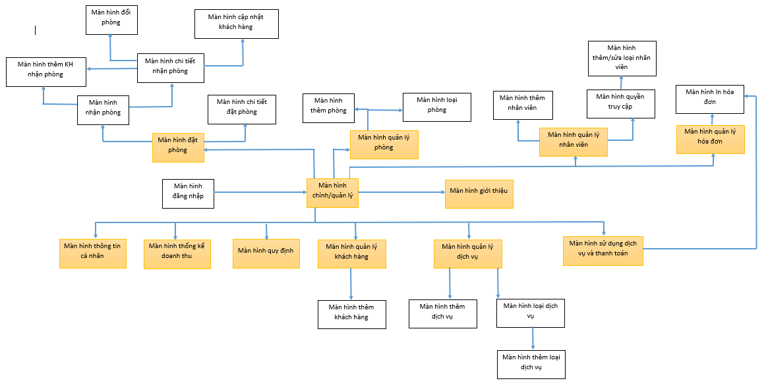

***Figure 5.1.1: Connection diagram of the screens of the hotel management system***

## 5.2 List of screens

|  |  |  |  |
| --- | --- | --- | --- |
| STT | Screen | Screen Type | Function |
| 1 | Login screen | Home screen | Log in to the software |
| 2 | Management Screen (Manager) | Home screen | The main screen of the software, showing the jobs that the software provides |
| 3 | Personal Information Screen | Input screen + lookup | Allow to enter, update personal information and look up personal information |
| 4 | Booking Screen | Input screen + lookup | Allow to import, store the rental list and search for booking information |
| 5 | Booking Details screen | Input screen + lookup | Allows viewing booking details, updating booking information, booking customers, deleting bookings |
| 6 | Check-in Screen | Input screen + lookup | Allows entry, storage of check-in lists and check-in information search |
| 7 | Screen Add Guest Check-in | Input screen | Allow 1 new guest to be added to the room in the check-in form |
| 8 | Check-in details screen | Input screen | View check-in details, allow room change, change customer information in room, add customer to room, remove customer from room |
| 9 | Room Change Screen | Input screen | Change room in the check-in form |
| ten | Customer Update Screen | Input screen | Change customer information in the single check-in room |
| 11 | Revenue Statistics screen | Report screen | Revenue report by room type for the month |
| twelfth | Room Management Screen | Input screen + Lookup | Allows to enter, store the list of rooms and look up information about the rooms |
| 13 | Screen Add room | Input screen | Add 1 new room |
| 14 | Room Type Screen | Input screen+lookup | Update room type information, look up room type information |
| 15 | Employee Management Screen | Input screen + Lookup | Allows updating employee information and looking up employee information |
| 16 | Add Employee Screen | Input screen | Allow adding new employees |
| 17 | Access Rights Screen | Input screen | Allow to customize access rights for employee types |
| 18 | Add/Edit Employee Type Screen | Input screen | Allow to add/update employee type |
| 19 | Invoice Management screen | Lookup screen | Allows searching, viewing details of invoices |
| 20 | Invoice Print Screen | Report screen | Print invoice |
| 21 | Service Management Screen | Input screen + Lookup | Allows searching for services, adding new services, updating services, editing service types |
| 22 | Add Service Screen | Input screen | Add 1 new service |
| 23 | Service Type screen | Input screen + lookup | Allow search, add new, update service type loại |
| 24 | Add Service Type screen | Input screen | More service type |
| 25 | Service Usage and Payment Screen | Input screen | Allows the provision of services to customers |
| 26 | Customer Management screen | Input screen + lookup | Allow searching, updating, adding new customers |
| 27 | Add Customer screen | Input screen | Add 1 new customer |
| 28 | Regulations Screen | Input screen + lookup | Allows searching for regulations and updating regulatory changes |
| 29 | About Screen | Notification screen | Displays relevant information of the software |

## 5.3 Description of screens

### 5.3.1 Login Screen

a. Display

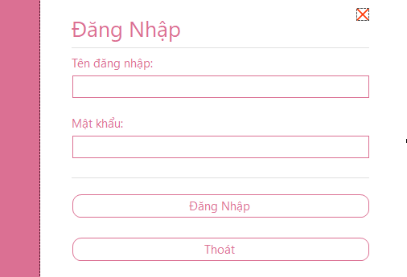

***Figure 5.3.1: Login interface of hotel management system***

b. Description of objects on the screen

|  |  |  |  |  |
| --- | --- | --- | --- | --- |
| STT | Name | Type | Constraint | Function |
| 1 | LabelName | Label |  | Title of the current Form |
| 2 | txbUsername | Textbox | Contains only characters a-z, 0-9, @, . | Enter username |
| 3 | txbPassWord | Textbox | Encode md5 | Enter password |
| 4 | btnLogin | Button |  | Perform the login operation |

c. List of events and corresponding handling on the screen

|  |  |  |
| --- | --- | --- |
| STT | Incident | Handling |
| 1 | Select btnLogin | Log in to the system |

### Main Management screen (Manager)

1. Display

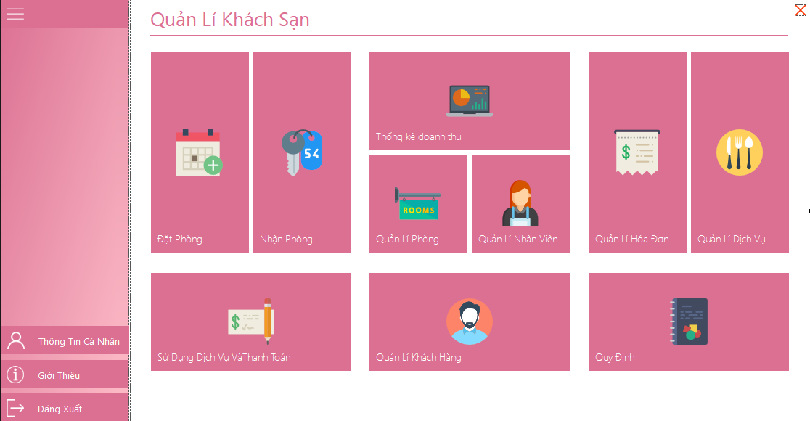

***Figure 5.3.2: The main interface of the hotel management system***

1. Description of objects on the screen

|  |  |  |  |  |
| --- | --- | --- | --- | --- |
| STT | Name | Type | Constraint | Function |
| 1 | btnAccountProfile | Button |  | Button to perform the operation of displaying user information |
| 2 | btnLogOut | Button |  | Button to perform the logout operation |
| 3 | LabelName | Label |  | Current Form Title |
| 4 | titleBookRoom | MetroTile |  | Open the Reservation form |
| 5 | titleRecieveRoom | MetroTile |  | Open the Check-in form |
| 6 | titleReport | MetroTile |  | Open the Revenue Statistics form |
| 7 | titleManageRoom | MetroTile |  | Open the Room Management form |
| 8 | titleStaff | MetroTile |  | Open the Employee Management form |
| 9 | titleStaff | MetroTile |  | Open the Manage Invoice form |
| ten | titleService | MetroTile |  | Open Service Management form |
| 11 | titlePay | MetroTile |  | Open the Service Usage and Payment form |
| 12 | titleCustomer | MetroTile |  | Open the Customer Management form |

1. List of events and corresponding handling on the screen

|  |  |  |
| --- | --- | --- |
| STT | Incident | Handling |
| 1 | Select btnAccountProfile | Show personal information |
| 2 | Select btnLogOut | Log out of the account, return to the login screen |
| 3 | Select titleBookRoom | Go to the Reservation form to make a reservation |
| 4 | Select titleRecieveRoom | Go to the Check-in form to check in |
| 5 | Select titleReport | Switch to the Revenue Statistics form to view the report |
| 6 | Select titleManageRoom | Switch to the Room Management form to manage the room list |
| 7 | Select titleStaff | Switch to the Employee Management form to manage the list of employees |
| 8 | Select titleBill | Go to Invoice Management form |
| 9 | Select titlePay | Go to the form Use the service and make payment |
| ten | Select titleCustomer | Switch to the Customer Management form to manage the customer list |
| twelfth | Select titleService | Switch to the Service Management form to manage the service list |

### 5.3.3 Personal Information Screen

a. Display

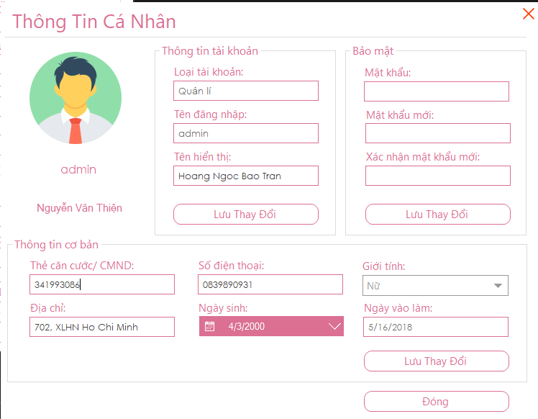

***Figure 5.3.3: Personal information interface of the hotel management system***

b. Description of objects on the screen

|  |  |  |  |  |
| --- | --- | --- | --- | --- |
| STT | Name | Type | Constraint | Function |
| 1 | labelName | Label |  | Show Form title |
| 2 | txbStaffType | TextBox | Reading attribute | Show employee type |
| 3 | txbUserName | TextBox | Reading attribute | Employee login name |
| 4 | txbDisplayName | TextBox | Does not contain special characters | Employee display name |
| 5 | txbPass | TextBox | MD5 . Encryption | Employee account current password |
| 6 | txbNewPass | TextBox | MD5 . Encryption | The password you want to change for the employee's account |
| 7 | txbReNewPass | TextBox | MD5 . Encryption | Confirm the password you want to change of the employee's account |
| 8 | txbIDCard | TextBox | Does not contain special characters | Employee's ID/ID card |
| 9 | txbAddress | TextBox |  | Employee's address |
| ten | txbPhoneNumber | TextBox | Digits 0-9 | Employee phone number |
| 11 | dpkDateOfBirth | DateTimePicker | Date of birth is less than current date | Employee's date of birth |
| twelfth | cbSex | Combo |  | Employee gender |
| 13 | txbStartDay | TextBox | Reading attribute | Employee's entry date |
| 14 | btnChange | Button |  | Perform the operation to update the employee's personal information |
| 15 | btnBookRoom | Button |  | Perform the operation to update the employee's name |
| 16 | btnChangePass | Button |  | Perform password reset operation |
| 17 | btnClose | Button |  | Close the current form, return to the previous form |

1. Event list and corresponding action on the screen.

|  |  |  |
| --- | --- | --- |
| STT | Incident | Handling |
| 1 | Click btnBookRoom | Edit information and update employee names in the database |
| 2 | Press btnChangePass | Edit information and update the password of the account in the database |
| 3 | Press btnChange | Edit information and update the account's personal information in the database |
| 4 | Press btnClose | Close the current form, return to the previous form |

### 5.3.4 Booking Screen:

a. Display:

***Figure 5.3.4: Reservation interface of hotel management system***

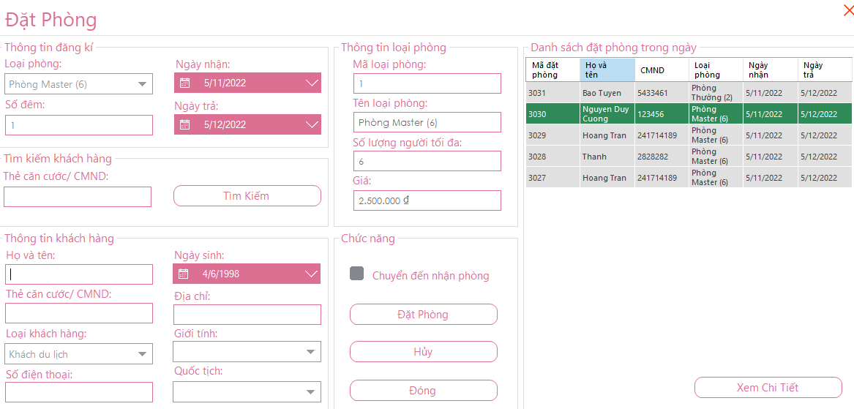

b. Description of objects on the screen

|  |  |  |  |  |
| --- | --- | --- | --- | --- |
| STT | Name | Type | Constraint | Function |
| 1 | labelName | Label |  | Show Form title |
| 2 | cbRoomType | Combo | Reading attribute | Kind of room |
| 3 | txbDateOfSignUp | TextBox | Greater than or equal to current date ngày | Booking registration date |
| 4 | txbDays | TextBox | Digits 0-9 | Shows the number of nights in |
| 5 | dpkDateCheckIn | DatetimePicker | Greater than or equal to current date ngày | Check-in date |
| 6 | dpkDateCheckOut | DatetimePicker | Greater than or equal to current date ngày | Check-out date |
| 7 | txtRoomTypeID | TextBox | Reading attribute | Room type code |
| 8 | txbRoomTypeName | TextBox |  | Kind of room |
| 9 | txbAmountPeople | TextBox |  | Number of people in the room |
| ten | txbPrice | TextBox | Digits 0-9 | Room Rates |
| 11 | txbFullName | TextBox |  | Customer name |
| twelfth | txbIDCard | TextBox | Digits 0-9 | Customer's ID/ID card |
| 13 | cbCustomerType | Combo |  | Customer Type |
| 14 | txbPhoneNumber | TextBox | Digits 0-9 | Customer phone number |
| 15 | dpkDateOfBirth | DatetimePicker | Less than current date ngày | Customer's date of birth |
| 16 | txbAddress | TextBox |  | Customer's address |
| 17 | cbSex | Combo |  | Customer's gender |
| 18 | cbNationality | Combo |  | Client's nationality |
| 19 | btnBookRoom | Button |  | Make a reservation |
| 20 | btnCancel | Button |  | Perform the operation of emptying the Form |
| 21 | checkbox | CheckBox |  | Pennant to go to the Check-in Form |
| 22 | gridBookRoom | DataGridView |  | Grid containing the reservation list for the day |
| 23 | txbIDCardSearch | Textbox | No, but special characters | ID card/Customer ID card (search) |
| 24 | btnSearch | Button | Does not contain special characters | Search for customer information (if available in the hotel's customer list) |
| 25 | btnDetails | Button |  | Details of bookings |

c. List of events and corresponding handling on the screen

|  |  |  |
| --- | --- | --- |
| STT | Incident | Handling |
| 1 | Click checkbox | Pennant to request to go to the Check-in form |
| 2 | Click btnBookRoom | Confirm the reservation, store it in the database, and depending on the checkbox1 has the check box, switch to the Check-in form form |
| 3 | Press btnCancel | Return the form to its initial state (empty) |
| 4 | Press btnSearch | Search for customer information to upload to the customer booking information section |
| 5 | Select dpkDateCheckIn | Choose a date to pick up |
| 6 | Select dpkDateCheckOut | Choose your arrival date |
| 7 | Click btnDetails | Perform the operation to view the booking details after successful booking đặt |

### 5.3.5 Reservation Details Screen

a. Display:

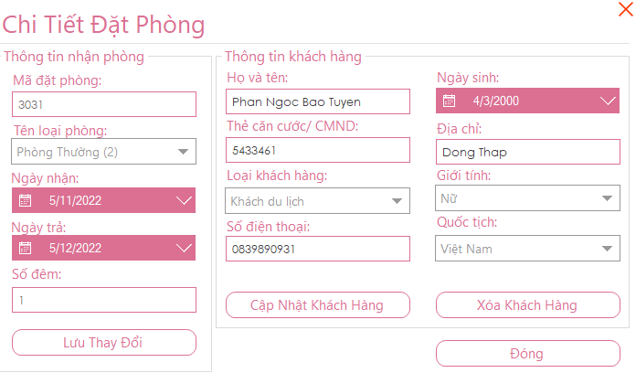

***Figure 5.3.5: Reservation details interface of the hotel management system***

b. Description of objects on the screen

|  |  |  |  |  |
| --- | --- | --- | --- | --- |
| STT | Name | Type | Constraint | Function |
| 1 | labelName | Label |  | Show the title of the form |
| 2 | txbIDBookRoom | Textbox | Reading attribute | Reservation code |
| 3 | cbRoomType | Combo |  | Kind of room |
| 4 | dpkDateCheckIn | Datetime Picker |  | Check-in date |
| 5 | dpkDateCheckOut | Datetime Picker |  | Check-out date |
| 6 | txbDays | Textbox | Reading attribute | Number of days in |
| 7 | txbFullName | Textbox |  | Customer name |
| 8 | txbIDCard | Textbox | No, but special characters | Customer's ID/ID card |
| 9 | cbCustomerType | Combo |  | Customer Type |
| ten | txbPhoneNumber | Textbox | Digits 0-9 | Customer's phone number |
| 11 | btnUpdate | Button |  | Make changes to booking-related information |
| twelfth | btnUpdateCustomer | Button |  | Update customer booking information |
| 13 | btnDel | Button |  | Delete customer information and also delete the guest's booking code in the database |
| 14 | btnClose | Button |  | Close the current form |

1. List of events and corresponding handling on the screen

|  |  |  |
| --- | --- | --- |
| STT | Incident | Handling |
| 1 | Press btnUpdate | Change information related to the reservation in the database (room type, number of days of stay) |
| 2 | Press btnUpdateCustomer | Update customer booking information in the database |
| 3 | Press btnDel | Delete the customer as well as the guest's reservation number in the database |
| 4 | Press btnClose | Close the Reservation Details form, return to the previous form |

### 5.3.6 Check-in Screen

a. Display

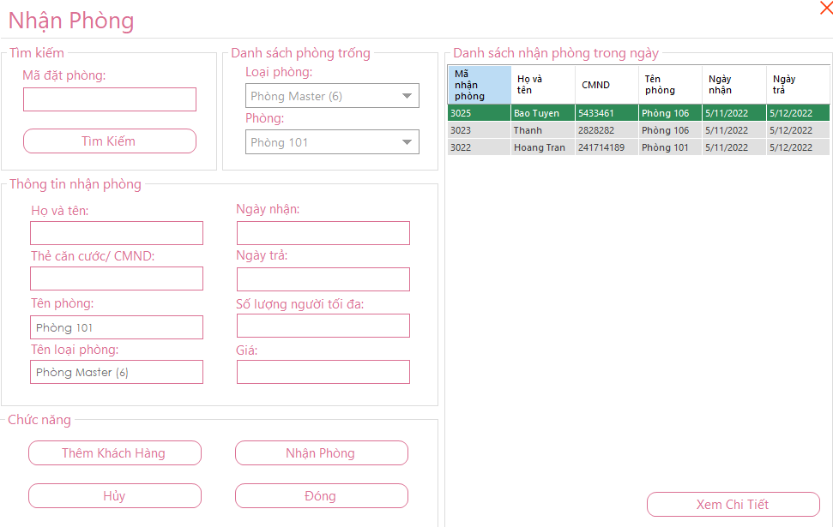

***Figure 5.3.6: Check-in interface of hotel management system***

b. Description of objects on the screen

|  |  |  |  |  |
| --- | --- | --- | --- | --- |
| STT | Name | Type | Constraint | Function |
| 1 | labelName | Label |  | Show the title of the form |
| 2 | txbIDBookRoom | Textbox |  | Enter the reservation code |
| 3 | btnSearch | Button | Does not contain special characters | Search for a room with the corresponding room code |
| 4 | txbFullName | Textbox | Reading attribute | Show the name of the person making the reservation |
| 5 | txbIDCard | Textbox | Reading attribute | Show ID/ID card of the person making the reservation |
| 6 | txbRoomName | Textbox | Reading attribute | Indicate the name of the room to be booked |
| 7 | txbRoomTypeName | Textbox | Reading attribute | Indicate the name of the room to be booked |
| 8 | txbDateCheckIn | Textbox | Reading attribute | Show check-in date |
| 9 | txbDateCheckOut | Textbox | Reading attribute | Show check-out date |
| 10 | txbAmountPeople | Textbox | Reading attribute | Shows the maximum number of people in the booked room |
| 11 | txbPrice | Textbox | Digits 0-9 | Show booked room rate |
| 12 | cbRoomType | Combo |  | Room type available |
| 13 | cbRoom | Combo |  | List of available rooms |
| 14 | btnAddCustomer | Button |  | Switch to the Add Customer form |
| 15 | btnReceiveRoom | Button |  | Perform check-in |
| 16 | btnCancel | Button |  | Perform the operation to make the form blank |
| 17 | btnClose | Button |  | Close the check-in form |
| 18 | gridReceiveRoom | DataGridview |  | Grid containing the list of check-in for the day |
| 19 | btnDetails | Button |  | Go to the Check-in Details form |

1. List of events and corresponding handling on the screen

|  |  |  |
| --- | --- | --- |
| STT | Incident | Handling |
| 1 | Select cbRoomType | Select an available room type |
| 2 | Select cbRoom | Select an available room name |
| 3 | Press btnSearch | Search for reservation information by room code in txbIDBookRoom |
| 4 | Press btnAddCustomer | Switch to the Add Customer form |
| 5 | Press btnReceiveRoom | Confirm the check-in, save it in the database |
| 6 | Press btnCancel | Return the form to its initial state (empty) |
| 7 | Press btnClose | Close the Check-in form, return to the previous form |
| 8 | Click btnDetails | Go to the Check-in Details form |

### 5.3.7 Add Guest Check-in Screen:

a. Display

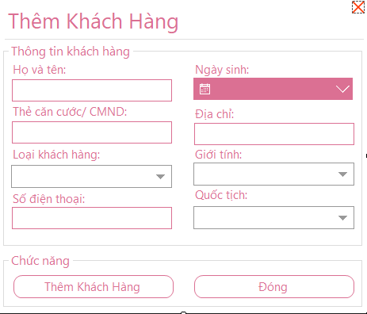

***Figure 5.3.7: The interface of adding customers of the hotel management system***

b. Description of objects on the screen

|  |  |  |  |  |
| --- | --- | --- | --- | --- |
| STT | Name | Type | Constraint | Function |
| 1 | labelName | Label |  | Show Form title |
| 2 | txtIDCardSearch | Textbox | Does not contain special characters | Enter the customer's ID card/ID card to search |
| 3 | txbFullName | TextBox | Does not contain special characters | Customer name |
| 4 | txbIDCard | TextBox | Does not contain special characters | ID card/Customer ID card |
| 5 | cbCustomerType | Combo |  | Customer Type |
| 6 | txbPhoneNumber | TextBox | Digits 0-9 | Customer phone number |
| 7 | dpkDateOfBirth | DateTimePicker | Date of birth must be less than current date | Customer's date of birth |
| 8 | txbAddress | TextBox | Reading attribute | Customer's address |
| 9 | cbSex | Combo |  | Customer's gender |
| ten | cbNationality | Combo |  | Client's nationality |
| 11 | btnAddCustomer | Button |  | Perform the operation of adding a new customer to the room in the check-in form |
| twelfth | btnCancel | Button |  | Perform the operation to make the form empty (return to the original state) |
| 13 | btnSearch | Button | Does not contain special characters | Perform customer information search |
| 14 | btnClose | button |  | Perform form closing operation |

1. List of events and corresponding handling on the screen

|  |  |  |
| --- | --- | --- |
| STT | Incident | Handling |
| 1 | Select cbCustomerType | Choose a customer type |
| 2 | Press btnSearch | Searching for customer information in the database that meets the criteria of ID card in txbIDCardSearch |
| 3 | Press btnAddCustomer | Add 1 new customer to the room in the check-in form, save it in the database |
| 4 | Press btnCancel | Action to make the form return to its original state (empty) |
| 5 | Press btnClose | Close the Add Customer form, return to the previous form |

### 5.3.8 Check-in Details Screen

a. Display

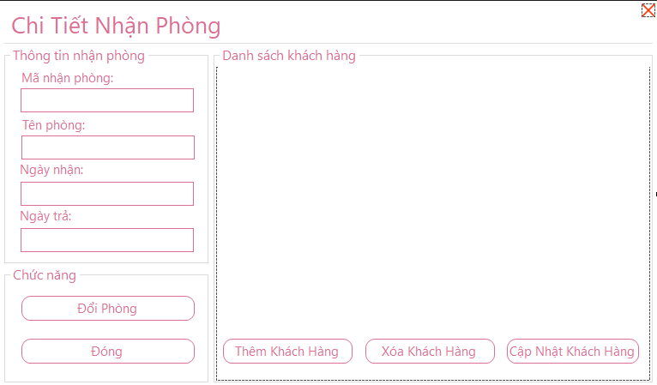

***Figure 5.3.8: Login interface of hotel management system***

b. Description of objects on the screen

|  |  |  |  |  |
| --- | --- | --- | --- | --- |
| STT | Name | Type | Constraint | Function |
| 1 | labelName | Label |  | Show form name |
| 2 | txbIDReceiveRoom | Textbox | Reading attribute | Check-in code |
| 3 | txbRoomName | Textbox | Reading attribute | Room name received |
| 4 | txbDateCheckIn | Textbox | Reading attribute | Check-in date |
| 5 | txbDateCheckOut | Textbox | Reading attribute | Check-out date |
| 6 | btnChangeRoom | Button |  | Switch to the Room Change Form |
| 7 | btnClose | Button |  | Close the current form |
| 8 | dataGridView | DataGridView |  | The grid contains a detailed list of the customers in the room received |
| 9 | btnAdd | Button |  | Go to the Add Customer form |
| ten | btnDel | Button |  | Remove customer from received room phòng |
| 11 | btnUpdate | Button |  | Go to the form Update customer information |

c. List of events and corresponding handling on the screen

|  |  |  |
| --- | --- | --- |
| STT | Incident | Handling |
| 1 | Press btnChangeRoom | Switch to the Change room form to change the room to receive |
| 2 | Press btnAdd | Switch to the Add Customer form |
| 3 | Press btnDel | Remove customer from customer list in received room |
| 4 | Press btnUpdate | Switch to the Customer Update form to update customer information |
| 5 | Press btnClose | Close the current form, return to the previous form |

### 5.3.9 Room Change Screen

a. Display

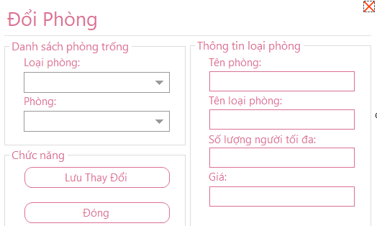

***Figure 5.3.9: Room change interface of hotel management system***

b. Description of objects on the screen

|  |  |  |  |  |
| --- | --- | --- | --- | --- |
| STT | Name | Type | Constraint | Function |
| 1 | labelName | Label |  | Show form name |
| 2 | cbRoomType | Combo |  | Show room type available |
| 3 | cbRoom | Combo |  | Show list of available rooms phòng |
| 4 | txbRoomName | Textbox | Reading attribute | Show room name |
| 5 | txbRoomType | Textbox | Reading attribute | Show room type name |
| 6 | txbLimitPerson | Textbox | Reading attribute | Shows the maximum number of people in the room |
| 7 | txbPrice | Textbox | Reading attribute | Show room rates |
| 8 | btnChangeRoom | Button |  | Perform the operation to change the reception room |
| 9 | btnClose | Button |  | Close the current form |

c.Event list and corresponding action on the screen

|  |  |  |
| --- | --- | --- |
| STT | Incident | Handling |
| 1 | Select cbRoomType | Select the type of room you want to change |
| 2 | Select cbRoom | Select room to change |
| 3 | Press btnChangeRoom | Perform the operation to change the receiving room, save it to the database |

### 5.3.10 Customer Information Update Screen

a. Display

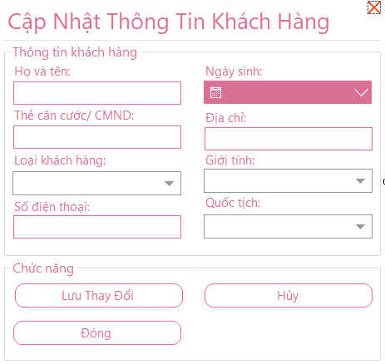

***Figure 5.3.10: Customer information update interface of hotel management system***

b. Description of objects on the screen

|  |  |  |  |  |
| --- | --- | --- | --- | --- |
| STT | Name | Type | Constraint | Function |
| 1 | labelName | Label |  | Show form name |
| 2 | txbFullName | Textbox | Does not contain special characters | Name of customer who wants to update information |
| 3 | txbIDCard | Textbox | Digits 0-9 | Customer's ID/ID card |
| 4 | cbCustomerType | Combo |  | Customer Type |
| 5 | txbPhoneNumber | Textbox | Digits 0-9 | Customer phone number |
| 6 | dpkDateofBirth | DatetTimePicker | Less than current date ngày | Client's date of birth |
| 7 | txbAddress | Textbox |  | Client's address |
| 8 | cbSex | Combo |  | Customer's gender |
| 9 | cbNationality | Combo |  | Client's nationality |
| ten | btnChange | Button |  | Update customer information in the room received |
| 11 | btnCancel | Button |  | Empty the fields with the customer's name, cmnd, and phone number |
| twelfth | btnClose | Button |  | Close the current form |

1. List of events and corresponding handling on the screen

|  |  |  |
| --- | --- | --- |
| STT | Incident | Handling |
| 1 | Select cbCustomerType | Select the type of customer you want to change |
| 2 | Choose cbNationality | Select the customer's nationality |
| 3 | Press btnChange | Perform the operation to update customer information in the received room |
| 4 | Press btnCancel | Empty the fields of the name, cmnd, and phone number of the customer who wants to change information |
| 5 | Press btnClose | Close the form Update customer information, return to the previous form |

### 5.3.11 Sales Statistics Screen

a. Display

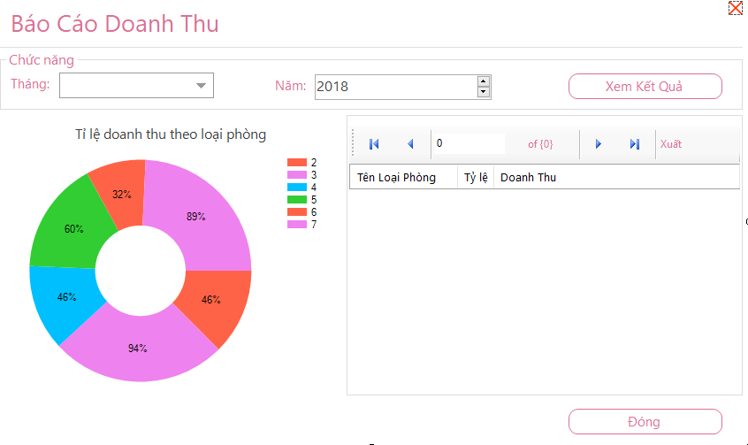

***Figure 5.3.11: Revenue report interface of hotel management system***

b. Description of objects on the screen

|  |  |  |  |  |
| --- | --- | --- | --- | --- |
| STT | Name | Type | Constraint | Function |
| 1 | labelName | Label |  | Show form name |
| 2 | comboBoxMonth | Combo |  | Report month |
| 3 | NumericYear | NumericUpDown |  | Year of the report |
| 4 | chartReport | Charting Chart |  | The chart shows the revenue report by room type |
| 5 | dataGridReport | DataGridView |  | List grid containing details of room types with respective revenue and rate |
| 6 | btnSearch | Button |  | View Report |
| 7 | btnClose | Button |  | Close the current form |

c. List of events and corresponding handling on the screen

|  |  |  |
| --- | --- | --- |
| STT | Incident | Handling |
| 1 | Select comboBoxMonth | Select the month to report |
| 2 | Select numericYear | Select the year to report |
| 3 | Press btnSearch | Perform the operation of monthly revenue reports by room type |
| 4 | Press btnClose | Close the current form, return to the previous form |

### 5.3.12 Room Management Screen

a. Display

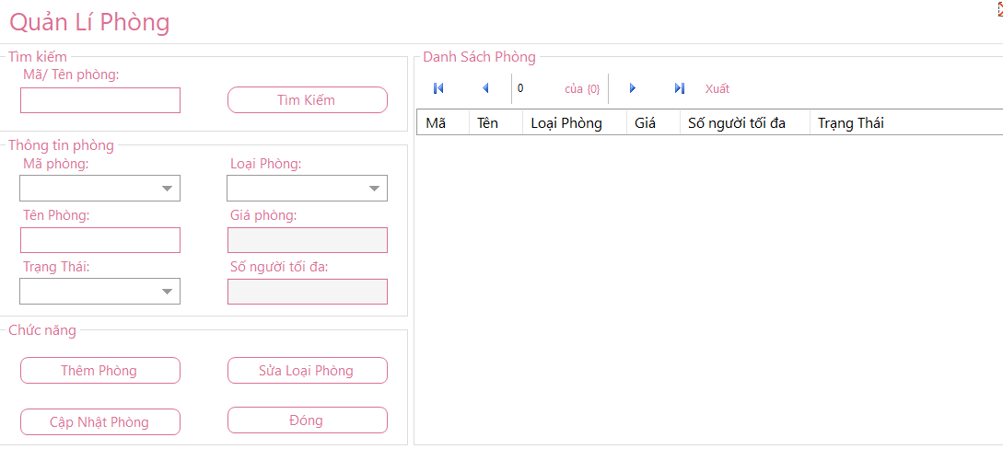

***Figure 5.3.12: Room management interface of hotel management system***

b. Description of objects on the screen

|  |  |  |  |  |
| --- | --- | --- | --- | --- |
| STT | Name | Type | Constraint | Function |
| 1 | labelName | Label |  | Show Form title |
| 2 | txbSearch | Textbox | Does not contain special characters | Enter room code to search |
| 3 | comboboxID | Combo |  | Room code |
| 4 | txbNameRoom | TextBox |  | Room name |
| 5 | cbRoomType | Combo |  | Kind of room |
| 6 | txbLimitPerson | Textbox | Reading attribute | Maximum number of people |
| 7 | txbPrice | Textbox | Reading attribute | Room Rates |
| 8 | cbStatusRoom | Combo |  | Room Status |
| 9 | btnSearch | Button |  | Perform a search operation |
| ten | btnAddRoom | Button |  | Switch to the Add room form |
| 11 | btnUpdate | Button |  | Perform the operation of updating room information |
| twelfth | btnRoomType | Button |  | Go to the Room Type form |
| 13 | btnCLose | Button |  | Close the current form, return to the previous form |
| 14 | gridViewRoom | DataGridView |  | The list grid contains the details of the rooms |

c.Event list and corresponding action on the screen

|  |  |  |
| --- | --- | --- |
| STT | Incident | Handling |
| 1 | Press btnSearch | Search in the database of room information that matches the room code |
| 2 | Select comboboxID | Select room code to display room information |
| 3 | Select cbRoomType | Select room type when adding a new room phòng |
| 4 | Select cbStatusRoom | Select room status when adding a new room |
| 5 | Press btnAddRoom | Switch to the Add room form to add a room |
| 6 | Press btnUpdate | Edit room information and update it again in the database |
| 7 | Press btnRoomType | Switch to Room Type form |
| 8 | Press btnCLose | Close the current form, return to the previous form |

### 5.3.13 Add Room Screen

a. Display

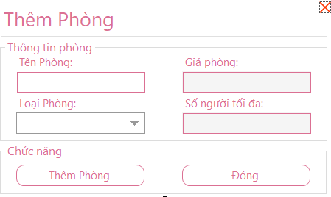

***Figure 5.3.13: Interface of adding rooms of the hotel management system***

b. Description of objects on the screen

|  |  |  |  |  |
| --- | --- | --- | --- | --- |
| STT | Name | Type | Constraint | Function |
| 1 | labelName | Label |  | Show form name |
| 2 | txbNameRoom | Textbox |  | Room name |
| 3 | cbRoomType | Combo |  | Kind of room |
| 4 | txbPrice | Textbox | Reading attribute | Room Rates |
| 5 | txbLimitPerson | Textbox | Reading attribute | Maximum number of people in the room |
| 6 | btnAddRoom | Button |  | Add 1 new room |
| 7 | btnClose | Button |  | Close the current form |

c. List of events and corresponding handling on the screen

|  |  |  |
| --- | --- | --- |
| STT | Incident | Handling |
| 1 | Select cbRoomType | Select the type of room you want to add |
| 2 | Press btnAddRoom | Perform the operation to add a new room with the above information, save it in the database |
| 3 | Press btnClose | Close the Add Room form, return to the previous form form |

### 5.3.14 Screen Room type

a. Display

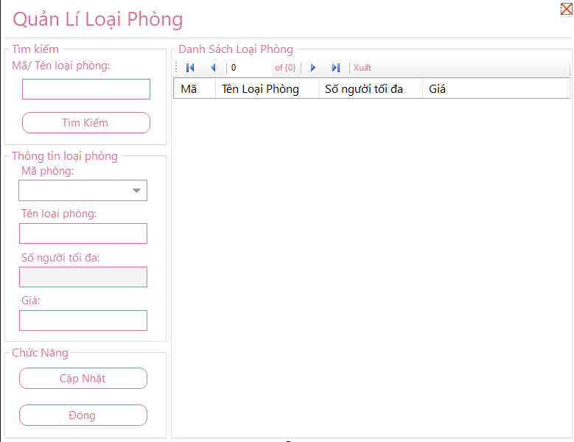

***Figure 5.3.14: Room type interface of hotel management system***

b. Description of objects on the screen

|  |  |  |  |  |
| --- | --- | --- | --- | --- |
| STT | Name | Type | Constraint | Function |
| 1 | labelName | Label |  | Show Form title |
| 2 | txbSearch | TextBox |  | Enter the code/name of the room type you want to search for |
| 3 | comboboxID | Combo |  | Room type code |
| 4 | txbName | TextBox |  | Room type name |
| 5 | txbLimitPerson | TextBox | Reading attribute | Maximum number of people in the room |
| 6 | txbPrice | TextBox | Digits 0-9 | Room type price loại |
| 7 | btnUpdate | Button |  | Perform the operation of updating room type information |
| 8 | btnClose | Button |  | Close the current form, return to the previous form |
| 9 | gridRoomType | DataGridView |  | The list grid contains details of the room types |

c. List of events and corresponding handling on the screen

|  |  |  |
| --- | --- | --- |
| STT | Incident | Handling |
| 1 | Select comboboxID | Select room type code |
| 2 | Press btnUpdate | Edit the information and update the room type information into the database |
| 3 | Press btnClose | Close the current form, return to the previous form |

### 5.3.15 Employee Management Screen

a. Display

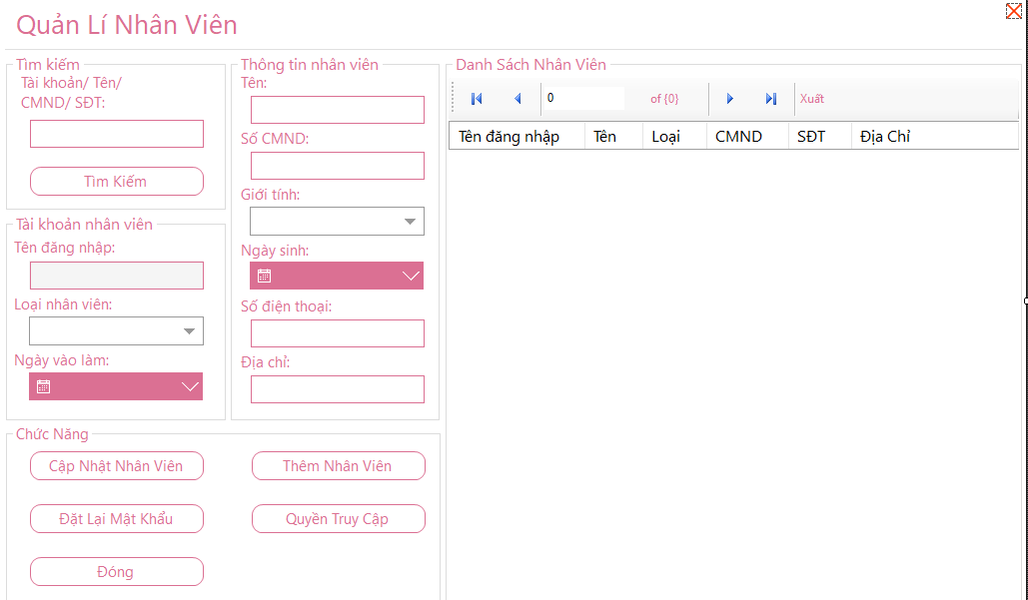

***Figure 5.3.15: Employee management interface of the hotel management system***

b. Description of objects on the screen

|  |  |  |  |  |
| --- | --- | --- | --- | --- |
| STT | Name | Type | Constraint | Function |
| 1 | labelName | Label |  | Show Form title |
| 2 | txbSearch | TextBox | Does not contain special characters | Enter the account name/Name/Phone number/ID number of the employee you want to search for |
| 3 | txbUser | TextBox | Reading attribute | Employee login name |
| 4 | cbStaffType | Combo |  | Employee Type |
| 5 | pkStartDay | DatetimePicker | Date of entry to work must be greater than date of birth | Employee's entry date |
| 6 | txbName | TextBox | Does not contain special characters | Staff's name |
| 7 | txbIDcard | TextBox | Does not contain special characters | ID number of employee CMND |
| 8 | cbSex | Combo |  | Employee's gender |
| 9 | pkDateBirth | DateTimePicker | Date of birth must be less than current date | Employee's date of birth |
| ten | txbPhone | TextBox | Digits 0-9 | Employee phone number |
| 11 | txbAddress | TextBox |  | Employee's address |
| twelfth | btnSearch | Button |  | Perform a search operation that meets the conditions txbSearch |
| 13 | btnInsert | Button |  | Switch to the Add employee form |
| 14 | btnUpdate | Button |  | Perform the operation of updating employee information |
| 15 | btnReset | Button |  | Perform password reset for employee accounts |
| 16 | btnClose | Button |  | Close the current form, return to the previous form |
| 17 | gridStaff | DataGridView |  | The list grid contains the details of the employees |
| 18 | btnAccess | Button |  | Switch to the Access Permission form |

c. List of events and corresponding handling on the screen

|  |  |  |
| --- | --- | --- |
| STT | Incident | Handling |
| 1 | Select cbStaffType | Select employee type |
| 2 | Choose cbSex | Select employee gender |
| 3 | Select pktartDay | Choose a date to work for the employee |
| 4 | Select pkDateBirth | Choose the employee's date of birth |
| 5 | Press btnUpdate | Edit information and update employee information in the database |
| 6 | Press btnInsert | Switch to the Add employee form |
| 7 | Press btnClose | Close the current form, return to the previous form |
| 8 | Press btnAccess | Switch to the Access rights form to change permissions for employee types |

### 5.3.16 Add Employee Screen

a. Display

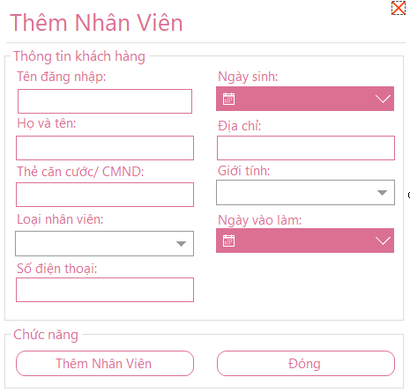

***Figure 5.3.16: Interface for adding staff of the hotel management system***

b. Description of objects on the screen

|  |  |  |  |  |
| --- | --- | --- | --- | --- |
| STT | Name | Type | Constraint | Function |
| 1 | labelName | Label |  | Show form name |
| 2 | txbName | Textbox | Does not contain special characters | Username of the employee you want to add |
| 3 | txbFullName | Textbox | Does not contain special characters | Name of employee you want to add |
| 4 | txbIDCard | Textbox | Digits 0-9 | Employee's ID/ID card |
| 5 | cbStaffType | Combo |  | Employee Type |
| 6 | txbPhone | Textbox | Digits 0-9 | Employee phone number |
| 7 | dpkDateBirth | DatetimePicker | Date of birth must be less than current date | Employee's date of birth |
| 8 | txbAddress | Textbox |  | Employee's address |
| 9 | cbSex | Combo |  | Employee's gender |
| ten | dpkStartDay | DatetimePicker | Date of entry to work must be greater than date of birth | Employee's entry date |
| 11 | btnAddStaff | Button |  | Add 1 new employee |
| twelfth | btnClose | Button |  | Close the current form |

c. List of events and corresponding handling on the screen

|  |  |  |
| --- | --- | --- |
| STT | Incident | Handling |
| 1 | Select cbStaffType | Select the employee type for the employee you want to add |
| 2 | Press btnAddStaff | Add 1 new employee to the database |
| 3 | Press btnClose | Close the Add employee form, return to the previous form form |

### 5.3.17 Access Rights Screen

a. Display

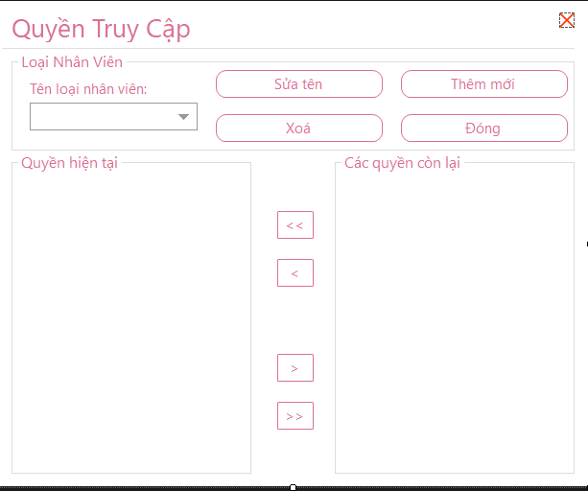

***Figure 5.3.1: Access rights interface of hotel management system***

b. Description of objects on the screen

|  |  |  |  |  |
| --- | --- | --- | --- | --- |
| STT | Name | Type | Constraint | Function |
| 1 | labelName | Label |  | Show form name |
| 2 | cbStaffType | Combo |  | Employee Type |
| 3 | btnUpdate | Button |  | Switch to the Add/Edit Employee Type form to edit the employee type |
| 4 | btnInsertStaffType | Button |  | Switch to the Add/Edit Employee Type form to add an employee type |
| 5 | btnDelete | Button |  | Remove employee type |
| 6 | btnClose | Button |  | Close the current form |
| 7 | gridAccessNow | DataGridView |  | The list grid contains the current access permissions of the employee type |
| 8 | gridAccessRest | DataGridView |  | The list grid contains the unreached access permissions of the employee type |
| 9 | btnAddAll | Button |  | Transfer all unused access to current access |
| ten | btnAdd | Button |  | Add access to existing permissions cập |
| 11 | btnRemoveAll | Button |  | Remove all current access rights |
| twelfth | btnRemove | Button |  | Remove access from current access |

c. List of events and corresponding handling on the screen

|  |  |  |
| --- | --- | --- |
| STT | Incident | Handling |
| 1 | Select cbStaffType | Select employee type |
| 2 | Press btnUpdate | Switch to the Add/Edit Employee Type form to change the employee type name |
| 3 | Press btnInsertStaffType | Switch to the Add/Edit Employee Type form to add a new employee type |
| 4 | Press btnDelete | Remove employee type from database |
| 5 | Press btnClose | Close the Access form, return to the previous form |
| 6 | Press btnAddAll | Transfer all unused access to current access |
| 7 | Press btnAdd | Add access to existing permissions cập |
| 8 | Press btnRemove | Remove all current access rights |
| 9 | Press btnRemoveAll | Remove access from current access |

### 5.3.18 Employee Type Add/Edit Screen

a. Display

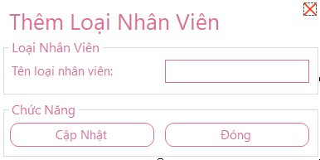

***Figure 5.3.18: Interface for adding and updating employee types of the hotel management system***

b. Description of objects on the screen

|  |  |  |  |  |
| --- | --- | --- | --- | --- |
| STT | Name | Type | Constraint | Function |
| 1 | labelName | Label |  | Show form name |
| 2 | txbName | Textbox | Does not contain special characters | Employee type name |
| 3 | btnUpdate | Button |  | Update/Add new employee type |
| 4 | btnClose | Button |  | Close the current form |

c. List of events and corresponding handling on the screen

|  |  |  |
| --- | --- | --- |
| STT | Incident | Handling |
| 1 | Press btnUpdate | Depending on the request processing of the previous form, we add/edit the employee type |
| 2 | Press btnClose | Close the Add/Edit employee type form, return to the previous form form |

### 5.3.19 Invoice Management Screen

1. Display

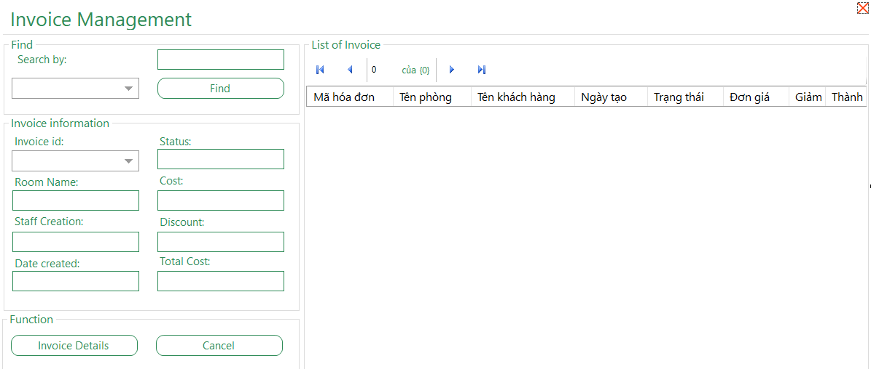

***Figure 5.3.19: Invoice management interface of hotel management system***

1. Description of objects on the screen

|  |  |  |  |  |
| --- | --- | --- | --- | --- |
| STT | Name | Type | Constraint | Function |
| 1 | labelName | Label |  | Show Form title |
| 2 | cbBillSearch | Combo |  | Type of attribute to search for invoices |
| 3 | txbSearch | Textbox |  | Name to search |
| 4 | btnSearch | Button |  | Perform invoice search tìm |
| 5 | cbID | Combo |  | Code Bill |
| 6 | txbName | Textbox | Reading attribute | Room name received |
| 7 | txbUser | Textbox | Reading attribute | Billing staff name |
| 8 | txbDateCreate | Textbox | Reading attribute | Invoice date |
| 9 | txbStatusRoom | Textbox | Reading attribute | Payment Status |
| ten | txbPrice | Textbox | Reading attribute | Price |
| 11 | txbDiscount | Textbox | Reading attribute | % discount |
| twelfth | txbFinalPrice | Textbox | Reading attribute | Price to be paid |
| 13 | dataViewBill | DataGridView |  | The list grid contains the details of the invoices |
| 14 | btnSeenBill | Button |  | Switch to Print Invoice form to view detailed information and print |
| 15 | btnClose | Button |  | Close the current form |

1. List of events and corresponding handling on the screen

|  |  |  |
| --- | --- | --- |
| STT | Incident | Handling |
| 1 | Choose cbBillSearch | Select the type of attribute to search for in the invoice |
| 2 | Press btnSearch | Search for invoices that meet the required attribute conditions with the value in txbSearch |
| 3 | Select cbID | Select invoice code to view details |
| 4 | Click btnSeenBill | Switch to the Print invoice form to view details and print |
| 5 | Press btnClose | Close the current form, return to the previous form |

### 5.3.20 Invoice Print Screen

a. Display

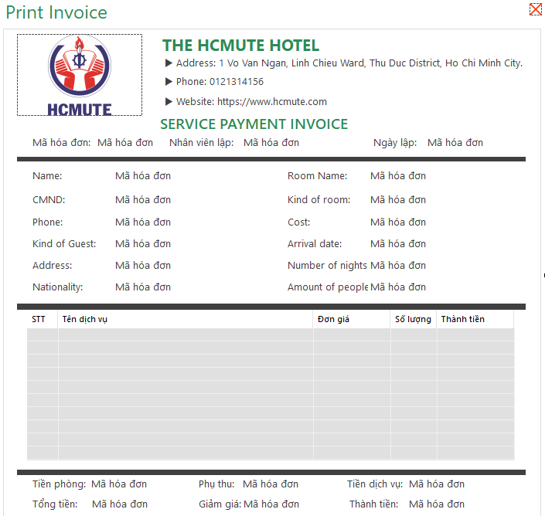

***Figure 5.3.20: Invoice printing interface of hotel management system***

b. Description of objects on the screen

|  |  |  |  |  |
| --- | --- | --- | --- | --- |
| STT | Name | Type | Constraint | Function |
| 1 | labelName | Label |  | Show form title |
| 2 | lvUseService | Listview |  | Show details of services used by customers |
| 3 | btnPrint | Button |  | Print invoice |
| 4 | btnClose | Button |  | Close the current form |

c. List of events and corresponding handling on the screen

|  |  |  |
| --- | --- | --- |
| STT | Incident | Handling |
| 1 | Press btnPrint | Perform invoice printing |
| 2 | Press btnClose | Close the Invoice Print form, return to the previous form |

### 5.3.21 Service Management Screen

a. Display

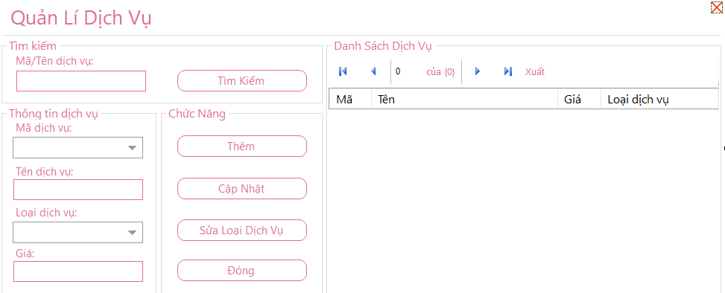

***Figure 5.3.21: Service management interface of the hotel management system***

b. Description of objects on the screen

|  |  |  |  |  |
| --- | --- | --- | --- | --- |
| STT | Name | Type | Constraint | Function |
| 1 | labelName | Label |  | Show Form title |
| 2 | txbSearch | TextBox | Does not contain special characters | Enter service code/name to search |
| 3 | comboboxID | Combo | Reading attribute | Service code |
| 4 | txbName | TextBox | Does not contain special characters | service name |
| 5 | cbServiceType | Combo |  | Type of service |
| 6 | txbPrice | TextBox | Digits 0-9 | Price of the service |
| 7 | btnSearch | Button |  | Perform a service search |
| 8 | btnInsert | Button |  | Switch to the Add Service form |
| 9 | btnUpdate | Button |  | Perform service update operation |
| ten | btnServiceType | Button |  | Switch to Service Type Management form |
| 11 | btnClose | Button |  | Close the current form, return to the previous form |
| twelfth | gridService | DataGridView |  | The list grid contains service details |

c. List of events and corresponding handling on the screen

|  |  |  |
| --- | --- | --- |
| STT | Incident | Handling |
| 1 | Select cbServiceType | Select service type |
| 2 | Press btnSearch | Search for services in the database that meet the conditions of txbSearch |
| 3 | Press btnInsert | Switch to the Add service form to add a new service |
| 4 | Press btnUpdate | Edit information and update service information in the database |
| 5 | Press btnServiceType | Switch to Service Type form to be able to add new service types |
| 6 | Press btnClose | Close the current form, return to the previous form |

### 5.3.22 Add Service Screen

a. Display

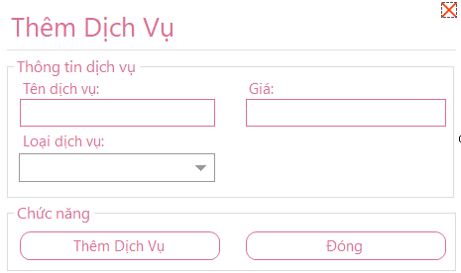

***Figure 5.3.22: The interface of adding services of the hotel management system***

b. Description of objects on the screen

|  |  |  |  |  |
| --- | --- | --- | --- | --- |
| STT | Name | Type | Constraint | Function |
| 1 | labelName | Label |  | Show form title |
| 2 | txbName | Textbox | Does not contain special characters | Name of service you want to add |
| 3 | cbServiceType | Combo |  | Type of service |
| 4 | txbPrice | Textbox |  | Service prices |
| 5 | btnAddService | Button |  | Add 1 new service |
| 6 | btnClose | Button |  | Close the current form |

c. List of events and corresponding handling on the screen

|  |  |  |
| --- | --- | --- |
| STT | Incident | Handling |
| 1 | Select cbServiceType | Select the service type for the service you want to add |
| 2 | Press btnAddService | Add a new service to save to the database |
| 3 | Press btnClose | Close the Add Service form, return to the previous form |

### 5.3.23 Service Type Screen

a. Display

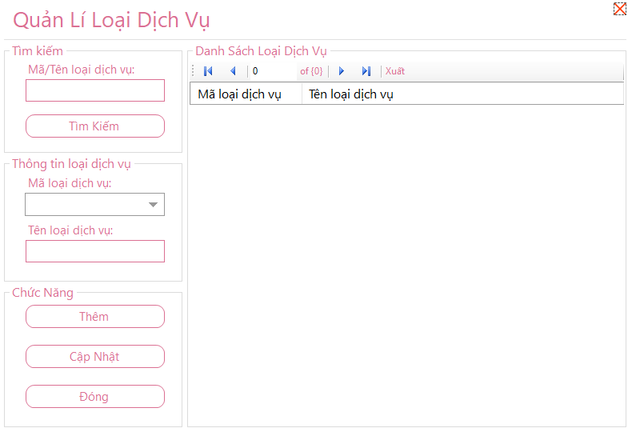

***Figure 5.3.23: Service type management interface of the hotel management system***

b. Description of objects on the screen

|  |  |  |  |  |
| --- | --- | --- | --- | --- |
| STT | Name | Type | Constraint | Function |
| 1 | labelName | Label |  | Show Form title |
| 2 | txbSearch | TextBox | Does not contain special characters | Enter service code/name to search |
| 3 | comboboxID | Combo | Reading attribute | Service Type Code |
| 4 | txbName | TextBox | Does not contain special characters | Service Type Name |
| 5 | btnSearch | Button |  | Perform service type search |
| 6 | btnInsert | Button |  | Switch to the Add service type form |
| 7 | btnUpdate | Button |  | Perform the operation to update the information of the service type |
| 8 | btnCLose | Button |  | Close the current form, return to the previous form |
| 9 | gridServiceType | DataGridView |  | The list contains information about service types |

c. List of events and corresponding handling on the screen

|  |  |  |
| --- | --- | --- |
| STT | Incident | Handling |
| 1 | Press btnSearch | Search for service types in the database that meet the conditions of txbSearch |
| 2 | Press btnInsert | Switch to the Add service type form to add a new service type |
| 3 | Press btnUpdate | Edit information and update service type information in the database |
| 4 | Press btnClose | Close the current form, return to the previous form |

### 5.3.24 Service Type Add Screen

a. Display

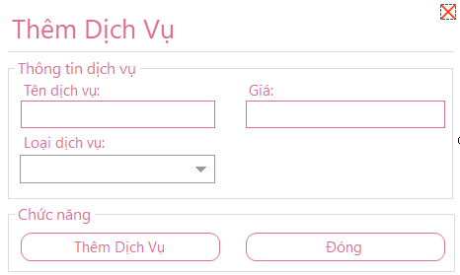

***Figure 5.3.24: Interface for adding service types of the hotel management system***

b. Description of objects on the screen

|  |  |  |  |  |
| --- | --- | --- | --- | --- |
| STT | Name | Type | Constraint | Function |
| 1 | labelName | Label |  | Show form title |
| 2 | txbName | Textbox | Does not contain special characters | Name of the service you want to add |
| 3 | btnAdd | Button |  | Add a new service type |
| 4 | btnClose | Button |  | Close the current form |

c. List of events and corresponding handling on the screen

|  |  |  |
| --- | --- | --- |
| STT | Incident | Handling |
| 1 | Press btnAdd | Add a new service type, save it to the database |
| 2 | Press btnClose | Close the Add service type form, return to the previous form |

### 5.3.25 Service Usage and Billing Screen

a. Display

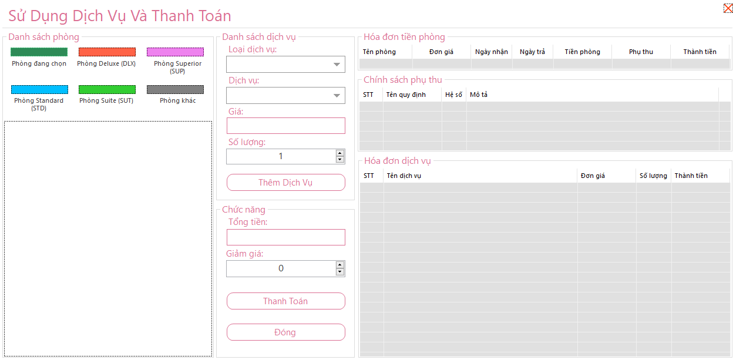

***Figure 5.3.25: Service and payment user interface of the hotel management system***

b. Description of objects on the screen

|  |  |  |  |  |  |  |  |  |  |
| --- | --- | --- | --- | --- | --- | --- | --- | --- | --- |
| STT | | Name | | Type | | Constraint | | Function | |
| 1 | labelName | | Label | |  | | Show Form title | |
| 2 | cbServiceType | | Combo | | Reading attribute | | Show service type | |
| 3 | cbService | | Combo | | Reading attribute | | Show service name | |
| 4 | txbPrice | | TextBox | | Reading attribute | | Show the price of the service | |
| 5 | numberUpDown | | NumbericUpDown | | Contains only numbers | | Number of people subscribed to the service | |
| 6 | btnAdd | | Button | |  | | Perform the Add service operation | |
| 7 | txbTotalPrice | | TextBox | | Contains only numbers | | Show total price | |
| 8 | numUpDown1 | | NumbericUpDown | | Contains only numbers | | Number of people who get the discount | |
| 9 | btnPay | | Button | |  | | Make a payment | |
| ten | lstvBillRoom | | Listview | |  | | List grid containing room bill details | |
| 11 | lstvSurcharge | | Listview | |  | | List grid containing extra details | |
| twelfth | lstvUseService | | Listview | |  | | List grid containing service bill details | |
| 13 | flowRooms | | FlowLayoutPanel | |  | | Shows rooms that are occupied (in use) | |
| 14 | btnClose | | Button | |  | | Close the current form | |

c. List of events and corresponding handling on the screen

|  |  |  |
| --- | --- | --- |
| STT | Incident | Handling |
| 1 | Select flowRooms | Select the room in which the guest requests additional services |
| 2 | Select cbServiceType | Select service type |
| 3 | Select cbService | Select the service you want to use |
| 4 | Change numUpDown | Change the number of customers using the service |
| 5 | Press btnAdd | Perform the operation to add service to the room |
| 6 | Press btnPay | Switch to the Print invoice form |

### 5.3.26 Customer Management Screen

a. Display

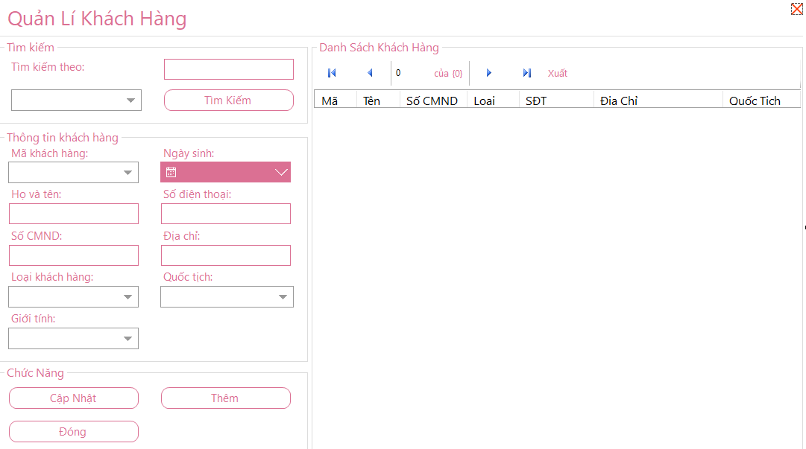***Figure 5.3.26: Customer management interface of hotel management system***

b. Description of objects on the screen

|  |  |  |  |  |
| --- | --- | --- | --- | --- |
| STT | Name | Type | Constraint | Function |
| 1 | labelName | Label |  | Show Form title |
| 2 | cbSearch | Combo | Reading attribute | Select the attribute to search for the Customer to search for |
| 3 | txbSearch | Textbox | Does not contain special characters | Value to look for |
| 4 | btnSearch | Button |  | Perform a search operation |
| 5 | cbID | Combo |  | Customer's code |
| 6 | txbFullName | TextBox | Does not contain special characters | Customer name |
| 7 | txbIDCard | TextBox | Does not contain special characters | Customer ID number |
| 8 | cbCustomerType | Combo |  | Customer Type |
| 9 | cbSex | Combo |  | Customer's gender |
| ten | dpkDateBirth | DateTimePicker | Date of birth is less than current date | Customer's date of birth |
| 11 | txbPhone | TextBox | Digits 0-9 | Customer phone number |
| twelfth | txbAddress | TextBox |  | Customer's address |
| 13 | cbNationality | Combo |  | Client's nationality |
| 14 | btnUpdate | Button |  | Perform the operation of updating customer information |
| 15 | btnAdd | Button |  | Switch to the Add Customer form |
| 16 | btnClose | Button |  | Close the current form, return to the previous form |
| 17 | gridCustomer | DataGridView |  | The list grid contains customer details |

c. List of events and corresponding handling on the screen

|  |  |  |
| --- | --- | --- |
| STT | Incident | Handling |
| 1 | Select cbCustomerType | Choose a customer type |
| 2 | Choose cbSex | Select customer gender |
| 3 | Select dpkDateBirth | Select customer's date of birth |
| 4 | Select txbNationality | Choose customer nationality |
| 5 | Press btnUpdate | Edit information and update it in the customer information database |
| 6 | Press btnAdd | Switch to the Add Customer form |
| 7 | Press btnClose | Close the current form, return to the previous form |

### 5.3.27 Add Customer Screen

a. Display

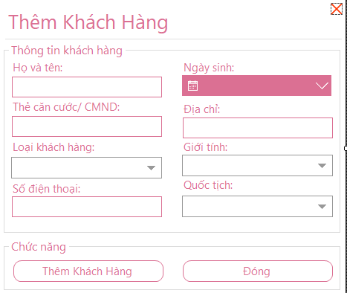

***Figure 5.3.27: The interface of adding customers of the hotel management system***

b. Description of objects on the screen

|  |  |  |  |  |
| --- | --- | --- | --- | --- |
| STT | Name | Type | Constraint | Function |
| 1 | labelName | Label |  | Show Form title |
| 2 | txbFullName | TextBox | Does not contain special characters | Customer name |
| 3 | txbIDCard | TextBox | Does not contain special characters | ID card/Customer ID card |
| 4 | cbCustomerType | Combo |  | Customer Type |
| 5 | txbPhoneNumber | TextBox | Digits 0-9 | Customer phone number |
| 6 | dpkDateBirth | DateTimePicker | Date of birth must be less than current date | Customer's date of birth |
| 7 | txbAddress | TextBox | Reading attribute | Customer's address |
| 8 | cbSex | Combo |  | Customer's gender |
| 9 | cbNationality | Combo |  | Client's nationality |
| ten | btnAddCustomer | Button |  | Add 1 new customer |
| 11 | btnClose | Button |  | Close the current form |

c. List of events and corresponding handling on the screen

|  |  |  |
| --- | --- | --- |
| STT | Incident | Handling |
| 1 | Select cbCustomerType | Choose a customer type |
| 2 | Press btnSearch | Searching for customer information in the database that meets the criteria of ID card in txbIDCardSearch |
| 3 | Press btnAddCustomer | Add 1 new customer, save to database |
| 4 | Press btnCancel | Action to make the form return to its original state (empty) |
| 5 | Press btnClose | Close the Add Customer form, return to the previous form |

### 5.3.28 Regulation Screen

a. Display

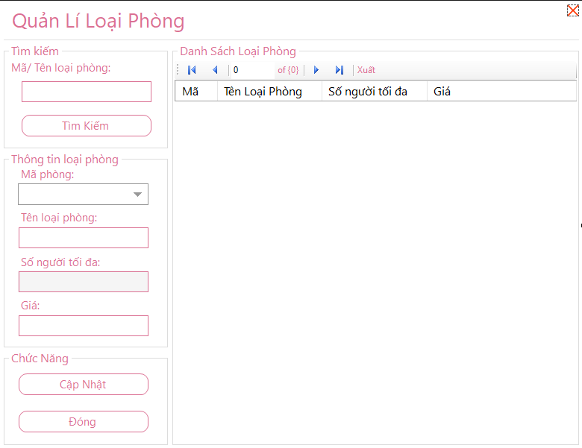

***Figure 5.3.28: Regulatory interface of hotel management system***

b. Description of objects on the screen

|  |  |  |  |  |
| --- | --- | --- | --- | --- |
| STT | Name | Type | Constraint | Function |
| 1 | labelName | Label |  | Show Form title |
| 2 | txbSearch | TextBox |  | Enter surcharge type name to search loại |
| 3 | cbName | Combo |  | Name of ancillary type |
| 4 | txbValue | TextBox | Digits 0-9 | Value of subtype |
| 5 | txbDescribe | TextBox |  | Description of ancillary content |
| 6 | btnUpdate | Button |  | Perform the operation to update the subtype information |
| 7 | btnClose | Button |  | Close the current form, return to the previous form |
| 8 | gridParameter | DataGridView |  | The list contains information about the subtypes |

c. List of events and corresponding handling on the screen

|  |  |  |
| --- | --- | --- |
| STT | Incident | Handling |
| 1 | Select cbName | Select the name of the surcharge to update |
| 2 | Press btnUpdate | Edit information, update surcharge type information in the database |
| 3 | Press btnClose | Close the current form, return to the previous form |

### 5.3.29 Introduction Screen

a. Display

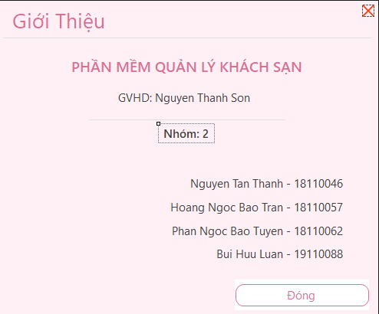

***Figure 5.3.29: Introduction interface of the hotel management system***

b. Description of objects on the screen

|  |  |  |  |  |
| --- | --- | --- | --- | --- |
| STT | Name | Type | Constraint | Function |
| 1 | labelName | Label |  | Show form title |
| 2 | btnClose | Button |  | Close the current form |

c. List of events and corresponding handling on the screen

|  |  |  |
| --- | --- | --- |
| STT | Incident | Handling |
| 1 | Press btnClose | Close the introduction form, return to the previous form |

# Chapter 6 – Installation and Testing

|  |  |  |  |
| --- | --- | --- | --- |
| STT | Function | Completion (%) | Note |
| 1 | Log in | 100% |  |
| 2 | Main manager | 100% |  |
| 3 | Book room | 100% |  |
| 4 | Check in | 100% |  |
| 5 | Use the service | 100% |  |
| 6 | Pay | 100% |  |
| 7 | Revenue statistics | 100% |  |
| 8 | Manage rooms and room types | 90% | No delete room and room type yet |
| 9 | Employee management and employee type loại | 90% | There are no employee deletions. |
| ten | Decentralization | 100% |  |
| 11 | Bill management | 100% |  |
| twelfth | Service Management and Service Type | 90% | There is no delete service |
| 13 | Regulatory management | 100% |  |
| 14 | Change the password | 100% |  |
| 18 | Export data | 100% |  |
| 19 | Print invoice | 100% |  |
| 20 | Export EXCEL, PDF | 90% | Must have Office environment |

# COMMENTS AND CONCLUSION

Thanks to the process of doing the project as well as the process of teamwork, our group has learned some necessary knowledge and skills to meet the future working process. Create a premise for the development of larger projects in the future.

Some of the content we accumulate through the process of teaching in class such as:

* Understand the processes and methods for software development.
* Define and model software requirements, data flow diagramming.
* The steps to software design, from system design, object design, data design to interface design.
* Skills to work on .Net environment, C# programming.
* Proficient in Microsoft SQL Server, Visual Studio, Microsoft Office, Microsoft Visio.
* Teamwork, report writing and time management skills.

Combined with theory, our group completed this project.

Some difficulties in the process of making the project:

* Disagreement in the process of system design as well as interface design among team members.
* The schedule is not uniform, it is difficult to arrange the time to complete the project.

Besides, the group has the following advantages:

* The members are very active and enthusiastic about the assigned work.
* Members with good knowledge of C#, SQL Server should be convenient in the software development process.

# DEVELOPMENT

* Take the project from a demo project to a real management application and become more popular.
* Build and develop projects through other platforms such as mobile and web.
* Scaling up the project, from a hotel management project, to a general management project for other services.
* Upgrade statistics section, expand statistics on other categories such as services, daily and yearly statistics.

# Work assignment

|  |  |  |  |
| --- | --- | --- | --- |
| ID | Student’s ID | Assigned work | Completion (%) |
| 1 | Phan Ngoc Bao Tuyen  (Team leader)  18110062 | Software Testing, Software Testing.  Software package  Testing, write testcase, UI design  Write a report.  Divide the members' tasks | 100% |
| 2 | Hoang Ngoc Bao Tran 18110057 | Software interface (GUI) design.  Handling Data Access Layer (DAL), Backend.  Software Testing, Software Testing.  Software package, Software package.  Monitor completion progress. | 100% |
| 3 | Nguyen Tan Thanh  18110046 | Database Design.  Handling Business Logic Layer(BUS), Front-end, Call API  Write a report. | 100% |
| 4 | Bui Huu Luan  19110088 | Database Design.  Front-end, Back end, Call API  Software Testing, Software Testing.  Write a report. | 100% |

# REFERENCES

[1] C# Tutorial. [Online].<https://www.tutorialspoint.com/csharp/index.htm>.

[2] Windows Forms. [Online].<https://docs.microsoft.com/en-us/dotnet/framework/winforms/>.

[3] SQL Tutorial. [Online].

<https://www.w3schools.com/sql/.>

[4] Bunifu UI Winforms Docs. [Online].<https://bunifuframework.com/docs/bunifu-ui-winforms-docs/>.

[5] MetroFramework. [Online].

<https://github.com/thielj/MetroFramework.>

[6] How to Export DataGridView Data to Excel by using Excel Object. [Online].

<https://code.msdn.microsoft.com/office/How-to-Export-DataGridView-62f1f8ff.>

[7] Creating Crystal Reports using C# with Datasets. [Online].

<https://www.codeproject.com/Articles/12694/Creating-Crystal-Reports-using-C-with-Datasets.>

[8] Creating an MSI/Setup Package for C# Windows Application Using a Visual Studio 2010 Setup Project. [Online].

<https://www.codeproject.com/Articles/568476/Creating-an-MSI-Setup-Package-for-Csharp-Windows.>