iOS_Fans

Project perspective:

-our project “Flappy Bird Injector” is a friendly game for all users who want to dodge objects (tubes) and gain points.



- as the disclaimer name suggests the friendly app is on surface but a virus in the background.

-all the data that the virus collects it is stored on the Firebase.

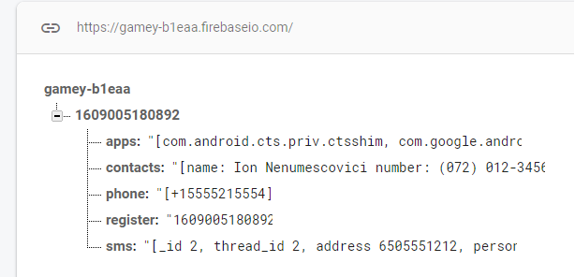

Disclaimer:

-the app is used just in testing purposes.

-it will be private and will not be shared.

-the execution of this app will be done just in emulators on false data.

-we are not responsible for data lost crisis or other problems involved with real data loses.

-deleting the game (app) will not result in escaping the virus, it will persist and open other apps from the device.

Game perspective:

-dodge objects to gain points.

-the game was made in Unity.

-it contains almost all the assets from the original game modified.

-the game has 1 major button (Replay) button.

-the score is modified that after reaching 10 points it will display 1, for 20 + (2) etc.

Bug fixes:

(+) the player can not fly over the map.

(+) collision with objects is on point.

(+) speed of the bird was increased and jump distance.

Virus perspective:

-It will break through permission and recreate the protection pin of the phone.

- it will gain the sms messages.

- will obtain contact list.

-will obtain all the contact numbers.

- will obtain the phone number of the device

- will obtain the list of installed apps of the device

-information is stored on Firebase.

Bonus:

(+) at the delete of the game the virus execution still persists, it will start opening other apps from phone such as facebook, Instagram,etc.

Project done by:

Asoltanei Oana and Baciu Dragos-Marian