Zack Rosales – 0510870
Advanced Computer Programming ITSE 2459 1001

General Ledger
analysis document

Version history
0.01 | 11.03.2014 | Document created | Zack Rosales
0.02 | 05.04.2014 | Document updated | Zack Rosales

Table of Contents

1. Introduction 3
2. Use Cases 3
2.1. Use Case diagram 3
2.2. Use Case descriptions 4
2.2.1. Use Case 1: Enter Transaction 4
2.2.2. Use Case 2: Print Adjusted Trial Balance 4
2.2.3. Use Case 3: Print Income Statement 4
2.2.4. Use Case 4: Print Retained Earnings Statement 4
2.2.5. Use Case 5: Print Balance Sheet 4
2.2.6. Use Case 6: View Transaction Log 4
2.2.7. Use Case 7: Remove Transaction 4

3. Requirements 5
3.1. Technical Requirements 5
3.2. Functional Requirements 5
4. Architectural analysis 6
4.1. System overview 6
4.2. Analysis object model 7
5. User Interface Specification 9
5.1. GUI Concept 9
5.2. UI Tasks 9
5.2.1. Task list 9
5.2.2. Task specifications 9

Introduction
This program will be a general accounting ledger. The user of the program is intended to be an accountant or someone with accounting knowledge. The user will be able to enter transactions to the ledger’s transaction log and be able to print an Adjusted Trial Balance, Income Statement, Retained Earnings Statement, and Balance Sheet reports.

Use Cases

Use Case diagram

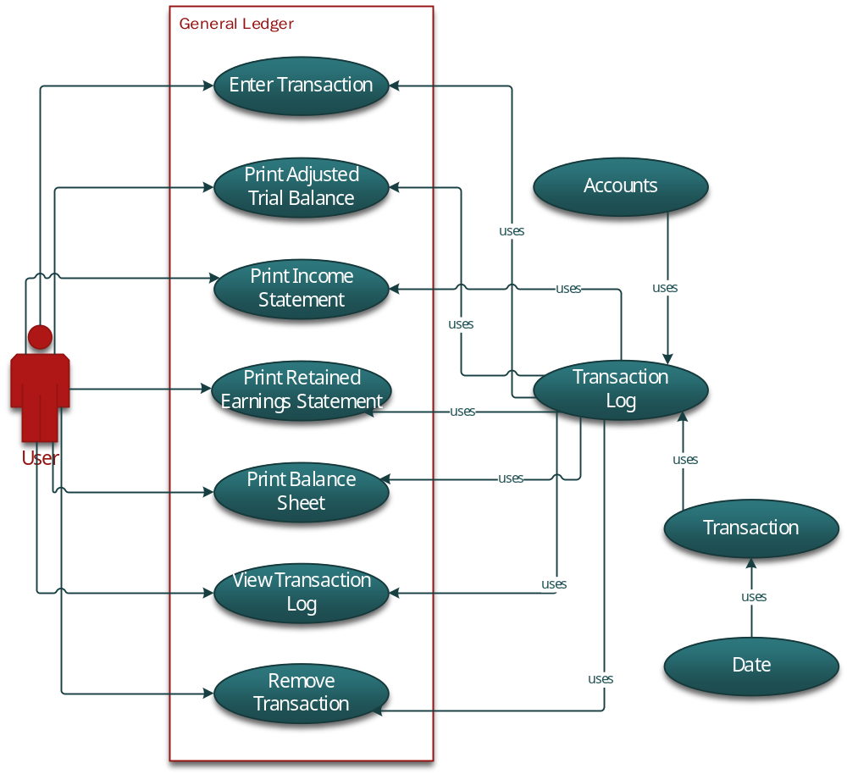
- General Ledger Use Case Diagram

Use Case descriptions

Use Case 1: Enter Transaction
Actors: User
Preconditions: User must choose at least one account to debit and one account to credit and the total amount being debited must equal the total amount being credited.
Description: Transaction is processed: selected accounts are debited and credited accordingly, and transaction is given a transaction number and added to the transaction log.
Exceptions: N/A
Post-conditions: Transaction has been processed.

Use Case 2: Print Adjusted Trial Balance
Actors: User
Preconditions: N/A
Description: Prints an Adjusted Trial Balance which displays the balance of all accounts.
Exceptions: N/A
Post-conditions: Adjusted Trial Balance has been printed.

Use Case 3: Print Income Statement
Actors: User
Preconditions: N/A
Description: Prints an Income Statement which displays the net income.
Exceptions: N/A
Post-conditions: Income Statement has been printed.

Use Case 4: Print Retained Earnings Statement
Actors: User
Preconditions: N/A
Description: Prints a Retained Earnings Statement which displays retained earnings.
Exceptions: N/A
Post-conditions: Retained Earnings Statement has been printed.

Use Case 5: Print Balance Sheet
Actors: User
Preconditions: N/A
Description: Prints an Balance Sheet which displays assets against liabilities and stockholder’s equity
Exceptions: N/A
Post-conditions: Balance Sheet has been printed.

Use Case 6: View Transaction Log
Actors: User
Preconditions: N/A
Description: Shows the log of transaction, if any exist
Exceptions: N/A
Post-conditions: Transaction Log is displayed

Use Case 7: Remove Transaction
Actors: User
Preconditions: Transaction ID entered must match a transaction ID in the Transaction Log
Description: Removes specified transaction from the Transaction Log
Exceptions: N/A
Post-conditions: Transaction is permanently deleted

Requirements
Presents the list of requirements for the system. Technical requirements present the requirements for the hardware/software platform, whereas the functional requirements define the requirements for the developed software.

Priorities:
1=must implement
2=should implement (time allowing)
3=be nice to have

Technical Requirements
- Technical Requirements
#No | Description | Priority
1.1 | System must be able to run Java | 1

Functional Requirements
- Functional Requirements
#No | Description | Referred Use Cases | Priority
1.1 | Transaction: User must choose at least one account to debit and one account to credit and the total amount being debited must equal the total amount being credited. | 1 | 1

Architectural analysis

System overview

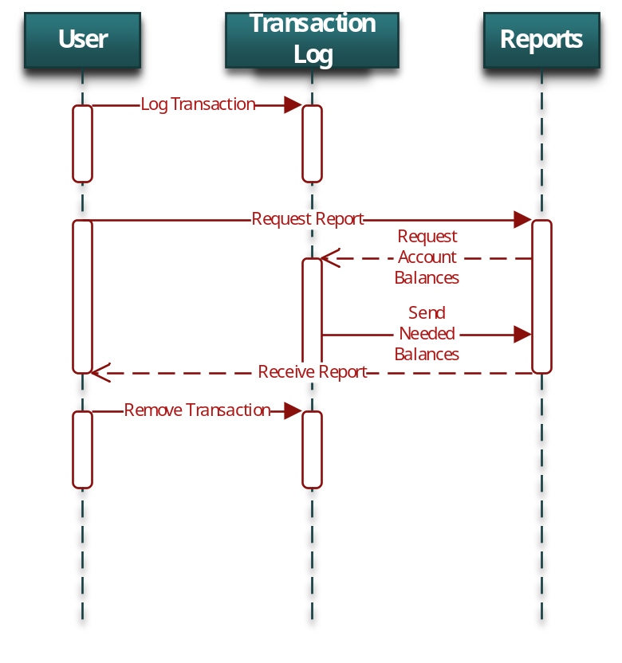
- General Ledger Sequence Overview

Object relationship diagram
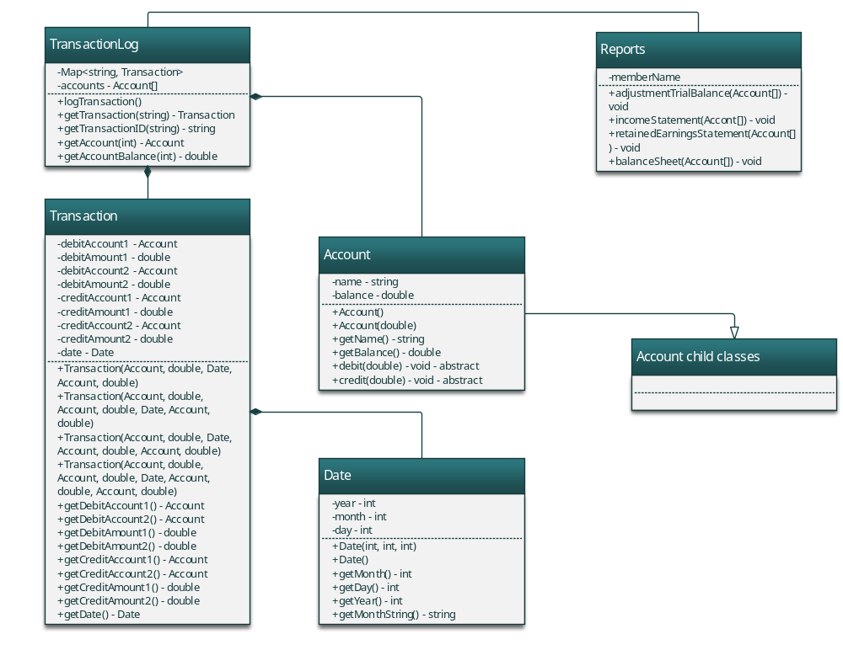
- General Ledger Object Relationship Diagram

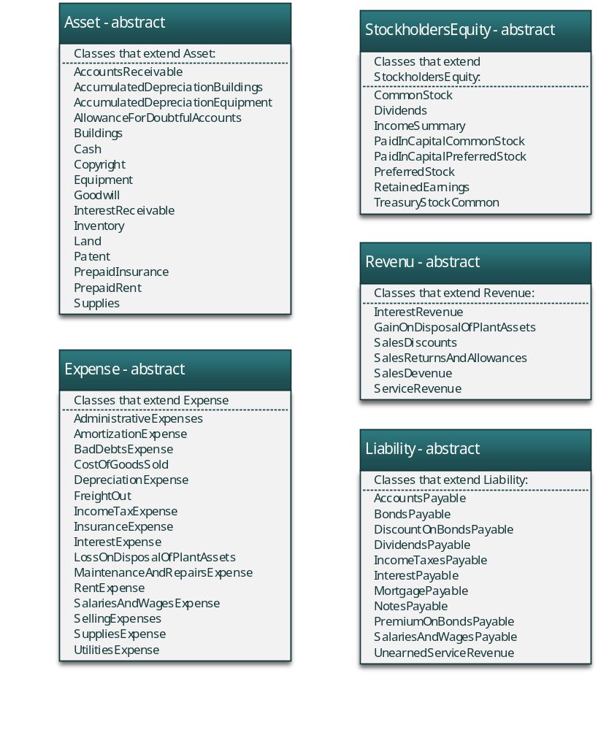
- Final Account classes

User Interface Specification

GUI
Screenshots of the program GUI

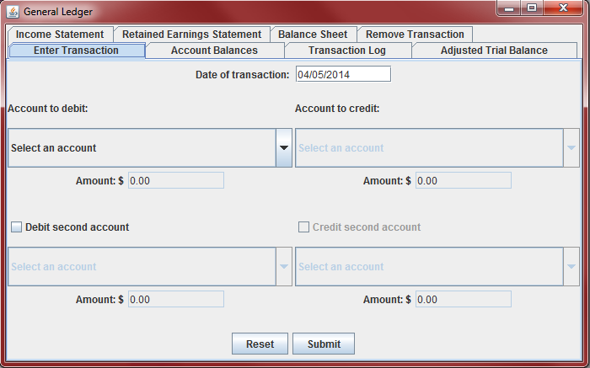

- General Ledger Transaction GUI

UI Tasks

Task list
Program task list:

- Enter Transaction
- Print Adjustment Trial Balance
- Print Income Statement
- Print Retained Earnings Statement
- Print Balance Sheet
- View Transaction Log
- Remove Transaction

Task specifications
Program task specifications:

- Task #1: Enter Transaction
The user has started the program and selected the “Add Transaction” tab. The user must then enter at least one account to debit and one account to credit and the total amount being debited must equal the total amount being credited.

- Task #2 Print Adjustment Trial Balance
The user has started the program and selected the “Adjustment Trial Balance” tab.

- Task #3 Print Income Statement
The user has started the program and selected the “Income Statement” tab.

- Task #4 Print Retained Earnings Statement
The user has started the program and selected the “Retained Earnings Statement” tab.

- Task #5 Print Balance Sheet
The user has started the program and selected the “Balance Sheet” tab.

- Task #6 View Transaction Log
The user has started the program and selected the “Transaction Log” tab. If there are no transactions, the log will be empty.

- Task #7 Remove Transaction
The user has started the program and selected the “Remove Transaction” tab. If there are no transactions to remove or if the user does not enter a valid transaction ID the operation will do nothing.

