**Handwritten Digit Recognition**

**BY:**

**Name: Shivam Joshi**

**Course: BTECH (**AI and DS)

**University Roll NO**: 2017670

**INDEX**

1. **Introduction**
2. **Problem statement**
3. **Motivation**
4. **Neural Network**
5. **Methodology/Planning of work**
6. **Tools**
7. **Future scope**
8. **Conclusion**
9. **Bibliography**

* **Introduction**

Recognition plays an important role in the modern world. Can solve more complex problems and people's work easier. The example is handwritten character recognition. Handwritten digit recognition is a highly non-linear problem. Recognition of handwritten digits plays an active role in everyday life these days. Office automation, e-governors and many other areas, reading printed or handwritten documents and converting them to digital media is a very essential and time-consuming task. Thus, the system should be designed to be able to read handwritten digits and provide an appropriate response like humans.

Handwritten digit recognition is becoming increasingly important in the modern world due to practical applications in our daily lives. Early handwritten digit recognition was presented for postcode recognition. Automatic bank check processing, postal address is a widely used handwritten digit recognition application.

* **Problem statement**

Handwritten digit recognition using Artificial Neural Network (ANN)

* **Motivation**

Handwritten number recognition is a feature of computer applications that recognize numbers handwritten by humans. This is a difficult task for machines, as handwritten numbers are incomplete and can be made into different shapes and sizes. The handwritten number recognition system is one way to deal with this problem of getting an image of numbers and recognizing the numbers present in the image.

* **Neural Network**

**What is artificial neural network?**

An artificial neural network mimics the way nerve works in human brain and its computational model is inspired by the Structure, Processing Model, and Learning Ability of human brain.

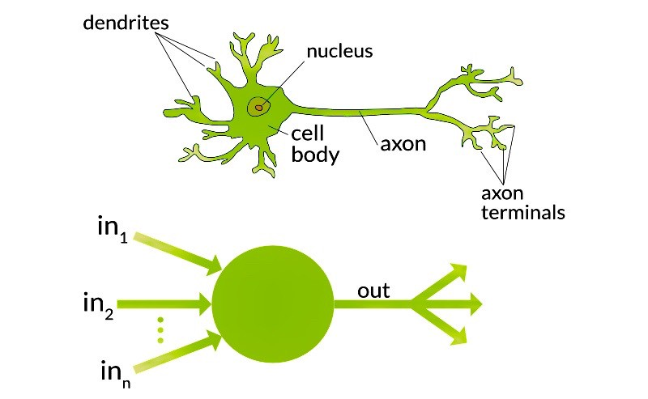

**Characteristics of Artificial Neural Network:**

* Many very simple processing Neuronlike processing elements
* Many weighted connections between elements
* Distributed representation of knowledge over connections
* Knowledge is acquired over the network through the learning process.

**Why artificial neural network?**

* Massive Parallelism
* Distributed representation
* Learning ability
* Generalization ability
* Fault tolerance
* **Methodology/Planning of work**

**Handwritten Character Recognition:**

There are many different types of recognitions in the modern time, which can really solve complex problems in the real world today. Some of them are` face recognition, shape recognition, handwritten character recognition, such as handwritten Chinese character recognition and handwritten digit recognition.

**THEORY**

Neural network systems is used in this project to recognize 10 different handwritten digits. These are numbers from 0 to 9. Here we use a backpropagation neural network to train all the data. The main problem is that the numbers are handwritten. Therefore, it is subject to data fluctuations as the numbers are written by different people, using different sizes, styles, and instruments.

Backpropagation is used to avoid real image recognition issues and avoid complex pre-processing. The learning node fed the image directly but not as vectors. The image must be closed and there should be no small holes before inserting data into the network. As a result, the image becomes thin and only the larger parts are called skeletons.

The dataset used is MNIST dataset:

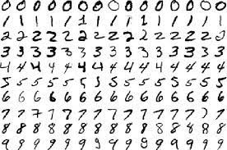

These images are low resolution and grayscale is of only 28x28 pixels. Also note that it is properly segmented. This means that each image contains exactly one digit. When working with the image, I used raw pixels as a feature. Well, a 28x28 pixel image has 784 pixels, so it has 784 features. So, we need to flatten the image. Flattening an image means converting the image from a 2D array to a 1D array by unstacking and arranging the rows.

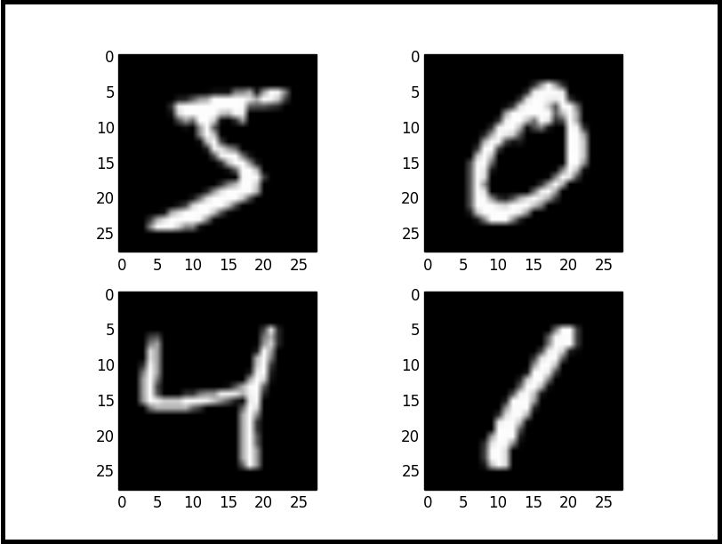

Steps:

1. Load MINST data set



2.

* After loading the data set normalize the x_train and x_test.
* Normalize: it is nothing just converting the pixel value between zero and one.
* Sequential: it is arranging the Keras layers in a sequential order and so, it is called Sequential

3. Then we use Flatten function to arrange 2D array into 1D array

4. Then we use 2 Dense layers one as hidden layer and one as output layer

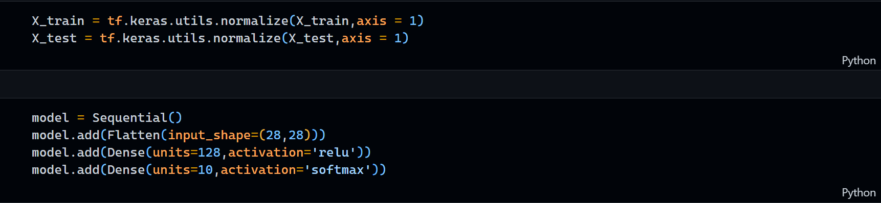

5. Then train the machine



6. Evaluate model for Loss and Accuracy

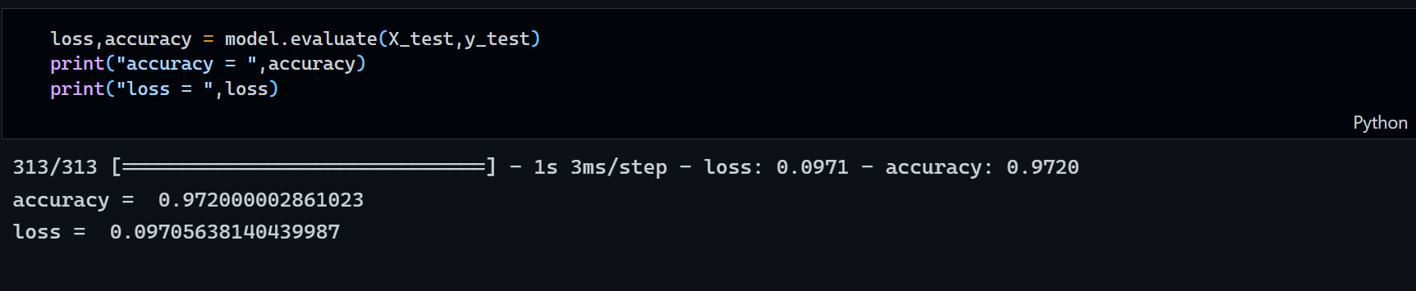

8. predicting the image at ‘1256’

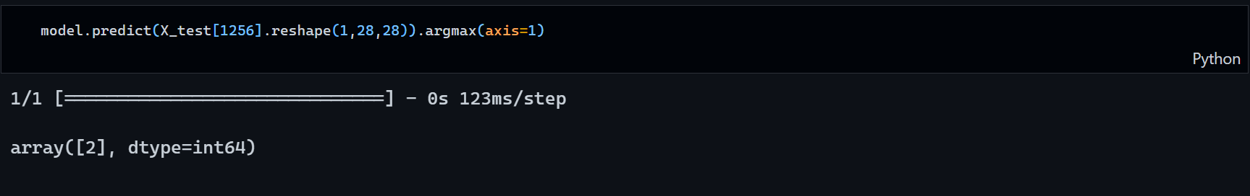

9.Predict function for input images and output snippet.

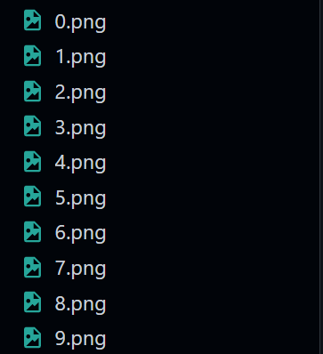

* **Tools**

1. Libraries that I have used:

TensorFlow

Matplotlib

MNIST dataset

Keres

Keres-layer Dense, Flatten

OpenCV

NumPy

1. Jupyter Notebook

* **Future scope**

In future I would like to make a graphic user interface (GUI) app with a white board where user can write the number and based on the image the output will be shown.

* **Conclusion**

The completion of the project went quiet well, I learned much new things while I was building this project and I get to know various platforms which help us to learn all this stuff. I was able to learn the practical use of AI. This practical helped me to learn the developing of code and development tools for Machine Learning.

Overall working on this project was great fun as I came up with great piece of knowledge and understanding of the topic.

* **Bibliography**

Stack Overflow

Geeks For Geeks

Google

Wikipedia

YouTube