The Vices and Virtues of Conglomerates
Class Notes | Week 10, Session 2 | 17 March 2026

JPMorgan Guest Presentation: Private Equity & Debt
A JPMorgan practitioner outlined how debt can be used to create value in private equity deals, covering the current market environment and industry consolidation.

Private Equity Market Overview
- The three dominant PE platforms — Blackstone, KKR, and Apollo — collectively manage approximately $2.5 trillion AUM, with roughly one-third in pure private equity.
- Large managers are increasingly relying on insurance company balance sheets to provide stable, long-duration capital — analogous to how banks historically lend.
- Real estate funds have become a significant asset class for large managers due to their “stickier” investor base.
- "While the number of PE firms overall continues to grow, AUM and deal flow are increasingly concentrating among the largest platforms (Blackstone, KKR, Apollo), as institutional investors prefer large, diversified managers."

Using Debt to Create Value
- In a traditional LBO, PE firms create equity value through three levers: (1) using significant debt (placed on the acquired company's balance sheet) to minimise the equity outlay at acquisition; (2) using the company's own operating cash flows to repay that debt over time, increasing the PE firm's free-and-clear equity stake; and (3) improving the company's operations and credit profile to reduce its interest burden — together driving a higher equity valuation at exit."
- (*Why PE does this?)
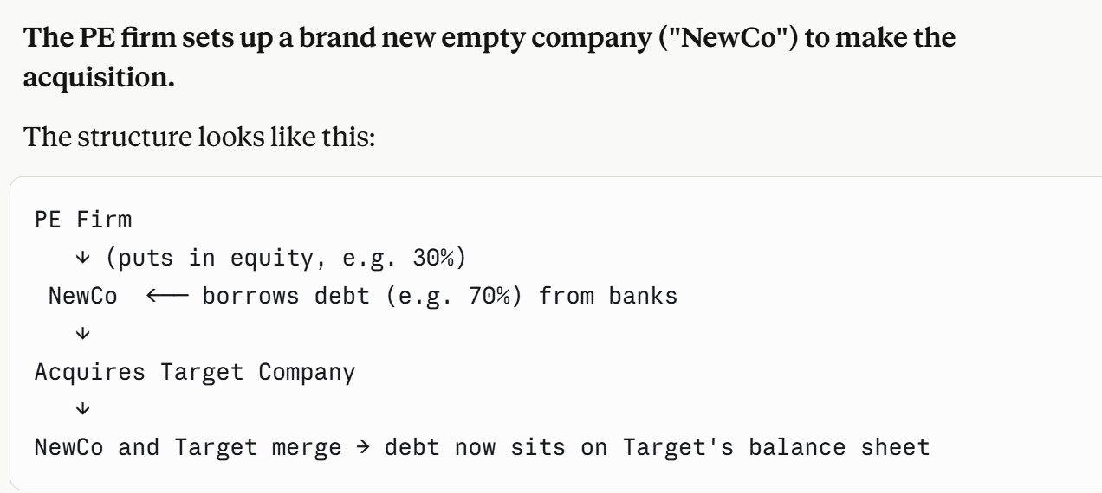
- In the current higher-rate environment, debt is more expensive, shifting the risk/reward calculus for leveraged deals.
- Tech businesses represent 30–40% of deal flow through the cycle. The sector is attractive when target companies have subscription models, sticky customers, and dominant market share.

Exit Strategies & Returns
- Common routes to exit: secondary sales, IPOs, and strategic acquisitions.
- Wealth management and asset management businesses can generate double-digit returns. PE creates value primarily by reducing costs and improving operational efficiency.
- Infrastructure funds: typically target low-teen returns with stable, long-dated cash flows — appealing to institutional investors seeking yield.

Conglomerate Valuation & The Discount

Measuring the Conglomerate Discount
The standard approach is a sum-of-the-parts (SOTP) valuation: each segment is valued at the same multiple as the median focused (pure-play) firm in its industry, and these values are summed. The difference between implied value and actual market value is the conglomerate discount.
- Berger and Ofek (1995) and Lins and Servaes (1999): the implied value of diversified firms is approximately 15–17% higher than their actual market value, both in the UK and US.
- More recent estimates put the traditional discount at 7–11%, while modern mega-tech conglomerates (Apple, Alphabet) actually trade at a diversification premium of up to 70%.
- Rule of thumb: when computing the average discount, including conglomerates that trade at a premium reduces the average — this is a subtle but important point for interpretation.

Why Does the Discount Exist? — Demand-Side Explanation
- Investors who want exposure to one division must buy the entire group. They cannot sell individual businesses separately, which forces unwanted bundling.
- Example: An investor who wants exposure to a profitable hotel chain does not want it bundled with an underperforming coffee chain (the "WizWard" illustration).
- Transparency issue: conglomerates are harder to analyse and value because segment-level disclosure is limited. Analyst coverage increases significantly after spin-offs, as different sector specialists can cover each standalone business.

Eni & Elliott: A Live Case Study
Eni (formerly E&I), the Italian energy conglomerate, is partially state-owned (Italian government holds ~30%). The company spans gas distribution, pipeline ownership, laboratory operations, and upstream field development — making SOTP valuation extremely difficult.
- Elliott Management identified that Eni had not hedged its oil price exposure; when oil prices fell, earnings were highly volatile — a vulnerability activist investors can exploit.
- Elliott pushed Eni to divest non-core assets, mirroring its broader playbook of identifying undervalued or poorly managed conglomerates and pressing for unbundling.

SoftBank & Elliott
- Elliott's core concern: cross-subsidisation — SoftBank’s profitable investments (e.g. Alibaba) were being used to subsidise loss-making portfolio companies. The internal capital flow obscured true economic performance.
- Elliott sought to surface the value of SoftBank’s most valuable investments by pushing for buybacks and more transparent capital allocation.

US Steel & Marathon Oil
- The two businesses had zero operational relationship. Marathon Oil’s cash flows were subsidising US Steel’s losses.
- Workers at US Steel, knowing the cash came from Marathon, had reduced incentives to improve productivity.
- Carl Icahn argued that the wrong analysts were covering the bundled entity — steel analysts applied a steel multiple to the whole group, systematically undervaluing the oil assets. Spin-offs correct this misvaluation.

Cross-Country Variation in the Discount
- Germany: diversified German firms do not trade at a discount (Lins and Servaes, 1999). The discount only emerges when manager ownership falls below 5% — aligning with principal-agent concerns.
- Family ownership premium: in both developed and emerging markets, conglomerates with concentrated family ownership tend to trade at a premium, while those with dispersed ownership and low insider stakes trade at a discount.
- Emerging markets: conglomerates often trade at a premium because external capital markets are thin, costly, and unsophisticated. The internal capital market is genuinely valuable in this context.
- Keiretsu (Japan): horizontal networks of companies with interlocking shareholdings and a central group bank (e.g. Mitsubishi). Self-contained groups that send human capital across member firms and protect against hostile takeovers. Toyota additionally operates a vertical keiretsu with stakes in key suppliers.

Benefits of Diversification

1. Internal Capital Markets
- Divisions with excess cash and limited investment opportunities can fund divisions with strong opportunities but limited external access to capital.
- Historical example — Harold Geneen’s ITT: all subsidiaries were 100% owned, allowing genuine arms-length capital allocation. Each division presented performance to headquarters, which directed capital from low-return to high-return businesses.
- Contrast — Tata Group: many Tata subsidiaries are independently listed with different external shareholders. Moving capital between entities constitutes a related-party transaction, requiring shareholder approval and limiting the internal capital market’s fluidity.
- Duchin (2010): multidivision firms hold significantly less cash (12% of assets) vs standalone firms (21%), reflecting efficient internal reallocation of capital across divisions with uncorrelated investment opportunities.

2. Co-Insurance Effect & Debt Capacity
- When business unit cash flows are imperfectly correlated, the consolidated balance sheet is less volatile. This allows the combined firm to sustain higher leverage at a lower cost.
- Value creation mechanism: higher debt capacity → larger interest tax shields → higher firm value (in a world with taxes and bankruptcy costs).
- Hann, Ogneva, and Ozbas (2013): diversified firms have a lower cost of capital than comparable portfolios of standalone firms. Moving from the highest to the lowest cash flow correlation quintile generates approximately 5% value gain.
- Important caveat — Modigliani-Miller: in a frictionless world (no taxes, no bankruptcy costs), co-insurance simply redistributes risk between lenders (who take on more) and shareholders (who take on less) — no net value is created. Value only arises when there are real frictions.

3. Financial Crisis Evidence (Kuppuswamy & Villalonga, 2015)
- During the 2007–2009 financial crisis, diversified US firms became significantly more leveraged than single-segment firms (the “more money effect” per Jeremy Stein).
- “Smarter money effect” when external capital markets froze, internal capital markets became more valuable — divisions competed for scarce internal funds, improving allocation discipline.
- The conglomerate discount fell by between one-half and two-thirds during the crisis, confirming that internal capital markets are most valuable precisely when external markets fail.

4. Family Business Diversification Rationale
- Institutional investors can diversify cheaply via market portfolios. Corporate diversification adds no value for them. However, controlling families — with wealth concentrated in a single entity — cannot personally diversify easily.
- For family-controlled groups (Tata, Samsung, Schroder AM), the conglomerate structure serves as a private diversification vehicle. This explains why family conglomerates often trade at a premium.
- Schroder case: the Schroder family held a large undiversified stake in the asset manager, recently acquired by Nuveen for ~$13 billion — illustrating the tension between family wealth concentration and maximising shareholder value.

Costs of Diversification

Cross-Subsidisation
- The most common and damaging cost. Profitable “cash cow” divisions fund loss-making divisions, destroying value and distorting incentives across the group.
- Managers have strong incentives to sustain this arrangement — they can empire-build without market discipline.

Analyst Coverage & Valuation Complexity
- Conglomerates are followed by fewer analysts. Sector specialists may not cover the full group, and generalist analysts may apply inappropriate multiples (e.g. applying a steel multiple to an oil-and-steel conglomerate).
- Post-spin-off, the number of analysts covering each entity rises substantially, improving price discovery and reducing the discount.

Related-Party Transaction Risk (Samsung, Toyota)
- Capital transfers within a group where parent and subsidiary have different external shareholders are not at arm’s length. Minority shareholders in subsidiaries can challenge transactions.
- Toyota / Elliott case: Elliott successfully challenged the price at which Toyota’s parent was buying out a subsidiary, arguing it was too low — forcing a higher payment to minority investors.
- Samsung: Elliott faced similar battles for over a year before any financial benefit materialised, illustrating the time and legal cost of activist campaigns in complex group structures.

Activist Investors & the Push to Unbundle
- The 1980s and 1990s saw a wave of hostile bust-up takeovers (e.g. KKR-Nabisco, Beatrice) that destroyed many conglomerates. Finance theory argued that investor diversification made corporate diversification redundant.
- Sir James Goldsmith, Jacob Rothschild, and Kerry Packer attempted to break up BAT, separating its tobacco and insurance divisions — ultimately unsuccessful but emblematic of the era.
- Bill Ackman / Pershing Square: in contrast, is attempting to build a Berkshire-style conglomerate, acquiring stakes and using cash flows to fund further acquisitions.
- GE: Jack Welch built GE into the largest US conglomerate in history (aerospace, healthcare, capital, and more). Successive CEOs were forced to unbundle it; GE Capital was sold, and the company was ultimately renamed GE Aerospace following energy and healthcare spin-offs.

Berkshire Hathaway: An Enduring Conglomerate
- Berkshire currently trades at or near the conglomerate discount. If this is the case, an equivalent portfolio of standalone businesses would imply a higher market value.
- The key unanswered question: does Berkshire survive in its current form over the next 5–10 years? The primary risk is succession — Buffett’s unique capital allocation skill is extremely difficult to replicate.
- GEICO and BNSF Railroad: two of Berkshire’s largest wholly-owned subsidiaries, illustrating the breadth of the portfolio (insurance and transport).

Adjusted Present Value (APV) & Valuation Methods

Three Equivalent Valuation Approaches
In principle, three methods produce the same answer if applied consistently:
- WACC / NPV: discount enterprise cash flows at the weighted average cost of capital.
- APV: discount at the unlevered cost of equity, then add the present value of tax shields (and subtract distress costs).
- Return on Equity (PE / Equity Cash Flow): compare IRR on equity cash flows to the cost of equity.

When to Use APV
- APV is preferred in highly leveraged transactions (PE buyouts, MBOs) where the debt schedule changes significantly over time, making a constant WACC assumption inappropriate.
- Financial leases: return-on-equity and equity cash flow methods are particularly appropriate here.
- The cost of equity in a highly leveraged transaction (20–40x) can be 25–27% — seemingly high, but the correct benchmark given the risk profile. Comparing to WACC in these situations can be deceptive.
- Key principle: use the beta of equity (not asset beta) when estimating the cost of equity in R(E) = APV framework. The discount rate must match the risk of the cash flows being valued.

Key Takeaways
- Diversified firms on average trade at a discount to a portfolio of pure-play equivalents. The discount is persistent but varies over time and across geographies.
- Activist investors routinely target conglomerates, demanding spin-offs or divestitures to surface hidden value.
- Family ownership is a notable exception — controlling families use corporate diversification as a personal diversification substitute, and these groups frequently trade at a premium.
- The financial benefits of diversification (internal capital markets, co-insurance, lower cash holdings) are real but modest in developed markets. They become materially more valuable in emerging markets or during financial crises when external capital markets are impaired.
- Cross-subsidisation is the primary cost. Strong cash-flow businesses financing loss-makers destroys value and undermines incentives throughout the group.

