**Ratios**

**BIS**

**1- Liquidity Ratios:**

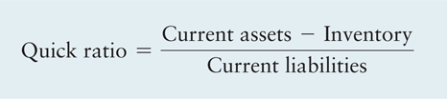**1- Current ratio = Current assets ÷ Current liabilities**

**2-Quick (acid-test) ratio =**

**2- Activity Ratios:**

**1- Inventory turnover = Cost of goods sold ÷ Inventory**

**2- Average Age of Inventory = 365 ÷ Inventory turnover**

**3- Average collection period= AR x 365 ÷ annual sales**

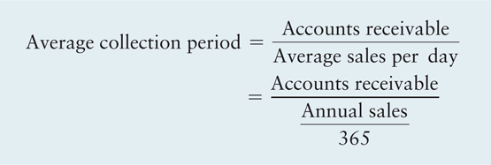

**4- Total asset turnover = Sales ÷ Total assets**

**3-Debt Ratios:**

**1- Debt ratio = Total liabilities ÷ Total assets**

**2- Debt to equity = Total liabilities ÷ Common stock equity**

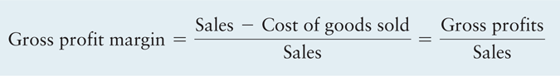**4- Profitability Ratios:**

**1- Gross profit margin=**

**2- Operating profit margin = Operating profits ÷ sales**

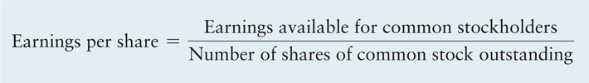**3- Net profit margin = Earnings available for common stockholders ÷ Sales**

**4- Earnings per share=**

**5- Return on total assets (ROA) = Earnings available for common stockholders ÷ Total assets**

**6- Return on Equity (ROE) = Earnings available for common stockholders ÷Common stock equity**

**5- Market Ratios:**

**1- Price Earnings (P/E) Ratio = Market price per share of common stock ÷ Earnings per share**