**Abstract**

**The purpose of this work is to assist the medical system in portable integrated information entry, allowing the medical system to cover more areas at a lower cost. The function of this work is to simplify the complicated process of information entry. With just one portable device, temperature measurement and information entry (such as Yuekang code and nucleic acid code) can be completed without requiring personnel participating in testing to present their information, making it a more comfortable experience for those involved in information entry.**

**It supports multiple devices, data synchronization and intelligent voice assistance. This makes the entire medical information input process more efficient while also providing better experiences for both staff and participants.**

**Keywords: face recognition, wireless transmission, intelligent voice.**

**2. Program Introduction**

1. Circuit Design

1.1 Charging Section

The power supply section from top to bottom consists of a lithium battery protection chip, charging control chip, and boost chip (Figure 1).

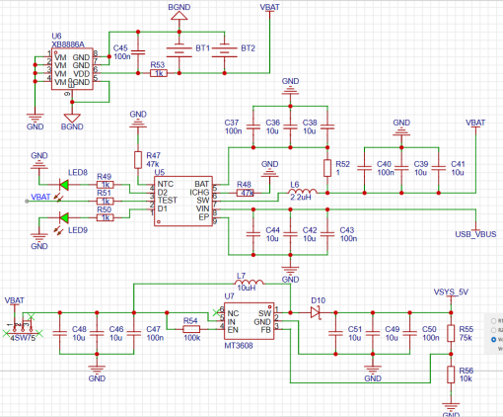

Figure 1: Schematic diagram of the power supply section.

1.2 Selection of CH340 Burner and Serial Port for Multiple Devices

In this design, there are many devices that need to be burned, and jumpers are used for selection. This allows them to be programmed through the Type-C interface. Jumpers were also designed for serial communication between modules, which can flexibly switch the serial connections between various devices or directly use a computer with pin headers inserted to debug a specific module. The schematic diagram is shown in Figure2.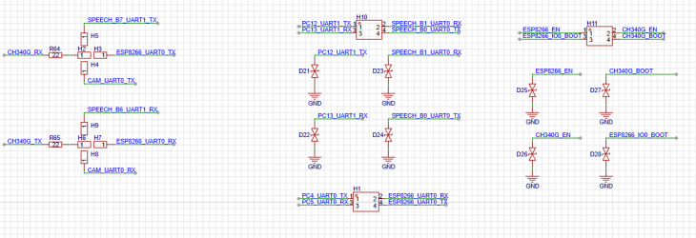

Figure 2: Schematic diagram of burning jumper cap

1.3 PCB Design

The aim of this project is to interconnect multiple modules and electronic components. At the same time, in order to ensure the portability and ease of grip of the circuit board, we need to design a compact circuit board that does not obstruct key components such as cameras and temperature measurement modules when held. The entire circuit board adopts a four-layer board design with dimensions of 75mm x 100mm. The overall design is shown in Figure 3. (DRC refers to errors within the package.)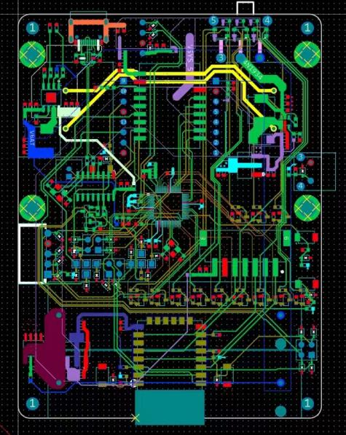

Figure 3: PCB Design

2. Reasons for selecting peripheral modules and components

2.1 Voice module

The SU-03T module was selected for the following reasons:

① Small size, but powerful functionality. It can support both speaker output and microphone input, as well as multiple GPIO ports and a serial port on the module.

② Rich customization options. With Intelligent Era, direct programming of functions such as voice wake-up words, voice input triggering voice output, and serial port triggering voice is possible.

2.2 Image transmission module

The ESP32-CAM was chosen for the following considerations:

① Powerful processing performance: The ESP32 chip is a high-performance, low-power dual-core processor with up to 240 MHz main frequency and 520 KB SRAM memory capacity that enables easy handling of high-definition video and image data by the ESP32-CAM.

② Low cost and small size: The price of the ESP32-CAM is relatively low compared to other similar products in its class while also being compact in size making it suitable for embedding into various devices or applications.

③ Abundant development resources: Based on the ESP32 chip architecture, there are extensive development resources available along with community support including comprehensive documentation, sample code libraries etc., which enable rapid application development such as video surveillance systems or smart homes.

2.3 Display Module

The ILI9341 from Waveshare was chosen due to several factors:

① High resolution: The Waveshare ILI9341 display screen has a resolution of 320×240 pixels enabling it to display high-quality images or videos.

② Good display effect: TFT technology used by Waveshare ILI9341 provides excellent color reproduction with high contrast ratio resulting in vivid colors even when viewed at wide angles.

③ Easy driver integration: Using SPI interface data transfer method means only minimal IO ports are required making it easy to integrate into embedded systems such as microcontrollers.

④ High stability: The ILI9341 controller chip used in the Waveshare ILI9341 display screen is highly stable with low power consumption and supports multiple display modes and peripheral interfaces, making it suitable for various applications.

⑤ Abundant development resources: There are abundant development resources available for the Waveshare ILI9341 display screen including detailed documentation, sample code libraries etc. Additionally, Waveshare provides matching driver boards and development boards which facilitate prototype design and testing.

2.4 Infrared temperature measurement module

The GY-906-DAA was chosen due to several factors:

① High precision measurement: The GY-906-DAA uses Melexis' MLX90614 infrared sensor chip enabling high-precision non-contact temperature measurements with an error of only 0.5℃.

② Non-contact measurement: The GY-906-DAA is a non-contact temperature sensor that can measure temperatures without touching the object being measured avoiding any impact on the object by traditional contact sensors during temperature measurements.

③ Convenient integration: With its small size, simple interface, high degree of integration along with multiple packaging options and measuring modes available make it convenient to integrate into various applications according to user needs.

2.5 Power module & IC

Tengfei New Energy lithium batteries were selected for their compact size which perfectly matched our PCB package requirements among other reasons such as sufficient capacity (2000mAh) ensuring device operation for several hours while also having built-in protection circuits integrated with existing power management ICs on PCB board resulting in greater product stability and safety.

The IP2312U was chosen as the power management IC due to following considerations:

① Supports single-cell lithium battery synchronous switch buck charging management providing more stable charging performance.

② Supports output voltage level reflection when fully charged allowing external circuitry to connect two LEDs that reflect whether the charging is in constant current stage (charging) or constant voltage stage (charging complete), making it more user-friendly.

③ Fewer peripheral components required when used, simplifying circuit design. The chip integrates high-efficiency MOS and adopts a synchronous switch architecture resulting in fewer peripheral circuit components which makes it easier for circuit designers.

3. Code Focus

3.1 HT MCU Embedded Code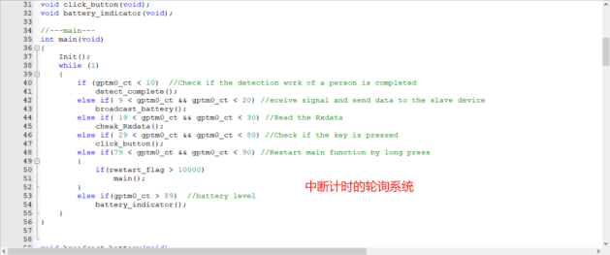

Figure 4: HT main function

3.2 Face recognition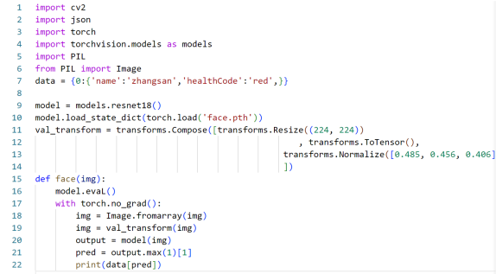

Figure 5: Recognition Section

3.3 Image Transmission Module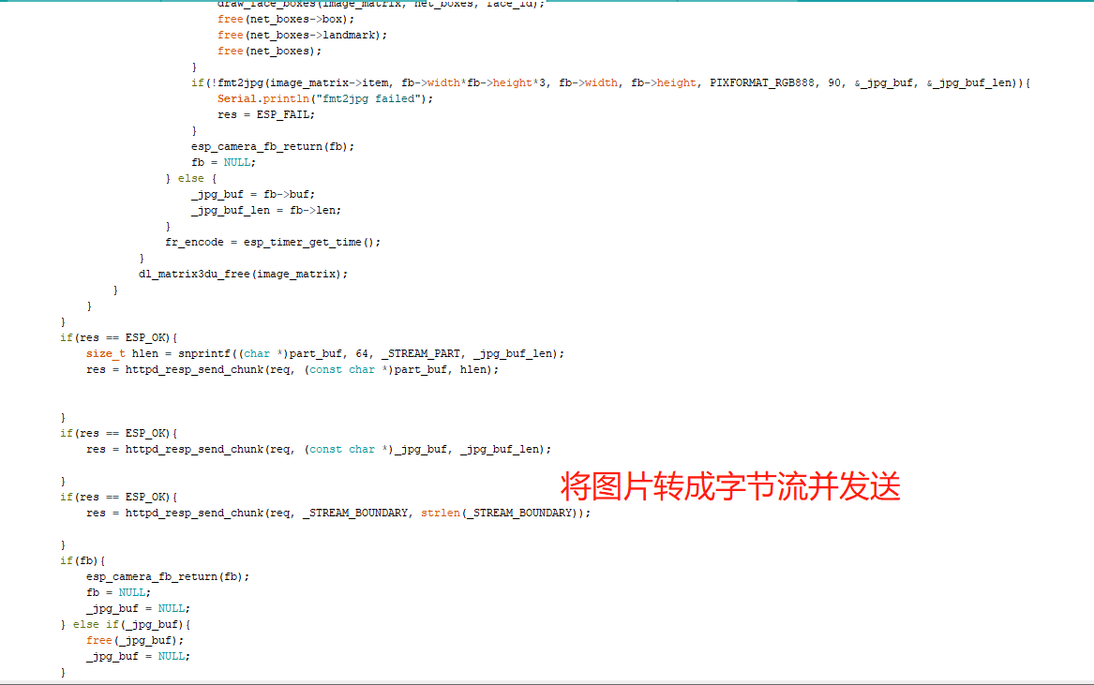

Figure 6: Conversion to Byte Stream

3.4 Display Module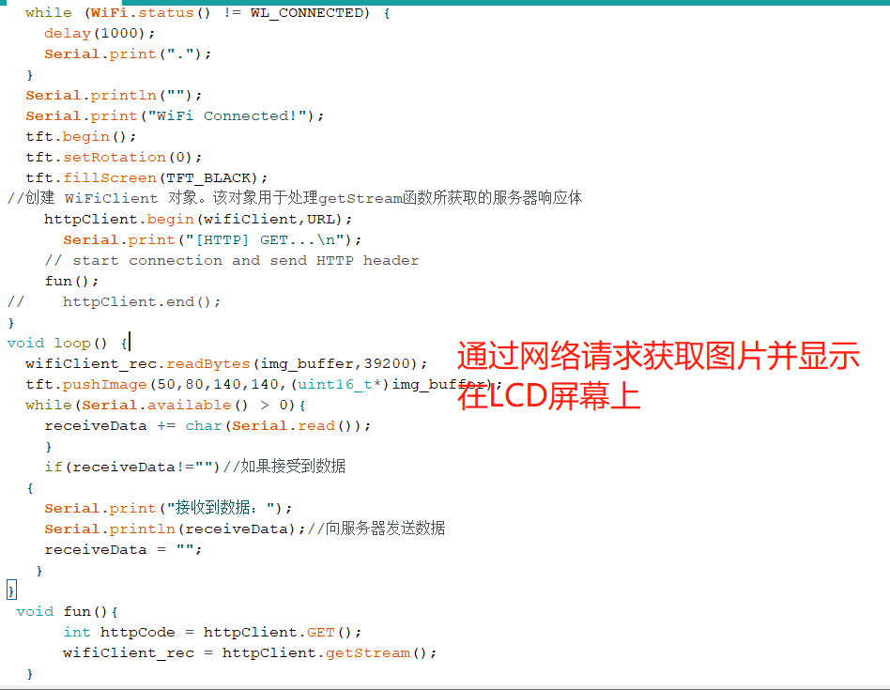

Figure 7: Sending and displaying images over the network.

4. Exterior Design

As shown in (Figure 8).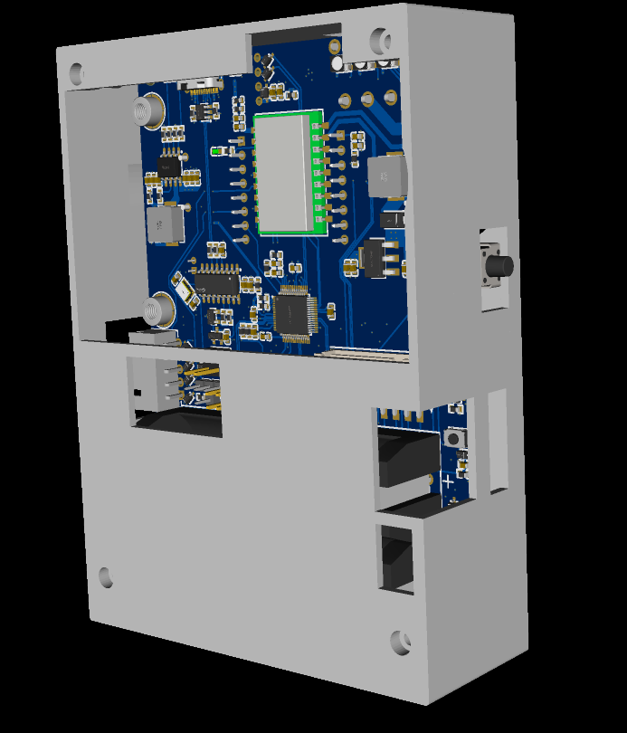

Figure 8: PCB enclosure

II. Working Principle

1. Workflow

This product includes the following modules: main control module, image transmission module, facial recognition module, display module, sensor module, voice module and mini program. When performing information entry tasks, personnel responsible for entering information need to hold the device and stand in front of medical workers who are performing medical work (such as vaccination, blood sampling, nucleic acid sampling).

During the detection period, personnel turn on the device and confirm that it is online through the mini program. The image transmission module captures real-time camera images and presents them on the display module. When a worker sees a face selected on the display screen, they press a button and send a signal to the main control module via the image transmission module to perform facial recognition and search for relevant information in the database.

During facial recognition process，workers can measure body temperature again by pressing another button. The RGB light on the device will show different colors (red or green) depending on whether their body temperature is normal or not. Another RGB light is used to indicate whether related information is normal (such as health code status). If all information is normal，the device will complete its task of recording information.

If any abnormal situation occurs during any step，the light group and voice modules on the device will provide prompts。Workers can then contact relevant personnel to bring abnormal individuals to designated locations for further observation。Workers can also view all recorded identity information in real time through mini programs.

2.Working principle

2.1 Battery level display & Light group control

The light group uses HT32F52352's GPIO output function.For LED lights,the design of this product makes them high-level bright lights,and low-level off-lights.The brightness of each color of an RGB lamp depends upon which one out of three GPIOs connected with N-channel MOSFETs has been turned ON.

Battery level display combines ADC's OneShot_SWTrigger function. The typical value of the battery voltage is read and the size of this value is judged by embedded code, which combined with light group control completes different combinations of light display for battery level.

2.2 Infrared temperature measurement module

The temperature measurement module uses GY-906-DAA and communicates via I2C. PA0 and PA1 are used as analog I2C SCL and SDA in single-chip microcomputer.According to the reference data provided by the device, address, command, read data request are sent in order，and then high 8 bits、low 8 bits information and check information are read.Finally,the specific temperature value is calculated according to the formula provided in the datasheet.

2.3 Voice Module

The voice module adopts multiple input methods including serial port,GPIO,and microphone.The main output is speaker output.By writing different pin level inputs,microphone keyword detection inputs,and su-03t's receiving serial port inputs,different voice outputs can be achieved through voice modules,to achieve intelligent speech goals.

2.4 Image Transmission Module

ESP32-Cam will act as a server to convert images captured by cameras into byte streams in real time,and send server IP addresses through serial communication or wireless transmission via mqtt servers.When initializing,this product sends its service-side IP address opened by ESP32-Cam to facial recognition module using device name as topic through mqtt protocol.The latter can obtain pictures from ESP32-Cam by reque**sting this IP address.**

IV Testing Methods

1. Battery Display Test

Without adding battery voltage judgment, all the light groups display may be written once after normal power-on, and delay functions are added in between to make the status displayed sequentially.

For the voltage reading module, ADC reading and voltage calculation are separately written. Open Keil's Debug debugging and add watch window to observe whether the values exist and are within a reasonable range. Finally, these two parts are combined to complete the requirement of battery display.

2. Voice Module Test

Use Intelligent Era for custom trigger and action writing, generate SDK and firmware packages after completion, then download them into SU-03T. Then use HT32 code for serial port triggering and GPIO input/output testing.

After multiple version tests updates, language module testing is completed, achieving intelligent voice assistant design.

3. Face Recognition and Mini Program

Compared with traditional image processing-based face recognition methods, this solution uses deep learning methods for face recognition with lightweight deployment to achieve real-time accuracy combination. The mini program uses self-written data that meets format requirements for import/export testing functionality completeness.

4. Overall Testing

In the integration phase of the project, we combine all modules together to ensure collaboration among various functional modules as well as compatibility. Based on problems found during testing process，we gradually revised and optimized products through continuous iteration improvement until we finally obtained a complete，reliable，and efficient product.

V.Conclusion

This work fully considers user experience practicality while providing long-lasting stable service without frequent charging due to its long battery life capability . Meanwhile ,the product has built-in voice assistant function which provides users with real-time voice prompts & interaction making operation more convenient & simple . In addition ,its compact design makes it easy to carry around & store saving space .

Overall,this work satisfies basic functional requirements of one-stop coding entry device while bringing users more comfortable&efficient usage experience .

VI.Reference

None

VII Attachment

1. List of hardware components used in the work and progress table for completion of physical work.

|  |  |  |  |
| --- | --- | --- | --- |
| **The work uses the names, models, and specifications of hardware modules.** | **Hardware manufacturer** | **amount** | **purpose** |
| HT32F52352 64LQFP | 合泰半导体 | 1颗 | 主控芯片 |
| GY-906红外测温 | 信德电子 | 1块 | 测温 |
| 3.7v充电锂电池聚合物 | 腾飞新能源 | 1块 | 供电 |
| SU-03T | 机芯智能 | 1块 | 语音芯片 |
| ESP8266 | 安信可科技 | 1块 | 无线通信 |
| EPS32-CAM | 安可信科技 | 1块 | 视频捕获 |
| IP2312U | 英集芯科技 | 1颗 | 充电控制芯片 |
| MT3608 | AEROSEMI | 1颗 | 升压芯片 |
| AMS1117 | AMS | 2颗 | 降压芯片 |
| XB8886A | ysemi | 1颗 | 锂电保护 |
| CH340 | WCH(南京沁恒) | 1颗 | Type-C烧录 |

