1 SpringMVC 入门

简介：
MVC
M:Model
V:View
C:Controller - servlet/action/controller

Spring MVC是Spring提供的一个强大而灵活的web框架。借助于注解，Spring MVC提供了几乎是POJO的开发模式，使得控制器的开发和测试更加简单。这些控制器一般不直接处理请求，而是将其委托给Spring上下文中的其他bean，通过Spring的依赖注入功能，这些bean被注入到控制器中。

Spring MVC主要由DispatcherServlet、处理器映射【找控制器】、适配器【调用控制器的方法】、控制器【业务】、视图解析器、视图组成。

1.2 SpringMVC注解的开发

1.3 Spring入门注解案例

第一步：导入springmvc jar包
暂时先导入下面的jar包
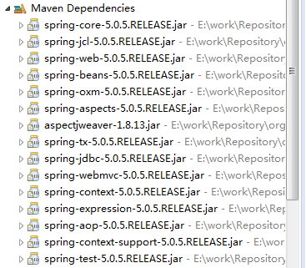

第二步：在web.xml配置DispatcherServlet
<?xml version="1.0" encoding="UTF-8"?>
<web-app xmlns:xsi="http://www.w3.org/2001/XMLSchema-instance"
xmlns="http://xmlns.jcp.org/xml/ns/javaee"
xsi:schemaLocation="http://xmlns.jcp.org/xml/ns/javaee
http://xmlns.jcp.org/xml/ns/javaee/web-app_3_1.xsd" id="WebApp_ID" version="3.1">

<servlet>
<servlet-name>DispatcherServlet</servlet-name>
<servlet-class>org.springframework.web.servlet.DispatcherServlet</servlet-class>
<init-param>
<!-- 修改黑底springmvc加载的配置文件路径 -->
<param-name>contextConfigLocation</param-name>
<param-value>classpath:springmvc.xml</param-value>
</init-param>
<load-on-startup>1</load-on-startup>
</servlet>
<servlet-mapping>
<servlet-name>DispatcherServlet</servlet-name>
<url-pattern>*.do</url-pattern>
</servlet-mapping>

第三步：在src/main/resources目录下创建springmvc.xml
<?xml version="1.0" encoding="UTF-8"?>
<beans xmlns="http://www.springframework.org/schema/beans"
xmlns:xsi="http://www.w3.org/2001/XMLSchema-instance" xmlns:mvc="http://www.springframework.org/schema/mvc"
xmlns:context="http://www.springframework.org/schema/context"
xmlns:aop="http://www.springframework.org/schema/aop" xmlns:tx="http://www.springframework.org/schema/tx"
xsi:schemaLocation="http://www.springframework.org/schema/beans
http://www.springframework.org/schema/beans/spring-beans.xsd
http://www.springframework.org/schema/mvc
http://www.springframework.org/schema/mvc/spring-mvc.xsd
http://www.springframework.org/schema/context
http://www.springframework.org/schema/context/spring-context.xsd
http://www.springframework.org/schema/aop
http://www.springframework.org/schema/aop/spring-aop.xsd
http://www.springframework.org/schema/tx
http://www.springframework.org/schema/tx/spring-tx.xsd">

</beans>

第四步：配置springmvc.xml
<!-- 1.配置注解扫描位置 -->
<context:component-scan base-package="com.neuedu.ws"></context:component-scan>
<!-- 2.mvc驱动配置 -->
<mvc:annotation-driven/>
<!-- 3.配置视图解析器 -->
<bean class="org.springframework.web.servlet.view.InternalResourceViewResolver">
<property name="prefix" value="/WEB-INF/views/"/>
<property name="suffix" value=".jsp"></property>
</bean>

第五步：创建个Controller控制器
@Controller
public class UserController {
@RequestMapping("list")
public String list() {
System.out.println("list");
return "user/userList";
}
}

第六步：创建一个userList.jsp页面
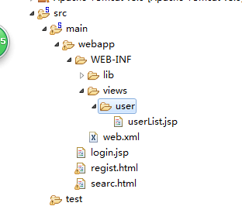

乱码问题
POST请求乱码
<!-- 配置编码过滤器 -->
<filter>
<filter-name>EncodingFilter</filter-name>
<filter-class>org.springframework.web.filter.CharacterEncodingFilter</filter-class>
<init-param>
<param-name>encoding</param-name>
<param-value>UTF-8</param-value>
</init-param>
</filter>
<filter-mapping>
<filter-name>EncodingFilter</filter-name>
<url-pattern>/*</url-pattern>
</filter-mapping>

GET请求乱码
Tomcat8 默认进行了url编码，get请求不乱码，Tomcat7会乱码
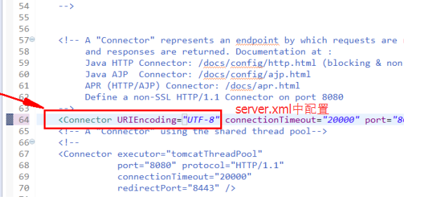

SpringMVC的注解开发

2.1 RequestMapping讲解

配置请求路径映射路径
写法：
@RequestMapping(“list”)
@RequestMapping(“/list”)
@RequestMapping(value=”/list”)
@RequestMapping(value = "/list3",method=RequestMethod.POST) 只能使用POST方法
@RequestMapping(value = "/list3",method=RequestMethod.Get) 只能使用GET方法
@Controller
public class UserController{
@RequestMapping("list")
public String list() {
System.out.println("list");
return "/user/userList";
}
@RequestMapping("/list1.do")
public String list1() {
System.out.println("list1");
return "/user/userList";
}
@RequestMapping(value="/list2")
public String list2() {
System.out.println("list2");
return "/user/userList";
}
@RequestMapping(value="/list3",method=RequestMethod.POST)
public String list3() {
System.out.println("list3");
return "/user/userList";
}
}

自定义根路径
可以控制器上添加一个RequestMapping,如图
@Controller
@RequestMapping("/user")
public class UserController {
@RequestMapping("/list.do")
public String list() {
System.out.println("list");
return "user/userList";
}
}

2.3接收请求参数

封装参数分析
参数类型有：基本类型，int，String等等基本类型, Pojo类
Springmvc参数封装：基于方法进行封装。

接收int,String,Date，数组类型
在views/user中提供一个form表单
<%@ page language="java" contentType="text/html; charset=utf-8"
pageEncoding="utf-8"%>
<!DOCTYPE html>
<html>
<head>
<meta charset="utf-8">
<title>注册页面</title>
</head>
<body>
<form action="${pageContext.request.contextPath}/user/register.do" method="post">
用户名:<input type="text" name="username"/><br>
密码:<input type="text" name="password"/><br>
性别:<input type="text" name="gender"/><br>
年龄:<input type="text" name="age"/><br>
生日:<input type="text" name="birthday"/><br>
爱好:<input type="checkbox" name="hobbyIds" value="1"/>蓝球
<input type="checkbox" name="hobbyIds" value="2"/>足球
<input type="checkbox" name="hobbyIds" value="3"/>排球<br>
<input type="submit" value="注册"/>
</form>
</body>
</html>
在UserController提供一个用户注册的方法
@RequestMapping("/user")
public class UserController {
@RequestMapping("/list.do")
public String list() {
System.out.println("list");
return "user/userList";
}
@RequestMapping("/regist.do")
public String regist() {
return "user/regist";
}
@RequestMapping("/register.do")
public String register(int age,String username,String password,
@DateTimeFormat(pattern="yyyy-MM-dd")Date birthday,String[]hobbyIds) {
System.out.println(age);
System.out.println(username);
System.out.println(password);
System.out.println(birthday);
return "user/info";
}
}

接收pojo类型
创建一个pojo User类型
public class User {
private String username;
private String password;
private String gender;
private int age;
private String[]hobbyIds;
@DateTimeFormat(pattern="yyyy-MM-dd")//注意日期要定义格式
private Date birthday;
配置一个注册方法
@RequestMapping("/register2.do")
public String register2(User user) {
System.out.println(user.getUsername());
return "user/info";
}
<form action="${pageContext.request.contextPath}/user/register2.do" method="post">
用户名:<input type="text" name="username"/><br>
密码:<input type="text" name="password"/><br>
性别:<input type="text" name="gender"/><br>
年龄:<input type="text" name="age"/><br>
生日:<input type="text" name="birthday"/><br>
爱好:<input type="checkbox" name="hobbyIds" value="1"/>蓝球
<input type="checkbox" name="hobbyIds" value="2"/>足球
<input type="checkbox" name="hobbyIds" value="3"/>排球<br>
<input type="submit" value="注册"/>
</form>

接收包装类型参数
把User写成一个类的属性
package com.neuedu.ws.pojo;
//用户的一个扩展类
public class UserVO {
private User user;
private String name;
public User getUser() {
return user;
}
public void setUser(User user) {
this.user = user;
}
public String getName() {
return name;
}
public void setName(String name) {
this.name = name;
}
}
添加一个注册方法
@RequestMapping("/register3.do")
public String register3(UserVO uservo) {
System.out.println(uservo.getUser().getBirthday());
return "user/info";
}
修改form表单
<form action="${pageContext.request.contextPath}/user/register3.do" method="post">
用户名:<input type="text" name="user.username"/><br>
密码:<input type="text" name="user.password"/><br>
性别:<input type="text" name="user.gender"/><br>
年龄:<input type="text" name="user.age"/><br>
生日:<input type="text" name="user.birthday"/><br>
爱好:<input type="checkbox" name="user.hobbyIds" value="1"/>蓝球
<input type="checkbox" name="user.hobbyIds" value="2"/>足球
<input type="checkbox" name="user.hobbyIds" value="3"/>排球<br>
<input type="submit" value="注册"/>
</form>

接收集合List类型参数
在User扩展中添加一个集合
//用户的一个扩展类
public class UserVO {
private User user;
private List<User>userList=new ArrayList<User>();//用于接收集合类型
添加一个注册 的方法，参数写UserVO
@RequestMapping("/register4.do")
public String register4(UserVO uservo) {
for(User user:uservo.getUserList()) {
System.out.println(user.getUsername());
}
return "user/info";
}
表单
<form action="${pageContext.request.contextPath}/user/register4.do" method="post">
用户名:<input type="text" name="userList[0].username"/><br>
密码:<input type="text" name="userList[0].password"/><br>
用户名:<input type="text" name="userList[1].username"/><br>
密码:<input type="text" name="userList[1].password"/><br>
性别:<input type="text" name="userList[0].gender"/><br>
年龄:<input type="text" name="userList[0].age"/><br>
生日:<input type="text" name="userList[0].birthday"/><br>
爱好:<input type="checkbox" name="userList[0].hobbyIds" value="1"/>蓝球
<input type="checkbox" name="userList[0].hobbyIds" value="2"/>足球
<input type="checkbox" name="userList[0].hobbyIds" value="3"/>排球<br>
<input type="submit" value="注册"/>
</form>

接收集合Map类型参数
UserExt上添加一个Map
//用户的一个扩展类
public class UserVO {
private User user;
private List<User>userList=new ArrayList<User>();//用于接收集合类型
private Map<String,Object>infos=new HashMap<>();//使用map接收参数
添加一个注册方法
@RequestMapping("/register5.do")
public String register5(UserVO uservo) {
System.out.println(uservo.getInfos().get("username"));
return "user/info";
}
表单
<form action="${pageContext.request.contextPath}/user/register5.do" method="post">
用户名:<input type="text" name="infos['username']"/><br>
密码:<input type="text" name="infos['password']"/><br>

3 页面回显

3.1 配置一个列表方法
@Controller
@RequestMapping("/user")
public class UserController {
@RequestMapping("/list.do")
public String list(Model model) {
List<User>list=new ArrayList<User>();
User user1=new User();
user1.setId(1);
user1.setUsername("张飞");
user1.setPassword("12345");
user1.setBirthday(new Date());
user1.setGender("man");
list.add(user1);
User user2=new User();
user2.setId(2);
user2.setUsername("张飞");
user2.setPassword("12345");
user2.setBirthday(new Date());
user2.setGender("man");
list.add(user2);
model.addAttribute("userList",list);
return "user/userList";
}

3.2 显示列表数据
<%@ page language="java" contentType="text/html; charset=utf-8"
pageEncoding="utf-8"%>
<%@taglib uri="http://java.sun.com/jsp/jstl/core" prefix="c"%>
<!DOCTYPE html>
<html>
<head>
<meta charset="utf-8">
<title>Insert title here</title>
</head>
<body>
用户列表界面
<table border="1">
<c:forEach items="${userList}" var="user">
<tr>
<td>${user.username }</td>
<td>${user.gender }</td>
<td>${user.birthday }</td>
<td><a href="${pageContext.request.contextPath}/user/edit.do?id={user.id}">修改</a></td>
</tr>
</c:forEach>

</table>
${name}
</body>
</html>
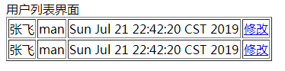

3.3 edit方法
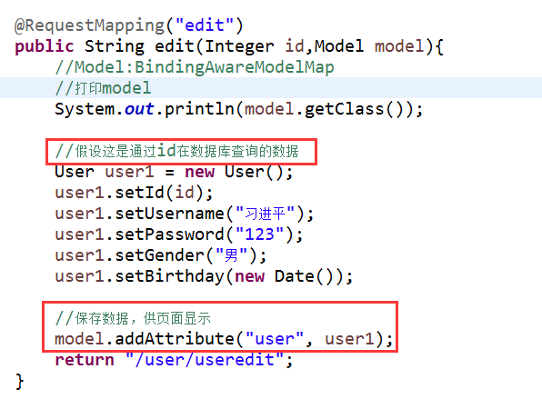

3.4 编辑页面
<form action="${pageContext.request.contextPath}/user/update.do" method="post">
用户Id:${user.id}
用户名:<input type="text" name="username" value="${user.username }"/><br>
密码:<input type="text" name="password" value="${user.password }"/><br>
性别:<input type="text" name="gender" value="${user.gender}"/><br>
<input type="submit" value="修改"/>
</form>

效果
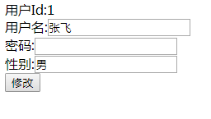

4 ResponseBody和RequestBody

4.1 简介
@ResponseBody把后台pojo转换json对象，返回到页面。
@RequestBody接受前台json数据，把json数据自动封装javaBean

4.2 使用

案例:请求和响应都是json数据

第一步：导入json的jar
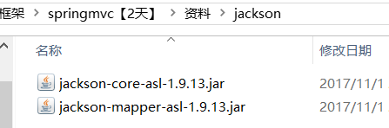

第二步：
添加个json转换器

配置文件
<bean class="org.springframework.web.servlet.mvc.method.annotation.RequestMappingHandlerAdapter">
<property name="messageConverters">
<bean class="org.springframework.http.converter.json.MappingJackson2HttpMessageConverter"/>
</property>
</bean>

第三步：写个jsp页面，提交json请求参数
<form action="#" method="post">
用户名:<input type="text" name="username" id="username"/><span id="span01"></span><br>
密码:<input type="password" name="password" id="password"/><br>
验证码:<input type="text" name="checkCode">
<input type="button" value="提交" id="load"/>
</form>
<script type="text/javascript" src="${pageContext.request.contextPath }/js/jquery-3.2.1.min.js"></script>
<script type="text/javascript">
$(function(){
$("#load").click(function(){
var username=$("#username").val();
var password=$("#password").val();
var url="${pageContext.request.contextPath}/user/login.do";
var json={"username":username,"password":password};
var jsonObj=JSON.stringify(json);

$.ajax({
type:"post",
url:url,
contentType:"application/json;charset=utf-8",
data:jsonObj,
success:function(respData){
alert(respData.username);//获取json属性数据
}
});

});
});
</script>

第四步：后台处理
注意学生类一定要提供无参的构造方法
public class Student {
private String username;
private String password;
@RequestMapping("/user")
public class UserController {
@RequestMapping("/login")
public @ResponseBody Student login(@RequestBody Student stu) {
System.out.println(stu.getUsername()+"====="+stu.getPassword());
return stu;
}

案例:只有响应json数据

第一步：表单
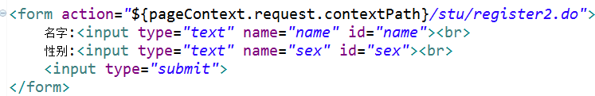

第二步：后台处理
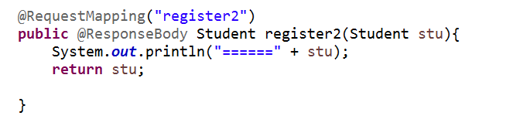

SSM整合
Spring + SpringMVC + Mybatis整合

a：导入jar包
- Spring+ SpringMVC + MyBatis + Mybatis-spring整合包
- AOP联盟+织入 + c3p0 数据库连接池 + MySQL连接驱动 + jstl
<properties>
<!-- spring版本号 -->
<spring.version>4.2.4.RELEASE</spring.version>
<!-- mybatis版本号 -->
<mybatis.version>3.2.6</mybatis.version>
<!-- log4j日志文件管理包版本 -->
<slf4j.version>1.7.7</slf4j.version>
<log4j.version>1.2.17</log4j.version>
</properties>
<dependencies>
<!-- spring核心包 -->
<dependency>
<groupId>org.springframework</groupId>
<artifactId>spring-core</artifactId>
<version>${spring.version}</version>
</dependency>
<dependency>
<groupId>org.springframework</groupId>
<artifactId>spring-web</artifactId>
<version>${spring.version}</version>
</dependency>
<dependency>
<groupId>org.springframework</groupId>
<artifactId>spring-oxm</artifactId>
<version>${spring.version}</version>
</dependency>
<dependency>
<groupId>org.springframework</groupId>
<artifactId>spring-aspects</artifactId>
<version>${spring.version}</version>
</dependency>
<!-- 事务处理 -->
<dependency>
<groupId>org.springframework</groupId>
<artifactId>spring-tx</artifactId>
<version>${spring.version}</version>
</dependency>

<dependency>
<groupId>org.springframework</groupId>
<artifactId>spring-jdbc</artifactId>
<version>${spring.version}</version>
</dependency>

<dependency>
<groupId>org.springframework</groupId>
<artifactId>spring-webmvc</artifactId>
<version>${spring.version}</version>
</dependency>
<dependency>
<groupId>org.springframework</groupId>
<artifactId>spring-aop</artifactId>
<version>${spring.version}</version>
</dependency>
<dependency>
<groupId>org.springframework</groupId>
<artifactId>spring-context-support</artifactId>
<version>${spring.version}</version>
</dependency>
<dependency>
<groupId>org.springframework</groupId>
<artifactId>spring-test</artifactId>
<version>${spring.version}</version>
</dependency>
<!-- mybatis核心包 -->
<dependency>
<groupId>org.mybatis</groupId>
<artifactId>mybatis</artifactId>
<version>${mybatis.version}</version>
</dependency>
<!-- mybatis/spring包 -->
<dependency>
<groupId>org.mybatis</groupId>
<artifactId>mybatis-spring</artifactId>
<version>1.2.2</version>
</dependency>

<!-- 导入Mysql数据库链接jar包 -->
<dependency>
<groupId>mysql</groupId>
<artifactId>mysql-connector-java</artifactId>
<version>5.1.30</version>
</dependency>
<dependency>
<groupId>c3p0</groupId>
<artifactId>c3p0</artifactId>
<version>0.9.1.2</version>
</dependency>
<!-- JSTL标签类 -->
<dependency>
<groupId>jstl</groupId>
<artifactId>jstl</artifactId>
<version>1.2</version>
</dependency>
<!-- 日志文件管理包 -->
<!-- log start -->
<dependency>
<groupId>log4j</groupId>
<artifactId>log4j</artifactId>
<version>${log4j.version}</version>
</dependency>
<!-- 格式化对象，方便输出日志 Json-->
<dependency>
<groupId>com.alibaba</groupId>
<artifactId>fastjson</artifactId>
<version>1.1.41</version>
</dependency>
<dependency>
<groupId>org.slf4j</groupId>
<artifactId>slf4j-api</artifactId>
<version>${slf4j.version}</version>
</dependency>
<dependency>
<groupId>org.slf4j</groupId>
<artifactId>slf4j-log4j12</artifactId>
<version>${slf4j.version}</version>
</dependency>
<!-- log end -->
<!-- 映入JSON -->
<dependency>
<groupId>org.codehaus.jackson</groupId>
<artifactId>jackson-mapper-asl</artifactId>
<version>1.9.13</version>
</dependency>
<dependency>
<groupId>com.fasterxml.jackson.core</groupId>
<artifactId>jackson-core</artifactId>
<version>2.5.0</version>
</dependency>
<dependency>
<groupId>com.fasterxml.jackson.core</groupId>
<artifactId>jackson-databind</artifactId>
<version>2.5.0</version>
</dependency>
<dependency>
<groupId>com.fasterxml.jackson.core</groupId>
<artifactId>jackson-annotations</artifactId>
<version>2.5.0</version>
</dependency>
<!-- 上传组件包 -->
<dependency>
<groupId>commons-fileupload</groupId>
<artifactId>commons-fileupload</artifactId>
<version>1.3.1</version>
</dependency>
<dependency>
<groupId>commons-io</groupId>
<artifactId>commons-io</artifactId>
<version>2.4</version>
</dependency>
<!-- commons-codec是Apache开源组织提供的用于摘要运算、编码解码的包。常见的编码解码工具Base64、MD5、Hex、SHA1、DES -->
<dependency>
<groupId>commons-codec</groupId>
<artifactId>commons-codec</artifactId>
<version>1.9</version>
</dependency>

<!-- https://mvnrepository.com/artifact/commons-dbcp/commons-dbcp -->
<dependency>
<groupId>commons-dbcp</groupId>
<artifactId>commons-dbcp</artifactId>
<version>1.4</version>
</dependency>

<dependency>
<groupId>jetty</groupId>
<artifactId>servlet-api</artifactId>
<version>2.5-6.0.2</version>
</dependency>
<!-- junit -->
<dependency>
<groupId>junit</groupId>
<artifactId>junit</artifactId>
<version>4.0</version>
</dependency>
</dependencies>
<build>
<plugins>
<plugin>
<groupId>org.apache.maven.plugins</groupId>
<artifactId>maven-compiler-plugin</artifactId>
<configuration>
<source>1.8</source>
<target>1.8</target>
</configuration>
</plugin>
</plugins>
</build>

b：创建一个springmvc文件
<?xml version="1.0" encoding="UTF-8"?>
<beans xmlns="http://www.springframework.org/schema/beans"
xmlns:xsi="http://www.w3.org/2001/XMLSchema-instance"
xmlns:aop="http://www.springframework.org/schema/aop"
xmlns:context="http://www.springframework.org/schema/context"
xmlns:mvc="http://www.springframework.org/schema/mvc"
xmlns:tx="http://www.springframework.org/schema/tx"
xsi:schemaLocation="http://www.springframework.org/schema/beans http://www.springframework.org/schema/beans/spring-beans.xsd
http://www.springframework.org/schema/aop http://www.springframework.org/schema/aop/spring-aop-4.2.xsd
http://www.springframework.org/schema/context http://www.springframework.org/schema/context/spring-context-4.2.xsd
http://www.springframework.org/schema/mvc http://www.springframework.org/schema/mvc/spring-mvc-4.2.xsd
http://www.springframework.org/schema/tx http://www.springframework.org/schema/tx/spring-tx-4.2.xsd">
<!-- 1.配置注解扫描位置 -->
<context:component-scan base-package="com.neuedu.ws"></context:component-scan>
<!-- 2.mvc驱动配置 -->
<mvc:annotation-driven/>
<bean class="org.springframework.web.servlet.mvc.method.annotation.RequestMappingHandlerAdapter">
<property name="messageConverters">
<bean class="org.springframework.http.converter.json.MappingJackson2HttpMessageConverter"/>
</property>
</bean>
<!-- 3.配置视图解析器 -->
<bean class="org.springframework.web.servlet.view.InternalResourceViewResolver">
<property name="prefix" value="/WEB-INF/views/"/>
<property name="suffix" value=".jsp"></property>
</bean>
</beans>

c：在web.xml添加springmvc配置
这次我们更改默认的springmvc配置文件路径
<?xml version="1.0" encoding="UTF-8"?>
<web-app xmlns:xsi="http://www.w3.org/2001/XMLSchema-instance" xmlns="http://java.sun.com/xml/ns/javaee" xsi:schemaLocation="http://java.sun.com/xml/ns/javaee http://java.sun.com/xml/ns/javaee/web-app_2_5.xsd" version="2.5">
<servlet>
<servlet-name>DispatcherServlet</servlet-name>
<servlet-class>org.springframework.web.servlet.DispatcherServlet</servlet-class>
<init-param>
<!-- 修改黑底springmvc加载的配置文件路径 -->
<param-name>contextConfigLocation</param-name>
<param-value>classpath:springmvc.xml</param-value>
</init-param>
<load-on-startup>1</load-on-startup>
</servlet>
<servlet-mapping>
<servlet-name>DispatcherServlet</servlet-name>
<url-pattern>*.do</url-pattern>
</servlet-mapping>
<!-- 配置编码过滤器 -->
<filter>
<filter-name>EncodingFilter</filter-name>
<filter-class>org.springframework.web.filter.CharacterEncodingFilter</filter-class>
<init-param>
<param-name>encoding</param-name>
<param-value>UTF-8</param-value>
</init-param>
</filter>
<filter-mapping>
<filter-name>EncodingFilter</filter-name>
<url-pattern>/*</url-pattern>
</filter-mapping>
</web-app>

d：先配置一个Controller跑出一个页面
@Controller  @RequestMapping("user")  public class UserController {  @RequestMapping("list")  public String list() {  return "user/list";  }  } | <%@ page language="java" contentType="text/html; charset=utf-8"  pageEncoding="utf-8"%>  <!DOCTYPE html>  <html>  <head>  <meta charset="utf-8">  <title>Insert title here</title>  </head>  <body>  <h1>list</h1>  </body>  </html>

JSON验证 ResponseBody和RequestBody

第一步：
添加个json转换器

配置文件
<bean class="org.springframework.web.servlet.mvc.method.annotation.RequestMappingHandlerAdapter">
<property name="messageConverters">
<bean class="org.springframework.http.converter.json.MappingJackson2HttpMessageConverter"/>
</property>
</bean>

第二步：写个jsp页面，提交json请求参数
<form action="#" method="post">
用户名:<input type="text" name="username" id="username"/><span id="span01"></span><br>
密码:<input type="password" name="password" id="password"/><br>
验证码:<input type="text" name="checkCode">
<input type="button" value="提交" id="load"/>
</form>
<script type="text/javascript" src="${pageContext.request.contextPath }/js/jquery-3.2.1.min.js"></script>
<script type="text/javascript">
$(function(){
$("#load").click(function(){
var username=$("#username").val();
var password=$("#password").val();
var url="${pageContext.request.contextPath}/user/login.do";
var json={"username":username,"password":password};
var jsonObj=JSON.stringify(json);

$.ajax({
type:"post",
url:url,
contentType:"application/json;charset=utf-8",
data:jsonObj,
success:function(respData){
alert(respData.username);//获取json属性数据
}
});

});
});
</script>

第三步：后台处理
注意学生类一定要提供无参的构造方法
public class Student {
private String username;
private String password;
@RequestMapping("/user")
public class UserController {
@RequestMapping("/login")
public @ResponseBody Student login(@RequestBody Student stu) {
System.out.println(stu.getUsername()+"====="+stu.getPassword());
return stu;
}

e：通过MyBatis的逆向工程生成JavaBean/Mapper

f：修改ItemsMapper.java和ItemsMapper.xml
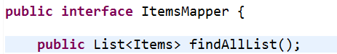
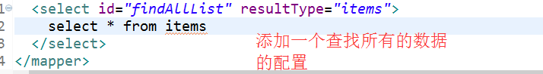

g：定义Service层接口并实现
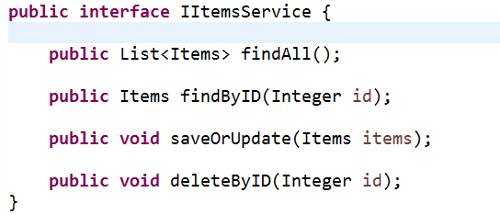
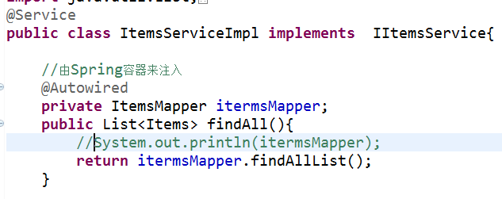

h：配置SqlMappingConfig.xml、mybatis
<?xml version="1.0" encoding="UTF-8" ?>
<!DOCTYPE configuration
PUBLIC "-//mybatis.org//DTD Config 3.0//EN"
"http://mybatis.org/dtd/mybatis-3-config.dtd">
<configuration>
<!-- 别名配置 -->
<typeAliases>
<!-- 批量配置别名：指定批量定义别名的类包，别名为类名（首字母大小写都可） -->
<package name="com.neuedu.ws.pojo"/>
</typeAliases>
<mappers>
<!-- 批量加载映射文件 -->
<package name="com.neuedu.ws.mapper"/>
</mappers>
</configuration>

i：创建spring的applicaiontContext.xml
配置数据源和mybaties的session工厂
<?xml version="1.0" encoding="UTF-8"?>
<beans xmlns="http://www.springframework.org/schema/beans"
xmlns:xsi="http://www.w3.org/2001/XMLSchema-instance"
xmlns:context="http://www.springframework.org/schema/context"
xmlns:aop="http://www.springframework.org/schema/aop"
xmlns:tx="http://www.springframework.org/schema/tx"
xsi:schemaLocation="http://www.springframework.org/schema/beans
http://www.springframework.org/schema/beans/spring-beans.xsd
http://www.springframework.org/schema/context
http://www.springframework.org/schema/context/spring-context.xsd
http://www.springframework.org/schema/aop
http://www.springframework.org/schema/aop/spring-aop.xsd
http://www.springframework.org/schema/tx
http://www.springframework.org/schema/tx/spring-tx.xsd">
</beans>

j：配置c3p0数据源和mybatis的会话工厂
<!-- 1.加载db配置文件 -->
<context:property-placeholder location="classpath:db.properties"/>

<!-- 2.配置c3p0数据源 -->
<bean id="dataSource" class="com.mchange.v2.c3p0.ComboPooledDataSource">
<property name="driverClass" value="${jdbc.driver}"/>
<property name="jdbcUrl" value="${jdbc.url}"/>
<property name="user" value="${jdbc.username}"/>
<property name="password" value="${jdbc.password}"/>
<property name="maxPoolSize" value="30"/>
<property name="minPoolSize" value="2"/>
</bean>

<!-- 3.让spring管理sqlsessionFactory -->
<bean class="org.mybatis.spring.SqlSessionFactoryBean" id="sqlSessionFactoryBean">
<property name="dataSource" ref="dataSource"/>
<!-- 指定配置文件位置 -->
<property name="configLocation" value="classpath:SqlMapConfig.xml"/>
</bean>

<!-- 4.配置mapper扫描器.批量扫描创建代理对象 -->
<bean class="org.mybatis.spring.mapper.MapperScannerConfigurer">
<property name="basePackage" value="com.neuedu.ws.mapper"/>
<property name="sqlSessionFactoryBeanName" value="sqlSessionFactoryBean"/>
</bean>
db文件内容
jdbc.driver=com.mysql.jdbc.Driver
jdbc.url=jdbc:mysql://localhost:3306/wsshop
jdbc.username=root
jdbc.password=root

k：Web.xml配置spring容器
<!-- spring的配置 -->
<context-param>
<param-name>contextConfigLocation</param-name>
<param-value>classpath:config/applicationContext.xml</param-value>
</context-param>
<listener>
<listener-class>org.springframework.web.context.ContextLoaderListener</listener-class>
</listener>

l：添加bean的注解装配
<!-- 配置扫描注解 -->
<context:component-scan base-package="com.neuedu.ws"/>

m：ItemsService
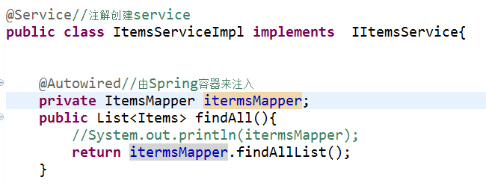

n：ItemsController
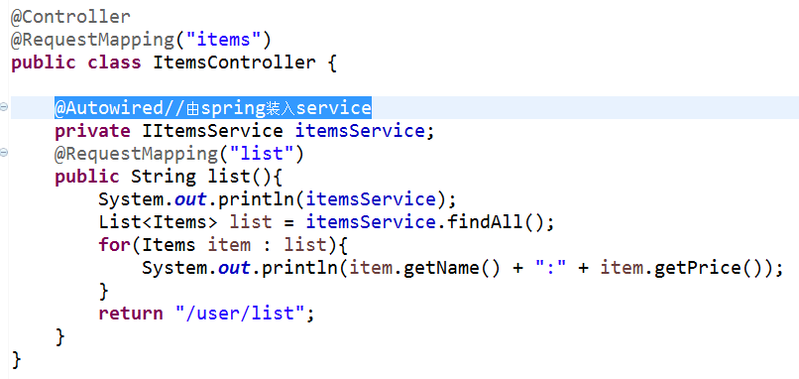
这里可以方法items/list.do，是否可以获取数据

o：事务配置
Spring中Propagation类的事务属性详解：
REQUIRED：支持当前事务，如果当前没有事务，就新建一个事务。这是最常见的选择。
SUPPORTS：支持当前事务，如果当前没有事务，就以非事务方式执行。
MANDATORY：支持当前事务，如果当前没有事务，就抛出异常。
REQUIRES_NEW：新建事务，如果当前存在事务，把当前事务挂起。
NOT_SUPPORTED：以非事务方式执行操作，如果当前存在事务，就把当前事务挂起。
NEVER：以非事务方式执行，如果当前存在事务，则抛出异常。
NESTED：支持当前事务，如果当前事务存在，则执行一个嵌套事务，如果当前没有事务，就新建一个事务

<!-- 5.事务管理器 -->
<bean id="transactionManager" class="org.springframework.jdbc.datasource.DataSourceTransactionManager">
<property name="dataSource" ref="dataSource"/>
</bean>
<!-- 6.通知 -->
<tx:advice id="txAdvice" transaction-manager="transactionManager">
<tx:attributes>
<!-- 传播行为 -->
<tx:method name="save*" propagation="REQUIRED"/>
<tx:method name="insert*" propagation="REQUIRED"/>
<tx:method name="delete*" propagation="REQUIRED"/>
<tx:method name="update*" propagation="REQUIRED"/>
<tx:method name="find*" propagation="SUPPORTS" read-only="true"/>
<tx:method name="get*" propagation="SUPPORTS" read-only="true"/>
</tx:attributes>
</tx:advice>

<!-- 7. 切面 -->
<aop:config>
<aop:advisor advice-ref="txAdvice"
pointcut="execution(* com.neuedu.ws.service.*.*(..))"/>
</aop:config>
<!-- 5.配置事务管理器 -->
<bean id="transactionManager" class="org.springframework.jdbc.datasource.DataSourceTransactionManager">
<property name="dataSource" ref="dataSource"/>
</bean>
<!-- 6.开启事务注解-->
<tx:annotation-driven></tx:annotation-driven>

