CUSTOMER CHURN RISK & RETENTION ANALYTICS
AICTE | IBM SkillsBuild Data Analytics with AI Internship 2026
Project Report

1. Executive Summary
Customer Churn Risk & Retention Analytics is a data analytics and machine learning project designed to identify customer churn patterns, estimate individual churn risk, and convert the analysis into actionable retention insights. The project uses the IBM Telco Customer Churn dataset downloaded from Kaggle.
The analytical workflow covers data loading, cleaning, exploratory data analysis, business KPI calculation, churn-driver analysis, Logistic Regression modelling, model evaluation, customer risk segmentation, and revenue-at-risk analysis.
The final objective is not only to predict churn, but to help a business understand which customer segments show higher observed churn and which customers may require further retention attention.

2. Problem Statement
Customer churn can affect recurring revenue and customer relationships. A business needs a systematic way to understand historical churn patterns and identify customers with higher predicted churn probability. This project addresses the problem by using customer service, contract, tenure, payment and account-related information to build a churn prediction and risk-segmentation workflow.

3. Objectives
- Load and validate the Kaggle customer churn dataset.
- Clean data and handle invalid or missing values.
- Explore churn patterns across important customer segments.
- Calculate business-oriented KPIs.
- Build a Logistic Regression churn classification model.
- Evaluate the model using Accuracy, Precision, Recall, F1 Score and ROC-AUC.
- Assign customers to Low, Medium and High churn-risk groups using project-defined thresholds.
- Estimate monthly charges associated with the high-risk group.
- Convert analytical findings into possible retention actions.

4. Dataset
Dataset used: IBM Telco Customer Churn dataset, downloaded from Kaggle.
The dataset contains customer-level information such as tenure, contract type, internet service, payment method, monthly charges, total charges and churn status.
Dataset source:
https://www.kaggle.com/datasets/blastchar/telco-customer-churn
The dataset was loaded locally from the CSV file downloaded by the project author.

5. Technologies Used
- Python
- Jupyter Notebook
- Pandas
- NumPy
- Matplotlib
- Seaborn
- Scikit-learn
- Logistic Regression
- Kaggle dataset

6. Project Workflow
Raw Data → Data Cleaning → Exploratory Data Analysis → Business KPIs → Churn Driver Analysis → Machine Learning → Model Evaluation → Risk Segmentation → Revenue-at-Risk Analysis → Business Insights → Retention Actions

7. Data Preparation
- Converted TotalCharges to numeric format; invalid values were treated as missing.
- Removed rows without a valid churn target.
- Filled missing TotalCharges values using the median.
- Removed duplicate records.
- Created Churn_Flag where Yes = 1 and No = 0.
- Excluded customerID and target-related columns from model training to avoid target leakage.
- Used one-hot encoding for categorical variables and standard scaling for numeric variables.

8. Exploratory Data Analysis
The notebook examined overall churn distribution and churn rates across contract type, tenure group, internet service and payment method. These comparisons were used to identify segments with comparatively higher observed churn rates.

9. Business KPIs — Actual Results
KPI | Actual Value
Total Customers | 7,043
Churned Customers | 1,869
Churn Rate | 26.54%
Average Monthly Charges | 64.76
Total Monthly Charges | 456,116.60

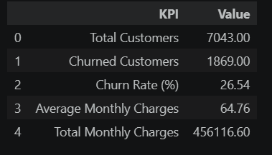
Figure 1. Actual KPI output from the executed notebook.

10. Machine Learning Model
A Logistic Regression classification model was trained using an 80/20 stratified train-test split. Numeric variables were imputed and standardized, while categorical variables were imputed and one-hot encoded. Class weighting was used to account for the imbalance between churned and non-churned customers.

11. Model Evaluation — Actual Results
Metric | Score
Accuracy | 0.7381
Precision | 0.5043
Recall | 0.7834
F1 Score | 0.6136
ROC-AUC | 0.8413

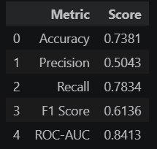
Figure 2. Actual model evaluation metrics.

12. Confusion Matrix
The confusion matrix from the executed test set contains 747 true negatives, 288 false positives, 81 false negatives and 293 true positives.
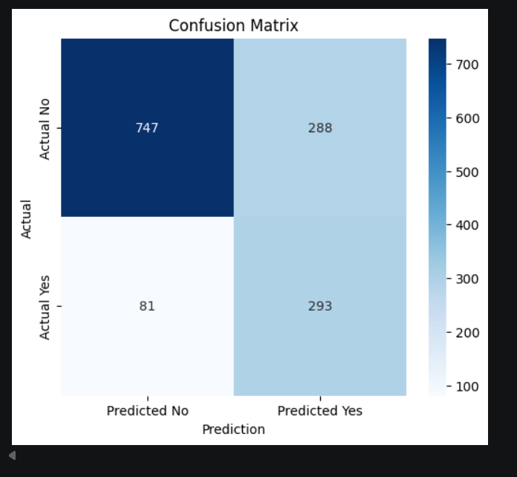
Figure 3. Actual confusion matrix.

13. ROC Curve
The ROC curve produced an AUC of 0.8413 on the test set.
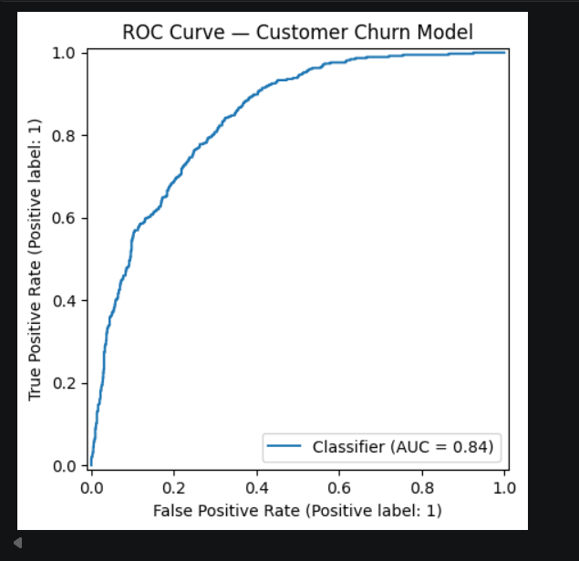
Figure 4. Actual ROC curve.

14. Customer Risk Segmentation
The trained model generated a churn probability for each customer. For project segmentation, probabilities below 35% were labelled Low Risk, 35% to 65% Medium Risk, and above 65% High Risk.
Risk Tier | Customers
Low | 3,254
Medium | 1,703
High | 2,086

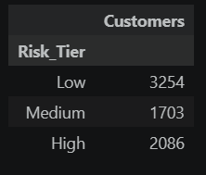
Figure 5. Actual customer risk distribution.

15. Revenue-at-Risk Analysis
The model classified 2,086 customers as High Risk. The monthly charges associated with these high-risk customers were calculated as 164,795.80.
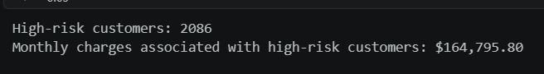
Figure 6. Actual high-risk customer and monthly-charge output.

16. Key Business Insights — Actual Results
- Overall observed churn rate: 26.54%.
- Month-to-month contract customers had the highest observed churn rate among the contract segments at 42.71%.
- Fiber optic customers had the highest observed churn rate among the internet-service segments at 41.89%.
- Electronic check customers had the highest observed churn rate among the payment-method segments at 45.29%.
- 2,086 customers were classified as High Risk by the project's model-based segmentation.
- Monthly charges associated with the High Risk group were 164,795.80.
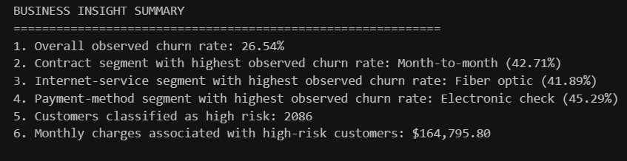
Figure 7. Actual business insight summary generated by the notebook.

17. Risk, Opportunity and Action
Risk:
A substantial customer group is classified as High Risk by the project model. The high-risk group can therefore be used as a prioritization list for further customer review.
Opportunity:
The observed differences across contract, internet-service and payment-method segments provide areas for further investigation and targeted retention experiments.
Possible Actions:
- Prioritize high-risk customers for retention outreach.
- Investigate customer experience for month-to-month contracts.
- Review service-related issues among high-churn internet-service segments.
- Investigate payment experience for customers using electronic checks.
- Monitor churn after retention interventions to measure whether the interventions are effective.

18. Limitations
- The dataset represents historical customer information; predictions do not guarantee future customer behaviour.
- Risk thresholds used for Low, Medium and High are project-defined segmentation thresholds.
- Observed segment-level churn rates describe associations in this dataset and do not by themselves establish causation.
- Business interventions should be tested and evaluated using future outcomes.

19. How to Run the Project
- Install the libraries listed in requirements.txt.
- Open the .ipynb notebook in Jupyter Notebook or JupyterLab.
- In the dataset-path cell, replace the example path with the local path to the downloaded Kaggle CSV.
- Run the notebook cells sequentially.
- Verify the final project verification cell.

20. Submission Deliverables
The internship session specifies four main files for submission: code file, requirements.txt, project report and README.md, together with the GitHub repository link. The session also states that the dataset link should be included in the README.
- Niharika_Tiwari_Customer_Churn_Retention_Analytics.ipynb
- requirements.txt
- Niharika_Tiwari_Customer_Churn_Retention_Analytics_ProjectReport.docx
- README.md
- GitHub repository link

21. Conclusion
This project demonstrates an end-to-end customer churn analytics workflow. It combines data preparation, exploratory analysis, business KPIs, supervised machine learning, customer risk segmentation and revenue-at-risk analysis. The executed results provide a structured basis for identifying customer groups that may require further retention investigation and for translating analytical findings into potential business actions.

