Weather and Air Quality in Bengaluru, 2023–2025: A Data Visualization Study
A PROJECT REPORT
Submitted by
Hiranamyi Kiran Gudekota (1RUA25CSE0191)
Neharika Anant Gowda (1RUA25CSE0290)
Niharika K P (1RUA25CSE0292)
Sai Yashasvi (1RUA25CSE0407)
Sonali (1RUA25CSE0455)
as part of the Continuous Internal Evaluation
for the course
CS2214 Introduction to Data Analysis
Offered in
Semester III
of
B.Tech. (Hons.)

School of Computer Science and Engineering
RV University
RV Vidyaniketan, 8th Mile, Mysore Road, Bengaluru, Karnataka, India - 560059
November 2026
DECLARATION
We, the students listed below, of the 3rd semester B.Tech in Computer Science & Engineering at the School of Computer Science and Engineering, RV University, hereby declare that the project work titled “Weather and Air Quality in Bengaluru, 2023–2025: A Data Visualization Study” has been carried out by us and submitted in partial fulfilment for the award of degree in Bachelor of Technology in Computer Science & Engineering during the academic year 2026-2027. Further, the matter presented in the project has not been submitted previously by anybody for the award of any degree or any diploma to any other University, to the best of our knowledge and faith.

Name | USN | Signature
Hiranamyi Kiran Gudekota | 1RUA25CSE0191
Neharika Anant Gowda | 1RUA25CSE0290
Niharika K P | 1RUA25CSE0292
Sai Yashasvi | 1RUA25CSE0407
Sonali | 1RUA25CSE0455

Place: Bengaluru
Date:


School of Computer Science and Engineering
RV University
RV Vidyaniketan, 8th Mile, Mysore Road, Bengaluru, Karnataka, India – 560059
CERTIFICATE
This is to certify that the project work titled “Weather and Air Quality in Bengaluru, 2023–2025: A Data Visualization Study” is performed by Hiranamyi Kiran Gudekota (1RUA25CSE0191); Neharika Anant Gowda (1RUA25CSE0290); Niharika K P (1RUA25CSE0292); Sai Yashasvi (1RUA25CSE0407); Sonali (1RUA25CSE0455), bonafide students of Bachelor of Technology at the School of Computer Science and Engineering, RV University, Bengaluru, as part of the Continuous Internal Evaluation for the course CS2214 Introduction to Data Analysis offered in Semester III of Bachelor of Technology in Computer Science & Engineering, during the Academic year 2026-2027.

Name of Course Faculty:
Signature with date of Faculty:
TABLE OF CONTENTS

 | TITLE
 | LIST OF FIGURES | i
 | LIST OF SYMBOLS AND ABBREVIATIONS | ii
1.0 | INTRODUCTION | 1
1.1 | Background | 1
1.2 | Problem Statement | 1
1.3 | Objectives | 1
1.4 | Scope and Limitations | 1
1.5 | Organisation of the Report | 2
2.0 | DATASET AND METHODOLOGY | 3
2.1 | Data Source and Selection | 3
2.2 | Location, Period and Sampling Approach | 3
2.3 | Dataset Description | 3
2.4 | Data Preparation and Cleaning | 4
2.5 | Derived Variables and Benchmarks | 4
2.6 | Tools and Reproducibility | 5
3.0 | METHOD OF ANALYSIS | 6
3.1 | Descriptive Statistics | 6
3.2 | Seasonal and Monthly Aggregation | 6
3.3 | Comparison of Rainy and Dry Days | 6
3.4 | Correlation Analysis | 6
3.5 | Comparison with Benchmarks | 6
3.6 | Visualization Design | 6
4.0 | RESULTS AND DISCUSSION | 8
4.1 | Overview of the Data | 8
4.2 | Seasonal Pattern of Weather | 9
4.3 | Air Quality Through the Years | 10
4.4 | PM2.5 by Month and Rainfall | 11
4.5 | Rainy Days and Dry Days | 12
4.6 | Air-Quality Categories by Season | 13
4.7 | Relationships Between Variables | 14
4.8 | Key Findings | 14
4.9 | Recommendations | 15
4.10 | Limitations of the Study | 15
5.0 | CONCLUSION | 16
6.0 | FUTURE SCOPE | 17
 | REFERENCES | 18
 | APPENDIX A: MONTHLY SUMMARY | 19
 | APPENDIX B: PROJECT FILES AND SOURCE CODE | 19

LIST OF FIGURES

Figure 4.1 | Monthly temperature, humidity and rainfall | 9
Figure 4.2 | Calendar heatmap of daily AQI | 10
Figure 4.3 | Daily PM2.5 and 30-day average | 10
Figure 4.4 | Mean PM2.5 by month and average yearly rainfall | 11
Figure 4.5 | PM2.5 on dry and rainy days | 12
Figure 4.6 | AQI categories by season | 13
Figure 4.7 | Spearman correlation heatmap | 14
LIST OF SYMBOLS AND ABBREVIATIONS
Symbol / abbreviation | Meaning
AQI | Air Quality Index (here, the US AQI, scale 0–500)
API | Application Programming Interface
CAMS | Copernicus Atmosphere Monitoring Service
CPCB | Central Pollution Control Board, India
CSV | Comma-separated values (file format)
ECMWF | European Centre for Medium-Range Weather Forecasts
ERA5 | Fifth-generation ECMWF atmospheric reanalysis
IMD | India Meteorological Department
IQR | Interquartile range
NAAQS | National Ambient Air Quality Standards (India)
NO₂ | Nitrogen dioxide
O₃ | Ozone
PM2.5 | Particulate matter with diameter below 2.5 µm
PM10 | Particulate matter with diameter below 10 µm
ρ (rho) | Spearman rank correlation coefficient
SD | Standard deviation
USN | University Seat Number
US EPA | United States Environmental Protection Agency
WHO | World Health Organization
µg/m³ | Micrograms per cubic metre (unit of pollutant concentration)
°C | Degrees Celsius
mm | Millimetres (rainfall depth)

1.0 INTRODUCTION
1.1 Background
Weather and air quality shape daily life, public health and planning in every city. Temperature, humidity and rainfall describe the physical environment. Particulate matter (PM2.5 and PM10), nitrogen dioxide (NO₂) and ozone (O₃) describe the quality of the air people breathe. The two groups of variables are widely reported to be linked: for example, rain can remove particles from the air, and heat and sunlight influence how ozone forms. Looking at them together, day by day, shows when the air is cleaner or more polluted and which weather conditions go along with it.
Bengaluru lies at an elevation of about 914 m and has a moderate climate with a marked monsoon season. Health guidelines give a way to judge the air: the World Health Organization (WHO) 2021 guideline for the 24-hour mean of PM2.5 is 15 µg/m³, and India’s National Ambient Air Quality Standards (NAAQS) set a 24-hour limit of 60 µg/m³. Comparing observed levels with these two benchmarks puts the numbers in context.
1.2 Problem Statement
Using publicly available daily data for Bengaluru from January 2023 to December 2025, how do temperature, humidity and rainfall vary through the year, how does air quality vary alongside them, and in which seasons is the air worst compared with health guidelines?
1.3 Objectives
• Describe the seasonal pattern of temperature, humidity and rainfall in Bengaluru.
• Measure how PM2.5, PM10, NO₂, ozone and the US AQI vary by month and by season.
• Compare air quality on rainy days and dry days.
• Check the observed air quality against WHO and CPCB benchmarks.
• Present the results as clear, labelled Python visualizations with evidence-based findings and practical recommendations.
1.4 Scope and Limitations
The study covers one location (Bengaluru), three years (1,096 days) and ten daily variables. The data are modelled and reanalysed grid values from a public service. They are not readings from a ground monitoring station, and they were not collected by the project group. The analysis is observational. It describes patterns and associations, and it does not establish cause and effect. Three years are enough to describe the yearly cycle but too short to judge long-term climate or pollution trends.
1.5 Organisation of the Report
Chapter 2 describes the dataset, its source and its preparation. Chapter 3 explains the analysis methods and the choice of charts. Chapter 4 presents the results, the figures with interpretations, the findings and the recommendations. Chapters 5 and 6 give the conclusion and the future scope. The references and appendices follow.
2.0 DATASET AND METHODOLOGY
2.1 Data Source and Selection
The data were not collected by our group. They were downloaded from two public application programming interfaces (APIs) run by Open-Meteo (open-meteo.com). Open-Meteo states that its data are licensed under CC BY 4.0, so the source is credited here and on the poster. Table 2.1 lists the two products.
Table 2.1: Data sources used
Product | Underlying data | Variables used | Resolution
Open-Meteo Historical Weather API | ERA5 reanalysis (ECMWF) | Temperature at 2 m, relative humidity at 2 m, precipitation | Hourly
Open-Meteo Air Quality API | CAMS atmospheric composition model (Copernicus / ECMWF) | PM2.5, PM10, NO₂, ozone, US AQI | Hourly

Why this source. The topic asks for daily temperature, humidity, rainfall and air-quality readings from reliable sources. Open-Meteo serves all four for the same place and dates, in a consistent format, without an access key, so the analysis can be repeated by anyone. Its inputs, ERA5 and CAMS, come from established meteorological centres.
2.2 Location, Period and Sampling Approach
• Location: Bengaluru, India (latitude 12.97° N, longitude 77.59° E, elevation about 914 m).
• Period: 1 January 2023 to 31 December 2025, which is 1,096 days.
• Time zone: Asia/Kolkata (IST).
• Download date: 11 November 2026.
• Sampling approach: no sampling. All available hourly values for the period were downloaded and then combined into one row per day.
2.3 Dataset Description
The prepared dataset has 1,096 daily records and 10 attributes with no missing values. Every attribute has a single unit throughout. Table 2.2 gives the meaning, unit and daily aggregation of each attribute.
Table 2.2: Attributes of the daily dataset
Attribute | Meaning | Unit | Daily value from hourly data
date | Calendar date (YYYY-MM-DD) | – | –
temp_mean | Air temperature at 2 m | °C | mean
temp_max | Highest hourly temperature | °C | maximum
temp_min | Lowest hourly temperature | °C | minimum
humidity_mean | Relative humidity at 2 m | % | mean
rainfall_mm | Precipitation | mm | sum
pm25 | Particulate matter below 2.5 µm | µg/m³ | mean
pm10 | Particulate matter below 10 µm | µg/m³ | mean
no2 | Nitrogen dioxide | µg/m³ | mean
ozone | Ozone | µg/m³ | mean
aqi_us | US Air Quality Index | 0–500 | mean of hourly values

2.4 Data Preparation and Cleaning
The two hourly series were joined on the date and aggregated to daily values as shown in Table 2.2. The following checks were then run in code. Table 2.3 gives the result of each and how it was handled.
Table 2.3: Data-quality checks and handling
Check | Result | Handling
Missing values | 0 of 10,960 cells | None needed
Duplicate dates | 0 | None needed
Temperature order (min ≤ mean ≤ max) | Holds on all days | None needed
Humidity between 0 and 100 % | All values valid | None needed
Rainfall and pollutants not negative | All values valid | None needed
Temperature between −10 and 50 °C | All values valid | None needed
Outliers (1.5 × IQR rule) | Present: 140 days for rainfall, 42 for mean temperature, 48 for NO₂, 2 for PM2.5 and 4 for PM10 | Kept. They are real extremes, not errors
Units | One unit per column | None needed

Rainfall has many outliers under the 1.5 × IQR rule because most days have little or no rain, so any wet day lies far above the interquartile range. The highest daily maximum temperature was 39.5 °C on 1 May 2024. These values were not removed. The dataset contains no personal or sensitive information.
2.5 Derived Variables and Benchmarks
Four variables were derived to support the analysis.
• Season: Winter (December–February), Summer (March–May), Monsoon (June–September) and Post-monsoon (October–November).
• AQI category: the US AQI band of each day. Good (0–50), Moderate (51–100), Unhealthy for sensitive groups (101–150), Unhealthy (151–200). No day reached 201 or above.
• Rainy day: a day with rainfall of 2.5 mm or more. Other days are called dry days.
• Year and month: taken from the date.
Table 2.4: Air-quality benchmarks used
Pollutant | WHO 2021 guideline (24-hour) | CPCB NAAQS limit (24-hour)
PM2.5 | 15 µg/m³ | 60 µg/m³
PM10 | 45 µg/m³ | 100 µg/m³

2.6 Tools and Reproducibility
All work was done in Python 3 with pandas and NumPy for data handling, SciPy for the statistical test, and Matplotlib for every chart. The complete workflow, from download to charts, is in a Google Colab notebook (Bengaluru_Weather_AQ_Visualization.ipynb) and in the scripts of the project folder, so every number in this report can be regenerated. Appendix B lists the files.
3.0 METHOD OF ANALYSIS
3.1 Descriptive Statistics
For each variable the mean, standard deviation, minimum, median and maximum were computed over the 1,096 days (Table 4.1). These show the typical level and spread before any comparison is made.
3.2 Seasonal and Monthly Aggregation
Daily values were grouped by season and by calendar month. For month-wise charts, rainfall is the average yearly total for that month (the three-year total divided by three) and the other variables are three-year means. Grouping removes day-to-day noise and shows the yearly cycle.
3.3 Comparison of Rainy and Dry Days
Daily PM2.5 was compared between rainy days (2.5 mm or more) and dry days using medians and a box plot. A Mann–Whitney U test (two-sided) was used as an indicative check of whether the two groups differ. This test makes no assumption that the data are normally distributed. Consecutive days are not fully independent, so the p-value is a guide to the size of the difference and not a precise probability.
3.4 Correlation Analysis
Relationships between variables were measured with the Spearman rank correlation coefficient (ρ). It was chosen over the Pearson coefficient because rainfall is strongly skewed with many zeros, and because the relationships need only be monotonic, not linear. A coefficient near +1 means two variables tend to rise together, near −1 means one tends to fall as the other rises, and near 0 means no consistent link. A correlation is a description of association only.
3.5 Comparison with Benchmarks
The number and share of days above the WHO and CPCB limits (Table 2.4) were counted for PM2.5 and PM10, and the days with a US AQI above 100 were counted, since an AQI above 100 is the point at which air quality is rated unhealthy for sensitive groups.
3.6 Visualization Design
Seven charts were drawn with Matplotlib. Each has a title, labelled axes with units, readable scales and a legend where more than one colour or line is used. Colours were chosen to be distinguishable by readers with colour-vision deficiency: one blue ramp for magnitude, blue and orange for two groups, and a blue–red scale centred on a neutral grey for correlations. No chart uses two vertical axes. Variables with different units are shown in separate panels. Table 3.1 lists the chart types and what each is used for.
Table 3.1: Charts used
Figure | Chart type | Purpose
4.1 | Line plot with band, and bar chart | Monthly temperature, humidity and rainfall
4.2 | Calendar heatmap | Daily AQI across three years
4.3 | Line plot | Daily PM2.5 and its 30-day average
4.4 | Bar chart (two panels) | Monthly PM2.5 against the WHO guideline, with rainfall
4.5 | Box plot | PM2.5 distribution on dry and rainy days
4.6 | Stacked bar chart | Share of days in each AQI category, by season
4.7 | Correlation heatmap | Relationships between weather and pollutants

4.0 RESULTS AND DISCUSSION
4.1 Overview of the Data
Table 4.1: Descriptive statistics of the daily data (1,096 days)
Variable | Unit | Mean | SD | Min | Median | Max
Mean temperature | °C | 23.6 | 2.2 | 18.4 | 23.2 | 31.5
Maximum temperature | °C | 29.3 | 3.0 | 21.4 | 28.6 | 39.5
Minimum temperature | °C | 19.1 | 2.0 | 11.9 | 19.6 | 24.7
Relative humidity | % | 68.8 | 15.2 | 27.2 | 73.3 | 94.0
Rainfall (daily total) | mm | 2.7 | 5.0 | 0.0 | 0.3 | 36.6
PM2.5 | µg/m³ | 20.9 | 12.7 | 2.0 | 20.2 | 66.3
PM10 | µg/m³ | 28.9 | 16.7 | 2.8 | 28.0 | 107.1
NO₂ | µg/m³ | 16.3 | 8.0 | 5.1 | 14.1 | 51.0
Ozone | µg/m³ | 70.5 | 25.7 | 19.0 | 72.3 | 143.4
US AQI | index | 71.8 | 29.7 | 16.8 | 72.7 | 155.6

Daily mean temperature averaged 23.6 °C, with a hottest daily maximum of 39.5 °C (1 May 2024) and a coldest daily minimum of 11.9 °C (11 January 2023). Humidity ranged widely, from 27 % to 94 %. The heaviest rain in one day was 36.6 mm (30 May 2023). Mean PM2.5 was 20.9 µg/m³, with a highest daily value of 66.3 µg/m³ on 26 October 2024. The highest daily AQI was 156 on 2 May 2025. Yearly rainfall totals were 796 mm (2023), 1081 mm (2024) and 1035 mm (2025).
4.2 Seasonal Pattern of Weather
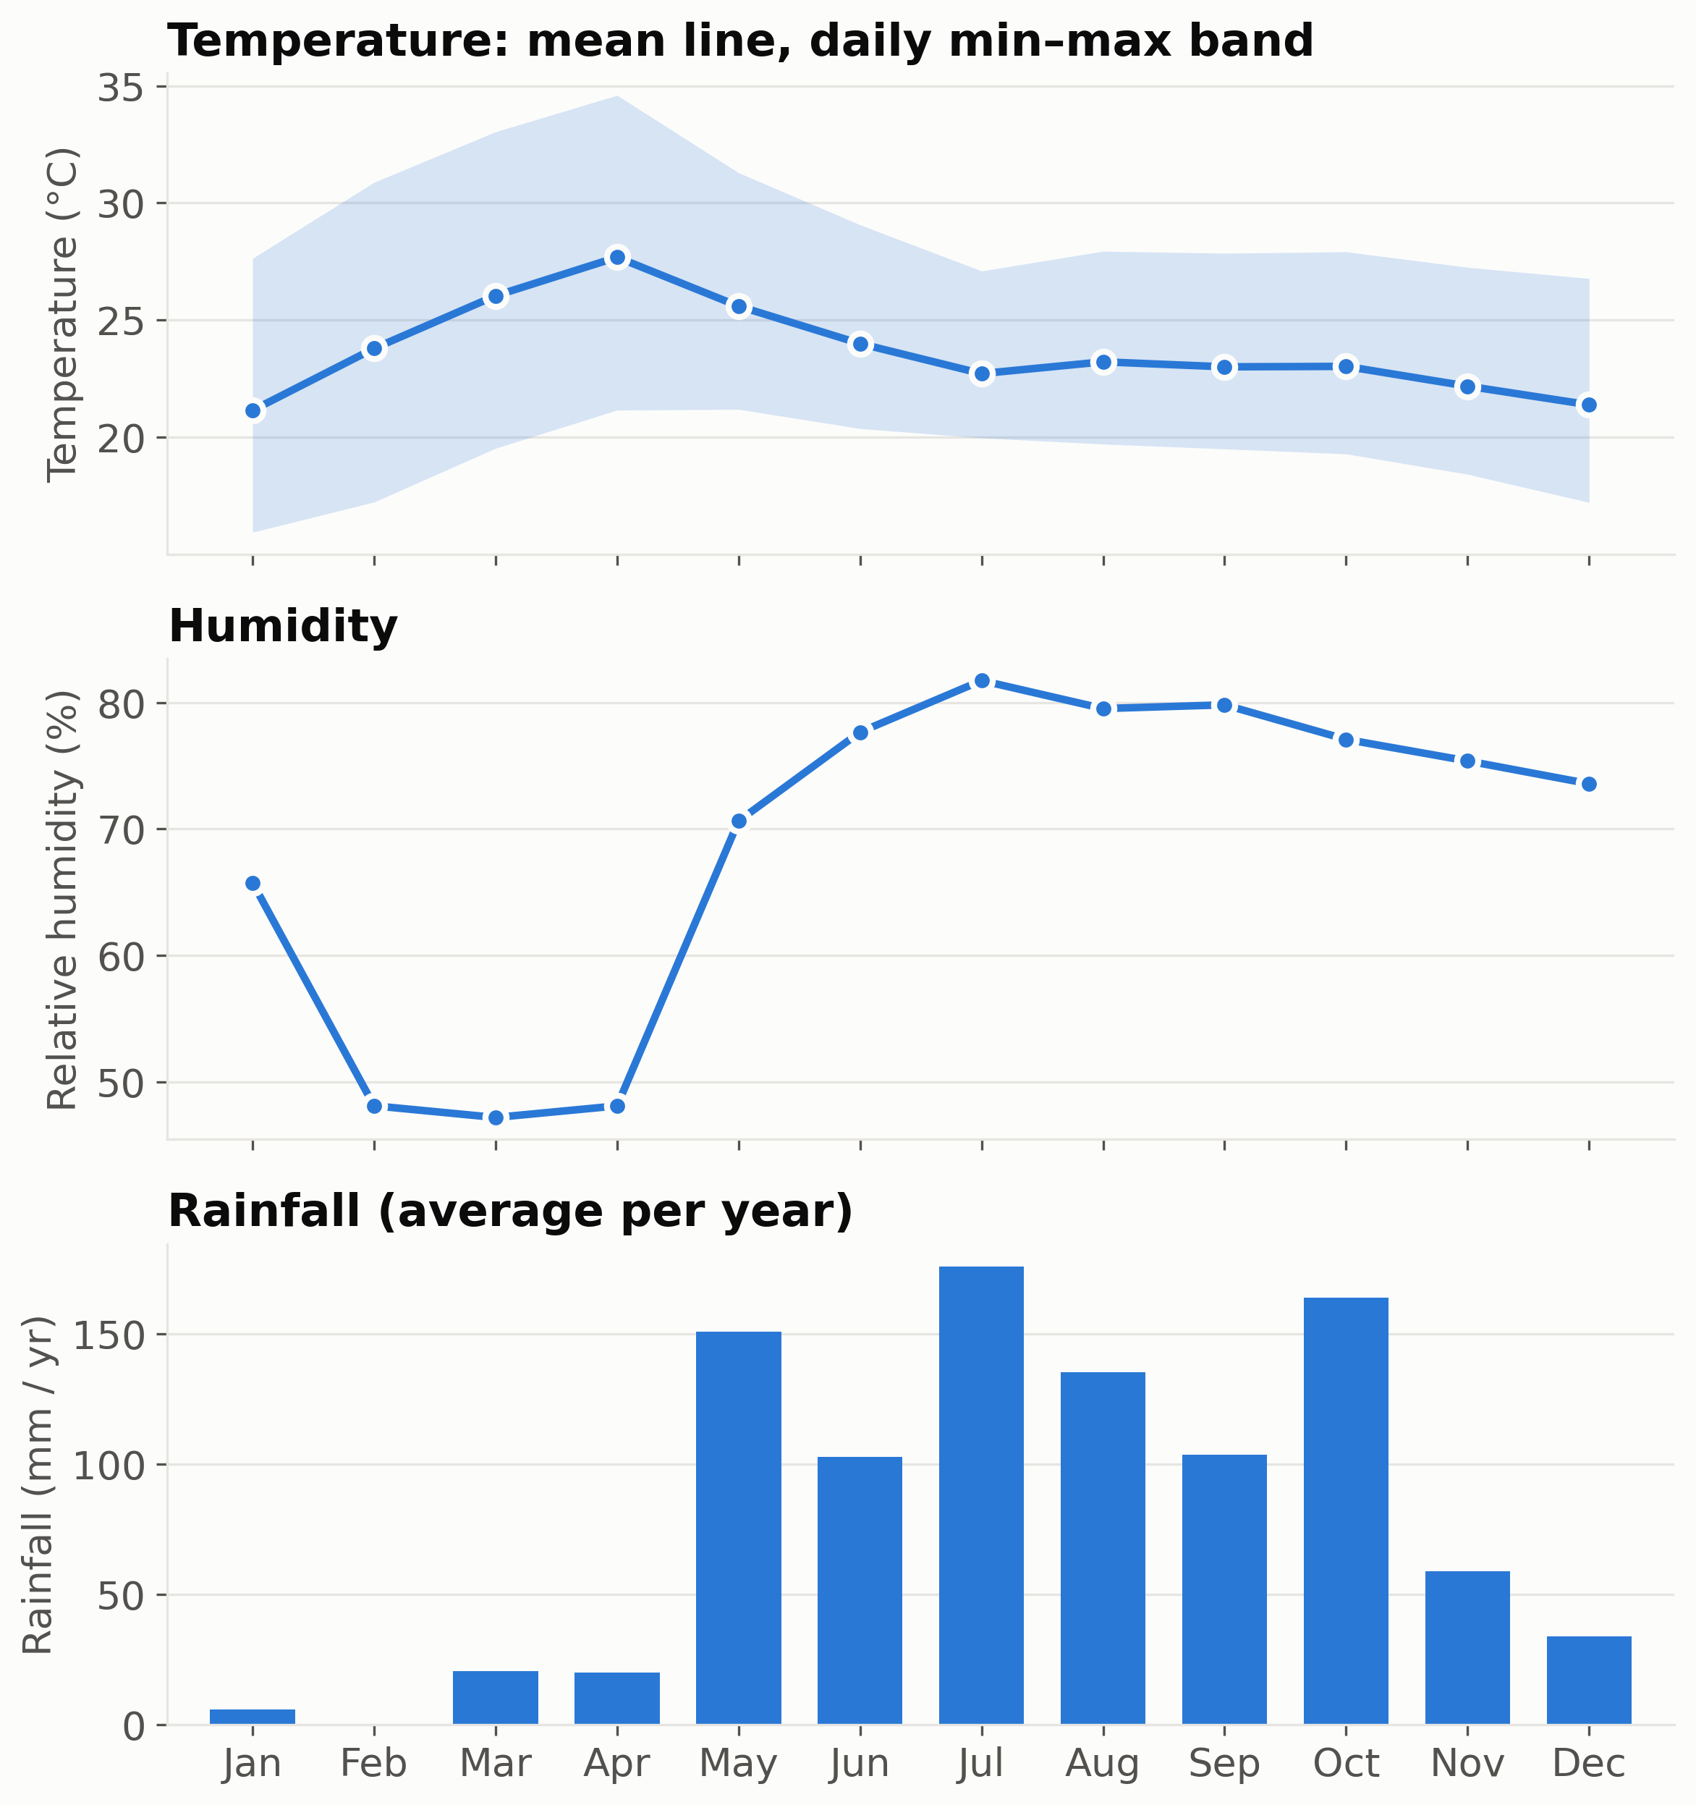
Figure 4.1: Monthly temperature, humidity and rainfall in Bengaluru, 2023–2025 (temperature in °C, humidity in %, rainfall in mm per year).
Figure 4.1 shows the yearly cycle. Mean temperature peaks in April (27.7 °C) and is lowest in January (21.1 °C). The gap between the daily minimum and maximum is widest in the dry months February to April, when the daily maximum averages up to 34.6 °C. Relative humidity is lowest in March (47 %) and highest in July (82 %). Rainfall is concentrated from May to October, with almost none in February. By season, the Monsoon accounts for 53 % of yearly rain (on average 517 mm), against 223 mm in Post-monsoon, 191 mm in Summer and 39 mm in Winter (Table 4.2).
Table 4.2: Seasonal means (rainfall is the average yearly total for the season)
Season | Temp (°C) | Humidity (%) | Rain (mm) | PM2.5 | PM10 | NO₂ | Ozone | AQI
Winter | 22.0 | 63 | 39 | 28.5 | 36.4 | 16.2 | 87 | 88
Summer | 26.4 | 55 | 191 | 26.6 | 37.4 | 19.3 | 92 | 89
Monsoon | 23.2 | 80 | 517 | 9.0 | 14.9 | 11.9 | 44 | 43
Post-monsoon | 22.6 | 76 | 223 | 24.9 | 33.2 | 20.8 | 66 | 80
PM2.5, PM10, NO₂ and ozone are in µg/m³.
4.3 Air Quality Through the Years
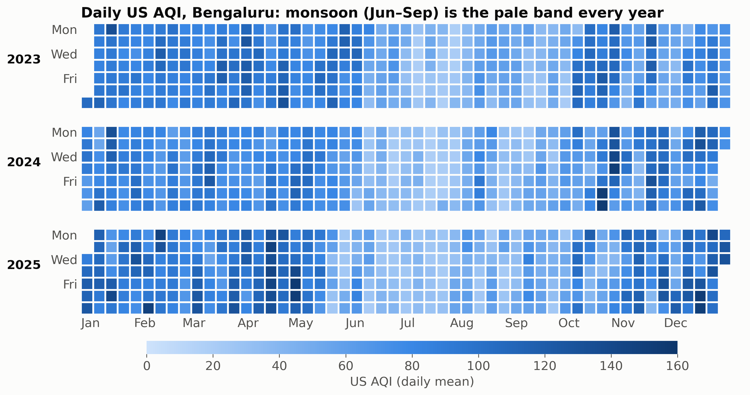
Figure 4.2: Calendar heatmap of the daily US AQI in Bengaluru, 2023–2025. Each square is one day; paler squares mean lower AQI.
In Figure 4.2 the paler squares of the monsoon months, June to September, form a band that repeats in every year, while darker squares dominate January to May and October to December. The highest AQI day was 2 May 2025 (AQI 156). Across the whole period the AQI reached the “unhealthy” band (151–200) on only 7 days.
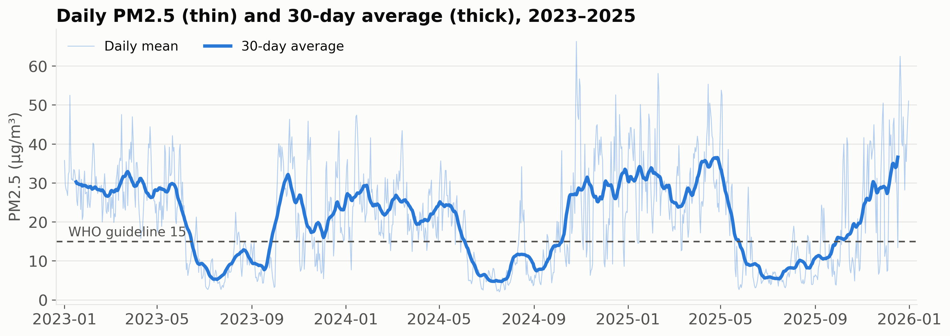
Figure 4.3: Daily PM2.5 (thin line) and its 30-day centred average (thick line), with the WHO guideline of 15 µg/m³ (dashed).
Figure 4.3 shows the same cycle for PM2.5. The 30-day average falls below the WHO guideline during the monsoon of each year and rises above it for the rest of the time. All 86 days above 40 µg/m³ fall outside the monsoon. The highest day, 26 October 2024, reached 66.3 µg/m³. Yearly mean PM2.5 was 21.4, 19.5 and 21.8 µg/m³ in 2023, 2024 and 2025. These are similar, so three years of data show a stable seasonal pattern but no clear long-term trend.
4.4 PM2.5 by Month and Rainfall
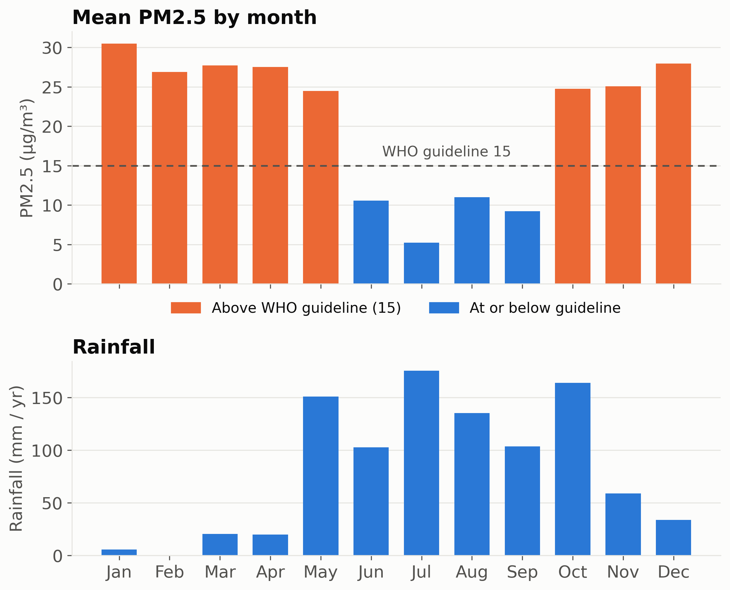
Figure 4.4: Mean PM2.5 by calendar month against the WHO guideline (top) and average yearly rainfall by month (bottom).
Only June to September have a mean PM2.5 at or below 15 µg/m³ (Figure 4.4). July is lowest at 5.2 µg/m³ and January highest at 30.5 µg/m³. The monthly mean is above the WHO guideline in 8 of the 12 months. May deserves a note: it has heavy rain (about 151 mm per year) yet its PM2.5 (24.5 µg/m³) stays above the guideline. Rainfall alone therefore does not explain the monthly pattern. Other factors, such as wind and the mixing of air, are not in this dataset.
4.5 Rainy Days and Dry Days
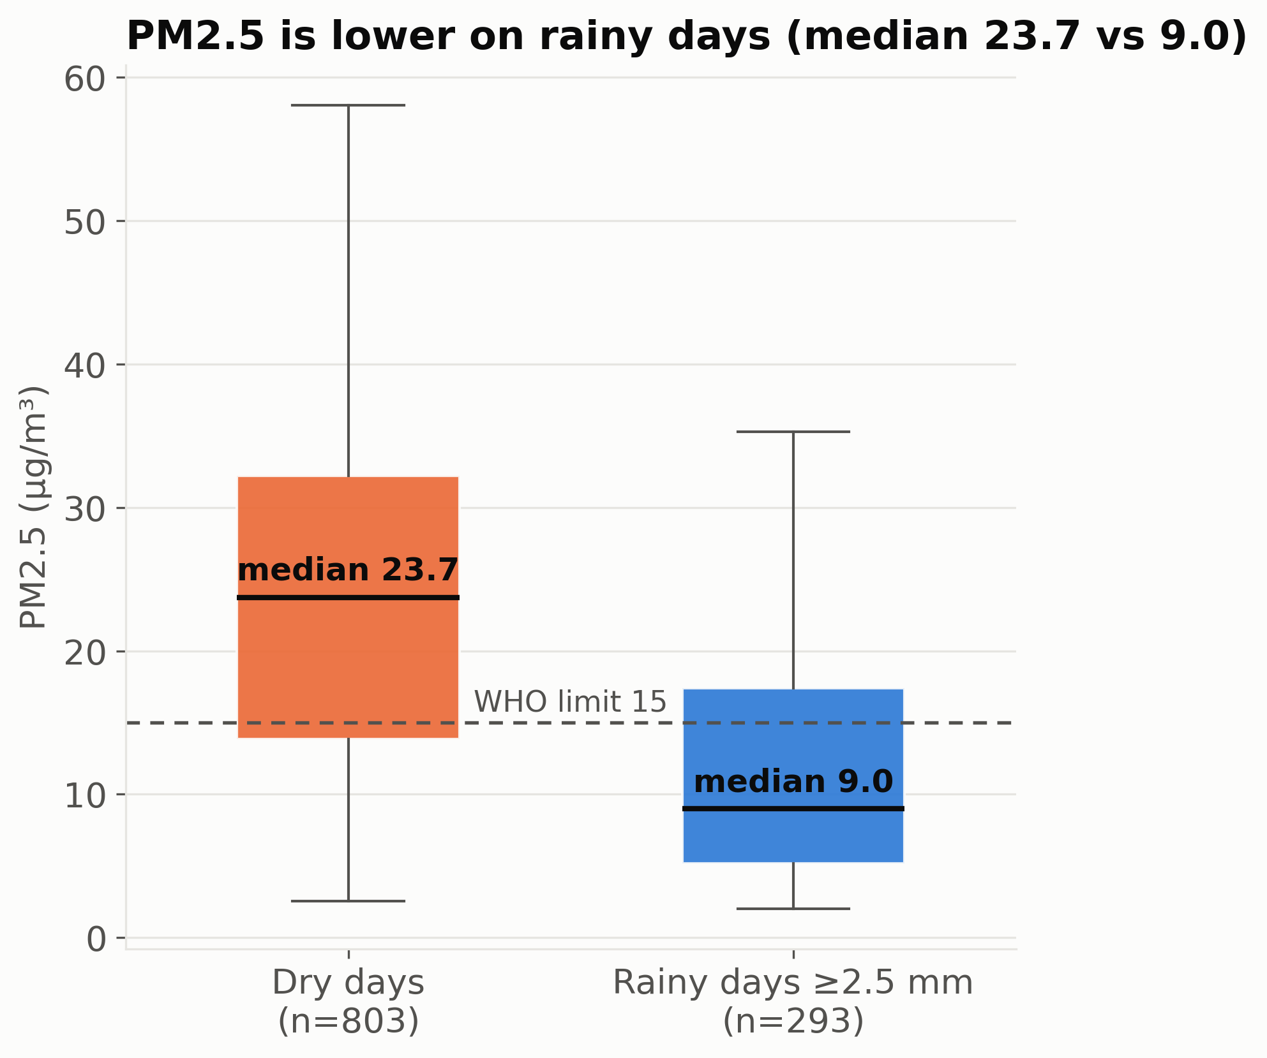
Figure 4.5: Distribution of daily PM2.5 on dry days and rainy days (rainy: 2.5 mm or more). Boxes show the interquartile range; the line is the median.
Table 4.3: Air quality on dry and rainy days
Group | Days | PM2.5 median | PM2.5 mean | PM10 mean | AQI mean | Humidity (%)
Dry days | 803 | 23.7 | 23.8 | 32.9 | 79 | 64
Rainy days | 293 | 9.0 | 12.9 | 18.1 | 53 | 82
PM2.5 and PM10 in µg/m³.
The median PM2.5 was 9.0 µg/m³ on rainy days and 23.7 µg/m³ on dry days, so dry days ran 2.6 times higher at the median (Figure 4.5, Table 4.3). Most rainy days lie below the WHO guideline, and dry days spread much wider and reach higher values. A Mann–Whitney U test also finds a clear difference between the two groups (p < 0.001). The Spearman correlation between daily rainfall and PM2.5 is −0.58, and the correlation with the previous day’s rainfall is −0.57. This is consistent with rain being linked to cleaner air, but it is an association: rainy days also differ in humidity, cloud and wind in ways this dataset does not record.
4.6 Air-Quality Categories by Season
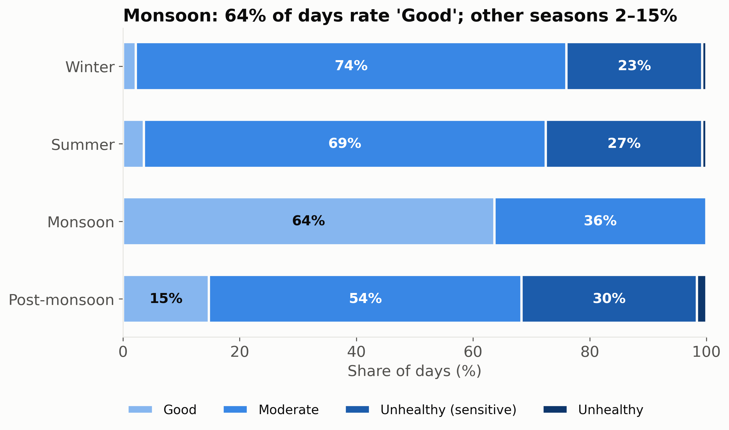
Figure 4.6: Share of days in each US AQI category, by season.
Figure 4.6 shows that in the Monsoon 64 % of days (233 of 366) were rated Good and none rose above Moderate. In the other three seasons only 6 % of days (43 of 730) were rated Good. Moderate days made up 54 % to 74 % of those seasons, and 23 % to 30 % of days were rated Unhealthy for sensitive groups. Table 4.4 gives the day counts and Table 4.5 compares the days with the benchmarks.
Table 4.4: Days in each AQI category, by season
Season | Good | Moderate | Unhealthy (sensitive) | Unhealthy | Total
Winter | 6 | 200 | 63 | 2 | 271
Summer | 10 | 190 | 74 | 2 | 276
Monsoon | 233 | 133 | 0 | 0 | 366
Post-monsoon | 27 | 98 | 55 | 3 | 183

Table 4.5: Days above air-quality benchmarks (1,096 days)
Measure | Days | Share of days
PM2.5 above WHO guideline (15 µg/m³) | 675 | 62 %
PM2.5 above CPCB limit (60 µg/m³) | 2 | 0.2 %
PM10 above WHO guideline (45 µg/m³) | 197 | 18 %
PM10 above CPCB limit (100 µg/m³) | 1 | 0.1 %
US AQI above 100 | 199 | 18 %

The Indian limit for PM2.5 was passed on only 2 days, whereas the stricter WHO guideline was passed on 62 % of days. All 199 days with an AQI above 100 fell outside the monsoon (none in June to September).
4.7 Relationships Between Variables
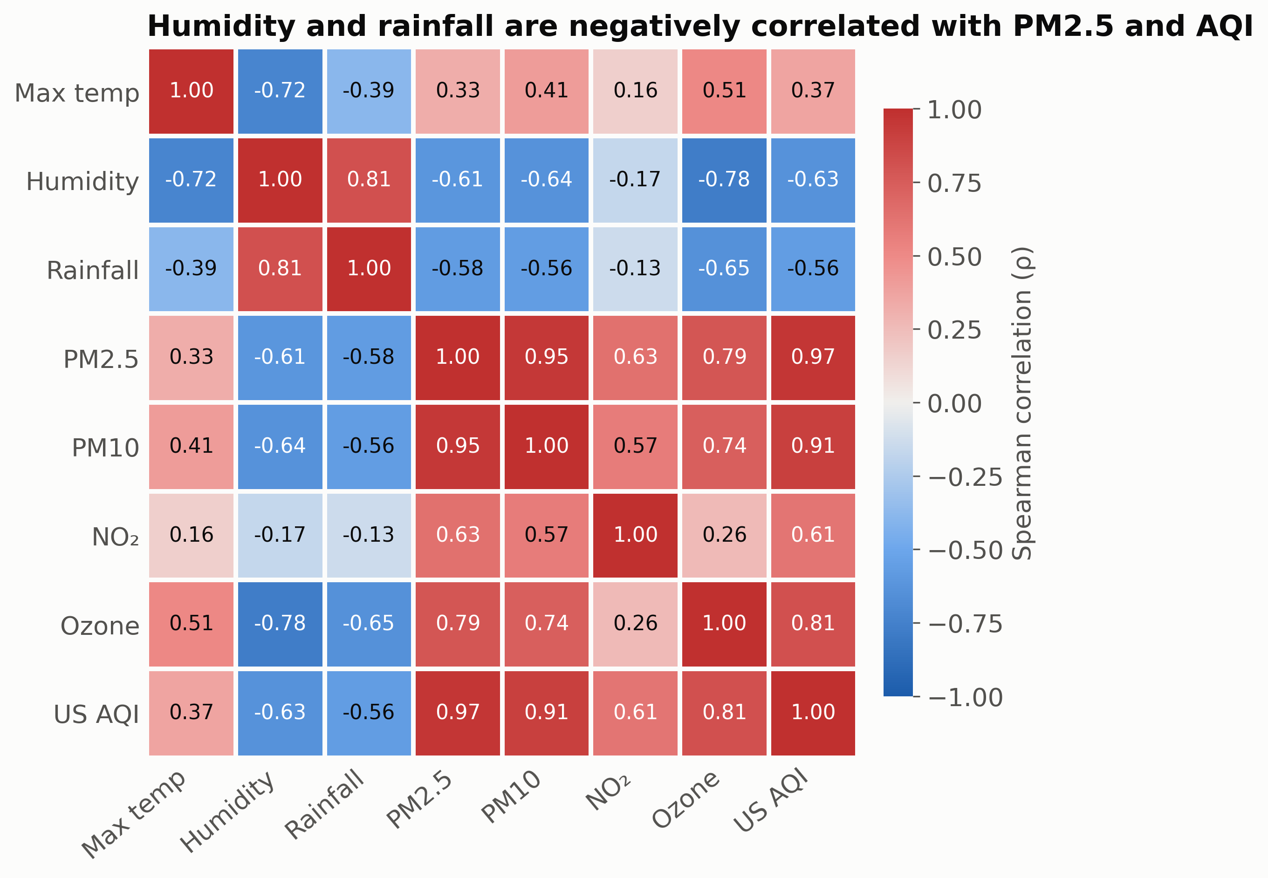
Figure 4.7: Spearman rank correlation between weather variables and pollutants (daily data, 1,096 days).
Table 4.6: Selected Spearman correlations (ρ)
Pair of variables | ρ
Rainfall and PM2.5 | −0.58
Humidity and PM2.5 | −0.61
Humidity and ozone | −0.78
Maximum temperature and ozone | 0.51
Maximum temperature and humidity | −0.72
PM2.5 and PM10 | 0.95
PM2.5 and NO₂ | 0.63

Humidity and rainfall move opposite to the particles (Figure 4.7). Humidity correlates with PM2.5 at −0.61 and with ozone at −0.78. Ozone rises with the daily maximum temperature (ρ = 0.51), and mean ozone is 92 µg/m³ in Summer against 44 µg/m³ in the Monsoon. PM2.5 and PM10 are almost perfectly aligned (0.95), and PM2.5 closely tracks the AQI (0.97) because particles most often set the AQI. NO₂ is only weakly related to humidity and rainfall (−0.17 and −0.13). These are correlations in observational data and they do not show that one variable causes the other.
4.8 Key Findings
• Finding 1: The monsoon air was cleanest. 64 % of June–September days were rated Good against 6 % of other days. Mean PM2.5 was 9 µg/m³ in the Monsoon and 27 µg/m³ in the rest of the year.
• Finding 2: PM2.5 was lower on rainy days. The median was 9.0 µg/m³ on rainy days against 23.7 µg/m³ on dry days (Spearman ρ = −0.58 between rainfall and PM2.5; p < 0.001).
• Finding 3: PM2.5 exceeded the WHO guideline on most days. It was above 15 µg/m³ on 675 of 1,096 days (62 %) and in 8 of 12 months, but above the Indian limit of 60 µg/m³ on only 2 days.
• Finding 4: Days with a poor AQI occur in the dry months. All 199 days (18 %) with AQI above 100 fell between October and May.
• Finding 5: The yearly cycle is stable. Mean PM2.5 was 21.4, 19.5 and 21.8 µg/m³ in the three years, with the same seasonal shape each year.
4.9 Recommendations
• Recommendation 1: Time health advisories to the dry months. Since all 199 days with AQI above 100 fell between October and May, advisories for sensitive groups (children, older adults and people with asthma) and the planning of outdoor events should focus on these months.
• Recommendation 2: Do not rely on rain to clean the air. The air meets the WHO guideline only in the monsoon months, so measures to reduce emissions and dust should be planned for October to May. Data on likely sources (traffic, construction, burning) should be collected to decide where to act.
• Recommendation 3: Check the data against ground stations before policy use. The values here are modelled. A comparison with CPCB monitor readings, over five or more years, should confirm the patterns before they guide decisions.
4.10 Limitations of the Study
• The data are modelled grid values for one point. They can differ from a single ground monitor and do not capture very local conditions.
• Only three years are covered, which is too short to separate seasonal variation from long-term trends.
• Correlations describe association only. Wind, traffic, industry and burning, which also affect air quality, are not in the dataset.
• Daily averages hide hourly peaks, such as rush-hour pollution, that matter for health.
5.0 CONCLUSION
This project analysed 1,096 days of public weather and air-quality data for Bengaluru (2023–2025). Weather followed a clear yearly cycle, with temperature peaking in April, humidity lowest in the dry months and rain concentrated from May to October. Air quality followed the seasons: it was cleanest in the monsoon (June to September) and above the WHO PM2.5 guideline in the other eight months. PM2.5 was clearly lower on rainy and humid days (median 9.0 against 23.7 µg/m³), and all 199 days with a poor AQI fell outside the monsoon.
The analysis met its objectives. It described the seasonal weather pattern, measured air quality by month and season, compared rainy and dry days, checked the values against WHO and CPCB benchmarks, and presented the results in seven labelled charts. The findings are associations in observational, modelled data. They do not prove that rain causes cleaner air. They do give a clear, evidence-based basis for the recommendations on timing health advisories and planning emission control for the dry months.
6.0 FUTURE SCOPE
• Validate with ground stations. Compare the modelled values with CPCB monitor readings in Bengaluru to measure the difference.
• Extend the period and the places. Use five to ten years of data and several cities to separate trends from the seasonal cycle.
• Add explanatory variables. Include wind speed, boundary-layer height, traffic counts and fire activity to explain why May is rainy yet above the guideline.
• Use stronger models. Apply time-series or regression models that allow for the dependence between consecutive days, and test whether rainfall adds explanatory power after controlling for season.
• Look at hourly data. Study daily cycles and rush-hour peaks instead of daily averages.
• Build an interactive dashboard. Let residents see the current day against the WHO and CPCB limits and the seasonal pattern.
REFERENCES
[1] Open-Meteo. Historical Weather API (ERA5). open-meteo.com/en/docs/historical-weather-api
[2] Open-Meteo. Air Quality API. open-meteo.com/en/docs/air-quality-api
[3] Zippenfenig, P. (2023). Open-Meteo.com Weather API [Computer software]. Zenodo. doi:10.5281/zenodo.7970649
[4] Hersbach, H., Bell, B., Berrisford, P., et al. (2020). The ERA5 global reanalysis. Quarterly Journal of the Royal Meteorological Society, 146, 1999–2049.
[5] Copernicus Atmosphere Monitoring Service (CAMS), ECMWF. Global atmospheric composition forecasts. atmosphere.copernicus.eu
[6] World Health Organization (2021). WHO global air quality guidelines: particulate matter (PM2.5 and PM10), ozone, nitrogen dioxide, sulfur dioxide and carbon monoxide. Geneva: WHO.
[7] Central Pollution Control Board, India. National Ambient Air Quality Standards (NAAQS). cpcb.nic.in
[8] US Environmental Protection Agency. Air Quality Index (AQI) basics. airnow.gov/aqi/aqi-basics
[9] Mann, H. B., & Whitney, D. R. (1947). On a test of whether one of two random variables is stochastically larger than the other. Annals of Mathematical Statistics, 18(1), 50–60.
[10] Spearman, C. (1904). The proof and measurement of association between two things. American Journal of Psychology, 15(1), 72–101.
[11] Hunter, J. D. (2007). Matplotlib: A 2D graphics environment. Computing in Science & Engineering, 9(3), 90–95.
[12] McKinney, W. (2010). Data structures for statistical computing in Python. Proceedings of the 9th Python in Science Conference, 56–61.
[13] Harris, C. R., Millman, K. J., van der Walt, S. J., et al. (2020). Array programming with NumPy. Nature, 585, 357–362.
[14] Virtanen, P., Gommers, R., Oliphant, T. E., et al. (2020). SciPy 1.0: fundamental algorithms for scientific computing in Python. Nature Methods, 17, 261–272.
APPENDIX A: MONTHLY SUMMARY
Table A.1: Monthly means over 2023–2025 (rainfall is the average yearly total for the month)
Month | Temp mean (°C) | Temp max (°C) | Temp min (°C) | Humidity (%) | Rain (mm) | PM2.5 (µg/m³) | AQI
January | 21.1 | 27.6 | 15.9 | 66 | 6 | 30.5 | 92
February | 23.8 | 30.9 | 17.2 | 48 | 0 | 26.9 | 87
March | 26.0 | 33.0 | 19.5 | 47 | 20 | 27.7 | 90
April | 27.7 | 34.6 | 21.1 | 48 | 20 | 27.5 | 93
May | 25.6 | 31.3 | 21.2 | 71 | 151 | 24.5 | 83
June | 24.0 | 29.1 | 20.4 | 78 | 103 | 10.6 | 48
July | 22.7 | 27.1 | 20.0 | 82 | 176 | 5.2 | 30
August | 23.2 | 27.9 | 19.7 | 80 | 135 | 11.0 | 49
September | 23.0 | 27.8 | 19.5 | 80 | 103 | 9.2 | 45
October | 23.0 | 27.9 | 19.3 | 77 | 164 | 24.8 | 79
November | 22.2 | 27.2 | 18.4 | 75 | 59 | 25.1 | 81
December | 21.4 | 26.8 | 17.2 | 74 | 34 | 27.9 | 86

APPENDIX B: PROJECT FILES AND SOURCE CODE
Table B.1: Files submitted with this report
File | Content
data/bengaluru_daily_2023_2025.csv | Daily dataset (10 columns, 1,096 rows)
data/bengaluru_daily_clean.csv | Dataset with derived columns (season, AQI category, rainy-day flag)
data/raw/weather.json, aq.json | Hourly data exactly as returned by the APIs
data/DATA_DICTIONARY.md | Source, period, attribute meanings, quality checks
Bengaluru_Weather_AQ_Visualization.ipynb | Google Colab notebook: download, preparation, analysis and all charts
scripts/build_daily.py, analyse.py, make_figures.py | Python scripts for aggregation, analysis and the figures in this report
poster/ | Poster (PDF) and its source files

Core of the data-preparation step (hourly values to daily values):
daily_w = weather.groupby("date").agg(
temp_mean=("temperature_2m", "mean"), temp_max=("temperature_2m", "max"),
temp_min=("temperature_2m", "min"), humidity_mean=("relative_humidity_2m", "mean"),
rainfall_mm=("precipitation", "sum"))
daily_a = air.groupby("date").agg(
pm25=("pm2_5", "mean"), pm10=("pm10", "mean"), no2=("nitrogen_dioxide", "mean"),
ozone=("ozone", "mean"), aqi_us=("us_aqi", "mean"))
df = daily_w.join(daily_a, how="outer").round(2)
assert df.isna().sum().sum() == 0
df["rainy"] = df.rainfall_mm >= 2.5

