Name: Nihaal K Zaheer
Section: 2
University ID: 105254206

Lab 2 Report

Summary:
In this lab we learn about various Unix Processes and their behaviors. We learn about process codes, forking processes, wait, and even killing processes. What I found really interesting was the concept of forking process to parent and child and how they relate to each other.

By the end of the lab, we learned to decipher process tables, forking a system call, time slicing, using the wait() function, the kill() function which terminated processes, the execve family of functions, and finally returning exit codes.

Lab Questions:

3.1:
6pts In the report, include the relevant lines from “ps -l” for your programs, and point out the following items:
- output
- process name
- process state (decode the letter!)
- process ID (PID)
- parent process ID (PPID)
2pts Repeat this experiment and observe what changes and doesn't change.
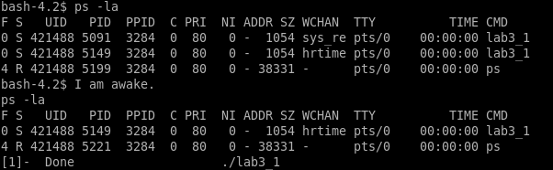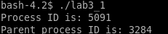
- Output – it gives the current processes running (running, sleeping and zombie), ps -el would give all processes, even those that have already been terminated.

- process name - lab3_1
- process state (decode the letter!) : S (Sleeping)
- process ID (PID) : 5091
- parent process ID (PPID) : 3284

2pts Find out the name of the process that started your programs. What is it, and what does it do?
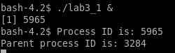
Process ID (PID) changes
Parent Process ID (PPID) stays the same
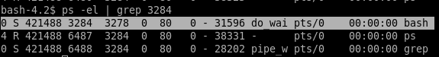
When we search up the PID of the parent process, we find out that the Process name is bash.
Bash is the shell we use. It is the command processor that runs in a text window.
It also reads and executes commands.
3.2:
1pt Include the output from the program
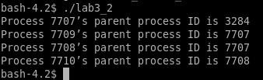

4pts Draw the process tree (label processes with PIDs)
3pts Explain how the tree was built in terms of the program code
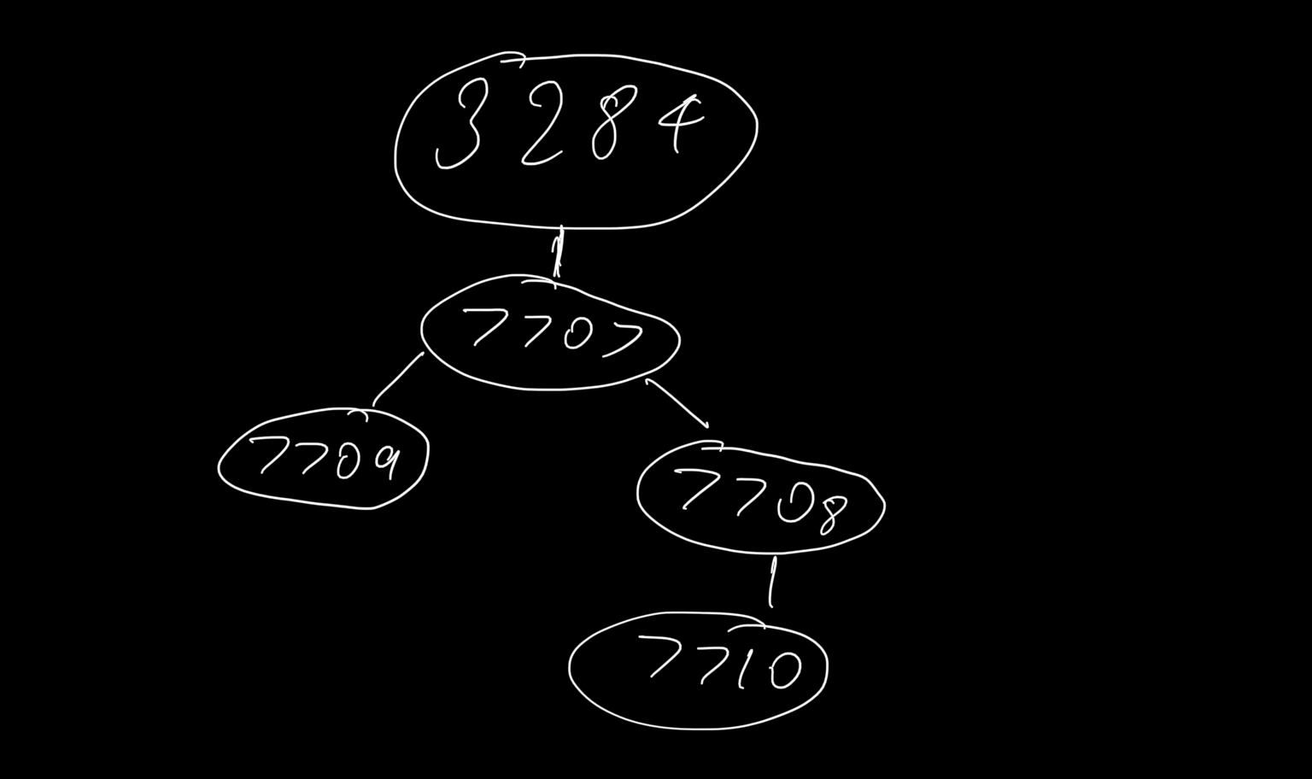
2pts Explain what happens when the sleep statement is removed. You should see processes reporting a parent PID of 1. Redirecting output to a file may interfere with this, and you may need to run the program multiple times to see it happen.
The main/ the program has the PID 7707, when we call the fork() function,
it makes a new process 7708. Now on calling fork() again, it is executed on both the parent and the child, so it makes 2 new process statements(forks), one from the parent(7709) and the other from the child (7710). These in-turn runs the rest of the code, that is, usleep, printf and sleep(2).
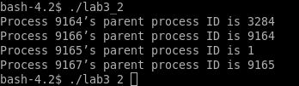
When the sleep commands are removed, the fork doesn’t have enough time to build the tree, but creates a fork by default. Since it doesn’t have enough time to build, it makes a fork with PID 1 as it’s parent.

3.3:
2pts Include the (completed) program and its output
4pts Speculate why it might be useful to have fork return different values to the parent and child. What advantage does returning the child's PID have?
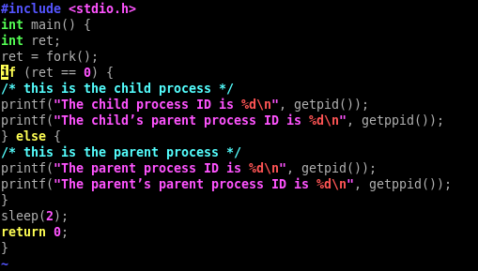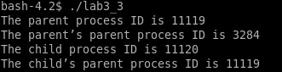

If for returned the same value for child and parent processes, we cannot differentiate between the 2.
Let’s say we want to kill the child process, and let the parent process run. This would not be possible if they both had the same PID.
Since there isn’t a function that returns the child’s PID, like how we have the PPID that returns the parent’s PID, returning the child’s PID would be useful.
3.4:
2pts Include small (but relevant) sections of the output
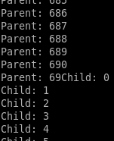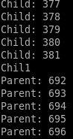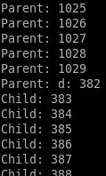

4pts Make some observations about time slicing. Can you find any output that appears to have been cut off? Are there any missing parts? What's going on (mention the kernel scheduler)?
We see that the output keeps switching between the Parent process and child processes. This is handled by the kernel scheduler.
We see that the output gets cutoff as it switches between processes. In the first instance, when the parent is at 690 it switches to the child process, but the 0 in 690 gets cutoff and is overwritten with the child process.
We see several instances of the similar discrepancies consistently upon switching.

3.5:
6pts Explain the major difference between this experiment and experiment 4.
Be sure to look up what wait does (man 2 wait).
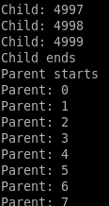

n this case there isn’t an abrupt switch between the child and the parent processes. We see that the parent condition executes only when the child process is done executing. I decreased the number of iterations to 5000 so that it was easier verifying.
The wait(NULL) command blocks the parent process until the child process are finished executing.
This is different as compared to experiment 3.4 where the kernel scheduler would switch process, which would abruptly stop or corrupt existing running processes.
3.6:
2pts The program appears to have an infinite loop. Why does it stop?
4pts From the definitions of sleep and usleep, what do you expect the child's count
Close to a 1000, 10 seconds, parents sends signal to kill termination signal
The program terminates because the parent process sends a SIGTERM(Signal terminate)
signal. This happens when the parent process goes to sleep for 10 seconds. Finally the wait function is called, and “done” is printed out.
to be just before it ends?
2pts Why doesn't the child reach this count before it terminates?
Sleep pauses the program for some amount of time while usleep pauses the program for some amount of microseconds.
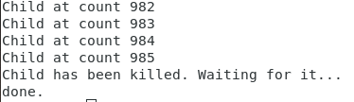The child process receives usleep(10000), which is 10 milliseconds, so this is the time between each count of the child process. The sleep(10) in the parents process, makes the parent process sleep for 10 seconds after which the termonation signal is sent.
Child count is always around 985 on multiple attempts. We expect the child count to be 1000 because it prints child count every 10 miliiseconds for 10 seconds which is a 1000.

Count is supposed to be 1000. Parent sends a SIGTERM after 10 seconds. Though the count is supposed to be 1000, this isnt the case. This is because it is affected by various factors including speed of the machine, load on the machine etc.

3.7:
8pts Read the man page for execl and relatives (man 3 exec). Under what conditions is the printf statement executed? Why isn't it always executed?
(consider what would happen if you changed the program to execute something other than /bin/ls.)

Execl creates a process image, and if it is true, it will complete the function. Basically it replaces the current process image with a new process image. That means that if the execl function returns something there was an error.

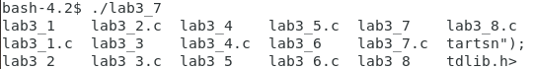

This is what it returns usually

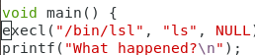
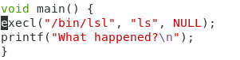When we change the code to the below one.
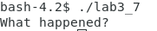
We get “What happened”. That is the execl function is returned which has the printf statement in it. That is if the main() function is false, then it executes the printf statement.
3.8:
2pts What is the range of values returned from the child process?
2pts What is the range of values sent by child process and captured by the parent process?
RAND_MAX has values ranging upto 32767, (2^15) -1.
Therefore RAND_MAX/4 will be 2^13, which will be the range of the child process.
2pts When do you think the return value would be useful?
This is going to be 256 -1 (255), which is the highest exit status number we get on running the program multiple times. Therefore range will be 0 – 255.

Hint: look at the commands true and false.
It will be useful to know if the child processes have ended, which is why return values are useful.
For example, 0 can indicate child process termonated successfully and any other non-zero exit code would tell the parent process that the child process did not terminate successfully.

