Name: Nihaal K Zaheer
Section: 2
University ID: 105254206

Lab 3 Report

Summary:
20pts
In this lab we learned about pthreads. We started of understanding the use of pthread_create and join by performing tasks that showed us what would happen if we didn’t have these statements in our code.
Next we learnt about mutex and conditional variables, this is something that I found really interesting. I understood that mutex and conditional variables, controls process scheduling and locks the process scheduling so that one function is entirely executed before moving onto the next one. We do this by using mutex_lock and unlock and pthread cond signal, control and broadcast.
Finally we put it all together by simulating a producer-consumer model.
Lab Questions:

3.1:
10pts To make sure the main terminates before the threads finish,
add a sleep(5) statement in the beginning of the thread functions.
Can you see the threads' output? Why?
5pts Add the two pthread_join statements just before the printf statement in
No, we don’t see the thread outputs.

When I ran the executable ./ex1, it displayed “Hello From main”. The main function did not start the threads, thread1 or thread2. We know this because it did not run the sleep(5).

This happens because we did not have the pthread_join command. This is what starts the thread. It makes the main wait for the 2 threads to finish or terminate.
main. Pass a value of NULL for the second argument. Recompile and rerun the program. What is the output? Why?

5pts Include your commented code.
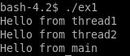
The output is as shown above. Thread1 compiles first, it gives the output, the moves on to thread2 after thread1 terminates (pthread_join). Then finally we see the statement “Hello from main” after the 2 threads are terminated
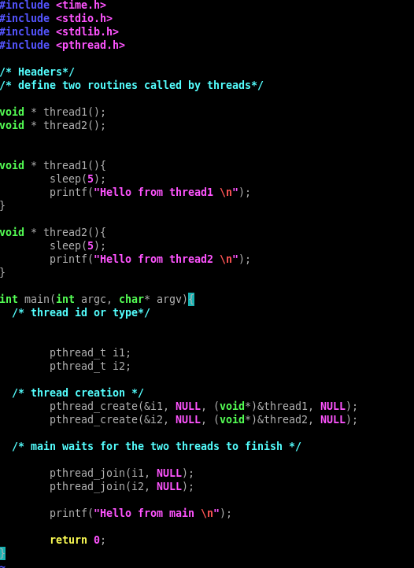
3.2:
3.2.1:
5 pts Compile and run t1.c, what is the output value of v?
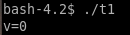

15 pts Delete the pthread_mutex_lock and pthread_mutex_unlock statement in both increment and decrement threads. Recompile and rerun t1.c, what is the output value of v? Explain why the output is the same, or different.
3.2.2:
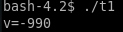

Output is different, we only get the output for decrement.
This is because we don’t use mutex, what mutex_lock() does is blocks the process so that it finishes executing, and then mutex_unlock(), unblocks it once it’s done executing entirely.

Since we deleted the mutex lines, the OS doesn’t know that it has to complete one process before moving on to the next, and so messes up and only ends up showing decrement() as the final output without taking into account increment().
20 pts Include your modified code with your lab submission and comment
on what you added or changed.

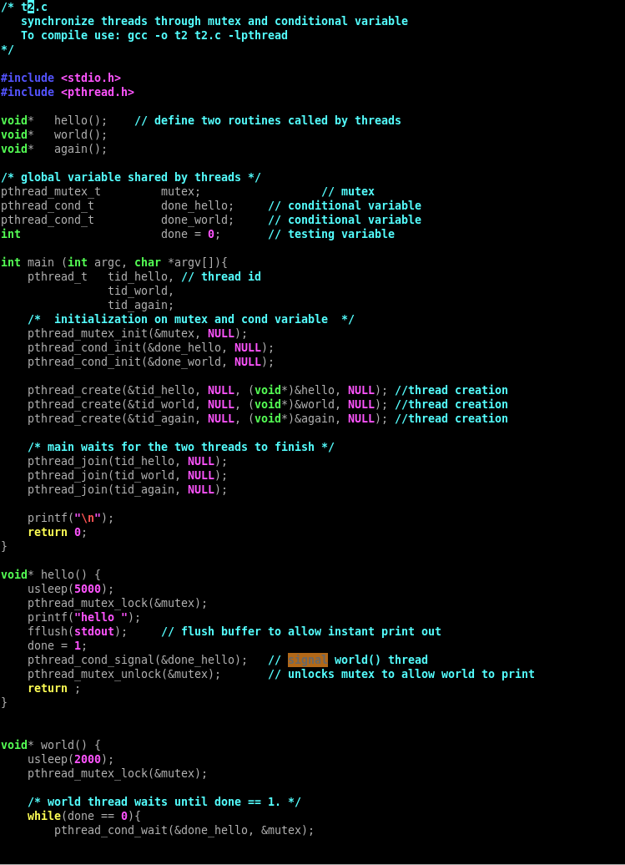

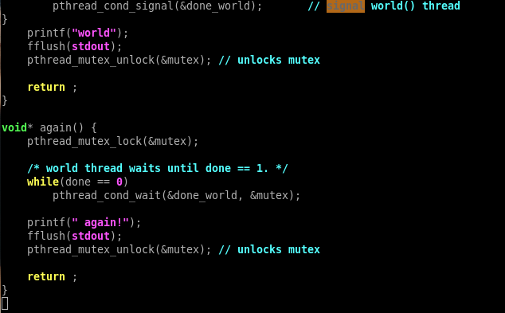

I added a new function called again(), and also made a new pthread_cond_t called done_world(). I also made a new pthread called tid_again.
Basically what I did was, called a signal within world() called done_world. Now within the new function, again(), I had the pthread_comd_wait that called done_world. This would wait until the world() function would be done executing, but because we had a pthread_cond_wait(&done_hello,&mutex), this would in-turn wait for hello() to finish executing. Because of this it would go in order and give us the required output as follows:
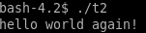

3.3:
20pts Include your modified code with your lab submission and comment on what you added or changed.
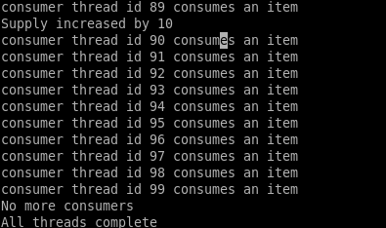
Part of the output:
I changed the producer() function to perform the needful. I added a mutex lock and unlock, and within ther while loop, I added another while loop which took care of performing required functions when supply was not 0. Within this while loop there was an if statement that checked of num_cons_remaining was 0, and if it was if would break out of the top while loop, and else, supply would be increased by 10.

